Table of Contents

Part A – Project Planning 2

Part B – Database Design 4

Part C – Database Implementation and Testing 5

References 9

# Part A – Project Planning

Business Overview –

The football club has players and employees. They want to save data for players , physio and employees .

The club wants to maintain data so as to find the number of player who have opted for multiple physio , which all physios are involved with which all players. Players which are associated with which location.

Business requirements –

Players data should contain names, addresses, phone numbers. Physio ID is the identifier of Physio along with their specialization (orthopedic, chiropractic, and acupuncture) , name and office addresses and phone numbers should be saved. The club employees data like employee ID, an employee type (Manager, Receptionist, Coach, and IT Admin) and employee id as an identifier along with their names, email addresses, phone number and office addresses are stored. A Player can be associated with many physios . Employees can be assigned to one physio.

Expected Project Outcomes –

* 1. Export Files , ER diagram

Technical and administrative details –

* 1. *DBMS software used : Mysql Workbench,*
  2. *Storage : MySQL Database*
  3. *Backup : Mysql Dumps*

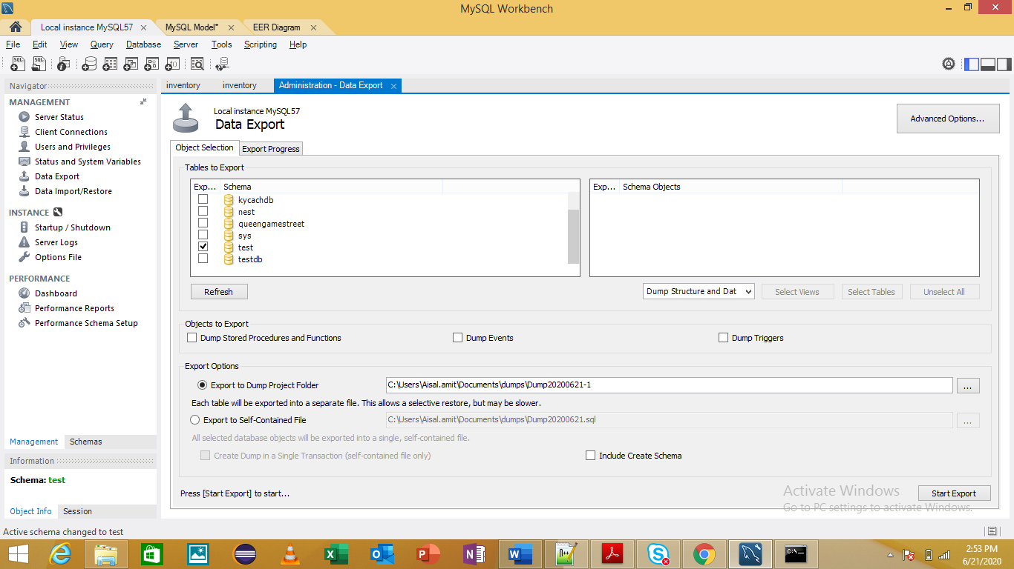

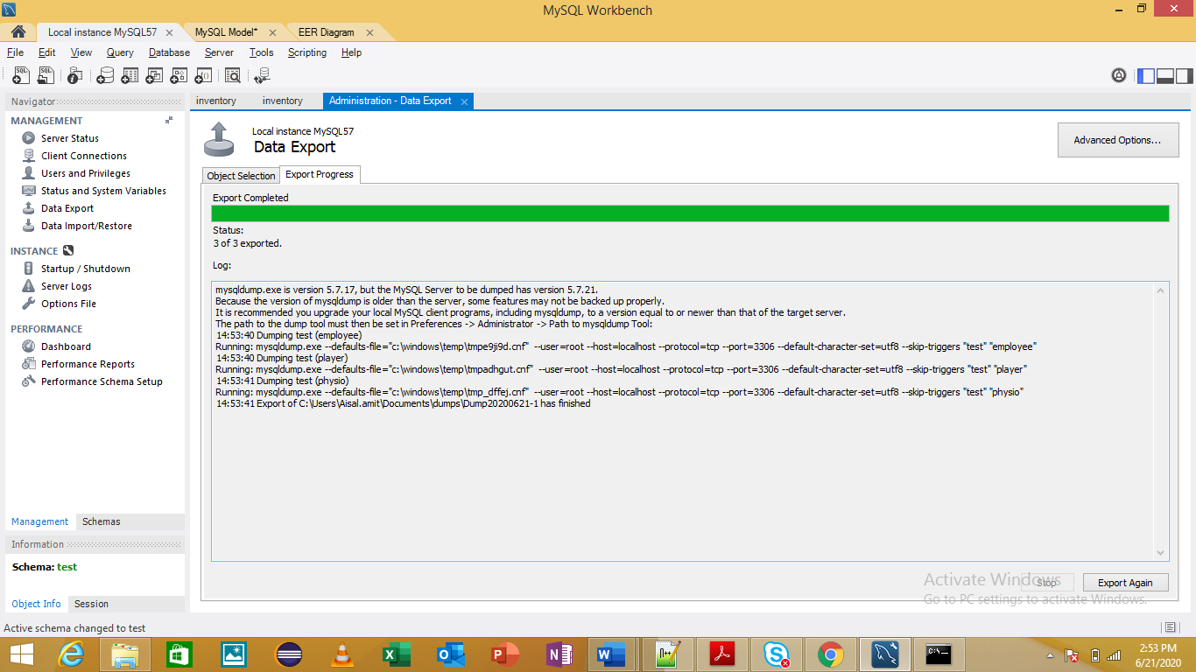

# Part B – Database Design

ER Diagram –

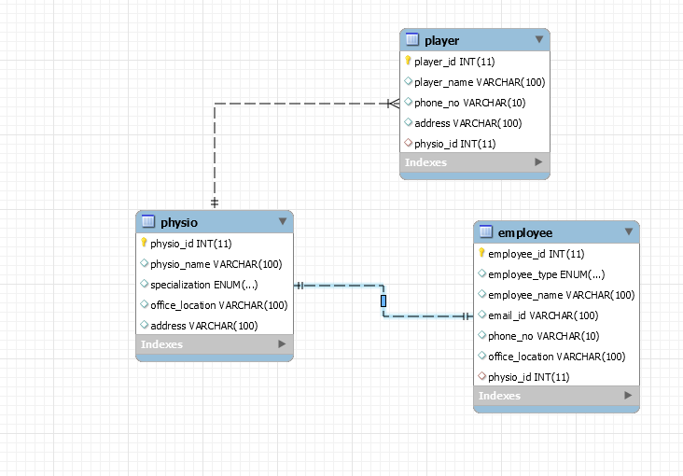

Relational schemas –

* 1. Player
  2. Physio
  3. Employee

Normal Forms : Applied 1st NF , 2nd NF and 3rd NF

# Part C – Database Implementation and Testing

**Database Implementation** –

Create database test

**The tables and their relationships**

create table Player(

  player_id int primary key,

  player_name varchar(100),

  phone_no varchar(10),

  address varchar(100),

  physio_id int REFERENCES physio(physio_id)

  );

 create table physio(

                physio_id int primary key,

                physio_name varchar(100),

                specialization ENUM ('Orthopedic','Chiropractic','Acupuncture'),

                office_location varchar(100),

                address varchar(100)

);

 create table employee(

                employee_id int primary key,

                employee_type ENUM ('Manager', 'Receptionist', 'Coach', 'IT' ,'Admin'),

                employee_name varchar(100),

                email_id varchar(100),

                phone_no varchar(10),

                office_location varchar(100),

                physio_id int unique,

    FOREIGN KEY(physio_id) REFERENCES physio(physio_id)

);

2. Database Testing

1. 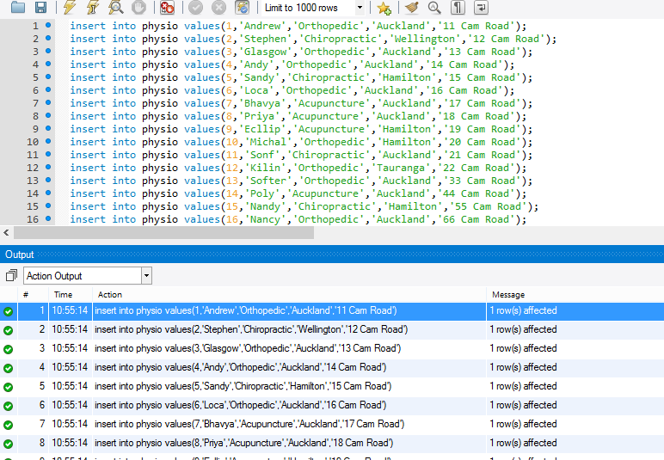*Populate your database with at least 20 test records*

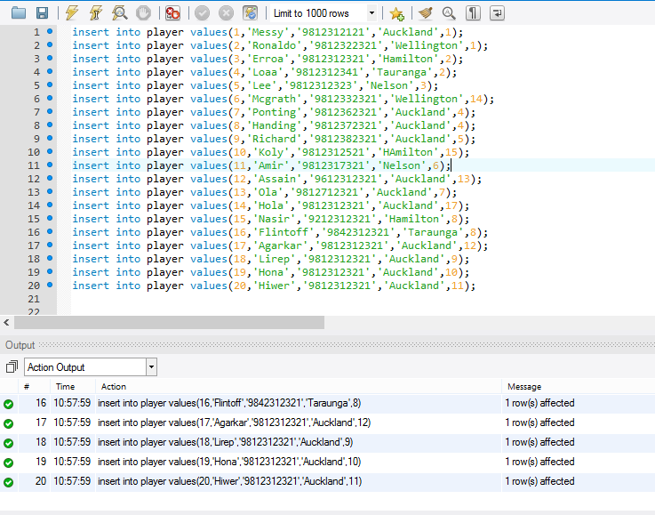

1. *Test insertion and deletion of records*

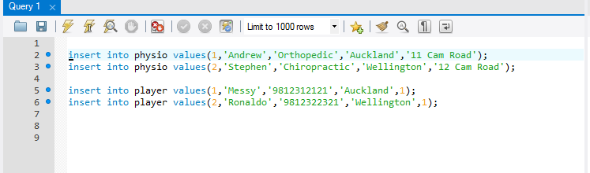

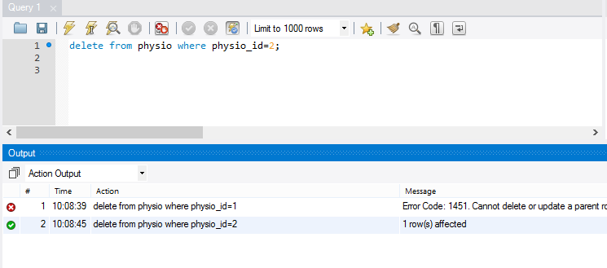

1. *Test relationship between the tables*
   * Testing Relationship one to one between Employee and Physio

select * from employee where physio_id=1;



* + Testing Relationship one to many between Player and Physio

select * from player where physio_id=1;

# References

* [www.w3schools.com](http://www.w3schools.com)
* [www.dev.mysql.com](http://www.dev.mysql.com)
* [www.tutorialpoint.com](http://www.tutorialpoint.com)