Table of Contents

Part A – Project Planning 2

Part B – Database Design 4

Part C – Database Implementation and Testing 5

References 8

# Part A – Project Planning

Business Overview –

Needs to design a database for Queens Street Video Game Rental Shop which consists of employees , products , members and inventory. To manage all the transactions and which employee has done the sales for which product . Manager wants to see the sales for the period of time , so that he/she can take business decisions to improve overall sales. Manage wants to see how many members have been created and manage them , which again help in business decisions . All the reports needs to be created in which all transactions and by whom , all the details should be created accordingly.

Business requirements –

The company consists of following number of employees

* 1 Manager
* 2 shop attendants
* 1 back office or DBA

All the employees identified by employee ID along with their names and employee type i.e manager , shop attendants and IT. Database should also store the games that are sold in the shop and game should be identified by product ID along with their price and from where they are shipped. There is a need to maintain the data of the members associated with the shop and they will buy the product from the employees only and data should include member ID, names , phone number and addresses and membership plans .

Expected Project Outcomes –

* 1. Export Files , ER diagram

Technical and administrative details –

* 1. *DBMS software used : Mysql Workbench,*
  2. *Storage : MySQL Database*
  3. *Backup : Mysql Dumps*

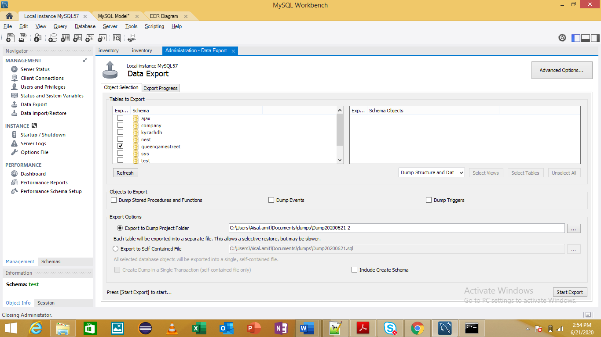

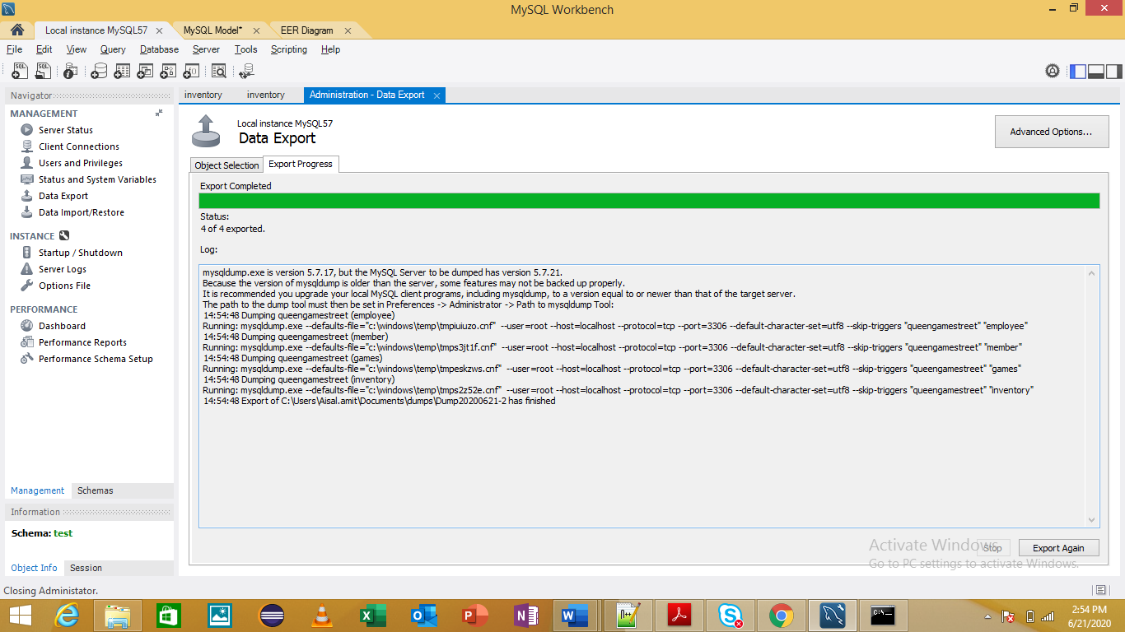

# Part B – Database Design

ER Diagram –

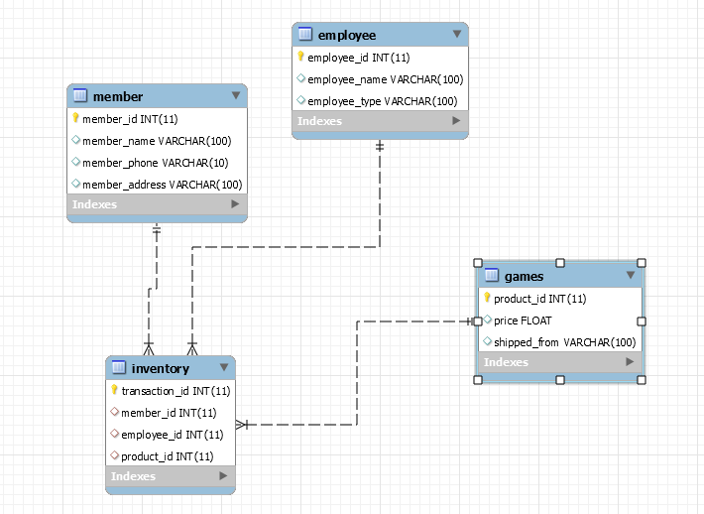

Relational schemas –

* 1. Games
  2. Member
  3. Employee
  4. inventory

Normal Forms : Applied 1st NF , 2nd NF and 3rd NF

# Part C – Database Implementation and Testing

**Database Implementation** –

Create database queengamestreet

**The tables and their relationships**

CREATE TABLE `employee` (

`employee_id` int(11) NOT NULL,

`employee_name` varchar(100) DEFAULT NULL,

`employee_type` varchar(100) DEFAULT NULL,

PRIMARY KEY (`employee_id`)

) ENGINE=InnoDB DEFAULT CHARSET=utf8;

 CREATE TABLE `games` (

`product_id` int(11) NOT NULL,

`price` float DEFAULT NULL,

`shipped_from` varchar(100) DEFAULT NULL,

PRIMARY KEY (`product_id`)

) ENGINE=InnoDB DEFAULT CHARSET=utf8;\

CREATE TABLE `inventory` (

`transaction_id` int(11) NOT NULL ,

`member_id` int(11) DEFAULT NULL references member(member_id),

`employee_id` int(11) DEFAULT NULL references employee(employee_id),

`product_id` int(11) DEFAULT NULL references games(product_id),

PRIMARY KEY (`transaction_id`)

) ENGINE=InnoDB DEFAULT CHARSET=utf8;

CREATE TABLE `member` (

`member_id` int(11) NOT NULL,

`member_name` varchar(100) DEFAULT NULL,

`member_phone` varchar(10) DEFAULT NULL,

`member_address` varchar(100) DEFAULT NULL,

PRIMARY KEY (`member_id`)

) ENGINE=InnoDB DEFAULT CHARSET=utf8;

2. Database Testing

1. *Populate your database*

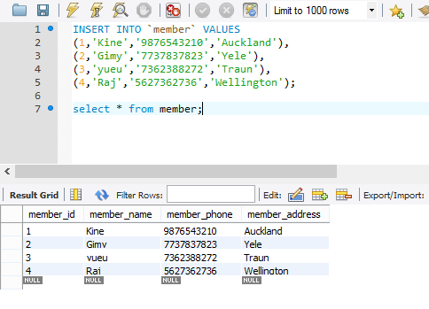

1. *Testing Deleting the records*

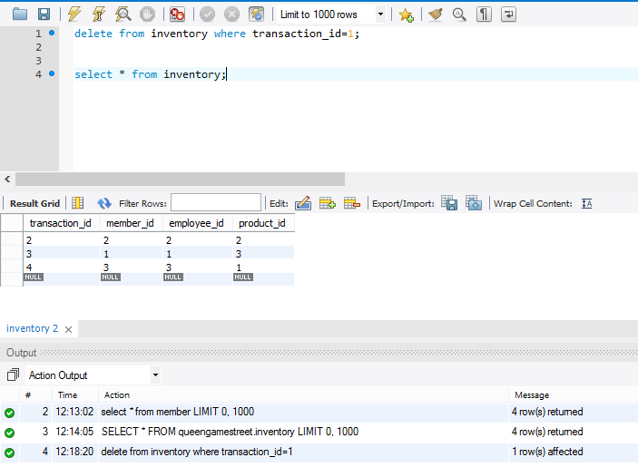

1. *Test relationship between the tables*

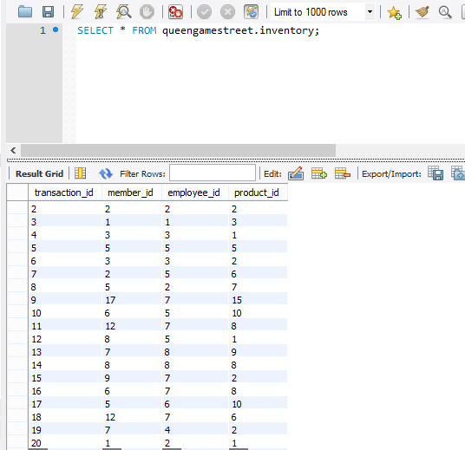

# References

* [www.w3schools.com](http://www.w3schools.com)
* [www.dev.mysql.com](http://www.dev.mysql.com)
* [www.tutorialpoint.com](http://www.tutorialpoint.com)