Contents

Introduction 2

Aim of the website 2

Technology Used 2

User Guide 4

References: 10

# Introduction

In today’s fast moving time people don’t have much time to go to the library and check the availability of books and then issue it . So to overcome this problem this website will information about the books that are available in the library and availability status also. It is a online based library knowledge hub that have information about the library.

# Aim of the website

This websites aim is to overcome the manually go the library and check the status of the books and which books are available in the library .User will check online about the various books that are in library. This website will also help the staff member to manage the books and update the status of the books availability. This website consisting of 3 pages i.e index , admin , login.

# Technology Used

Along with the front end languages , client side scripting language is also used to validate the user.

* HTML5

HTML stands for Hyper Text Markup Language. It is used to design websites.

HTML is widely used language on the web. It is a markup language instead of programming language.

Basic structure of HTML

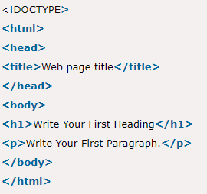

* CSS3

It stands for Cascading Style Sheets . It is also used in designing web pages or we can say that look and feel of the website , like back ground color , table designs etc. It is widely used in websites. HTML, CSS and JavaScript are used for web designing. It helps the web designers to apply style on HTML tags.

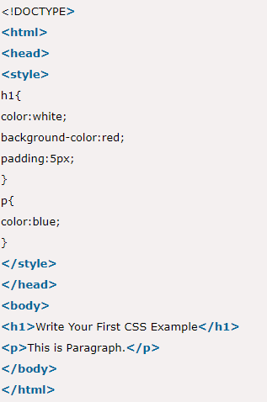

* Javascript

It is an object based scripting language with lightweight and cross platform features . It is interpreted by the browser with the help of Java script transalator. To add dynamic features to the website this scripting language is used. Users can build modern web applications to interact directly without reloading the page every time .

Features:

* + Built-in execution environments.
  + It has a structure like C Language
  + Structured based programming language.
  + Light weight and interpreted language.
  + Case sensitive language
  + Good control to the users over web clients.

Basic Structure

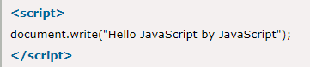

# User Guide

**Index.html**

The user will open the index.html page that will be the first page of the website .

Features of this page

* Link to go to the Admin Page.
* The Treaty of Waitangi – brief description.
* For any query and suggestion a contact us form is also available.
* When a user submits the contact us form , a message will be displayed “Hi your message has been sent”.

**Screenshot**

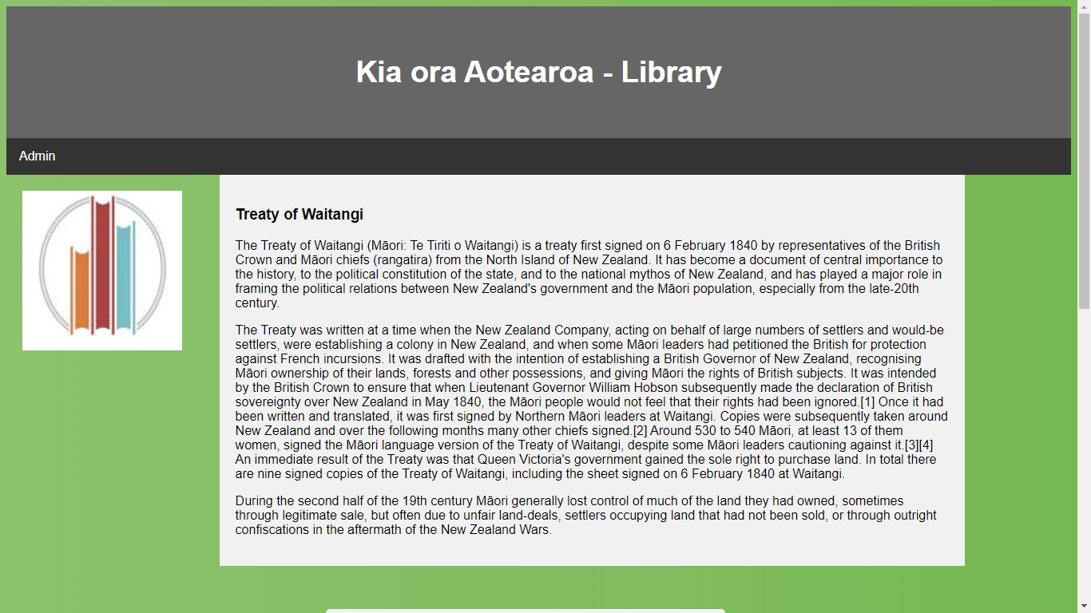

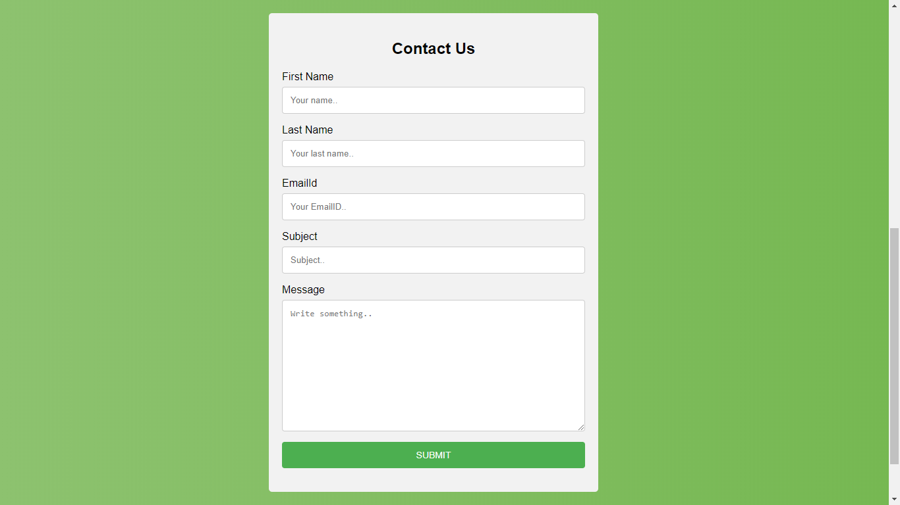

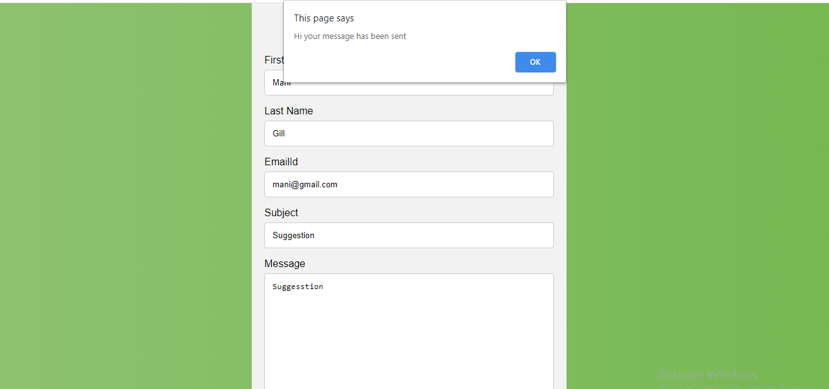

**Login.html**

This page opened when user clicks on Admin menu link on index page.

Features:

* This page will allow admin to login .
* When admin puts in his/her credentials and click on submit it will go to the admin.html page.

**Screenshot**

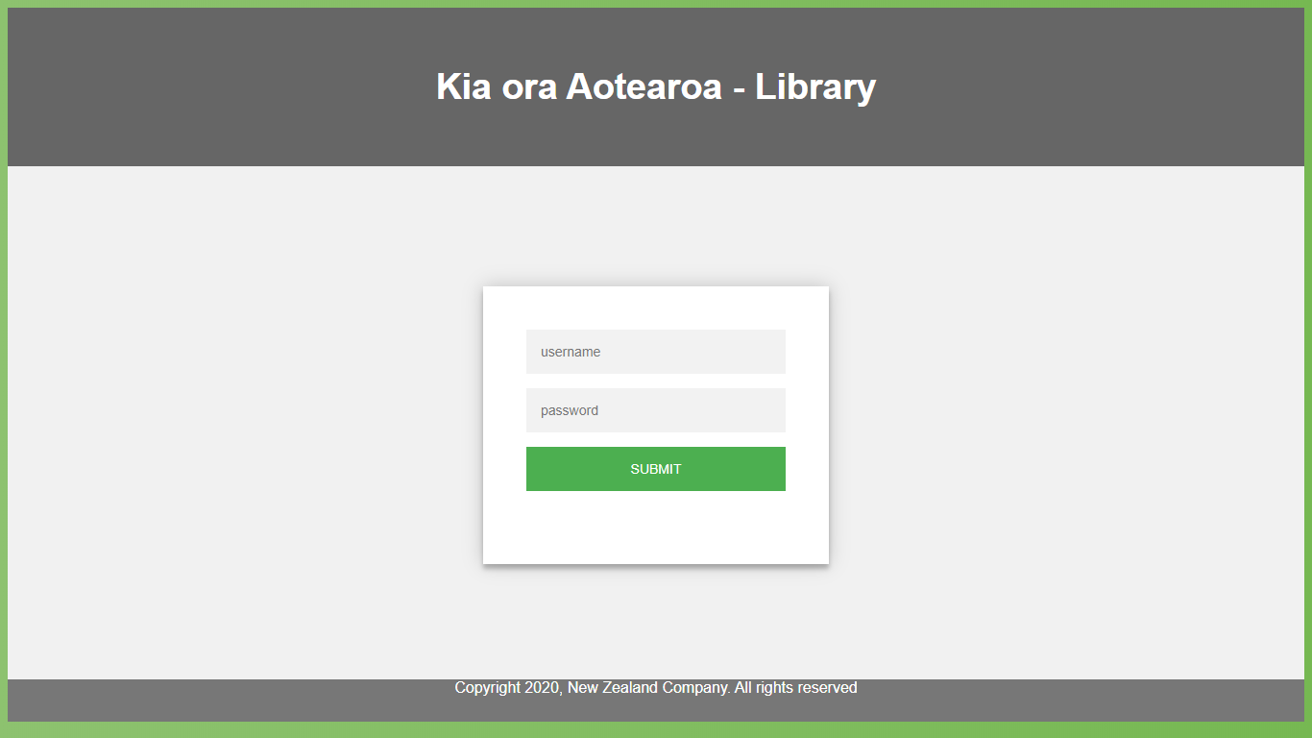

When user enters username as “user” and password as “password” , it will go to the admin page.

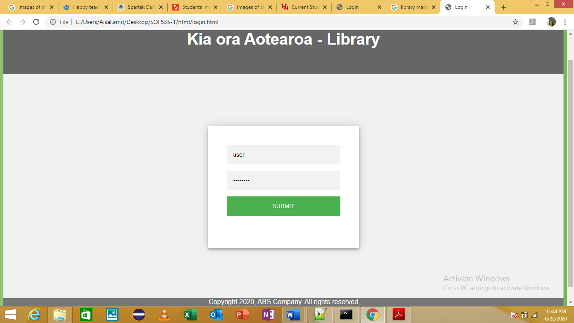

Script used to check username and password

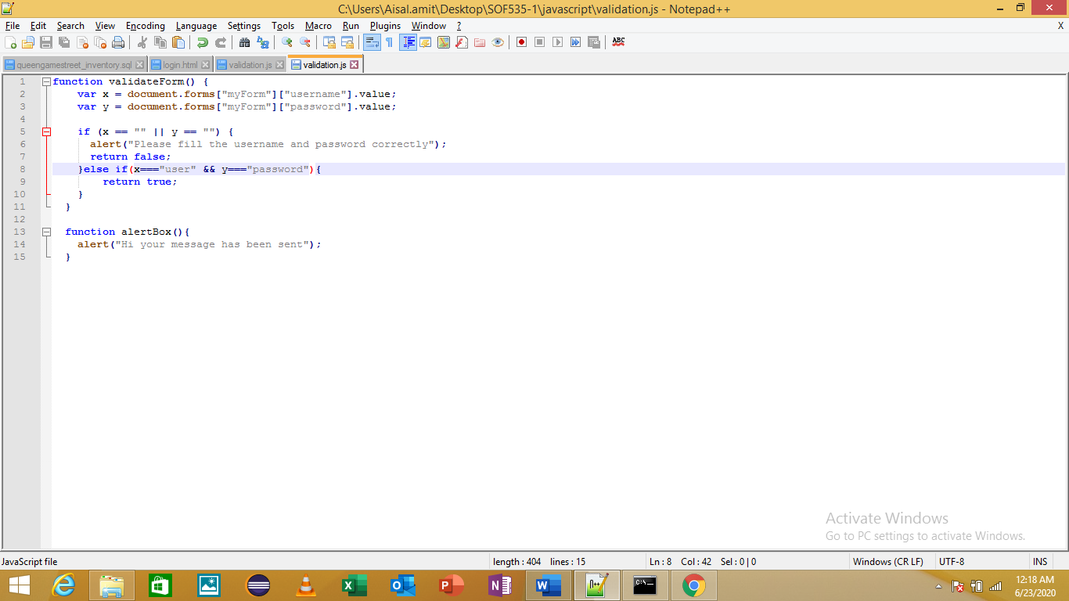

**Admin.html**

This page opens when admin puts in the credentials on the login page.

Features

* List of books registered in the library are available on this page
* A table consists of details of the books with their information like author , name , year , status

**Screenshot**



(list of students, 2020)

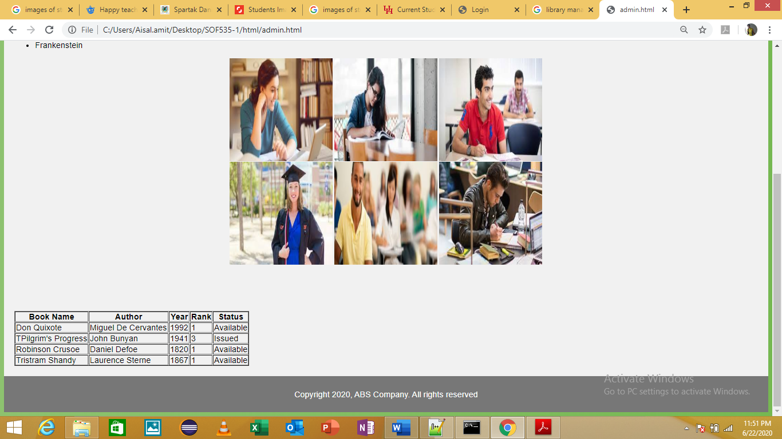

# References:

**Image source**

* <https://firstgen.naspa.org/why-first-gen/students/are-you-a-first-generation-student>
* <https://www.google.com/search?q=images+of+students&rlz=1C1CHBF_en-GBIN802IN803&sxsrf=ALeKk02P9XQ_mlOwfrrrFIOIjGm0UbqZzw:1592847506181&tbm=isch&source=iu&ictx=1&fir=ONTALFATOreTXM%253A%252CniuRFvtgYh2XQM%252C_&vet=1&usg=AI4_-kSxe4SFPR6OX_tlTXOo0Sxf0PvFkQ&sa=X&ved=2ahUKEwj2z6Wu-5XqAhXszDgGHeItB-UQ9QEwAHoECAoQLQ&biw=1366&bih=657#imgrc=uGLjeDwDHD96JM>
* <https://www.facultyfocus.com/articles/online-education/synchronous-online-classes-10-tips-engaging-students/>
* [www.wikipedia.com](http://www.wikipedia.com)
* <https://www.javatpoint.com/css-tutorial>
* <https://www.javatpoint.com/html-tutorial>
* <https://www.javatpoint.com/javascript-tutorial>