Contents

Introduction 2

Technology Used 2

User Guide 3

References: 8

# Introduction

In today’s world people wants everything should be online for eg people used to go library to read books , issue books and return them but now user wants that the status of books availability , which type of books are in library can be checked online. So the aim is to create a website for the library that gives the information that the user wants by sitting home i.e online.

# Aim of the project

This website motive is to cater the requirements of the user who wants to check the availability of the books and order them and go to the library to read which helps them to grow and increase knowledge. Another aim is to create a Knowledge base which will help staff to organize the library information and materials. This website consisting of 3 pages i.e index , admin , login.

# Technology Used

This website is created with the help of some languages and some client side scripting language.

1. HTML5

2. CSS3

3. JavaScript

# 

# User Guide

**Index.html**

The user will open the index.html page that will be the first page of the website .

Features of this page

* Admin Login menu link is there to go the Admin Page.
* A brief description of the Treaty of Waitangi.
* A contact us form in which user can contact if he is having any query or suggestion.
* When a user puts in information and click the submits button a message will be displayed “Hi your message has been sent”.

**Screenshot**

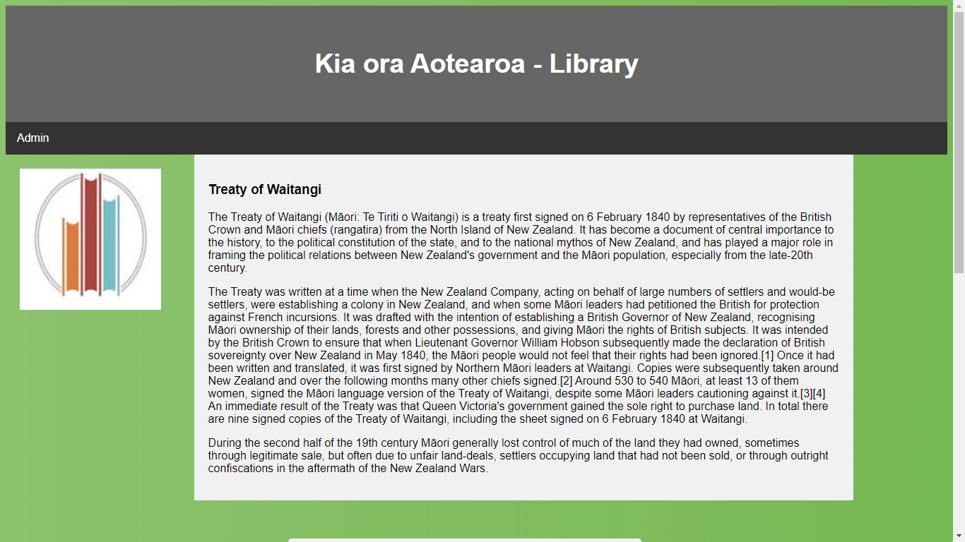

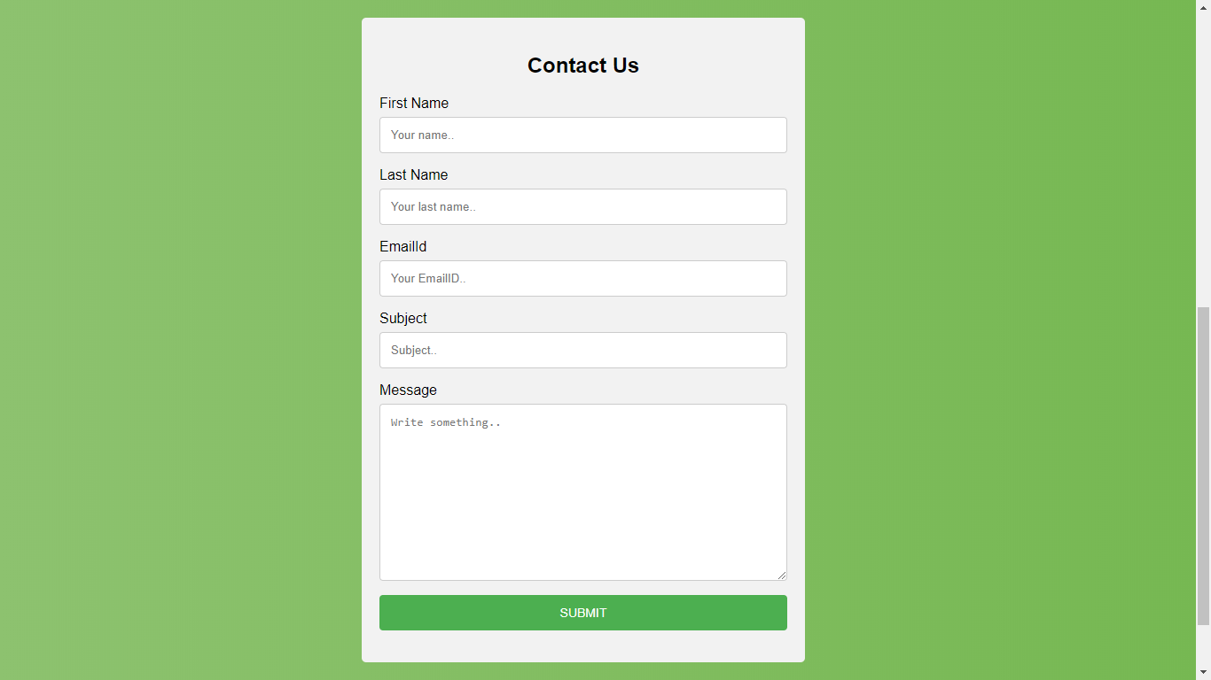

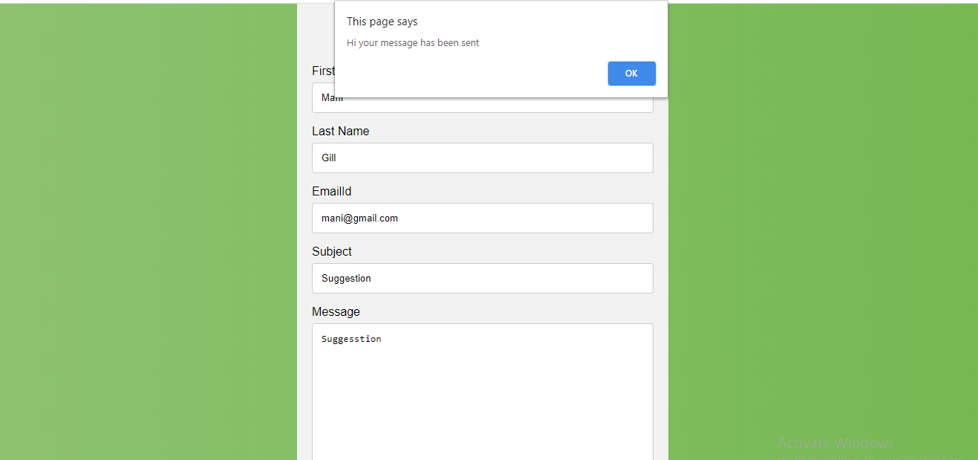

**Login.html**

This page opened when user clicks on Admin menu link on index page.

Features:

* This page will allow admin to login .
* When admin puts in his/her credentials and click on submit it will go to the admin.html page.

**Screenshot**

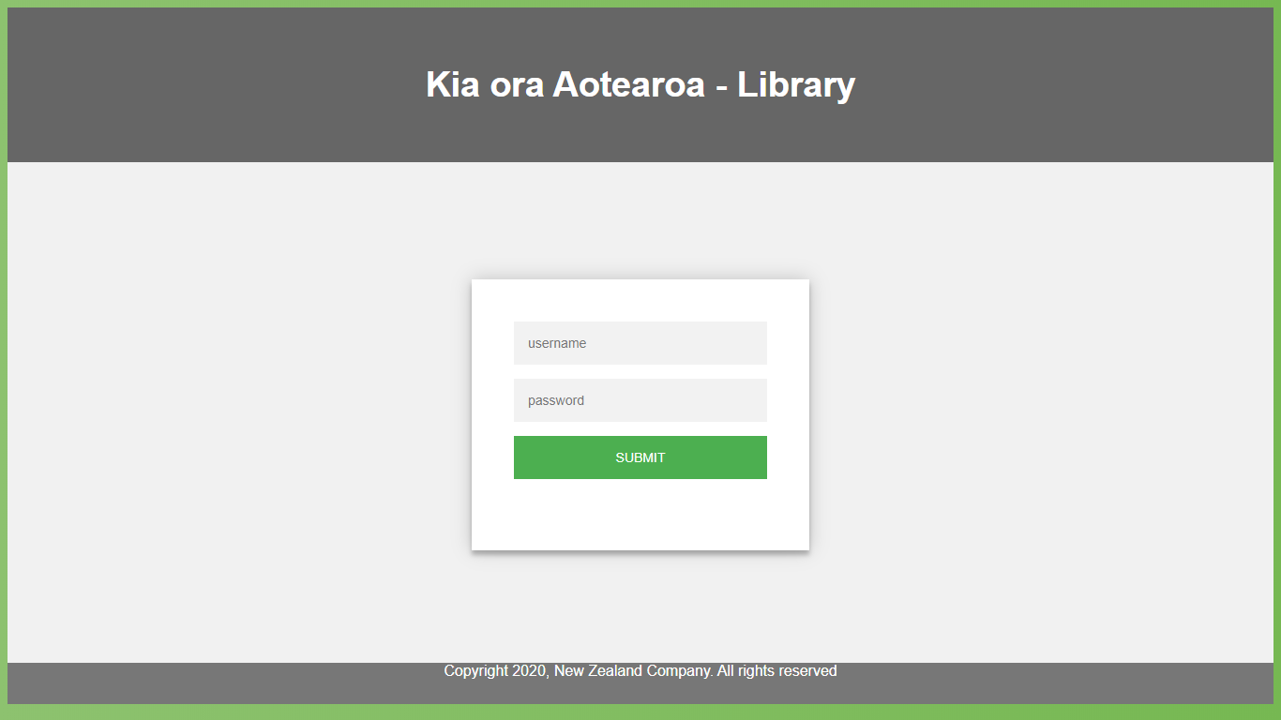

**Admin.html**

This page opens when admin puts in the credentials on the login page.

Features

* This page consists of list of books registered in the library
* It also consists of details of the books with their information like author , name , year , status

**Screenshot**

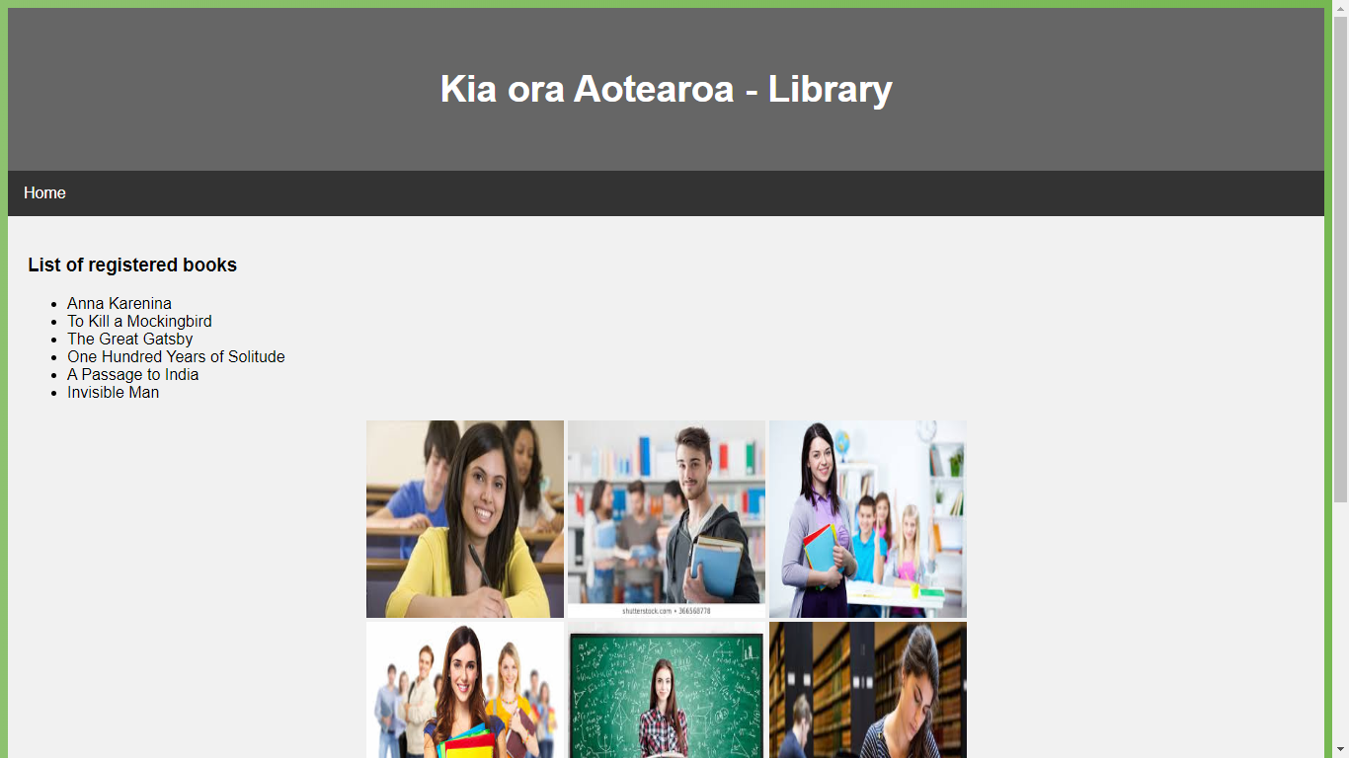

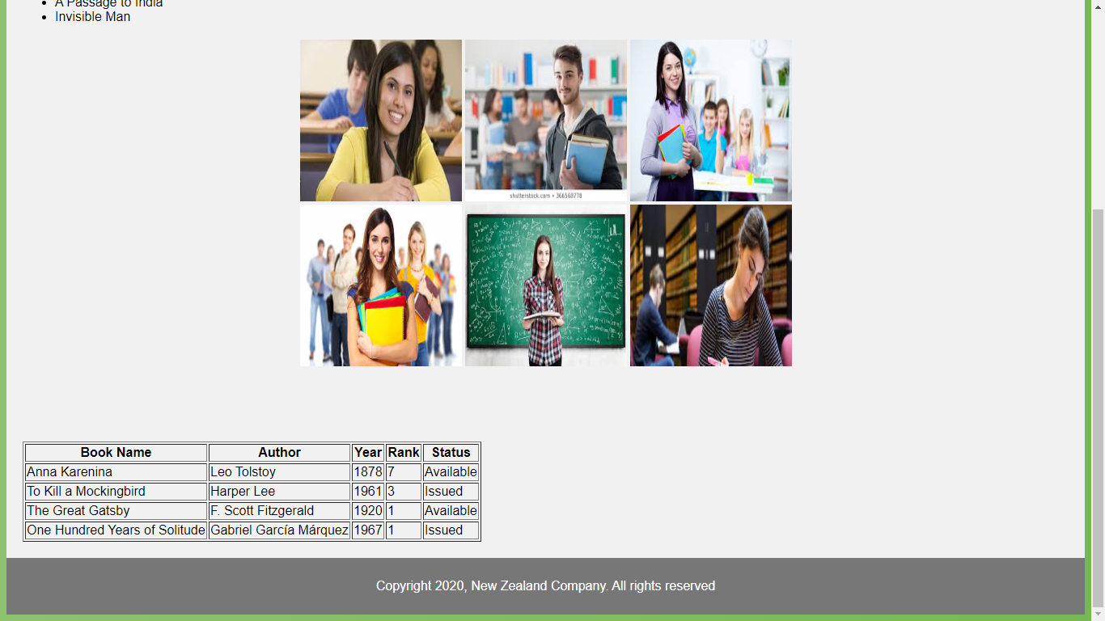

# References:

**Image sources:**

* <https://adventbkk.ac.th/portfolio/spartak-daniel/>
* <https://www.freepik.com/free-photo/happy-teacher-with-students-background_864157.htm>
* <https://www.ila-france.com/french-language-students>
* <https://uh.edu/students/>
* [www.w3schools.com](http://www.w3schools.com)
* [www.wikipedia.com](http://www.wikipedia.com)