CONSTRUCTION OS
Master Product Requirements Document
Enterprise SaaS · Construction Operations · Company Network · Professional Identity
Document status | Build-ready specification for senior full-stack estimation
Version | 1.0
Date | 2 August 2026
Primary languages | English and Albanian

Private by design. Configurable by subscription. Connected when collaboration is required.

Document Control
Version | Date | Prepared for | Purpose | Status
1.0 | 02 Aug 2026 | Senior full-stack development teams | Technical estimation, architecture and delivery planning | Approved product baseline
This document consolidates the complete product direction and decisions confirmed during discovery. Items marked “Open” require resolution during technical inception; they do not invalidate the current scope.

How to Use This Document
- Product owners use Sections 1–15 to validate scope and operating rules.
- UX/UI leads use Sections 16–18 and the visual-reference appendix.
- Backend and platform engineers use Sections 19–25.
- QA and delivery leads use Sections 26–29.
- The development team must return effort, assumptions, exclusions, risks and phased pricing against the roadmap in Section 29.

Table of Contents
1. Product Vision and Executive Summary | 25. Site Operations, QA/QC and HSE
2. Confirmed Product Decisions | 26. Assets, Equipment and Fleet
3. Product Architecture: One Platform, Three Embedded Experiences | 27. Approval and Workflow Engine
4. Multi-Tenant SaaS, Data Isolation and Joint Ventures | 28. Global Search, Access Requests and AI Assistant
5. Company, Group, Subsidiary and Branch Structure | 29. Company Profiles, Business Directory, Tenders and Trust
6. User Personas and Account Types | 30. Digital Twin and BIM/3D Integration
7. Baseline Role and Permission Matrix | 31. Dashboards, Analytics and Reports
8. Authentication, Accounts and Company Administration | 32. Offline Mode and Synchronisation
9. Subscription, Licensing and Company Lifecycle | 33. UX/UI and Responsive Design Specification
10. Human Resources, Attendance and Recruitment | 34. Approved Visual References
11. Projects, Programmes and Progress Control | 35. Recommended Technical Architecture
12. Tasks, Contributions, Collaboration and Decisions | 36. Core Data Model and Entity Relationships
13. Timelines, Comments and Object Relationships | 37. Identifier, Status and Draft Standards
14. Notifications and Communication | 38. API and Event Requirements
15. Documents, Drawings, Revisions, RFIs and Submittals | 39. Notification Event Matrix
16. Meetings and Minutes of Meeting | 40. File, Storage and Document Security Requirements
17. Contracts, Legal, Claims and Penalties | 41. Security, Privacy and Compliance
18. Contractor Profiles and Contractor Portal | 42. Non-Functional Requirements
19. Finance, Budgeting, Payments and Spending | 43. QA, Testing and Acceptance Strategy
20. Procurement, Suppliers and Purchase Orders | 44. Recommended Delivery Roadmap
21. Warehouses, Stock and Material Accountability | 45. Required Response from Senior Full-Stack Developer Team
22. Architecture and Engineering Workspaces | 46. Open Technical and Commercial Decisions
23. Sales, CRM, Units and Client Customisation | 47. Glossary
24. Client Collaboration Portal | 48. Product Baseline Sign-Off
Word navigation pane uses the same heading structure throughout the document.

1. Product Vision and Executive Summary
Construction OS is a premium, private, multi-tenant operating system for construction companies. Each Company Owner and CEO should experience the product as software built exclusively for their organisation, while shared network capabilities remain embedded and appear only when needed for joint ventures, tendering, recruitment or verified-company collaboration.
Primary promise | One secure source of truth for projects, people, contracts, finance, contractors, documents, stock, approvals and decisions.
Primary buyer | Construction company CEO, Company Owner, developer, holding group or enterprise administration team.
Core users | Executives, Company Admins, HR, Finance, Legal, Architects, Engineers, Project Managers, Sales, Procurement, Site and Stock Managers.
External users | Contractors, clients, consultants and professionals with restricted portal access.
Commercial model | Modular SaaS priced by licensed users, enabled modules, storage and enterprise add-ons.
Differentiator | Private company OS with cross-company JV collaboration, company/professional identities, structured accountability and optional Digital Twin navigation.

Product Principles
- Private-first: company data is isolated and never exposed by default.
- One identity, many contexts: a person can hold company roles and an independent professional profile without separate accounts.
- Everything is traceable: every entity has a permanent ID, timeline, comments, relationships and audit history.
- Approval before authority: financial, legal, contractual, design and stock actions follow configurable approval chains.
- Premium clarity: role-specific fixed dashboards, light visual design, controlled information density and contextual help.
- Connected only when required: JV, tenders, contractor portals, client portals and business directory are integrated capabilities, not a social-network home screen.

2. Confirmed Product Decisions
Decision area | Confirmed direction
Platform | Multi-company SaaS with cross-company collaboration for Joint Venture projects.
JV visibility | Fully configurable per module and per record: private to one company, shared with all JV partners, or shared with selected users.
Subscription | Modular pricing by licensed users, modules, storage and premium options.
Data ownership | Each company owns its data. Platform support access is temporary, company-approved, time-limited and fully logged.
Customization | Subscription-based limited customization. New modules are built only by the Construction OS team as a paid service.
Database | Hybrid: shared multi-tenant database for standard customers; dedicated database option for enterprise customers.
Governance | One Company Owner and unlimited Company Admins. Only the Owner manages subscription, ownership transfer, deletion and support access.
Deletion | Owner requests deletion; company enters seven-day standby/read-only state; Platform Main Admin provides final approval.
Initial integrations | WhatsApp notifications and time tracking; optional external cloud storage connections.
Licensing | Only login-enabled users consume paid licenses; non-login labourers and other employees may remain in HR without licenses.
Languages | English and Albanian.
Authentication | Username and password. Accounts are created only by Company Admins; no public self-service access to company workspaces.
Files | Files committed into Construction OS are the official final controlled versions; external cloud storage may be connected.
Drawing revisions | Full revision control with code, description, approvals, signatures, history, notifications and linked-task updates.
Templates | Official platform templates plus company-created templates according to subscription.
Notifications | In-app, email and WhatsApp; each user chooses channels, subject to company defaults and critical-event rules.
Theme | Light mode only; professional minimal design with dark-grey accents and refined motion.
Dashboards | Fixed by role; Finance, HR, Architecture, CEO and other roles receive purpose-built dashboards.
Search | Smart global search. Restricted results are visible as locked; users may request permission.
Saving | Manual save for records; Universal Draft Mode before submission.
Offline | Full offline creation and update for supported field workflows, with encrypted local storage, sync and conflict handling.
Digital Twin | Premium enterprise module linking model objects to tasks, drawings, progress, inspections, contracts, stock and timelines.
Company profiles | Every company has a public/private profile, parent/child structure, public projects, contacts and verified trust score.
Professional profiles | Architects, engineers and other professionals can create profiles, portfolios and job applications; HR can search and recruit.
Landing page | Login-first, flat premium page with central sign-in card, “Apply for sign up”, and About menu containing Request Demo and Security.

3. Product Architecture: One Platform, Three Embedded Experiences
The product is marketed and presented as one private Construction OS. Network and career capabilities are never shown as three separate products. The user’s home, navigation and permissions are determined by identity, company membership, role and subscription.
Company Workspace | The private operating environment purchased by a company. Includes operational modules, dashboards, projects and governance.
Business Collaboration Layer | Company directory, tenders, verified profiles, JV workspaces and secure cross-company communication, shown only in relevant modules.
Professional Identity Layer | A persistent Construction Passport for professionals, with CV, portfolio, certifications, skills, jobs, invitations and verified experience.

Workspace Switching
- A user may belong to one or more companies, a parent group and JV projects.
- The same login can open a professional profile or a permitted company workspace.
- Company dashboards remain private and role-specific; professional profile functionality is secondary once the person joins a company.
- Contractor and client users see restricted portals rather than the full company OS.

Premium Positioning Rules
- The CEO landing and dashboard must display the company identity, not a marketplace feed.
- Network features are surfaced as Business Directory, Tenders, Recruitment, Public Profile or Joint Venture tools.
- No social feed appears in the default executive workspace.
- Companies may disable public profiles, job visibility, tenders or directory participation subject to subscription and platform policy.

4. Multi-Tenant SaaS, Data Isolation and Joint Ventures
TEN-001 Strict tenant isolation [Must]
All tenant-owned data must be scoped by tenant identifier at application, service, database, cache, search-index, background-job and file-storage levels.
TEN-002 Hybrid database model [Must]
Standard customers may share logically isolated databases. Enterprise customers may purchase a dedicated database and migrate without data loss.
TEN-003 Cross-tenant collaboration objects [Must]
JV projects and shared tender records must use explicit collaboration entities rather than weakening tenant isolation.
TEN-004 Record-level visibility [Must]
Every shareable record supports owner tenant, permitted tenants, selected users, permitted roles and access expiry.
TEN-005 Temporary support access [Must]
Platform staff gain no implicit access. Support access requires owner approval, reason, duration, scope and immutable audit log.

Joint Venture Project Setup
Step | Actor | Action | System result
1 | Company A Owner/Admin | Creates JV workspace and invites Company B. | Pending JV invitation is created.
2 | Company B Owner/Admin | Reviews terms and accepts. | JV participant tenant is linked.
3 | JV Admins | Assign members and module access. | Only selected users can enter the JV project.
4 | Record owner | Sets each record as private, shared to all JV parties or shared to selected users. | Visibility policy is enforced across UI, API, search and exports.
5 | Approvers | Complete cross-company approvals. | Audit trail records company, person, action and decision.

Acceptance Criteria
- □ A user from Company B cannot discover Company A private records through API, search, notifications, exports or AI.
- □ A shared JV invoice can be viewed only by specifically assigned users from both companies.
- □ Revoking a company or user removes future access while preserving historical audit records.

5. Company, Group, Subsidiary and Branch Structure
- Every company has its own Construction OS profile and tenant identity.
- A parent company can display and govern child companies while preserving legal and data separation.
- Parent profiles show group contact information, child companies and optionally shared public projects.
- The system supports acquisitions and mergers while preserving historical ownership, visibility and audit records.
- Companies may have unlimited offices/branches. Albania-specific registered “Degë” status must be supported in company legal records.
- Branch records can contain address, local contacts, employees, projects, warehouses, equipment, working hours and local administrators.
- Resource lending between unrelated companies is not supported. Collaboration occurs through explicit JV or contract relationships.
Parent Company | Group-level identity, consolidated oversight and child-company navigation.
Child Company | Independent company workspace with its own users, projects, contracts and permissions.
Branch/Office | Operational location within one company; may be marked as legally registered branch where relevant.
Merger/Acquisition | Controlled ownership transition preserving source history and access boundaries.

6. User Personas and Account Types
Persona | Primary responsibility
Platform Main Admin | Operates the SaaS, verifies companies, approves final company deletion, manages plans and temporary support sessions.
Company Owner | Owns company workspace, subscription, ownership transfer, deletion requests and support authorization.
Company Admin | Creates users and credentials, assigns departments/positions/permissions, configures company and manages all internal modules.
CEO / Director | Executive oversight of projects, finance, approvals, risks, departments and subsidiaries.
Project Manager / Task Manager | Coordinates projects, schedules, dependencies, contributors, approvals and delay accountability.
Architect | Drawings, design packages, revisions, RFIs, approvals, tasks, decisions and floor-plan requests.
Engineer | Technical specifications, calculations, inspections, submittals, RFIs and coordination.
HR | Employee records, attendance, absence reports, recruitment, onboarding, performance, training and certifications.
Finance | Budgets, spending approvals, invoices, payments, cash flow, contractor balances and reports.
Legal | Contracts, claims, notices, penalties, disputes, legal fees, compliance and signed documents.
Sales / Commercial | CRM, unit inventory, client requests, floor-plan tasks, customisation approvals and sales packages.
Procurement | Suppliers, tenders, quotations, purchase orders, deliveries and vendor performance.
Stock / Quantity Manager | Warehouse control, daily stock confirmation, movements, tagged recipients and physical counts.
QA/QC | Inspections, non-conformities, punch lists, approvals and quality evidence.
HSE | Safety inspections, incidents, permits, risk assessments and training.
Contractor Representative | Restricted access to own contracts, tasks, meetings, penalties, invoices, documents and comments.
Client | Configurable collaboration portal for progress, approvals, variations, requests, meetings and signatures.
View-only / Trainee | Can navigate and read assigned information without creating, uploading, approving or changing records.
Professional Applicant | Independent profile, CV, portfolio, certifications, job search, applications, messages and company invitations.

7. Baseline Role and Permission Matrix
Module/Action | Owner | Admin | CEO | PM | Architect | Engineer | HR | Finance | Legal | Sales | Stock | Contractor | Client | Viewer
Company settings | Owner/Admin | Admin | Read | No | No | No | No | No | No | No | No | No | No | Read
User creation | Owner/Admin | Create | No | No | No | No | No | No | No | No | No | No | No | No
Projects | Full | Full | Full | Manage | Assigned | Assigned | Read | Finance view | Legal view | Sales view | Stock view | Assigned only | Assigned only | Read assigned
Tasks | Full | Full | Full | Manage | Create/Contribute | Create/Contribute | Assigned | Assigned | Assigned | Create/Contribute | Assigned | Assigned | Comment/Approve | Read
Finance | Full | Full | Full | Project view | Restricted | Restricted | Payroll only | Manage | Legal-linked | Sales-linked | Expense submit | Own payments | Configured | No
HR | Full | Full | Summary | Team view | Own profile | Own profile | Manage | Payroll-linked | Restricted | Own profile | Own profile | Own profile | No | No
Contracts | Full | Full | Full | Project contracts | Assigned docs | Technical docs | Employment only | Financial terms | Manage | Sales contracts | PO-linked | Own contracts | Configured | Read assigned
Audit logs | Full | Full | No by default | No | No | No | No | No | No | No | No | No | No | No
Company network | Full | Full | Read | Tender access | Read | Read | Recruitment | Financial due diligence | Legal due diligence | Business development | Supplier view | Own company | Own company | Read public

8. Authentication, Accounts and Company Administration
Controls identity, credentials, company membership, positions, permissions and account lifecycle. Only Company Admins or Owners create internal company accounts.
Primary actors | Company Owner, Company Admin, Platform Main Admin, All users
Module visibility | Role- and subscription-controlled; tenant and record permissions always apply.

Functional Scope
- Create user profile from inside Company Administration.
- Assign department, position, team, manager, projects and access mode.
- Generate username and temporary password; require password change on first login if enabled by policy.
- Assign standard role and optional individual permission overrides.
- Set View-only mode for onboarding or training periods.
- Activate, suspend, archive, revoke access or reset password.
- Show licensed-seat use and non-login employee count separately.
- Maintain employee account and independent professional identity as separate but linked records.

Business Rules
AUT-001 Admin-only creation [The Create User action is available only to Company Owner/Admin.]
Internal company accounts cannot self-register.
AUT-002 Credential ownership [Professional identity remains owned by the individual; company records remain company property.]
The company controls workspace credentials and can reset or revoke them.
AUT-003 View-only onboarding [View-only users cannot create tasks, upload, approve or edit.]
A new user may be limited to viewing assigned records until the Admin changes access mode.
AUT-004 One account, multiple roles [Permissions are evaluated in the active workspace.]
A user may have different roles in different company/JV workspaces.

Key Workflows

Create and Assign Architect Account
Step | Actor | Action | System result
1 | Company Admin | Selects Create User and enters name, username, contact details and optional professional-profile link. | Draft user is created.
2 | Company Admin | Assigns Architecture department, Architect position, manager, projects and access mode. | Role permissions are previewed.
3 | Company Admin | Generates temporary credentials and confirms creation. | Account becomes active and invitation is sent.
4 | Architect | Signs in with supplied username/password and changes temporary password if required. | Architect dashboard opens with only permitted modules.

Core Data
Field / Entity | Type | Required | Notes
User ID | UUID + display code | Yes | Permanent immutable identifier
Username | String | Yes | Unique within platform or configured namespace
Password hash | Secure hash | Yes | Never stored or logged in plain text
Department/Position | Reference | Yes | Controls dashboard and baseline permissions
Manager | User reference | Conditional | Used for approvals and escalations
Access mode | Enum | Yes | Standard, View-only, Suspended, Archived

Notifications
- Account created
- Credentials issued
- Role changed
- Access suspended/revoked
- Password reset
- Project access changed

Acceptance Criteria
- □ Admin creates an Architect account and the Architect can sign in with generated credentials.
- □ The Architect cannot access Finance unless an explicit permission is granted.
- □ View-only mode blocks all write actions and APIs.

9. Subscription, Licensing and Company Lifecycle
Manages modular SaaS plans, licensed seats, storage, premium options, dedicated database upgrades and controlled company deletion.
Primary actors | Company Owner, Company Admin, Platform Main Admin, Billing team
Module visibility | Role- and subscription-controlled; tenant and record permissions always apply.

Functional Scope
- Price by active licensed users, modules, storage and premium add-ons—not total employee count.
- Allow unlimited non-login employee records subject to plan policy.
- Activate or deactivate modules by subscription entitlements.
- Offer branding, dedicated database, Digital Twin, AI, advanced customization and custom development as paid options.
- Track plan, renewal, usage, storage and invoice history.
- Support seven-day deletion standby with cancellation and final platform approval.

Business Rules
SUB-001 Licensed user rule [Non-login labourers do not consume seats.]
Any user who can log into a company workspace consumes a licensed seat unless a special portal license applies.
SUB-002 Deletion safeguard [Deletion request enters seven-day standby; Platform Main Admin approves final deletion.]
Company Owner cannot instantly delete a tenant.
SUB-003 Module entitlements [Existing data remains retained according to contract and can be exported.]
Disabled modules must be inaccessible through UI and API.

Key Workflows

Company Deletion
Step | Actor | Action | System result
1 | Company Owner | Submits deletion request and confirms reason. | Workspace enters standby/pending deletion.
2 | System | Notifies Owner, Admins and Platform Main Admin; makes workspace read-only according to policy. | Seven-day countdown begins.
3 | Company Owner | Cancels request during cooling-off period if needed. | Workspace is restored.
4 | Platform Main Admin | Reviews after seven days and confirms or rejects. | Tenant is archived/deleted per retention policy and export obligations.

Notifications
- Seat threshold reached
- Storage threshold reached
- Module activation/deactivation
- Renewal due
- Deletion requested/cancelled/approved

Acceptance Criteria
- □ A 50-seat plan blocks creation of the 51st licensed login unless the plan is upgraded.
- □ Deleting a company cannot complete before the seven-day period and platform approval.

10. Human Resources, Attendance and Recruitment
Provides complete workforce control for login users and non-login employees, including attendance, absences, recruitment and professional profiles.
Primary actors | HR, Company Admin, Supervisors, Employees, Professional Applicants
Module visibility | Role- and subscription-controlled; tenant and record permissions always apply.

Functional Scope
- Employee profile, contract, position, salary metadata, manager and project assignments.
- Daily attendance: present, late, missing, sick, vacation, business trip, remote, training or unexcused.
- Superiors report missing workers for a specific day; HR reviews and records outcome.
- Leave requests, approvals, balances and calendar integration.
- Certifications, licenses, training, expiry reminders and performance history.
- Recruitment pipeline: job, applicants, screening, interviews, technical review, offer and hire.
- Professional Construction Passport with CV, portfolio, skills, certificates, languages, experience, availability and visibility controls.
- AI-assisted matching by skill, experience, certification, availability and workload.

Business Rules
HUM-001 Supervisor absence reporting [HR receives an immediate notification and may request evidence.]
Missing workers are recorded by their direct superior or authorised site lead.
HUM-002 Employee history [Company-confidential entries are not exported to a public professional profile.]
Employment, absence, project, performance, warning and training events remain in the employee timeline.
HUM-003 Professional visibility [Company confidential data is excluded.]
Professionals choose private, company-only, parent-group, JV or verified-company visibility.
HUM-004 Hire conversion [Role and credentials are still created by Company Admin.]
A successful applicant can become a company user or non-login employee without duplicate data entry.

Key Workflows

Report Missing Worker
Step | Actor | Action | System result
1 | Supervisor | Selects employee, date, status/reason and optional evidence. | Absence report is created.
2 | System | Notifies HR and updates attendance as pending review. | Employee and project timelines are updated.
3 | HR | Approves, corrects or rejects the entry. | Final attendance record and payroll impact are stored.

Recruit Professional
Step | Actor | Action | System result
1 | HR | Publishes job and defines skills, location and requirements. | Job appears in authorised career search.
2 | Professional | Applies using Construction Passport. | Application enters pipeline.
3 | HR/Reviewers | Screen, interview and score candidate. | Decision and notes are permission-controlled.
4 | HR/Admin | Marks hired and requests account creation. | Employee profile is linked; Admin creates company credentials.

Notifications
- Missing worker reported
- Leave request submitted/approved/rejected
- Certification expiring
- Candidate applied
- Interview scheduled
- Offer issued

Acceptance Criteria
- □ A supervisor can report a missing worker for one day and HR can approve it.
- □ A professional can apply without accessing private company modules.
- □ Hiring does not expose prior employer confidential data.

11. Projects, Programmes and Progress Control
Provides the central project workspace and company-wide oversight of schedule, scope, budget, progress, risks, documents and participants.
Primary actors | CEO, Project Manager, Architects, Engineers, Finance, Legal, Contractors, Clients
Module visibility | Role- and subscription-controlled; tenant and record permissions always apply.

Functional Scope
- Project metadata: client, location, budget, contract value, start/finish dates, project manager and team.
- Hierarchical work breakdown: project, building, block, floor, zone, unit, package and discipline.
- Phase progress: structure, facade, MEP, interior, landscape and configurable packages.
- Planned versus actual progress, days ahead/behind, health and forecast completion.
- Gantt schedule, dependencies, milestones, critical path and resource assignments.
- Project timeline, activity, meetings, documents, contracts, finances, risks and issues.
- Public project profile optionally exposed through company profile without confidential information.
- Project templates for residential, hotel, villa, commercial, hospital, school, infrastructure, industrial and mixed-use projects.

Business Rules
PRO-001 Calculated progress [Manual overrides require a reason, approver and audit entry.]
Project progress should derive from approved tasks, installed quantities, milestones and inspections.
PRO-002 Project access [External participants see only approved/shared records.]
Membership and role determine module access inside each project.
PRO-003 Archiving [Must preserve timelines and audit logs.]
Archived projects become read-only, searchable, restorable and downloadable as an authorised archive package.

Key Workflows

Create Project from Template
Step | Actor | Action | System result
1 | Admin/Project Director | Selects template, legal entity, branch, client, project type and dates. | Project draft is created.
2 | Project Manager | Reviews packages, tasks, workflows, folders and team. | Project configuration is adjusted.
3 | Approver | Approves project activation if required. | Workspace becomes active and invitations are sent.

Notifications
- Project created/activated
- Milestone due
- Project delayed
- Progress override
- Project archived/restored

Acceptance Criteria
- □ CEO sees accurate project health without opening each project.
- □ Project progress cannot be silently overwritten.
- □ A complete authorised archive can be downloaded.

12. Tasks, Contributions, Collaboration and Decisions
The task engine is the operational core. It supports individual assignments, departmental contributions, public collaboration, voting, dependencies, approvals and mandatory delay accountability.
Primary actors | All licensed users, Contractors, Clients where permitted, Task Managers, Superiors
Module visibility | Role- and subscription-controlled; tenant and record permissions always apply.

Functional Scope
- Any authorised user may create a task.
- Creator assigns main responsible person, contributors, reviewers, approvers, watchers and departments.
- Each contributor receives a separate required deliverable and status.
- Required file formats, signatures, checklists and metadata can block completion.
- Task visibility: Private, Department Public or Company Public.
- Visible users can follow, comment, suggest improvements or request to join; Task Manager/Admin approves membership.
- Decision Mode supports options, discussion, evidence, informational votes and final superior decision.
- Parent/subtasks, dependencies, recurrence, priority, deadlines, estimated hours and linked records.
- Completion notifies all involved users and writes to relevant timelines.

Business Rules
TAS-001 Mandatory overdue explanation [Fields include reason, progress, new forecast, support needed, cost impact and dependency impact.]
When a deadline passes, the assignee or assigned contributor must submit a delay explanation before further progress updates.
TAS-002 Manager assessment [Must]
The Task Manager/creator must record accepted/rejected reason, impact, corrective action and revised deadline.
TAS-003 Escalation [Must]
Missing delay explanations escalate through superior, department head, project manager and director according to configurable timing.
TAS-004 Main-task completion [Must]
A parent task cannot complete until all mandatory contributions are approved.
TAS-005 Decision authority [Must]
Everyone permitted may vote and comment; votes are advisory. The designated superior/decision owner records the final decision and justification.
TAS-006 Public collaboration [Must]
Public task participants cannot edit until their join request is approved.

Key Workflows

Facade Multi-Department Task
Step | Actor | Action | System result
1 | Creator | Creates “New Facade” and assigns Legal, Engineering and Architecture contributions. | Contributors receive required deliverables.
2 | Legal | Uploads signed contract and annexes. | Legal contribution enters review.
3 | Engineering | Uploads specifications/calculations. | Engineering contribution enters review.
4 | Architect | Uploads DWG, signed PDF, revision and material schedule. | Architecture contribution enters review.
5 | Approvers | Approve or request revisions per contribution. | Parent task progress updates.
6 | Task Manager | Closes after all required contributions are approved. | All members are notified; project timeline is updated.

Decision Task
Step | Actor | Action | System result
1 | Creator | Creates question such as “Aluminium or steel?” and defines options, voters and decision owner. | Discussion opens.
2 | Participants | Vote, comment, upload evidence and propose alternatives. | Advisory result is visible according to settings.
3 | Decision Owner | Selects final option and records mandatory reasoning. | Decision is locked and linked tasks/documents update.

Core Data
Field / Entity | Type | Required | Notes
Task ID | Code | Yes | Example TSK-2026-000582
Visibility | Enum | Yes | Private, Department Public, Company Public, JV custom
Contributors | Many-to-many | Conditional | Per-person deliverables and status
Decision options | Collection | Conditional | Used in Decision Mode
Delay record | Entity | Conditional | Immutable history of each overdue cycle

Notifications
- Assigned/removed
- Mentioned
- Join requested/approved
- Submission uploaded
- Approval/rejection
- Due soon
- Overdue
- Delay explanation missing
- Completed

Acceptance Criteria
- □ The parent facade task cannot complete while Legal is unapproved.
- □ An overdue contributor is blocked from updating progress until a delay explanation is submitted.
- □ A superior may decide against the majority but must record a reason.

13. Timelines, Comments and Object Relationships
Every entity has a complete digital history and collaboration layer. Timelines and related items connect the entire operating system.
Primary actors | All authorised users
Module visibility | Role- and subscription-controlled; tenant and record permissions always apply.

Functional Scope
- Every object receives a permanent unique ID and immutable timeline.
- Timeline events cross-link user, company, project, task, document and related objects.
- Enterprise comments support rich text, mentions, files, images, voice notes, screen recordings and annotations.
- Comments may be classified as Decision, Question, Issue or Information.
- Discussions may be resolved/reopened and converted into tasks.
- Related Items panel automatically links records and allows authorised manual links.
- Edit history is retained for comments and relationship changes.

Business Rules
TIM-001 Timeline integrity [Corrections are represented as new events.]
Business events may not be deleted by normal users.
TIM-002 Cross-link security [Must]
A visible timeline event must not reveal confidential field values from a restricted related record.
TIM-003 Comment authority [Must]
Comment visibility follows parent-record visibility and explicit thread permissions.

Notifications
- Mention
- Reply
- Discussion resolved/reopened
- Comment converted to task

Acceptance Criteria
- □ Opening a contractor shows all authorised contract, payment, meeting and penalty events chronologically.
- □ A restricted contract may appear as a locked relation without exposing its content.

14. Notifications and Communication
Delivers actionable event notifications through in-app, email and WhatsApp with user choice and company governance.
Primary actors | All users, Company Admin
Module visibility | Role- and subscription-controlled; tenant and record permissions always apply.

Functional Scope
- In-app notification centre with unread, priority, module and project filters.
- User-configurable channel preferences by event category.
- Company-defined defaults and mandatory channels for critical events.
- Daily/weekly digest options and quiet hours.
- Notification links deep-link to the permitted record and action.
- Delivery, read and acknowledgement status where legally relevant.

Business Rules
NOT-001 Permission-aware delivery [Must]
A notification cannot expose a record after access is revoked.
NOT-002 Critical event policy [Should]
Company can require WhatsApp/email for defined critical events.
NOT-003 No duplicate noise [Should]
Events should be grouped and de-duplicated where possible.

Acceptance Criteria
- □ A task completion notification reaches every included member through their selected channels.
- □ A user removed from a task no longer receives future task notifications.

15. Documents, Drawings, Revisions, RFIs and Submittals
Provides controlled document storage, versioning, approvals, design coordination and official final-file governance.
Primary actors | Architects, Engineers, Document Controllers, Project Managers, Contractors, Clients
Module visibility | Role- and subscription-controlled; tenant and record permissions always apply.

Functional Scope
- Searchable project/company folder structures with permissions.
- Universal Draft Mode; drafts visible only to author and selected collaborators until submitted.
- Final official version is committed into Construction OS.
- Revision code, description, author, reviewers, approvers, signatures and status.
- Previous versions preserved and downloadable according to permissions.
- RFIs with question, assignee, response, due date and status.
- Submittals for materials, technical data, certifications and approvals.
- PDF/drawing annotation, approval stamps, watermarks and digital signatures.
- Optional external storage import/connection; no uncontrolled two-way editing of official final records.

Business Rules
DOC-001 Official file rule [Must]
Dropping/importing a file into Construction OS as final creates the controlled official version.
DOC-002 Revision supersession [Must]
Superseded drawings remain available but clearly marked and cannot be mistaken for current.
DOC-003 Approval reset [Must]
A material content revision triggers reapproval according to workflow rules.
DOC-004 Required formats [Must]
Tasks can require DWG, PDF, RVT, IFC, XLSX or other configured formats.

Key Workflows

Drawing Revision Approval
Step | Actor | Action | System result
1 | Architect | Uploads revision in Draft Mode with code and description. | Only draft collaborators can view.
2 | Architect | Submits revision. | Parallel/sequential approval workflow begins.
3 | Reviewers | Approve, reject or request revision with comments/annotations. | Status and timeline update.
4 | Final Approver | Approves final. | Revision becomes current official version; affected users/tasks are notified.

Notifications
- Document submitted
- Revision superseded
- RFI assigned/answered/overdue
- Submittal approved/rejected
- Signature required

Acceptance Criteria
- □ A submitted revision preserves the previous revision and clearly marks current status.
- □ A contractor cannot download a private internal drawing.
- □ Required DWG and signed PDF block facade contribution completion until present.

16. Meetings and Minutes of Meeting
Captures every contractor/client/internal meeting, decisions, attendance, action items and legally traceable approvals.
Primary actors | Project Managers, Contractors, Clients, Legal, All invitees
Module visibility | Role- and subscription-controlled; tenant and record permissions always apply.

Functional Scope
- Meeting title, project, date/time, location/online link, organiser and attendees.
- Agenda topics with discussion, decision, responsible person and due date.
- Action items convertible to tasks with direct links to MoM.
- Internal review, contractor/client review, comments, correction requests and digital signatures.
- Final approved MoM locked and archived with timeline entry.
- Every meeting with a contractor must have a Minutes of Meeting record.

Business Rules
MEE-001 Mandatory contractor MoM [Must]
A contractor meeting cannot be marked complete without a MoM draft or explicit cancelled/no-meeting status.
MEE-002 Final lock [Must]
Signed final MoM is immutable; corrections require a new revision/addendum.
MEE-003 Action linkage [Must]
MoM action items retain meeting reference when converted to tasks.

Key Workflows

Contractor Meeting
Step | Actor | Action | System result
1 | Organiser | Creates meeting, agenda and attendees. | Invitations are issued.
2 | Organiser/Recorder | Records discussions, decisions and action items. | MoM draft is created.
3 | Internal reviewers | Review and approve draft. | Contractor review is requested.
4 | Contractor | Approves, comments or requests correction. | Response is logged.
5 | Final approver | Locks and signs final MoM. | Tasks are activated and final record is archived.

Notifications
- Meeting invited/changed
- MoM ready for review
- Correction requested
- Signature required
- Action item due

Acceptance Criteria
- □ A contractor can comment on a MoM without accessing internal meeting notes.
- □ Final MoM preserves signatures and cannot be edited in place.

17. Contracts, Legal, Claims and Penalties
Centralises company, client and contractor agreements, legal obligations, variations, claims, penalties, fees and dispute workflows.
Primary actors | Legal, Finance, Project Managers, Company Owner, Contractors, Clients
Module visibility | Role- and subscription-controlled; tenant and record permissions always apply.

Functional Scope
- Contract profile with number, parties, value, currency, signed date, start/end, retention, warranty and status.
- Signed contract, annexes, variations, change orders, notices and correspondence.
- Milestones, payment schedule, penalties, extensions and obligations.
- Claims, disputes, court/arbitration cases, legal costs and settlements.
- Contractor right of response to penalties through restricted portal.
- Internal legal comments remain private; contractor-facing notice and evidence are explicitly shared.
- Public tender documents may be published cross-company; final signed contract remains restricted to authorised parties.

Business Rules
CON-001 Penalty response [Must]
Contractor may accept, dispute, comment, upload evidence or request a meeting.
CON-002 Legal decision [Must]
Legal/Project Management may confirm, reduce, cancel or escalate a penalty with mandatory reasoning.
CON-003 Financial linkage [Must]
Final penalty and legal fees update contractor financial overview and project cost records.
CON-004 Expiry alerts [Must]
Contracts, insurance, licenses and warranties trigger configurable reminders.

Key Workflows

Penalty Dispute
Step | Actor | Action | System result
1 | Project Manager/Legal | Creates penalty with amount, reason, contract clause and evidence. | Contractor is notified.
2 | Contractor | Accepts or disputes; adds comments/evidence. | Status changes to Under Review.
3 | Legal/PM | Reviews and records final decision. | Penalty is confirmed, reduced, cancelled or escalated.
4 | Finance | Applies final amount to balances where required. | Financial records and timelines update.

Notifications
- Contract signed/expiring
- Variation submitted/approved
- Penalty issued/responded/decided
- Legal deadline
- Warranty ending

Acceptance Criteria
- □ Contractor can dispute only penalties belonging to its own company.
- □ Legal fees and final penalties appear in financial and contractor profiles.

18. Contractor Profiles and Contractor Portal
Creates a permanent 360-degree contractor record covering contacts, qualification, contracts, payments, penalties, performance, meetings and warranty.
Primary actors | Procurement, Legal, Finance, Project Managers, QA/QC, HSE, Contractor Representatives
Module visibility | Role- and subscription-controlled; tenant and record permissions always apply.

Functional Scope
- Company identity, registration, VAT, licenses, trades, address, bank details and status.
- Multiple contacts with roles, phone, email, WhatsApp and language.
- Prequalification: insurance, certifications, safety, financial review, references and risk rating.
- Contracts, variations, invoices, transfers, retentions, balances, penalties, legal fees and claims.
- Project history, tasks, inspections, issues, meetings, communications and warranty obligations.
- Performance score for quality, schedule, safety, communication, documentation and payment/claim behaviour.
- Restricted portal for own records, documents, tasks, invoices, penalties and comments.

Business Rules
CON-001 Portal isolation [Must]
Contractor cannot view other contractors or unrelated company/project information.
CON-002 Qualification gate [Must]
Only approved contractors may be selected for new work unless an authorised override is recorded.
CON-003 Balanced review [Should]
Company and contractor evaluations are recorded separately; subjective ratings are secondary to objective performance.

Acceptance Criteria
- □ The contractor overview displays signed value, paid amount, outstanding amount, penalties and legal fees.
- □ A contractor portal user sees only records belonging to their contractor company.

19. Finance, Budgeting, Payments and Spending
Provides project and company financial control, including budgets, spending requests, invoices, payments, cash flow, contractor exposure and approvals.
Primary actors | Finance, Company Owner, CEO, Project Managers, All users for spending submission, Legal
Module visibility | Role- and subscription-controlled; tenant and record permissions always apply.

Functional Scope
- Company/project budgets, cost centres, accounts, revenue, expenses and forecasts.
- Invoices, bills, receipts, transfers, payment status and attachments.
- Anyone may submit a spending bill with project, category, amount, currency, supplier and evidence.
- Approval chain: submitter → immediate superior → department head if configured → Finance → paid/archived.
- Threshold-based approvals and Director escalation for high-value spending.
- Budget-versus-actual, cash flow, profit/loss, receivables, payables and retention.
- Contractor financial overview linked to contracts, variations, penalties and legal fees.

Business Rules
FIN-001 Two-stage spending approval [Must]
Every spending bill requires superior approval before Finance approval.
FIN-002 Evidence requirement [Must]
Receipt/invoice is required unless a policy exception is selected and approved.
FIN-003 Budget control [Must]
Over-budget or unbudgeted spending triggers extra approval.
FIN-004 Manual save [Must]
Financial forms do not autosave committed records; drafts are explicitly saved.
FIN-005 European format [Must]
Default numbers use European format 1.000,50; currency is always explicit.

Key Workflows

Spending Bill
Step | Actor | Action | System result
1 | Any authorised user | Creates draft bill and uploads receipt/invoice. | Draft remains private.
2 | Submitter | Submits bill. | Immediate superior is notified.
3 | Superior | Approves, rejects or requests information. | Finance review starts only after approval.
4 | Finance | Validates category, tax, budget and evidence; approves/rejects. | Approved bill is posted for payment.
5 | Finance | Marks paid with transfer reference. | Project budget, contractor/vendor timeline and reports update.

Notifications
- Spending submitted
- Superior approval required
- Finance approval required
- Payment made
- Budget threshold exceeded
- Invoice overdue

Acceptance Criteria
- □ A bill cannot reach Finance before superior approval.
- □ A paid amount automatically updates the related project and contractor/vendor financial views.

20. Procurement, Suppliers and Purchase Orders
Controls sourcing, quotations, supplier selection, orders, deliveries and vendor performance.
Primary actors | Procurement, Finance, Project Managers, Legal, Stock Managers
Module visibility | Role- and subscription-controlled; tenant and record permissions always apply.

Functional Scope
- Supplier database and verified company link where available.
- RFQs, quotations, comparison tables and approval workflows.
- Purchase orders, change orders, expected deliveries and receiving status.
- Material/subcontract package linkage to project, contract and budget.
- Supplier performance for price, quality, delivery, response and claims.
- Centralised procurement option within parent groups subject to legal entity rules.

Business Rules
PRO-001 Supplier linkage [Should]
If supplier already exists on platform, company may link its verified profile instead of creating a duplicate.
PRO-002 PO approval [Must]
Purchase orders follow value and category thresholds.
PRO-003 Delivery reconciliation [Must]
Received quantity is reconciled with PO and warehouse receipt.

Acceptance Criteria
- □ A quotation comparison can be approved and converted to a PO.
- □ Warehouse receiving can identify PO quantity variances.

21. Warehouses, Stock and Material Accountability
Gives each stock/quantity manager a dedicated control panel for assigned warehouses and complete traceability of all goods movements.
Primary actors | Stock Managers, Procurement, Project Managers, Finance, Tagged recipients, Contractors
Module visibility | Role- and subscription-controlled; tenant and record permissions always apply.

Functional Scope
- Multiple warehouses, storage locations, shelves/bins and assigned managers.
- Material master with unit, quantity, minimum stock, project owner, supplier, batch, serial, expiry, value and photos.
- Stock In, Stock Out, transfer, return, damaged/lost, correction and reservation.
- Mandatory end-of-day prompt asking whether anything entered or left the warehouse.
- Stock manager comments where goods went and tags any OS user—architect, engineer, contractor or other authorised recipient.
- Tagged recipient confirms, partially confirms, disputes, returns or comments on receipt.
- Daily close, cycle counts, audits, variance explanations, QR/barcode scanning and reports.

Business Rules
WAR-001 Daily confirmation [Must]
Each assigned stock manager must confirm No Movement or record movements for each working day.
WAR-002 Persistent escalation [Must]
Unconfirmed daily movement remains in notifications and escalates to superior/Procurement/PM.
WAR-003 Recipient confirmation [Must]
Stock Out remains open until tagged receiver confirms or an authorised manager closes with reason.
WAR-004 Insufficient quantity [Must]
System blocks issue above available stock unless authorised override with mandatory comment.
WAR-005 Transfer dual confirmation [Must]
Sending manager confirms dispatch; receiving manager confirms receipt; differences create an issue.

Key Workflows

Tagged Stock Out
Step | Actor | Action | System result
1 | Stock Manager | Selects item, quantity, project, destination, purpose and related task; adds comment. | Available stock is validated.
2 | Stock Manager | Tags receiving user/contractor and submits movement. | Stock is reserved/issued; receiver is notified.
3 | Receiver | Confirms quantity, disputes or reports damage with evidence. | Movement closes or issue workflow begins.
4 | System | Writes event to warehouse, project, task, contractor and user timelines. | Reports and valuation update.

Notifications
- End-of-day confirmation
- Low stock
- Delivery received
- Goods issued to you
- Receipt disputed
- Inventory variance

Acceptance Criteria
- □ A stock manager can tag an Architect or Contractor and the recipient can confirm.
- □ No end-of-day response escalates automatically.

22. Architecture and Engineering Workspaces
Provides discipline-specific dashboards and workflows while maintaining shared project coordination.
Primary actors | Architects, Engineers, BIM Managers, Project Managers, Clients, Sales
Module visibility | Role- and subscription-controlled; tenant and record permissions always apply.

Functional Scope
- Role-specific fixed dashboards for active projects, drawings, RFIs, revisions, submittals, approvals and tasks.
- Architectural design packages, floor plans, elevations, details, material schedules and renders.
- Engineering disciplines: structural, civil, MEP, calculations, specifications and inspections.
- Coordination tasks across Architecture, Structural, MEP, QA/QC, Legal and Finance.
- Sales floor-plan requests and client customisation workflows.
- Digital signatures and approved-document status.

Business Rules
ARC-001 Role dashboard [Must]
Architects and Engineers see only relevant modules and assigned projects by default.
ARC-002 Cross-discipline approval [Must]
Hybrid sequential/parallel workflow is supported.
ARC-003 Design promise control [Must]
Sales cannot promise technical changes before required design/engineering/legal/finance approvals.

Acceptance Criteria
- □ An Architect receives a floor-plan request and uploads final PDF/DWG package.
- □ A structural reviewer can reject a facade revision without accessing unrelated Finance data.

23. Sales, CRM, Units and Client Customisation
Manages leads, clients, project units, reservations, sales packages, floor-plan requests and approved customisation from inquiry to handover.
Primary actors | Sales, Architects, Engineers, Finance, Legal, Clients, Project Managers
Module visibility | Role- and subscription-controlled; tenant and record permissions always apply.

Functional Scope
- Client profile, contact details, interests, budget, communication, meetings and documents.
- Unit status: available, reserved, sold, under negotiation or blocked.
- Reservations with expiry, salesperson and conditions.
- Floor-plan request tasks to Architecture/Interior/Engineering with required deliverables.
- Client customisation request: design, technical feasibility, cost, legal variation, client approval and construction.
- Sales package generator with floor plans, brochure, specifications, price, payment plan and availability.
- Sales KPIs, targets, pipeline, conversion and commissions where configured.

Business Rules
SAL-001 Reservation consistency [Must]
A unit cannot be actively reserved or sold to multiple clients.
SAL-002 Customisation approval [Must]
No client change proceeds to construction before required approvals and client acceptance.
SAL-003 Approved collateral [Must]
Sales uses only approved floor plans and materials.

Key Workflows

Client Floor Plan Request
Step | Actor | Action | System result
1 | Sales | Creates task linked to client and unit. | Architecture is assigned required PDF/DWG/furniture/area package.
2 | Architect | Prepares draft and submits for internal review. | Review workflow starts.
3 | Approver | Approves final package. | Sales and client are notified according to permissions.

Acceptance Criteria
- □ Sales can see available units in real time.
- □ A client modification request automatically creates linked design, cost and legal actions.

24. Client Collaboration Portal
Gives developers/property owners configurable access to progress, documents, decisions and approvals without exposing internal company data.
Primary actors | Clients, Project Managers, Company Admin, Architects, Finance, Legal
Module visibility | Role- and subscription-controlled; tenant and record permissions always apply.

Functional Scope
- View project progress, schedules, approved drawings, photos and reports.
- Approve drawings, variations, quotations and invoices where configured.
- Create requests, RFIs and change requests.
- Participate in meetings, MoM approval and decision voting.
- Upload documents, comment on permitted tasks and digitally sign records.
- Access Digital Twin views if subscribed and permitted.

Business Rules
CLI-001 Least privilege [Must]
Client portal permissions are project- and record-specific.
CLI-002 Internal separation [Must]
Internal comments, budgets and legal strategy remain hidden unless explicitly shared.

Acceptance Criteria
- □ A client can approve a drawing without seeing internal review notes.
- □ Client access can be revoked without deleting signed approvals.

25. Site Operations, QA/QC and HSE
Captures daily field activity, quality inspections, safety controls, evidence and corrective actions online or offline.
Primary actors | Site Managers, QA/QC, HSE, Project Managers, Contractors
Module visibility | Role- and subscription-controlled; tenant and record permissions always apply.

Functional Scope
- Daily site report: weather, labour, equipment, deliveries, completed work, problems, photos and next-day plan.
- QA inspections, checklists, pass/fail, non-conformities, punch lists, retests and approvals.
- HSE inspections, incidents, PPE, toolbox talks, permits, risk assessments and emergency information.
- Issue tracking with owner, priority, root cause, corrective action and closure evidence.
- Progress photos and visual timelines.
- Offline completion and later synchronisation.

Business Rules
SIT-001 Inspection evidence [Must]
Failed inspections require issue/corrective action before closure.
SIT-002 Safety escalation [Must]
Critical incidents immediately notify designated management and HSE contacts.
SIT-003 Offline traceability [Must]
Offline timestamps, device and sync time are recorded.

Acceptance Criteria
- □ A QA inspector can complete an inspection offline and sync later.
- □ A failed inspection creates a trackable corrective-action task.

26. Assets, Equipment and Fleet
Tracks company assets, machinery, vehicles, assignments, maintenance, fuel, documents and utilisation.
Primary actors | Equipment Managers, Fleet Managers, Project Managers, Finance, HSE
Module visibility | Role- and subscription-controlled; tenant and record permissions always apply.

Functional Scope
- Asset record, QR code, location, assigned user/project, purchase value, warranty and depreciation metadata.
- Equipment availability, operator, maintenance, fuel and reservation.
- Vehicle driver, mileage, trips, insurance, inspection and service history.
- Maintenance alerts, service tasks and downtime.
- No cross-company resource lending outside explicit JV operational rules.

Business Rules
ASS-001 Double booking [Must]
Equipment reservations cannot overlap unless override is approved.
ASS-002 Document expiry [Must]
Insurance and technical-inspection expiries generate alerts.

Acceptance Criteria
- □ A crane cannot be reserved for two projects at the same time.
- □ Maintenance history remains linked after project reassignment.

27. Approval and Workflow Engine
Standardises sequential, parallel, mixed and conditional approvals across every module.
Primary actors | Company Admin, Department Heads, Approvers, All modules
Module visibility | Role- and subscription-controlled; tenant and record permissions always apply.

Functional Scope
- Sequential, parallel and mixed approval stages.
- Conditional branches by amount, risk, department, contract impact, project or category.
- Delegation, temporary approver, escalation and expiry.
- Reapproval after revision and stage reset rules.
- One Approval Centre for pending items.
- Subscription-based company workflow configuration; custom modules remain platform-developed.

Business Rules
APP-001 No silent bypass [Must]
Any override requires authorised permission, reason and audit event.
APP-002 Parallel completion [Must]
Stage completion rules may require all, minimum count or selected mandatory approvers.
APP-003 Access consistency [Must]
Approver receives temporary record access only when necessary and according to policy.

Acceptance Criteria
- □ A facade drawing can require Architect and Structural in parallel, followed by QA/QC then Client.
- □ A €10,000+ spending request can add Director approval automatically.

28. Global Search, Access Requests and AI Assistant
Enables permission-aware discovery, locked-result access requests and AI-assisted company knowledge without bypassing security.
Primary actors | All users, Record Owners, Approvers, Company Admin
Module visibility | Role- and subscription-controlled; tenant and record permissions always apply.

Functional Scope
- Smart global search across projects, tasks, documents, contracts, companies, people, meetings, finance, stock and timelines.
- Restricted results appear locked with safe metadata only.
- User can request permanent, temporary or read-only access with mandatory reason.
- Record owner or designated approver approves/rejects with duration.
- AI distinguishes company knowledge from general knowledge and cites source records internally.
- AI can summarise progress, identify delays, search documents, draft reports and suggest assignments.
- AI can use only data the current user is authorised to access.

Business Rules
GLO-001 Locked metadata safety [Must]
Locked search results may reveal title/type but not confidential contents, values or hidden participant names if policy forbids.
GLO-002 AI permission parity [Must]
AI access must be no broader than direct user access.
GLO-003 Access request logging [Must]
Request reason, approver, outcome, scope and expiry are audited.

Key Workflows

Request Access from Search
Step | Actor | Action | System result
1 | User | Clicks locked result and enters reason. | Access request is created.
2 | Record owner/approver | Approves permanent, temporary, read-only or rejects. | Access policy is updated or request closes.
3 | System | Notifies requester and audits the outcome. | Search result becomes accessible for approved scope/duration.

Acceptance Criteria
- □ AI refuses to summarise a Finance contract the Architect cannot access.
- □ Temporary access expires automatically.

29. Company Profiles, Business Directory, Tenders and Trust
Creates a controlled construction-business network behind the private OS, enabling verified discovery, public projects, tendering and cross-company communication.
Primary actors | Company Owners, Business Development, Procurement, Legal, Verified companies, Professionals
Module visibility | Role- and subscription-controlled; tenant and record permissions always apply.

Functional Scope
- Every company has a profile with logo, description, contacts, services, countries, certifications, parent/child companies and public projects.
- Company determines public, platform-only and private fields.
- Verified badges and professional Trust Score based mainly on objective platform data.
- Business Directory filters by country, trade, certification, experience, verified status and services.
- Public tender/opportunity with scope, drawings, specifications, BOQ, requirements, dates and visibility.
- Companies apply with proposal, price, programme, credentials and questions.
- Evaluation compares price, schedule, performance, safety, quality, workload and certifications.
- Award links selected company as contractor and creates collaboration records.
- Secure company messaging can become meeting, tender, task or JV invitation.

Business Rules
COM-001 Tender confidentiality [Must]
Internal estimate, evaluation notes and final contract are not public.
COM-002 Company score integrity [Must]
Trust Score uses objective data as primary input; subjective reviews are secondary and only from verified relationships.
COM-003 Parent/child visibility [Must]
Parent company profile may show child companies without exposing private child data.

Acceptance Criteria
- □ A company can publish a facade tender visible to verified companies and receive applications.
- □ The final signed contract is shared only with selected parties.

30. Digital Twin and BIM/3D Integration
Provides premium navigation and control through a live 2D/3D project model linked to Construction OS records.
Primary actors | Project Teams, Executives, Clients, Contractors, Digital Twin Admins
Module visibility | Role- and subscription-controlled; tenant and record permissions always apply.

Functional Scope
- Navigate project, building, block, floor, zone, unit, room and model elements.
- Select object to view progress, responsible contractor, tasks, drawings, RFIs, inspections, photos, materials, spending, contracts, risks and timeline.
- Link model GUIDs to system entities and maintain model-version mapping.
- Support IFC first; future connectors for Revit, Navisworks, Unreal Engine, Cesium and ROZARIS technology.
- Permission-aware object data and model layers.
- Premium subscription and separate performance/storage limits.

Business Rules
DIG-001 Model is navigation, not authority [Must]
The model links to authoritative OS records; it does not replace contract/document controls.
DIG-002 Version mapping [Must]
Object relationships survive model revisions or are flagged for remapping.
DIG-003 Performance [Must]
Large models require streaming, level-of-detail and background processing.

Acceptance Criteria
- □ Selecting a facade panel opens its assigned tasks, contractor, inspection and drawing.
- □ A client sees only data permitted by the client portal.

31. Dashboards, Analytics and Reports
Delivers fixed role-specific dashboards, executive oversight and exportable reports.
Primary actors | All roles, Company Admin, CEO
Module visibility | Role- and subscription-controlled; tenant and record permissions always apply.

Functional Scope
- Fixed dashboard layouts per user type for consistency and training.
- CEO: active projects, revenue, pending approvals, risks, project overview, finance, activity and subsidiaries.
- HR: employees, hires, leave, vacancies, attendance, birthdays and actions.
- Architect: projects, drawings, RFIs, revisions, approvals and activity.
- Finance: revenue, expenses, profit, cash, receivables, cash flow, accounts, transactions, budgets and payments.
- Company Admin: users, roles, invitations, licensed seats, security and audit actions.
- Reports: project, contract, contractor, finance, HR, stock, procurement, QA, HSE, risks, sales and daily site.
- PDF/Excel export with company branding according to subscription.

Business Rules
DAS-001 Role consistency [Must]
Users cannot rearrange dashboard widgets in V1.
DAS-002 Branding [Must]
Full branded PDF templates are subscription-dependent.
DAS-003 Status colours [Must]
Platform status colours are fixed to preserve universal meaning.

Acceptance Criteria
- □ Finance and Architect accounts open different dashboards from the same platform.
- □ PDF report uses company-approved branding without exposing platform-internal data.

32. Offline Mode and Synchronisation
Supports field work in poor-connectivity environments while maintaining security, data integrity and auditability.
Primary actors | Site staff, QA/QC, HSE, Stock Managers, All supported mobile users
Module visibility | Role- and subscription-controlled; tenant and record permissions always apply.

Functional Scope
- Offline create/update for tasks, comments, photos, inspections, stock, attendance, daily reports, MoM and signatures.
- Explicit download of drawings and project data for offline use.
- Encrypted device storage, per-user workspace isolation and remote logout policy.
- Background sync, retry queue, progress and failure visibility.
- Conflict detection and user-assisted merge for incompatible edits.
- Server is authoritative after conflict resolution; all versions remain in history.

Business Rules
OFF-001 Sensitive exclusions [Must]
Finance/legal records may be excluded from offline storage by policy.
OFF-002 Conflict safety [Must]
System must never silently overwrite a conflicting server version.
OFF-003 Sync audit [Must]
Creation time, device time, sync time and actor are recorded.

Acceptance Criteria
- □ A stock issue recorded offline syncs exactly once when connectivity returns.
- □ Two conflicting edits produce a merge/review state rather than data loss.

33. UX/UI and Responsive Design Specification
- Light mode only.
- Flat, premium, minimalist visual language with dark-grey typography and restrained gold/brand accents.
- Subtle 150–250 ms transitions and high-quality toggle/on-off animation.
- High information density managed through clear hierarchy, cards, tabs, tables, drawers and progressive disclosure.
- Desktop: collapsible sidebar, top search/notifications, main content and optional right activity/approval region.
- Tablet: two-column layouts, collapsible panels and simplified tables.
- Mobile: single-column summaries, card-based table rows, bottom/sheet navigation, full-width forms and tap-based help.
- Sidebar auto-collapses on smaller screens.
- Skeleton loading with subtle branded animation; interactive empty states.
- No keyboard shortcuts in V1.
- Favorites and Recently Opened are supported.
- Calendar default is user-selected; time format is user choice with 12-hour default; number format is European.
- Session restoration: ask user whether to restore previous workspace.

Contextual “?” Help System
- A minimal question-mark icon appears after important labels, fields, statuses and features.
- Desktop: hover/focus tooltip. Mobile/tablet: tap opens a popover or bottom sheet.
- Help explains meaning, why it matters, expected data, format, example, responsibility and validation.
- Complex help may link to internal documentation or “Learn more”.
- Tooltips must support keyboard focus, screen readers and sufficient dismissal time.

Landing Page
- Login-first page with central sign-in card for company username/password.
- Single understated “Apply for sign up” link for professionals or contractors who need a platform profile.
- About menu contains Request Demo and Security.
- No visible three-platform narrative; the message is private software for construction companies.
- Fully responsive with login card prioritised on mobile.

34. Approved Visual References
These renders define direction, not pixel-perfect production layouts. The development design system must normalise branding, typography, spacing, data density and accessibility across all screens.
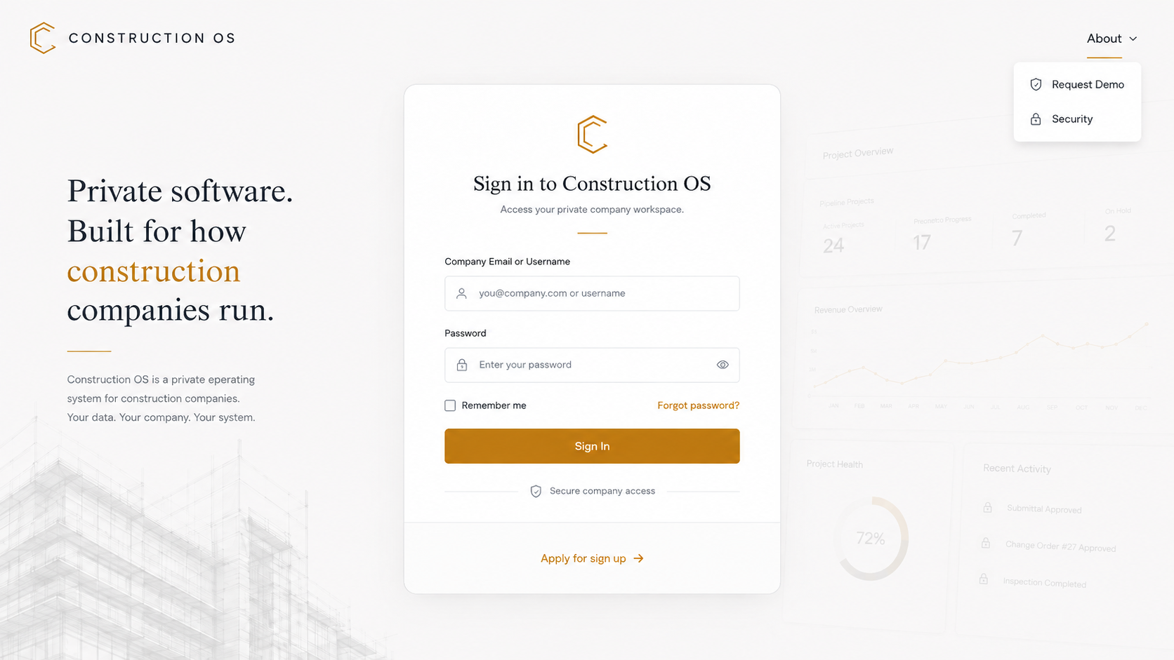
Landing Page — final reference: central login and Apply for sign up.

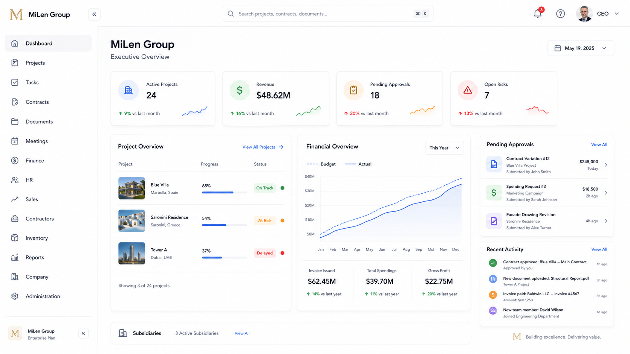
CEO Login / Executive Dashboard — simplified role-specific reference.

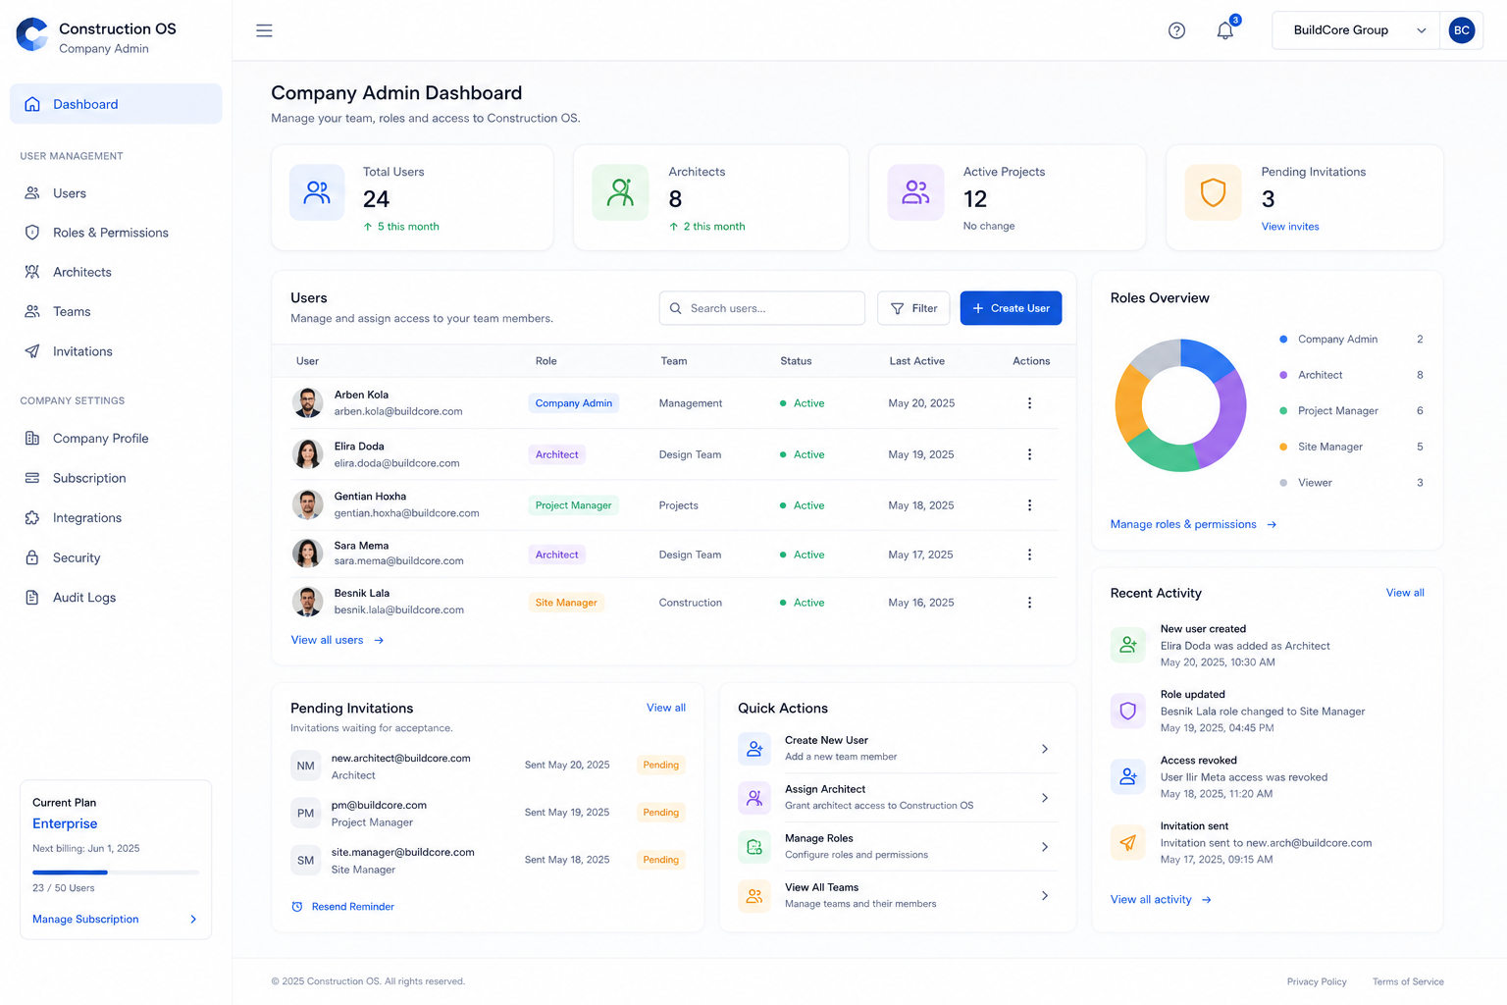
Company Admin Dashboard — user creation, roles, invitations and access management.

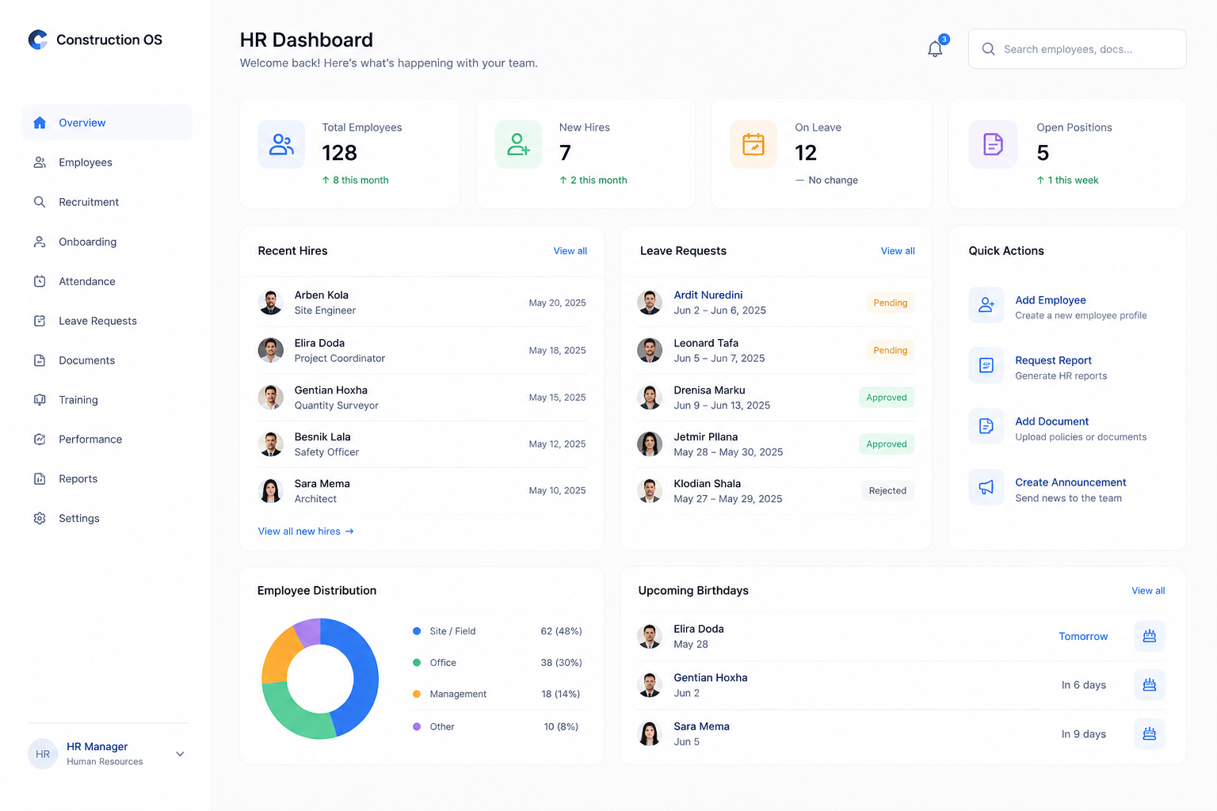
HR Dashboard — employee and recruitment overview.

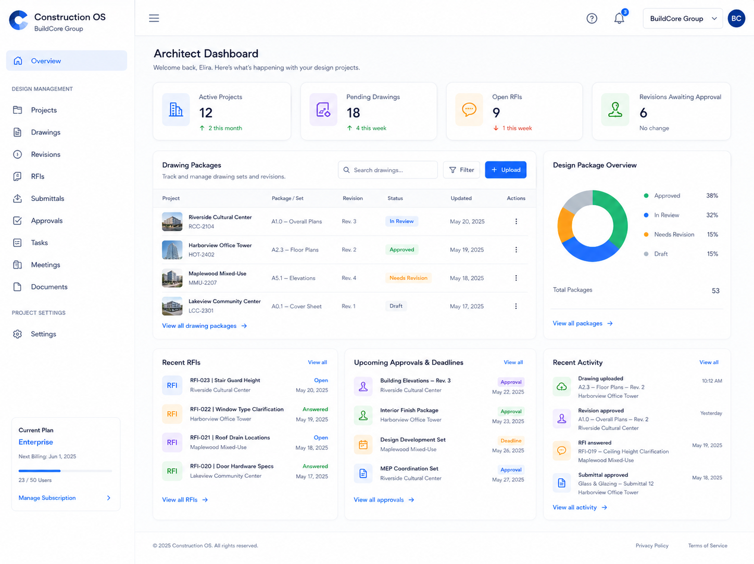
Architect Dashboard — drawings, RFIs, revisions and approvals.

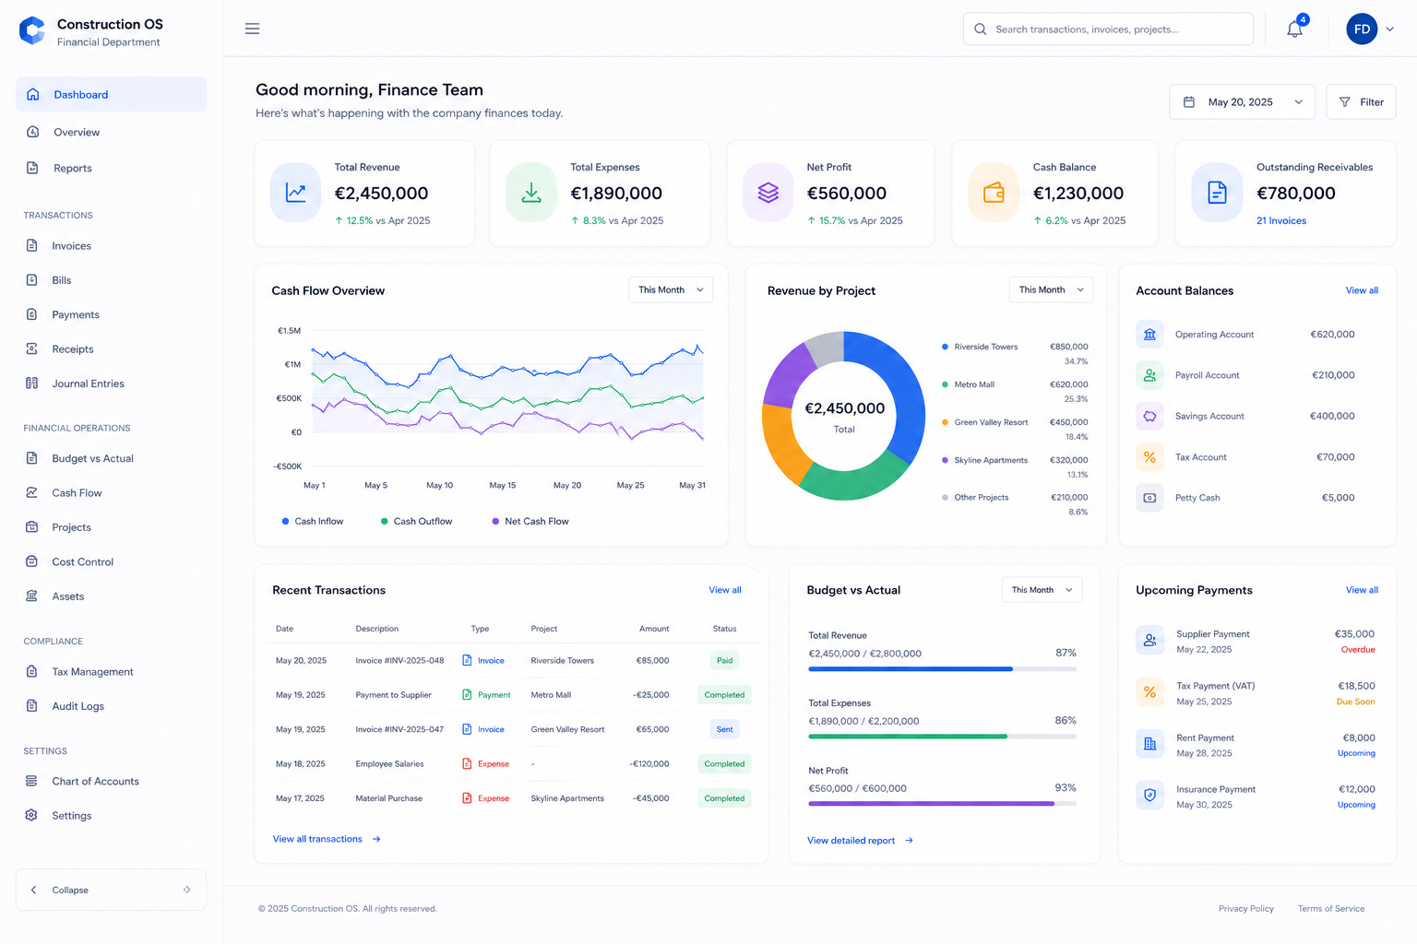
Finance Dashboard — finance department overview.

35. Recommended Technical Architecture
The final stack may be changed by the senior engineering team after an architecture review, but the following decomposition is the required baseline for estimation.
Frontend | TypeScript, React/Next.js or equivalent enterprise web framework; responsive PWA and offline-capable service worker.
Backend | Modular TypeScript/.NET/Java service architecture with clear domain boundaries; start as modular monolith unless scale justifies services.
API | Versioned REST/JSON APIs documented with OpenAPI; real-time events via WebSocket/SSE where appropriate.
Database | PostgreSQL recommended; tenant-scoped schema/data model with dedicated-database deployment option.
Files | Object storage with tenant-prefixed keys, signed URLs, malware scanning, metadata database and retention policies.
Search | Permission-aware search index (OpenSearch/Elasticsearch or equivalent) with tenant and ACL filters.
Background jobs | Queue-based processing for notifications, reports, file conversion, sync, AI indexing and model processing.
Cache | Tenant-aware Redis or equivalent; never cache cross-tenant data without scoped keys.
Identity | Internal username/password authentication with secure session/token management and future-ready identity abstraction.
Observability | Central logging, metrics, traces, audit-event monitoring and security alerts.
Cloud | Containerised deployment with separate development, staging and production environments; infrastructure as code and automated CI/CD.

Domain Boundaries
- Identity and Access
- Tenant/Company and Subscription
- Projects and Work Management
- Documents and Approvals
- People/HR/Recruitment
- Contracts/Legal/Contractors
- Finance/Procurement
- Inventory/Assets
- Sales/Clients
- Network/Tenders
- Notifications/Timeline/Search
- Digital Twin
- Reporting/AI
- Audit/Security/Support

Architecture Rule
Shared cross-cutting engines—permissions, approvals, timelines, comments, notifications, files and audit—must be reusable platform services. Individual modules must not implement incompatible versions of these behaviours.

36. Core Data Model and Entity Relationships

Entity Catalogue
Entity | Purpose
Tenant | Top-level data-isolation boundary for a company workspace.
Company | Business identity; can be parent, child or independent.
Branch | Office/operating location within a company.
UserIdentity | Platform login identity.
ProfessionalProfile | Portable Construction Passport owned by individual.
CompanyMembership | Links identity to company role, position, department and status.
Role / Permission / Policy | Authorisation model and overrides.
Subscription / Entitlement | Licensed seats, modules, storage and options.
JVWorkspace / JVParticipant | Controlled collaboration between companies.
Project / ProjectMember | Project scope and memberships.
Task / TaskContribution / TaskDependency | Collaborative work and deliverables.
Decision / Vote | Advisory participation and final authority.
Document / Version / Revision / Signature | Controlled files and approvals.
RFI / Submittal | Technical questions and material submissions.
Meeting / MoM / ActionItem | Meeting record and follow-up work.
Contract / Variation / Claim / Penalty | Commercial/legal record.
Contractor / ContractorContact / Qualification | External company relationship.
Invoice / Payment / Expense / Budget | Financial records.
Supplier / RFQ / Quote / PurchaseOrder | Procurement.
Warehouse / StockItem / StockMovement | Inventory.
Employee / Attendance / Leave / Certification | HR.
Client / Unit / Reservation / SalesOpportunity | Sales.
Inspection / Issue / Risk / Incident | QA/QC/HSE.
Asset / Equipment / Vehicle / Maintenance | Physical resources.
Tender / TenderApplication | Cross-company opportunity.
CompanyProfile / Verification / TrustMetric | Business network identity.
Notification / DeliveryPreference | Communication.
TimelineEvent / Comment / Relationship | Universal history and collaboration.
ApprovalWorkflow / ApprovalInstance / ApprovalDecision | Reusable approvals.
AccessRequest / AccessGrant | Locked record request workflow.
AuditEvent / SupportSession | Security and compliance evidence.
Model / ModelObject / ObjectLink | Digital Twin.

37. Identifier, Status and Draft Standards
Permanent internal ID | UUID/ULID; never exposed as sole business reference.
Human-readable code | Tenant-configurable prefix + year + sequence, e.g., TSK-2026-000582.
Draft lifecycle | Draft → Submitted → Under Review → Approved / Rejected → Published or Completed.
Task lifecycle | To Do → In Progress → Review → Approved → Completed; alternatives include Blocked, On Hold, Needs Revision, Rejected, Overdue.
Receipt lifecycle | Awaiting confirmation → Confirmed / Partially received / Disputed / Returned → Closed.
Approval lifecycle | Pending → Approved / Rejected / Changes requested / Withdrawn / Expired.
Status | Meaning | Transition rule
Draft | Visible only to author and selected draft collaborators. | Submit to enter formal workflow.
Submitted | Formally delivered for review. | Moves to review/approval according to workflow.
Under Review | Reviewers are evaluating. | Approve, reject or request revision.
Approved | Accepted by required authority. | May publish, execute or complete.
Rejected | Not accepted. | Return to draft/revision with reason.
Published / Completed | Official or closed state. | Changes require new revision or reopen authority.

38. API and Event Requirements
The development team must deliver an OpenAPI specification covering all endpoints. The following resource groups are mandatory.
Resource group | Required coverage
/auth | login, logout, refresh/session, password change/reset
/companies | profiles, hierarchy, branches, verification, settings
/memberships | users, roles, positions, departments, invitations, access mode
/projects | projects, members, packages, progress, archive, templates
/tasks | tasks, contributions, decisions, votes, join/follow, delay records
/documents | files, versions, revisions, signatures, annotations
/rfis and /submittals | technical workflows
/meetings | meetings, MoM, action items, signatures
/contracts | contracts, variations, claims, penalties, warranties
/contractors | profiles, contacts, qualifications, performance
/finance | budgets, expenses, invoices, payments, reports
/procurement | suppliers, RFQs, quotes, POs, deliveries
/inventory | warehouses, items, movements, counts, confirmations
/hr | employees, attendance, leave, recruitment, certifications
/sales | clients, units, reservations, floor-plan/customisation requests
/quality and /hse | inspections, issues, incidents, checklists
/assets | equipment, fleet, reservations, maintenance
/network | company directory, tenders, applications, messaging
/approvals | workflow definitions, instances, decisions, delegation
/search | global search, locked metadata and access requests
/notifications | feed, preferences, delivery and acknowledgement
/timeline and /comments | events, threads, relationships
/offline-sync | change sets, conflicts and retries
/digital-twin | models, objects, links and viewer tokens
/reports | generation, status, download and schedules
/admin | subscriptions, support access, deletion and audit

API Rules
- Every request is authenticated, tenant-scoped and permission-checked.
- List endpoints support pagination, filtering, sorting and safe search.
- Write operations support idempotency where duplicate submission is dangerous.
- All errors return stable codes, human-readable messages and correlation IDs.
- Long jobs use asynchronous status resources and notifications.
- Webhooks/events must be signed, replay-safe and tenant-scoped.

39. Notification Event Matrix
Event | Recipients | Channels / policy
Task assigned | Assignee, creator, watchers | In-app; user-selected email/WhatsApp
Task completed | All included task members | In-app + selected channels
Task overdue | Assignee, task manager, escalation chain | Critical per policy
Delay explanation missing | Assignee and superior | Escalating
Drawing submitted/approved/rejected | Author, reviewers, linked task members | Selected channels
Spending submitted | Immediate superior | In-app + selected channels
Spending approved by superior | Finance | In-app + selected channels
Payment made | Submitter, finance stakeholders, linked contractor/vendor | Selected channels
Penalty issued | Contractor authorised contacts, Legal, PM | In-app/email/WhatsApp according to legal policy
Contractor response | Legal, PM, Finance if financial | In-app + selected channels
MoM ready | Attendees/reviewers | In-app + selected channels
Stock out tagged | Recipient, stock manager | In-app + selected channels
Daily stock confirmation missing | Stock manager → superior → Procurement/PM | Persistent escalation
Access requested | Record owner/designated approver | In-app + selected channels
Access granted/denied | Requester | In-app + selected channels
Certification/contract expiry | Owner, responsible department | Configurable lead times
Critical HSE incident | HSE, PM, Director, emergency contacts | Mandatory critical channels
Company deletion requested | Owner, Admins, Platform Main Admin | Email + in-app; WhatsApp optional

40. File, Storage and Document Security Requirements
- Object storage must be private by default; downloads use short-lived signed URLs and permission checks.
- Virus/malware scan every upload before availability.
- Store checksum, MIME type, extension, size, author, tenant, project, object relation, version and retention class.
- Configurable file-size limits by plan and file type.
- Support common construction formats: PDF, DWG, DXF, RVT, IFC, XLSX, DOCX, images, videos and approved archives.
- Preview generation for safe formats; source files remain unmodified.
- Digital signatures and approval stamps must be verifiable and tied to version hash.
- Watermarks and branded exports follow company subscription and permissions.
- Archive export includes manifest, metadata, timelines, approved files and audit summaries, filtered by requester permissions.
- External cloud connection imports/links content; Construction OS retains authority over official final versions.

41. Security, Privacy and Compliance
ID | Requirement | Specification
SEC-001 | Password security | Use modern adaptive hashing, password-strength policy, secure reset tokens and no plaintext credential exposure.
SEC-002 | Session security | Secure cookies/tokens, inactivity timeout, device/session list, revocation and CSRF/XSS protections.
SEC-003 | Authorisation | Deny by default; evaluate tenant, workspace, module, project, record, role and temporary grants.
SEC-004 | Encryption | TLS in transit; encryption at rest for databases, files, backups and offline device data.
SEC-005 | Audit | Immutable audit events for authentication, permissions, approvals, finance, legal, support, exports and deletion.
SEC-006 | Support sessions | Company-approved, scoped, time-limited, prominently visible and fully logged.
SEC-007 | Data privacy | GDPR-ready rights, lawful retention, export, deletion and processor/subprocessor documentation.
SEC-008 | Backups | Encrypted backups, tested restoration, documented RPO/RTO and dedicated-database procedures.
SEC-009 | Search and AI | Indexes and AI retrieval must enforce the same permissions as source records.
SEC-010 | Offline | Encrypted cache, device binding, remote revoke and policy-based data expiry.
SEC-011 | Company deletion | Seven-day standby, owner cancellation and Platform Main Admin approval.
SEC-012 | Security testing | SAST, dependency scanning, DAST, penetration testing and tenant-isolation test suite before launch.

42. Non-Functional Requirements

Non-Functional Targets
Area | Requirement
Availability | Target 99.9% monthly for standard plans; enterprise SLA separately contracted.
Performance | Typical authenticated page initial load ≤ 2.5 s on supported broadband; key API reads p95 ≤ 500 ms excluding heavy reports/files.
Search | Permission-filtered common search response p95 ≤ 2 s.
Notifications | In-app event creation ≤ 10 s; external channels subject to provider SLAs.
Scalability | Horizontal scaling for web/API/jobs; no tenant-specific code forks.
Concurrency | Architecture must support at least thousands of concurrent users and future regional expansion; final load targets established in inception.
Documents | Resumable large uploads and background preview processing.
Offline | Queue survives app restart; sync is idempotent and observable.
Browsers | Current and previous major versions of Chrome, Edge, Safari and Firefox; responsive mobile browsers.
Accessibility | WCAG 2.1 AA target for core workflows.
Localisation | English and Albanian resource files; date/time/currency formatting separated from content.
Audit retention | Configurable by legal plan and jurisdiction; critical records may be immutable for contracted period.
Observability | Structured logs, metrics, traces, tenant-safe diagnostics and alerting.
Disaster recovery | Documented RPO/RTO, tested restoration and incident runbooks.

43. QA, Testing and Acceptance Strategy
- Unit tests for domain rules, calculations, status transitions and permissions.
- Integration tests for database, files, queues, search, WhatsApp/email and background jobs.
- Contract/API tests generated from OpenAPI.
- Automated tenant-isolation tests across every resource and search path.
- Role/permission matrix tests for all roles and overrides.
- Workflow tests for tasks, delay explanations, spending, stock, penalties, MoM, approvals and JV sharing.
- Responsive UI testing on desktop, tablet and mobile breakpoints.
- Offline/sync conflict and retry tests.
- File-format, upload, virus scan, version and archive tests.
- Security testing, penetration testing and dependency scanning.
- Performance/load tests for dashboards, search, uploads, notifications and large project lists.
- User acceptance testing with CEO, Admin, Architect, HR, Finance, Project Manager, Stock Manager, Contractor and Client personas.

Definition of Done
- Acceptance criteria pass in staging.
- Permission and tenant-isolation tests pass.
- Responsive and accessibility checks pass.
- Audit events and notifications verified.
- Documentation and admin configuration supplied.
- Monitoring and rollback plan active.
- Product Owner approves workflow and visual behaviour.

44. Recommended Delivery Roadmap

Phased Roadmap
Phase | Scope
Phase 0 — Inception | Architecture validation, domain model, design system, security model, prototype, backlog, estimates and deployment foundation.
Phase 1 — Core Private OS | Authentication, tenant/company, users/roles, projects, tasks, comments, timelines, notifications, documents, approvals, search, dashboards and audit.
Phase 2 — Operations | HR, attendance, meetings/MoM, contracts, contractor profiles/portal, finance/spending, procurement, warehouses/stock.
Phase 3 — Construction Delivery | Drawings/RFIs/submittals, architecture/engineering workflows, daily site, QA/QC, HSE, assets/fleet and offline mode.
Phase 4 — Commercial and External Portals | Sales/CRM/units, floor plans, customisation, client portal, tenders, company profiles and professional recruitment.
Phase 5 — Intelligence and Premium | Advanced analytics, AI company knowledge, dedicated databases, Digital Twin, model integrations and enterprise automation.

45. Required Response from Senior Full-Stack Developer Team
- Recommended architecture and justified changes to this baseline.
- Team composition by role and phase.
- Work breakdown and estimated person-days/hours per module.
- Calendar timeline with dependencies and parallel workstreams.
- Cost per phase, ongoing infrastructure and third-party costs.
- MVP scope recommendation and explicit deferred features.
- Security, privacy and compliance approach.
- Multi-tenancy and dedicated-database migration design.
- Offline architecture and limitations.
- Search/AI permission enforcement design.
- File storage and large BIM/model handling plan.
- Testing strategy, release process, SLA and maintenance model.
- Assumptions, exclusions, risks and open questions.

Mandatory Estimation Format
Workstream | Scope | Team | Effort | Dependencies | Risk / assumption

46. Open Technical and Commercial Decisions

Open Decisions
Decision | Required outcome
Hosting region(s) | Select launch cloud/provider and primary data region.
SLA/RPO/RTO | Confirm plan-specific targets and enterprise contract options.
Payment provider | Select subscription billing/payment processor.
Email/WhatsApp providers | Select providers and country availability.
Digital signature legality | Select provider and supported jurisdictions.
Accounting integrations | Define V1 export or direct integrations by target market.
File limits | Confirm plan-specific storage and upload limits.
AI provider and quotas | Define model provider, isolation, retention, cost and plan limits.
Public profile moderation | Define publication review and prohibited content policy.
Trust Score formula | Create transparent metric model and dispute/appeal process.
Data retention | Define legal retention by record type and plan.
Professional sign-up verification | Define identity, credential and portfolio verification process.
Mobile packaging | Confirm whether PWA only or native wrappers are required after V1.
MVP countries | English/Albanian interface confirmed; confirm legal/tax localisation beyond Albania.

47. Glossary
Term | Definition
Construction OS | The complete private SaaS operating platform.
Company Owner | Highest company role with ownership, billing and deletion authority.
Company Admin | Operational administrator who creates users and configures access.
Platform Main Admin | Construction OS provider administrator.
Construction Passport | Portable professional profile and verified career identity.
JV Workspace | Cross-company collaborative project boundary.
Record owner | Person or role responsible for access and record lifecycle.
Contribution | A required deliverable assigned to a person/department inside a task.
MoM | Minutes of Meeting.
RFI | Request for Information.
Submittal | Technical/material document package submitted for approval.
Digital Twin | 3D/2D model-linked operational view.
Tenant | Company data-isolation boundary.
Locked result | Search result visible by title/type but unavailable until access is granted.
Standby deletion | Seven-day read-only/cooling-off state before final deletion approval.

48. Product Baseline Sign-Off
This PRD represents the consolidated baseline for technical estimation and detailed solution design. The engineering team may recommend implementation changes, but any change to confirmed product behaviour, security, tenant isolation, permissions or legal accountability requires documented Product Owner approval.
Role | Name | Approval / Date
Product Owner
Technical Lead
UX/UI Lead

