**DevOps culture and its best practices**

Over the years, DevOps culture has been an emerging trend in the IT world to provide rapid development and deployment of an application with better scalability & reliability.

**D**evOps **Culture**

A DevOps is streamline process, which involves shared responsibilities and closer collaboration between development teams and operation teams for the products they develop, build, test, deploy and maintain. It helps organizations aligned their people, processes, and tools toward a more unified client focus.

DevOps is made up with two names Development and Operation. It works as a bridge between Development team and Operation team.

DevOps is a set of tools, practices and a cultural that automate and integrate the processes between software development teams and IT Operation teams. DevOps emphasizes cross-team communication, team empowerment, cross-team collaboration, and automation of the processes.

**DevOps Lifecycle:** The lifecycle of DevOps is the continuous in nature and DevOps practitioners use the infinity loop to show all the phases of the DevOps lifecycle relate to each other. The symbol does not appear like flow sequentially, but it shows an infinite loop, which symbolizes the need for constant collaboration and iterative improvement throughout the entire lifecycle.

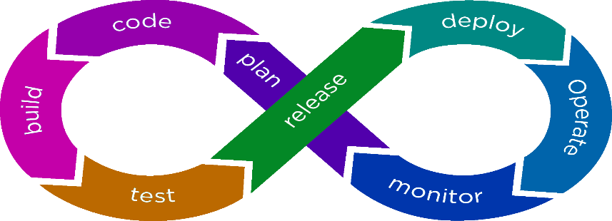

DevOps Lifecycle

**How DevOps process Works:**

There are certain phases in DevOps, which helps in development and deployment of an application.