Changes for Administration => Profile field => customer and admin tab new/update profile
Add New section in: Your Profile [that is show on vendor administrator profile]
app\Tygh\Enum\ProfileFieldSections.php
const YOUR_PROFILE = 'Y';
your_profile ============ Your Profile
Changes are highlight below image
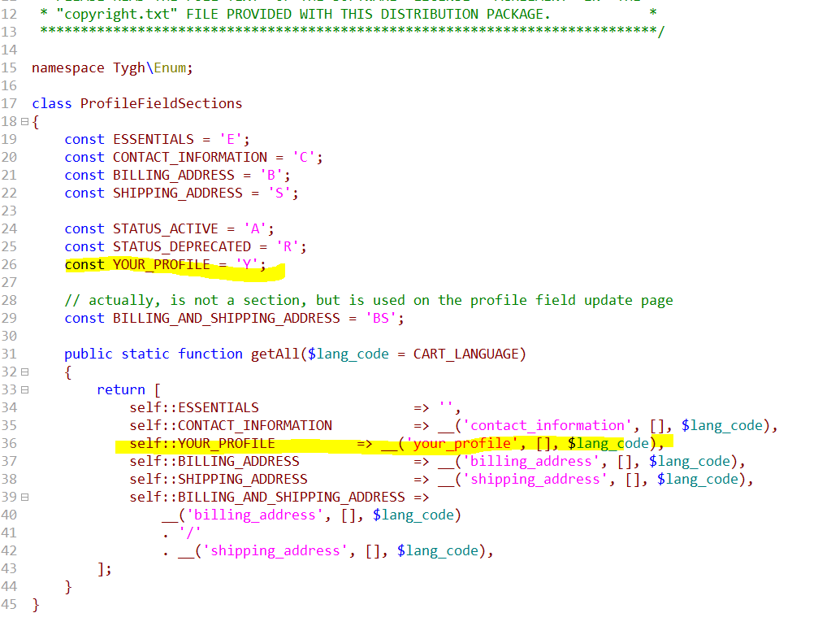

Add db value in table
INSERT INTO `cscart_profile_field_sections` (`section_id`, `code`, `position`, `status`) VALUES (NULL, 'Y', '4', 'A');

For Vendor Panel remove Products on moderation & Disapproved products
Custom file changes : D:\wamp64\www\Project\restore\public_html\app\addons\vendor_data_premoderation\controllers\backend

