# Matrix Course Cheat Sheet

# Given Formulas

# Useful Matlab formulas and functions

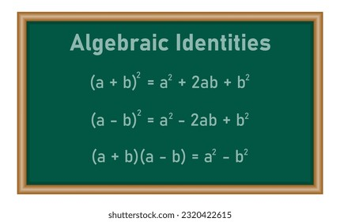dot_product = dot(u, v);

cross(u,v); # cross product

norm(u); # Length of vector u

proj_u_v = (dot(u, v) / norm(u)^2) * u; # Projection of vector v onto u:

A_transpose = A';

Element_wise_mul 🡪 C = A .* B;

determinant_A = det(A);

A_inversion = inv(A);

x = A \ b; # Solving Linear Systems: Instead of inverting matrices, solve systems of equations:

[V, D] = eig(A); # V contains the eigenvectors. D contains the eigenvalues along the diagonal.

N = null(A); # null space

RowSpace = null(A')';

ColSpace = orth(A);

r = rank(A);

[R, pivot_cols] = rref(A); #R gives the reduced row echelon form, and pivot_cols shows the indices of pivot columns.

# Plotting a vector

x = 1:10;  
y = [1,2,3,4,5,6,7,8,9,10];  
plot(x, y);

# Week1 - Vector Operations

* Displacement: Describes the change in position of a point, represented as vectors.
* Linear Combination: Represents one vector as a combination of other vectors.  
  v = a * u + b * w (where a, b are scalars)
* Dot product: Scalar product of two vectors, **yielding a real number**.
* Length: magnitude of a vector, found using the dot product. ‖u‖ = sqrt(dot(u, u))
* Normalization: Converts a vector into a unit vector (length = 1). u_normalized = u / norm(u)
* Cauchy-Schwarz Inequality: Relationship between the dot product and vector lengths.
* Triangle Inequality: ‖u + v‖ ≤ ‖u‖ + ‖v‖
* Projection: proj_u(v) = dot(u, v) * u (if u is a unit vector)
* Orthogonality: Two vectors are orthogonal if their dot product is zero.
* Pythagoras Theorem: If two vectors are orthogonal, their magnitudes follow Pythagoras' theorem. **‖u + v‖ = ‖u‖ + ‖v‖ if u ⊥ v**
* Equation of a Line**: X = P + td** where P is a point on the line, and d is the direction vector.
* A screenshot of a math book

  Description automatically generated

# Week 2: Linear Equations

* General equation of a plane: **ax + by + cz = d** where a, b, and c are coefficients representing the normal vector of the plane.
* Intersection of planes: a line (if the system is consistent) or no solution (if inconsistent).
* Solving Linear Equations: A * x = b In Matlab: x = A\b
* Gaussian Elimination: A systematic method for solving linear equations by transforming the matrix to row-echelon form.
* Inverse of a Matrix: A matrix is invertible if it can be transformed into the identity matrix by row operations.
* Elementary row operations: row swaps, multiplying a row by a scalar, and adding/subtracting multiples of rows.
* Matrices are row equivalent if and only if they have the same RREF.
* The span of a set of vectors is the set of all linear combinations of the vectors.   
  Span(d) = {***t***d: t of R}
* To show S is a spanning set, should be solvable, rank(S) less than the dimension of space.

# Week 3 – Matrix operations

* Matrix Operations: addition, multiplication, and scalar multiplication.
* Transpose: flipping it over its diagonal (rows become columns). In matlab: A’
* 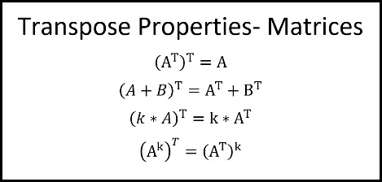
* A screenshot of a math problem

  Description automatically generated
  + Matrix multiplication is not commutative 🡪 AB <> BA
* Diagonal Matrix: Multiplication of any matrix by a diagonal matrix scales the rows or columns accordingly.
* Inverse: A matrix A is invertible if there exists a matrix B such that A * B = I.
* Matrix Determinant: Is a scalar value, if non-zero then the matrix is invertible.
* Matrix Rank: The number of linearly independent rows or columns.
* Null Space: The null space (kernel) of a matrix A consists of all vectors x such that A * x = 0.
* A diagram of mathematical equations

  Description automatically generated
* A math formula with black letters

  Description automatically generated with medium confidence
* If AA’ and A’A are symmetric, (AB)’ = B’A’

# Week 4 – Inverse and rank

* Inverse: A transformation that undoes transformation A and is undone by A is an inverse of A  
  X(A**z**) = **z** and A(X**z**)=**z**
* Inverse is both right and left 🡪 AX = I also XA = I if X is the inverse of A.
* 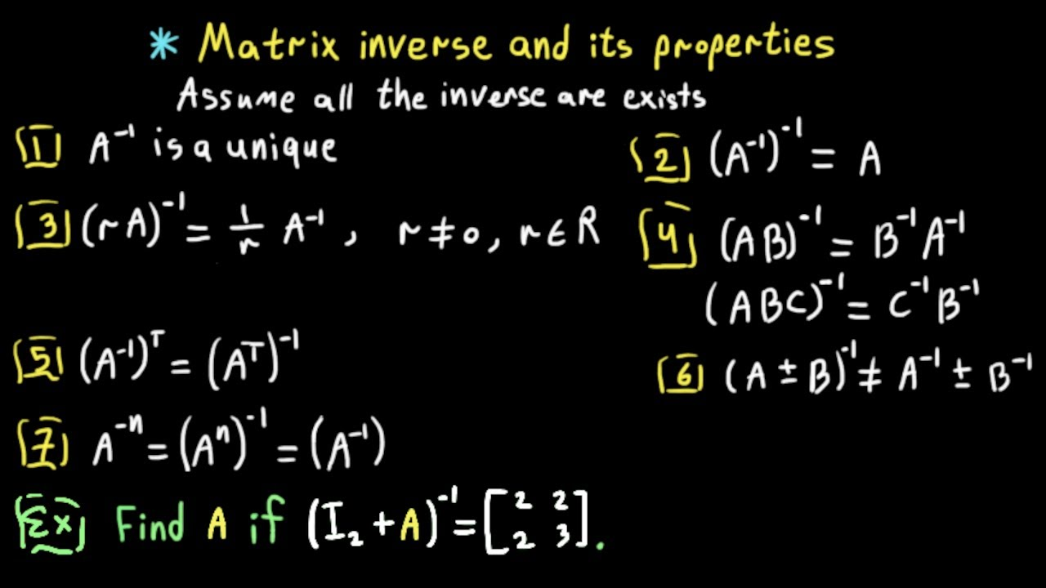
* Conditions for Invertibility: matrix is square, and determinant is non-zero.
* Rank-Nullity Theorem: rank(A) + nullity(A) = number of columns.
* Singular and Non-Singular Matrices: A matrix is singular if it is not invertible (i.e., det(A) = 0), and non-singular if it is invertible (det(A) ≠ 0).
* A math equation with black text

  Description automatically generated
* A is invertible if 🡪 Ax = b has a unique solution for any b; Ax = 0 has a nontrivial solution; rref(A)=I; A is the product of elementary matrices.
* To calculate inv, augment with I. A math equations with numbers and symbols

  Description automatically generated with medium confidence
* Basis for null is the solution of Ax = 0.

# Week 5 – Determinants

* The determinant is a scalar value that can be computed from a square matrix. It helps determine whether a matrix is invertible and has important applications in geometry and linear transformations. Determinant is important because of eigenvalues.
* A math equation with black text

  Description automatically generated with medium confidenceProperties of determinant  
  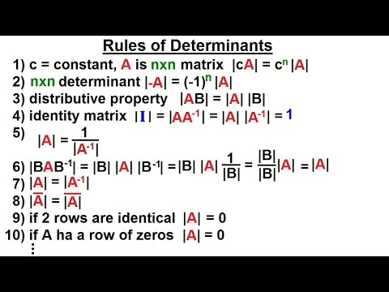  
  det(A^T) = det(A)  
  det(I) = 1  
  If A is 2x2 🡪 det(A)=ad−bc  
  Det(triangular matrix) = product of the diagonal elements حاصل‌ضرب عناصر روی قطر
* Eigenvalues and Eigenvectors: Eigenvalues are scalars **λ** such that for a matrix A and a non-zero **vector v**, we have: **𝐴∗𝑣 = 𝜆∗𝑣**. Eigenvectors are the corresponding vectors. Eigenvalues give important information about the transformation properties of a matrix.
* Finding Eigenvalues: roots of the characteristic equation: **𝑑𝑒𝑡(𝐴−𝜆𝐼)=0**.
* Geometric Interpretation of Eigenvectors: Eigenvectors represent directions along which the linear transformation associated with matrix A stretches or compresses the space. Eigenvalues determine the factor by which the stretching or compressing happens.
* Diagonalization: A matrix A is diagonalizable if there exists an invertible matrix P and a diagonal matrix D such that: **𝐴=𝑃∗𝐷∗𝑃−1** where the diagonal elements of D are the eigenvalues of A, and the columns of P are the corresponding eigenvectors.
* A math problem with text

  Description automatically generated with medium confidence
* A table of mathematical equations

  Description automatically generated with medium confidence

# Week 6 – Eigenvalue and eigenvectors

* Finding Eigenvectors: After calculating eigenvalues, substitute each eigenvalue λ into the equation **(𝐴−𝜆𝐼)𝑣=0** to find the corresponding eigenvectors. Matlab: [V, D] = eig(A)
* Diagonalization Criteria: A matrix A can be diagonalized if it has n linearly independent eigenvectors, where n is the dimension of the matrix.
* Geometric Multiplicity: The geometric multiplicity of an eigenvalue λ is the number of linearly independent eigenvectors corresponding to λ. For a matrix to be diagonalizable, the geometric multiplicity of each eigenvalue must equal its algebraic multiplicity (the number of times it appears as a root of the characteristic equation).
* Defective Matrix: A matrix is called defective if it cannot be diagonalized, meaning it does not have enough linearly independent eigenvectors. This happens when the geometric multiplicity of some eigenvalues is less than their algebraic multiplicity.
* Symmetric Matrices: Symmetric matrices are always diagonalizable, and their eigenvalues are always real.
* To find eigenvectrs, should replace (𝐴−**𝜆**𝐼)𝑥=0
* 
* 
* A black text on a white background

  Description automatically generated
* 