DOMINICAN COLLEGE OF TARLAC, INC.

OOTDLY : A MOBILE APP FOR ORGANIZING WARDROBE

A Capstone Proposal presented to the
Faculty of the College of Computer Studies,
Dominican College of Tarlac, Inc.

In Partial Fulfillment
of the Requirements for the Degree of
Bachelor of Science in Information Technology

by:

Baluyut, Lucilla M.
Ningala, Vim Aurem
Pasia, John Paul S.
Romero, John Adams S.
Sembria, Marlon R.
Tangonan, Armand Robin I.

Victor C. Yu
Adviser

April 2025

DOMINICAN COLLEGE OF TARLAC, INC.

ADVISER’S RECOMMENDATION SHEET

This Capstone Proposal entitled

OOTDLY : A MOBILE APP FOR ORGANIZING WARDROBE

by:

Baluyut, Lucilla M.
Ningala, Vim Aurem
Pasia, John Paul S.
Romero, John Adams S.
Sembria, Marlon R.
Tangonan, Armand Robin I.

And submitted in partial fulfillment of the requirements of the
Bachelor of Science in Information Technology degree has been examined
and is recommended for acceptance and approval

Victor C. Yu
Adviser

April 2025

DOMINICAN COLLEGE OF TARLAC, INC.

DEAN’S ACCEPTANCE SHEET

This Capstone Proposal entitled

OOTDLY : A MOBILE APP FOR ORGANIZING WARDROBE

After having been recommended and approved is hereby accepted
by the College of Computer Studies Department
of Dominican College of Tarlac, Inc.

Carolina C. Sanchez, D.I.T.
Dean

April 2025
DOMINICAN COLLEGE OF TARLAC, INC.

PANEL’S APPROVAL SHEET

This Capstone Proposal entitled

OOTDLY : A MOBILE APP FOR ORGANIZING WARDROBE

developed by:

Baluyut, Lucilla M.
Ningala, Vim Aurem
Pasia, John Paul S.
Romero, John Adams S.
Sembria, Marlon R.
Tangonan, Armand Robin I.

after having been presented is hereby approved
by the following members of the panel

Jan Nicole B. Apostol Gerald B. Tolentino
Panelist Panelist

Rossano C. Samson
Lead Panelist

April 2025
Acknowledgement

This achievement was made possible through the collaboration and dedication of many individuals, primarily the proponents who gave their precious time, effort, and hard-work. They sincerely extend their gratitude to everyone else who contributed to the completion of this project.
The proponents express their appreciation to College of Computer Studies (CCS) department at Dominican College of Tarlac for providing the necessary support and resources that facilitated the study. The guidance and encouragement received throughout the process played a significant role in shaping the project's success. The proponents are also thankful for the unwavering support from their families, who encouraged and helped them both financially and emotionally for the completion of this project. Above all, the proponents acknowledge the divine guidance of the Lord that provided strength and wisdom throughout the journey. This project stands as a testament to collective effort and hard-work.
To God be all the glory!

Abstract
This project aims to help physical wardrobe owners to create a digital copy of their wardrobe items to their mobile devices. The project includes several menus and modules with different functionalities. Physical wardrobe owners are the expected users of the project, and they need to sign-in using their Google account for Android devices, and Google or Apple account for iOS devices to access the features of the project.
The project has four tabs: Home, Wardrobe, Schedules, and Profile. The Home Tab includes the information about the total number of added wardrobe items, total number of lent items, total number of generated outfits, colors module for managing and viewing colors, and models module for viewing and managing image-based models. The Wardrobe Tab includes several modules for viewing and managing the digital copy of physical wardrobe items. It includes the Wardrobe Module for managing items, Preview Outfit Module for creating outfit based on item combinations, Lent Records Module for tracking lent items or outfits, Favorites Module for managing favorite items or outfits, Wardrobe Gallery Module for displaying all items and all generated outfits, and Location Current Temperature Module for displaying the current temperature of a city or location and the suggested outfits to wear based on the temperature. The Schedules Tab includes a module for scheduling item or outfit on a specific date. The Profile Tab includes modules for viewing the currently logged in user, viewing the terms and conditions, privacy policy, tips, and log out module.

Table of Contents
- Introduction 1-1
1.1 Project Context 1-1
1.2 Objectives 1-2
1.2.1 General Objective 1-2
1.2.2 Specific Objectives 1-2
1.3 Scope and Limitations 1-60
1.3.1 Scope 1-60
1.3.2 Limitations 1-122

- Review of Related Literature 2-1
2.1 Related Theories 2-1
A. Virtual Wardrobe 2-1
B. Image Background Removal 2-1
C. Camera Quality 2-2
2.2 Related Projects 2-2
A. Clozzie - Your Digital Closet 2-2
B. XZ (Closet) 2-7
C. Fits – Outfit Planner & Closet 2-10

- Technical Background 3-1
3.1 Development 3-1
3.1.1 Hardware 3-1
3.1.2 Software 3-2
3.1.3 Peopleware 3-4
3.2 Implementation 3-6
3.2.1 Hardware 3-6
3.2.2 Software 3-8
3.2.3 Peopleware 3-8
3.2.4 Network 3-8

- Methodology 4-1
4.1 Prototype Model 4-1
4.1.1 Phases in Prototype Model 4-2
4.1.1 Initial Requirements 4-2
4.1.2 Design 4-2
4.1.3 Prototyping / Building Prototype 4-2
4.1.4 Customer / User Evaluation 4-2
4.1.5 Review and Updation 4-2
4.1.6 Development 4-3
4.1.4 Testing 4-2
4.1.5 Maintain 4-2

4.2 Requirement Specification 4-4
4.2.1 Operational Feasibility 4-4
A. Fishbone Diagram 4-4
B. Functional Decomposition 4-5
Diagram
4.2.2 Technical Feasibility 4-14
A. Relevance of Technology 4-15
4.2.3 Schedule Feasibility 4-15
A. Gantt Chart 4-15
4.2.4 Economic Feasibility 4-22
A. Cost and Benefit Analysis 4-22
B. Cost Recovery Scheme 4-22
4.2.5 Requirements Modeling 4-23
A. Use Case Diagram 4-23
B. Sequence Diagram 4-34
C. Activity Diagram 4-44
4.2.6 Risk Assessment / Analysis 4-46
4.3 Design 4-46
4.3.1 Output and User-interface Design Forms 4-46
4.3.2 Application Logo 4-48
4.3.3 Data Design 4-49
A. Entity Relationship Diagram 4-49
B. Data Dictionary 4-50
4.3.3 System Architecture 4-55
A. Network Model 4-55
B. Security 4-55

LIST OF APPENDICES
Appendix A Work Assignment A-1
Appendix B Definition of Terms B-1
Appendix C Screen Design C-1
Appendix D Transcript of Interview D-1
Appendix E Curriculum Vitae E-1

LIST OF TABLES

Table No. 1 Month of January of 2025 4-15
Table No. 2 Month of February of 2025 4-16
Table No. 3 Month of March of 2025 4-16
Table No. 4 Month of April of 2025 4-18
Table No. 5 Month of May of 2025 4-18
Table No. 6 Month of June of 2025 4-19
Table No. 7 Month of July of 2025 4-20
Table No. 8 Month of August of 2025 4-20
Table No. 9 Month of September of 2025 4-21
Table No. 10 Month of October of 2025 4-21
Table No. 11 Cost and Benefit Analysis 4-22
Table No. 12 Models 4-50
Table No. 13 Colors 4-51
Table No. 14 Wardrobe Items 4-51
Table No. 15 Wardrobe Item Colors 4-51
Table No. 16 Scheduled Items 4-51
Table No. 17 Favorites Item 4-52
Table No. 18 Lent Items 4-52
Table No. 19 Generated Outfits 4-53
Table No. 20 Lent Outfits 4-53
Table No. 21 Preview Outfit Projects 4-53
Table No. 22 Project Canvas Items 4-54
Table No. 23 Scheduled Outfits 4-54
Table No. 24 Favorites Outfits 4-54

LIST OF FIGURES

Figure No. 1 New Item Module 2-3
Figure No. 2 Take a Photo Module 2-3
Figure No. 3 Captured Photo Module 2-4
Figure No. 4 Background Remove Module 2-4
Figure No. 5 Closet Module 2-5
Figure No. 6 New Outfit Module 2-5
Figure No. 7 Selecting Items Module 2-6
Figure No. 8 Edit Outfit Module 2-6
Figure No. 9 Location Module 2-8
Figure No. 10 Suggested Outfit in Location Temperature Module 2-8
Figure No. 11 Outfit Suggested Module 2-9
Figure No. 12 Add Outfit Schedule Module 2-10
Figure No. 13 Select Schedule Module 2-11
Figure No. 14 Choose Outfit Module 2-11
Figure No. 15 Select Occasion Module 2-12
Figure No. 16 Saved Outfit Schedule Module 2-12
Figure No. 17 Prototype Model 4-1
Figure No. 18 Fishbone Diagram 4-4
Figure No. 19 Online Home Tab FDD 4-5
Figure No. 20 Online Wardrobe Tab FDD 4-6
Figure No. 21 Online Wardrobe Tab FDD 4-7
Figure No. 22 Online Calendar Tab FDD 4-8
Figure No. 23 Online Settings Tab FDD 4-9
Figure No. 24 Offline Home Tab FDD 4-10
Figure No. 25 Offline Home Tab FDD 4-11
Figure No. 26 Offline Wardrobe Tab FDD 4-12
Figure No. 27 Offline Calendar Tab FDD 4-13
Figure No. 28 Offline Application Manual Tab FDD 4-14
Figure No. 29 Use Case Diagram – Online My Wardrobe 4-23
Figure No. 30 Use Case Diagram – Online Registration or 4-24
Log in and Home Tab
Figure No. 31 Use Case Diagram – Online Preview Outfit 4-25
Figure No. 32 Use Case Diagram – Online Favorites and Gallery 4-26
Figure No. 33 Use Case Diagram – Online Generated Outfits 4-27
and Location Current Temperature
Figure No. 34 Use Case Diagram – Online Calendar Tab 4-28
Figure No. 35 Use Case Diagram – Online Settings Tab 4-29
Figure No. 36 Use Case Diagram – Offline Home Tab 4-30
Figure No. 37 Use Case Diagram – Offline My Wardrobe 4-31
Figure No. 38 Use Case Diagram– Offline Lent Items and Outfits 4-32
Figure No. 39 Use Case Diagram – Offline Generated Outfits 4-33
and Location Current Temperature
Figure No. 40 User Log In 4-34
Figure No. 41 Models Module 4-35
Figure No. 42 Colors Module 4-36
Figure No. 43 Favorites Module 4-37
Figure No. 44 Item Scheduling 4-38
Figure No. 44 Figure No. 44: My Wardrobe Module 4-38
Figure No. 45 Figure No. 45: Preview Outfit Project CRUD 4-39
Figure No. 46 Preview Outfit Project – Offline Mode 4-40
Figure No. 47 Lent Item Module 4-41
Figure No. 48 Scheduled Items 4-42
Figure No. 49 Log Out 4-43
Figure No. 50 Activity Diagram – Online Mode 4-44
Figure No. 51 Activity Diagram – Online Mode 4-45
Figure No. 52 Color Palettes 4-47
Figure No. 53 Imprima Font 4-47
Figure No. 54 Roboto Font 4-47
Figure No. 55 Application Logo 4-48
Figure No. 56 Entity Relationship Diagram 4-49
Figure No. 57 Entity Relationship Diagram 4-49
Figure No. 58 Network Model 4-55

1.0 Introduction
1.1 Project Context
A physical wardrobe is the home of the clothing items or outfits of an individual, and it includes storage areas for item storage. Physical wardrobes are made of durable materials and varies in sizes and design, ranging from simple small clothes to bigger ones that includes additional areas for personalized item storage.
Looking through a physical wardrobe to find a specific outfit or clothing item involves patience, energy, and physical presence to the physical wardrobe. Individuals with walking closet who wants to find the right item or outfit needs more energy and patience, especially when their closet is disorganized. The scenario of finding a clothing item or outfit on a disorganized physical wardrobe is stressful and leads to delays. Individuals who are in a hurry because of important events like business meetings might end up wearing inappropriate outfit, resulting in unprofessional appearance and increased stress level.
Another problem is when physical wardrobe owners are unable to view clothing items on mobile devices. When an individual is not at their house, they have no way to know what items are already in their physical wardrobe. This lack of remote view hinders the opportunity to creatively generate outfit based on matching wardrobe items, as the individual is unsure of what they already own. Inability to remotely view physical wardrobe items also leads to unnecessary purchases of extra items, resulting in money being wasted, extra space, and clutter. According to Bang and Su [1], there is a need for digital wardrobe to enhance clothing management and solve difficulties in outfit planning.
When individuals lend their clothes to others, they might forget to get them back because they have no reminder. When the lent item or outfit is valuable or important, not getting it back can cause stress. Individuals will also have fewer options especially when they rely on the lent item to complete an outfit for special occasion or everyday wear. An article entitled “Friendship Fallout and Bailout Backlash: The Psychology of Borrowing and Lending” [5] indicates that lending without proper tracking can lead to negative emotions and damaged relationships. The article highlights the importance of having effective management solutions, which applies to wardrobe lent items or outfits tracking to implement return monitoring.
Outfit planning in advance for special occasions or important events is another problem. Physical wardrobes cannot provide a way to schedule an outfit for specific date and notify the owner beforehand. When an individual is away from their house and needs to plan outfit for an important or unexpected event, they will not able to plan properly because they are unsure of what items are available on their physical wardrobe. An individual may rush to pick an outfit and might end up wearing inappropriate one that looks unprofessional. An article entitled “I Plan All My Outfits at the Beginning of the Week—Here’s Why You Should Too” [2] notes that without planning outfits ahead of time, mornings can be stressful.
To address these problems, the proponents developed a digital wardrobe organizer application that let the users view their physical wardrobe items on their mobile devices. The project provided a way for users to store a copy of physical wardrobe items on mobile devices and on the internet, generate outfits based on the items on digital wardrobe, track lent items or outfits, and schedule an item or outfit for a specific date. These approaches delivered ways to help users plan, track, and schedule using only their mobile devices.
1.2 Objectives
1.2.1 General Objective
The general objective of the study was to develop an application called OOTDLY that let the users have a digital view of their physical wardrobe items. Users were able to organize and manage the digital wardrobe items.
1.2.2 Specific Objectives
A. Online Mode
A.1 Developed a module that allowed the users to sign up or sign in using their Google account or Apple account.
This module allowed the users to sign up or sign in to an online account using their Google account or Apple Account. Users needed to agree to the Terms and Conditions and Privacy Policy to create an account. Users could sign in using their Google or Apple account if they already had an existing account. Upon successful sign-up or sign-in, users will be redirected to the online Home screen where they could use the features. All data and changes that the users put and made in this online mode were saved and uploaded, and only showed when the user was in online mode. If only one device was used for the application, users could also see all the data of offline mode when online.
A.2 Home Tab
A.2.1 Developed a module that allowed the users to see the total number of user-added models, total colors, total wardrobe items, total generated outfits, and total lent items/outfits.
A.2.1.1 Total Added Models Module
A.2.1.1.1 Developed a module that allowed users to view the two default image-based models and manage the user-added image-based models.
This module displayed the two default image-based full body standing male and female models. Users were able to upload their own standing pictures, remove the background, enter a name, and pick a gender to make a new model. Users could pick a model to use to generate an outfit. Users had an option to update or delete added models, but default models cannot be modified nor deleted.
A.2.1.2 Total Added Colors Module
A.2.1.2.1 Developed a module that allowed users to view the 12 default colors and manage the user-added colors.
This module displayed the 12 default colors from the color wheel. Users could also add a color and put a name to it. This module also allowed the users to view the possible color combinations of the 12 default colors from the color wheel. Only the default 12 colors had color combination suggestions.
A.2.1.3 Total Wardrobe Items Module
A.2.1.3.1 Developed a module that allowed users to see the total number of added wardrobe items.
This module displayed the total number of the added wardrobe items by the user in numeric format.
A.2.1.4 Total Generated Outfits Module
A.2.1.4.1 Developed a module that allowed users to see the total number of added generated outfits.
This module displayed the total number of generated outfits. It displayed the numbers in numeric format.
A.2.1.5 Total Lent Items Module
A.2.1.5.1 Developed a module that allowed users to see the total number of added lent items and outfits.
This module displayed the total number of lent items and outfits in numeric format.
A.3 Wardrobe Tab
A.3.1 Developed a module that allowed the users to select wardrobe feature options.
This module displayed the seven (7) feature options available in the wardrobe tab screen together with the feature display icon. The seven options were: My Wardrobe, Preview Outfit, Favorites, Wardrobe Gallery, Lent Items and Outfits, Generated Outfits, and Location Current Temperature. Users could select one feature option at a time and could switch to another feature by clicking the back button to navigate back to the wardrobe tab screen.
A.3.2 My Wardrobe Module
A.3.2.1 Developed a module that allowed users to view the content of “My Wardrobe”
This module displayed the ten (10) default categories: Formal, Casual, Work, Sports, Seasonal, Classic, Travel, Party, Street Style, and Date. Users were able to browse the online categories by scrolling up or scrolling down on the screen. This module allowed the users to add a new online wardrobe item category. The users needed to upload a category image either from the gallery or take a photo from the camera, turn on or turn off the automatic background removal for the image, enter a category name made of letters and numbers, and click the “Save” button to add the new category. This module also allowed the users to search an online category by entering the category name into the search category input. Only the user-added categories could be updated and deleted.
A.3.2.2 Developed a module that allowed users to add and view wardrobe items based on the selected categories. Each category had default sample items to provide an insight into the selected category.
This module allowed the users to add a wardrobe item under the selected category. Users needed to pick an image from the gallery or take a photo using the camera. Users also needed to turn on or turn off automatic background removal for the image, provide the wardrobe item name, color, and note, and click the “Save” button to add the wardrobe item. This module allowed the users to specifically search for a wardrobe item by entering the item name, color, or note. Wardrobe items could be updated or deleted and could also be added as Favorites by clicking the heart button.
A.3.3 Preview Outfit Module
A.3.3.1 Developed a module that allowed the users to add and view the online preview outfit projects.
This module allowed the users to add a preview outfit project. Users needed to enter the project name in letter and number format and select between “Plain Canvas” and “With Model” canvas types. By creating a project, users could use “Lock Scroll” to conveniently place the selected wardrobe items onto the canvas, and the items could be moved, scaled, and rotated by the users to the desired position. Users could delete an individual item by double-clicking it. They could use the search box to specifically find an item to use in the project. Users could use the “Clear Canvas” button to remove all the selected wardrobe items on the canvas at once. They could save the project by clicking “Save Project” to add it to the preview outfit. A project could also be saved as an outfit and added to the Generated Outfit by clicking the “Save Outfit” button. Users could also update and delete a project by clicking the edit icon above. Finally, this module displayed the preview outfit projects, and users could browse the projects by scrolling up or down on the screen or search for a specific project by entering the project name.
A.3.4 Favorites Module
A.3.4.1 Developed a module that allowed the users to view the wardrobe items set as favorites.
This module allowed the users to view the wardrobe items and generated outfits set as favorites. Favorite wardrobe items and outfits could also be removed by the users by clicking the remove button.
A.3.5 Wardrobe Gallery Module
A.3.5.1 Developed a module that allowed the users to view all wardrobe items and generated outfits.
This module allowed the users to browse all the wardrobe items and generated outfits by scrolling up or scrolling down on the wardrobe gallery interface.
A.3.6 Lent Records Module
A.3.6.1 Developed a module that allowed the users to record lent wardrobe items or outfits in calendar format.
This module allowed the users to add records of the lent wardrobe items or outfits by selecting the date when the users lent the item, clicking the add button below, and entering the borrower’s name. The same date could be used multiple times, so users could put notes on the record if necessary. When a wardrobe item or outfit was returned, users could click the returned button to save the changes. Records could be updated and deleted by clicking the item; only the name, notes, and return status of the lent items were editable. If there were multiple records on the same date, the users could use the search box to specifically find the record.
A.3.7 Generated Outfits Module
A.3.7.1 Developed a module that allowed the users to view the online generated outfit categories.
This module displayed the ten (10) default categories: Formal, Casual, Work, Sports, Seasonal, Classic, Travel, Party, Street Style, and Date. Users were able to browse the online categories by scrolling up or down on the screen. This module allowed the users to add a new online wardrobe item category. The users needed to upload a category image either from the gallery or take a photo using the camera, turn on or turn off the automatic background removal for the image, enter a category name made of letters and numbers, and click the “Save” button to add the new category. This module also allowed the users to search an online category by entering the category name into the search category input. Only the user-added categories could be updated and deleted. The generated outfits came from the combination of items from the “Preview Outfit Module,” and generated outfits could also be added as favorites by clicking the heart button.
A.3.8 Location Current Temperature Module
A.3.8.1 Developed a module that allowed the users to search a location and view the current temperature and possible outfits to wear.
This module allowed the users to enter a location from the Philippines and see the current temperature. Users could also see the current temperature by turning on the device location and granting permission to use it. The users were able to see the possible outfits to wear based on the current temperature.
A.4 Schedules Tab
A.4.1 Developed a module that allowed the users to schedule outfits for upcoming events.
This module allowed the users to schedule an item or outfit for a specific date. The users needed to select an item or outfit and add a note. The users were required to put a note on the scheduled outfit to help easily find the outfit when there were multiple outfits scheduled on the same date. The same date could be used multiple times to schedule outfits, and it displayed how many outfits were scheduled on that date. Past dates could not be used to schedule an outfit. The module allowed the users to navigate to other months of the calendar by clicking the right arrow near the month name and year to go to the next month, and the left arrow to go to the previous month to see past and upcoming scheduled outfits. The users could update and delete scheduled outfits and find a specific scheduled outfit on the same date by entering the note of the saved scheduled outfit.

A.5 Profile Tab
A.5.1 Developed a module that allowed the users to view the account information.
This module allowed the users to see the account first name and last name, account email, and the “Online Account” text. Under the profile tab, it had several options. The Tips option contained guidance on how to take a good photo. The Privacy Policy option displayed the privacy policy that was implemented in the application. The Terms and Conditions option displayed the terms and conditions that were implemented in the application. The Delete Account option provided warning notes on what would happen after the users deleted the account, and confirmation boxes needed to be confirmed before deletion. The Contact Us option displayed the contact details of the developers in email format. Finally, the Log Out option allowed the users to log out of their online account in the application.
A.5.2 Developed a module that allowed the users to log out automatically when their account was signed in on another device or when the account was deleted.
This module automatically logged out the users from the application when their account was signed in on another device or when the account was deleted. Users needed to sign in again or sign up to use the online mode features.
B. Offline Mode
B.1 To develop a module that will allow the users to use the application when offline.
This module will display four navigation tabs: Home, Wardrobe, Schedules, and Profile on the bottom part of application screen after opening the application. Users will be able to select one navigation tab at a time and switch between navigation tabs by clicking the desired tab.
Home Tab
To develop a module that will allow the users to see the total number of user-added models, total colors, total wardrobe items, total generated outfits, and total lent items/outfits.

Total Added Models Module
To develop a module that allow users to view the two default 2D models and the user-added 2D models.
This module displays the two default 2D full body standing male and female model. Users will be able to upload their own standing pictures, remove background, enter name, and pick a gender to make a new model. Users can pick a model to use to generate an outfit. Users will have an option to delete added models but build-in default models stay.
Total Added Colors Module
To develop a module that allow users to view the 12 default colors and the users-added colors.
This module displays an illustration of colors in image format. It will display “Total Added Colors” and will display the text “Total Colors” and the total number of user-added colors, excluding the 12 default colors from the color. User can also add color and put a name to it. This module will also allow the users to view the possible color combination of the 12 default colors from the color wheel. Only the default 12 colors has color combination suggestion.

Total Wardrobe Items Module
To develop a module that allow users to see the total number of added wardrobe items.
This module will display the total numbers of the added wardrobe items by the user in numeric format.
Total Generated Outfits Module
To develop a module that allow users to see the total number of added generated outfits.
This module will display the total number of generated outfits based on mixing and matching of the user. It will show the numbers in numeric format.

Total Lent Items Module
To develop a module that allow users to see the total number of added lent items and outfits.
This module will display the total numbers of lent items or outfits in numeric format.

Wardrobe Tab
To develop a module that will allow the users to select wardrobe feature option.
This module will display the seven (7) feature options available in the wardrobe tab screen together with the feature display icon. The seven options are: My Wardrobe, Preview Outfit, Favorites, Wardrobe Gallery, Lent Items and Outfits, Generated Outfits, and Location Current Temperature. Users can select one feature option at a time, and can switch to another feature by clicking the back button to navigate back to the wardrobe tab screen.
My Wardrobe Module
To develop a module that will allow users to view the content of “My Wardrobe”
This module will display the ten (10) default categories: Formal, Casual, Work, Sports, Seasonal, Classic, Travel, Party, Street Style, and Date. Users will be able to browse the offline categories by scrolling up or scrolling down to the screen. This module will allow the users to add a new online wardrobe item category. The users will need to upload a category image either from the gallery or take a photo from the camera, turn on or turn off the automatic background removal for the image, enter a category name made of letters and numbers, and click the “Save” button to add the new category. This module also allow the users to search an online category by entering the category name to the search category input. Only the users added categories can be updated and deleted.
Wardrobe Category Module
To develop a module that allow users to add and view wardrobe items based on the selected categories. In each category has a default Sample items to have an insight of the selected category.
This module will allow the users to add a wardrobe item under the selected category. Users will need to pick an image from gallery, or take a photo using the camera. User will also need to turn on or turn off automatic background removal for the image, and will need to provide wardrobe item name, color, note, and will need to click the “Save” button to add the wardrobe item. This module will allow user to specifically search a wardrobe item by entering the item name, color, or note. Wardrobe item can be updated or deleted, and can also be added as Favorites by clicking the heart button.

Preview Outfit Module
To develop a module that will allow the users to add and view the online preview outfit projects.
This module will allow the users to add a preview outfit project. Users will need to enter the project name in letter and number format and select between “Plain Canvas” and “With Model” canvas type. By creating a project, users can use “Lock scroll” to conveniently place the selected wardrobe items onto the canvas, and the item can be move, scale and rotate by the users to the desired direction. Users can use the search box to specifically find an item to use in the project. Users can use the “Clear Canvas” button to remove all the selected wardrobe items on the canvas at once. Users can save the project by clicking “Save Project” to add to the preview outfit, project can also be saved as outfit to add to the Generated Outfit, by clicking the “Save Outfit” button. Users can also update and delete a project by clicking the edit icon right above. And finally, this module will display the preview outfit projects and users can browse the projects by scrolling up or down to the screen, search for the specific project by entering the project name.
Favorites Module
To develop a module that will allow the users to view the wardrobe items set as favorite.
This module will allow the users to view the wardrobe items and generated outfits set as favorite. Favorites wardrobe items and outfits can also be remove by the users by clicking the remove button.
Wardrobe Gallery Module
To develop a module that will allow the users to view all wardrobe items and generated outfits.
This module will allow the users to browse all the wardrobe items and generated outfits by scrolling up or scrolling down to the wardrobe gallery interface.
Lent Records Module
To develop a module that will allow the users to record lent wardrobe items and outfits in calendar format.
This module allows the users to add records of the lent wardrobe items or outfits by selecting the date when the users lend the item, clicking the add button below, and entering the borrower name. The same date can be use multiple times so users may put notes on the record if necessary. When a wardrobe item or outfit is returned, users can click the returned button to save the changes. Records can be updated and deleted by clicking the item; only the name, notes, and return status of the lent items are editable. If there are multiple records on the same date, the user can use the search box to specifically find the record.
Generated Outfits Module
To develop a module that will allow the users to view the online generated outfits categories.
This module will display the ten (10) default categories: Formal, Casual, Work, Sports, Seasonal, Classic, Travel, Party, Street Style, and Date. Users will be able to browse the online categories by scrolling up or scrolling down to the screen. This module will allow the users to add a new online wardrobe item category. The users will need to upload a category image either from the gallery of take a photo from the camera, turn on or turn off the automatic background removal for the image, enter a category name made of letters and numbers, and click the “Save” button to add the new category. This module also allow the users to search an online category by entering the category name to the search category input. Only the users added categories can be updated and deleted. The generated outfits can also be added as favorites by clicking the heart button.
Location Current Temperature Module
To develop a module that allow the users to view a clothing recommendation based on temperature ranges.
This module allow the users to see the recommended clothes for hot, mild and cold weather. each recommendation have three (3) sample clothing.
Schedules Tab
To develop a module that will allow the users to schedule outfits for upcoming events.
This module will allow the users to schedule an item or outfit to a specific date. The users will need to select an item or outfit, and add a note. The users required to put a note to the scheduled outfit to easily find the outfit when there are more outfits schedule at the same date. The same date can be use multiple times to schedule an outfit, and will appear how many outfits are schedule at the same date, and past date cannot be used to schedule an outfit. The module allow the users to navigate to other months of the calendar by clicking the right arrow near the month name and year to navigate to the next month, and the left arrow to navigate to the previous month to see past and upcoming scheduled outfits. The users can update and delete a scheduled outfits, and find a specific schedule outfit that is scheduled at the same date by putting the note of the save schedule outfit.

Profile Tab
To develop a module that allow the users to view tips.
This module allow the users to see tips on how to take good photo for the application.
1.3 Scope and Limitations
1.3.1 Scope
A. Online Mode
A.1 Loading Screen.
This module will allow the user to see the application logo, application name, and attribution for the illustrations and default images used in the application. The attribution will be use to have the rights to use the illustrations and images without having right to use issues. This module will also check if there is an account that is already logged in before to avoid repetitive log in prompt every time the user opens the application. This module will let the users to wait until the checking of previously logged in account is finished. The speed of checking a previously logged in account will depend on the device performance capabilities and internet connection speed.
A.2 Google Account Registration.
This module will show when the application detects that the device has a working internet connection and if the user does not have a logged in account. This module will allow the users to register or create an online account using Google Gmail account only. Users do not need to enter a password or verification code to verify the account.
A.3 Google Account Log In.
This module will show when the application detects that the device has a working internet connection and if the user does not have a logged in account. This module will allow the users to log in an existing account using Google Gmail account. When the Google Gmail account was logged in, the screen for account registration and account log in will not show the next time the application detects that the device has a working internet connection

A.4 Navigation Tabs.
This module will display four navigation tabs: Home, Wardrobe, Calendar, and Settings on the bottom part of application screen after successful sign up or sign in. Users will be able to select one navigation tab at a time and switch between navigation tabs by clicking the desired tab.
A.5 Home Tab
A.5.1 Total Model Images Display.
This module will display the images of a standing male and female model, together with the text “Total Model Images” and the total number of user-added 2D model images, excluding the two default models.
A.5.2 View models.
This module will display a button with the text “View models” and arrow icon pointing to the right. This module will allow the user to view the two default model images and user-added model images when the button was clicked.
A.5.2.1 Information note.
This module will display an information note that the two default models cannot be updated or deleted, and note that the users can add more models.
A.5.2.2 Browse models.
This module will allow the users to browse the two default model images and user-added model images together with the model name and model sex by scrolling up or scrolling down the screen.

A.5.2.3 Search model.
This module will allow the users to enter a model name or model sex to the search model input to find a specific model.
A.5.2.4 Add new model.
This module will allow the users to add a new model.
A.5.2.4.1 Upload model image.
This module will allow the users to select one image of the model between two image sources: camera and gallery. Users must enable camera permission to successfully take a model photo, and file storage permission to select a model photo.
A.5.2.4.2 Deselect Model Image
When there is an already selected model image, a circle button with “X” indicator will enable the users to deselect the image and can select a model image again.
A.5.2.4.3 Auto Background Remove.
This module will allow the users to turn on or turn off automatic background removal for the model image. When there is an already selected image, automatic background remove option will be disabled. The user must turn on or turn off automatic background removal for model image before selecting model or taking image of model.

A.5.2.4.4 Assign Model Name.
This module will allow the users to enter letter and number name for the model.
A.5.2.4.5 Assign Model Sex.
This module will allow the users to assign a sex to the model by choosing between male and female option on the dropdown input.
A.5.2.4.6 Save Model.
This module will allow the users to save the model image together with the model name and model sex to Firebase by clicking the “Save” button.
A.5.2.4.7 Update Model.
This module will allow the users to click a model image to show the update information interface. Users can update a model name and sex by changing the name on the name input, changing sex on the sex dropdown input, and by clicking the “Save” button to apply the changes made. The model image cannot be changed.
A.5.2.4.8 Delete Model.
This module will allow the users to click a model to show the delete button. Users will need to click the “Delete” button and click “OK” on the delete confirmation to successfully delete the model.

A.5.3 Total Color Display.
This module will display an illustration of colors in image format and will display the text “Total Colors” and the total number of user-added colors, excluding the 12 default colors from the color wheel.
A.5.4 View Colors.
This module will display a button with the text “View colors” and arrow icon pointing to the right. This module will allow the user to view the 12 default colors from the color wheel and the user-added colors when the button was clicked.
A.5.4.1 Information note.
This module will display an information note that the 12 default colors are from the color wheel and the colors will be use to add color to a wardrobe item.
A.5.4.2 Browse colors.
This module will allow the users to browse the 12 default colors and user-added colors together with the color names and color HEX value by scrolling up or scrolling down the screen.
A.5.4.3 Search color.
This module will allow the users to search a color by entering the color name or color HEX value on the search input.
A.5.4.4 Add new color.
This module will allow the users to add a new color.

A.5.4.4.1 Select color.
This module will display a clickable text “Click here to pick color”. Upon clicking, it will allow the users to select color from the color selection and the HEX value of the selected color will be automatically applied to the HEX value input.
A.5.4.4.2 Assign color name.
This module will allow the users to enter letter and number name for the color.
A.5.4.4.3 Set color HEX value.
This module will allow the users to set the HEX value instead of picking color from the color selection. Users will need to enter the value to the HEX value input.
A.5.4.4.4 Save color.
This module will allow the users to save the color together with the color name and color HEX value to Firebase by clicking the “Save” button.
A.5.4.4.4 Update color.
This module will allow the users to click a color to show the update information screen. Users can update the color, color name, and HEX value. By clicking the “Save” button, changes made will be applied.

A.5.4.4.4 Delete color.
This module will allow the users to click a color to show the delete button. Users will need to click the “Delete” button and click “OK” on the delete confirmation to successfully delete the color.
A.5.4.5 Color Combination Suggestions.
This module will allow the users to view the possible color combination of the 12 default colors from the color wheel. Only the default 12 colors has color combination suggestion.
A.5.5 Upcoming Schedule Display.
This module will display the earliest scheduled item or oufit on the nearest scheduled date between one-week range. The module will only display one item or outfit image, the date and time, and the note of the schedule item or outfit.
A.5.6 Total Wardrobe Items Display.
This module will only display the text “Total Wardrobe Items” and the total number of user-added wardrobe items.
A.5.7 Total Generated Outfits Display.
This module will only display the text “Total Generated Outfits” and the total number of generated outfits.
A.5.8 Total Lent Items and Outfits Display.
This module will only display the text “Total Lent Items and Outfits” and the total number of lent items and outfits.

A.6 Wardrobe Tab
A.6.1 Wardrobe Tab Option Features.
This module will display the seven (7) feature options available in the wardrobe tab screen together with the feature display icon. The seven options are: My Wardrobe, Preview Outfit, Favorites, Wardrobe Gallery, Lent Items and Outfits, Generated Outfits, and Location Current Temperature. Users can select one feature option at a time, and can switch to another feature by clicking the back button to navigate back to the wardrobe tab screen.
A.6.1.1 My Wardrobe Option
A.6.1.1.1 My Wardrobe Content.
This module will display the text “My Wardrobe” and a wardrobe icon on the Wardrobe Tab screen. Users will need to click the icon or the text to navigate to the My Wardrobe screen to see the contents.
A.6.1.1.1.1 Online or Offline Wardrobe Item Categories Browsing.
This module will display the ten (10) default categories: Formal, Casual, Work, Sports, Seasonal, Classical, Travel, Party, Street, Date and the user-added categories together with the category display image. Users will be able to browse the online or offline categories by scrolling up or scrolling down to the screen.

A.6.1.1.1.2 Search Online or Offline Wardrobe Item Category.
This module will allow the users to search an online or offline category by entering the category name to the search category input.
A.6.1.1.1.3 Upload Offline Category to Online.
This module will allow the users to upload the offline user-added categories to online by clicking the “Save to online” button with red color background. The button will turn to sky blue color background with the text “Saved to online” when the category was successfully uploaded to online. The uploaded category on online will have the text “From offline” to indicate that the category is originally created in offline and uploaded to online.
A.6.1.1.1.4 Add New Online or Offline Wardrobe Item Category.
This module will allow the users to add a new online or offline wardrobe item category. Users will need to upload a category image either from the gallery of take a photo from the camera, turn on or turn off the automatic background removal for the image, enter a category name made of letters and numbers, and click the “Save” button to add the new category.
A.6.1.1.1.5 Update Online or Offline Wardrobe Item Category.
This module will allow the users to update an online or offline wardrobe item category name and category image. Users will need to enter the updated category name on the name input, turn on or turn off the automatic background remove for the category image, and choose new category image either from the gallery or take a photo using the camera, and finally click the “Save” button to save the changes.
A.6.1.1.1.6 Delete Online or Offline Wardrobe Item Category.
This module will allow the users to delete an online or offline wardrobe item category. Users will need to tap the pencil icon on the upper part of the wardrobe item screen, then click the “Delete Category” button and confirm the deletion to successfully delete the wardrobe item category.
A.6.1.1.1.7 View Wardrobe Items based on Selected Category.
This module will allow the users to view the wardrobe items under the selected category. Users need to click the category name or category image of any of the online or offline ten default categories or user-added categories to view the wardrobe items.
A.6.1.1.1.8 Browse Wardrobe Items based on Selected Category.
This module will allow the users to browse the wardrobe items under the selected category by scrolling upward or downward to the screen.
A.6.1.1.1.9 Search Wardrobe Item based on Selected Category.
This module will allow the users to search a wardrobe item under the selected category. Users will need to enter the wardrobe item name, color, or note to search a specific wardrobe item.
A.6.1.1.1.10 Set a Wardrobe Item as Favorite.
This module will let the users to click the button “Add to favorites” with the green background to add a wardrobe item to favorites. The background color of the button will turn to gray to indicate that the wardrobe item was added to favorites. Users will be able to click the button with gray background to remove the wardrobe item to favorites, and the button will turn to green background again.
A.6.1.1.1.11 Upload Offline Wardrobe Item to Online.
This module will allow the users to upload the offline user-added wardrobe items to online by clicking the “Save to online” button with red color background. The button will turn to sky blue color background with the text “Saved to online” when the wardrobe item was successfully uploaded to online. The uploaded wardrobe item on online will have the text “From offline” to indicate that the wardrobe item is originally created in offline and uploaded to online.
A.6.1.1.1.12 Add New Wardrobe Item.
This module will allow the users to add a new wardrobe item under the selected category.
A.6.1.1.1.12.1 Upload a Wardrobe Item.
Users will need to pick an image from stock images, gallery, or take a photo using the camera. Stock images are the default wardrobe items images included in the app like t-shirts, jackets, and dresses. On the gallery option, user must allow the file storage access to successfully choose an image from the gallery and to successfully upload the selected image. On the camera option, the user must allow the camera access to successfully take a photo and successfully upload the image. The allowed image file type are: .jpg, .jpeg, and .png. The maximum allowed image file size is 2 megabytes (MB). The application will automatically reduce the image resolution to 1200px of the wardrobe item image if the resolution is above 2000px width. The application will also automatically keep the 85% quality of the wardrobe item image to reduce the file size but keep the identical image view.
A.6.1.1.1.12.2 Deselect Model Image
When there is an already selected model image, a circle button with “X” indicator will enable the users to deselect the image and can select a wardrobe item image again.

A.6.1.1.1.12.3 Wardrobe Item Image Auto Background Removal.
This module will allow the users to turn on or turn off automatic background removal for the wardrobe item image. Turned on means that the image will be automatically background removed, and turned off means that there will be no background removal that will happen. When there is an already selected image, the auto background remove will be disabled.
A.6.1.1.1.12.4 Wardrobe Item Name.
This module will allow the users to enter wardrobe item name made with letters and numbers.
A.6.1.1.1.12.5 Wardrobe Item Color.
This module will allow the users to assign a one color to the wardrobe item by choosing on the color dropdown input.
A.6.1.1.1.12.6 Wardrobe Item Note.
This module will allow the users to enter wardrobe item note made with letters, numbers, and special characters.
A.6.1.1.1.12.7 Save Wardrobe Item.
This module will allow the users to click the “Save” button to add the wardrobe item.
A.6.1.1.1.13 Update a wardrobe item.
This module will allow the users to update a wardrobe item name, color, and note under the selected category. Users will need to enter the updated information to the desired input and click the “Save” button to save the changes. Users cannot change the wardrobe item image.
A.6.1.1.1.14 Delete a wardrobe item.
This module will allow the users to delete a wardrobe item under the selected category. Users will need to tap the wardrobe item, click the “Delete Item” button and confirm the deletion to successfully delete the wardrobe item.
A.6.1.1.1.14 Suggested Category Items.
This module will allow the users to view suggested wardrobe items based on the selected online or offline category. Suggested items will only available on the ten (10) default categories. User-added categories will not have suggested items.
A.6.1.2 Preview Outfit Option
A.6.1.2.1 View Online or Offline Preview Outfit Projects.
This module will allow the users to view the online or offline preview outfit projects when the preview outfit option was clicked.
A.6.1.2.2 Browse Online or Offline Preview Outfit Projects.
This module will display the online and offline preview outfit projects and users can browse the projects by scrolling up or down to the screen.
A.6.1.2.3 Search an Online or Offline Preview Outfit Project.
This module will allow the users to search a specific online or offline project by entering the project name on the search input.
A.6.1.2.4 Upload Offline Preview Outfit Project to Online.
This module will allow the users to upload the offline preview outfit projects to online by clicking the “Save to online” button with red color background. The button will turn to sky blue color background with the text “Saved to online” when the wardrobe item was successfully uploaded to online. The uploaded wardrobe item on online will have the text “From offline” to indicate that the wardrobe item is originally created in offline and uploaded to online.
A.6.1.2.5 Add a New Online or Offline Preview Outfit Project.
This module will allow the users to add a new preview outfit project. Users will need to enter the project name in letter and number format and select between “Plain Canvas” and “With Model” canvas type. Users will need to click the “Create Project” button to successfully add the project.
A.6.1.2.6 View the plain canvas online or offline preview outfit project.
This module will allow the users to see the plain canvas with a light gray background color.
A.6.1.2.7 View the with model canvas online or offline preview outfit project.
This module will allow the users to see the canvas with model. The canvas will have a gray background with the default male model shown on the center of the canvas.
A.6.1.2.8 Change model on “With Model” Online or Offline Canvas Preview Outfit Project.
This module will allow the users to change the model shown in the center of the canvas. Users will need to click the “Change Model” and choose between default models or user-added models. Users can also search a model by model name or model sex.
A.6.1.2.9 Browse the wardrobe items that can be put to the “Plain Canvas” and “With Model” canvas online or offline projects.
This module will display all the wardrobe items in the bottom part of the screen and will allow the users to scroll horizontally to see the other wardrobe items that can be put to the plain and with model canvas.
A.6.1.2.10 Search a wardrobe item category to display the category items that can put to the “Plain Canvas” and “With Model” canvas online or offline projects.
This module will allow the users to enter a category name to the search input to see all the wardrobe items under the category in the bottom part of the screen. Users will be able to scroll horizontally to see the other wardrobe items if there are many results.
A.6.1.2.11 Search a wardrobe item that can put to the “Plain Canvas” and “With Model” canvas online or offline projects.
This module will allow the users to enter a wardrobe item name, color, or note to the search input to see the specific wardrobe item in the bottom part of the screen. Users will be able to scroll horizontally to see the other wardrobe items if there are many results.
A.6.1.2.12 Put a wardrobe item to the “Plain Canvas” or “With Model” canvas online or offline project.
This module will allow the users to click the desired wardrobe item to put it in the plain or with model canvas. This module will let the users to combine different wardrobe items and see the output of combination.
A.6.1.2.13 Move, scale, and rotate the wardrobe items in the “Plain Canvas” and “With Model” canvas online or offline projects.
This module will allow the users to move the wardrobe items to the area of the plain and with model canvas by holding the wardrobe item with one finger to move to the other area of the canvas. This module will also allow the users to increase or decrease the size of the wardrobe item by holding and pinching two fingers outward to increase the size, and pinching inward to decrease the size. This module will also allow the users to rotate the wardrobe item by holding the wardrobe item with two fingers and rotating the two fingers to the desired direction.
A.6.1.2.14 Clear the wardrobe items on the plain and with model canvas online or offline project.
This module will allow the users to remove all the wardrobe items on the plain or with model canvas at once by clicking the “Clear” button.
A.6.1.2.15 Save online or offline preview outfit project.
This module will allow the users to save the preview outfit project together with the position of the wardrobe items that are in the plain or with model canvas.
A.6.1.2.16 Save the combined wardrobe items as outfit on the online or offline project.
This module will allow the users to save the combined wardrobe items on the plain or with model canvas project as an outfit.
A.6.1.2.16.1 Choose Outfit Category.
This module will allow the users to select a category for the outfit.
A.6.1.2.16.2 Outfit Name.
This module will allow the users to enter outfit name made with letters and numbers.
A.6.1.2.16.3 Outfit Color.
This module will allow the users to assign one color to the outfit by choosing on the color dropdown input.
A.6.1.2.16.4 Outfit Note.
This module will allow the users to enter outfit note made with letters, numbers, and special characters.

A.6.1.2.16.5 Save Outfit.
This module will allow the users to click the “Save” button to save the outfit to the generated outfits.
A.6.1.2.17 Update Online or Offline Preview Outfit Project name.
This module will allow the users to only update the name of the project. Users cannot change the project canvas type.
A.6.1.2.18 Delete an online or offline preview outfit project.
This module will allow the users to delete an online or offline preview outfit project. Users will need to confirm the deletion to successfully delete the project.
A.6.1.3 Favorites Option
A.6.1.3.1 View the Wardrobe Items set as Favorite.
This module will allow the users to view the wardrobe items set as favorite.
A.6.1.3.2 Remove Wardrobe Items to Favorite.
This module will allow the users to remove wardrobe items to the favorites by clicking the “Added to Favorites” button with green background below the wardrobe item name.

A.6.1.3.3 View the Outfits set as Favorite.
This module will allow the users to view the generated outfits set as favorite.
A.6.1.3.4 Remove Outfits to Favorite.
This module will allow the users to remove generated outfits to the favorites by clicking the “Added to Favorites” button with green background below the wardrobe item name.
A.6.1.4 Wardrobe Gallery Option
A.6.1.4.1 View all wardrobe items.
This module will allow the users to see all the wardrobe items.
A.6.1.4.2 Browse all wardrobe items.
This module will allow the users to browse all the wardrobe items by scrolling up or scrolling down to the wardrobe gallery screen.
A.6.1.4.3 View all Generated Outfits.
This module will allow the users to see all the generated outfits.
A.6.1.4.4 Browse all Generated Outfits.
This module will allow the users to browse all the Generated Outfits by scrolling up or scrolling down to the wardrobe gallery screen.

A.6.1.5 Lent Items and Outfits Option
A.6.1.5.1 View Online or Offline Lent Wardrobe Items and Lent Generated Outfits.
This module will allow the users to see the offline lent wardrobe items and lent generated outfits, and the online lent wardrobe items and lent generated outfits.
A.6.1.5.2 Browse online or offline lent wardrobe items and lent generated outfits.
This module will allow the users to browse the online or offline lent wardrobe items and lent generated outfits by scrolling up or scrolling down to the screen.
A.6.1.5.3 Search an online or offline lent wardrobe item or lent generated outfit.
This module will allow the users to enter a wardrobe item name, note, or borrower name to the search input to search a specific lent wardrobe item. Users will also able to enter generated outfit name, note, or borrower name to search a specific lent generated outfit.
A.6.1.5.4 Filter online or offline lent wardrobe items or lent generated outfits based on selected date.
This module will allow the users to select a specific date to filter the result of the online or offline lent wardrobe items or lent generated outfits.
A.6.1.5.5 Add a New Online or Offline Lent Item or Outfit.
This module will allow the users to add a new online or offline lent item or outfit record.
A.6.1.5.5.1 Select Wardrobe Item or Outfit.
This module will allow the users to choose an existing wardrobe item or outfit.
A.6.1.5.5.2 Borrower name.
This module will allow the users to enter the borrower name in letter only.
A.6.1.5.5.3 Lent Note.
This module will allow the users to enter a lent item or outfit note in letter, number, or special characters.
A.6.1.5.5.4 Return Notification 1.
This module will allow the users to enter the date and time for the first return notification. The notification type is an application notification that will appear once on top of the screen and will adopt the device system notification sound found on device settings. The notification will include the text “Return Reminder for” then the wardrobe item name or generated outfit name, and the borrower name.

A.6.1.5.5.5 Return Notification 2.
This module will allow the users to enter the date and time for the second return notification. The notification type is an application notification that will appear once on top of the screen and will adopt the device system notification sound found on device settings. The notification will include the text “Return Reminder for” then the wardrobe item name or generated outfit name, and the borrower name.
A.6.1.5.5.6 Return Notification 3.
This module will allow the users to enter the date and time for the third return notification. The notification type is an application notification that will appear once on top of the screen and will adopt the device system notification sound found on device settings. The notification will include the text “Return Reminder for” then the wardrobe item name or generated outfit name, and the borrower name.
A.6.1.5.5.7 Save Lent Item or Outfit Record.
This module will allow the users to save the lent item or outfit record. Users will need to click the “Save” button to successfully save the record.
A.6.1.5.6 Update an online or offline lent item or outfit information.
This module will allow the users to update the name of the borrower, the date and time for the three notifications, the note, and the return status of the lent item. The dropdown input options for the return status are: Returned and Not Yet. Users will need to click the “Save” button to save the changes.
A.6.1.5.7 Delete an online or offline lent item or outfit.
This module will allow the users to delete a lent item or outfit record. Users will need to click the “Delete” button and confirm the deletion to successfully delete a lent item or outfit record.
A.6.1.5.8 Automatically upload the lent items or outfits from offline mode to online.
This module will automatically upload the lent wardrobe items or outfits from offline mode to online when working internet connection was detected by the application. Offline lent item records will have the text “Saved to online” and the online records will have the “From offline” text.
A.6.1.5.9 View online or offline returned wardrobe items and returned generated outfits.
This module will allow the users to see the returned online or offline wardrobe items or generated outfits.
A.6.1.5.10 Browse the online or offline returned wardrobe items and generated outfits.
This module will allow the users to browse the returned wardrobe items and returned generated outfits by scrolling up or scrolling down to the screen.
A.6.1.5.11 Search an online or offline returned wardrobe item or returned generated outfit.
This module will allow the users to enter a returned wardrobe item name, note, or borrower name to search a specific returned wardrobe item. Users will also able to enter generated outfit name, note, or borrower name to search a specific returned generated outfit.
A.6.1.5.12 Filter the result to show the online or offline returned wardrobe items or returned generated outfits based on selected date.
This module will allow the users to select a specific date to filter the result of the returned wardrobe items or returned lent generated outfits based on selected date.
A.6.1.5.13 Delete an online or offline returned item or outfit.
This module will allow the users to delete a returned item or outfit record. Users will need to confirm the deletion to successfully delete the record of returned item or outfit.
A.6.1.5.14 Automatically upload the returned items or outfits from offline mode to online.
This module will automatically upload the returned wardrobe items or outfits from offline mode to online when working internet connection was detected by the application. Offline returned item records will have the text “Saved to online” and the online records will have the “From offline” text.
A.6.1.6 Generated Outfits Option
A.6.1.6.1 View the online or offline generated outfits categories.
This module will display the online and offline ten (10) default categories: Formal, Casual, Work, Sports, Seasonal, Classical, Travel, Party, Street, Date and the user-added categories together with the category display image.
A.6.1.6.2 Browse the online or offline generated outfits categories.
This module will allow the users to browse the online or offline default ten categories and the user-added categories by scrolling up or scrolling down to the screen.
A.6.1.6.3 Search an online or offline generated outfit category.
This module will allow the users to enter a category name on the search input to search an online or offline specific category.
A.6.1.6.4 Add a new online or offline generated outfit category.
This module will allow the users to add a new online or offline generated outfit category. Users will need to upload a category image either from the gallery of take a photo from the camera, turn on or turn off the automatic background removal for the image, enter a category name made of letters and numbers, and click the “Save” button to add the new category.
A.6.1.6.5 Update an online or offline generated outfit category.
This module will allow the users to change the category image and category name of an online or offline generated outfit category.
A.6.1.6.6 Delete an online or offline generated outfit category.
This module will allow the users to delete an online or offline generated outfit category. Users will need to confirm the deletion to successfully delete the category.
A.6.1.6.7 Upload the offline user-added generated outfits category to online.
This module will allow the users to upload the offline user-added categories to online by clicking the “Save to online” button with red color background. The button will turn to sky blue color background with the text “Saved to online” when the category was successfully uploaded to online.
A.6.1.6.8 Set an online generated outfit as favorite.
This module will allow the users to set a generated outfit as favorite.
A.6.1.6.9 Edit the name, color, and note of a generated outfit.
This module will allow the users to change the name, color, and note of the generated outfit. Users will need to click the “Save” button to save the changes.
A.6.1.6.10 Delete a generated outfit under the selected online or offline category.
This module will allow the users to delete a generated outfit. Users will need to confirm the deletion to successfully delete a generated outfit.
A.6.1.6.11 View suggested outfits based on the selected online or offline generated outfit category.
This module will allow the users to view suggested outfits based on the selected online or offline category. Suggested outfits will only available on the ten (10) default categories. User-added categories will not have suggested items.
A.6.1.7 Location Current Temperature Option
A.6.1.7.1 Search a location and view the current temperature and possible outfits to wear.
This module will allow the users to enter a location and see the current temperature on the entered location. Users will be able to see the possible outfits to wear based on the current temperature as well.
A.6.1.7.2 Turn on device location and view the current temperature and possible outfits to wear.
This module will allow the users to use the device location and see the current temperature based on the device location. Users will be able to see the possible outfits to wear based on the current temperature as well. Users will need to click the location icon in the right side of the search bar and allow location service permission. The location icon will turn to green color when the location access is successful.
A.7 Calendar Tab
A.7.1 View a calendar with the scheduled items and outfits.
This module will allow the users to see a calendar with the images of the scheduled items or outfits.
A.7.2 Browse the calendar with the scheduled items and outfits.
This module will allow the users to navigate to other months of the calendar by clicking the right arrow near the month name and year to navigate to the next month, and the left arrow to navigate to the previous month.
A.7.3 View upcoming online or offline scheduled items and outfits on a specific date.
This module will allow the user to see the upcoming online or offline scheduled items or outfits on a specific date. Users will need to click a day of the month on the screen.
A.7.4 Browse upcoming online or offline scheduled items and outfits on a specific date.
This module will allow the users to browse the online or offline scheduled items or outfits by scrolling up or scrolling down to the screen.
A.7.5 Search upcoming scheduled item or outfit based on a specific date.
This module will allow the users to enter a schedule note or schedule time to search a specific online or offline scheduled item or outfit.
A.7.6 Add a new upcoming online or offline scheduled item or outfits based on a specific date.
This module will allow the users to schedule an item or outfit to a specific date and time in online or offline. Users will need to select an item or outfit, add a note, and select a time for up to three (3) notifications.
A.7.7 Update the information of an upcoming online or offline scheduled item or outfit on a specific date.
This module will allow the users to change the online or offline scheduled wardrobe item or outfit, the note, and the three (3) notification time.
A.7.8 Delete an upcoming online of offline scheduled item or outfit on a specific date.
This module will allow the users to delete a scheduled online or offline item or outfit on a specific date.
A.7.9 Automatically upload the upcoming scheduled items or outfits from offline mode to online.
This module will automatically upload the scheduled items or outfits from offline mode to online when working internet connection was detected by the application.
A.7.10 View completed online or offline scheduled items and outfits on a specific date.
This module will allow the users to see the records of the completed online or offline scheduled items and outfits. Completed ones are the scheduled item or outfit that successfully happened.

A.7.11 Browse the completed online and offline scheduled items and outfits on a specific date.
This module will allow the users to browse the completed online or offline scheduled items or outfits by scrolling up or scrolling down to the screen.
A.7.12 Search a completed online or offline scheduled item or outfit on a specific date.
This module will allow the users to search a completed online or offline scheduled item or outfit by entering note or time to find the specific item or outfit.
A.7.13 Delete a completed online or offline scheduled item or outfit record on a specific date.
This module will let the users to delete a completed scheduled item or outfit record.
A.7.14 Automatically upload the completed scheduled items or outfits from offline mode to online.
This module will automatically upload the completed scheduled items or outfits from offline mode to online when working internet connection was detected by the application.
A.8 Settings Tab
A.8.1 View the account information.
This module will allow the users to see the account first name and last name, account email, and “Online Account” text.
A.8.2 View options under Settings Tab.
This module will allow the users to see the five (5) options under the settings tab which are: Application Manual, Contact, Privacy Policy, Terms and Conditions, and Log Out.
A.8.3 View the topics under the Application Manual.
This module will allow the users to see the topics under the Application Manual option. The manual topics will be: how to upload a wardrobe item, how to use preview outfit, how to use calendar for scheduling, how to properly take a model photo, and how to properly take a photo of your wardrobe item.
A.8.4 Browse the topics under the Application Manual.
This module will allow the users to browse the topics under application manual by scrolling up or scrolling down to the interface.
A.8.5 Select a topic and view the topic contents under the Application Manual option.
This module will allow the users to select a topic and view the contents of the selected topic.
A.8.6 View the contact details of the developers under the Contact option.
This module will allow the users to see the contact details of the developers in email format.
A.8.7 View the Terms and Condition.
This module will allow the users to see the terms and conditions that will be implemented on the application.
A.8.8 View the Privacy Policy.
This module will allow the users to see the privacy policy that will be implemented on the application.
A.8.9 Log out or sign out to their online account.
This module will let the users to log out to their online account to the application.
B. Offline Mode
B.1 Loading Screen.
This module will allow the user to see the application logo, application name, and attribution for the illustrations and default images used in the application. The attribution will be use to have the rights to use the illustrations and images without having right to use issues.
B.2 Navigation Tabs.
This module will display four navigation tabs: Home, Wardrobe, Calendar, and Settings on the bottom part of application screen after the loading screen. Users will be able to select one navigation tab at a time and switch between navigation tabs by clicking the desired tab.
B.3 Home Tab
B.3.1 Total Model Images Display.
This module will display the images of a standing male and female model, together with the text “Total Model Images” and the total number of user-added 2D model images, excluding the two default models.
B.3.2 View models.
This module will display a button with the text “View models” and arrow icon pointing to the right. This module will allow the user to view the two default model images and user-added model images when the button was clicked.
B.3.2.1 Information note.
This module will display an information note that the two default models cannot be updated or deleted, and note that the users can add more models.

B.3.2.2 Browse models.
This module will allow the users to browse the two default model images and user-added model images together with the model name and model sex by scrolling up or scrolling down the screen.
B.3.2.3 Search model.
This module will allow the users to enter a model name or model sex to the search model input to find a specific model.
B.3.2.4 Add new model.
This module will allow the users to add a new model.
B.3.2.4.1 Upload model image.
This module will allow the users to select one image of the model between two image sources: camera and gallery. Users must allow the camera access to successfully take a photo of the model, and also allow the storage access to successfully pick a model image from the gallery.
B.3.2.4.2 Auto Background Remove.
This module will allow the users to turn on or turn off automatic background removal for the model image.
B.3.2.4.3 Assign model name.
This module will allow the users to enter letter and number name for the model.

B.3.2.4.4 Assign Model sex.
This module will allow the users to assign a sex to the model by choosing between male and female option on the dropdown input.
B.3.2.4.5 Save Model.
This module will allow the users to save the model image together with the model name and model sex to Firebase SQLite and local storage by clicking the “Save” button.
B.3.2.4.6 Update Model.
This module will allow the users to click a model image to show the update information interface. Users can update a model name and sex by changing the name on the name input, changing sex on the sex dropdown input, and by clicking the “Save” button to apply the changes made. The model image cannot be changed.
B.3.2.4.7 Delete Model.
This module will allow the users to click a model to show the delete button. Users will need to click the “Delete” button and click “OK” on the delete confirmation to successfully delete the model.
B.3.3 Total Color Display
This module will display an illustration of colors in image format and will display the text “Total Colors” and the total number of user-added colors, excluding the 12 default colors from the color wheel.
B.3.4 View Colors.
This module will display a button with the text “View colors” and arrow icon pointing to the right. This module will allow the user to view the 12 default colors from the color wheel and the user-added colors when the button was clicked.
B.3.4.1 Information note.
This module will display an information note that the 12 default colors are from the color wheel and the colors will be use to add color to a wardrobe item.
B.3.4.2 Browse colors.
This module will allow the users to browse the 12 default colors and user-added colors together with the color names and color HEX value by scrolling up or scrolling down the screen.

B.3.4.3 Search color.
This module will allow the users to search a color by entering the color name or color HEX value on the search input.
B.3.4.4 Add new color.
This module will allow the users to add a new color.
B.3.4.4.1 Select color.
This module will display a clickable text “Click here to pick color”. Upon clicking, it will allow the users to select color from the color selection and the HEX value of the selected color will be automatically applied to the HEX value input.
B.3.4.4.2 Assign color name.
This module will allow the users to enter letter and number name for the color.
B.3.4.4.3 Set color HEX value.
This module will allow the users to set the HEX value instead of picking color from the color selection. Users will need to enter the value to the HEX value input.
B.3.4.4.4 Save color.
This module will allow the users to save the color together with the color name and color HEX value to Firebase by clicking the “Save” button.

B.3.4.4.5 Update color.
This module will allow the users to click a color to show the update information screen. Users can update the color, color name, and HEX value. By clicking the “Save” button, changes made will be applied.
B.3.4.4.6 Delete color.
This module will allow the users to click a color to show the delete button. Users will need to click the “Delete” button and click “OK” on the delete confirmation to successfully delete the color.
B.3.4.5 Color Combination Suggestions.
This module will allow the users to view the possible color combination of the 12 default colors from the color wheel. Only the default 12 colors has color combination suggestion.
B.3.5 Upcoming Schedule Display.
This module will display the earliest scheduled item or oufit on the nearest scheduled date between one-week range. The module will only display one item or outfit image, the date and time, and the note of the schedule item or outfit.
B.3.6 Total Wardrobe Items Display.
This module will only display the text “Total Wardrobe Items” and the total number of user-added wardrobe items.
B.3.7 Total Generated Outfits Display.
This module will only display the text “Total Generated Outfits” and the total number of generated outfits.
B.3.8 Total Lent Items and Outfits Display.
This module will only display the text “Total Lent Items and Outfits” and the total number of lent items and outfits.
B.4 Wardrobe Tab
B.4.1 Wardrobe Tab Option Features.
This module will display the seven (7) feature options available in the wardrobe tab screen together with the feature display icon. The seven options are: My Wardrobe, Preview Outfit, Favorites, Wardrobe Gallery, Lent Items and Outfits, Generated Outfits, and Location Current Temperature. Users can select one feature option at a time, and can switch to another feature by clicking the back button to navigate back to the wardrobe tab screen.
B.4.1.1 My Wardrobe Option
B.4.1.1.1 My Wardrobe Content.
This module will display the text “My Wardrobe” and a wardrobe icon on the Wardrobe Tab screen. Users will need to click the icon or the text to navigate to the My Wardrobe screen to see the contents.
B.4.1.1.1.1 Wardrobe Item Categories Browsing.
This module will display the ten (10) default categories: Formal, Casual, Work, Sports, Seasonal, Classical, Travel, Party, Street, Date and the user-added categories together with the category display image. Users will be able to browse the categories by scrolling up or scrolling down to the screen.
B.4.1.1.1.2 Search Wardrobe Item Category.
This module will allow the users to search a category by entering the category name to the search category input.
B.4.1.1.1.3 Add New Wardrobe Item Category.
This module will allow the users to add a new wardrobe item category. Users will need to upload a category image either from the gallery of take a photo from the camera, turn on or turn off the automatic background removal for the image, enter a category name made of letters and numbers, and click the “Save” button to add the new category.
B.4.1.1.1.4 Update Wardrobe Item Category.
This module will allow the users to update a wardrobe item category name and category image. Users will need to enter the updated category name on the name input, turn on or turn off the automatic background remove for the category image, and choose new category image either from the gallery or take a photo using the camera, and finally click the “Save” button to save the changes.
B.4.1.1.1.5 Delete Wardrobe Item Category.
This module will allow the users to delete a wardrobe item category. Users will need to tap the pencil icon on the upper part of the wardrobe item screen, then click the “Delete Category” button and confirm the deletion to successfully delete the wardrobe item category.
B.4.1.1.1.6 View Wardrobe Items based on Selected Category.
This module will allow the users to view the wardrobe items under the selected category. Users need to click the category name or category image of any of the ten default categories or user-added categories to view the wardrobe items.
B.4.1.1.1.7 Browse Wardrobe Items based on Selected Category.
This module will allow the users to browse the wardrobe items under the selected category by scrolling upward or downward to the screen.
B.4.1.1.1.8 Search Wardrobe Item based on Selected Category.
This module will allow the users to search a wardrobe item under the selected category. Users will need to enter the wardrobe item name, color, or note to search a specific wardrobe item.
B.4.1.1.1.9 Set a Wardrobe Item as Favorite.
This module will let the users to click the button “Add to favorites” with the green background to add a wardrobe item to favorites. The background color of the button will turn to gray to indicate that the wardrobe item was added to favorites. Users will be able to click the button with gray background to remove the wardrobe item to favorites, and the button will turn to green background again.
B.4.1.1.1.10 Add New Wardrobe Item.
This module will allow the users to add a new wardrobe item under the selected category.
B.4.1.1.1.10.1 Upload a Wardrobe Item.
Users will need to pick an image from stock images, gallery, or take a photo using the camera. Stock images are the default wardrobe items images included in the app like t-shirts, jackets, and dresses. On the gallery option, user must allow the file storage access to successfully choose an image from the gallery and to successfully upload the selected image. On the camera option, the user must allow the camera access to successfully take a photo and successfully upload the image. The allowed image file type are: .jpg, .jpeg, and .png. The maximum allowed image file size is 2 megabytes (MB). The application will automatically reduce the image resolution to 1200px of the wardrobe item image if the resolution is above 2000px width. The application will also automatically keep the 85% quality of the wardrobe item image to reduce the file size but keep the identical image view.
B.4.1.1.1.10.2 Wardrobe Item Image Auto Background Removal.
This module will allow the users to turn on or turn off automatic background removal for the wardrobe item image. Turned on means that the image will be automatically background removed, and turned off means that there will be no background removal that will happen.
B.4.1.1.1.10.3 Wardrobe Item Name.
This module will allow the users to enter wardrobe item name made with letters and numbers.
B.4.1.1.1.10.4 Wardrobe Item Color.
This module will allow the users to assign a one color to the wardrobe item by choosing on the color dropdown input.

B.4.1.1.1.10.5 Wardrobe Item Note.
This module will allow the users to enter wardrobe item note made with letters, numbers, and special characters.
B.4.1.1.1.10.6 Wardrobe Item Note.
This module will allow the users to enter wardrobe item note made with letters, numbers, and special characters.

B.4.1.1.1.10.7 Save Wardrobe Item.
This module will allow the users to click the “Save” button to add the wardrobe item.
B.4.1.1.1.11 Update a wardrobe item.
This module will allow the users to update a wardrobe item name, color, and note under the selected category. Users will need to enter the updated information to the desired input and click the “Save” button to save the changes. Users cannot change the wardrobe item image.
B.4.1.1.1.12 Delete a wardrobe item.
This module will allow the users to delete a wardrobe item under the selected category. Users will need to tap the wardrobe item, click the “Delete Item” button and confirm the deletion to successfully delete the wardrobe item.
B.4.1.1.1.13 Suggested Category Items.
This module will allow the users to view suggested wardrobe items based on the selected category. Suggested items will only available on the ten (10) default categories. User-added categories will not have suggested items.

B.4.1.2 Preview Outfit Option
B.4.1.2.1 View Preview Outfit Projects.
This module will allow the users to view the preview outfit projects when the preview outfit option was clicked.
B.4.1.2.2 Browse Preview Outfit Projects.
This module will display the preview outfit projects and users can browse the projects by scrolling up or down to the screen.
B.4.1.2.3 Search Preview Outfit Project.
This module will allow the users to search a specific project by entering the project name on the search input.
B.4.1.2.4 Add a New Preview Outfit Project.
This module will allow the users to add a new preview outfit project. Users will need to enter the project name in letter and number format and select between “Plain Canvas” and “With Model” canvas type.
B.4.1.2.5 View the plain canvas preview outfit project.
This module will allow the users to see the plain canvas with a light gray background color.
B.4.1.2.6 View the with model canvas preview outfit project.
This module will allow the users to see the canvas with model. The canvas will have a gray background with the default male model shown on the center of the canvas.
B.4.1.2.7 Change model on “With Model” Canvas Preview Outfit Project.
This module will allow the users to change the model shown in the center of the canvas. User can select between the default models or user-added models.
B.4.1.2.8 Browse the wardrobe items that can be put to the “Plain Canvas” and “With Model” canvas project.
This module will display all the wardrobe items in the bottom part of the screen and will allow the users to scroll horizontally to see the other wardrobe items that can be put to the plain and with model canvas.
B.4.1.2.9 Search a wardrobe item category to display the category items that can put to the “Plain Canvas” and “With Model” canvas projects.
This module will allow the users to enter a category name to the search input to see all the wardrobe items under the category in the bottom part of the screen. Users will be able to scroll horizontally to see the other wardrobe items if there are many results.

B.4.1.2.10 Search a wardrobe item that can put to the “Plain Canvas” and “With Model” canvas projects.
This module will allow the users to enter a wardrobe item name, color, or note to the search input to see the specific wardrobe item in the bottom part of the screen. Users will be able to scroll horizontally to see the other wardrobe items if there are many results.
B.4.1.2.11 Put a wardrobe item to the “Plain Canvas” or “With Model” canvas project.
This module will allow the users to click the desired wardrobe item to put it in the plain or with model canvas. This module will let the users to combine different wardrobe items and see the output of combination.
B.4.1.2.12 Move, scale, and rotate the wardrobe items in the “Plain Canvas” and “With Model” canvas projects.
This module will allow the users to move the wardrobe items to the area of the plain and with model canvas by holding the wardrobe item with one finger to move to the other area of the canvas. This module will also allow the users to increase or decrease the size of the wardrobe item by holding and pinching two fingers outward to increase the size, and pinching inward to decrease the size. This module will also allow the users to rotate the wardrobe item by holding the wardrobe item with two fingers and rotating the two fingers to the desired direction.
B.4.1.2.13 Clear the wardrobe items on the plain and with model canvas project.
This module will allow the users to remove all the wardrobe items on the plain or with model canvas at once by clicking the “Clear” button.
B.4.1.2.14 Save preview outfit project.
This module will allow the users to save the preview outfit project together with the position of the wardrobe items that are in the plain or with model canvas.
B.4.1.2.15 Save the combined wardrobe items as outfit on the project.
This module will allow the users to save the combined wardrobe items on the plain or with model canvas project as an outfit.
B.4.1.2.15.1 Choose Outfit Category.
This module will allow the users to select a category for the outfit.
B.4.1.2.15.2 Outfit Name.
This module will allow the users to enter outfit name made with letters and numbers.
B.4.1.2.15.3 Outfit Color.
This module will allow the users to assign one color to the outfit by choosing on the color dropdown input.

B.4.1.2.15.4 Outfit Note.
This module will allow the users to enter outfit note made with letters, numbers, and special characters.
B.4.1.2.15.5 Save Outfit.
This module will allow the users to click the “Save” button to save the outfit to the generated outfits.
B.4.1.2.16 Update Preview Outfit Project name.
This module will allow the users to only update the name of the project. Users cannot change the project canvas type.
B.4.1.2.17 Delete preview outfit project.
This module will allow the users to delete a preview outfit project. Users will need to confirm the deletion to successfully delete the project.
B.4.1.3 Favorites Option
B.4.1.3.1 View the Wardrobe Items set as Favorite.
This module will allow the users to view the wardrobe items set as favorite.
B.4.1.3.2 Remove Wardrobe Items to Favorite.
This module will allow the users to remove wardrobe items to the favorites by clicking the “Added to Favorites” button below the wardrobe item name.
B.4.1.3.3 View the Outfits set as Favorite.
This module will allow the users to view the generated outfits set as favorite.
B.4.1.3.4 Remove Outfits to Favorite.
This module will allow the users to remove generated outfits to the favorites by clicking the “Added to Favorites” button below the wardrobe item name.
B.4.1.4 Wardrobe Gallery Option
B.4.1.4.1 View all wardrobe items.
This module will allow the users to see all the wardrobe items.
B.4.1.4.2 Browse all wardrobe items.
This module will allow the users to browse all the wardrobe items by scrolling up or scrolling down to the wardrobe gallery screen.
B.4.1.4.3 View all Generated Outfits.
This module will allow the users to see all the generated outfits.
B.4.1.4.4 Browse all Generated Outfits.
This module will allow the users to browse all the Generated Outfits by scrolling up or scrolling down to the wardrobe gallery screen.

B.4.1.5 Lent Items and Outfits Option
B.4.1.5.1 View Lent Wardrobe Items and Lent Generated Outfits.
This module will allow the users to see the lent wardrobe items and lent generated outfits.
B.4.1.5.2 Browse lent wardrobe items and lent generated outfits.
This module will allow the users to browse the lent wardrobe items and lent generated outfits by scrolling up or scrolling down to the screen.
B.4.1.5.3 Search lent wardrobe item or lent generated outfit.
This module will allow the users to enter a wardrobe item name, note, or borrower name to the search input to search a specific lent wardrobe item. Users will also able to enter generated outfit name, note, or borrower name to search a specific lent generated outfit.
B.4.1.5.4 Filter online or offline lent wardrobe items or lent generated outfits based on selected date.
This module will allow the users to select a specific date to filter the result of the online or offline lent wardrobe items or lent generated outfits.
B.4.1.5.5 Add a New Lent Item or Outfit.
This module will allow the users to add a new online or offline lent item or outfit record.
B.4.1.5.5.1 Select Wardrobe Item or Outfit.
This module will allow the users to choose an existing wardrobe item or outfit.
B.4.1.5.5.2 Borrower name.
This module will allow the users to enter the borrower name in letter only.
B.4.1.5.5.3 Lent Note.
This module will allow the users to enter a lent item or outfit note in letter, number, or special characters.
B.4.1.5.5.4 Return Notification 1.
This module will allow the users to enter the date and time for the first return notification. The notification type is an application notification that will appear once on top of the screen and will adopt the device system notification sound found on device settings. The notification will include the text “Return Reminder for” then the wardrobe item name or generated outfit name, and the borrower name.
B.4.1.5.5.5 Return Notification 2.
This module will allow the users to enter the date and time for the second return notification. The notification type is an application notification that will appear once on top of the screen and will adopt the device system notification sound found on device settings. The notification will include the text “Return Reminder for” then the wardrobe item name or generated outfit name, and the borrower name.
B.4.1.5.5.6 Return Notification 3.
This module will allow the users to enter the date and time for the third return notification. The notification type is an application notification that will appear once on top of the screen and will adopt the device system notification sound found on device settings. The notification will include the text “Return Reminder for” then the wardrobe item name or generated outfit name, and the borrower name.
B.4.1.5.5.7 Save Lent Item or Outfit Record.
This module will allow the users to save the lent item or outfit record. Users will need to click the “Save” button to successfully save the record.
B.4.1.5.6 Update lent item or outfit information.
This module will allow the users to update the name of the borrower, the date and time for the three notifications, the note, and the return status of the lent item. The dropdown input options for the return status are: Returned and Not Yet. Users will need to click the “Save” button to save the changes.
B.4.1.5.7 Delete lent item or outfit.
This module will allow the users to delete a lent item or outfit record. Users will need to click the “Delete” button and confirm the deletion to successfully delete a lent item or outfit record.
B.4.1.5.8 View returned wardrobe items and returned generated outfits.
This module will allow the users to see the returned wardrobe items or generated outfits.
B.4.1.5.9 Browse returned wardrobe items and generated outfits.
This module will allow the users to browse the returned wardrobe items and returned generated outfits by scrolling up or scrolling down to the screen.
B.4.1.5.10 Search returned wardrobe item or returned generated outfit.
This module will allow the users to enter a returned wardrobe item name, note, or borrower name to search a specific returned wardrobe item. Users will also able to enter generated outfit name, note, or borrower name to search a specific returned generated outfit.

B.4.1.5.11 Filter the result to show the returned wardrobe items or returned generated outfits based on selected date.
This module will allow the users to select a specific date to filter the result of the returned wardrobe items or returned generated outfits based on selected date.
B.4.1.5.12 Delete a returned item or outfit.
This module will allow the users to delete a returned item or outfit record. Users will need to confirm the deletion to successfully delete the record of returned item or outfit.
B.4.1.6 Generated Outfits Option
B.4.1.6.1 View the generated outfits categories.
This module will display the online and offline ten (10) default categories: Formal, Casual, Work, Sports, Seasonal, Classical, Travel, Party, Street, Date and the user-added categories together with the category display image.
B.4.1.6.2 Browse the generated outfits categories.
This module will allow the users to browse the default ten categories and the user-added categories by scrolling up or scrolling down to the screen.

B.4.1.6.3 Search a generated outfit category.
This module will allow the users to enter a category name on the search input to search a specific category.
B.4.1.6.4 Add a new generated outfit category.
This module will allow the users to add a new generated outfit category. Users will need to upload a category image either from the gallery of take a photo from the camera, turn on or turn off the automatic background removal for the image, enter a category name made of letters and numbers, and click the “Save” button to add the new category.
B.4.1.6.5 Update an online or offline generated outfit category.
This module will allow the users to change the category image and category name of a generated outfit category.
B.4.1.6.6 Delete a generated outfit category.
This module will allow the users to delete a generated outfit category. Users will need to confirm the deletion to successfully delete the category.
B.4.1.6.7 Set a generated outfit as favorite.
This module will allow the users to set a generated outfit as favorite.

B.4.1.6.8 Edit the name, color, and note of a generated outfit.
This module will allow the users to change the name, color, and note of the generated outfit. Users will need to click the “Save” button to save the changes.
B.4.1.6.9 Delete a generated outfit under the selected online or offline category.
This module will allow the users to delete a generated outfit. Users will need to confirm the deletion to successfully delete a generated outfit.
B.4.1.6.10 View suggested outfits based on the selected generated outfit category.
This module will allow the users to view suggested outfits based on the selected category. Suggested outfits will only available on the ten (10) default categories. User-added categories will not have suggested items.
B.4.1.7 Location Current Temperature Option
B.4.1.7.1 View static temperatures and possible outfits to wear.
This module will allow the users view static temperatures and see the possible outfits to wear based on temperatures.
B.5 Calendar Tab
B.5.1 View a calendar with the scheduled items and outfits.
This module will allow the users to see a calendar with the images of the scheduled items or outfits.
B.5.2 Browse the calendar with the scheduled items and outfits.
This module will allow the users to navigate to other months of the calendar by clicking the right arrow near the month name and year to navigate to the next month, and the left arrow to navigate to the previous month.
B.5.3 View upcoming scheduled items and outfits on a specific date.
This module will allow the user to see the upcoming scheduled items or outfits on a specific date.
B.5.4 Browse upcoming scheduled items and outfits on a specific date.
This module will allow the users to browse the scheduled items or outfits by scrolling up or scrolling down to the screen.
B.5.5 Search upcoming scheduled item or outfit based on a specific date.
This module will allow the users to enter a schedule note or schedule time to search a specific scheduled item or outfit.
B.5.6 Add a new upcoming scheduled item or outfits based on a specific date.
This module will allow the users to schedule an item or outfit to a specific date and time. Users will need to select an item or outfit, add a note, and select a time for up to three (3) notifications.

B.5.7 Update the information of an scheduled item or outfit on a specific date.
This module will allow the users to change the scheduled wardrobe item or outfit, the note, and the three (3) notification time.
B.5.8 Delete an upcoming scheduled item or outfit on a specific date.
This module will allow the users to delete a scheduled item or outfit on a specific date.
B.5.9 View completed scheduled items and outfits on a specific date.
This module will allow the users to see the records of the completed scheduled items and outfits. Completed ones are the scheduled item or outfit that successfully happened.
B.5.10 Browse the completed scheduled items and outfits on a specific date.
This module will allow the users to browse the completed scheduled items or outfits by scrolling up or scrolling down to the screen.
B.5.11 Search a completed scheduled item or outfit on a specific date.
This module will allow the users to search a completed scheduled item or outfit by entering note or time to find the specific item or outfit.
B.5.12 Delete a completed scheduled item or outfit record on a specific date.
This module will let the users to delete a completed scheduled item or outfit record.
B.6 Application Manual Tab
B.6.1 View the topics under the Application Manual.
This module will allow the users to see the topics under the Application Manual option. The manual topics will be: how to upload a wardrobe item, how to use preview outfit, how to use calendar for scheduling, how to properly take a model photo, and how to properly take a photo of your wardrobe item.
B.6.2 Browse the topics under the Application Manual.
This module will allow the users to browse the topics under application manual by scrolling up or scrolling down to the interface.
B.6.3 Select a topic and view the topic contents under the Application Manual option.
This module will allow the users to select a topic and view the contents of the selected topic.

1.3.2 Limitations
1.3.2.1 Device Limitations
      - The user must allow camera access to use the camera.
      - The user must allow storage access to be able to upload images.
      - The application cannot detect if the photo uploaded by users is not an outfit.
      - The application cannot enhance the quality of uploaded images from the gallery and captured images from the camera.
      - The image file type that can be uploaded are .jpg and .png only.
      - The device location current temperature cannot be used if the location service in the phone is disabled.
      - When an item is deleted, it cannot be restored.
      - The image file requirement to upload is 2 MB below.
      - The application is supported for Android and iOS phones only.
      - The user must ensure the camera is clear before capturing an image.
      - The borrower of the lent items or outfits will not be able to receive a notification for return.
      - When downloading the OOTDLY app and uploading an image, Android and iOS phone devices must have at least 2GB of available internal storage.
      - Only one (1) image of model and wardrobe item is allowed per new model or new wardrobe item.
1.3.2.2 Online Mode
      - Online mode can only be used with an internet connection.
      - Users can only use a Google account to register or log in.
      - There is no forgot password on the online account.
      - In the online mode, user-added colors cannot be synced in the offline mode.
      - In the online mode, user-added models cannot be synced in the offline mode.
      - In online mode, wardrobe items categories cannot be saved in offline mode.
      - Users cannot update or delete the default models.
      - Users cannot update or delete the default colors.
      - Users cannot update or delete the default wardrobe stock items.
      - Users cannot update or delete the default wardrobe items and generated outfit categories.
1.3.2.3 Offline Mode
      - In the offline mode, user-added models cannot be synced in the online mode.
      - In the offline mode, user-added colors cannot be synced in the online mode.
      - In the offline mode, users cannot view the online mode wardrobe items.
      - In the offline mode, users cannot view the online mode scheduled and completed outfits.
      - In the offline mode, users cannot view the online mode lent items or outfits.
      - In the offline mode, users cannot view the online mode generated outfits.
      - Users cannot update or delete the default models.
      - Users cannot update or delete the default colors.
      - Users cannot update or delete the default wardrobe stock items.
      - Users cannot update or delete the default wardrobe item categories.
      - Users cannot update or delete the default wardrobe items category and default generated outfits.

2.0 REVIEW OF RELATED LITERATURE
2.1 RELATED THEORIES
A. Virtual Wardrobe
Virtual wardrobe is s digital tool aims to assist users to plan, organize, and visualize their closets. Users are able to digitally store their closet, combine match outfits, and get recommendations depending on different conditions such as weather or fashion trends. Also, users who are interested in fashion or who need assistance with daily dressing issues will find virtual wardrobes very useful.
Choosing and organizing clothes take a lot of time, especially for users with big physical closets. However, the procedure has gotten more convenient and effective with the rise of virtual wardrobes driven by digital platforms and smartphone applications.
According to Haeun Bang and Jin Su, people are more likely to use virtual wardrobe technology if they are more involved in fashion, innovative, and environmentally sensitive. These users value the ability of being able to manage their fashion. [1]
B. Image Background Removal
The process of removing an image background from its main subject is known as background removal. Applications for this technology include photography, where users can be positioned against multiple backgrounds, and commerce, where objects are positioned against numerous backgrounds to better showcase them.
Historically, background removal from images required manual editing, which was time consuming. However, deep learning, a type of artificial intelligence that copies how the human brain works, made this process faster and more automatic.
In the research experiment by Ahmed and Singh in INTI International University, the deep learning models were trained to identify and segregate foreground objects from their backgrounds. Such models learn on large image databases, picking out patterns and characteristics that differentiate between the subject matter and the background. As the result, the system will be able to automatically identify and remove backgrounds away from new pictures. [6]

C. Camera Quality
Camera Quality in smartphones are convenient for a range of activities, such as taking photos and using apps that need high-quality images. Expert previously assessed camera quality by analyzing the actual photos. But since smartphones became better, a faster and more precise way of measuring camera performance was needed. A system called “deep learning” automatically check the quality of pictures. It looks at things like sharpness, color, and brightness without needing a person to do it. This system can quickly spot problems like blurry pictures or incorrect colors, which helps ensure that smartphone cameras are up to standard. [7]
2.2 Related Projects
A. Clozzie - Your Digital Closet
Developer: Romaen Sale
Date Published: November 07, 2023
Source: Google Play Store
Clozzie is an online and free lifestyle application. It helps users to view their wardrobe and enable them to organize, their outfit. The app allows users to upload and catalog their clothing items, which can then be easily mixed and matched to design personalized outfits.

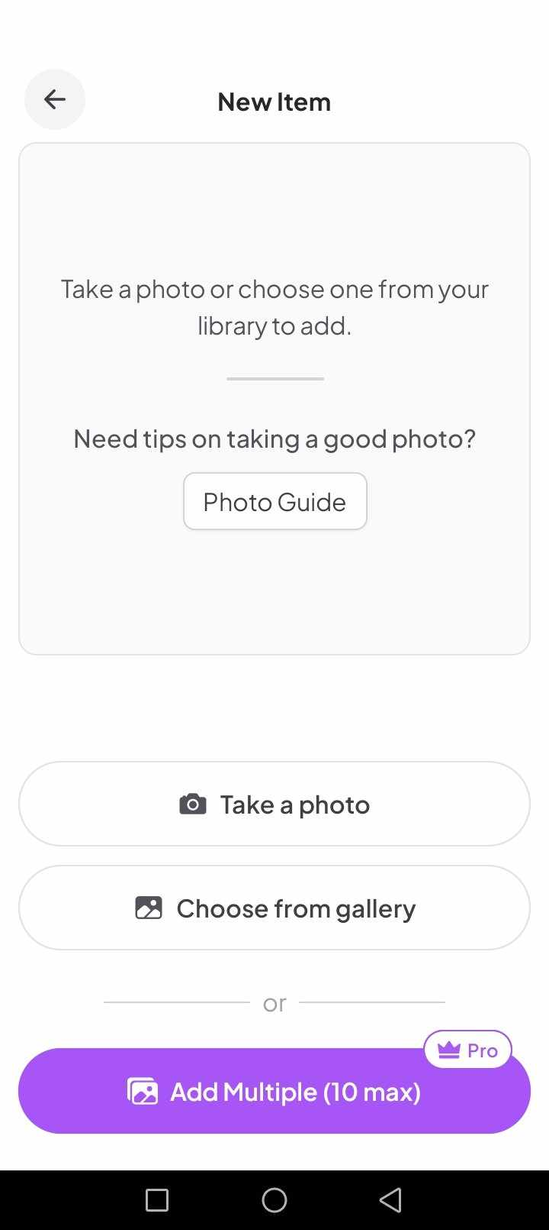

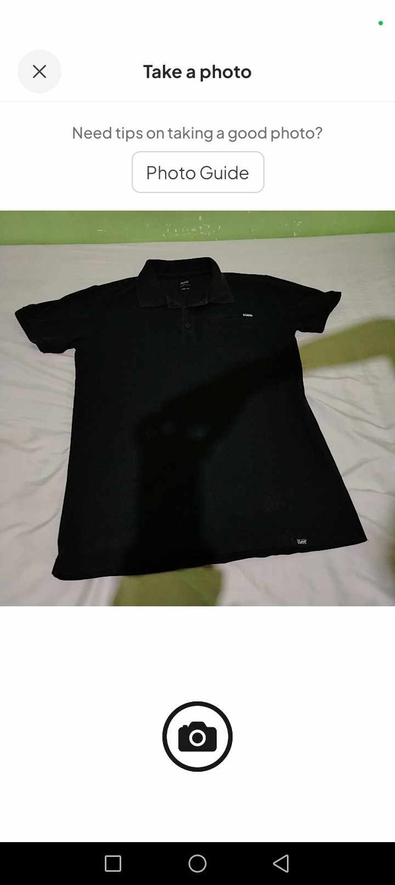
Figure No. 1: New Item Module

Figure No. 2: Take a Photo Module

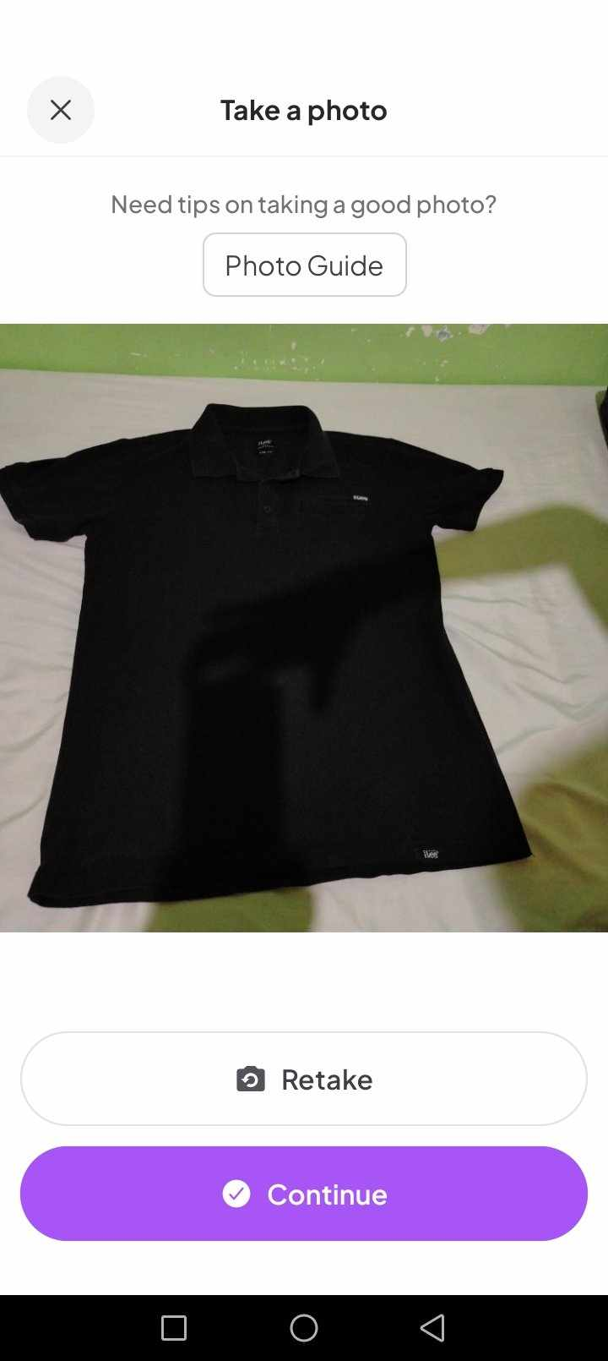

Figure No. 3: Captured Photo Module
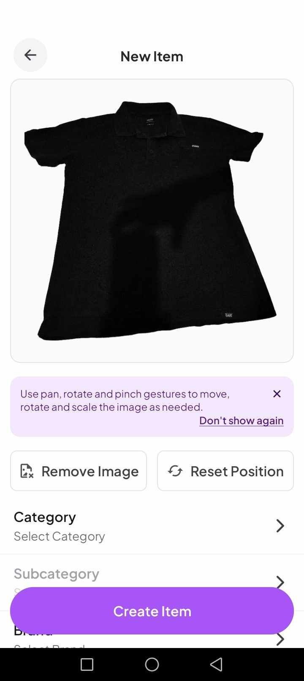

Figure No. 4: Background Remove Module
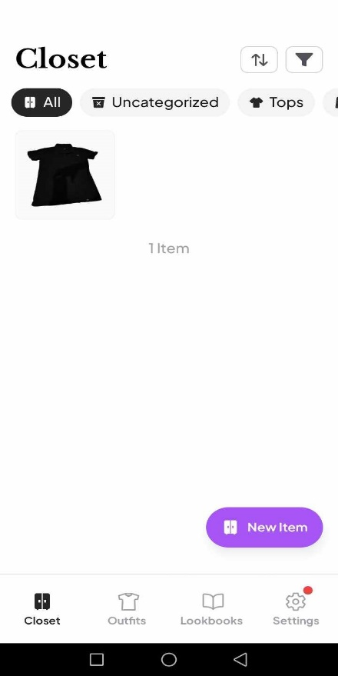
Figure No. 5: Closet Module
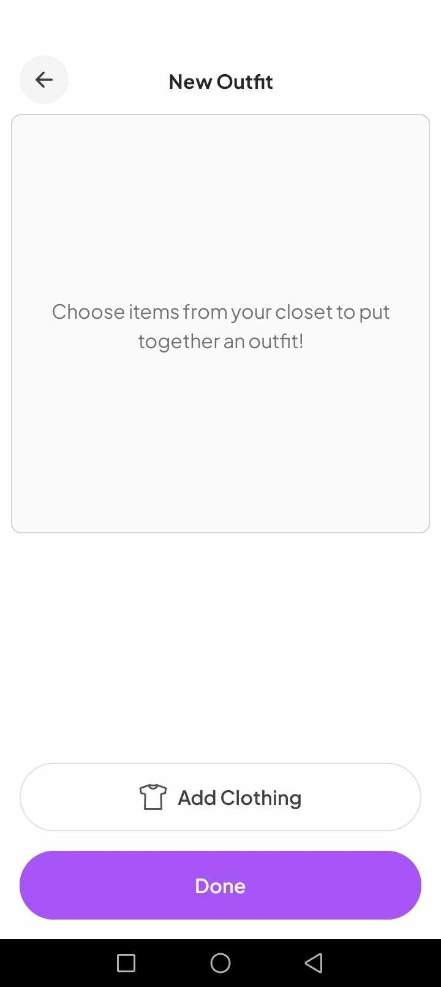
Figure No. 6: New Outfit Module
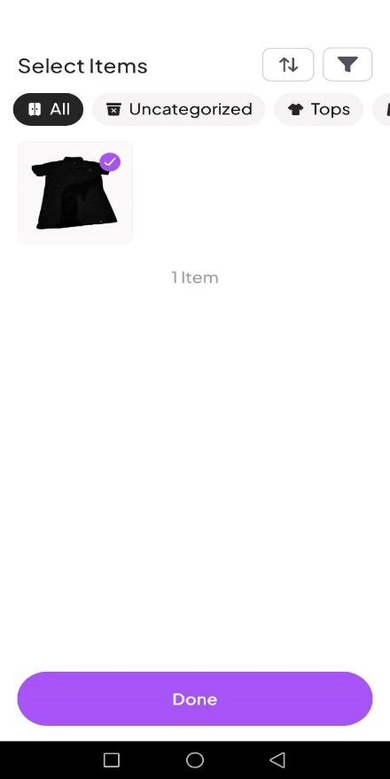
Figure No. 7: Selecting Items Module
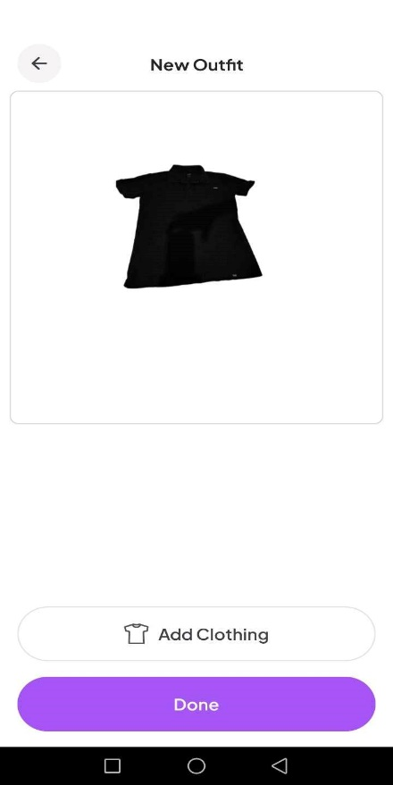
Figure No. 8: Edit Outfit Module

A.1 Similarities between OOTDLY and Clozzie
OOTDLY and Clozzie both assist users to manage and digitize their wardrobes, allowing them to plan and create outfits from their clothing items.
A.2 Difference between OOTDLY and Clozzie
OOTDLY provides calendar for scheduling outfits on specific dates, lent clothes tracker, 2D model image for outfit preview, location-based temperature information to suggest possible clothes to wear, and an offline mode so users can plan without an internet connection. Clozzie required an internet connection to fully function.
B. XZ(Closet)
Offered by: standing ovation inc
Date Published: August 24, 2024
Source: Google Play Store
XZ(Closet) is a free fashion app designed to help users improve their style by organizing their wardrobe and providing daily outfit suggestions.

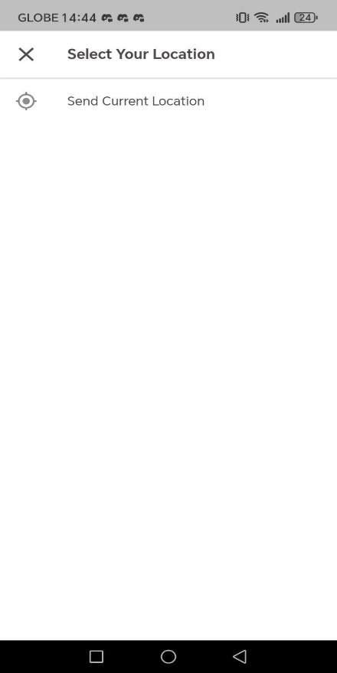

Figure No. 9: Location Module
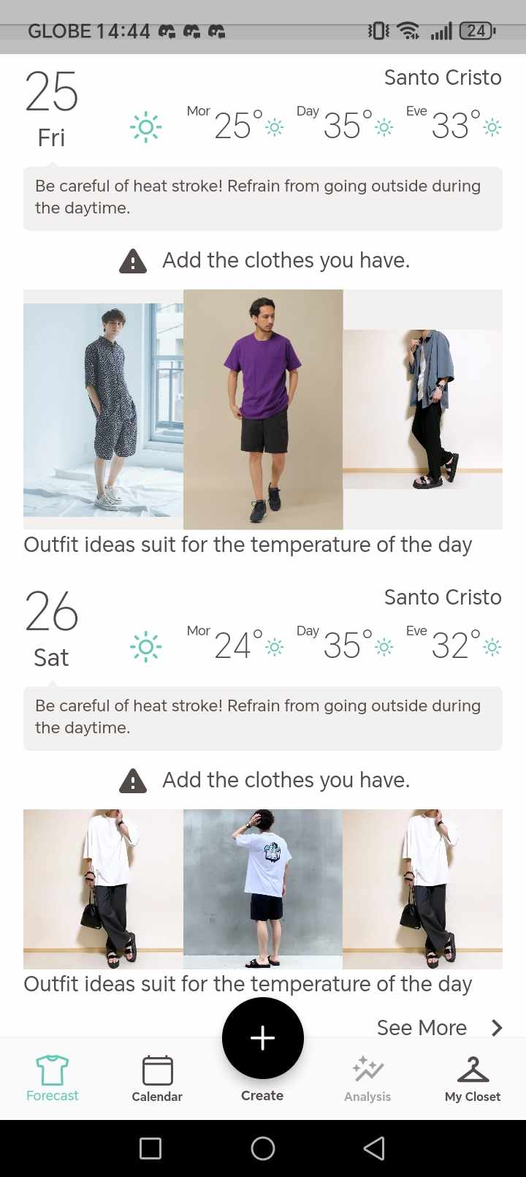

Figure No. 10: Suggested Outfit in Location Temperature Module
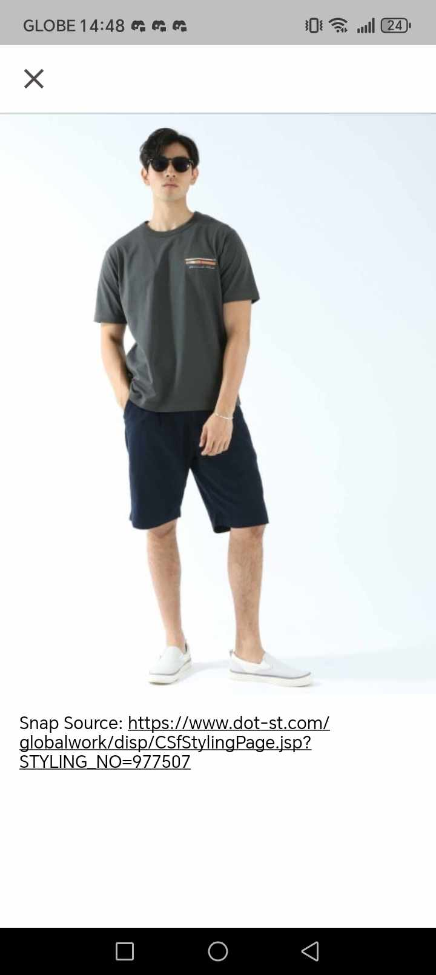
Figure No. 11: Outfit Suggested Module

B.1 Similarities between OOTDLY and XZ (Closet)
XZ(Closet) and OOTDLY have several similarities in helping users manage their wardrobe and plan stylish outfits. Additionally, the OOTYDY have temperature base outfit recommendation and XZ(Closet) have a weather base outfit recommendation base on the temperature. This feature helps user to dress clothes depends on the current temperature location.
B.2 Differences between OOTDLY and XZ (Closet)
OOTDLY provides lent clothes tracker, 2D model to preview looks, location-based temperature alerts to suggest what to wear, and an offline mode so users can plan without an internet connection. While, XZ (Closet) use a weather base outfit recommendation base on the temperature. Additionally, it cannot be run if the user does not have internet connection.

C. Fits – Outfit Planner & Closet
Developer: L. & J. Henne UG
Date Published: 27 Jan 2025
Source: Apple App Store
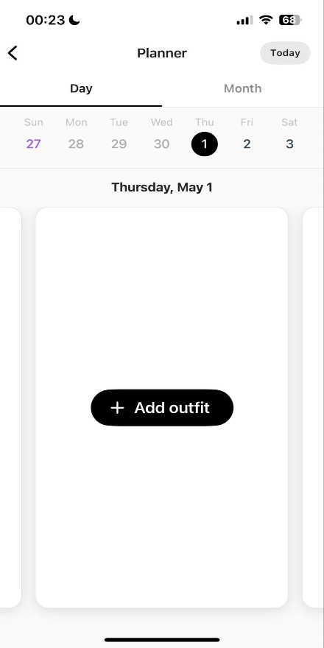
Fits is a free iOS app designed to help users organize their wardrobe and plan outfits. It allows users to digitize their closet by uploading photos of their clothing items and tagging them for easy organization.

Figure No.12: Add Outfit Schedule Module

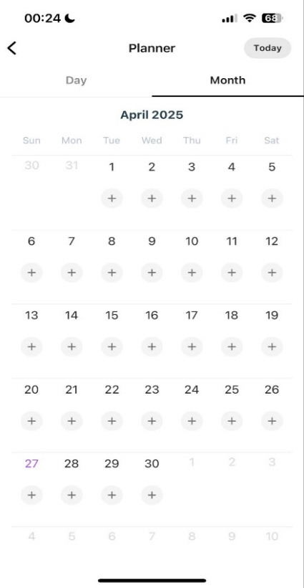

Figure No. 13: Select Schedule Module
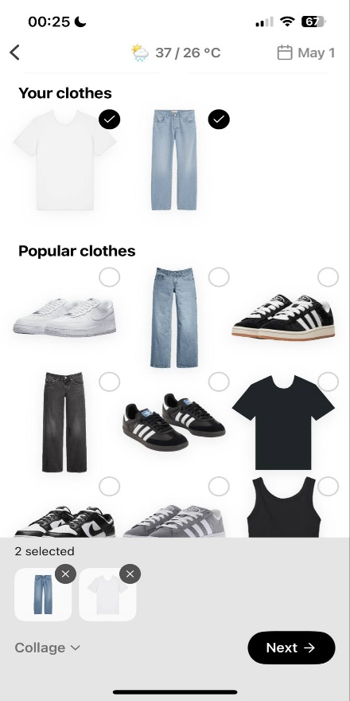

Figure No. 14: Choose Outfit Module
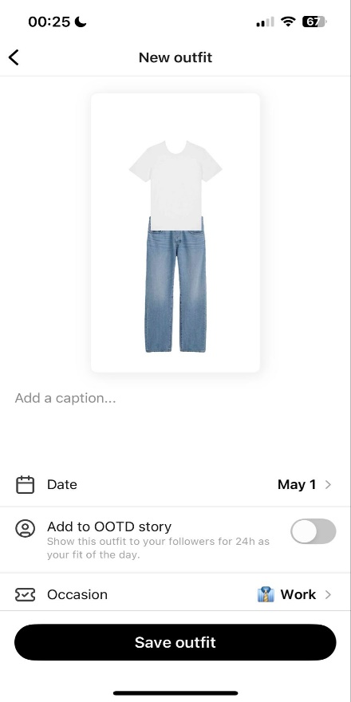

Figure No. 15: Select Occasion Module
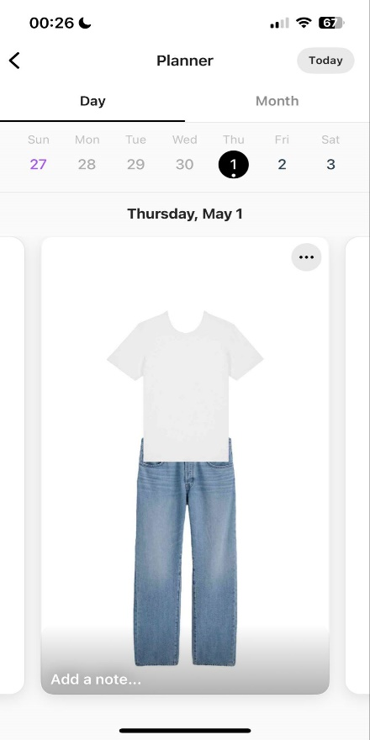

Figure No. 16: Saved Outfit Schedule Module
C.1 Similarities between OOTDLY and Fits
OOTDLY and Fits both help users organize their wardrobe by allowing them to upload photos of their clothes and create outfits. They both have a calendar feature where users can plan what to wear on different days.
C.2 Differences between OOTDLY and Fits
OOTDLY provides lent clothes tracker, 2D model to preview looks, and an offline mode so users can plan without an internet connection. While, Fits provides AI outfit suggestions and allows users to share the outfits they created with others. Additionally, it cannot be run if the user does not have internet connection.

3.0 Technical Background
3.1 Development
3.1.1 Hardware
A. Laptop
The proponents will use a laptop in order to access, download, install, and execute the tools needed to debug and develop the android version of the application.
Specifications:
- Operating System: Windows 11 Home
- Processor: Intel® Core™ i5-12500H
- Dedicated Graphics: NVIDIA® GeForce RTX™ 3060 Laptop GPU (6 GB GDDR6)
- Integrated Graphics: Intel® Iris® Xe Graphics
- Storage: SK Hynix 512 GB PCIe® Gen4 NVMe™ TLC M.2 SSD
- RAM: 16GB DDR5 4800 MHz
- Display: 40.9 cm (16.1") diagonal, FHD (1920 x 1080), IPS, micro-edge, anti-glare, 250 nits, 100% sRGB, 144Hz

B. MacBook
The proponents will use a MacBook in order to access, download, install, and execute the tools needed to debug and develop the iOS version of the application.
Specifications:
- Operating System: macOS Big Sur (upgradable to latest macOS)
- Processor: Apple M1 chip with 8-core CPU (4 performance cores + 4 efficiency cores)
- Integrated Graphics: Apple 7-core GPU
- Storage: 256 GB SSD (PCIe-based)
- RAM: 8 GB unified memory
- Display: 33.78 cm (13.3") diagonal, Retina display (2560 x 1600), IPS, True Tone technology, 400 nits brightness

C. Android Phone
The proponents will use android phone to perform debugging while developing the application to see the behavior of the application on a real android phone.
Minimum Requirements:
- Android Version: Android 10 (API Level 29) or higher
- Processor (CPU): Quad-core (4 cores) at 1.8 GHz or faster
- GPU (Graphics Processor): Adreno 506 or newer, or Mali-T830 MP2 or newer
- RAM: 4 GB RAM or higher
- Available Internal Storage: 2 GB free storage or higher
- Camera Specifications:
  - Rear Camera: 12 Megapixels with autofocus or higher
  - Front Camera: 5 Megapixels or higher
- Screen Size: Minimum 5.0 inches, Maximum 6.9 inches
- Battery: 3000mAh or higher

3.1.2 Software
A. Android Studio
Android studio is an Integrated Development Environment (IDE) that supports the development of application for both Android and iOS mobile phones. The proponents will use Android Studio to develop the Android and iOS version of the application.

B. Flutter
Flutter was made by Google and it lets the developers to create cross-platform applications, for both Android and iOS using only a single code. The proponents will use Flutter to develop the application for Android and iOS mobile phones.
C. Dart
Dart is the programming language used by Flutter for application development. The proponents will use the Dart programming language to write the functionality and algorithms of the application.
D. Web Browser
The proponents used web browser to search for good color combinations and fonts for user interface design. The proponents used web browser to access Figma, an online design tool for creating user interface designs. The proponents will use the web browser to search for application bug fixes during the application development.
E. Figma
The proponents used Figma to create the user interface design of the application. Figma is an online design tool that offers user-friendly interface and real-time collaboration.
F. Draw.io
Draw.io is a free online tool used for creating diagrams such as activity diagram, sequence diagram, and entity-relationship diagram. The proponents used Draw.io to create the diagrams related to the application flow.
G. Git
The proponents will use Git to track the development of the application. It is a free, open-source, distributed version control system that allows project collaboration.

H. GitHub
The proponents will use GitHub for cloud-based version control. It will be used alongside with Git and it will allow the proponents to track their development progress online.
I. Firebase
Firebase is a backend service provided by Google. It is loaded with different tools such as NoSQL database, cloud storage, authentication and real-time update feature. The proponents will use Firebase as their main online backend.
J. SQLite
SQLite is an offline relational database. The proponents will use SQLite for the application to operate offline.
K. DB Browser
DB Browser is a tool used to access and modify SQLite database schema. The proponents will use DB Browser to perform database creation and modification when necessary.
L. Open Meteo Weather API
Open Meteo is a free weather update provider. The proponents will use the API to get the current temperature on a location.
M. Camera API
The proponents will use the Camera API to access the device camera.
3.1.3 Peopleware
A. The Proponents
“Proponents” refers to a group of individuals collaborating together to develop the OOTDLY application. Each single proponent has specific roles, tasks, and responsibilities, contributing their skills and expertise. Their combined efforts will ensure that OOTDLY application will succeed.
B. Capstone Adviser
Mr. Victor C. Yu, a professional application developer, is the Capstone Adviser of the proponents. He plays a key part in guiding the group through the project development process. His knowledge and expertise help the group for the success of the project.
C. Resource Persons
C.1 Trisha Joy G. Tañedo
Trisha Joy G. Tañedo, 16 years old, used to not get ready for parties, such as Trisha’s friend's debut with a "starry night" theme, because Trisha didn’t know Trisha was invited and wasn’t prepared. Although Trisha’s clothes are organized within the cabinet, picking what to wear remains a struggle, especially for school or casual outings. Outfits are chosen based on the occasion, typically opting for plain and comfortable clothes. For evening events, a simple yet classy look that is comfortable is preferred. An app for planning clothes and recommending outfits would be extremely helpful, given the difficulty in deciding what to wear most of the time. If Trisha’s clothes could be reorganized, they would be categorized, separating house clothes from going-out clothes.
C.2 Jeffrey Galang Bais
Jeffrey Galang Bais, aged 28, said that he experienced lack of preparation when choosing what to wear for an event, especially when the event takes place suddenly or unexpectedly. Jeffrey's physical wardrobe items are sorted in a physical cabinet, with shirts separated from shorts. Most of the time, Jeffrey finds it hard to select clothes for an occasion or when going out, as there are times when the clothes he wears are inappropriate for the occasion. In Jeffrey’s opinion, there should be a way to choose outfits based on occasion or weather, and a mobile application that can help users choose outfits would be helpful.

C.3 Leonila Luis
Leonila Luis, at the age of 61, shared that she felt unprepared when it comes to selecting clothes to wear, especially when invited to serve as a godmother at a wedding. Leonila's attire is stored in a physical cabinet, with some clothes hung and others folded neatly. Leonila mentioned that at times, it is hard for her to decide on an outfit, particularly for special occasions like weddings or christenings. Leonila does not have a particular way of choosing outfits based on color, occasion, or season. Leonila feels that an app on her mobile phone that helps organize clothes and recommend outfits would be helpful in managing the process of choosing outfits for occasions with multiple events lined up. If Leonila had the opportunity, she would want her clothes to be sorted by color and style.
D. Wardrobe Owners
Individuals who are 13 years old and above and owns storage for their clothing items will be the main users of the application. These individuals will give the proponents useful insights to develop the application with user-friendly interface and functionalities.
3.2 Implementation
3.2.1 Hardware
A. Android Phone
The users will need an Android phone to download and use the Android version of the application.
B.1 Minimum Requirements:
- Android Version: Android 10 (API Level 29) or higher
- Processor (CPU): Quad-core (4 cores) at 1.8 GHz or faster
- GPU (Graphics Processor): Adreno 506 or newer, or Mali-T830 MP2 or newer
- RAM: 4 GB RAM or higher
- Available Internal Storage: 2 GB free storage or higher
- Camera Specifications:
  - Rear Camera: 12 Megapixels with autofocus or higher
  - Front Camera: 5 Megapixels or higher
- Screen Size: Minimum 5.0 inches, Maximum 6.9 inches
- Battery: 3000mAh or higher
Example Android Phones:
- Samsung Galaxy A21s
- Xiaomi Redmi Note 9
- realme 5 Pro
- Motorola Moto G9 Play
- Samsung Galaxy M21
B. iOS Phone
The users will need an iOS phone to download and use the iOS version of the application.
B.1 Minimum Requirements:
        - iOS Version: iOS 15 or higher
        - Processor (CPU): Apple A10 Fusion or newer
        - GPU (Graphics Processor):
          - Apple-designed GPU in A10 Fusion chip or newer
          - (PowerVR Series7XT Plus or newer equivalent)
        - RAM: 3 GB RAM or higher
        - Available Internal Storage: 2 GB free storage or higher
        - Camera Specifications:
          - Rear Camera: 8 Megapixels with autofocus or higher
          - Front Camera: 5 Megapixels or higher
        - Screen Size: Minimum 4.7 inches, Maximum 6.7 inches
        - Internet Connection: Wi-Fi or 4G LTE
        - Battery: 1960mAh or higher

Example iOS Phones:
- iPhone 7 Plus
- iPhone 8 Plus
- iPhone X
- iPhone XR
- iPhone 11
3.2.2 Software
A. Google Play Store
Users will need to have Play Store access to download the official application for Android phones.
B. Apple App Store
Users will need to have App Store access to download the official application for iOS phones.
3.2.3 Peopleware
A. Wardrobe Owners
Individuals who are 13 years old and above and owns storage for their clothing items will be the main users of the application. They are the individuals who will use the app to view their physical clothing items on their mobile devices.
3.2.4 Network
A. Internet
In order to use the online mode of the application, users will need to register or log in using Google account. This authentication will require them to have a working internet connection.

4.0 Methodology
4.1 Prototype Model
The Prototype Methodology is a step-by-step process to software development that focuses on creating a version of a system beforehand, called a prototype. The prototype provides a preview of how the final system will function. Development team will gather reviews and feedbacks, will make improvements, and will repeat the process until a final acceptable prototype is achieved. This approach will help to identify problems early, resulting in reduced risk on development.
The proponents used the Prototype Methodology for OOTDLY application. It enables the proponents to create a prototype first, and when a final acceptable prototype was achieved, the proponents will start the development. This approach will lay the foundation to develop a user-friendly and functional application.
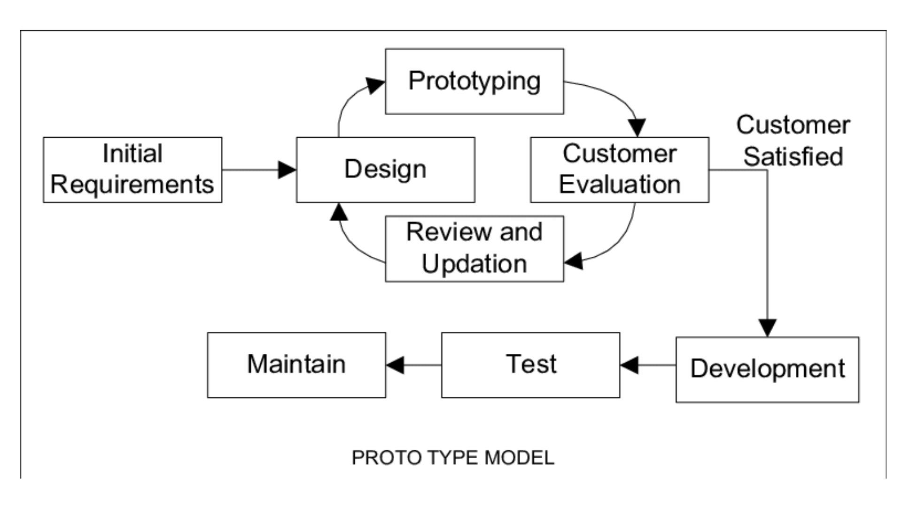

Figure No. 17: Prototyping Model

4.1.1 Phases in Prototype Model
A. Initial Requirements
In this stage, the proponents gathered essential information related to outfit planning, wardrobe organization, and fashion trends. To better understand the needs and expectations of potential users, the proponents conducted a survey that collected insights about user fashion habits, common challenges in choosing outfits in physical wardrobe, and desired features in a wardrobe management app. Also, the proponents researched existing applications and design inspirations to explore different user interface styles, layouts, and features.
B. Design
After gathering the necessary information, the proponents created an initial design for the application interface.
C. Prototyping / Building Prototype
Using the initial design, the proponents will develop a prototype of OOTDLY. The prototype will include navigation features such as navigating to other page when a button was clicked.
D. Customer / User Evaluation
Once the prototype is ready, users will be invited to test it and share their experiences. User feedback will be gathered to identify which aspects of the application needs improvements or adjustments to enhance usability and functionality.
E. Review and Updation
Based on user evaluations, the proponents will review the prototype results and will update the prototype accordingly. Modifications will enhance the design, improve feature performance, fix identified issues, and optimize the app usability.

F. Development
After the prototype was refined and approved based on user feedback, the proponents will move into the actual development phase. During development phase, the proponent will conduct the actual coding and application debugging.
G. Testing
In this stage, the proponents will conduct functionality testing, usability testing, and compatibility testing across various devices to ensure that OOTDLY is stable, user-friendly, and ready for launch.
H. Maintain
In this stage, the proponents will deploy the OOTDLY application to the Google Play Store and Apple App Store and will continue to maintain the application presence on Google Play Store and App Store.

4.2 Requirement Specification
4.2.1 Operational Feasibility
A. Fishbone Diagram
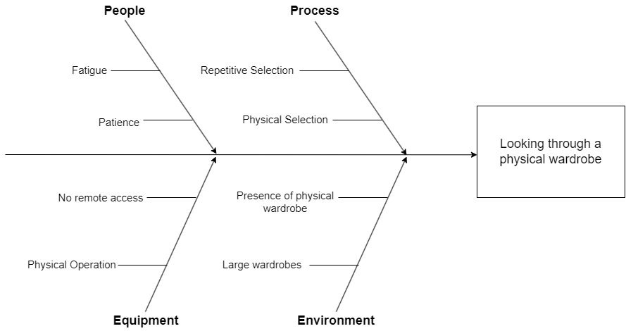

Figure No. 18: Fishbone Diagram

B. Functional Decomposition Diagram
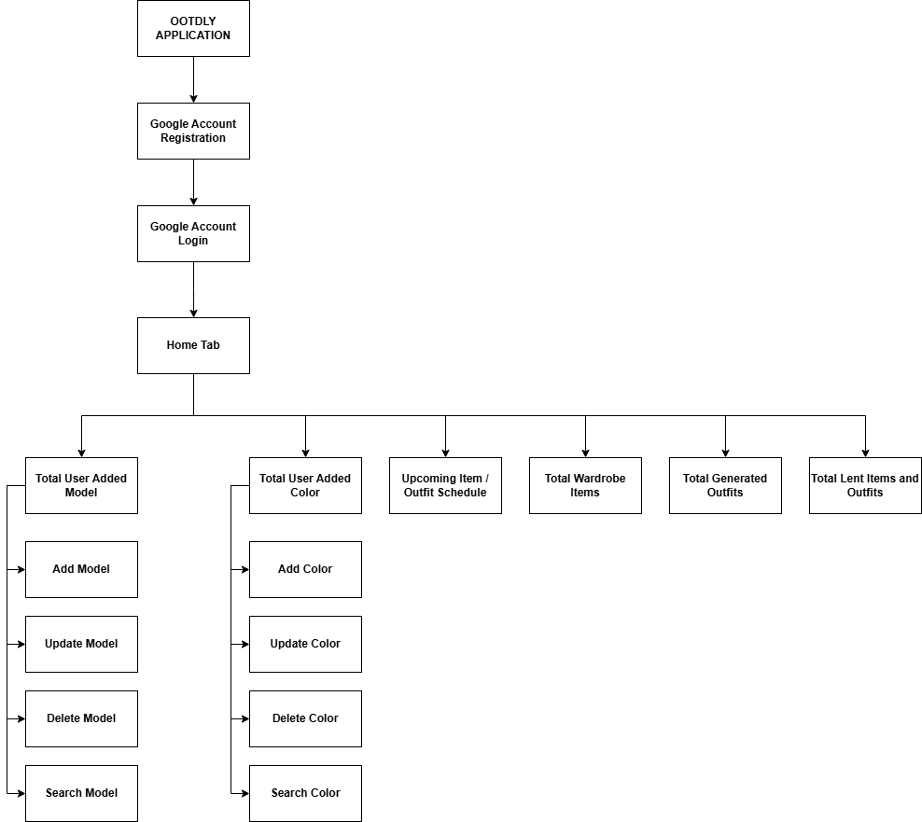

Figure No. 19: Online Home Tab FDD

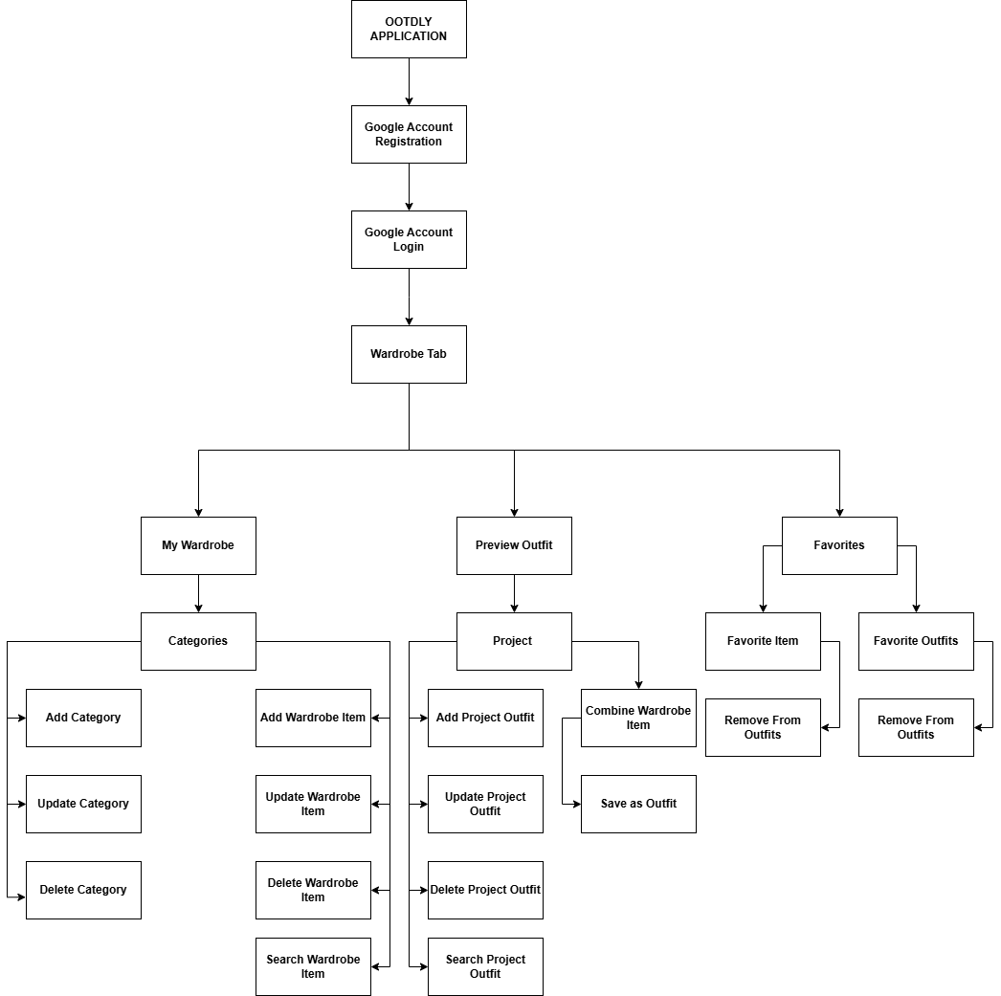
Figure No. 20: Online Wardrobe Tab FDD

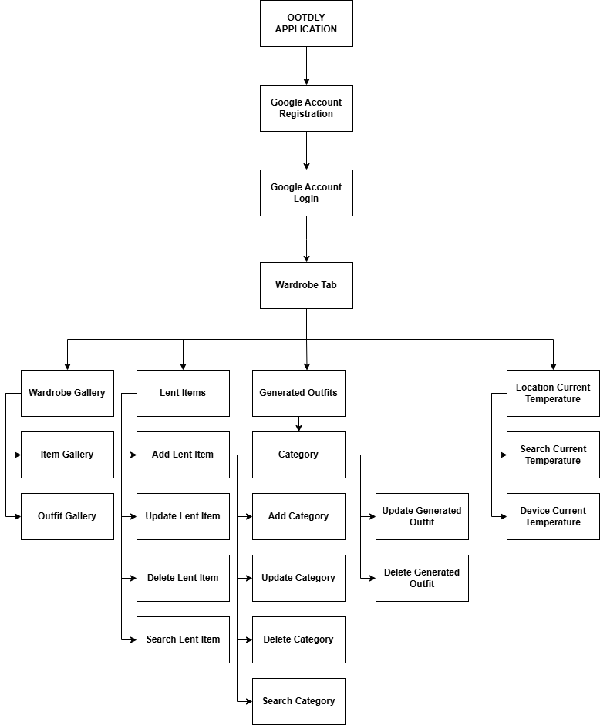

Figure No.21: Online Wardrobe Tab FDD

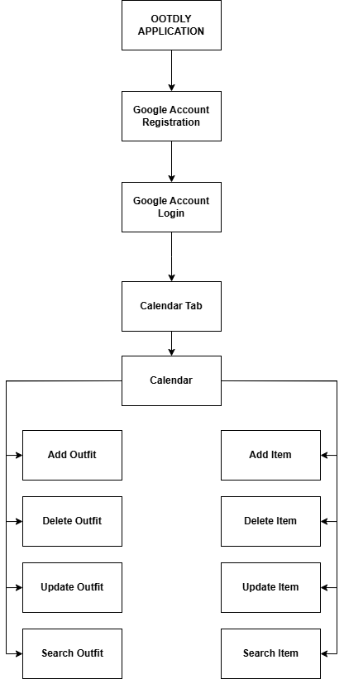
Figure No. 22: Online Calendar Tab FDD
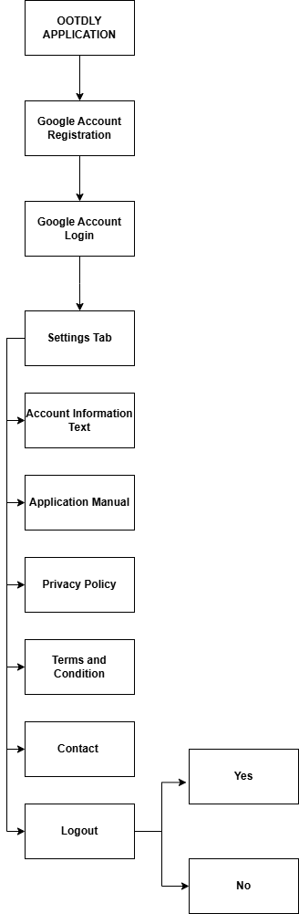

Figure No. 23: Online Settings Tab FDD
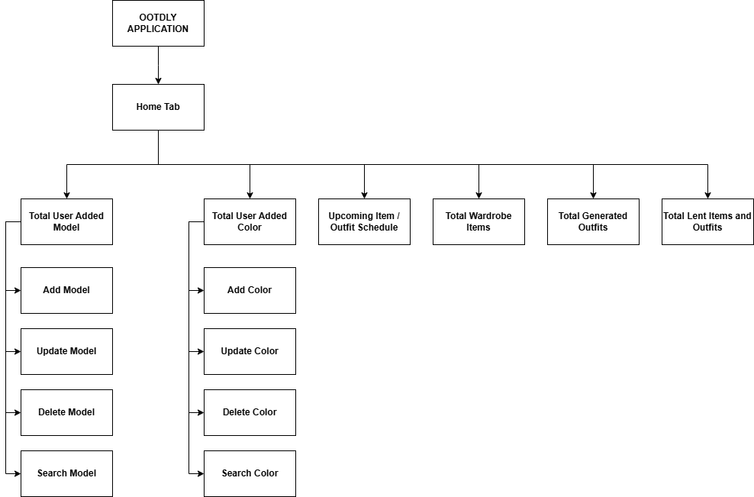
Figure No. 24: Offline Home Tab FDD

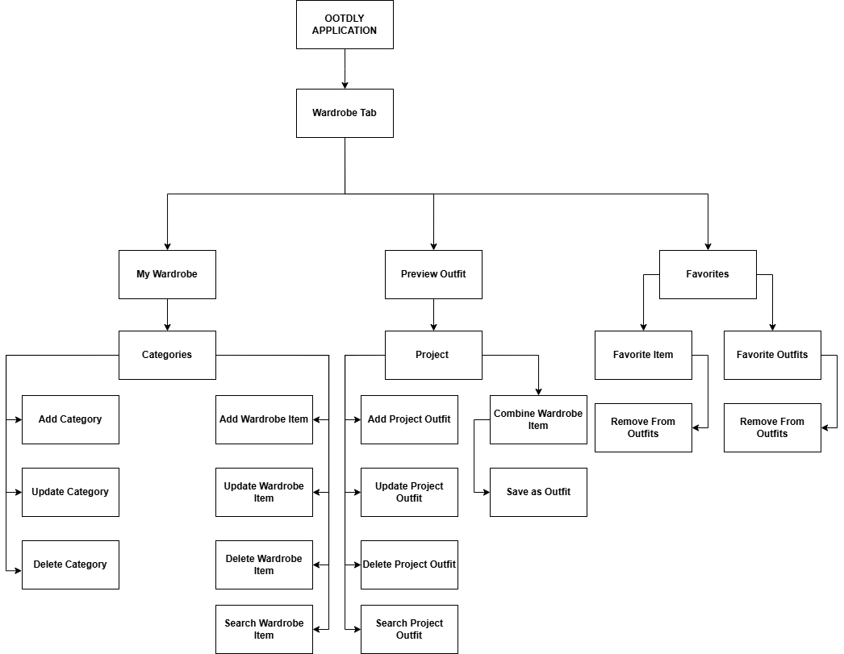
Figure No. 25: Offline Home Tab FDD

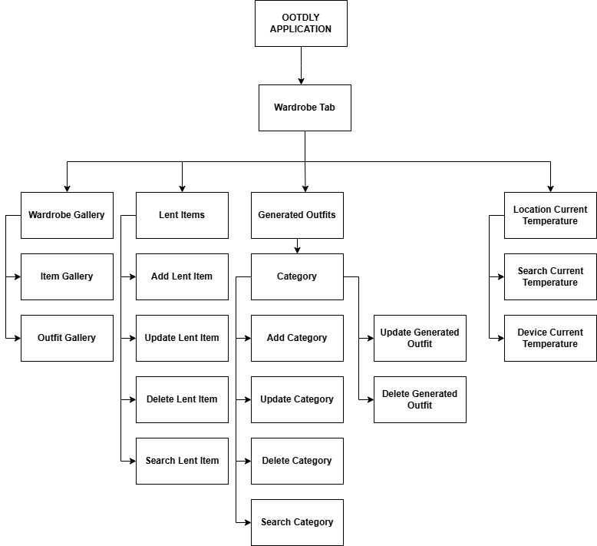

Figure No. 26: Offline Wardrobe Tab FDD

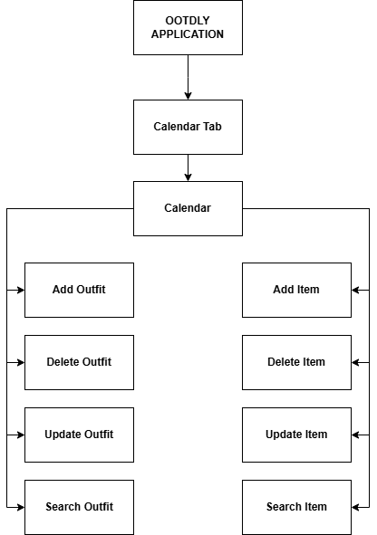

Figure No. 27: Offline Calendar Tab FDD

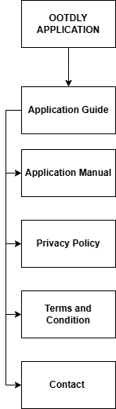

Figure No. 28: Offline Application Manual Tab FDD

4.2.2 Technical Feasibility
Technology is continuously making the daily life of humans easier, ranging from simple digital communication technologies to rising trend of digitization and digitalization of physical belongings. As technology is evolving, various tools for application development are actively growing, unlocking the potential to create applications that can help the daily life of humans. The proponents have considered the hardware and software compatibility to develop the OOTDLY application. The selected hardware, which is a laptop, is compatible with the required software tools, including Android Studio, Flutter, Firebase, and SQLite. The compatibility of hardware and software technologies will enable the proponents to achieve fully developed OOTDLY application.
A. Relevance of the Technology
The integration of technology into human life has unlocked new ways to live with ease. With the use of mobile devices, individuals can now keep track of their wardrobe. OOTDLY helps users to manage their clothing by allowing them to view their wardrobe items, combine different wardrobe items to create outfits, and schedule items or outfits for specific dates. Users can experience convenience in planning what to wear without going to their physical closet or wardrobe every time.
4.2.3 Schedule Feasibility
A. Gantt Chart
Table No. 1: Month of January of 2025
Activities | Week 1 | Week 2 | Week 3 | Week 4
Initial Requirements
Brainstorming
Online Research
Online Meeting
Tittle Defense
Selecting Adviser

Table No. 2: Month of February of 2025
Activities | Week 1 | Week 2 | Week 3 | Week 4
Brainstorming
Online Research
Online Meeting
Creating Documentation (Chapter 1)
Creating Documentation (Chapter 2)
Creating Documentation (Chapter 3)
Creating Documentation (Chapter 4)
Adviser checking of documentation (Chapter 1 – 4)

Table No. 3: Month of March of 2025
Activities | Week 1 | Week 2 | Week 3 | Week 4
Revision of document (chapter 1 - 4)
Initial submission of document for Plagiarism and AI checking
Online Meeting
Meeting and checking of document with Adviser
Revision of document (Chapter 1 to 4)
Submission of document for Plagiarism and Ai Checking
Design
Research about what colors, fonts, buttons, functions, API, and inputs implement
Brainstorming with team
Creating User Interface

Table No. 4: Month of April of 2025
Activities | Week 1 | Week 2 | Week 3 | Week 4
Preparation for Oral Defense
Oral Defense
Prototyping
Create prototype using figma

Table No. 5: Month of May of 2025
Activities | Week 1 | Week 2 | Week 3 | Week 4
Customer / User Evaluation
Presentation and testing of prototype to the target users
Review and Updation
Gather, organize, and review the feedback from the target users
Design
Online Research about the suggestion of the target users
Add and removal of features on the user interface base on the gathered feedback form the target users
Prototyping
Modification of prototype on figma to include the suggestion from the gathered feedback form the target users

Table No. 6: Month of June of 2025
Activities | Week 1 | Week 2 | Week 3 | Week 4
Customer / User evaluation
Presentation and Testing of prototype to the target users
Review and Updation
Target users accept the functionality of the prototype
Development
Setting Firebase Project for online functionality of the mobile app
Setting Flutter on Android Studio and integrating SQLite for offline functionality

Table No. 7: Month of July of 2025
Activities | Week 1 | Week 2 | Week 3 | Week 4
Developing loading screens, Online and Offline log in, registration, and forgot password modules
Developing Home Tab
Developing of Wardrobe Tab

Table No. 8: Month of August of 2025
Activities | Week 1 |  | Week 2 | Week 3 | Week 4
Developing Wardrobe Tab
Developing of Calendar Tab and Settings Tab
Building the application for Android and iOS Google Play Store and Apple App Store registration

Table No. 9: Month of September of 2025
Activities | Week 1 | Week 2 | Week 3 | Week 4
Testing
Functionality testing, usability testing, and compatibility testing for target users.
Maintain
Deployment of the application to Play Store and App Store

Table No. 10: Month of October of 2025
Activities | Week 1 | Week 2 | Week 3 | Week 4
Deployment of the application to Play Store and App Store
Preparation for Final Defense
Final defense

4.2.4 Economic Feasibility
A. Cost and Benefit Analysis
The project will be hosted on two known application providers: Google Play Store for Android devices and Apple App Store for iOS devices. It will require ₱1,438 for Play Store registration and ₱5,750 for App Store registration. The project will also use Firebase for the online backend. The project will use the free-tier offered by Firebase, but additional cost can be applied when the limit was exceeded. Therefore, the initial estimated cost is ₱7,188, with possible additional charges depending on Firebase usage.

Table No. 11: Cost and Benefit Analysis
Item | Cost | Benefits
Registration  (Google Play Store) | ₱ 1,438 | To made the application available to safely download for Android users.
Registration  (Apple App Store) | ₱ 5, 750 | To made the application available to safely download for iOS users.
Total Estimated Cost | ₱ 7, 188

B. Cost Recovery Scheme
The project will utilize an ad-based cost recovery model. There is no limit of uploading in the online mode but ads will pop up anytime while using the application in online mode. This approach will ensure that the core functionality of the application remains free while allowing the project to sustain itself through ad revenue from users.

4.2.5 Requirements Modeling
4.2.5.1 Object Modeling
- Use Case Diagram
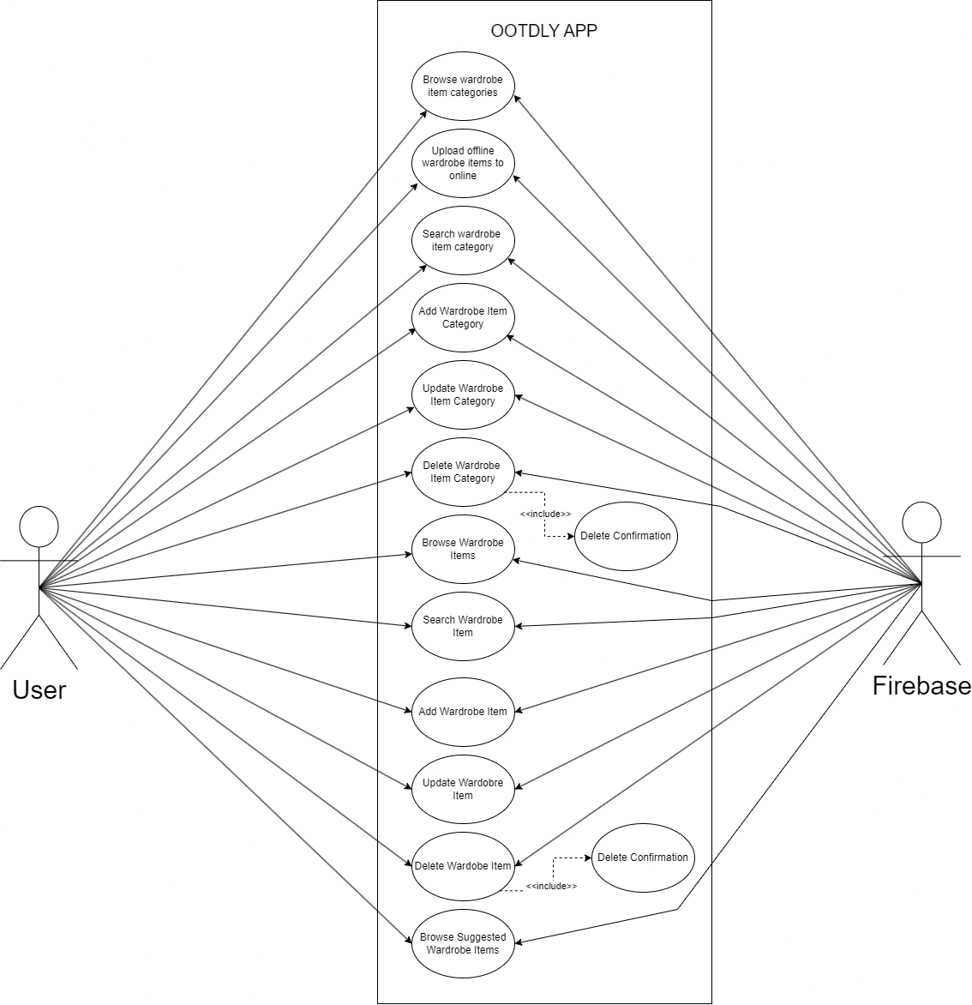

Figure No. 29: Use Case Diagram – Online My Wardrobe
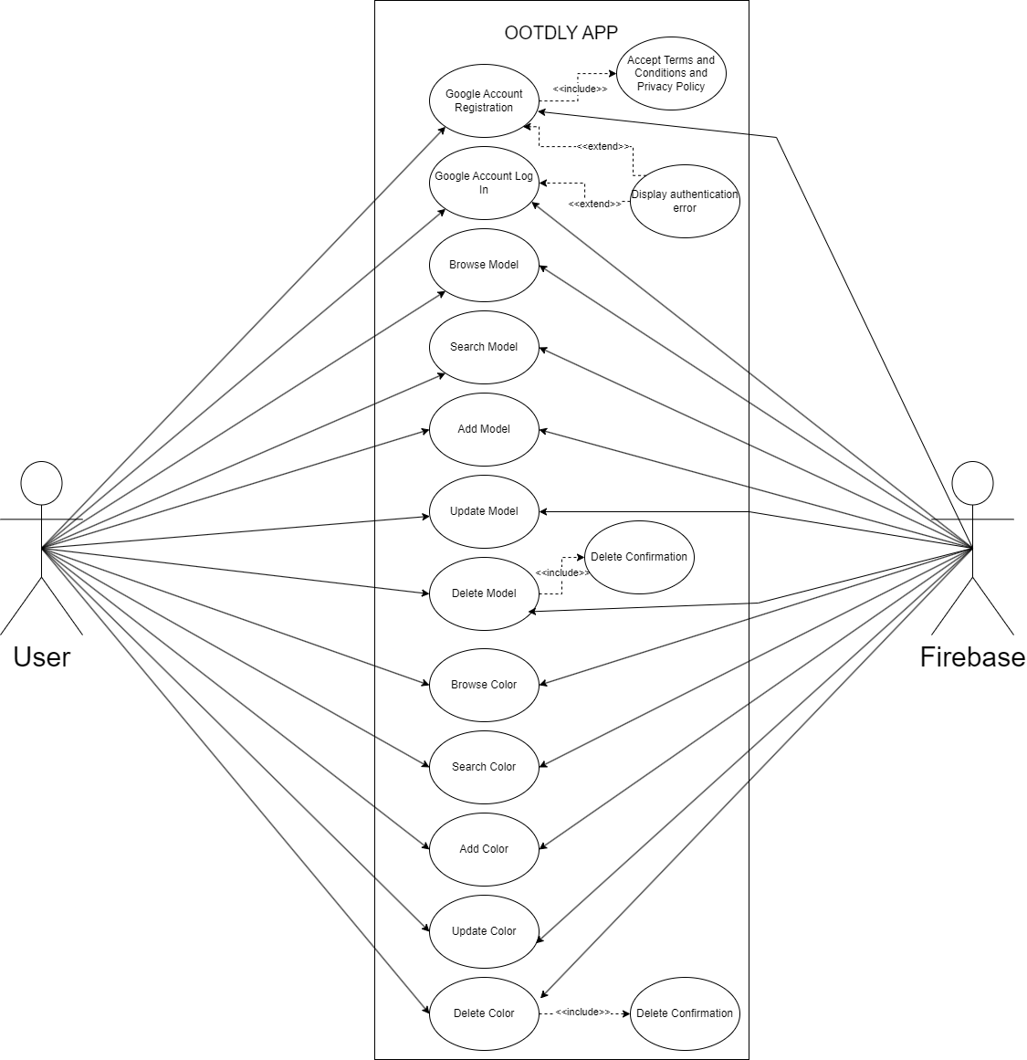
Figure No. 30: Use Case Diagram – Online Registration or Log in and Home Tab

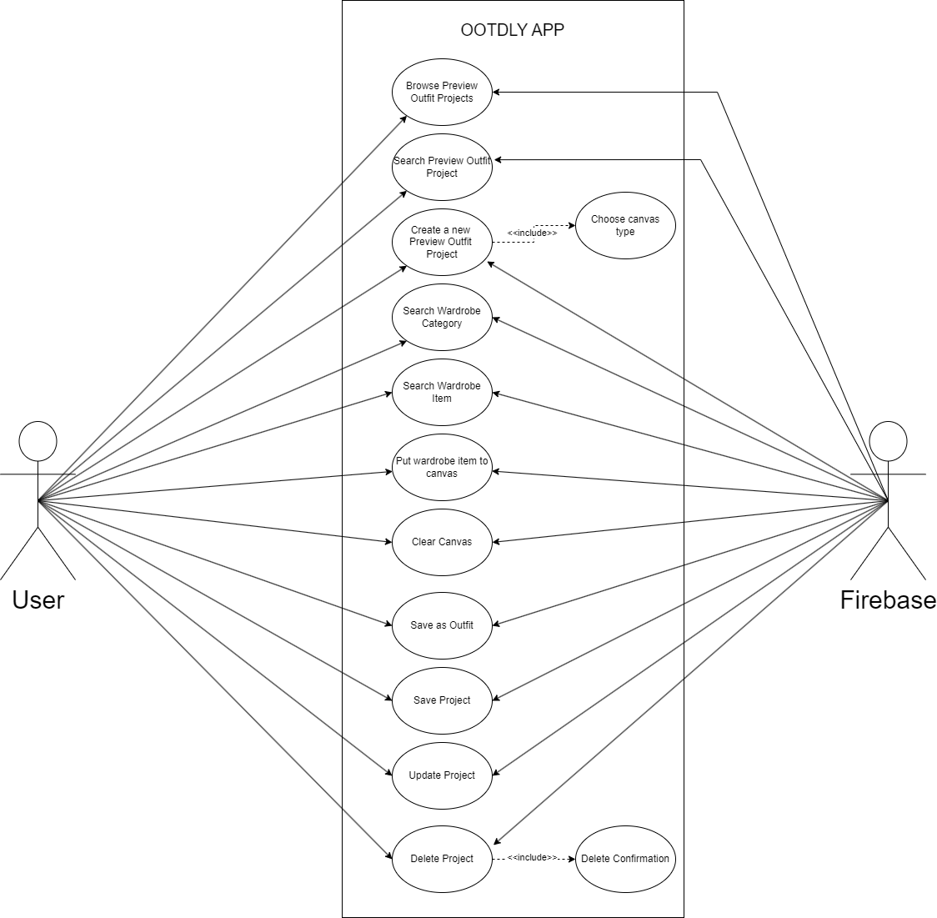
Figure No. 31: Use Case Diagram – Online Preview Outfit

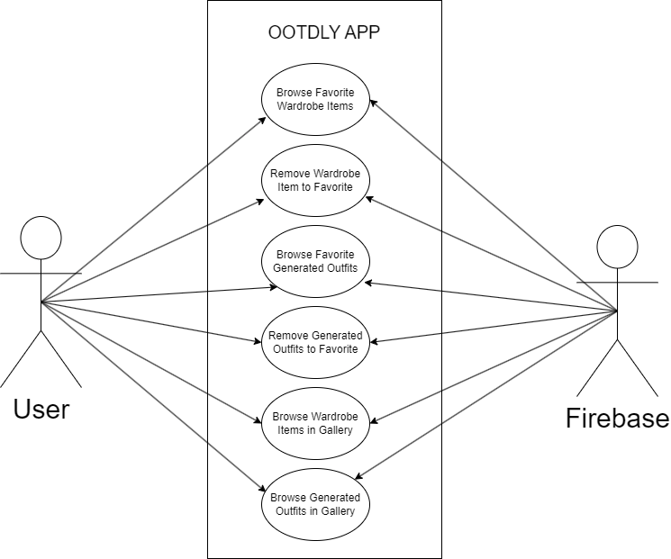

Figure No. 32: Use Case Diagram – Online Favorites and Gallery

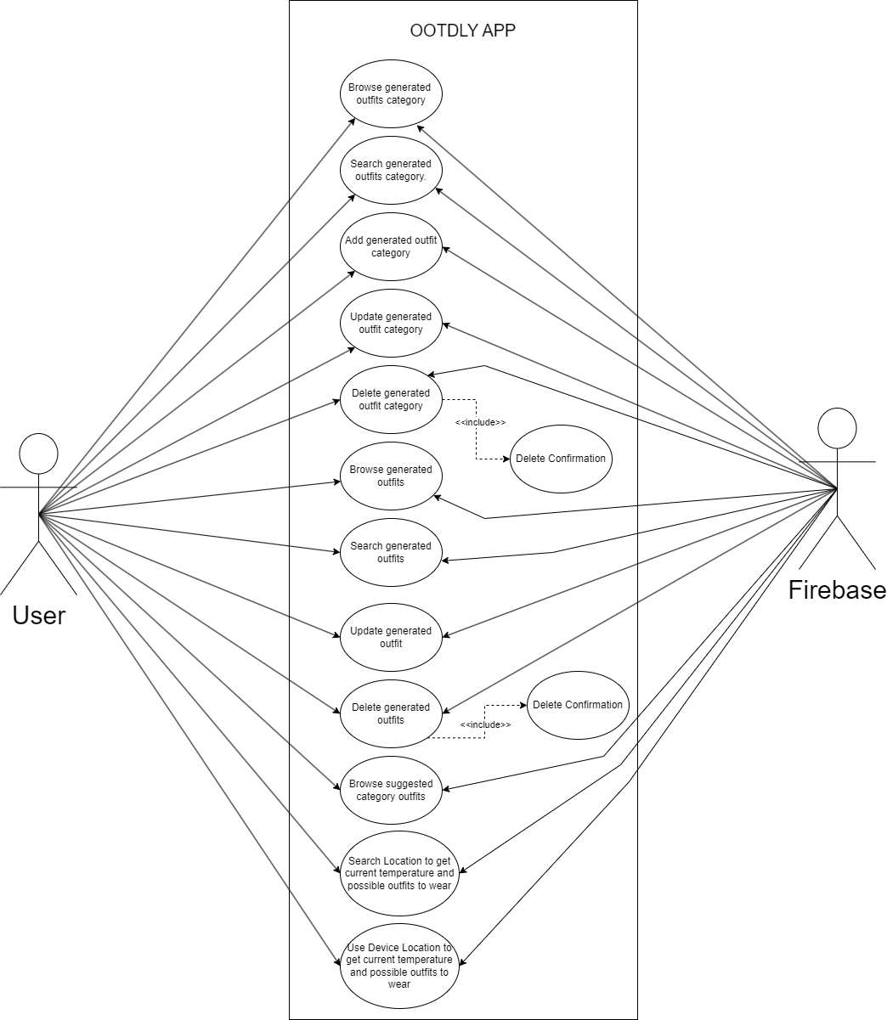
Figure No. 33: Use Case Diagram – Online Generated Outfits and Location Current Temperature

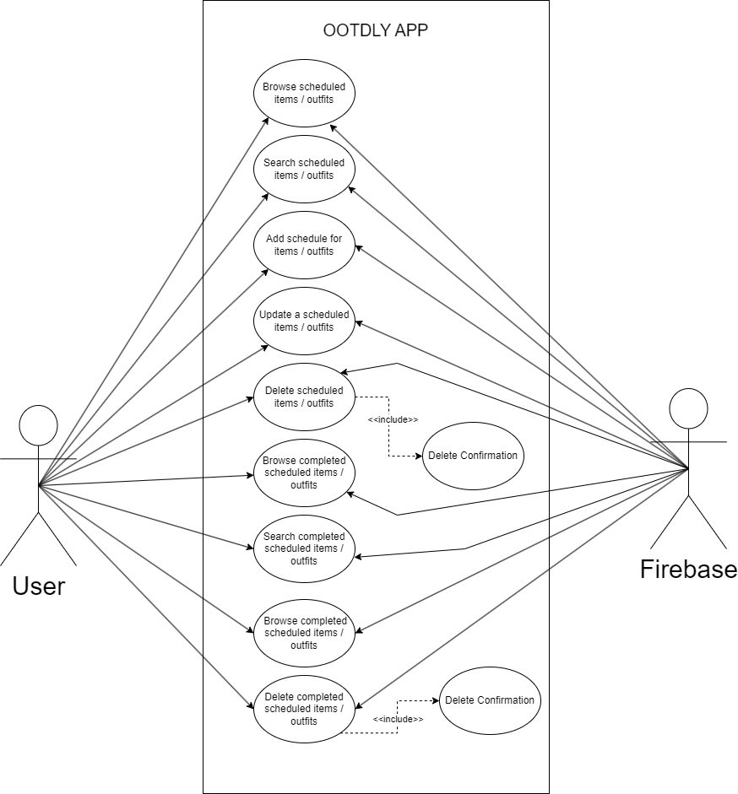

Figure No. 34: Use Case Diagram – Online Calendar Tab

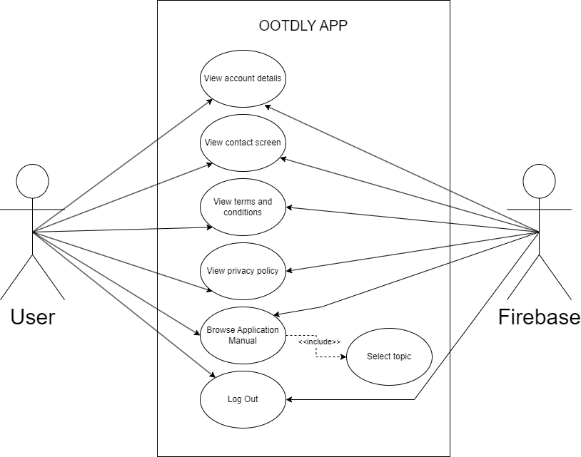

Figure No. 35: Use Case Diagram – Online Settings Tab

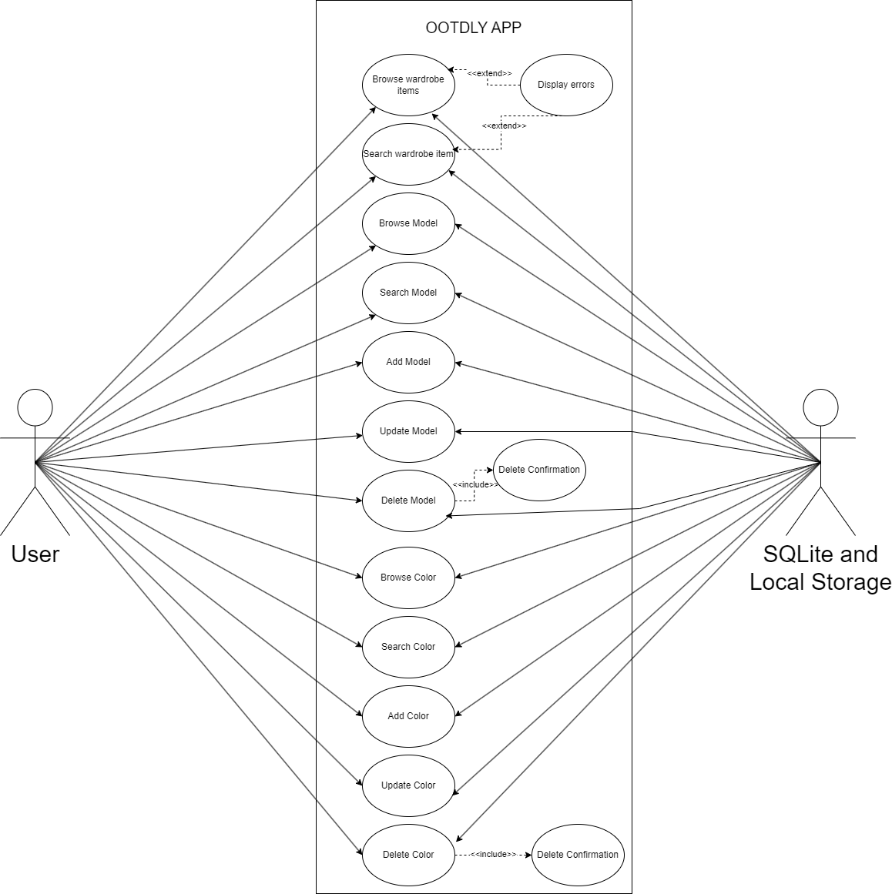

Figure No. 36: Use Case Diagram – Offline Home Tab

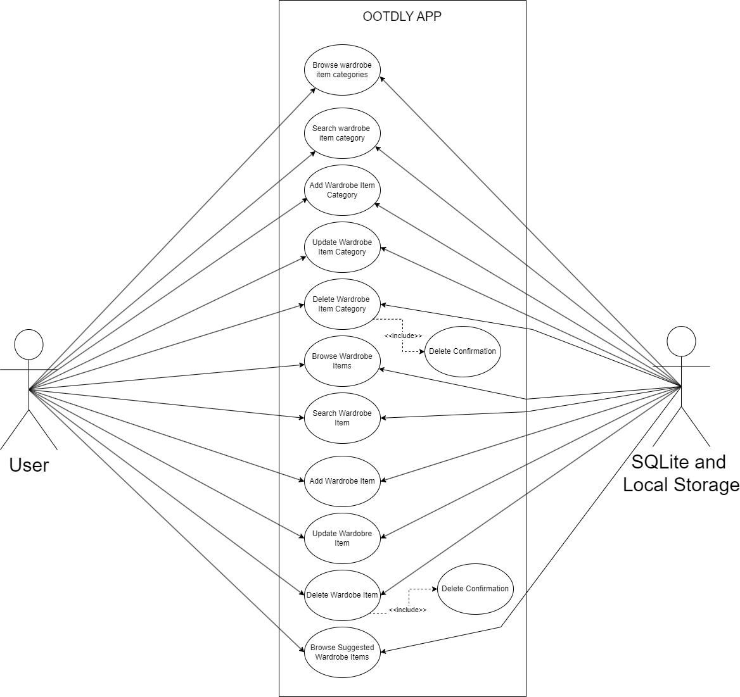

Figure No. 37: Use Case Diagram – Offline My Wardrobe

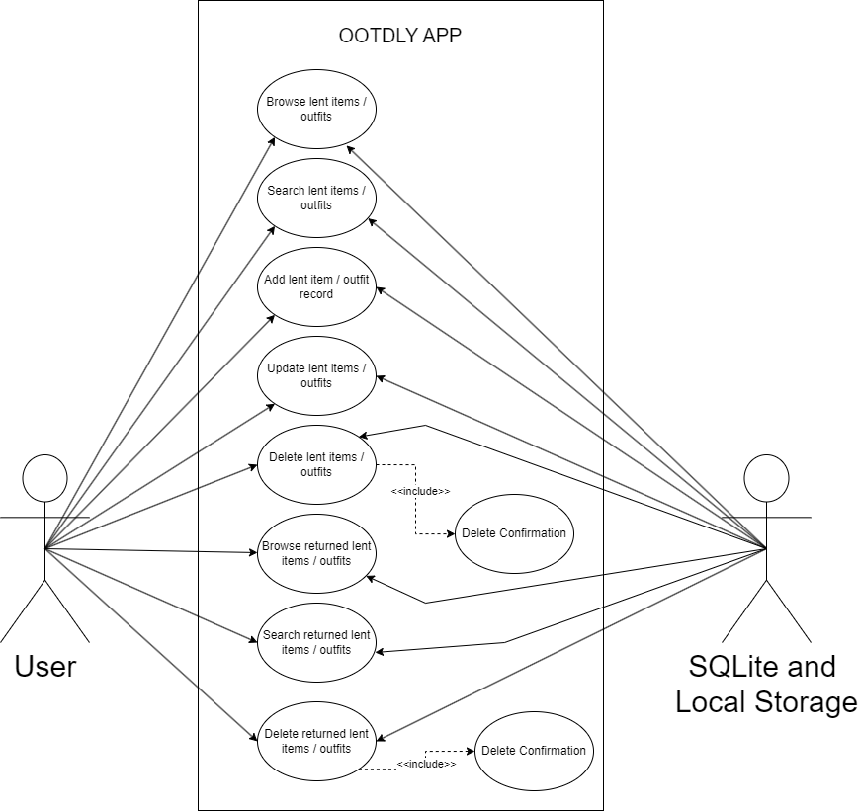

Figure No. 38: Use Case Diagram– Offline Lent Items and Outfits

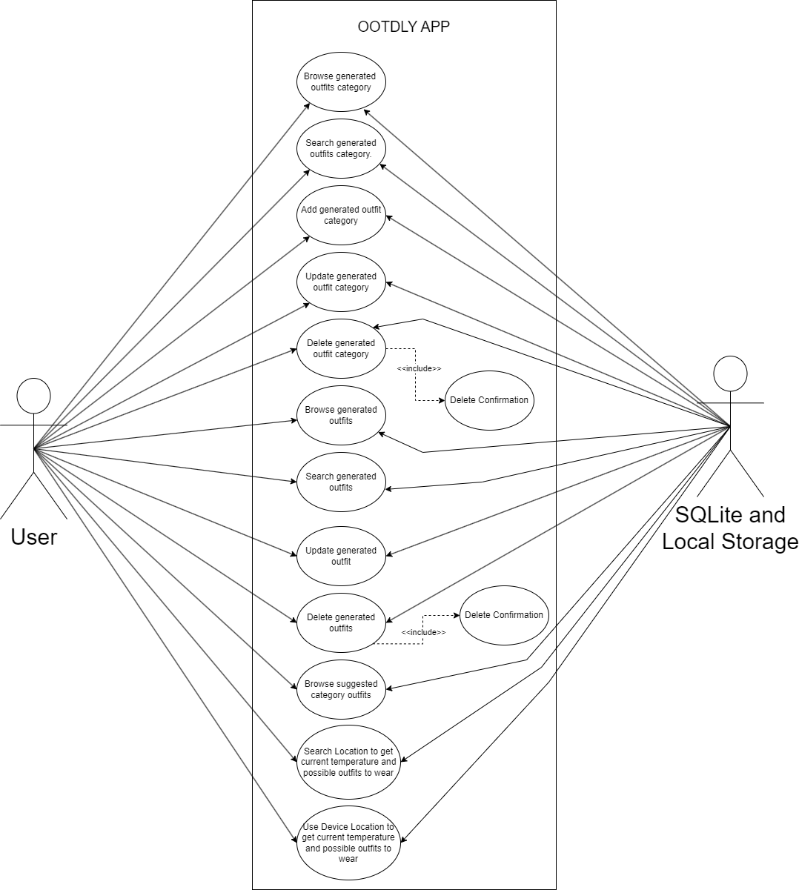
Figure No. 39: Use Case Diagram – Offline Generated Outfits and Location Current Temperature

- Sequence Diagram
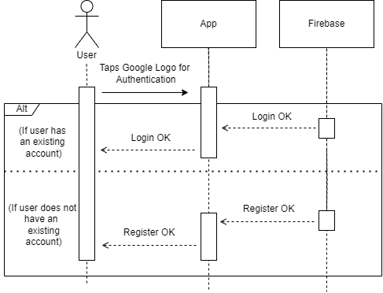

Figure No. 40: User Log In

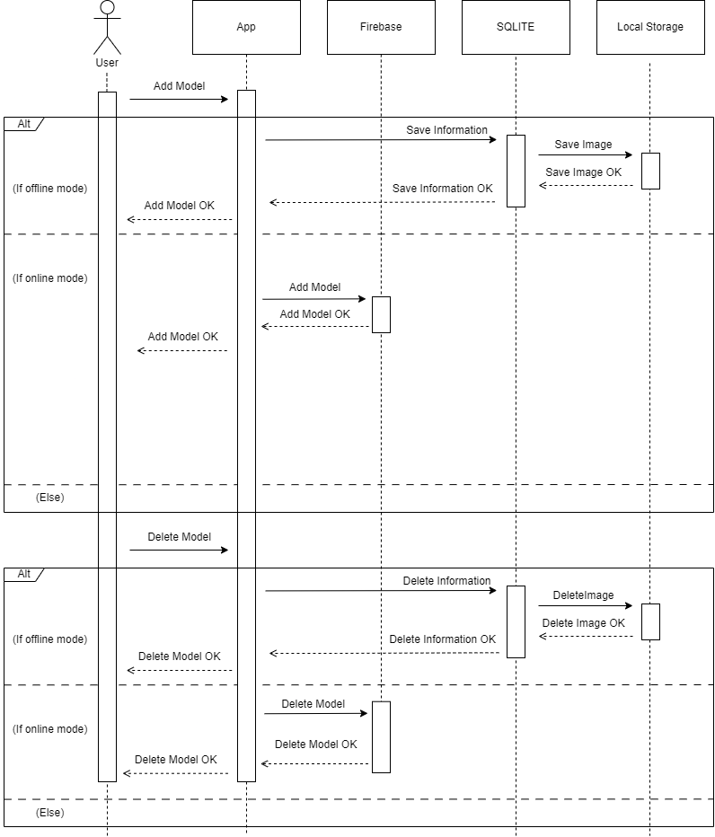
Figure No 41. Models Module

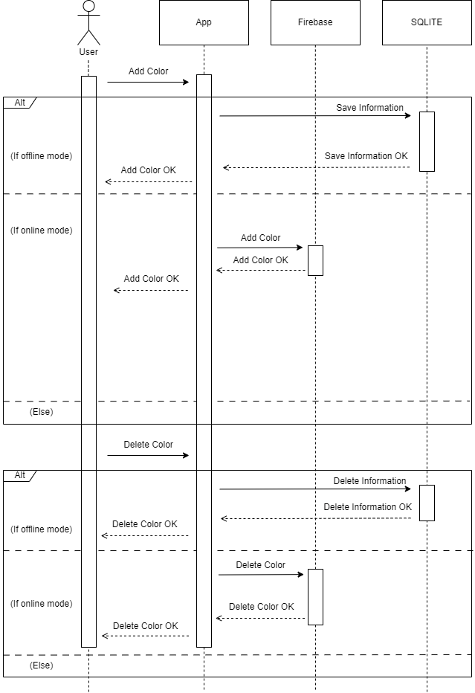

Figure No. 42: Colors Module

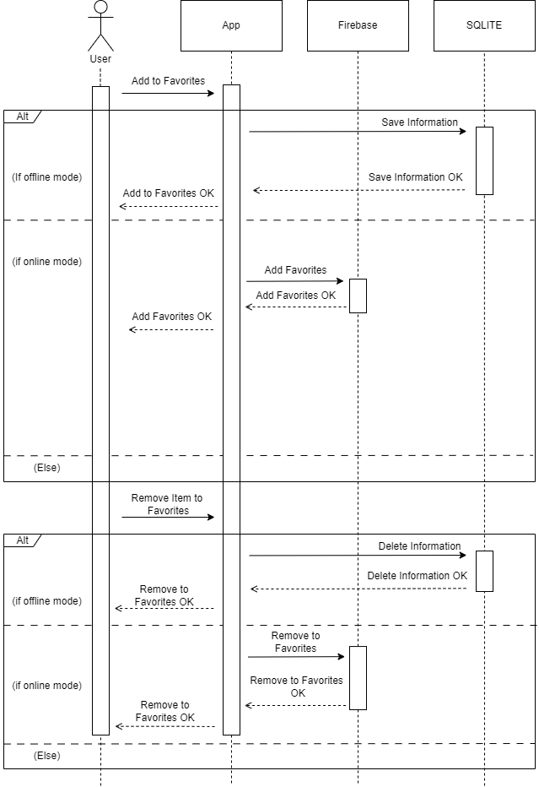

Figure No. 43: Favorites Module

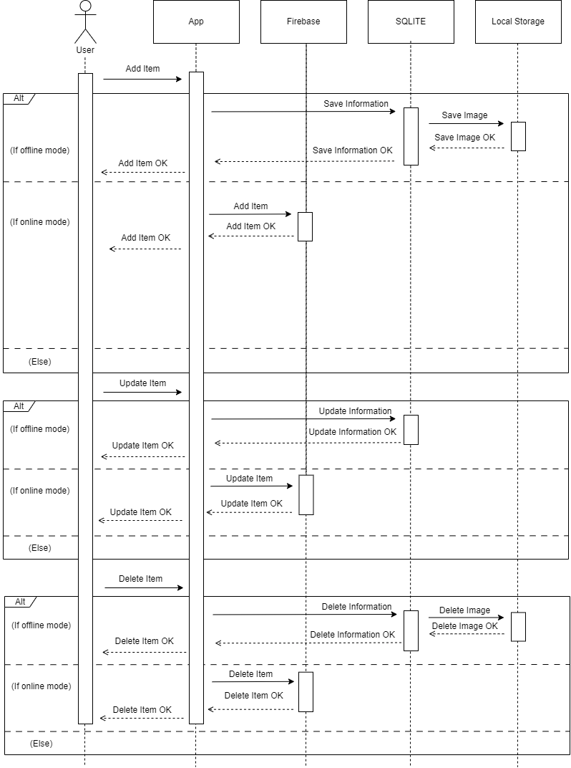

Figure No. 44: My Wardrobe Module

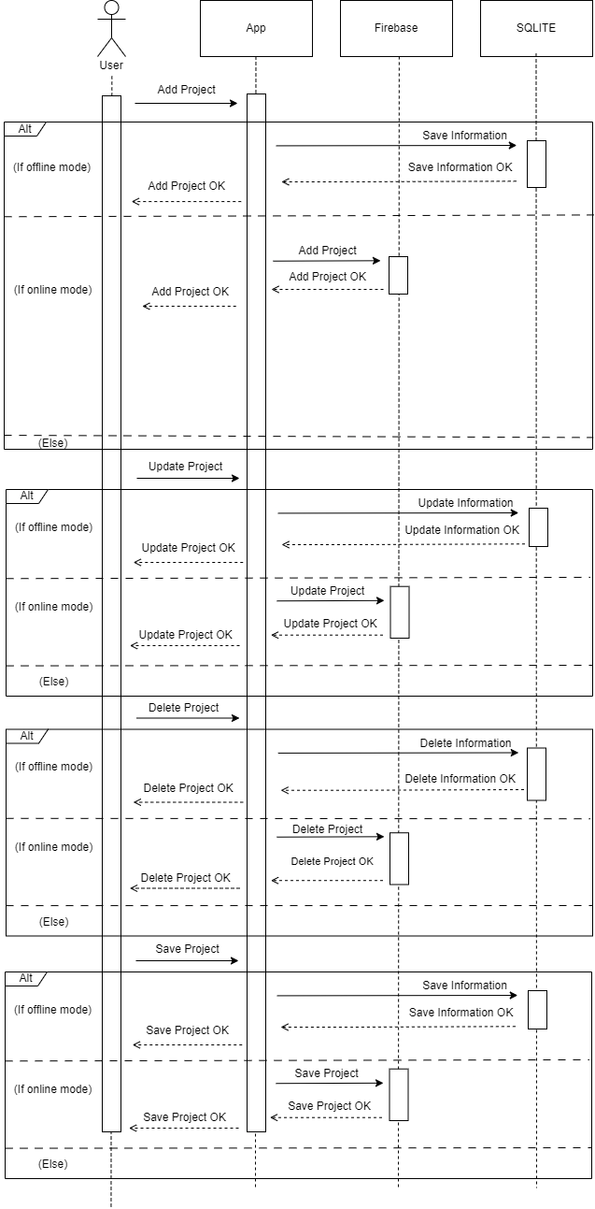

Figure No. 45: Preview Outfit Project CRUD

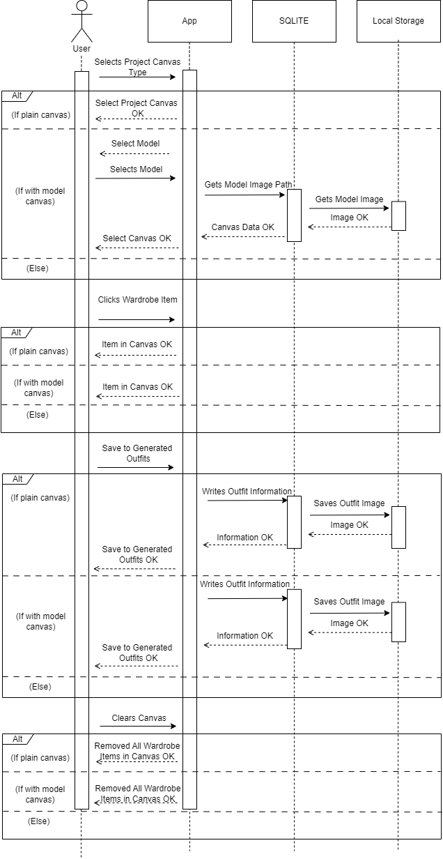
Figure No. 46: Preview Outfit Project – Offline Mode

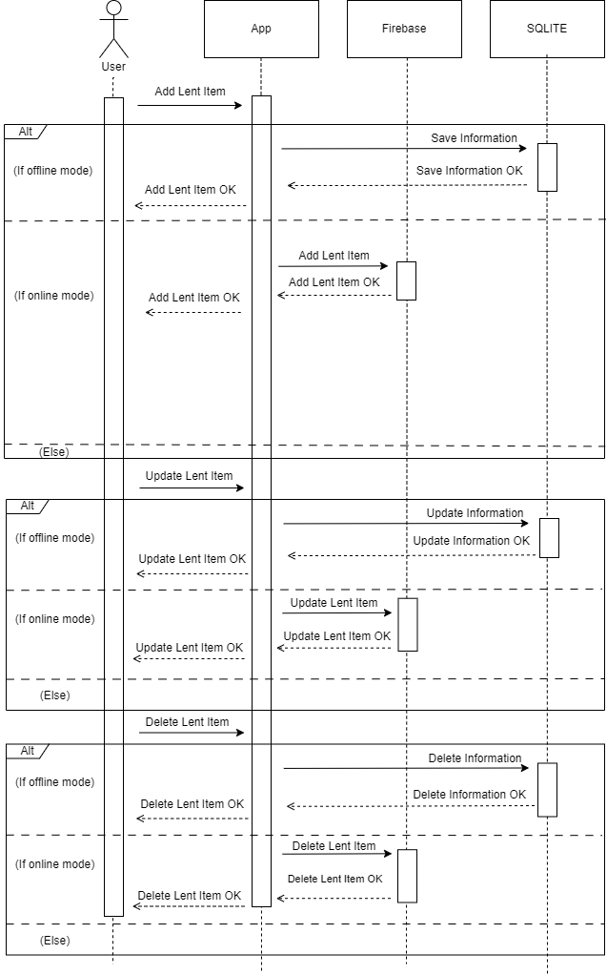

Figure No. 47: Lent Item Module

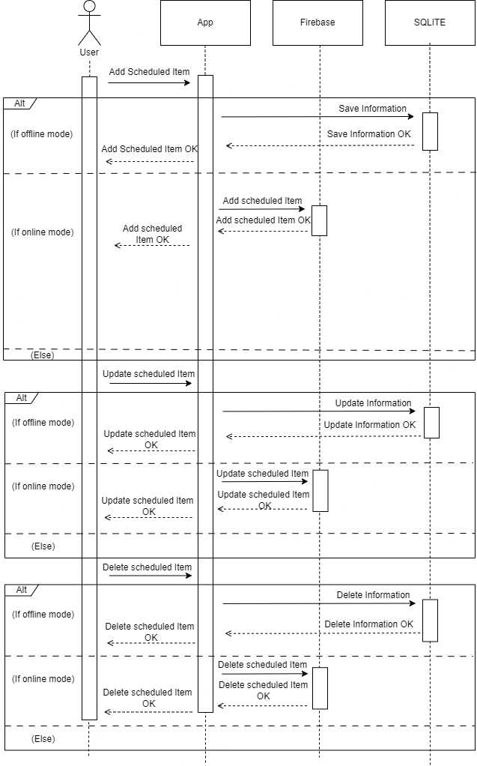

Figure No. 48: Scheduled Item

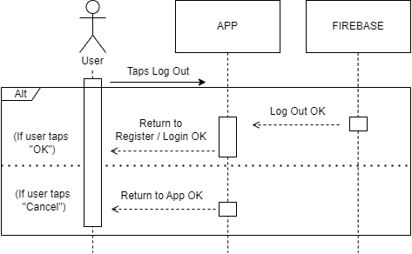

Figure No. 49: Log Out

C. Activity Diagram
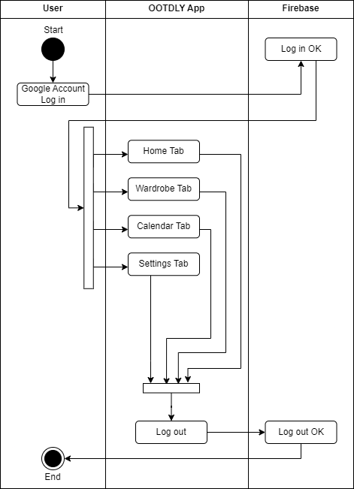

Figure No. 50: Activity Diagram – Online Mode

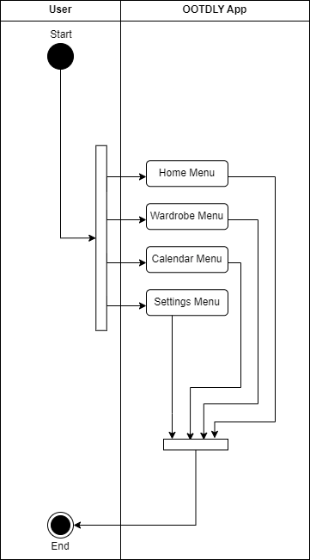

Figure No. 51: Activity Diagram – Online Mode

4.2.6 Risk Assessment / Analysis
The proponents rely only on online resources and guidance of adviser to develop the OOTDLY application. Implementing preview outfit canvas, and outfit scheduling will be challenging because it will require proper data handling and good algorithm. Interactive features, such as the ability to combine different wardrobe items to canvas and save as outfit will be also challenging as the proponents will need to deal about user actions. Online and offline modes will also a challenging part because it requires proper data sync to avoid conflicts. Additionally, ensuring the accurateness and functionality of schedule reminders and notifications will increase the development complexity. To address these challenges, the proponents will need to invest time and effort in learning about mobile application development.
4.3 Design
4.3.1 Output and User-interface Design Forms
The OOTDLY application will have a simple and organized design. The main theme color, Amethyst (#B771E5), will display a simple and stylish look, while Mauve (#CB9DF0) will provide a more lighter accent. Black and white will be used for text and icons to keep everything readable.
Additional colors will be used for different features. Mint Green (#80CA7E) will highlight positive actions, Salmon Pink (#F38484) will indicate alerts, and Sky Blue (#7CC1E9) will be used for buttons. These colors will help separate different sections of the app. The interface will have a clean layout with clear labels. Buttons will be accurately sized for easy tapping, and appropriate icon usage will help users recognize features quickly.




(Hex: #CB9DF0) (Hex: #B771E5) (Hex: #000000) (Hex: #FFFFFF)
(Hex: #7CC1E9) (Hex: #F38484) (Hex: #80CA7E)




Figure No. 52: Color Palettes

The proponents will choose Imprima and Roboto as the primary fonts for the application. Both fonts are known for their readability and modern design, making them suitable for various text elements. With multiple weights like regular and bold, they will provide a clean and professional look.
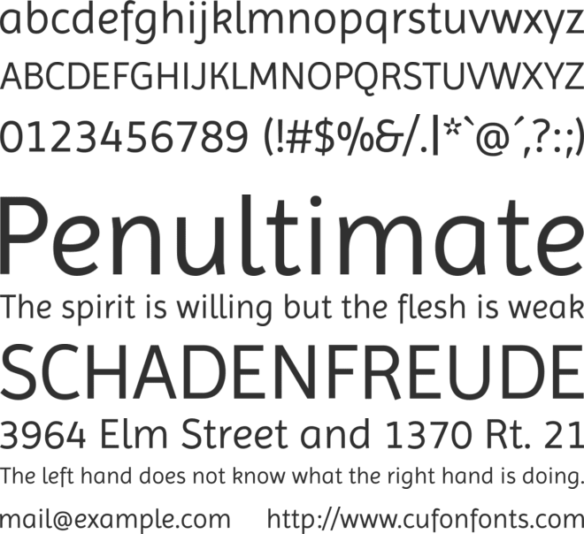

Figure No. 53: Imprima Font


Figure No. 54: Roboto Font

4.3.2 Application Logo
The proponents will use the logo below for the application. The proponents selected the logo because the logo design is fit to the application.
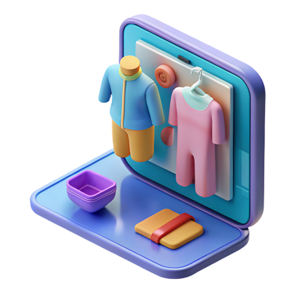

Figure No. 55: Application Logo

4.3.3 Data Design
A. Entity Relationship Diagram

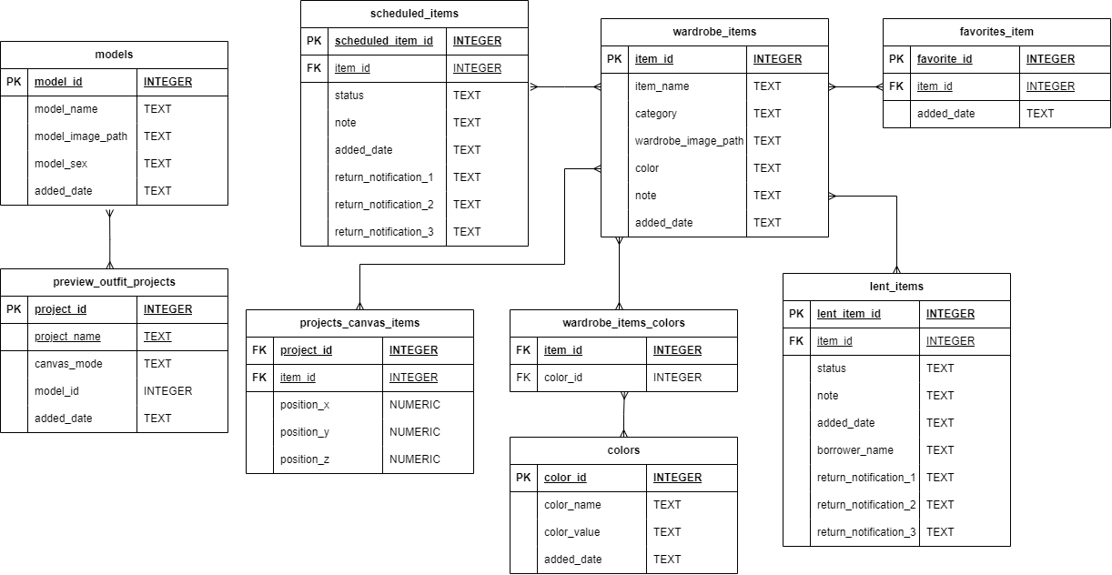

Figure No. 56: Entity Relationship Diagram
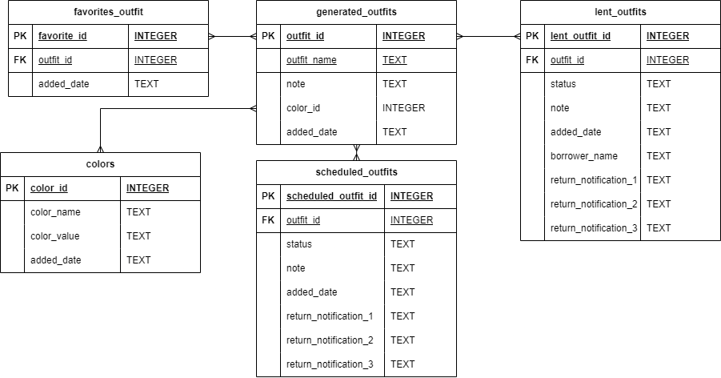
Figure No. 57: Entity Relationship Diagram

B. Data Dictionary

Table No. 12: Models

Column Name | Description | Data Type
model_id | Unique identification for each models. | INTEGER
model_name | Name of the model. | TEXT
model_image_path | Path of the model image to the local storage. | TEXT
model_sex | Indicates two options: Male of Female. | TEXT
added_date | The date and time when the model is added. | TEXT

Table No. 13: Colors

color_id | Unique identification for each color. | INTEGER
color_name | Name of the color. | TEXT
color_value | The color equivalent HEX value. | TEXT
added_date | The date and time when the color is added. | TEXT

Table No. 14: Wardrobe Items

item_id | Unique identification for each item. | INTEGER
item_name | Name of the item. | TEXT
category | The category of the item. | TEXT
wardrobe_image_path | The local path of the wardrobe item image. | TEXT
note | Note or details about the item. | TEXT
added_date | The date and time when the item is added. | TEXT

Table No. 15: Wardrobe Item Colors

item_id | The id of the wardrobe item | INTEGER
color_id | Unique identification for each color. | INTEGER

Table No. 16: Scheduled Items

scheduled_item_id | Unique identification for each scheduled item. | INTEGER
item_id | Unique identification for each item. | INTEGER
status | Indicates the status if coming or finished. | TEXT
note | Note or details about the scheduled item. | TEXT
added_date | The date and time when the item is added. | TEXT
return_notification_1 | The date and time for the first return notification. | TEXT
return_notification_2 | The date and time for the second return notification. | TEXT
return_notification_3 | The date and time for the third return notification. | TEXT

Table No. 17: Favorites Item

favorite_id | Unique identification for each favorite item. | INTEGER
item_id | Unique identification for each item. | INTEGER
added_date | The date and time when the item is added. | TEXT

Table No. 18: Lent Items

lent_item_id | Unique identification for each lent item. | INTEGER
item_id | Unique identification for each added outfit. | INTEGER
status | Indicates the status if returned or not. | TEXT
note | Note or details about the scheduled item. | TEXT
added_date | The date and time when the item is added. | TEXT
return_notification_1 | The date and time for the first return notification. | TEXT
return_notification_2 | The date and time for the second return notification. | TEXT
return_notification_3 | The date and time for the third return notification. | TEXT

Table No. 19: Generated Outfits

outfit_id | Unique identification for each added outfit. | INTEGER
outfit_name | The name of the outfit. | TEXT
note | Note or details about the scheduled item. | TEXT
color_id | Reference ID of the outfit color | INTEGER
added_date | The date and time when the item is added. | TEXT

Table No. 20: Lent Outfits

lent_outfit_id | Unique identification for each lent outfit. | INTEGER
outfit_id | Reference ID for the outfit. | INTEGER
status | Indicates the status if returned or not. | TEXT
note | Note or details about the scheduled item. | TEXT
added_date | The date and time when the item is added. | TEXT
return_notification_1 | The date and time for the first return notification. | TEXT
return_notification_2 | The date and time for the second return notification. | TEXT
return_notification_3 | The date and time for the third return notification. | TEXT

Table No. 21: Preview Outfit Projects

project_id | Unique identification for each project. | INTEGER
project_name | The name of the project. | TEXT
canvas_mode | Indicates if the canvas is empty or with model. | TEXT
model_id | Reference ID for the model on with model canvas. | INTEGER
added_date | The date and time when the project is added. | TEXT

Table No. 22: Project Canvas Items

project_id | Unique identification for each project. | INTEGER
item_id | Reference ID for the wardrobe item. | INTEGER
position_x | The x-axis position of an item. | NUMERIC
position _y | The y-axis position of an item. | NUMERIC
position _z | The z-index of an item. | NUMERIC

Table No. 23: Scheduled Outfits

scheduled_outfit_id | Unique identification for each scheduled outfit. | INTEGER
outfit_id | Unique identification for each added outfit. | INTEGER
status | Indicates the status if coming or finished. | TEXT
note | Note or details about the scheduled outfit. | TEXT
added_date | The date and time when the outfit is added. | TEXT
scheduled_date | The scheduled day for the outfit. | TEXT

Table No. 24: Favorites Outfits

favorite_id | Unique identification for each favorite outfit. | INTEGER
outfit_id | Reference ID for the outfit. | INTEGER
added_date | The date and time when the favorite outfit is added. | TEXT

4.3.3 System Architecture
A. Network Model
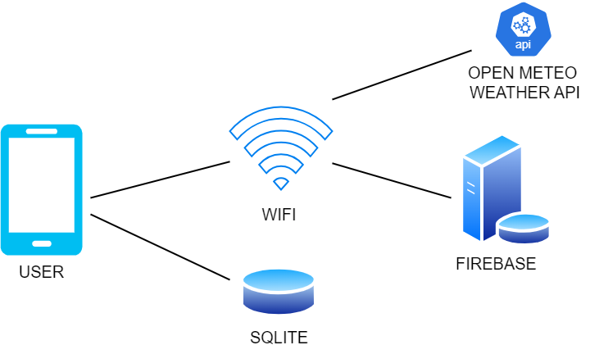
Figure No. 58: Network Model

B. Security
The application will implement Google Account Registration and Google Account Log In to obtain access control. Only the authenticated users will be able to have online access to online accounts.

References

[1] | H. Bang and J. Su, "Who Uses Virtual Wardrobes? Investigating the Role of Consumer Traits in the Intention to Adopt Virtual Wardrobes," Sustainability, vol. 14, no. 3, 2022.
[2] | B. Girl, "THE EVERYGIRL : I Plan All My Outfits at the Beginning of the Week—Here’s Why You Should Too," 2 January 2025. [Online]. Available: https://theeverygirl.com/beginning-of-week-outfit-planning. [Accessed 19 February 2025].
[3] | R. Sharma, "Innovative mobile application, Weather Wear:," Dublin Business School, Dublin, 2024.
[4] | A. Kumar, A. Verma and S. Iqbal, "Wardrobe Management App: An Answer to Wardrobe Dilemmas," Crimson Publishers, Hyderabad, 2021.
[5] | A. N. Angulo, N. J. Goldstein and M. I. Norton, "SPSP : Friendship Fallout and Bailout Backlash: The Psychology of Borrowing and Lending," 17 May 2024. [Online]. Available: https://spsp.org/news/character-and-context-blog/angulo-goldstein-norton-friends-loaning-borrowing-money-problems. [Accessed 19 February 2025].
[6] | F. A. Ahmed and H. K. R. Singh, "Study on Image Background Removal using Deep Learning," JOURNAL OF DATA SCIENCE, vol. 2024:06, p. 6, 2024.
[7] | Z. Fang, A. Ignatov, E. Zamfir and R. Timofte, "SQAD: Automatic Smartphone Camera Quality Assessment and Benchmarking," pp. pp. 20532-20542, 2023.

APPENDICES
Appendix A

A.1 Work Assignment


DOMINICAN COLLEGE OF TARLAC INC.
Capas, Tarlac
COLLEGE OF COMPUTER STUDIES
Name of the Proponent: Baluyut, Lucilla M. Signature:
OOTDLY : A Mobile App for Organizing Wardrobe
Title Project: Date: April 2025

Project Participations:
- Participated in Brainstorming
- Participated in Documentation of Chapter 1
- Participated in Documentation of Chapter 2
- Participated in constructing Appendix B
- Participated in constructing Appendix D
- Project Manager




DOMINICAN COLLEGE OF TARLAC INC.
Capas, Tarlac
COLLEGE OF COMPUTER STUDIES
Name of the Proponent: Ningala, Vim Aurem Signature:
OOTDLY : A Mobile App for Organizing Wardrobe
Title Project: Date: April 2025

Project Participations:
- Participated in Brainstorming
- Participated in Documentation of Chapter 1
- Participated in Documentation of Chapter 2
- Participated in constructing Appendix B
- Participated in constructing Appendix D




DOMINICAN COLLEGE OF TARLAC
Capas, Tarlac
COLLEGE OF COMPUTER STUDIES
Name of the Proponent: Pasia, John Paul S. Signature:
OOTDLY : A Mobile App for Organizing Wardrobe
Title Project: Date: April 2025

Project Participations:
- Participated in Brainstorming
- Participated in Documentation of Chapter 1
- Composed Chapter 2
- Composed Chapter 3
- Participated in Documentation of Chapter 4
- Composed Appendix A
- Participated in constructing Appendix B
- Participated in constructing Appendix D
- Co-Programmer




DOMINICAN COLLEGE OF TARLAC
Capas, Tarlac
COLLEGE OF COMPUTER STUDIES
Name of the Proponent: Romero, John Adams S. Signature:
OOTDLY : A Mobile App for Organizing Wardrobe
Title Project: Date: April 2025

Project Participations:
- Participated in Brainstorming
- Participated in Documentation of Chapter 1
- Participated in Documentation of Chapter 2
- Participated in constructing Appendix B
- Participated in constructing Appendix D




DOMINICAN COLLEGE OF TARLAC
Capas, Tarlac
COLLEGE OF COMPUTER STUDIES
Name of the Proponent: Sembria, Marlon R. Signature:
OOTDLY : A Mobile App for Organizing Wardrobe
Title Project: Date: April 2025

Project Participations:
- Participated in Brainstorming
- Participated in Documentation of Chapter 1
- Participated in Documentation of Chapter 2
- Participated in constructing Appendix B
- Participated in constructing Appendix D




DOMINICAN COLLEGE OF TARLAC
Capas, Tarlac
COLLEGE OF COMPUTER STUDIES
Name of the Proponent: Tangonan, Armand Robin I. Signature:
OOTDLY : A Mobile App for Organizing Wardrobe
Title Project: Date: April 2025

Project Participations:
- Participated in Brainstorming
- Composed Chapter 1
- Participated in Documentation of Chapter 2
- Participated in Documentation of Chapter 3
- Composed Chapter 4
- Composed Appendix B
- Composed Appendix C
- Composed Appendix D
- Programmer

Appendix B
B.1 Definition of Terms:
- Wardrobe – A storage of clothes such as a tshirt, pants, or outfits.

- Digital - Something that is accessed on a phone, computer, or app.

- Organizer - Something that keeps things in order and organized.

- Closet - A room at home where the clothes are stored.

- Clothing - Things we wear such as shirts, pants, or dresses.

- Item - a single piece of clothing wear such as tshirt, polo, pant, etc.

- Outfits – Combination of items that looks good for a person.

- Gallery - A section in the app where you can view all your items and outfits.

- Module - A feature or component of the app that serves a particular purpose.

- Reminder - A notification that reminds you of something.

- Event - A special occasion or holiday when you might need to wear a pre-planned outfit.

- Schedule - To plan a time or date for wearing an outfit.

- Canvas - An area in the app where you can design or build outfits.

- Preview - To view what something appears as before one uses or saves it.

- Lent – Clothes that you allow a person to use temporarily.

- Favorites - Outfits or clothes that you most prefer and would want to save.

- Colors - Tags that organize items or outfits according to color.

- Models - Images of girl and boy that indicate how clothes appear when put on.

- User - The user operating the app.

- Account - Users personal profile used to log into the app.

- Calendar - An application in the app where your outfit schedule by date is displayed.

- API – Application Programming Interface or API is to integrate other useful software of other application.

Appendix C
C.1 Screen Designs
Screen No: 1
Screen Name: Online and Offline Loading Screen
Narrative Overview: Allows the user to see the loading status of the application before redirected to account registration or log in.
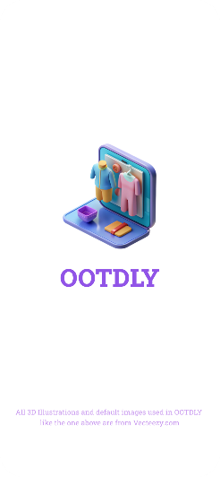
Screen Layout:

Screen No: 2
Screen Name: Online Account Registration or Log In
Narrative Overview: Allows the user to register or log in using google account.
Screen Layout:
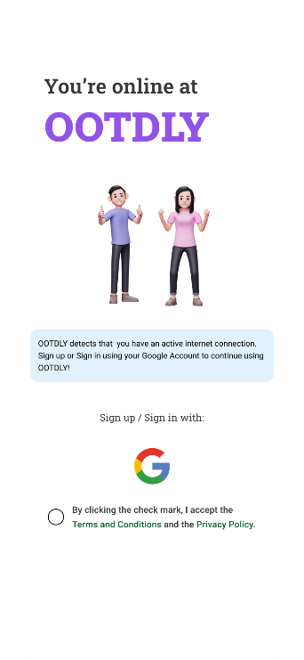

Screen No: 3
Screen Name: Choose Google Account
Narrative Overview: Allows the user to choose a google account for registration or login.
Screen Layout:
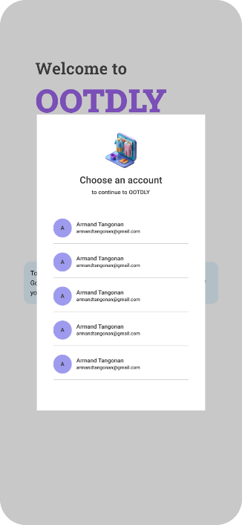

Screen No: 4
Screen Name: Online Mode Home Tab
Narrative Overview: Allows the user to view the home tab contents.
Screen Layout:
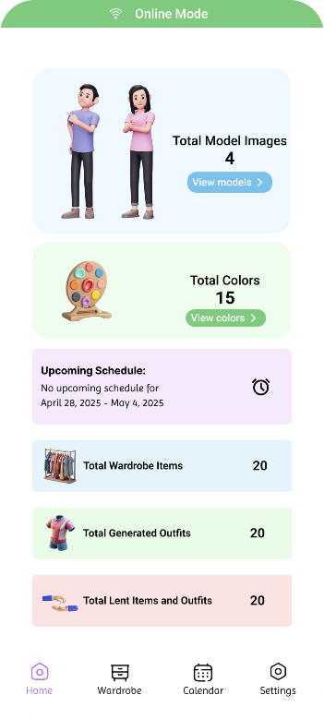

Screen No: 5
Screen Name: Online and offline Models
Narrative Overview: Allows the browse, search, and add model.
Screen Layout:
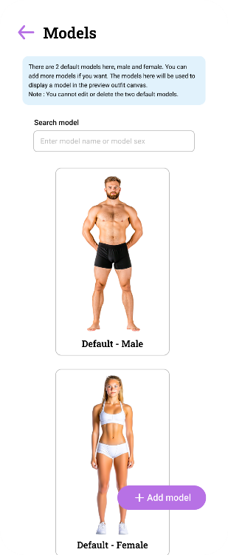

Screen No: 6
Screen Name: Online and Offline Add New Model
Narrative Overview: Allows the users to add new model.
Screen Layout:
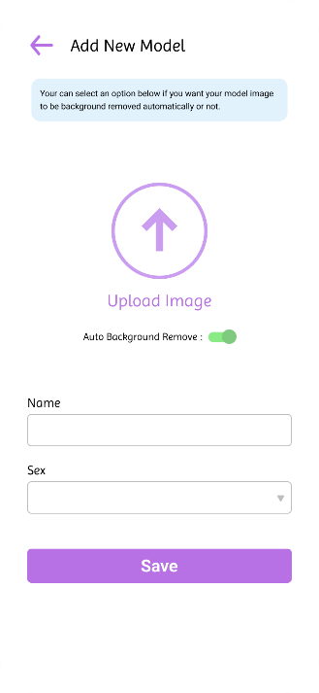

Screen No: 7
Screen Name: Online and Offline Select Model Image Source
Narrative Overview: Allows the user to select model image between camera and gallery.
Screen Layout:
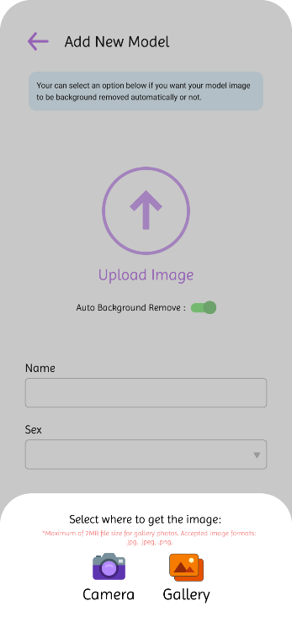

Screen No: 8
Screen Name: Online and Offline Add Model Information
Narrative Overview: Allows the user to enter model name and choose model sex.
Screen Layout:
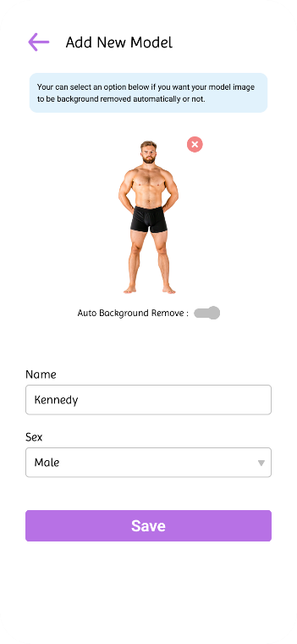

Screen No: 9
Screen Name: Added Online and Offline Model
Narrative Overview: Allows the user to see successful message when the model is added.
Screen Layout:
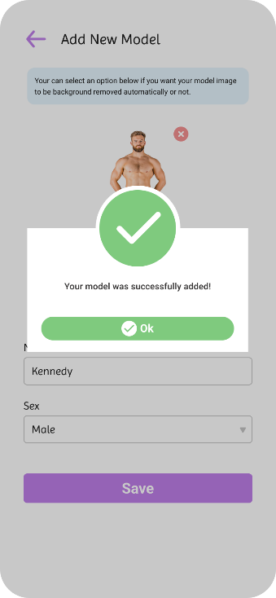

Screen No: 10
Screen Name: Online and Offline Update Model
Narrative Overview: Allows the user to update the model name and model sex.
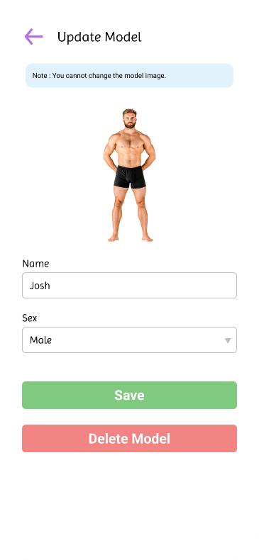
Screen Layout:

Screen No: 11
Screen Name: Online and Offline Update Model Successful
Narrative Overview: Allows the user to see successful message after updating the model.
Screen Layout:
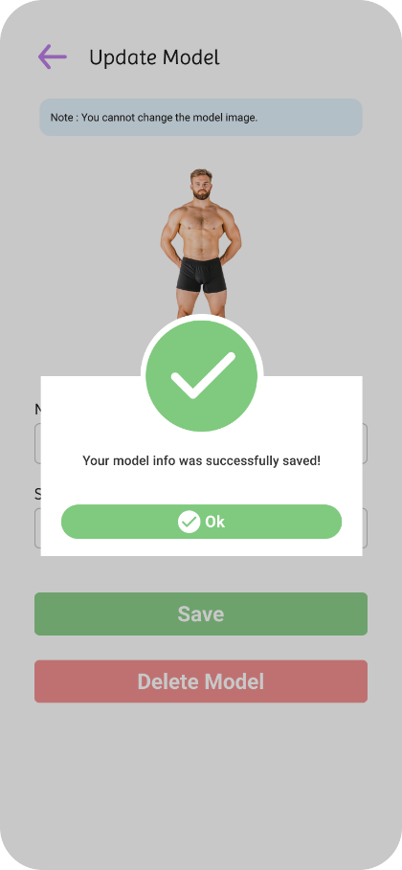

Screen No: 12
Screen Name: Online and Offline Delete Model
Narrative Overview: Allows the users to delete a model and confirm the deletion.
Screen Layout:
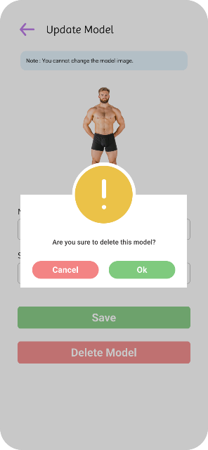

Screen No: 13
Screen Name: Online and Offline Colors
Narrative Overview: Allows the users to browse, search, add color, and view the color combinations.
Screen Layout:
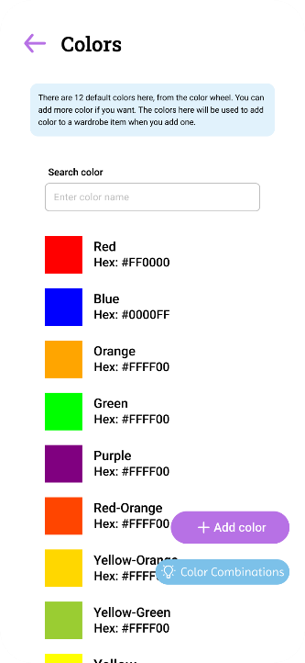

Screen No: 14
Screen Name: Online and Offline Add New Color
Narrative Overview: Allows the users to add a new color.
Screen Layout:
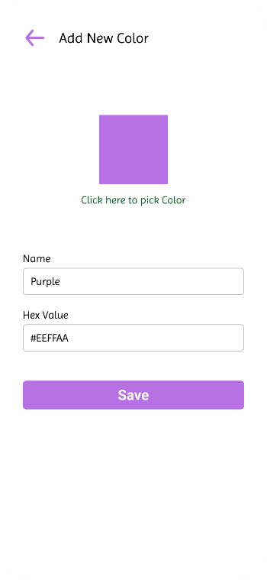

Screen No: 15
Screen Name: Online and Offline Add Color Success
Narrative Overview: Allows user to see successful message after the color was successfully added.
Screen Layout:
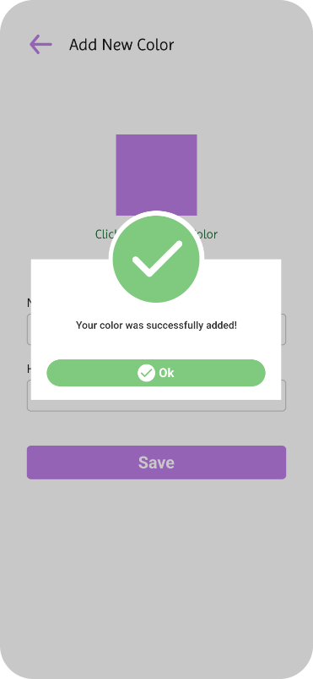

Screen No: 16
Screen Name: Online and Offline Update Color
Narrative Overview: Allows user to update the color, color name and color HEX.
Screen Layout:
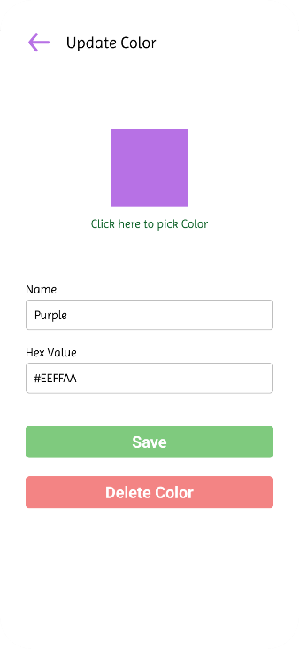
Screen No: 17
Screen Name: Online and Offline Update Color Success
Narrative Overview: Allows user to see successful message after the color was successfully updated.
Screen Layout:
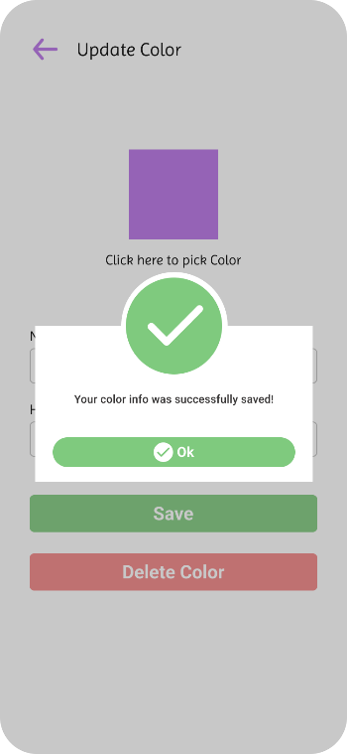

Screen No: 18
Screen Name: Online and Offline Delete Color
Narrative Overview: Allows user to delete the color and confirm the deletion.
Screen Layout:
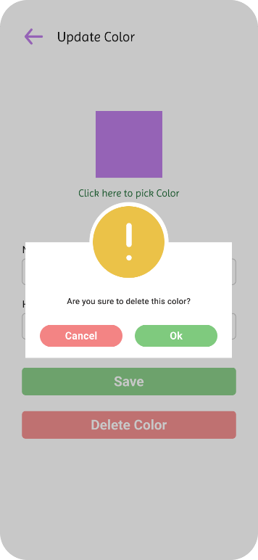

Screen No: 19
Screen Name: Online Wardrobe Tab
Narrative Overview: Allows user to see the wardrobe tab option features.
Screen Layout:
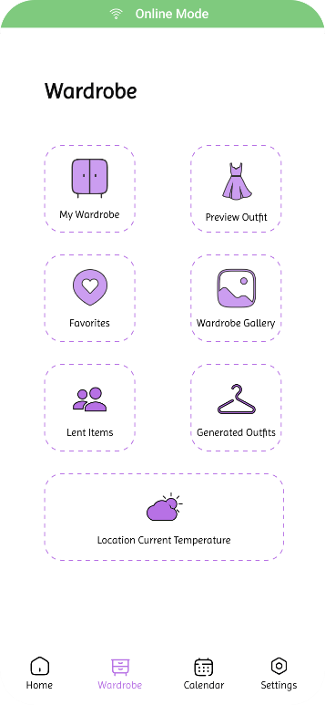

Screen No: 20
Screen Name: Online Wardrobe Item Categories
Narrative Overview: Allows the browse, search, and add a category.
Screen Layout:
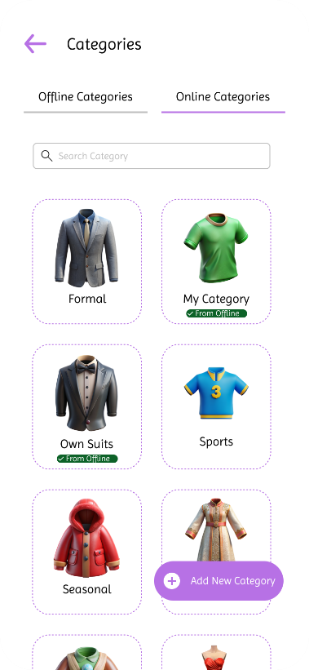

Screen No: 21
Screen Name: Offline Wardrobe Item Categories
Narrative Overview: Allows the user to browse, search, and add category.
Screen Layout:
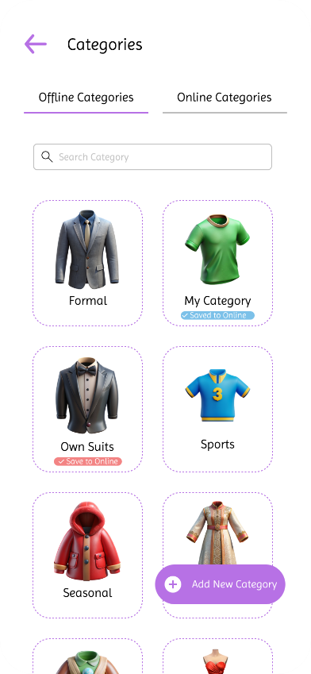

Screen No: 22
Screen Name: Online and Offline Add Wardrobe Item Category
Narrative Overview: Allows the user to add new category.
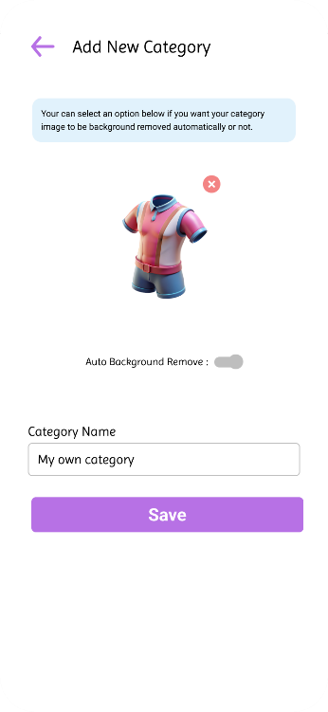
Screen Layout:

Screen No: 23
Screen Name: Online and Offline Add Category Success
Narrative Overview: Allows the user to see successful message after adding category.
Screen Layout:
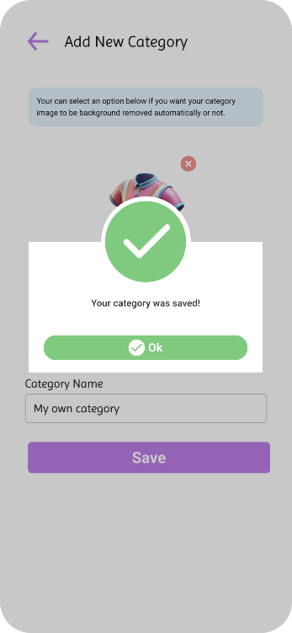

Screen No: 24
Screen Name: Online and Offline Update Category
Narrative Overview: Allows the user to update category name and image.
Screen Layout:
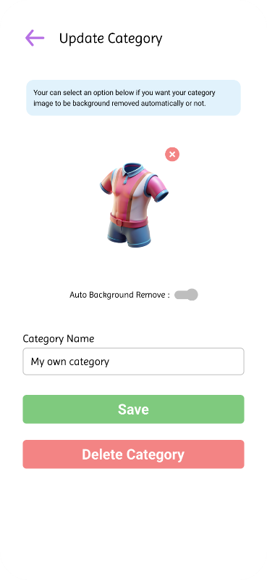

Screen No: 25
Screen Name: Online and Offline Update Wardrobe Item Category Success
Narrative Overview: Allows the user to see successful message after successfully category update.
Screen Layout:
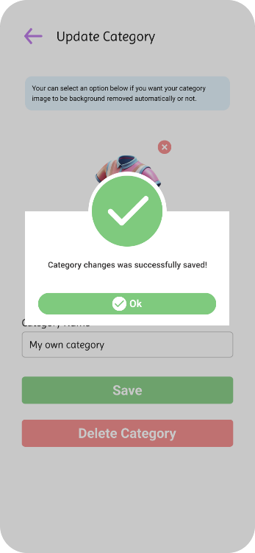

Screen No: 26
Screen Name: Online and Offline Delete Wardrobe Item Category
Narrative Overview: Allows user to delete a wardrobe item category.
Screen Layout:
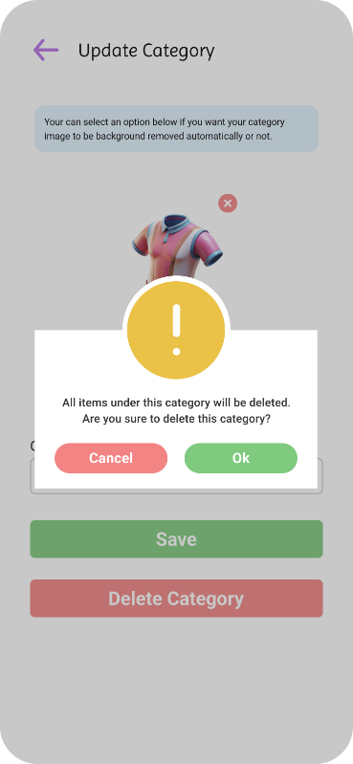

Screen No: 27
Screen Name: Online Wardrobe Items
Narrative Overview: allows the users to browse, search, and add wardrobe items.
Screen Layout:

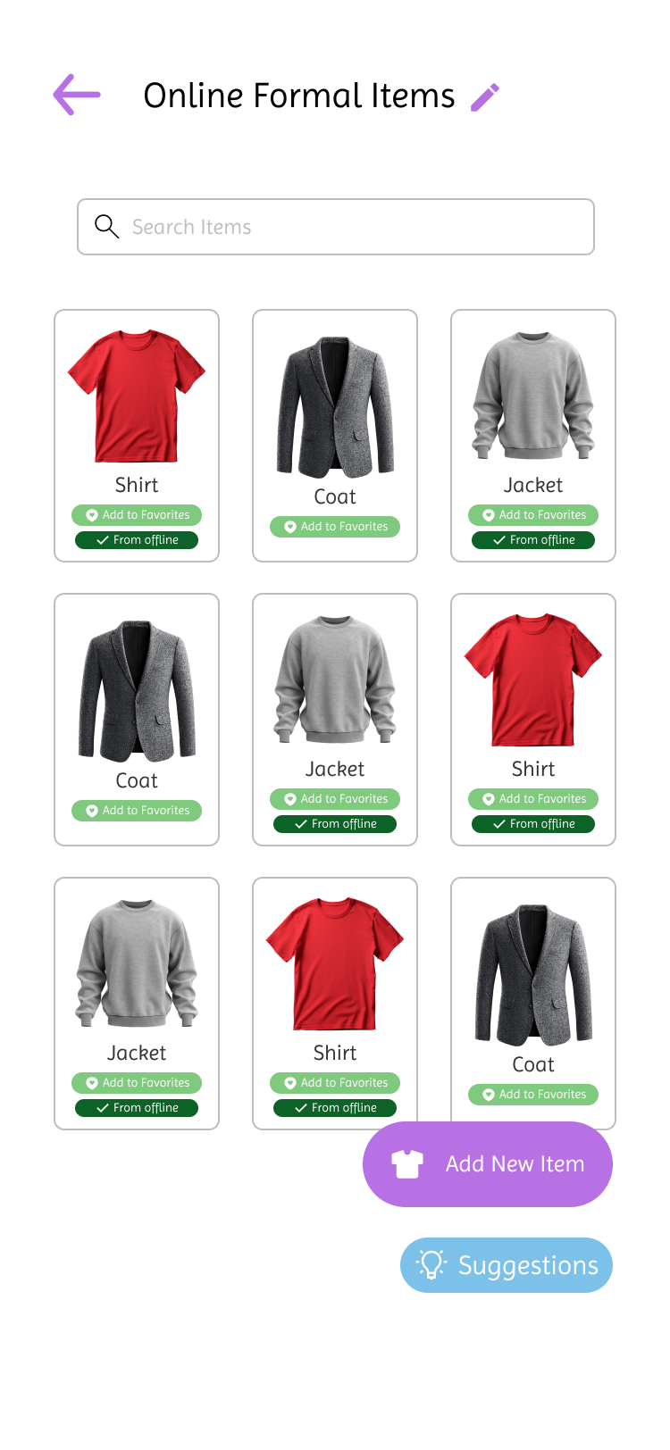

Screen No: 28
Screen Name: Offline Wardrobe Items
Narrative Overview: Allows the user to browse, search, and add wardrobe items.
Screen Layout:
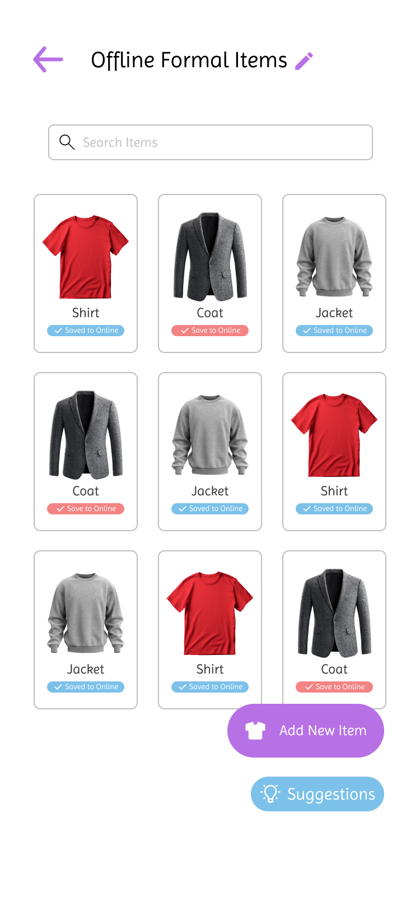

Screen No: 29
Screen Name: Online and Offline Add New Wardrobe Item
Narrative Overview: Allows user to add new wardrobe item.
Screen Layout:
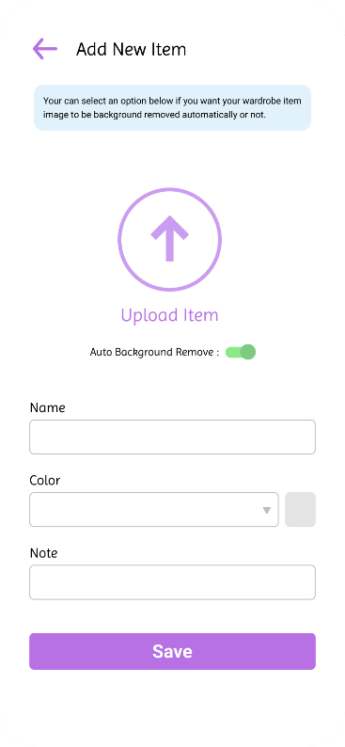

Screen No: 30
Screen Name: Online and Offline Wardrobe Item Image Source
Narrative Overview: Allows user to select the source to get the wardrobe image.
Screen Layout:
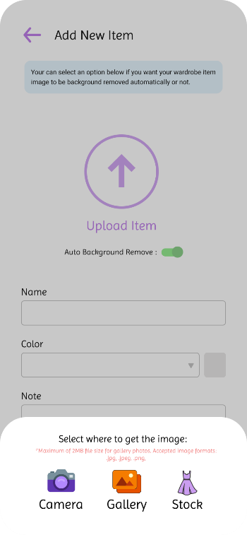

Screen No: 31
Screen Name: Online and Offline Wardrobe Item Image Stock Source
Narrative Overview: Allows user to select wardrobe item image from stock or default wardrobe images from the app.
Screen Layout:
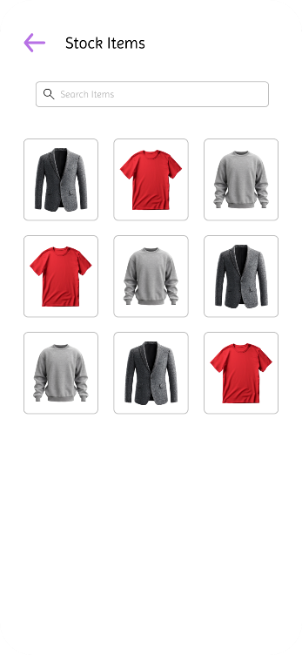

Screen No: 32
Screen Name: Online and Offline Add Wardrobe Item Information
Narrative Overview: Allows user to enter name, color, and note to the item.
Screen Layout:
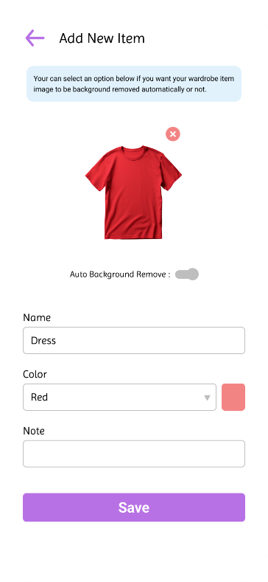

Screen No: 33
Screen Name: Online and Offline Add Wardrobe Item Success
Narrative Overview: Allows user see successful message when successfully added the wardrobe item.
Screen Layout:
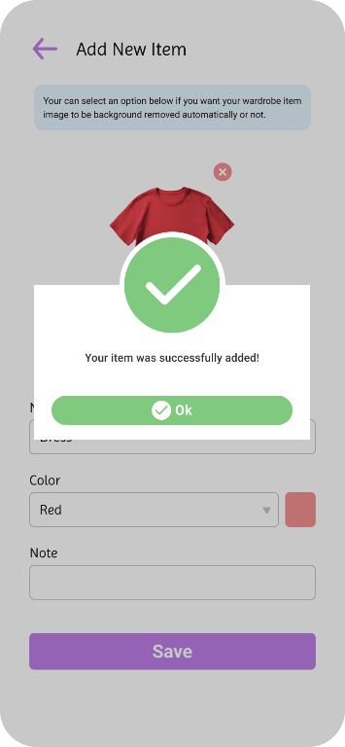

Screen No: 34
Screen Name: Online and Offline Update Wardrobe Item
Narrative Overview: Allows the user to update the wardrobe name, color, note or delete the wardrobe item.
Screen Layout:
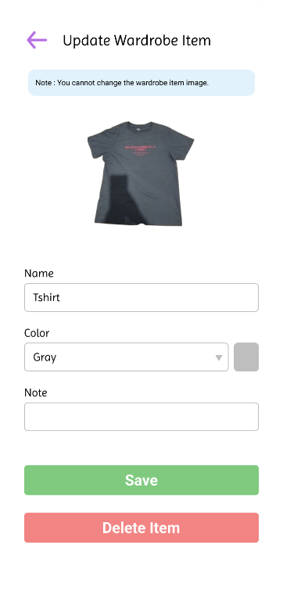

Screen No: 35
Screen Name: Online and Offline Update Wardrobe Item Success
Narrative Overview: Allows user see successful message when successfully updated the wardrobe item.
Screen Layout:
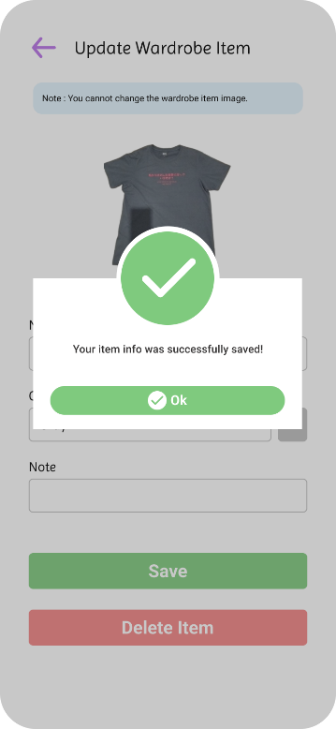

Screen No: 36
Screen Name: Online and Offline Delete Wardrobe Item
Narrative Overview: Allows the user to delete and confirm the deletion of a wardrobe item.
Screen Layout:
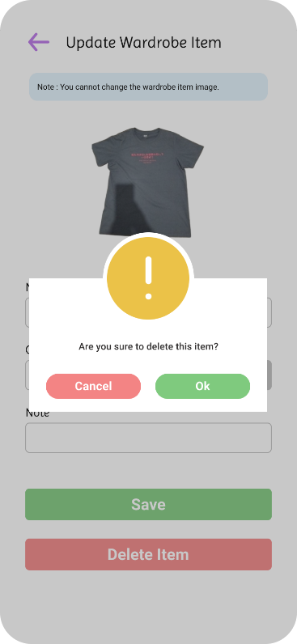

Screen No: 37
Screen Name: Online and Offline Default Category Item Suggestions
Narrative Overview: Allows user to view the suggested wardrobe items of the 10 default categories.
Screen Layout:

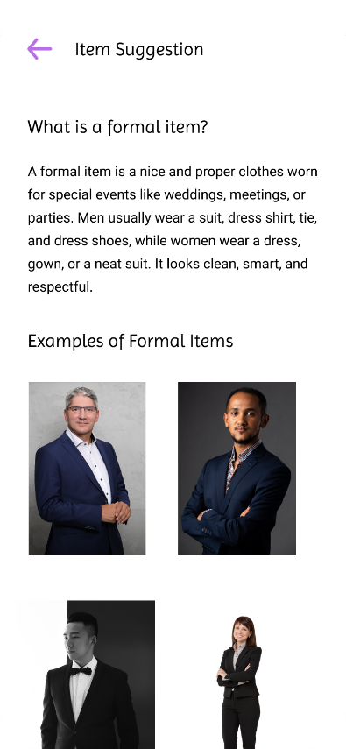

Screen No: 38
Screen Name: Online Preview Outfit Projects
Narrative Overview: Allows user to browse, search, and add project.
Screen Layout:

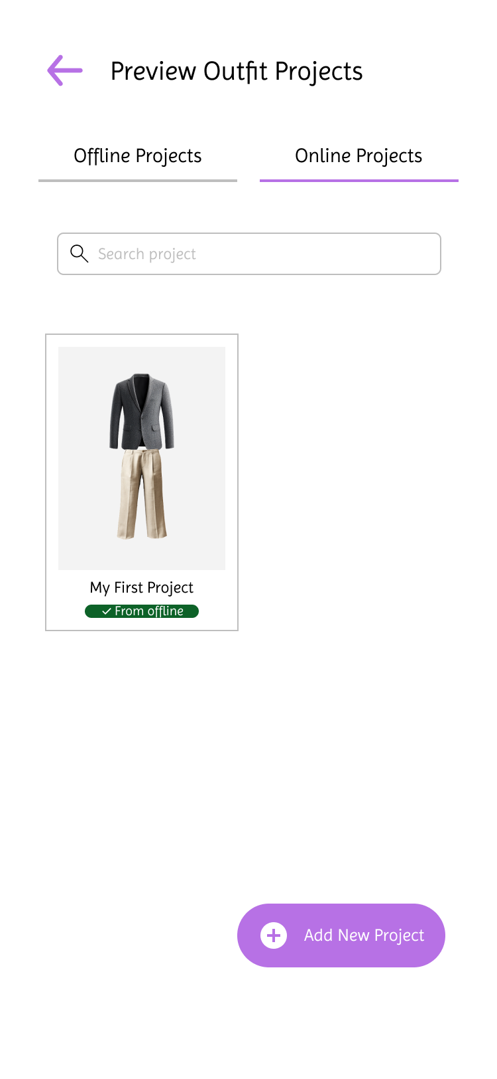

Screen No: 39
Screen Name: Offline Preview Outfit Project
Narrative Overview: Allows the user to browse, search, add a project.
Screen Layout:

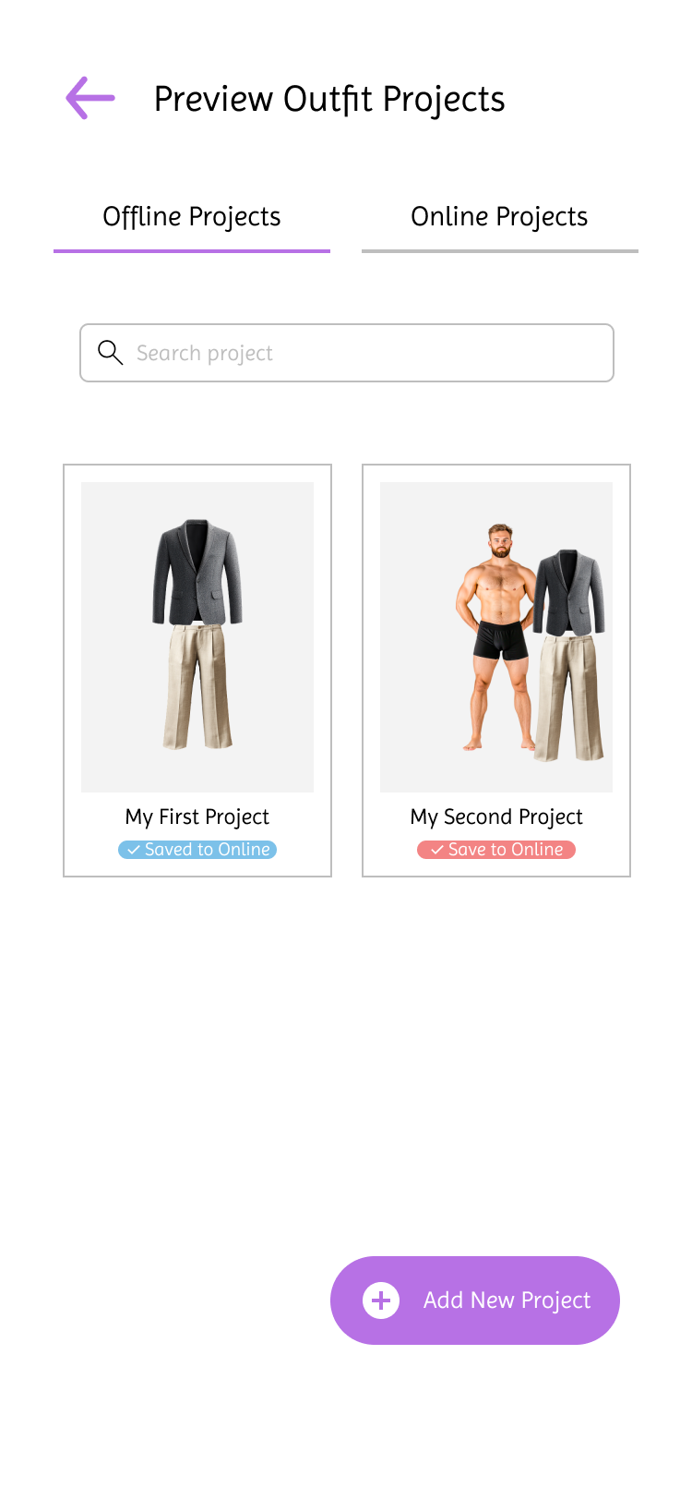

Screen No: 40
Screen Name: Online and Offline Add New Preview Outfit Category
Narrative Overview: Allows the user to add a project.
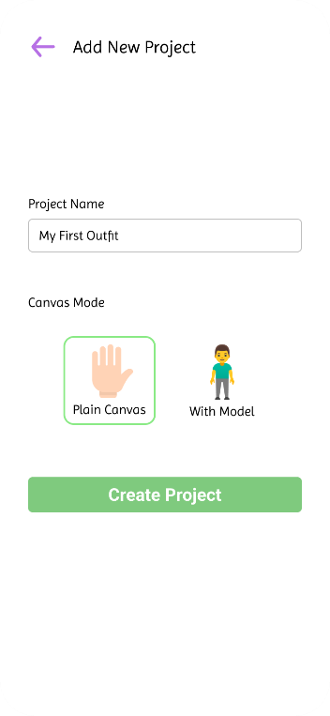
Screen Layout:

Screen No: 41
Screen Name: Online and Offline Preview Outfit Project Plain Canvas
Narrative Overview: Allows the user to combine wardrobe items on plain canvas.
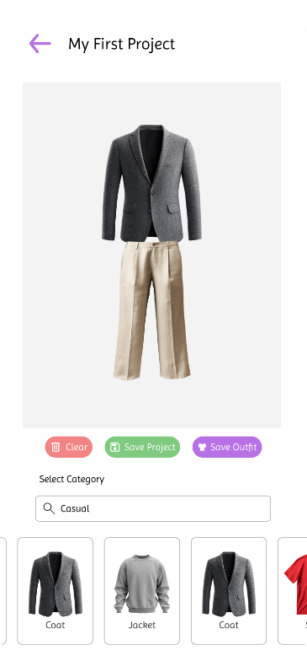
Screen Layout:

Screen No: 42
Screen Name: Online and Offline Preview Outfit Project With Model Canvas
Narrative Overview: Allows the user to combine wardrobe items on plain canvas.
Screen Layout:
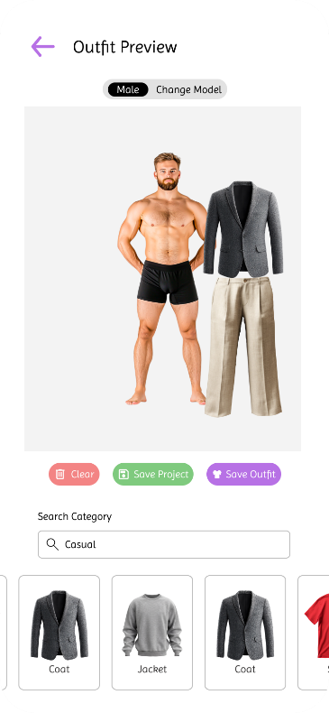

Screen No: 43
Screen Name: Online and Offline Change Model on With Canvas Project
Narrative Overview: Allows user to change model image on with canvas project.
Screen Layout:
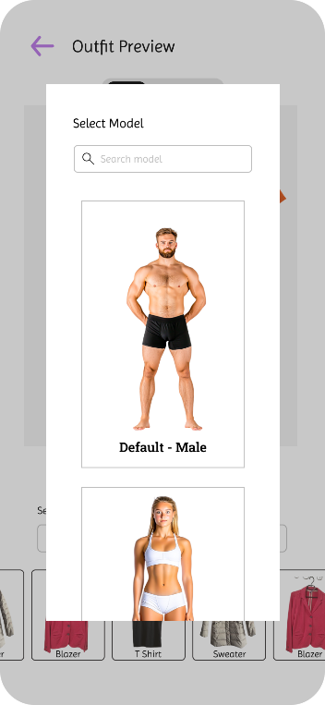

Screen No: 44
Screen Name: Online and Offline Save Outfit
Narrative Overview: Allows user to choose category where to save the combined wardrobe items as outfit.
Screen Layout:
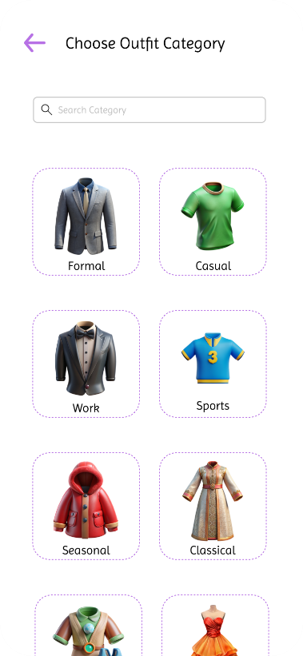

Screen No: 45
Screen Name: Online and Offline Save Outfit
Narrative Overview: Allows user to save outfit.
Screen Layout:
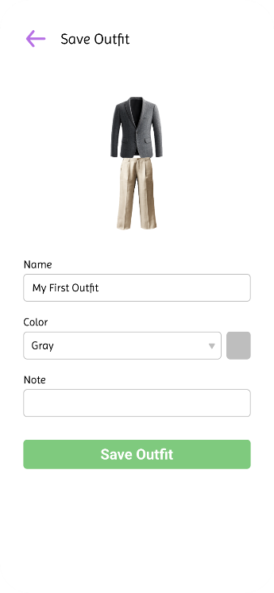

Screen No: 46
Screen Name: Online and Offline Save Outfit Success
Narrative Overview: Allows user to see successful message when outfit saving is successful.
Screen Layout:
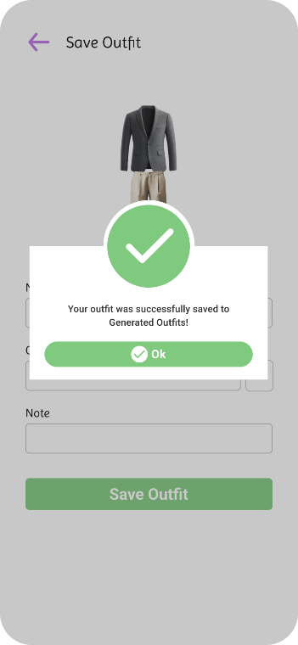

Screen No: 47
Screen Name: Online and Offline Update Project
Narrative Overview: Allows user to update the preview outfit project name.
Screen Layout:
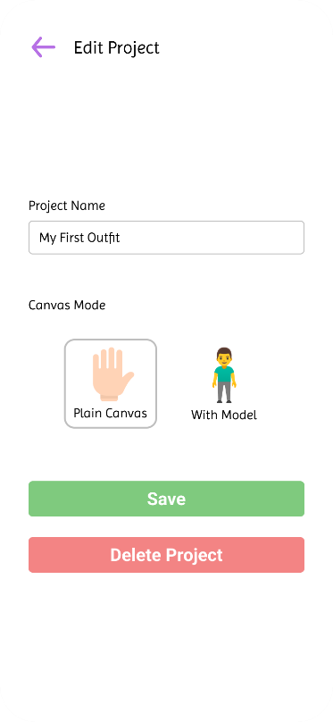

Screen No: 48
Screen Name: Online and Offline Delete Project
Narrative Overview: Allows user to delete a preview outfit project.
Screen Layout:
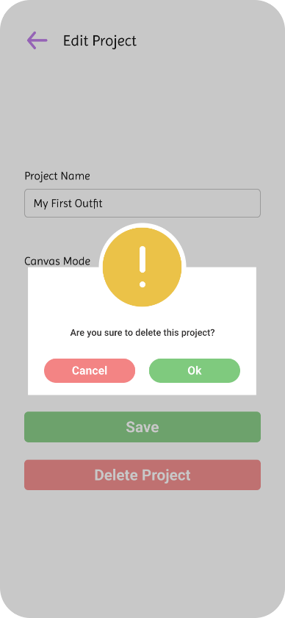

Screen No: 49
Screen Name: Online and Offline Favorite Wardrobe Items
Narrative Overview: Allows user to browse favorite wardrobe items
Screen Layout:
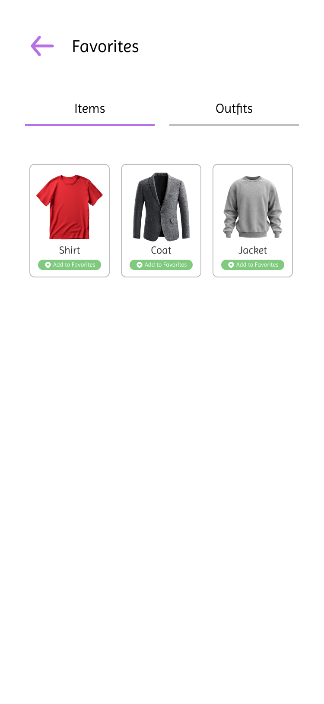

Screen No: 50
Screen Name: Online and Offline Favorite Outfit
Narrative Overview: Allows user to add browse the favorites generated outfits.
Screen Layout:

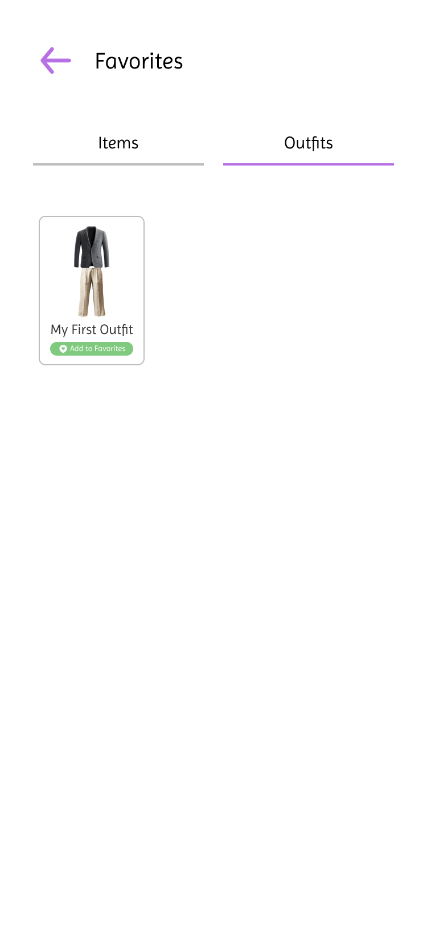

Screen No: 51
Screen Name: Online and Offline Wardrobe Item Gallery
Narrative Overview: Allows user to browse the all wardrobe items.
Screen Layout:
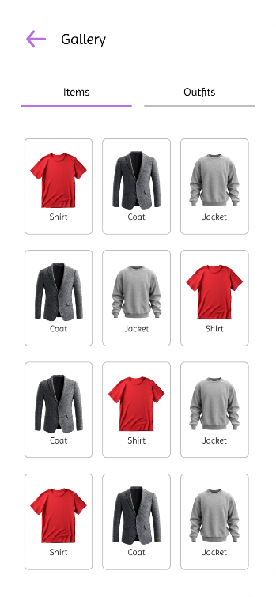

Screen No: 52
Screen Name: Online and Offline Outfits Gallery
Narrative Overview: Allows the user to browse all the generated outfits.
Screen Layout:
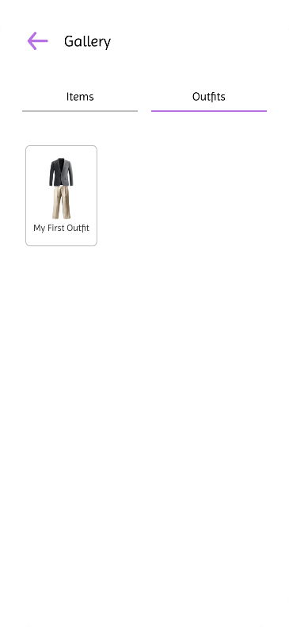

Screen No: 53
Screen Name: Online Lent Items / Outfits
Narrative Overview: Allows the user to browse, search. and add lent item record. Users can also filter the date to only show lent items on specific date.
Screen Layout:

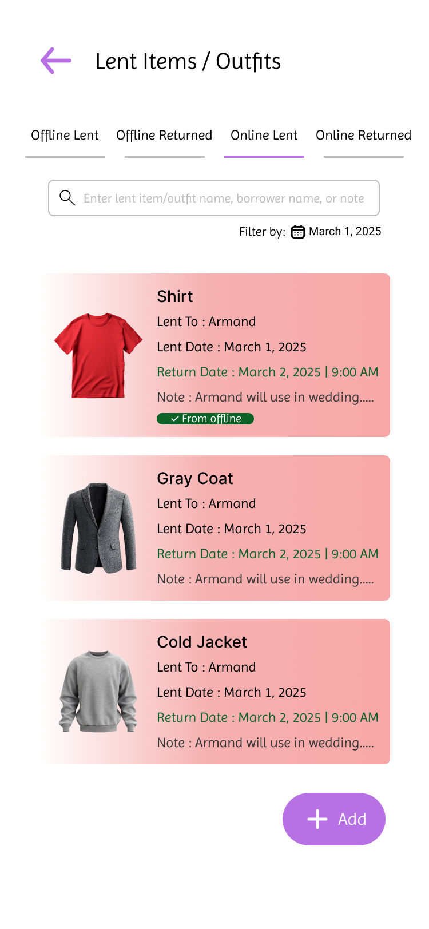

Screen No: 54
Screen Name: Offline Lent Items
Narrative Overview: Allows the user to browse, search. and add lent item record. Users can also filter the date to only show lent items on specific date.
Screen Layout:

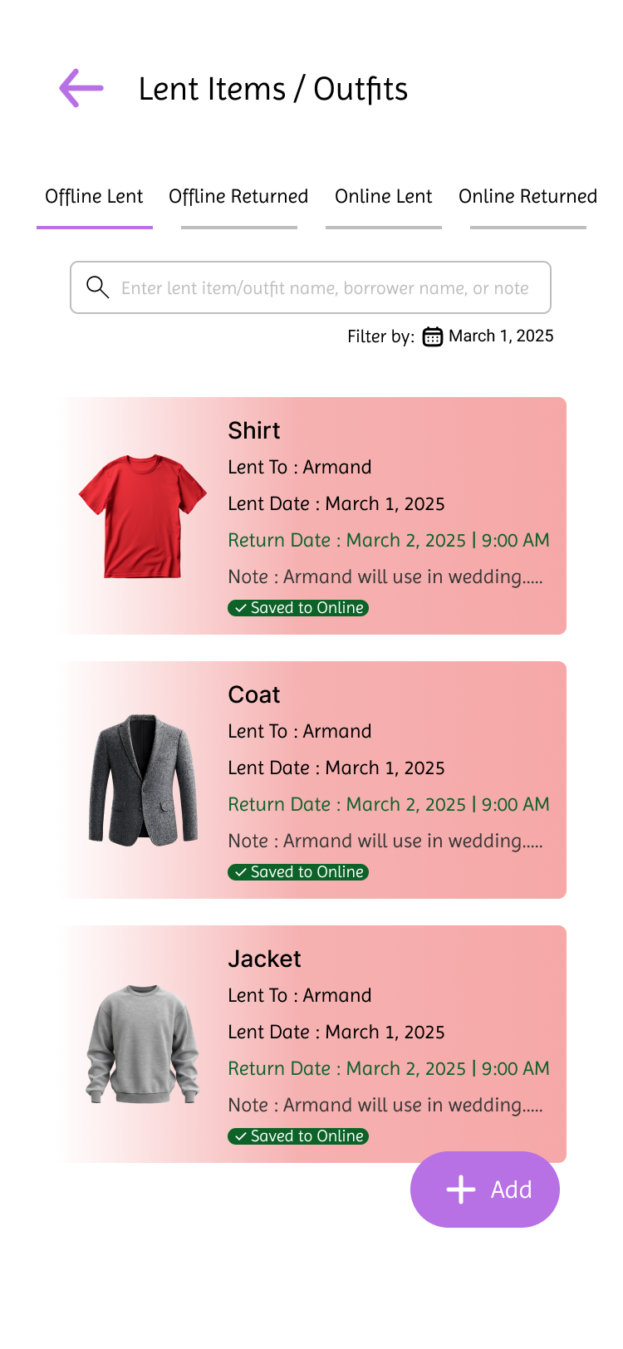

Screen No: 55
Screen Name: Online and Offline Add New Lent Item or Outfit
Narrative Overview: Allows the user to add a lent item or outfit record.
Screen Layout:
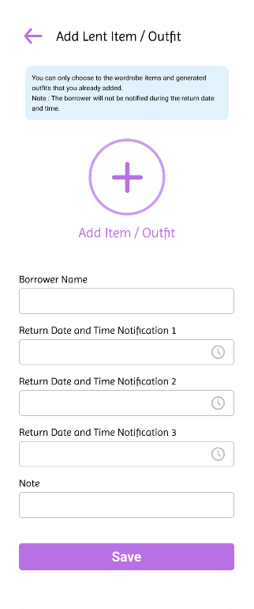

Screen No: 56
Screen Name: Online and Offline Lent or Outfit Selection
Narrative Overview: Allows the user to select an item or outfit to lent.
Screen Layout:

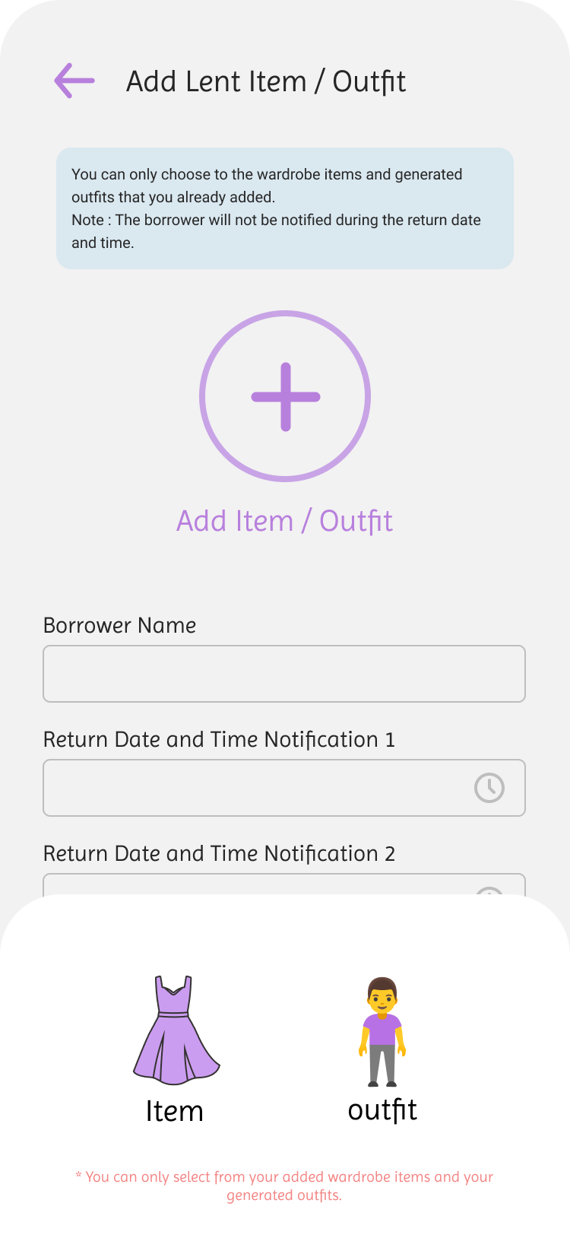

Screen No: 57
Screen Name: Online and Offline Lent Item or Outfit Information
Narrative Overview: Allows user to enter information of lent item or outfit.
Screen Layout:
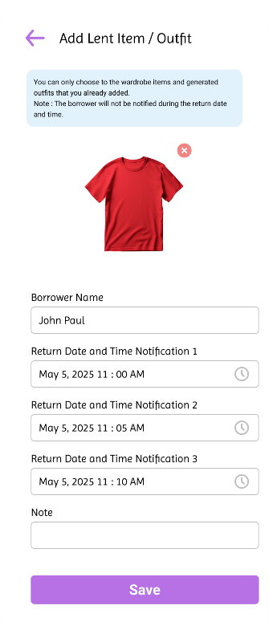

Screen No: 58
Screen Name: Online and Offline Add Lent Item Successful
Narrative Overview: Allows user to see a message after successful adding of lent record.
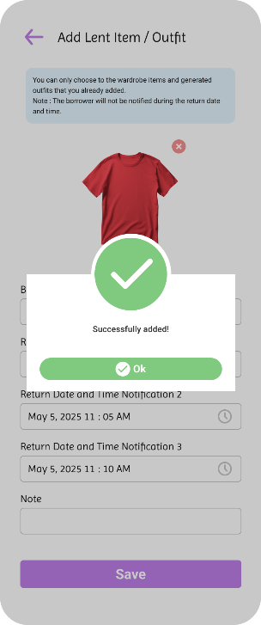
Screen Layout:

Screen No: 59
Screen Name: Online and Offline Update Lent Item or Outfit
Narrative Overview: Allows user to update or delete the lent item or outfit.
Screen Layout:
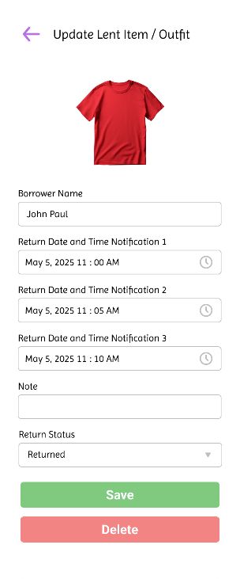

Screen No: 60
Screen Name: Online and Offline Update Lent Item or Outfit Successful
Narrative Overview: Allows user to see a message after successful update.
Screen Layout:
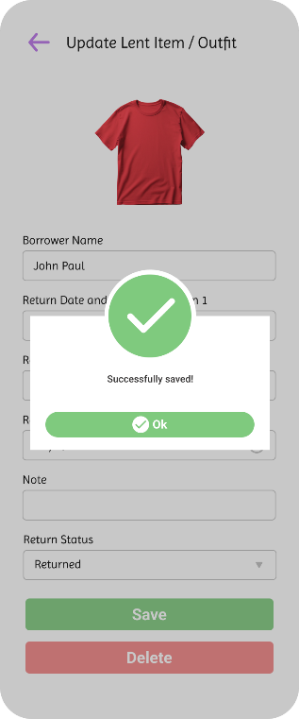

Screen No: 61
Screen Name: Online and Offline Delete Lent Item or Outfit Record
Narrative Overview: Allows the user to delete a lent record.
Screen Layout:

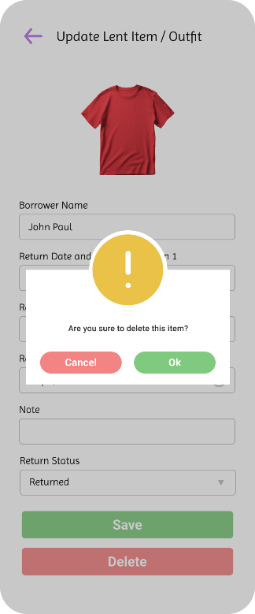

Screen No: 62
Screen Name: Online Returned Items or Outfits
Narrative Overview: Allows the user to browse, search, and filter returned items or outfits.
Screen Layout:
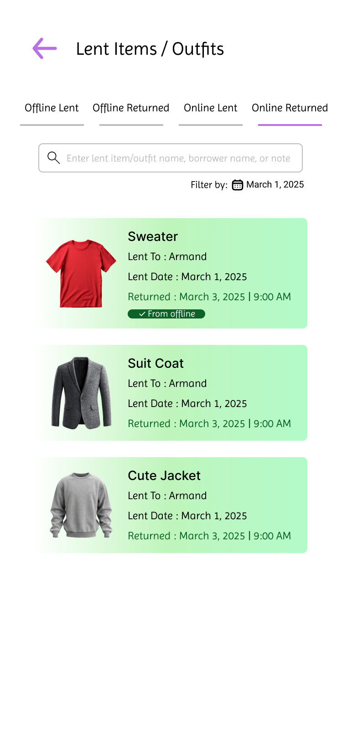

Screen No: 63
Screen Name: Offline Returned Items or Outfits
Narrative Overview: Allows the user to browse, search, and filter returned items or outfits.
Screen Layout:
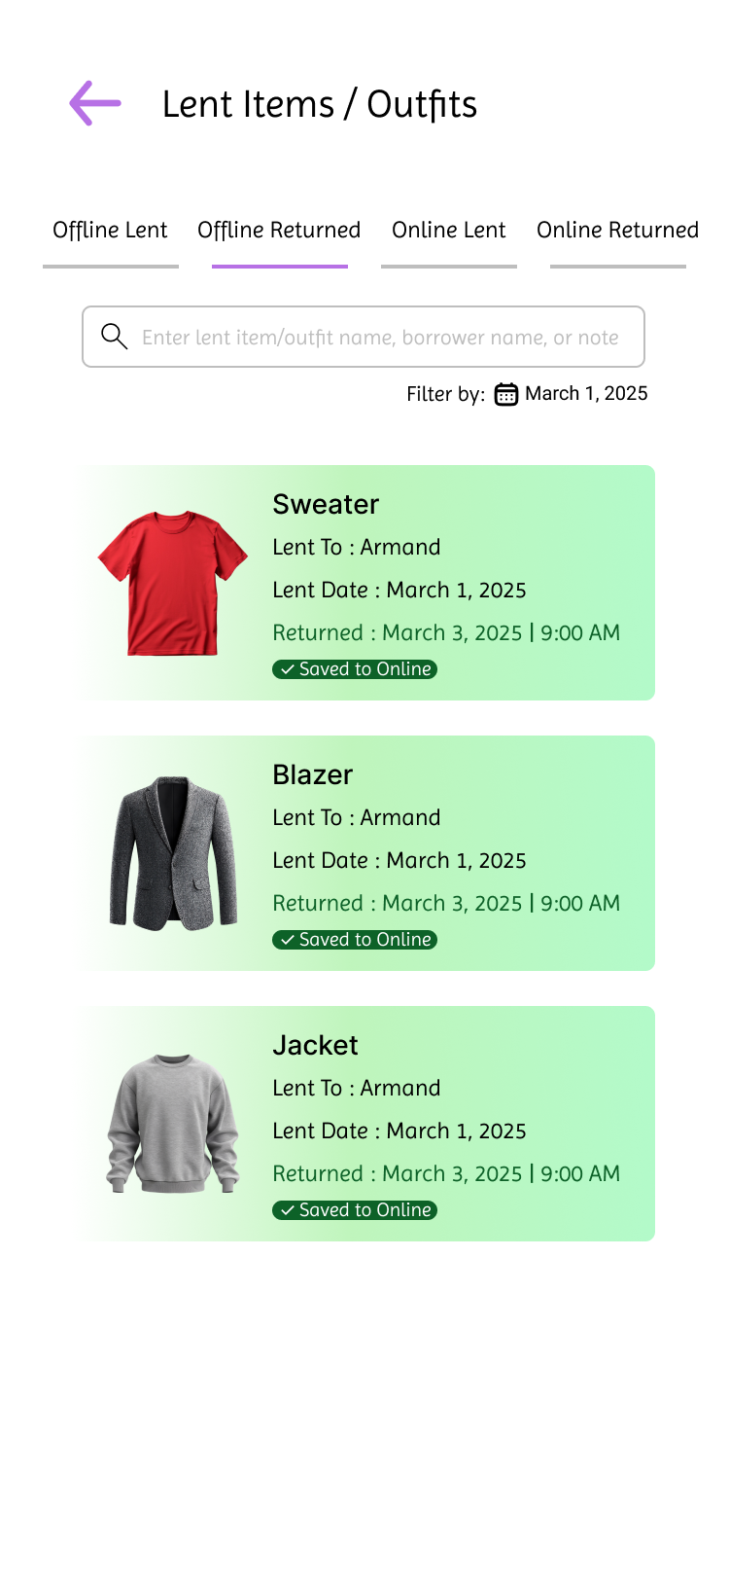

Screen No: 64
Screen Name: Online and Offline View Returned Item or Outfit
Narrative Overview: Allows the user to view returned wardrobe items of outfits.
Screen Layout:
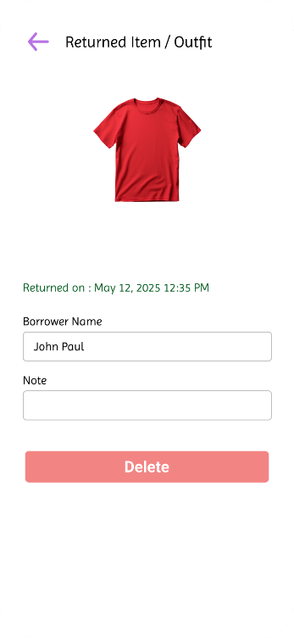

Screen No: 65
Screen Name: Online and Offline Delete Returned Item or Outfit Record
Narrative Overview: Allows the user to delete a returned item or outfit record.
Screen Layout:
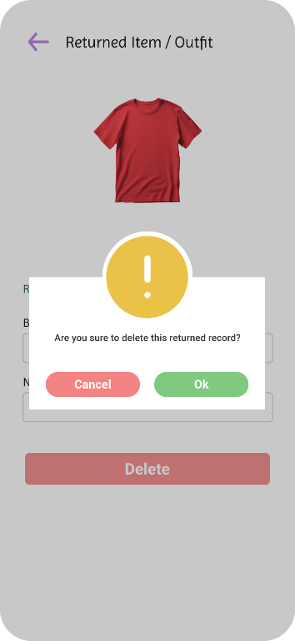

Screen No: 66
Screen Name: Online Generated Outfits Category
Narrative Overview: Allows the user to browse, search and add category.
Screen Layout:
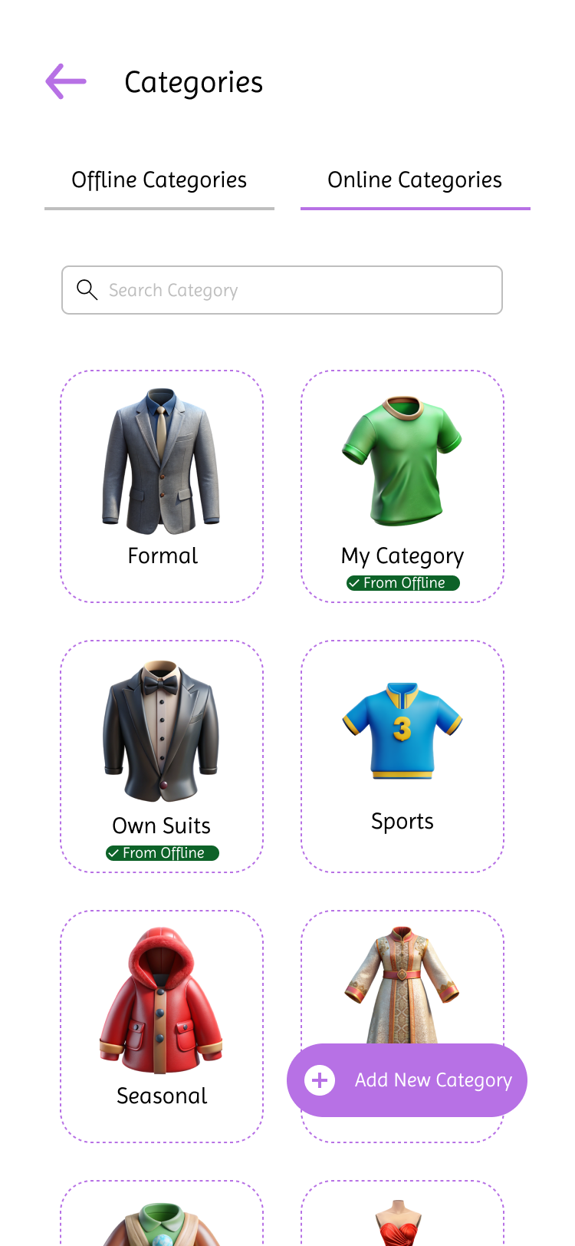

Screen No: 6 Screen Name: Offline Generated Outfits Category
Narrative Overview: Allows the user to browse, search and add category.
Screen Layout:

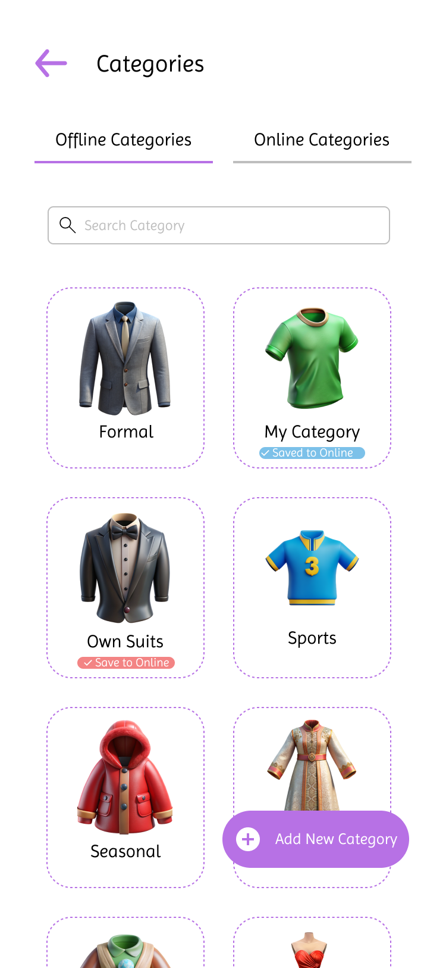

Screen No: 68
Screen Name: Online and Offline Add New Generated Outfit Category
Narrative Overview: Allows user to add a generated outfit category..
Screen Layout:

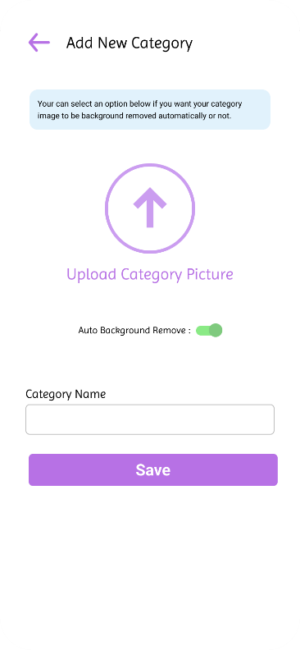

Screen No: 69
Screen Name: Online and Offline Generated Category Image Source
Narrative Overview: Allows user to select image source for category image.
Screen Layout:

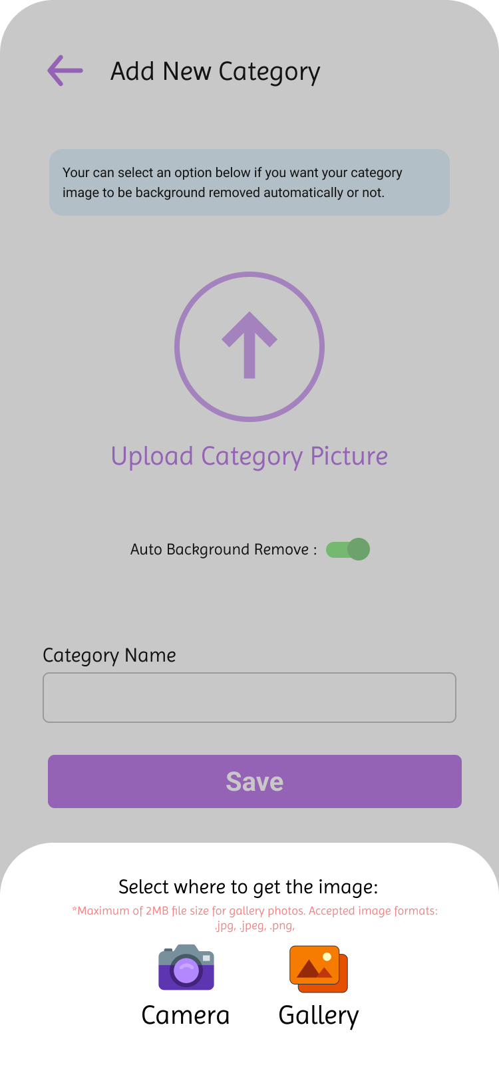

Screen No: 70
Screen Name: Online and Offline Add Generated Category Information
Narrative Overview: Allows user to enter category name.
Screen Layout:
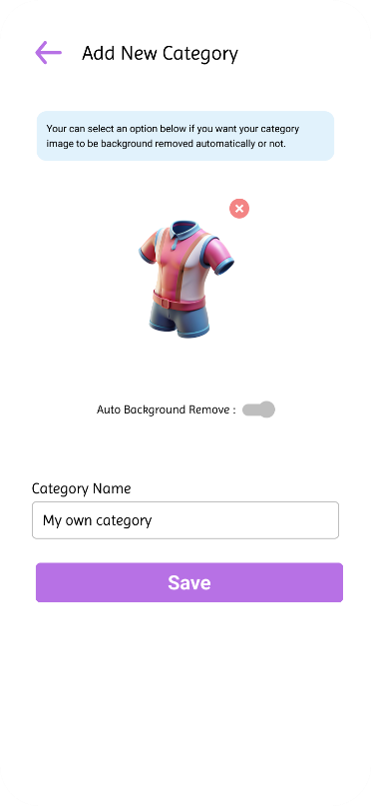

Screen No: 71
Screen Name: Online and Offline Add Generated Outfit Category Success
Narrative Overview: Allows the user to see successful message when category is added.
Screen Layout:
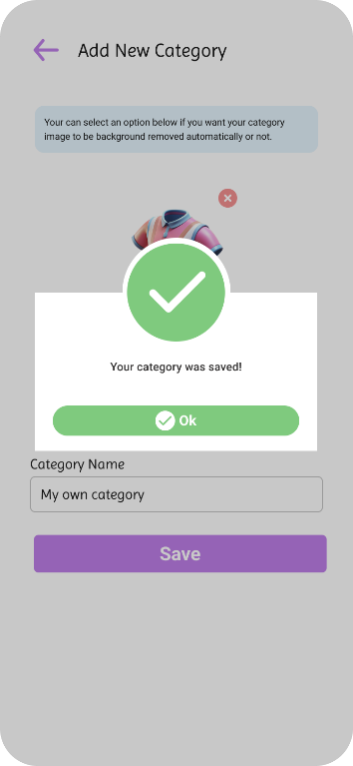

Screen No: 72
Screen Name: Online and Offline Update Generated Outfits Category
Narrative Overview: Allows the user to update the category name and image, or delete the category.
Screen Layout:
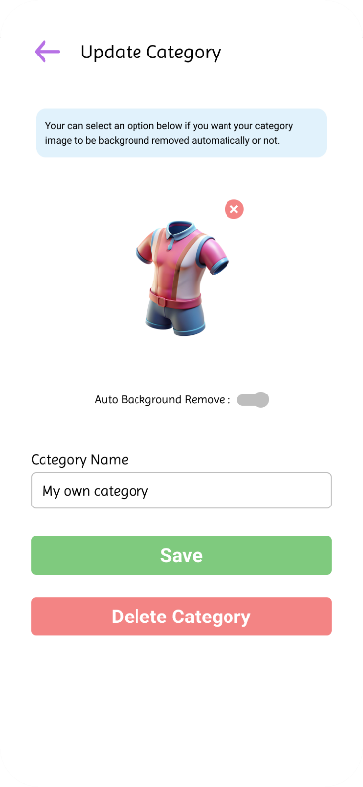

Screen No: 73
Screen Name: Online and Offline Update Generated Outfits Category Success
Narrative Overview: Allows the user to see message when update is successful.
Screen Layout:
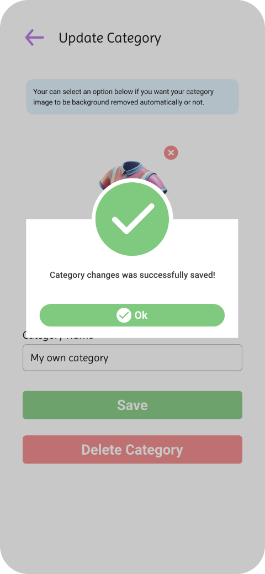

Screen No: 74
Screen Name: Online and Offline Delete Generated Outfit Category
Narrative Overview: Allows user to delete generated outfit category Screen Layout:

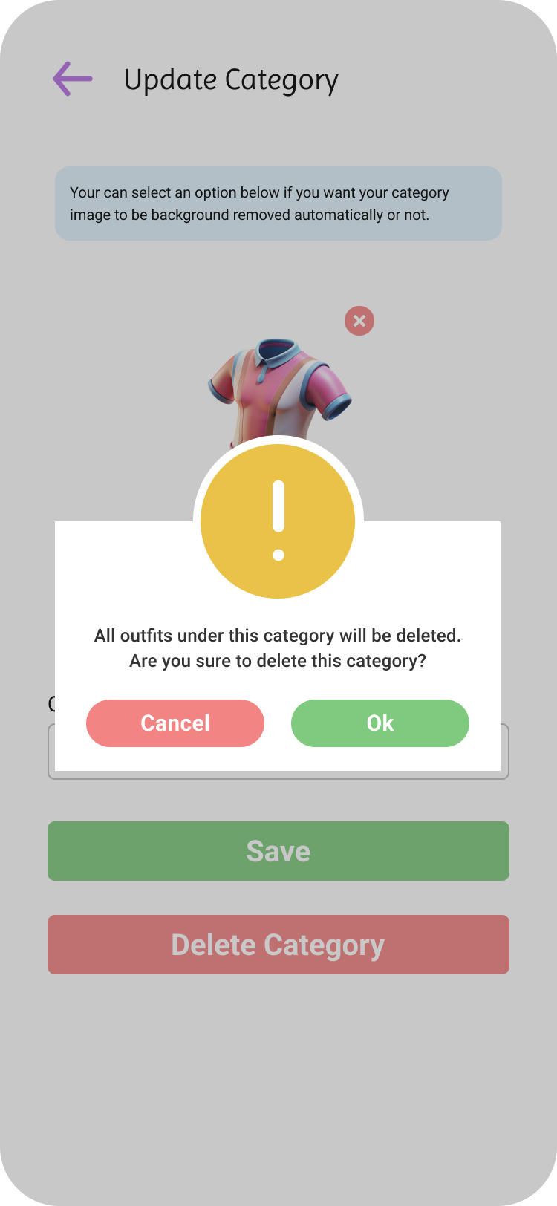

Screen No: 75
Screen Name: Online Category Outfits
Narrative Overview: Allows the user to browse, search, and view outfit suggestions.
Screen Layout:

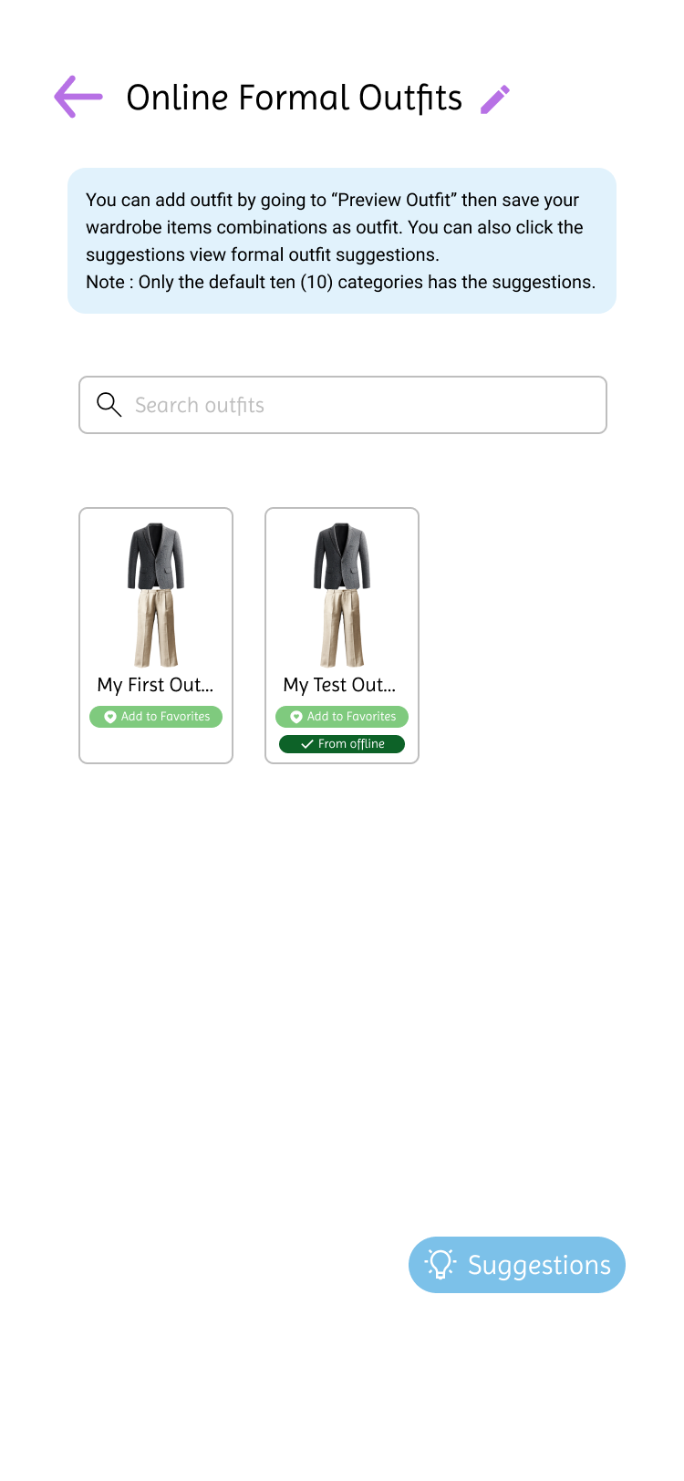

Screen No: 76
Screen Name: Online and Offline Update Outfit
Narrative Overview: Allows a user to update outfit name, color, and note.
Screen Layout:
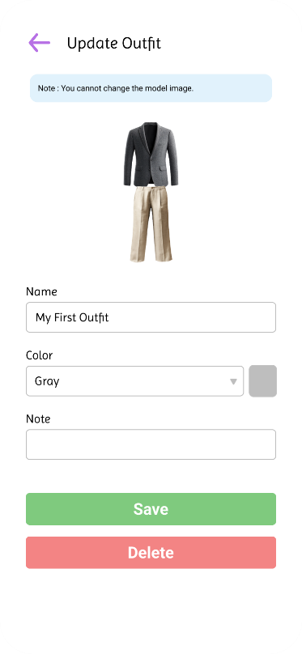

Screen No: 77
Screen Name: Online and Offline Update Outfit Success
Narrative Overview: Allows the user to message when update is success.
Screen Layout:
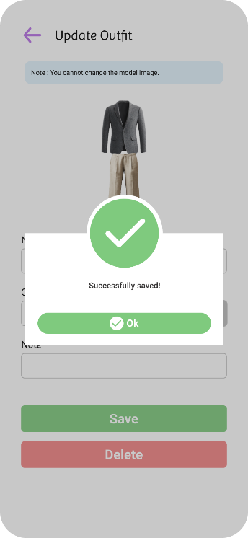

Screen No: 78
Screen Name: Online and Offline Delete Generated Outfit
Narrative Overview: Allows the user to delete generated outfit.
Screen Layout:
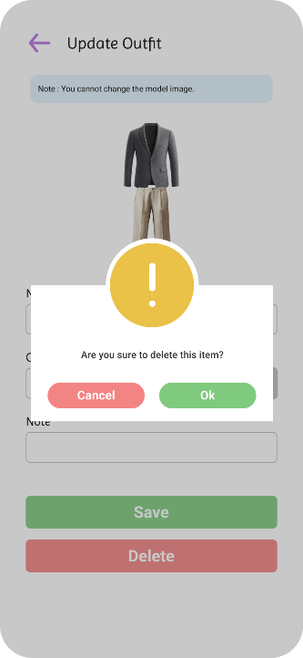

Screen No: 79
Screen Name: Online and Offline Default Category Outfit Suggestions
Narrative Overview: Allows the user to view default categories outfit suggestions.
Screen Layout:
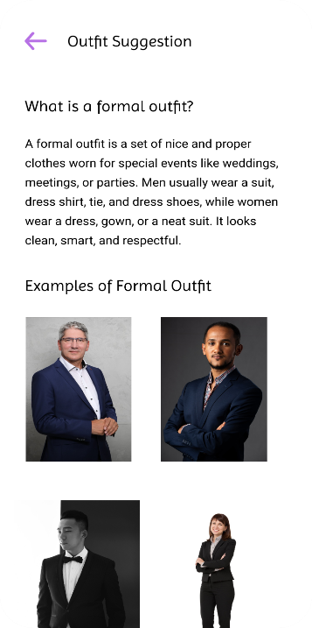

Screen No: 80
Screen Name: Search Location Current Temperature
Narrative Overview: Allows the user to view the current temperature based on searched location and see the recommended outfits to wear.
Screen Layout:
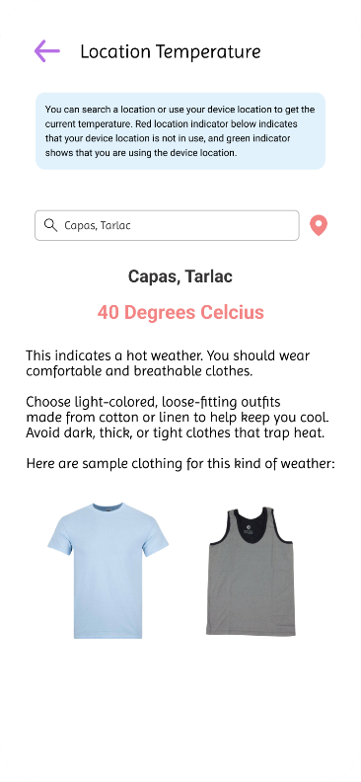

Screen No: 81
Screen Name: Device Location Current Temperature
Narrative Overview: Allows the user to view the current temperature based on device location and see the recommended outfits to wear.
Screen Layout:
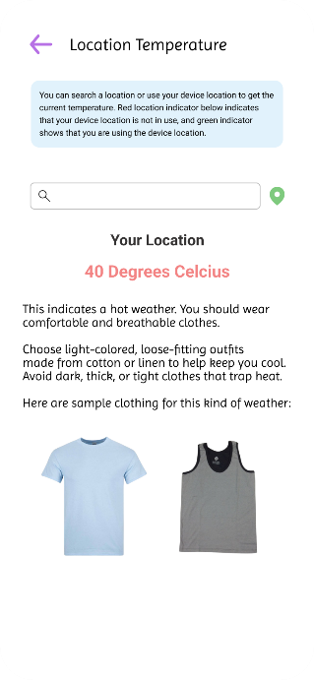

Screen No: 82
Screen Name: Calendar Module
Narrative Overview: Allows the user to view the scheduled items or outfits on different dates.
Screen Layout:

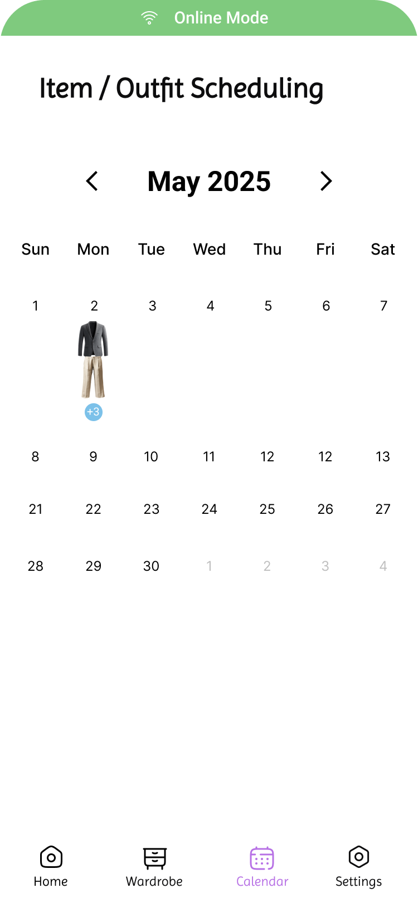

Screen No: 83
Screen Name: Offline Items or Outfits Upcoming Schedules
Narrative Overview: Allows the user to browse, search, and add scheduled items or outfits.
Screen Layout:
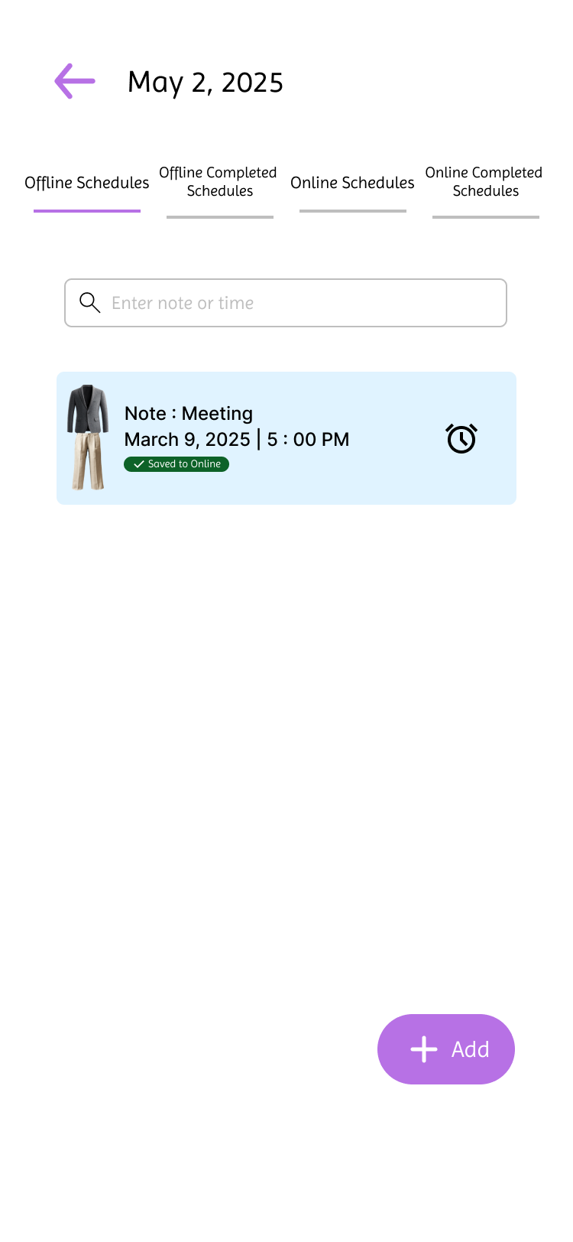

Screen No: 84
Screen Name: Online Items or Outfits Upcoming Schedules
Narrative Overview: Allows the user to browse, search, and add scheduled items or outfits.
Screen Layout:

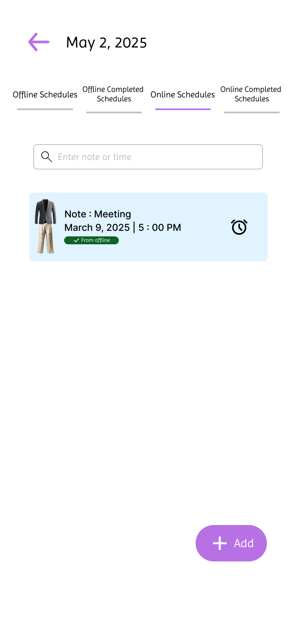

Screen No: 85
Screen Name: Online Completed Schedules
Narrative Overview: Allows the user to browse completed schedules.
Screen Layout:
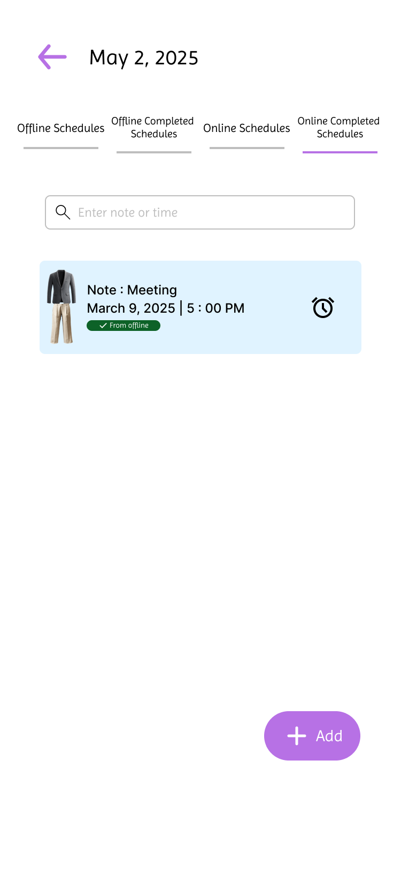

Screen No: 86
Screen Name: Offline Completed Schedules
Narrative Overview Allows the user to browse completed schedules.
Screen Layout:

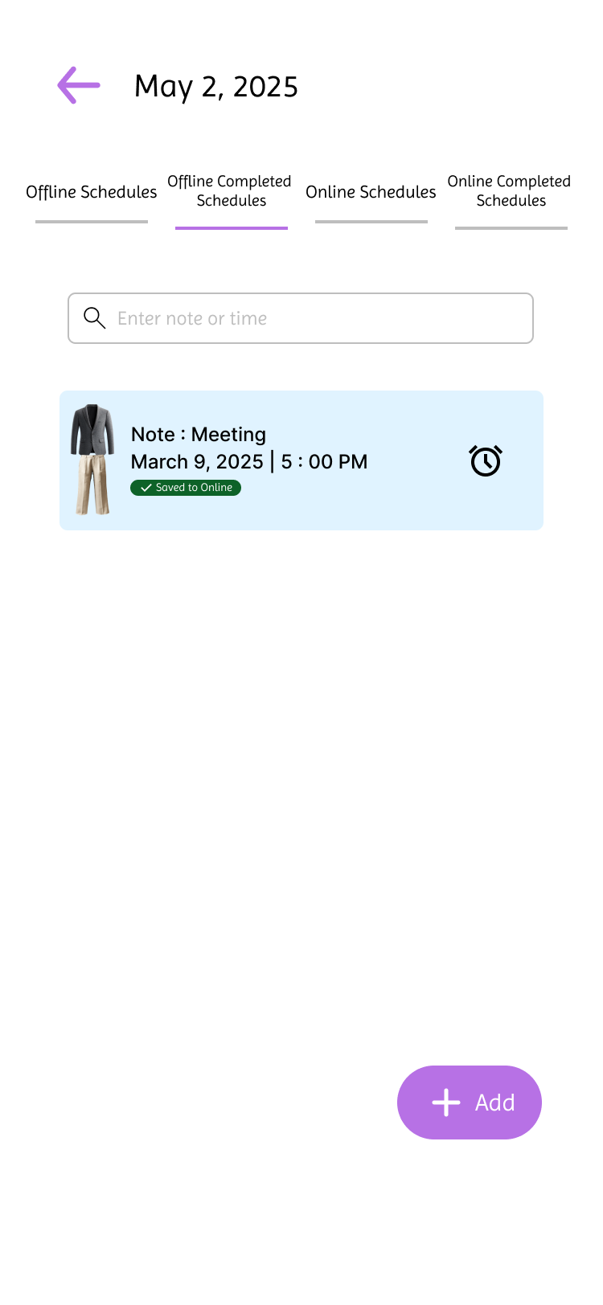

Screen No: 87
Screen Name: Online and Offline Item or Outfit Scheduling
Narrative Overview: Allows the user to schedule an item or outfit.
Screen Layout:
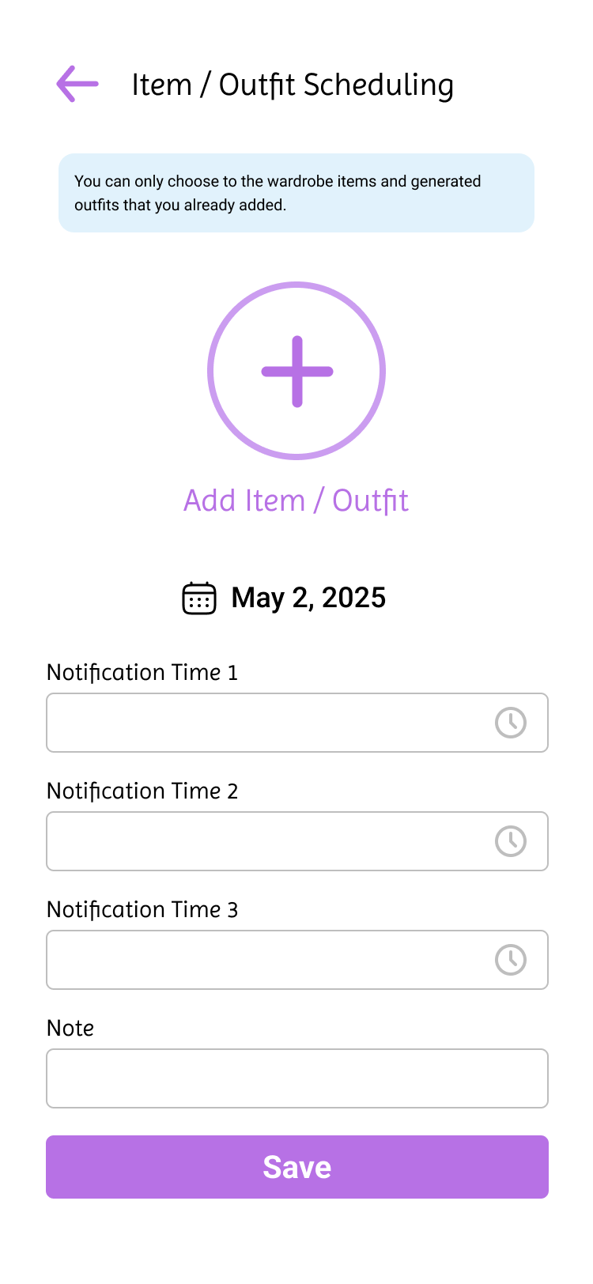

Screen No: 88
Screen Name: Online and Offline Add Item or Outfit Scheduling Success
Narrative Overview: Allows the user to save the item outfit schedule.
Screen Layout:

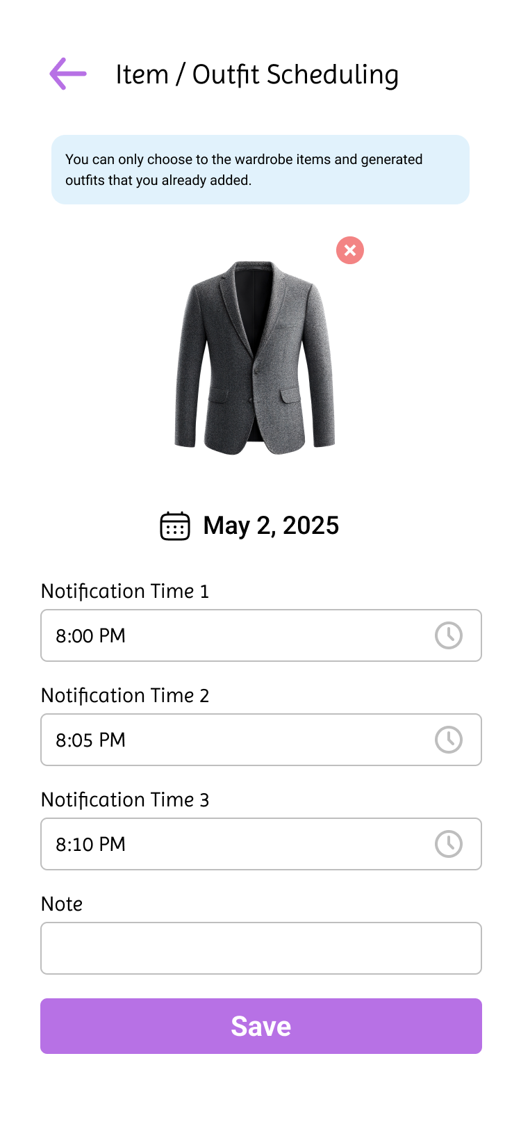

Screen No: 89
Screen Name: Online and Offline Update Item or Outfit Scheduling
Narrative Overview: Allows the user to update the item or outfit schedule.
Screen Layout:

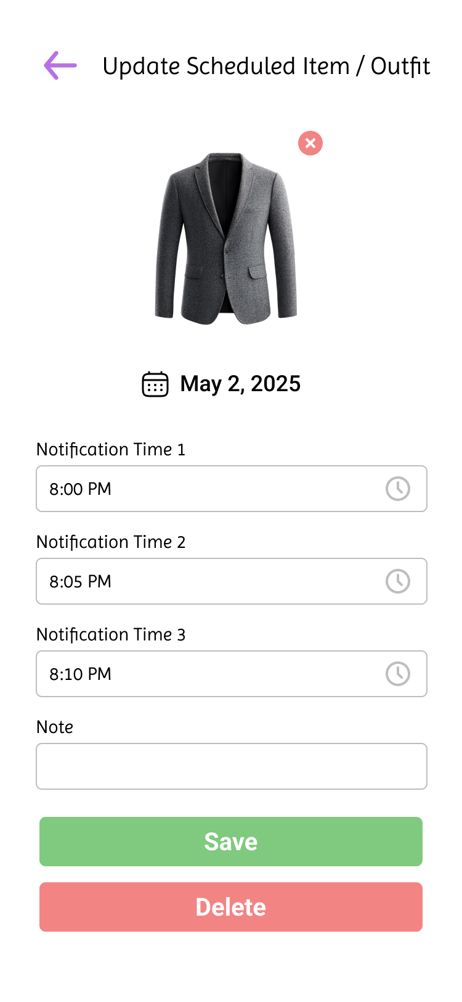

Screen No: 90
Screen Name: Online and Offline Delete Completed Item or Outfit Schedule
Narrative Overview: Allows the user to delete the completed item or outfit schedule.
Screen Layout:
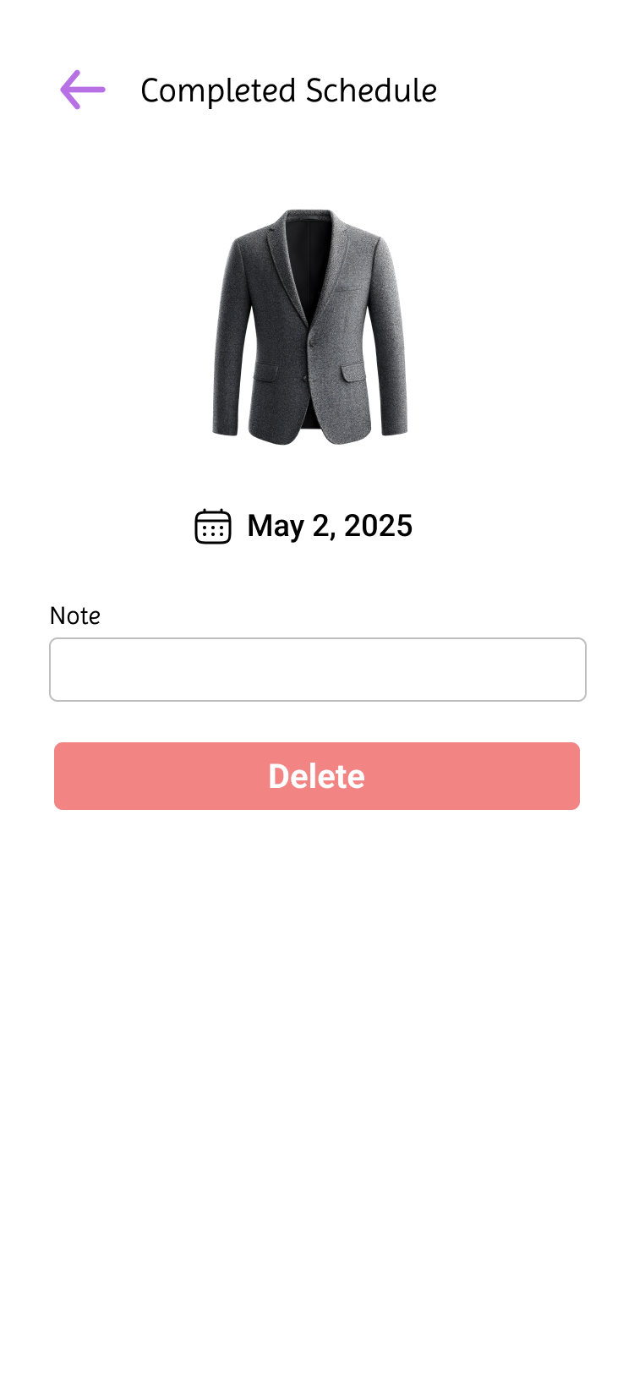

Screen No: 91
Screen Name: Online Settings Tab
Narrative Overview: Allows the user to view the options under Settings.
Screen Layout:

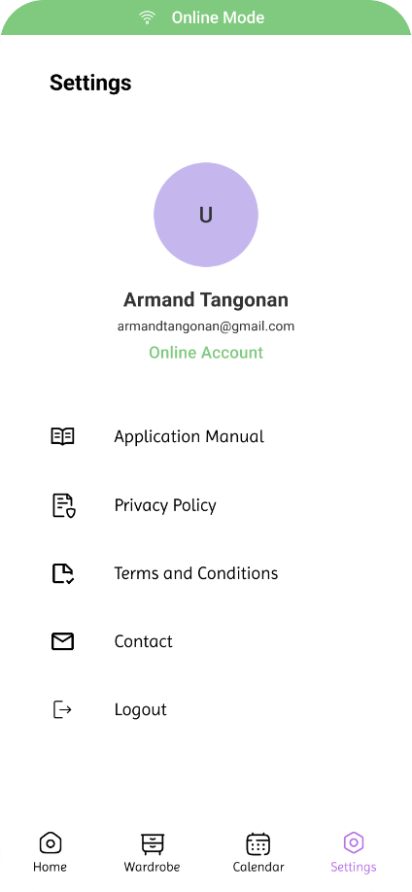

Screen No: 92
Screen Name: Online Application Manual
Narrative Overview: Allows user to view the topics on the application manual.
Screen Layout:
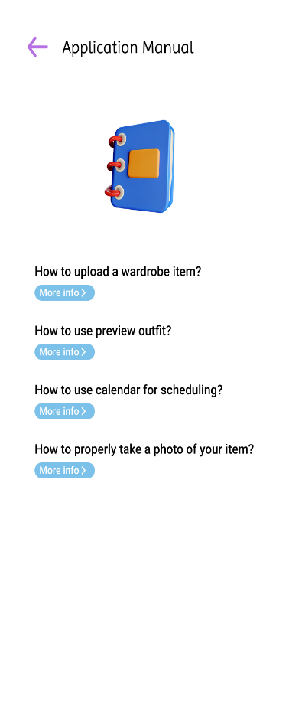

Screen No: 93
Screen Name: Online Application Guide Module Topic
Narrative Overview: Allows user to view the topic on the application manual.
Screen Layout:
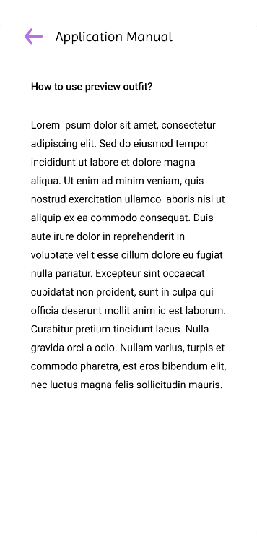

Screen No: 94
Screen Name: Online Contact
Narrative Overview: Allows user to view contact information of the developers.
Screen Layout:
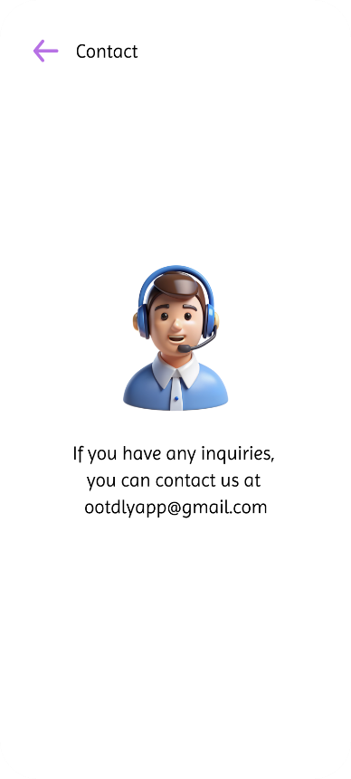

Screen No: 95
Screen Name: Online Terms and Conditions
Narrative Overview: Allows user to view the terms and conditions implemented on the app.
Screen Layout:
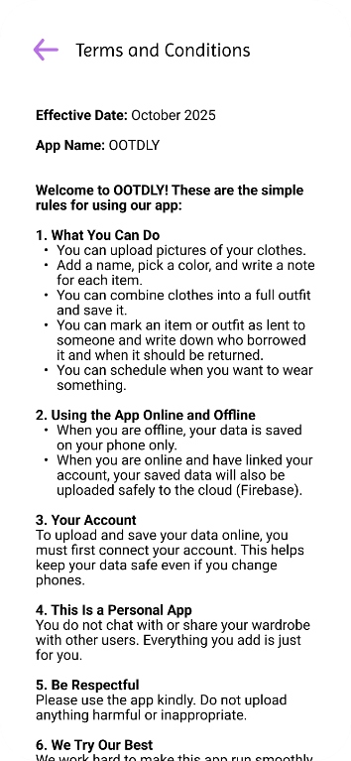

Screen No: 96
Screen Name: Online Privacy Policy
Narrative Overview: Allows user to view the privacy policy implemented on the app.
Screen Layout:
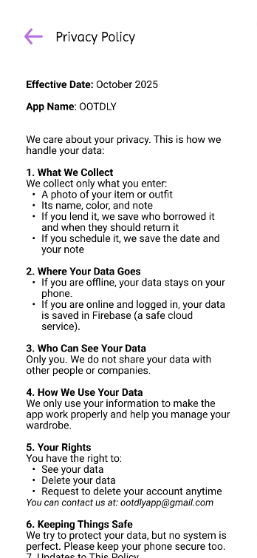

Screen No: 97
Screen Name: Online Log Out
Narrative Overview: Allows user to log out to the online account.
Screen Layout:
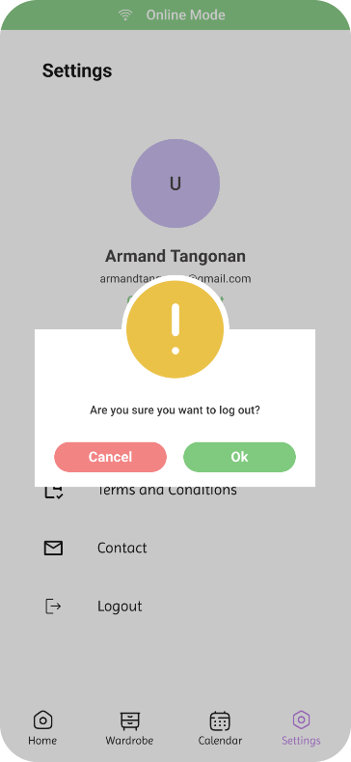

Screen No: 98
Screen Name: Offline Account Home Tab
Narrative Overview: Allows user to see the offline home tab.
Screen Layout:
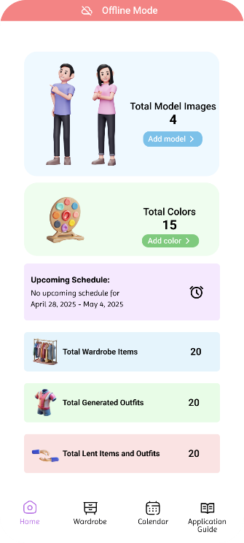

Screen No: 99
Screen Name: Offline Wardrobe Tab
Narrative Overview: Allows user to see the offline wardrobe tab.
Screen Layout:
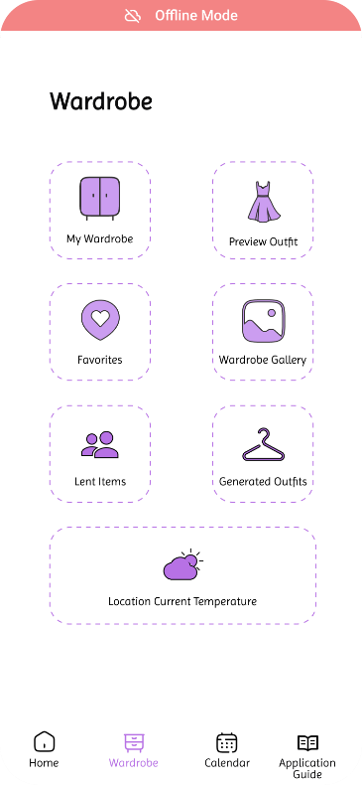

Screen No: 100
Screen Name: Offline Calendar Tab
Narrative Overview: Allows user to see the offline calendar tab. Screen Layout:
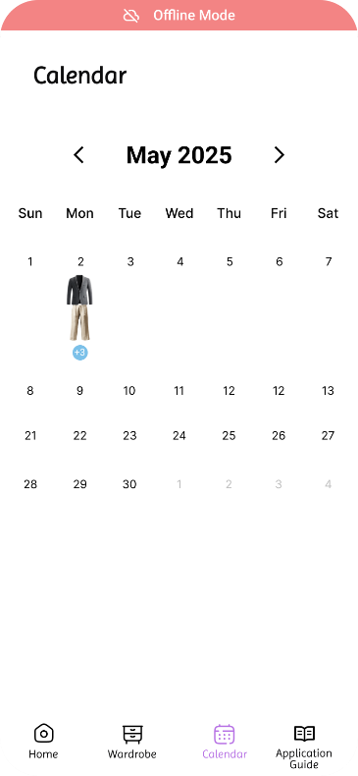

Screen No: 101
Screen Name: Offline Application Manual Tab
Narrative Overview Allows user to see the offline application manual tab.
Screen Layout:
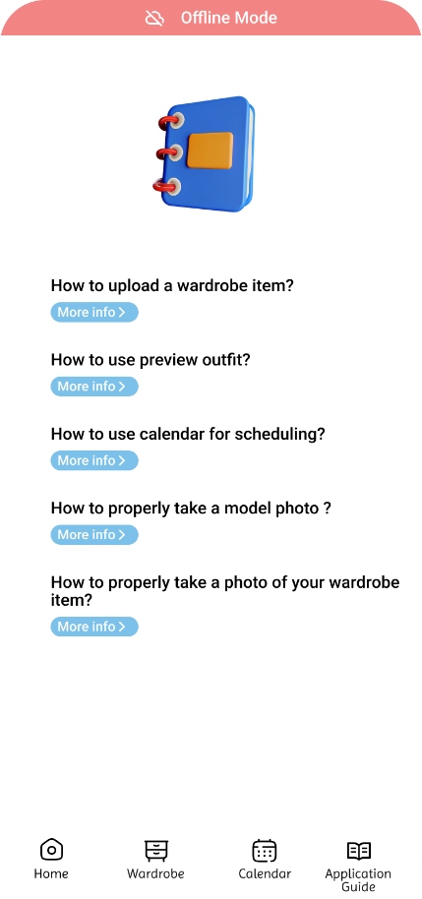

Screen No: 102
Screen Name: Offline Application Manual Tab Topic
Narrative Overview: Allow user to choose application manual tab topic.
Screen Layout:

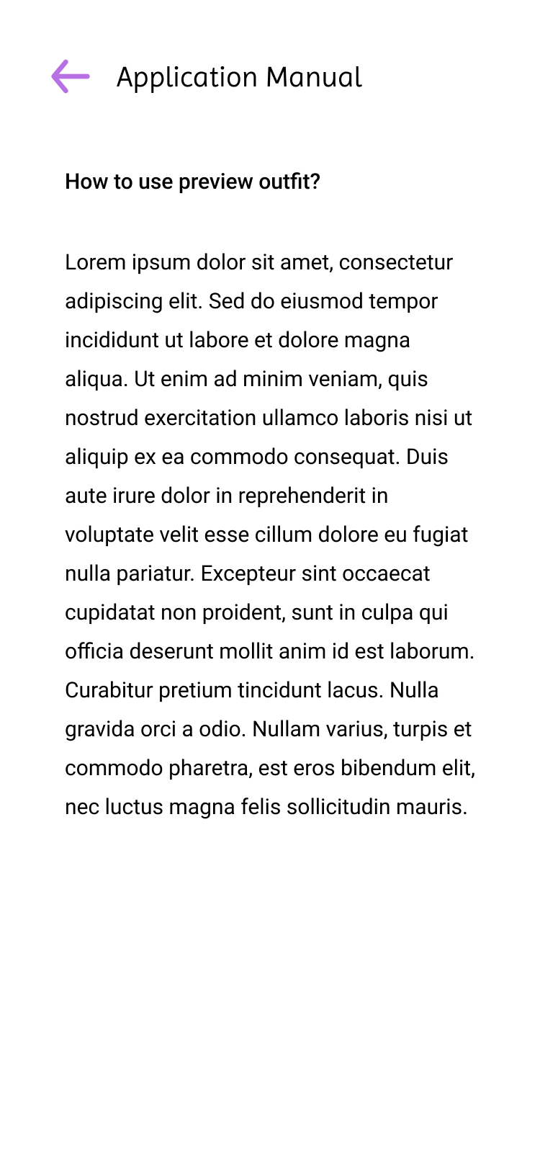

Appendix D
D.1 Transcript of Interview
D.1.1 Trisha Joy G. Tañedo


“Nakaranas na ba kayo ng pangyayari na mayroon kayong event na pupuntahan na hindi kayo handa kung ano ang inyong susuoting outfit?”

Trisha: Yeah nung debut ng friend ko and yung theme is dapat starry night, but I don't have something to wear kasi di ako prepared and hindi ako nainform na invited ako.

“Naka organize ba ang inyong mga damit sa physical cabinet or sa lalagyanan niyo ng mga damit?”

Trisha: Yeah my clothes are organized in my cabinet.

“Gaano kadalas kayong nahihirapang pumili ng damit sa tuwing may lakad o event kayo?”

Trisha: lagi pag papasok ng school, and pag gagala

“May sistema ba kayo sa pagpili ng outfit, tulad ng pag-aayos ayon sa kulay, okasyon, o panahon?”

Trisha: Depend sa lakad, pero most of the time gusto ko lang ng basic and comfy outfit, and pag event naman na kailangan talagang formal gusto ko padin nung basic but elegant look na dapat comfy pa din ako.
“Sa tingin nyo, makakatulong ba kung merong app na mag-oorganize ng mga damit nyo at mag-susuggest ng outfit?”

Trisha: For me yes, as a girly na hirap mamili ng masusuot everyday agree ako na mag karoon ng application na puwedeng mag organized or mag suggest ng daily outfits.

“Paano niyo gustong i-organize ang mga damit nyo kung may pagkakataon kayong ayusin ito muli? (Hal. ayon sa kulay, uri, style, o season)”

Trisha: ako sa uri, Say for example pang bahay na mga damit and pang labas ng mga damit.


D.1.2 Jeffrey Galang Bais

“Nakaranas na ba kayo ng pangyayari na mayroon kayong event na pupuntahan na hindi kayo handa kung ano ang inyong susuoting outfit?”

Jeffrey : Yes, lalo na kung biglaan ang pangyayari or pag alis

“Naka organize ba ang inyong mga damit sa physical cabinet or sa lalagyanan niyo ng mga damit?”

Jeffrey: Yes, naka separate sya ang mga damit at short

“Gaano kadalas kayong nahihirapang pumili ng damit sa tuwing may lakad o event kayo?”

Jeffrey: Madalas Kasi Hindi Minsan nababagay ang mga sinusuot sa kadahilan ng pagmamadali

“May sistema ba kayo sa pagpili ng outfit, tulad ng pag-aayos ayon sa kulay, okasyon, o panahon?”
Jeffrey: Dapat sapagkat dapat lamang naaayon ang iyong sinusuot sa panahon or okasyon

“Sa tingin nyo, makakatulong ba kung merong app na mag-oorganize ng mga damit nyo at mag-susuggest ng outfit?”

Jeffrey: Pwedi, para Hindi na mahirapan sa pagpili ng isusuot

“Paano niyo gustong i-organize ang mga damit nyo kung may pagkakataon kayong ayusin ito muli? (Hal. ayon sa kulay, uri, style, o season)”

Jeffrey: Wala Naman dapat pang ayusin para sakin Kasi alam ko kung saan ako kukuha ng isusuot na pang Araw Araw at pang alis.

D.1.3 Leonila G. Luis


“Nakaranas na ba kayo ng pangyayari na mayroon kayong event na pupuntahan na hindi kayo handa kung ano ang inyong susuoting outfit?”

Leonila : meron, nung mag ninang sa kasal

“Naka organize ba ang inyong mga damit sa physical cabinet or sa lalagyanan niyo ng mga damit?”

Leonila: yes.hung and folded sa loob ng cabinet

“Gaano kadalas kayong nahihirapang pumili ng damit sa tuwing may lakad o event kayo?”

Leonila: minsan, kung aattend ng kasal/binyag

“May sistema ba kayo sa pagpili ng outfit, tulad ng pag-aayos ayon sa kulay, okasyon, o panahon?”

Leonila: wala

“Sa tingin niyo, makakatulong ba kung merong app na mag-oorganize ng mga damit nyo at mag-susuggest ng outfit?”

Leonila: oo, para mapadali ang pagpili ng damit kung may lakad

“Paano niyo gustong i-organize ang mga damit nyo kung may pagkakataon kayong ayusin ito muli? (Hal. ayon sa kulay, uri, style, o season)”

Leonila: Pwede kahit naayon na lang sa kulay at style

Appendix E
E.1 Curriculum Vitae


NAME: Lucila M. Baluyut
ADDRESS: Sta.Lucia, Capas, Tarlac
CELLPHONE #: 09603237573
EMAIL ADDRESS: lucibaluyutxiii@gmail.com

PERSONAL INFORMATION
NICKNAME: Luci
BIRTHDAY: December 13, 1997
BIRTHPLACE: Capas, Tarlac
AGE: 27
NATIONALITY: Filipino
RELIGION: Roman Catholic
CIVIL STATUS: Single


NAME: Vim Aurem Ningala
ADDRESS: Bueno, Capas, Tarlac
CELLPHONE #: 09468514687
EMAIL ADDRESS: vimaurem@gmail.com

PERSONAL INFORMATION
NICKNAME: Vim
BIRTHDAY: January 17, 2004
BIRTHPLACE: San Juan
AGE: 21
NATIONALITY: Filipino
RELIGION: Roman Catholic
CIVIL STATUS: Single


NAME: John Paul S. Pasia
ADDRESS: Cristo Rey, Capas, Tarlac
CELLPHONE #: 09501766150
EMAIL ADDRESS: johnpaulsaspasia1702@gmail.com

PERSONAL INFORMATION
NICKNAME: Paul
BIRTHDAY: September 17, 2002
BIRTHPLACE: Tarlac, City
AGE: 22
NATIONALITY: Filipino
RELIGION: Roman Catholic
CIVIL STATUS: Single


NAME: John Adams S. Romero
ADDRESS: Cristo Rey, Capas, Tarlac
CELLPHONE #: 09641798590
EMAIL ADDRESS: romerojohnadams30@gmail.com

PERSONAL INFORMATION
NICKNAME: Adams
BIRTHDAY: December 09, 2002
BIRTHPLACE: Mabalacat District Hospital
AGE: 22
NATIONALITY: Filipino
RELIGION: Iglesia Ni Cristo
CIVIL STATUS: Single


NAME: Marlon R. Sembria
ADDRESS: Sto Domingo 1st, Capas, Tarlac
CELLPHONE #: 09501908095
EMAIL ADDRESS: razonmarlon17@gmail.com

PERSONAL INFORMATION
NICKNAME: Lonlon
BIRTHDAY: July 26, 2004
BIRTHPLACE: Conception, Tarlac
AGE: 20
NATIONALITY: Filipino
RELIGION: Roman Catholic
CIVIL STATUS: Single


NAME: Armand Robin I. Tangonan
ADDRESS: O'Donnell Capas, Tarlac
CELLPHONE #: 09461837927
EMAIL ADDRESS: armandinong21@gmail.com

PERSONAL INFORMATION
NICKNAME: Mand
BIRTHDAY: June 21, 2004
BIRTHPLACE: Tarlac Provincial Hospital
AGE: 20
NATIONALITY: Filipino
RELIGION: Born Again Christian
CIVIL STATUS: Single

