Process Control Unit
Documentation
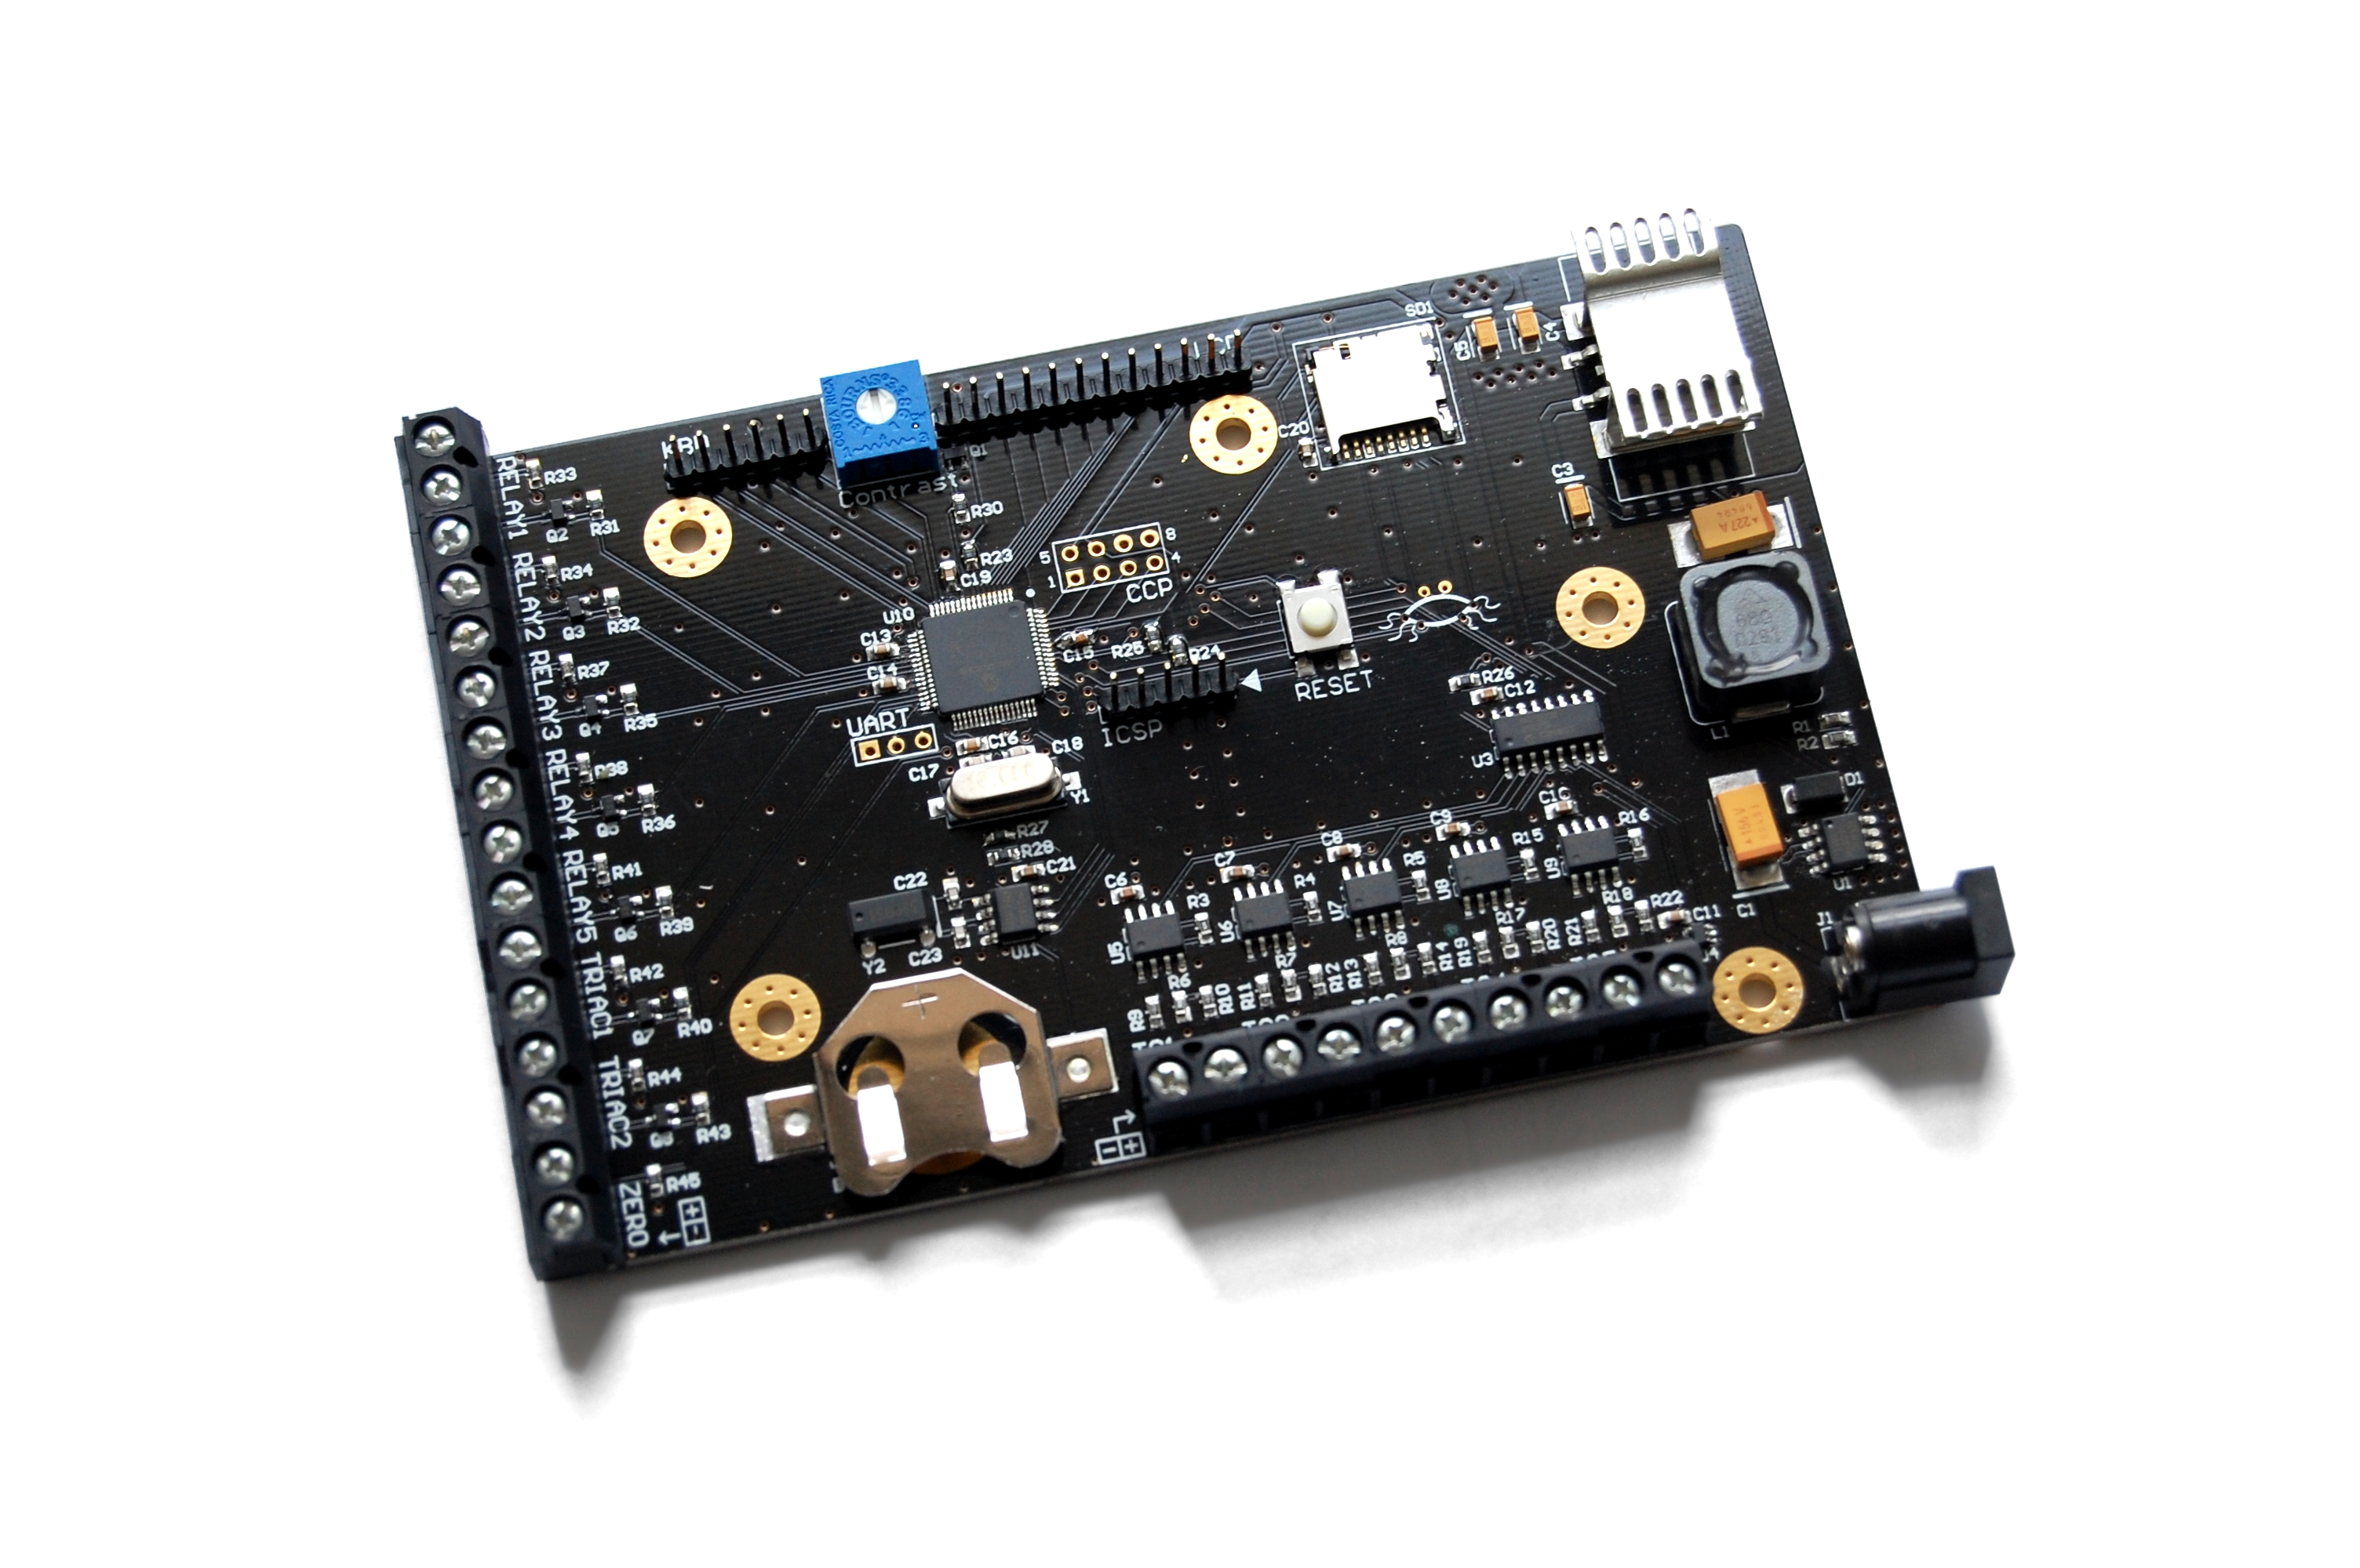
 | Small-Scale Biofuel Production  2010/2011

Contents
Introduction 3
Hardware Overview 3
Power Supply 3
Microcontroller 4
Temperature measurement 5
Electrical Interface 6
User Interface 7
Real Time Clock 8
MicroSD Card 9
Board Layout and Schematics 10

Introduction
This Process Control Unit board was designed to provide an integrated solution for controlling a small-scale biofuel production plant. The unit interfaces with an electro-mechanical installation consisting of motors, heaters, solenoid valves, relays and other components. User interface consists of an LCD and four push buttons.
This document provides the information required to use and develop the control system.

Hardware Overview
The main features of the board are:
- PIC18F66K22 8-bit microcontroller
  - 64KB Flash Program Memory
  - 4KB SRAM
  - 1KB Data EEPROM
- 16MHz crystal oscillator
- Switch-mode voltage regulator with input range of 4V to 34V and an adjustable output set to 5V
- Low Drop-Out linear regulator providing 3.3V output
- Five thermocouple channels
- Seven open-drain outputs and one input designed to interface to external opto-isolators
- HD44780-compatible LCD interface
- Push button interface consisting of 4 I/O pins and 2 power pins
- MicroSD card slot (SPI mode)
- Real-Time Clock with a dedicated 32.768kHz crystal
- In Circuit Serial Programming (ICSP) header

Power Supply
The on-board power supply, in Figure 1, was designed to accept a wide range of input voltages. The switching regulator is capable of working with up to 34V input. The output is set to 5V and is used to power the LDO regulator and the LCD.
The circuit takes power from a wall plug PSU rated for up to 1A at 12V. A standard DC jack with pin diameter of 2.1mm is used for power connection.
All components except the LCD are powered from a 3.3V supply. This is provided by a Low Drop-Out regulator.
For more information, refer to Schematic Sheet 2.
Note: The LDO used is in TO-252 package and the tab is connected to output. The heatsink is soldered to the same plane as the tab and, therefore, has 3.3V on it.
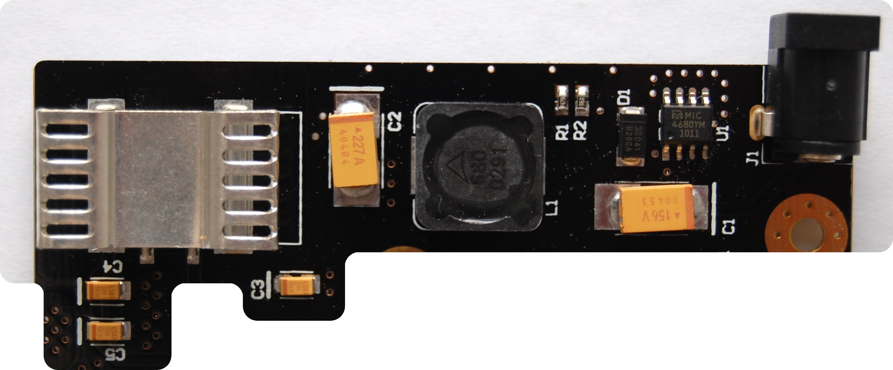Figure 1: Power supply circuitry

Microcontroller
The control logic is implemented on a PIC18F66K22 microcontroller (revision A3). The PIC and relevant components are shown in Figure 2.
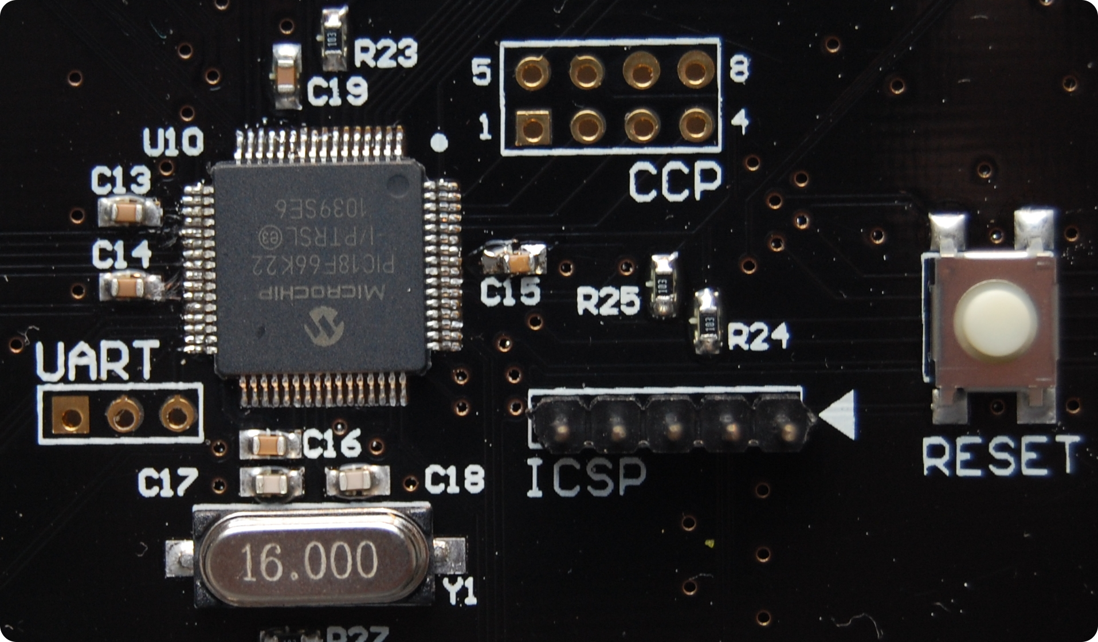Figure 2: Microcontroller circuitry

ICSP Header
The most relevant part of the circuitry, for the purpose of development, is the ICSP programming and debugging header. This is a standard 5-pin interface for programming PIC controllers.
Figure 3: ICSP pin layout
5 | 4 | 3 | 2 | 1 | ◀ | - MCLR  - 3.3V  - GND  - PGD  - PGC
ICSP |  |  |  |  |  | - MCLR  - 3.3V  - GND  - PGD  - PGC
Note: PIC programmers have 6-pin headers. Pin 6 is reserved for Low Voltage programming (LVP).

Expansion Headers
There are two unpopulated headers that can be used to further extend the functionality of the board.
The UART (Universal Asynchronous Receiver/Transmitter) port can be used to add a serial communication for debugging or data logging.
Figure 4: UART pin layout
UART
1 | 2 | 3 | - GND  - TX1  - RX1
The second header breaks out the CCP (Capture/Compare/PWM) pins. These have many possible uses. PWM output, for example, could be used to implement a piezoelectric buzzer driver for audio feedback.
Figure 5: CCP pin layout
5 | 5 | 6 | 7 | 8 | 8 | - CCP9  - CCP8  - CCP7  - CCP6  - 3.3V  - 3.3V  - GND  - GND
1 | 1 | 2 | 3 | 4 | 4 | - CCP9  - CCP8  - CCP7  - CCP6  - 3.3V  - 3.3V  - GND  - GND
 | CCP |  |  |  |  | - CCP9  - CCP8  - CCP7  - CCP6  - 3.3V  - 3.3V  - GND  - GND
The above headers can also be used as a general I/O expansion.

Temperature measurement
The temperature measurement circuitry consists of five thermocouple channels and an on-board reference temperature sensor.
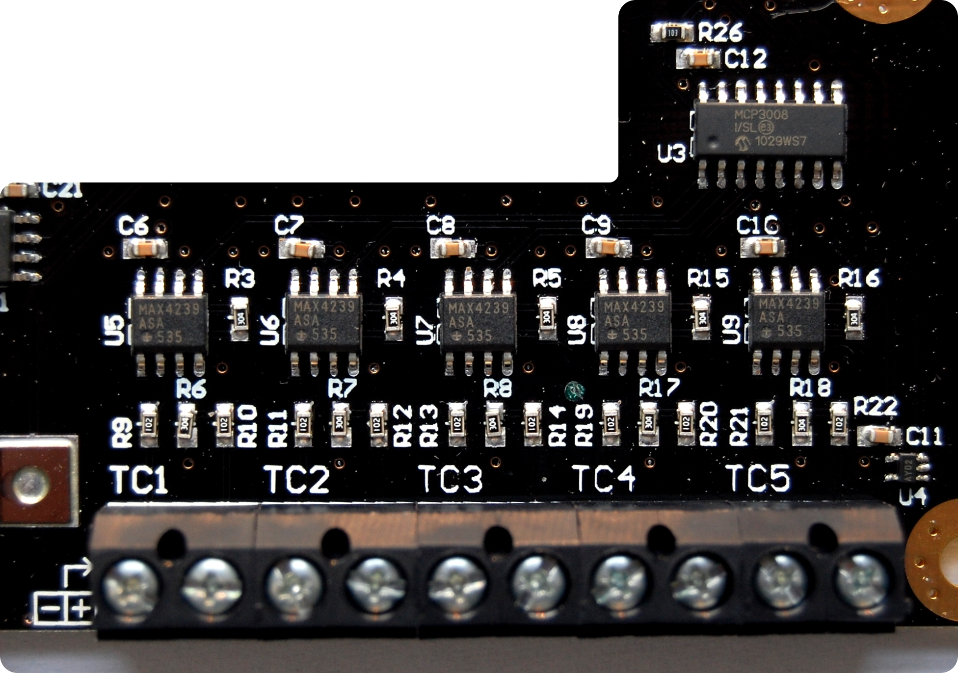Figure 6: Temperature measurement circuitry
The thermocouples are connected to the terminal blocks (at the bottom of Figure 6). The polarity is indicated by a special marking (shown in
Figure 7) and is the same for all five pairs.
Figure 7: Thermocouple input polarity indicator
↱
- | +
Signals from the thermocouples go the differential amplifier configured for a gain on 300. The amplified signals are then sampled by the Analogue to Digital Converter (ADC).
The on-board temperature sensor is a linear active thermistor. The device outputs 400mV at 0°C and has a temperature coefficient of 19.5mV/°C.
For further information, refer to Schematic Sheet 4.
Note: Due to noise problems, each negative input has been connected to ground. This is not reflected in the schematic diagram.

Electrical Interface
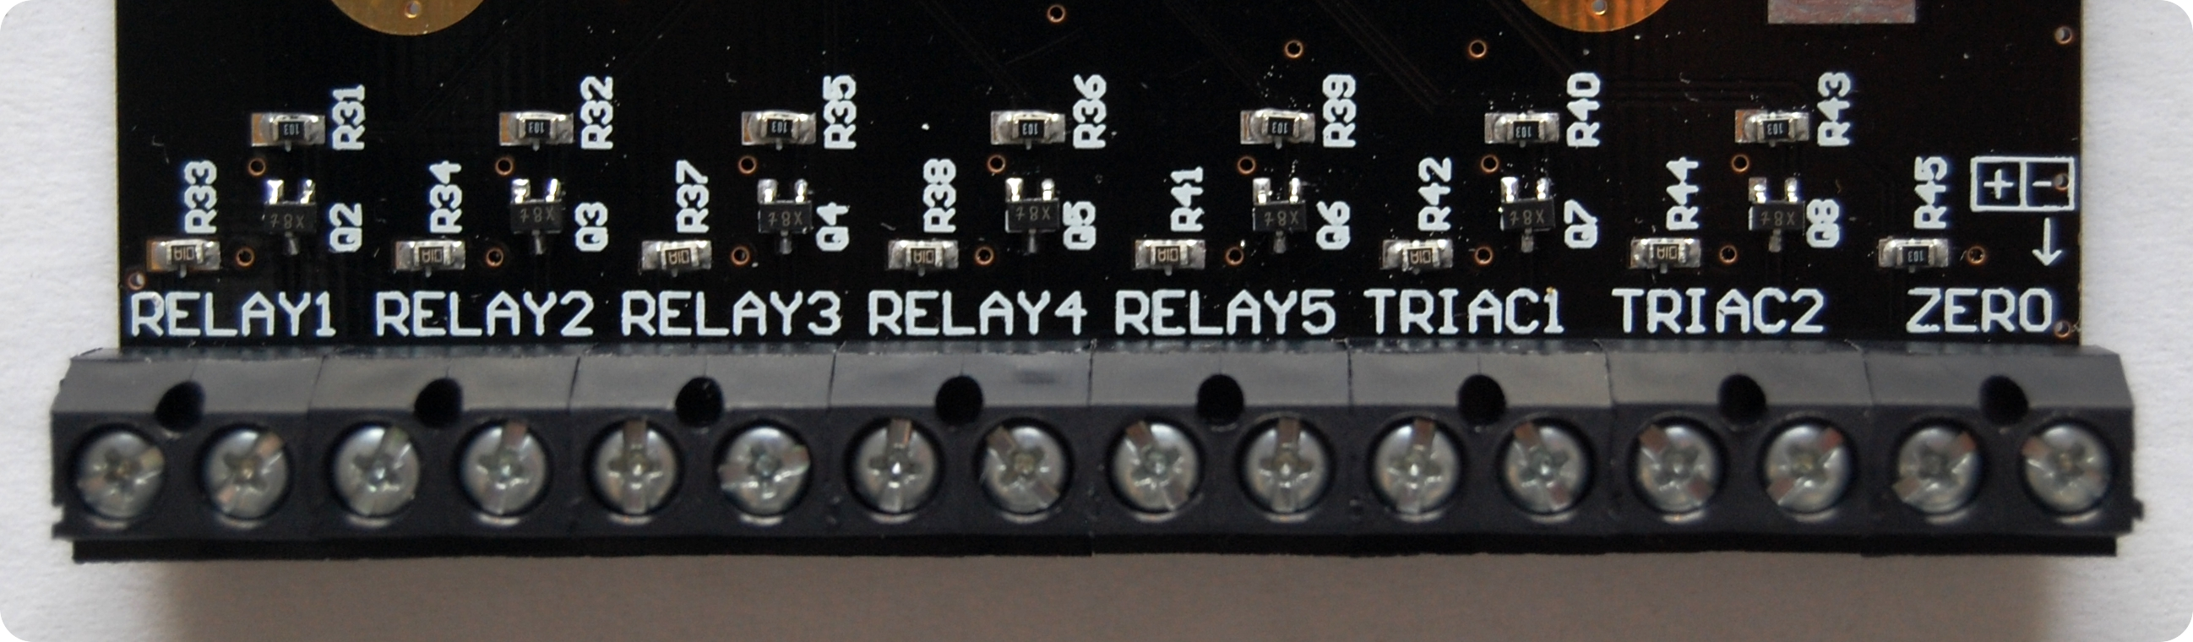Figure 8: Electrical interface circuitry
Due to high voltages present on the electrical system, signals that go between the electrical and control parts need to be isolated. The isolation is achieved by using opto-couplers.
While the opto-couplers are located on the electrical side, the interface is on the control PCB. Eight terminal block pairs are used for connecting the two parts.
Pairs labelled as RELAYx and TRIACx are open-drain outputs and they are used to turn on the LED inside the opto-isolator. Pair labelled as ZERO is an input that is driven by the open-collector output of the opto-isolator while the opto-isolator itself is driven by a Zero Crossing Detector (ZCD).
Input ZERO is pulled to 3.3V line through a 10k resistor and goes to INT1 (Interrupt 1) pin on the PIC.
The polarity of the connectors is indicated by a marking near the ZCD input and is the same for all pairs.
Figure 9: Electrical interface polarity indicator
+ | -
 | ↓
Further connection details can be found in Schematic Sheet 5.

User Interface
The user interface of the control system consists of an LCD and a key pad. The design supports all HD44780-compatible displays and currently uses a 4x20 character LCD. The key pad is made of four push buttons.
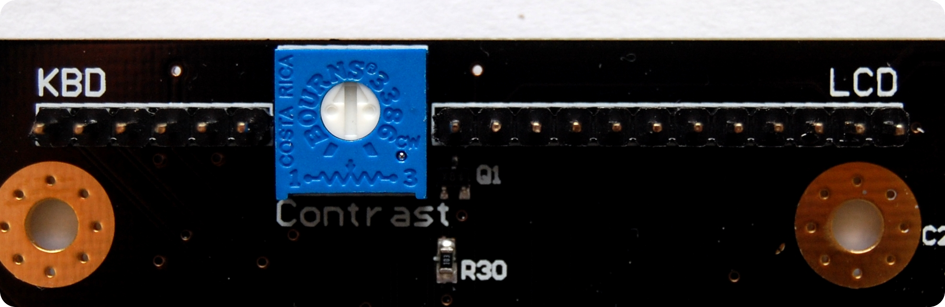Figure 10: User interface circuitry

Display
The LCD header pin layout and descriptions are shown in Figure 11. The cathode of the backlight LED is connected to the drain of the MOSFET Q1. This enables the backlight to be controlled by software.
Figure 11: LCD header pin layout
LCD
16 | 15 | 14 | 13 | 12 | 11 | 6 | 5 | 4 | 3 | 2 | 1
Pin # |  | Signal |  | Description
1 |  | GND |  | Ground
2 |  | 5V |  | Supply voltage
3 |  | V0 |  | Contrast
4 |  | RS |  | Register Select
5 |  | RW |  | Read/Write
6 |  | E |  | Enable
11 |  | DB4 |  | Data Bit 4
12 |  | DB5 |  | Data Bit 5
13 |  | DB6 |  | Data Bit 6
14 |  | DB7 |  | Data Bit 7
15 |  | LED + |  | Anode of the Backlight LED
16 |  | LED - |  | Cathode of the Backlight LED
As mentioned before, the LCD requires a 5V supply to operate, but the control and data pins can be driven directly by PIC, because a 3.3V signal is recognised, by the LCD, as a valid logic high.
Note: The board is designed for 4-bit LCD interface and, therefore, data bits 0 through 3 are not used.

Keypad
The keypad interface is very basic: it has two power pins and four I/O pins. The keypad was designed for this project and consists of four push buttons in an active-low configuration. The pin layout is shown in .
Figure 12: Keypad header pin layout
KBD
6 | 5 | 4 | 3 | 2 | 1 | - OK  - ESC  - 3.3V  - GND  - UP  - DOWN

Real Time Clock
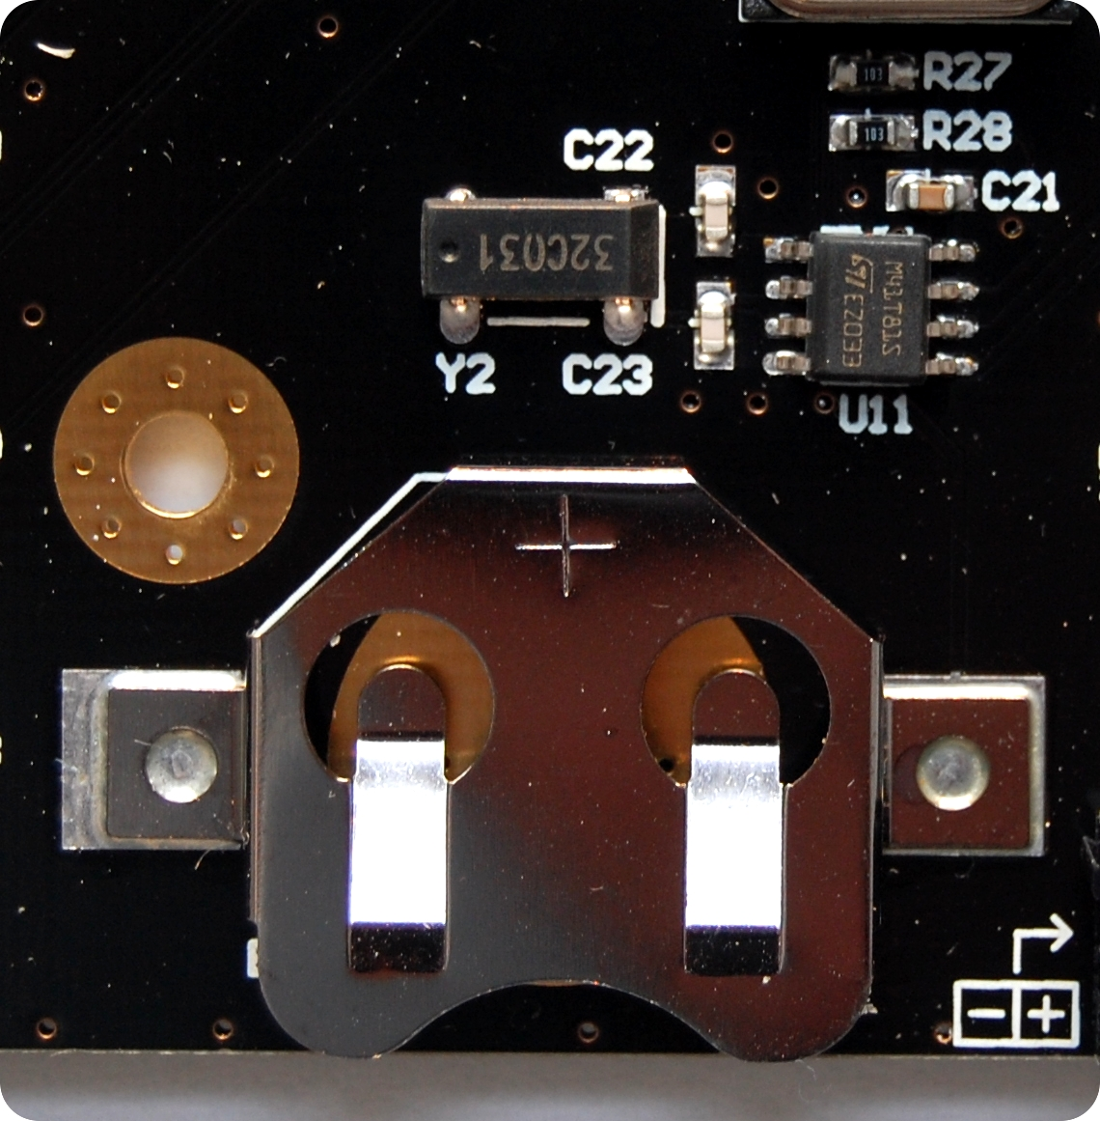Figure 13: Real Time Clock circuitry
The board also hosts a real time clock chip together with a 32.768kHz oscillator and a backup battery retainer.
The RTC communicates with PIC via an I2C bus. The battery retainer accepts CR2032 coin cells.

MicroSD Card
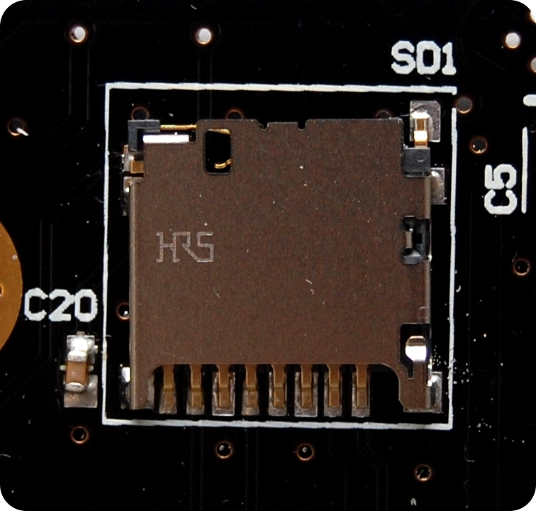Figure 14: MicroSD card slot
For data logging capabilities, the design includes a microSD card slot. The PIC and the card can communicate using an SPI bus and SPI mode protocol. The “card in” signal can be used to detect when the card is present.

Board Layout and Schematics


