**This repository helps lunch a wordpress application via an AWS Cloudformation template in two**

**ways. Either running an Ansible Script or loading the template inside to create stack.**

*This a stack that creates a VPC with one public subnet and two private subnets. The Public subnet has a WebServer that allows traffic to HTTP 80 only. The Private subnets have a RDSMySQL Database. There are two Security Groups: One for the WebServer and the other for the Database. One internet Gateway. One Route Table and one for internet Gateway attached to the Public Subnet*

1. Via an Ansible Playbook run, in that case the stack will be created automatically **with the default values.**

To do that, **assuming that you have ansible installed** in your playground machine with python, boto3 and git installed. You have to edit **/etc/ansible/hosts** file to add the localhost

[local]

localhost

.You have to add the credentials of the user who will provision the resources. **That user should have the permissions to provision..VPC..EC2 instance…RDS database…**, if not the Stack will fail. The root user should think of the principle of least privilege and create the access key and secret access key..so create a aws directore…create a file named credentials and add access key and secret access key in that file

[armand_gcp@hitashi]$mkdir ~/.aws/

[armand-gcp@hitashi]$cd ~/.aws/  
[armand-gcp@hitashi]$vi credentials  
[default]

aws_access_key_id=**the_user_access_key**

aws_secret_access_key=**the_user_secret_access_key**

Now clone the repo

[armand_gcp@hitashi]$git clone <https://github.com/armandk/hitashi-demo-ansible.git>

Then

[armand_gcp@hitashi]$ cd hitashi-demo-ansible

And run the following to provision the stack

[armand_gcp@hitashi]$ ansible-playbook -i /etc/ansible/hosts hitashi-domo-

stack.yml --verbose

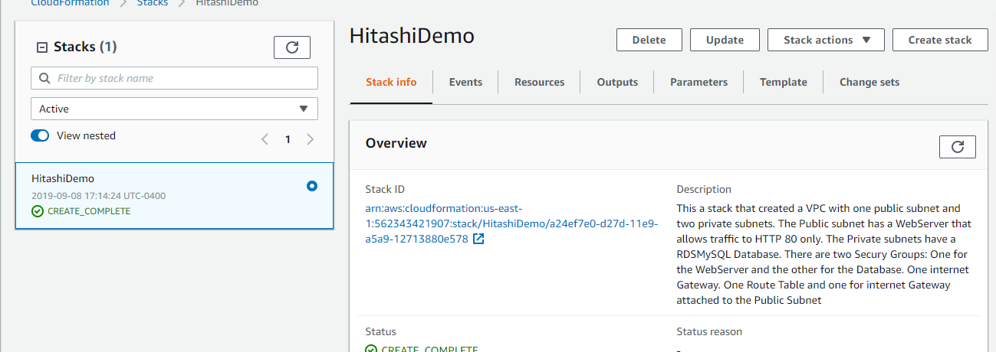

You can access the wordpress application from this URL <http://3.228.5.18/wordpress/wp-admin/install.php>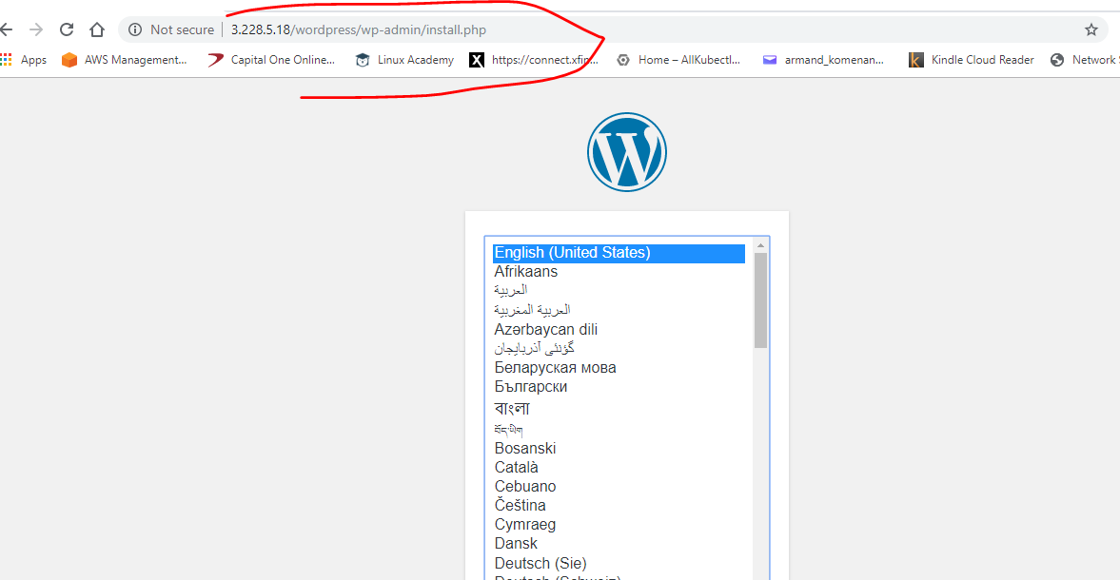

1. Note: Very important…The user assign to me for the exercise doesn’t have permissions to run the template via Ansible nor to load it from a file to create the stack, after log into the AWS Console….The second option will ask the user to add input parameters.

You can see that I was not able to create a S3 bucket to upload the template file

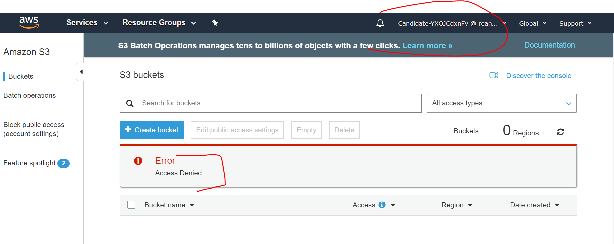

Here I am not able to Create a Stack (Screen below)

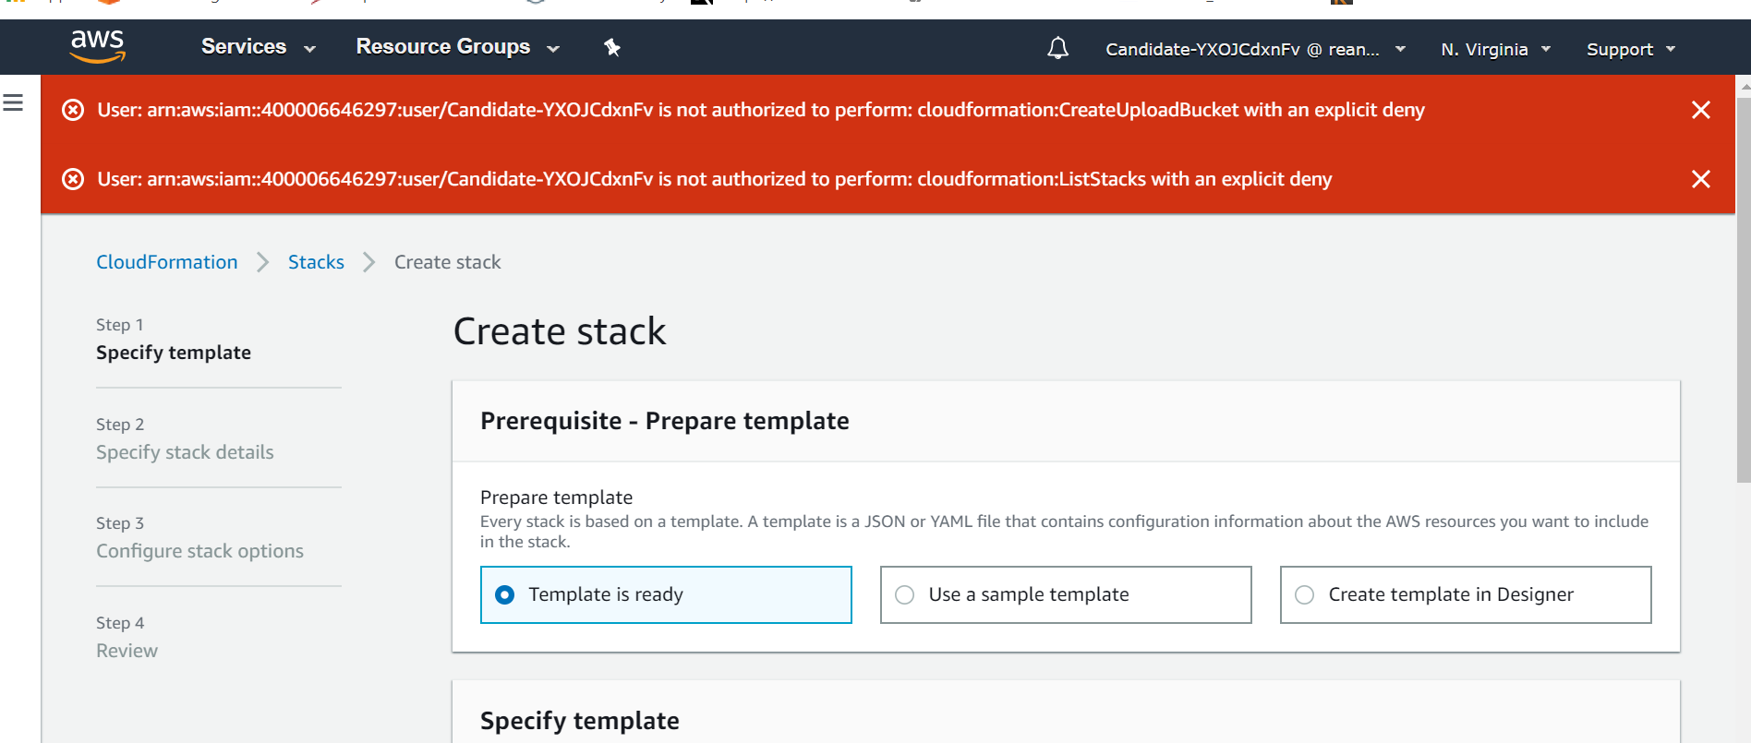

1. To run the stack 🡪 Login to the AWS Console and go to Cloudformation services

Click create Stack –

Under ‘Specify template’ copy this URL , under ‘Amazon S3 URL’ <https://open2theworld.s3.amazonaws.com/hitashi-demo-cloudformation.template>

And follow the rest until Stack completion..You will add parametes on you own and can see the

application at <http://{webserverIP}/wordpress/wp-admin/install.php>

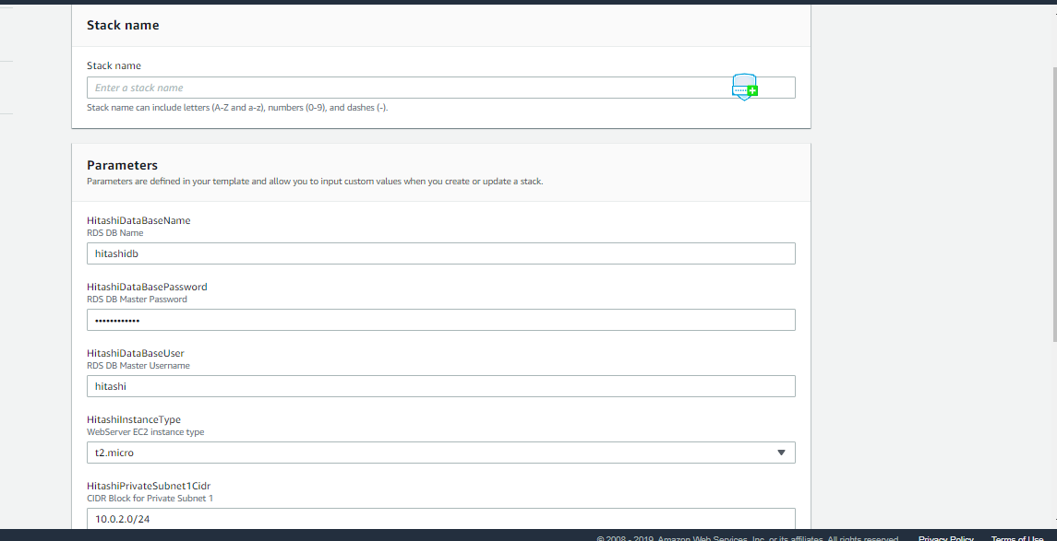dd

