SONGA: RISE OF THE SILVERBACK
Endless Runner Game Vision & Level 1 Story Synopsis
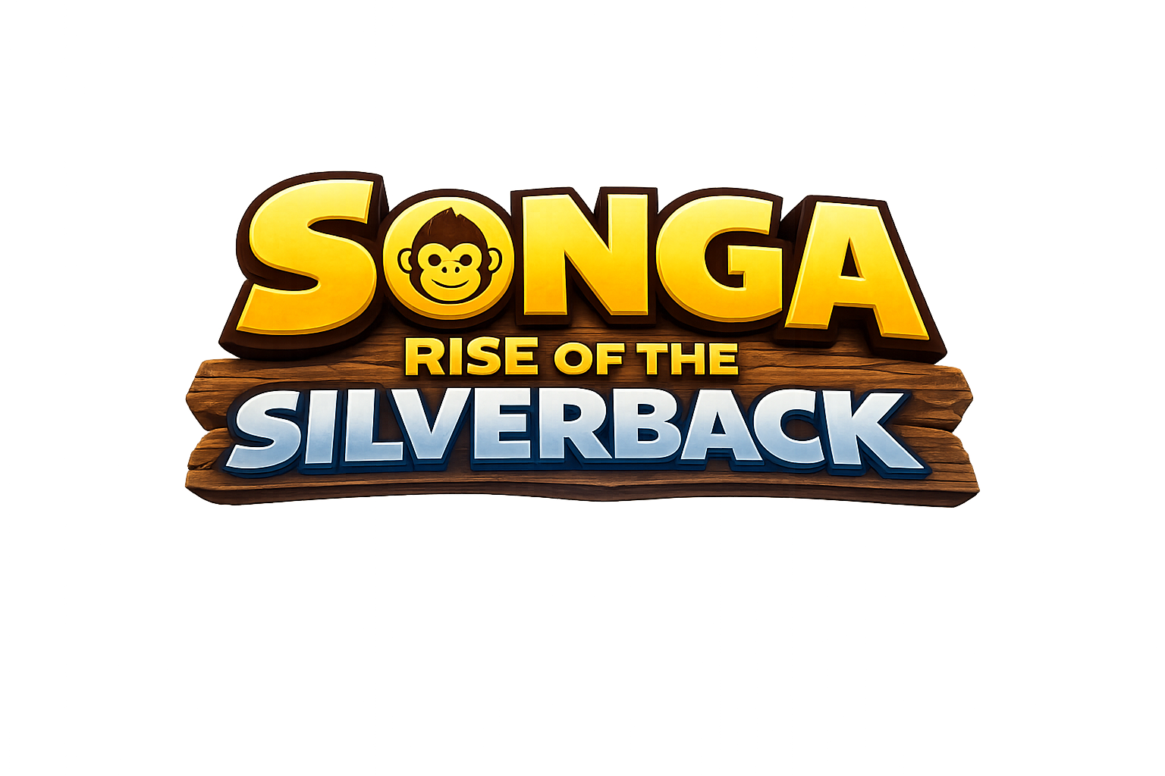

Character Identity: Songa
Songa is the central protagonist of the game. He is a stylized young silverback inspired by Pixar-like character appeal, Temple Run Legends aesthetics, and Rwandan cultural identity. The character design balances playful charm with athletic movement suitable for an endless runner experience.
Key Visual Traits:
- Warm brown fur with expressive eyes and soft stylized proportions
- Blue waist cloth inspired by African/Rwandan textile aesthetics
- Friendly but determined facial expression
- Strong silhouette readable on small mobile screens
- Designed for fast animation readability during gameplay



Game Overview
Songa: Rise of the Silverback is a stylized 3D endless runner mobile game set in a fictional gorilla kingdom inspired by Rwanda’s Volcanoes National Park and the misty mountain gorilla regions of East Africa.
Players control Songa as he escapes through lush bamboo forests, ancient gorilla ruins, muddy mountain cliffs, waterfalls, volcanic terrain, and sacred jungle pathways while being chased by a mysterious rogue silverback known as Karumo.
The game focuses on fast, satisfying movement, cinematic set-pieces, mystery-driven storytelling, and vibrant African-inspired worldbuilding.

Art Direction
- Stylized/cartoon aesthetic inspired by Temple Run Legends and Jumanji-style adventure games
- Pixar-like softness and readability
- Simplified mobile-first environment design
- Rwandan-inspired textures, patterns, and motifs
- Volcanoes National Park-inspired landscapes
- Bamboo forests, giant trees, misty mountains, cliffs, fog, rain, and muddy terrain
- Bright adventurous color palette balanced with mysterious jungle atmosphere

Core Gameplay Identity
- Endless running and lane switching
- Jumping, sliding, and dodging
- Gorilla strength smash mechanics
- Vine swinging traversal
- Wall climbing sequences
- Charging through destructible obstacles
- Animal companion assists
- Rhythm/percussion speed boosts inspired by African drumming
- Dynamic cinematic chase moments

Level 1: The Exile
Level 1 begins immediately during a moment of chaos inside the Emerald Canopy Kingdom — a sacred gorilla civilization hidden deep within the volcanic mountains.
Songa, a young silverback prince-in-training, is forced to flee after a massive rogue silverback named Karumo violently takes control of the kingdom.
The player is thrown directly into gameplay with no lengthy exposition. The focus is momentum, mystery, survival, and wonder.
Karumo remains mostly unseen throughout the level. Players hear thunderous footsteps, echoing roars, breaking trees, and collapsing terrain while only occasionally catching glimpses of his massive shadow through fog and mountain mist.
The level transitions through multiple environmental zones inspired by Rwanda’s landscapes:
- Dense bamboo jungle escape paths
- Ancient gorilla temple ruins
- Slippery volcanic cliff edges
- Waterfall crossings and rope bridges
- Rain-soaked mountain trails
- Fog-filled forests with giant roots and sacred statues

Narrative Tone
The tone of the game should feel adventurous, mysterious, emotional, and energetic — not dark or political. The world should feel alive with birds, jungle sounds, drums, mist, glowing plants, wildlife, waterfalls, and ancient myths.
The mystery surrounding Karumo and the hidden history of Songa’s father should unfold gradually over the course of the game.

Environment Design Goals
- Strong visual identity inspired by Rwanda
- Readable gameplay paths for mobile
- Verticality through cliffs and mountain terrain
- Dynamic weather systems including fog and rain
- Mix of sacred ruins and natural jungle environments
- High sense of speed and cinematic momentum
- Distinct environmental storytelling without heavy dialogue

