**REPORTS:** [**TTL 403 THE INTEGRATED CURRICULUM**](https://teachersoftomorrow.instructure.com/courses/1514)

**ISSUE #0**

‘Getting started’ and redirect to the same, unlocked module.

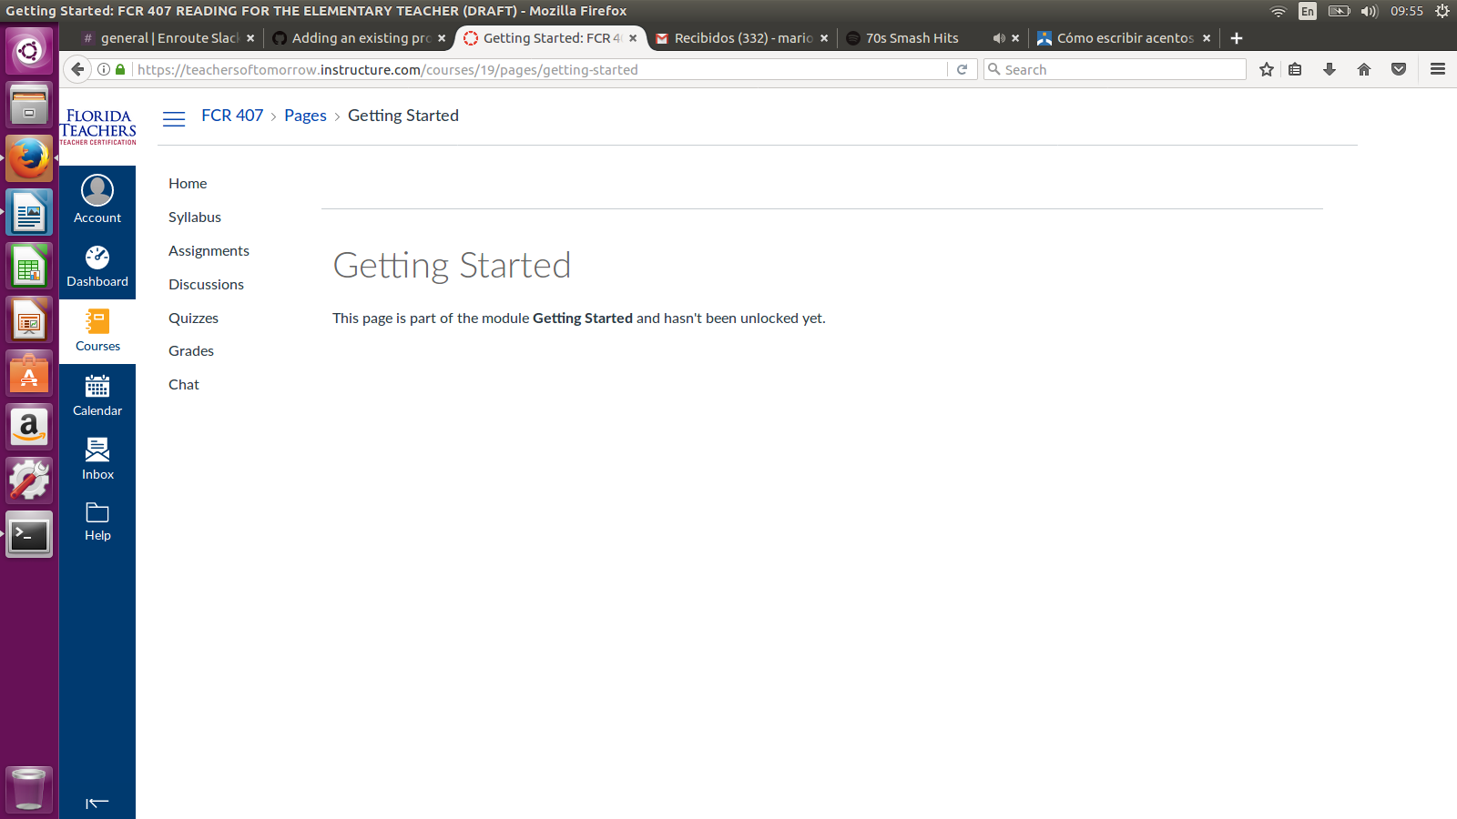

**ISSUE #1: Lesson 1 Objective**

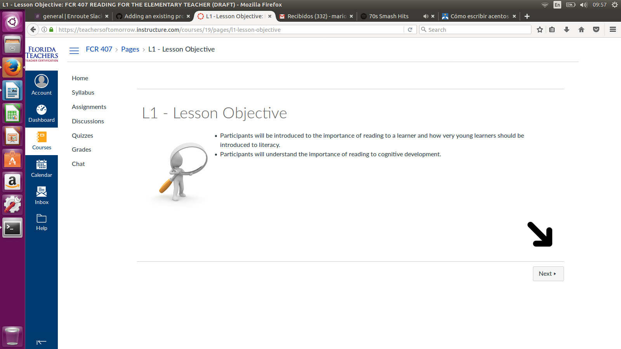‘Lesson objectives’ sometimes show objectives with list markers separated.

**ISSUE #2 Lesson 1 Objective**

At the start of some sentences there are 2 blank spaces. Check the entire topic web page. Check all topics in every lesson. This is a recurrent problem.

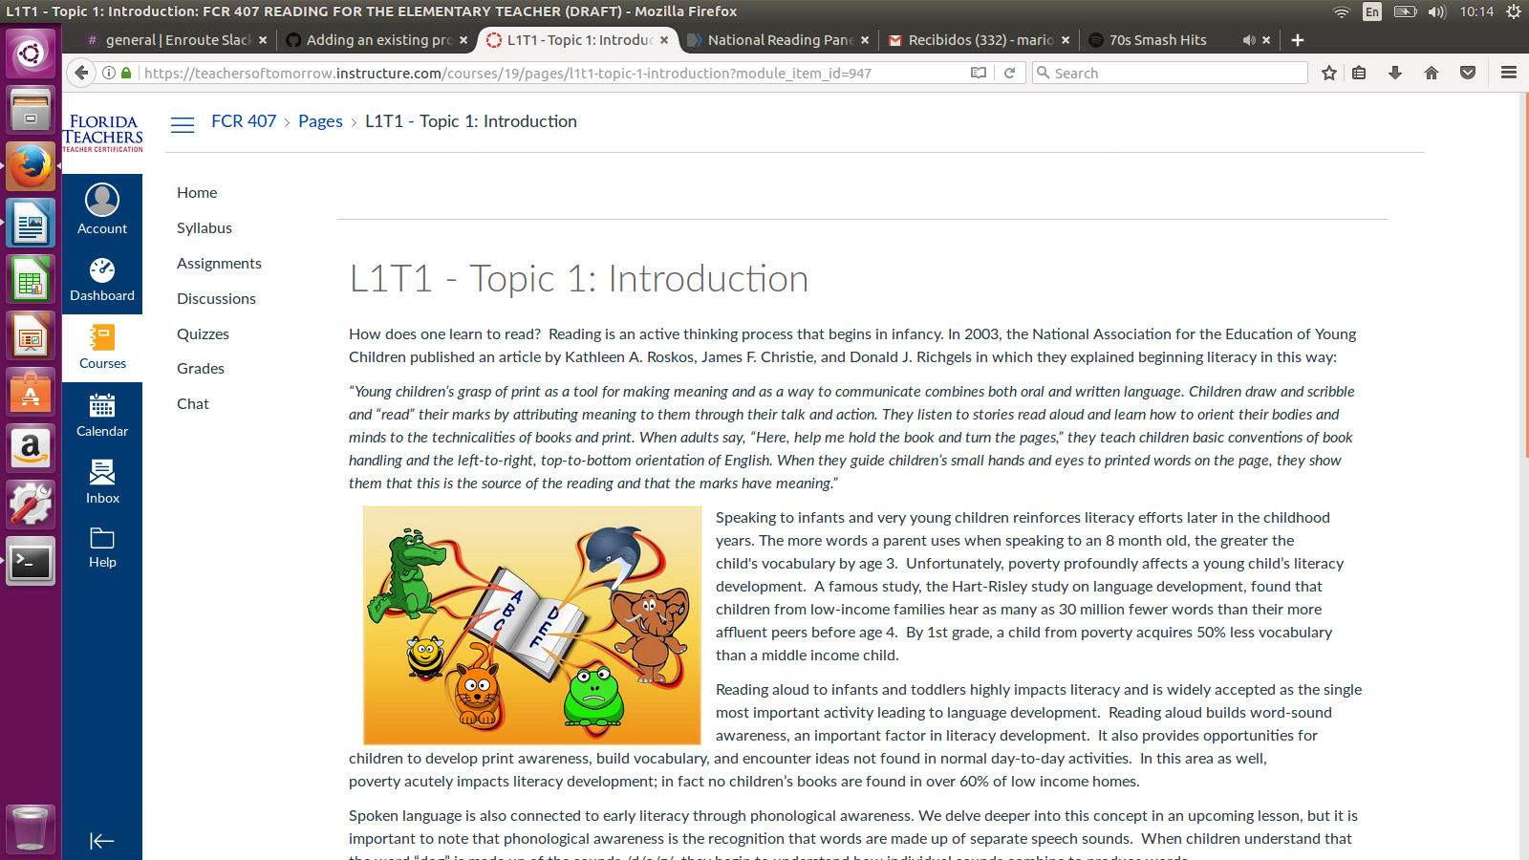

**ISSUE #3: Lesson 1 Quiz**

‘Resume Quiz’ button looks like is unabled but when clicked it redirects to quiz. Check all ‘Retake quiz’, ‘Take Quiz’ and ‘Resume Quiz’ buttons.

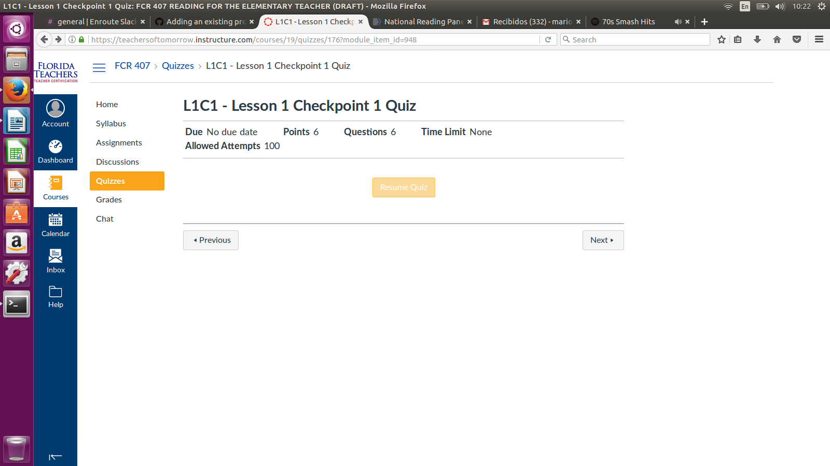

**ISSUE #4: Lesson 1 T2**

This table might look better if cell’s content would be centered.

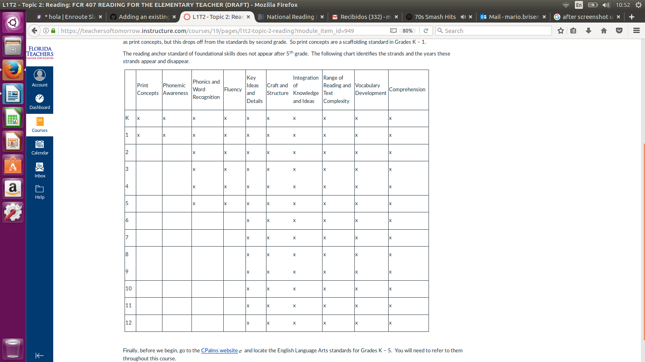

**ISSUE #5: Lesson 3 C1**

‘Pages’ dropdown show an error message.

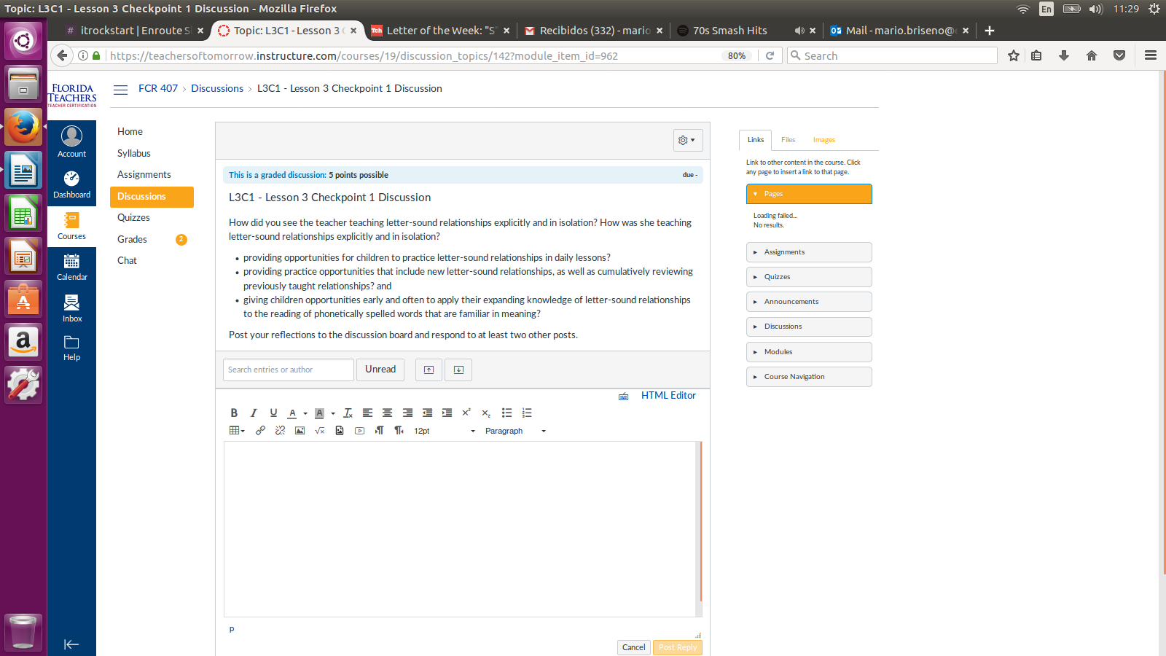

**ISSUE #6: Lesson 5 Quiz**

3 options are shown when 4 answers are commonly displayed.

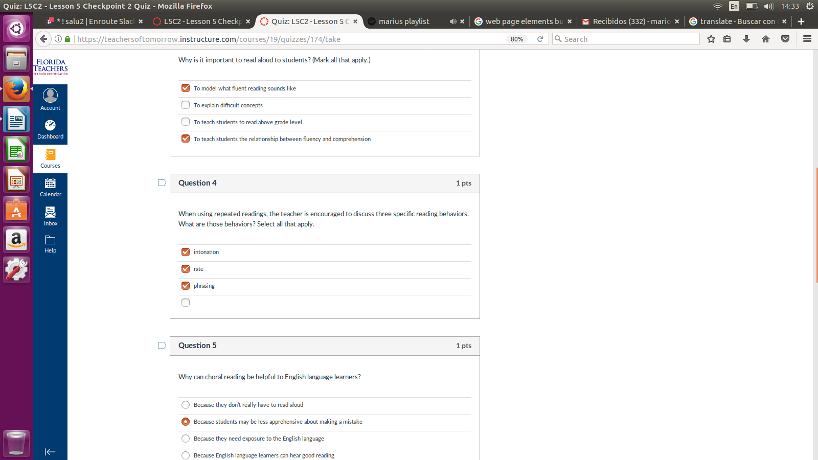

**ISSUE #7: Lesson 5 Quiz**

When quiz is finished mark all answers as the right answers but when is finished without answering any question just 2 answers are marked.

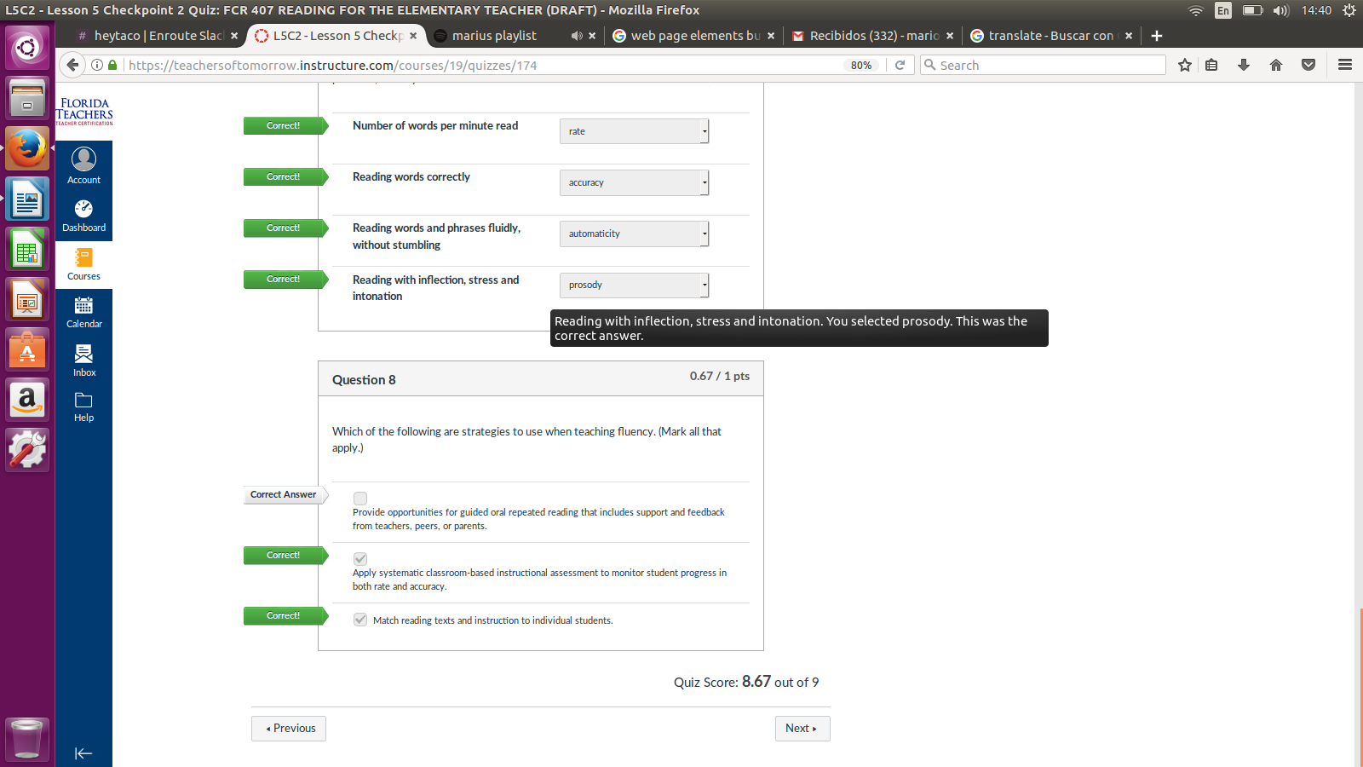

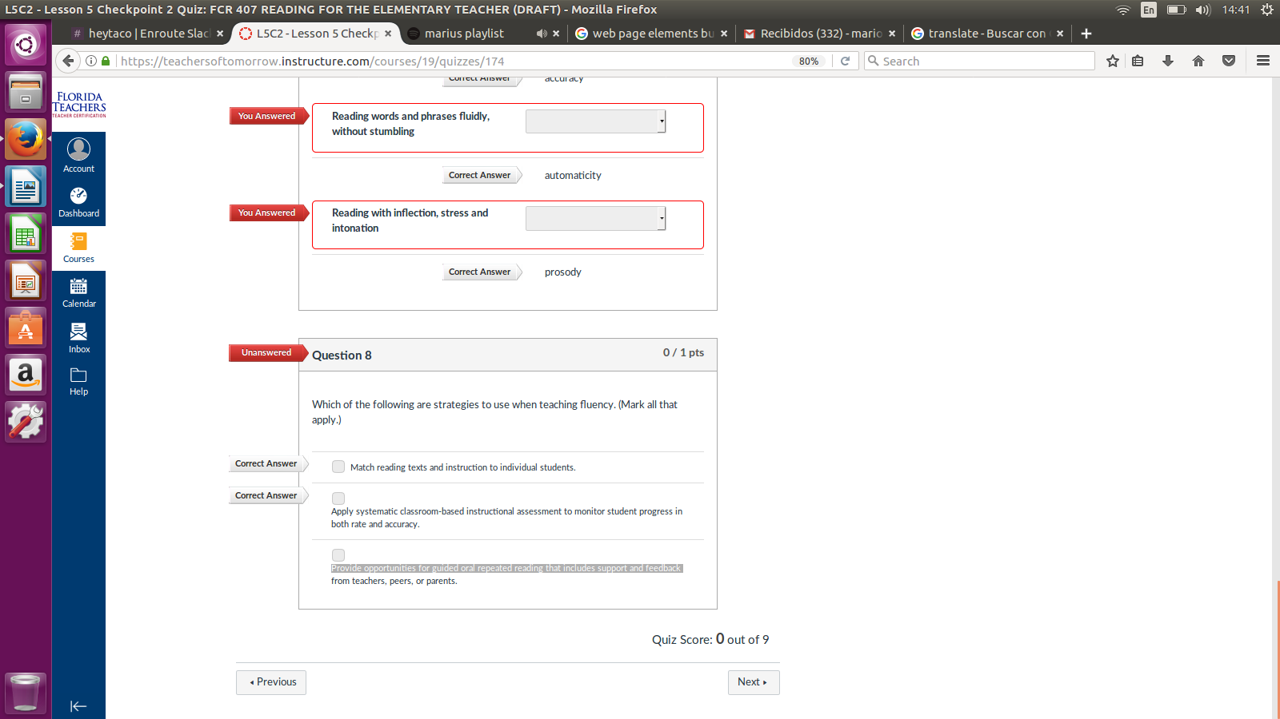

**ISSUE #8: Lesson 6 Quiz**

If ‘Next’ button is clicked it redirects to final project to another web page even when the quiz is not answered.

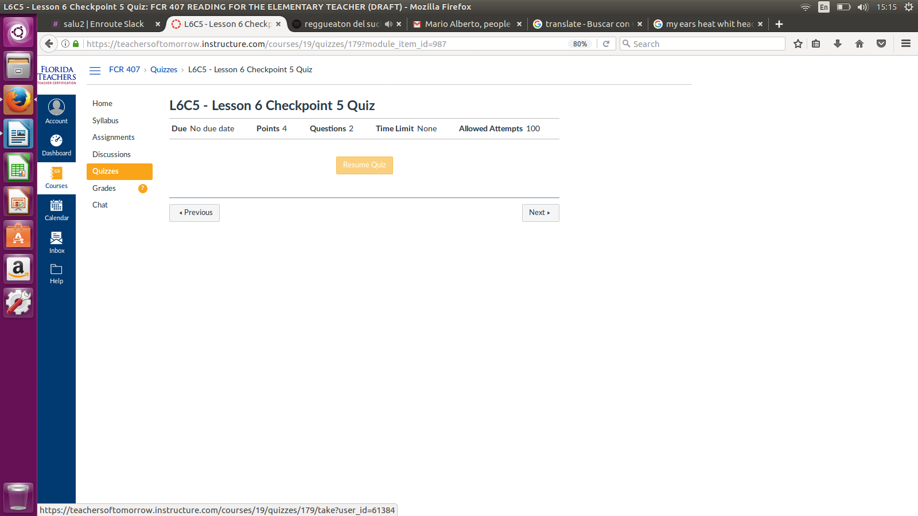

**ISSUE #: Lesson 5 Quiz**

Lesson 8 and 9 aren’t unlocked yet.

