**REPORTS:** **INNT 700.1A ASSESSMENT: THE TEACHER**

**ISSUE #0: GETTING STARTED**

In ‘INNT7001A’ should be a blank space after ‘INNT’.

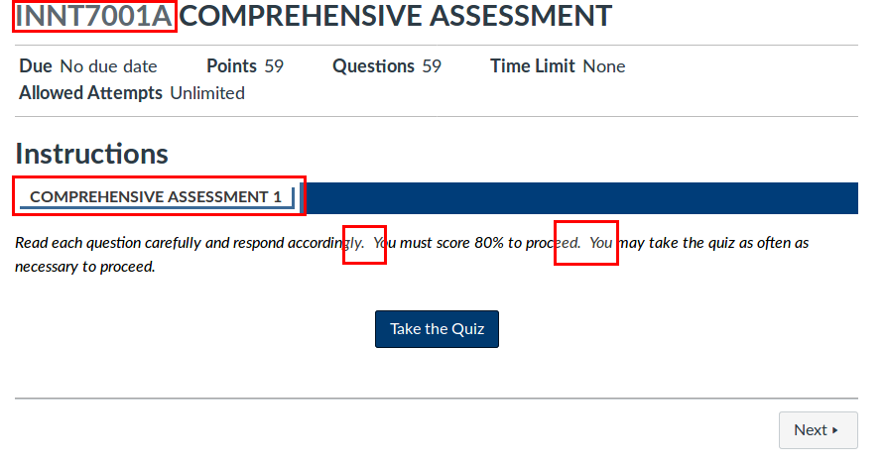

**ISSUE #1: QUIZ**

Answer is formated as a link instead of being formated as text. Question 45 has the same problem.

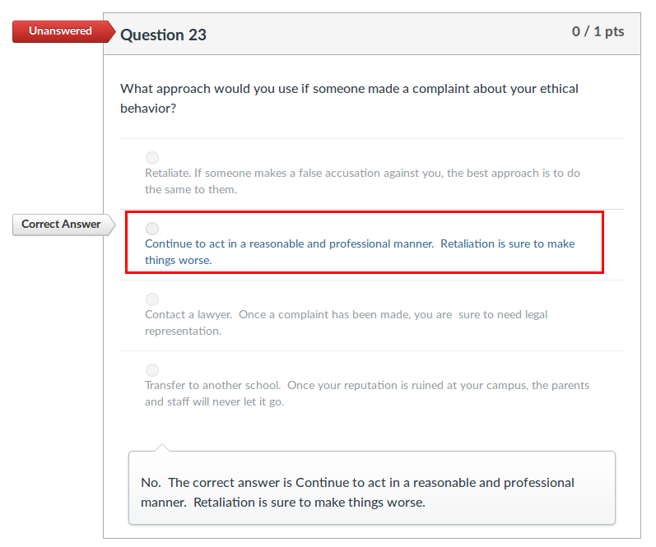

**ISSUE #2: QUIZ**

Answer is formated as a link instead of being formated as text.

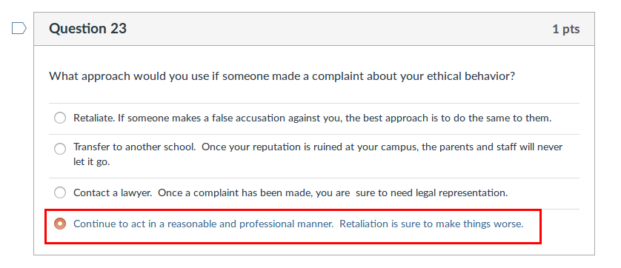

**ISSUE #3: QUIZ**

One can access to ‘congratulations’ webpage even if the quiz is no passed.

