|  |  |
| --- | --- |
| **INNT 700.1A ASSESSMENT: THE TEACHER** | |
| Browser | *Chrome* |

**Issue #*1***

Location: *Quiz*

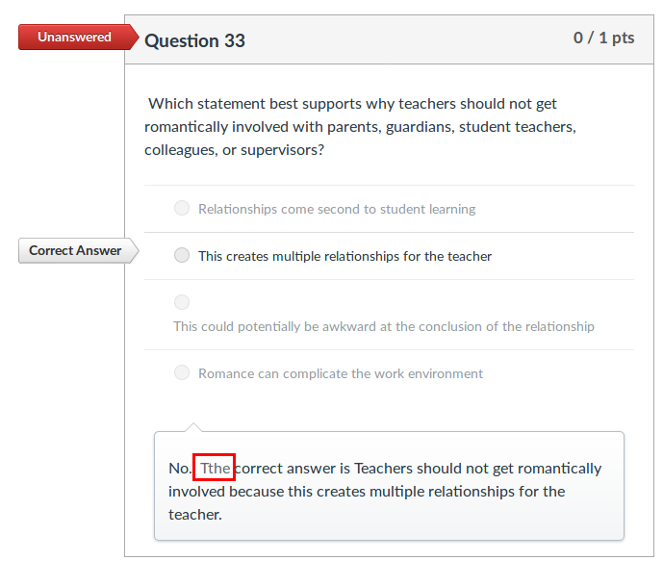Description: Questions 33 and 55 present orthographic mistakes