|  |  |
| --- | --- |
| **INNT 700.2P** **-- THE LEARNER PROJECT** | |
| Browser | *Mozilla Firefox* |
| Lessons | *None* |
| Topics | *None* |
| Questions | *None* |
| Time |  |

Issue #*1*

Location: *Project #2: Applying Child and Adolescent Developmental Theories and Strategies in the Classroom*

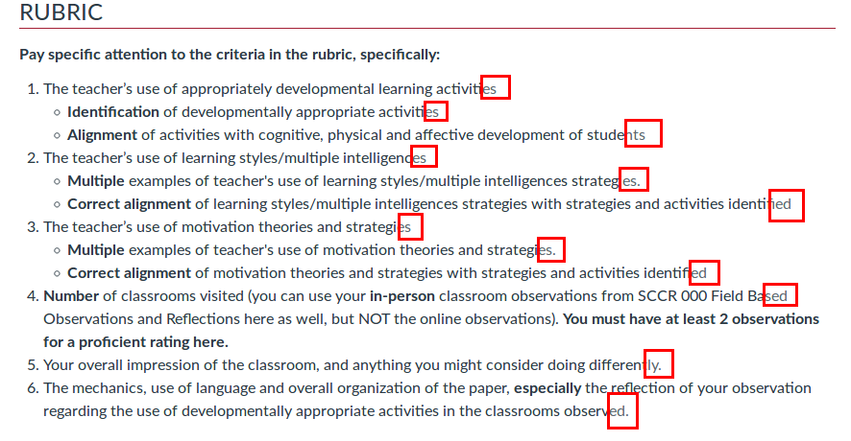Description: Some sentences end with a period, others don’t.