|  |  |
| --- | --- |
| **INTL 305:****DEVELOPING ENGLISH LANGUAGE PROFICIENCY** | |
| Browser | *Google Chrome* |
| Lessons | *7* |
| Topics | *17* |
| Questions | *17* |
| Time | *86 minutes* |

Issue #*1*

Location: L6T2

Description: Table looks like a screenshot.

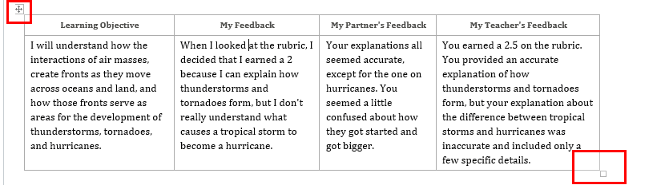

Issue #*2*

Location: Context tab, L6 T3

Description: The same URL is copied twice. It might be intended to be copied twice but looks confusing.

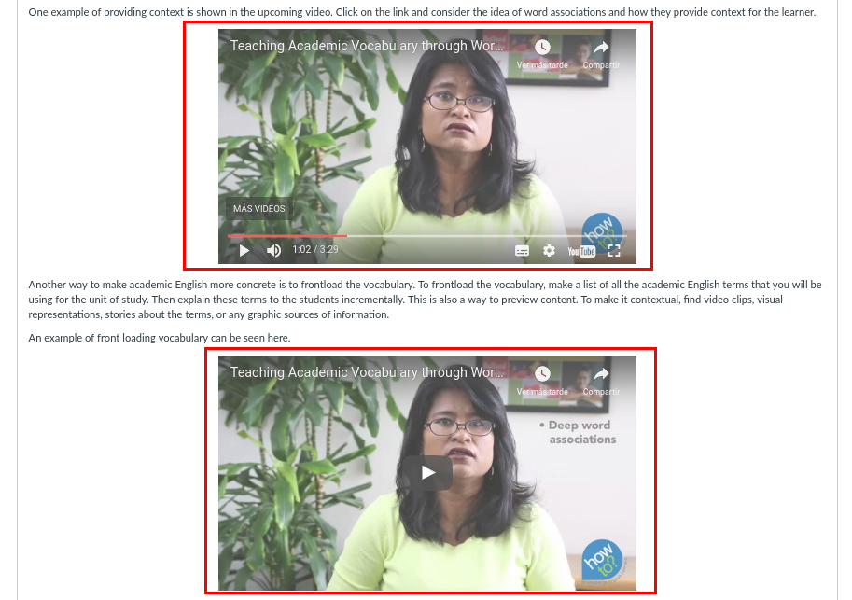

Issue #*3*

Location: L7 T1

Description: A video link is breaking a paragraph and it looks weird

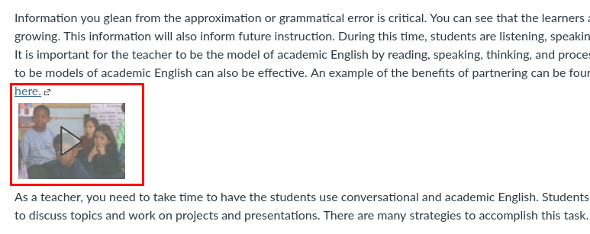

Issue #*4*

Location: Home

Description: When trying to access L6 from Home it redirects to a similar URL but it has a problem: there are not the ‘previous’ and ‘next’ buttons.

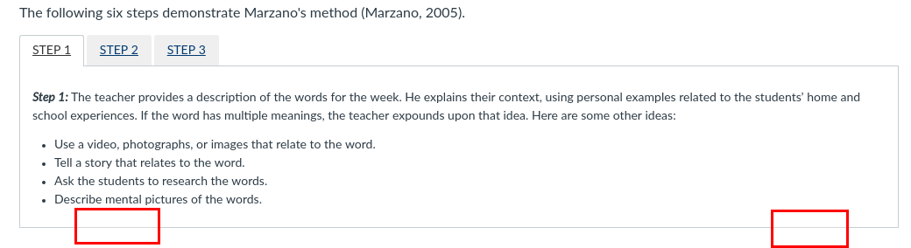

Issue #*5*

Location: L7 T2

Description: A video link is breaking the text shown at the web page.

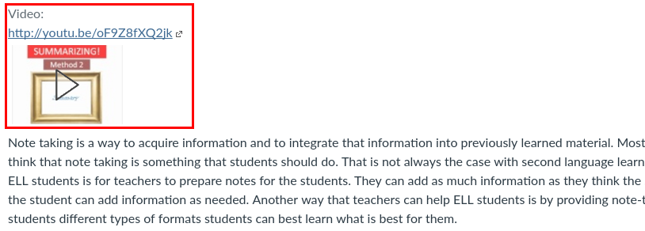

Issue #*6*

Location: L7 T2

Description: More than 1 marker is appearing at the first list element. The image is blurry.

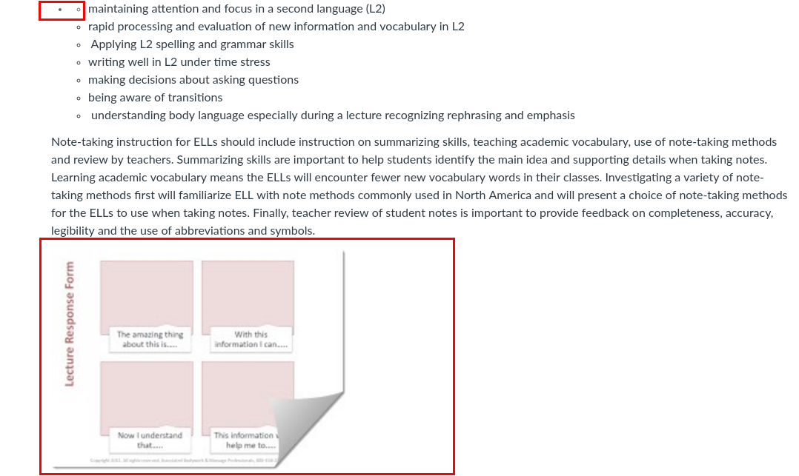

Issue #*7*

Location: Reinforcing effort tab, L7 T3.

Description: A video link is breaking the text at that web page.

