|  |  |
| --- | --- |
| **I****NTL 702** **-- CONTENT AREA LITERACY INSTRUCTION** | |
| Browser | *Chrome* |
| Lessons | *None* |
| Topics | *None* |
| Questions | *None* |
| Time |  |

**Issue #*1*** It has not been fixed.

Location: *U1L1 Quiz, unanswered, answered*

Description: At question 2, when quiz is finished without answering the quiz, there are always 2 ‘correct answer’ arrows. It doesn’t matter if the browser is chrome or firefox this is a recurrent problem.

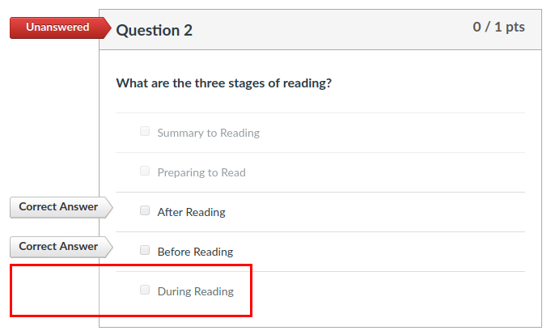

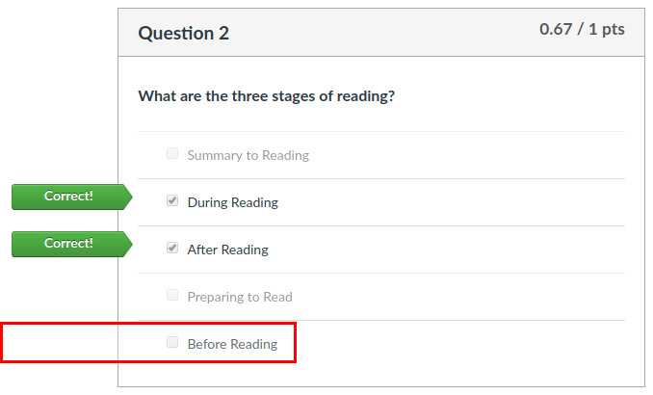

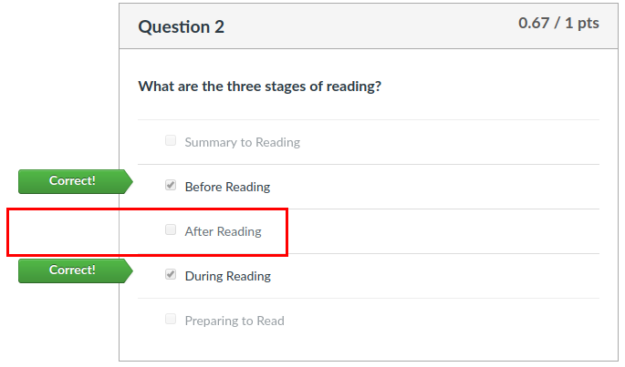

When question 2 is answered correctly the 3 ‘Correct!’ arrows are shown.

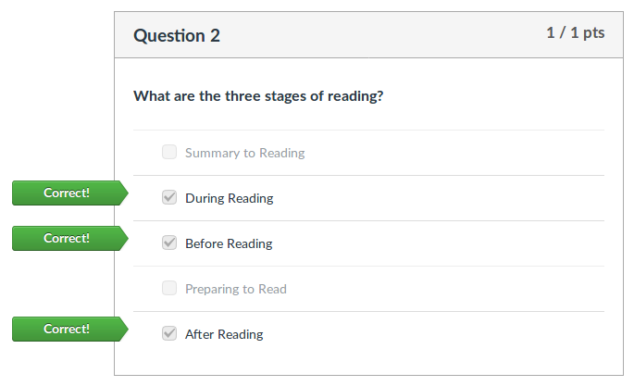

**Issue #2**It has not been fixed.

Location:

[Unit 1 Lesson 4 Discussion 2](https://teachersoftomorrow.instructure.com/courses/1749/discussion_topics/12623)

Unit 2 Lesson 1 Discussion 3

Unit 2 Lesson 3 Discussion 2

Unit 2 Lesson 4 Discussion 4

Unit 4 Lesson 2 Discussion 2

Unit 4 Lesson 3 Discussion

There’s a change in the font style in the middle of the text.

[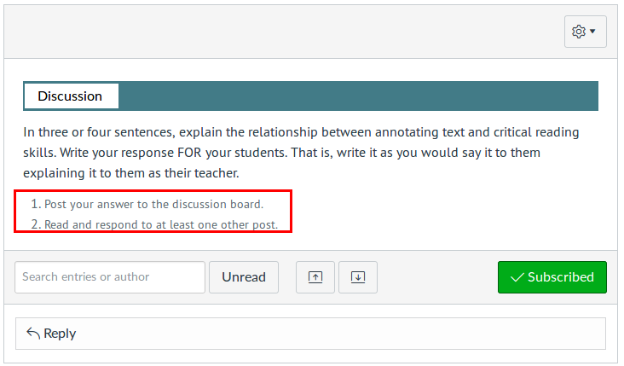](https://teachersoftomorrow.instructure.com/courses/1749/discussion_topics/12620)