|  |  |
| --- | --- |
| **INTL 702** **-- CONTENT AREA LITERACY INSTRUCTION** | |
| Browser | *Mozilla Firefox* |
| Lessons | *None* |
| Topics | *None* |
| Questions | *None* |
| Time |  |

**Issue #*1*** Not corrected

Location: *U1L1 Quiz, unanswered*

Description: Some questions are marked as ‘Unanswered’ when all answers weren’t answered. Question number 3 has the same problem.

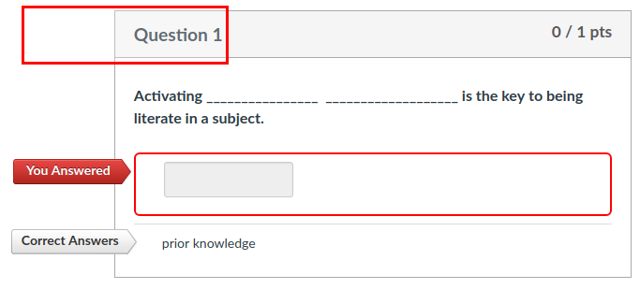

**Issue #*2*** Not corrected

Location: *U1L1 Quiz*

Description: 3 questions are correct answers but 1 answer arrow is missing.

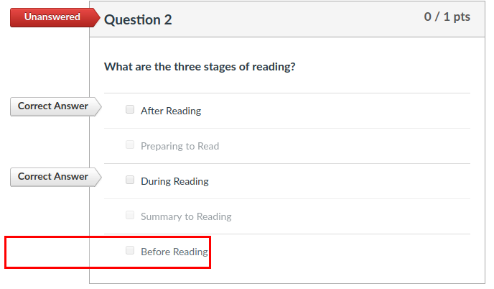

**Issue #3**

Location: *U1L1 Quiz, answered.*

Description: ‘Correct Answers’ arrow still appears even when question was answered correctly.

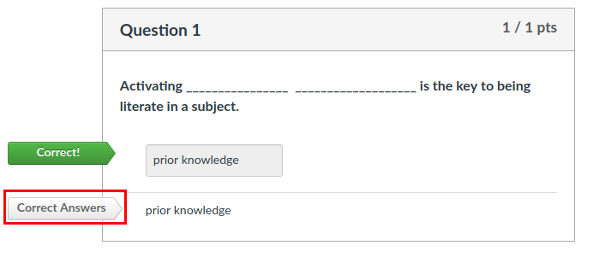

**Issue #4 Not corrected**

Location: *U4L4 Discussion*

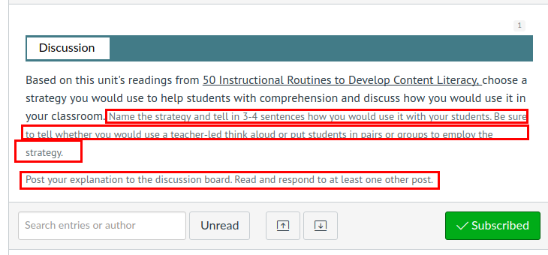Description: There is a change of font style in the middle of the text