**REPORTS:** **INTL 702** **CONTENT AREA LITERACY INSTRUCTION v2**

**ISSUE #0: GETTING STARTED**

A blank space after ‘:’ may be good.

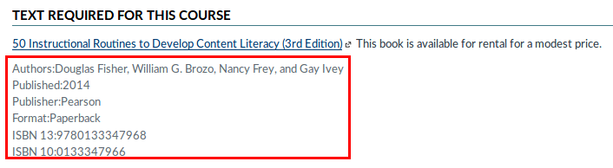

**ISSUE #1: U1L1T1**

Unused space.

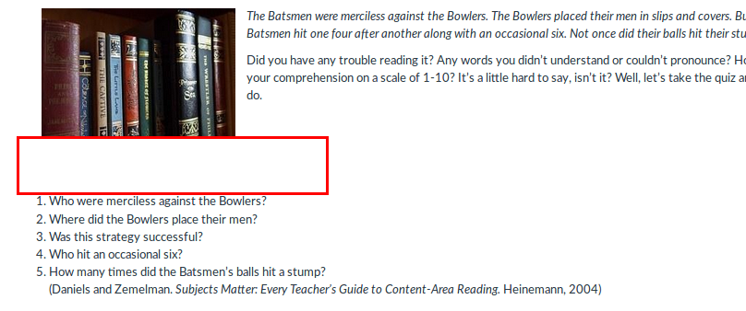

**ISSUE #2: U1L1T1**

There are some extra blank spaces at the end of some sentences.

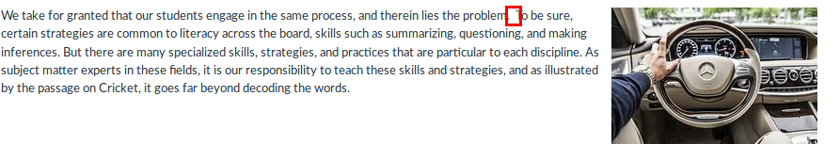

**ISSUE #3: U1L1 D1**

There are some extra blank spaces at the end of some sentences. Header ‘Discussion’ is within a white box. Shouldn’t be there.

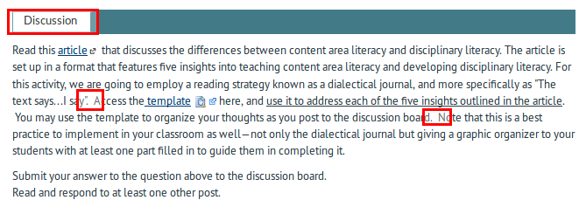

**ISSUE #4: U1L1 Quiz**

Same ISSUE as ISSUE #3.

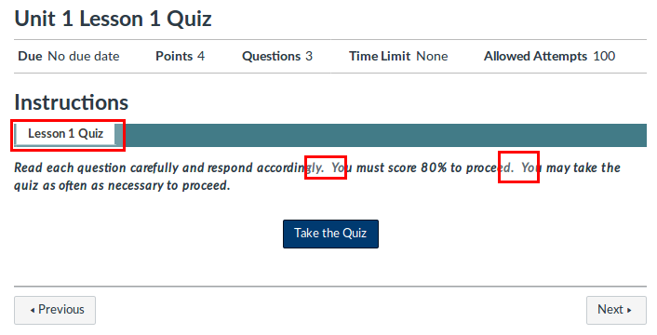

**ISSUE #5: U1L1 Quiz**

2 answers are marked as the correct answers but ‘Before Reading’ doesn’t disappear.

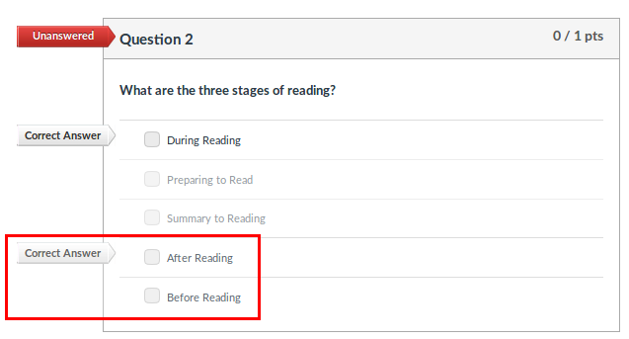

**ISSUE #6: U1 L1 Quiz**

Question 3 doesn’t have a ‘unanswered’ red marker as question 2.

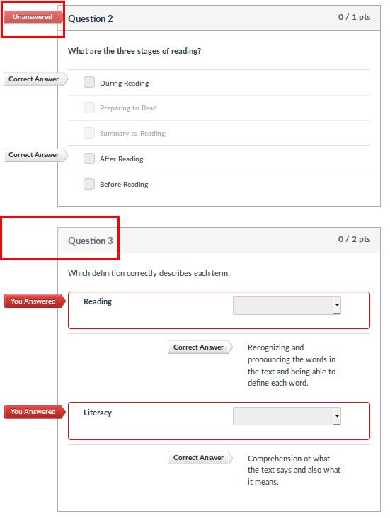

**ISSUE #7: U1 L2 T1**

After some sentences there are 2 blank spaces. This is a recurrent problem and it appears in almost every topic, at every lesson.

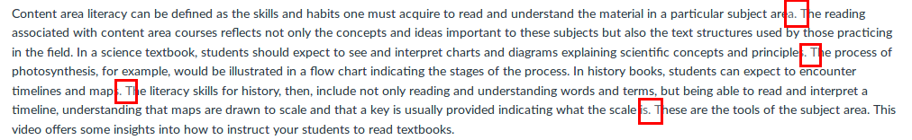

**ISSUE #8: U1 L2 Discussion**

‘Discussion’ is within a white box at the header. This problem appears at every discussion at every lesson.

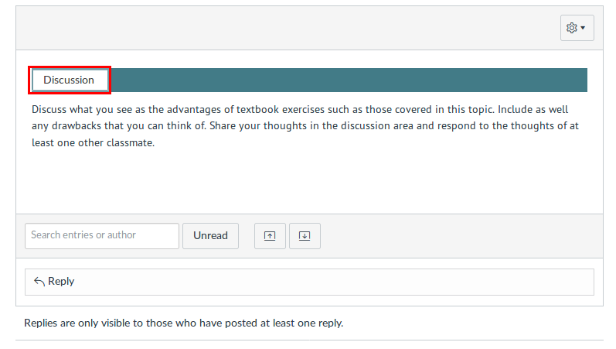

**ISSUE #9: U1 L2 Quiz**

‘Lesson 2 Quiz’ is within a white box at the header. This problem appears in every quiz at every lesson, and also there are 2 blank spaces after every sentence.

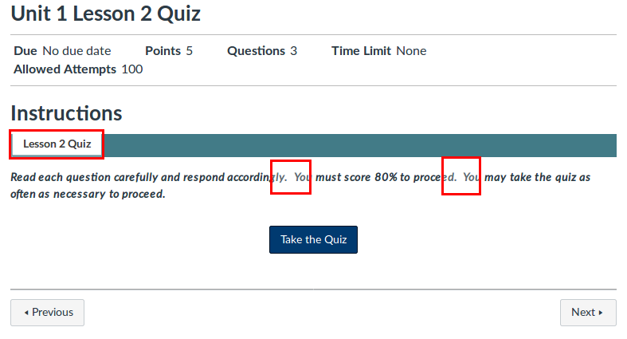

**ISSUE #10: U1 L3 T3**

Same problem as ISSUE 8.

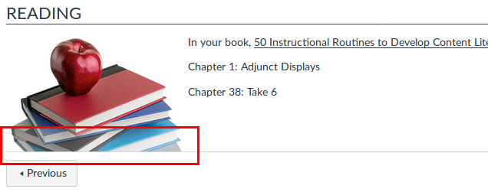

**ISSUE #11: U2 L1 T3**

‘Discussion’ is within a white box at the header. This problem appears at every discussion at every lesson.

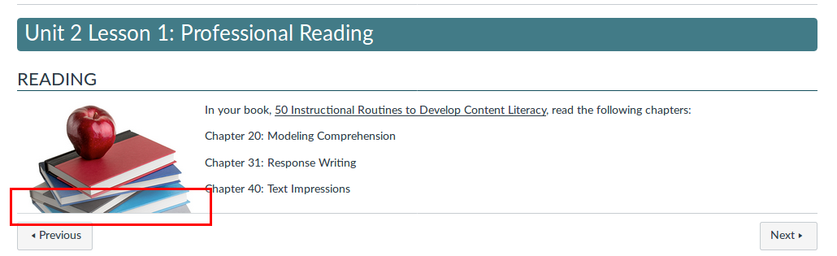

**ISSUE #12: U1 L2 T3**

‘Discussion’ is within a white box at the header. This problem appears in every Discussion at every lesson, and also there are 2 blank spaces after some sentences.

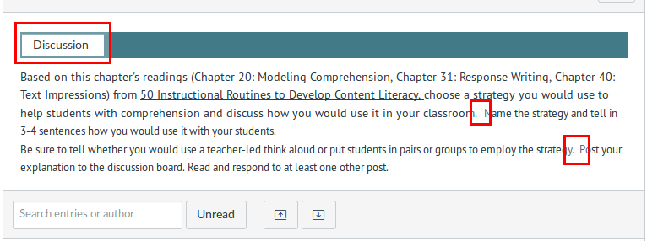

**ISSUE #13: U2 L2 T3**

‘Discussion’ is within a white box at the header. This problem appears in every Discussion at every lesson, and also there are 2 blank spaces after some sentences.

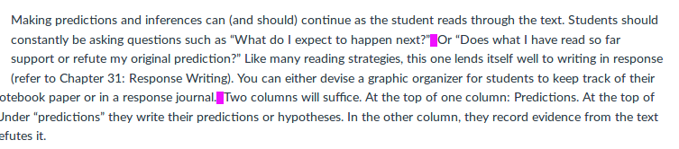

**ISSUE #14: U2 L2 Discussion 1**

‘Discussion’ is within a white box at the header. This problem appears in every Discussion at every lesson at every unit.

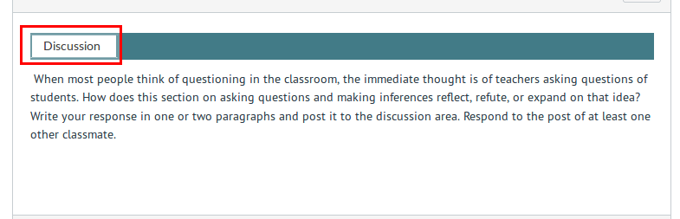

**ISSUE #15: U2 L2 Discussion 2**

‘Discussion’ is within a white box at the header. This problem appears in every Discussion at every lesson at every unit.

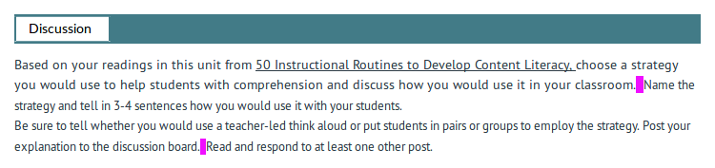

**ISSUE #16: U2 L2 Discussion 2**

‘Lesson 2 Quiz’ is within a white box at the header. This problem appears in every quiz at every lesson at every unit.

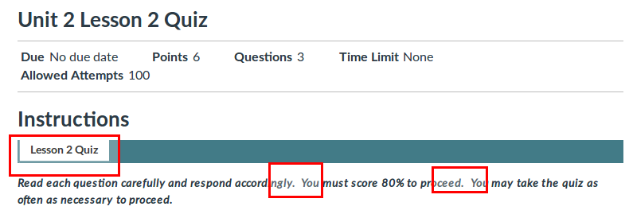

**ISSUE #17: U2 L2 Quiz**

Same problem as ISSUE #11.

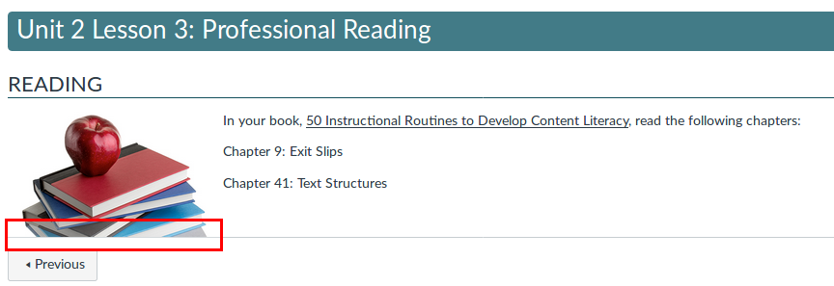

**ISSUE #18: U2 L4**

Same problem as ISSUE #11.

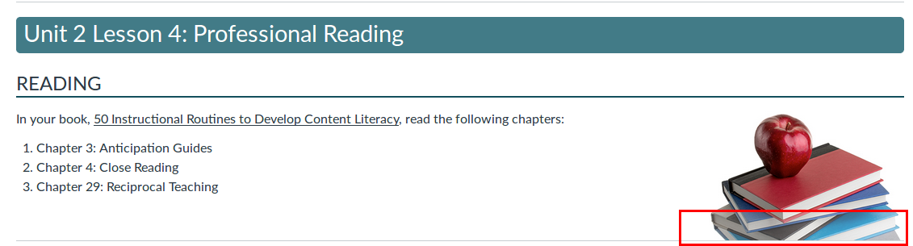

**ISSUE #19: U3 L1 Discussion**

Same problem as ISSUE #11. Suddenly the font type of some text changes. After the underlined text a blank space is also underlined.

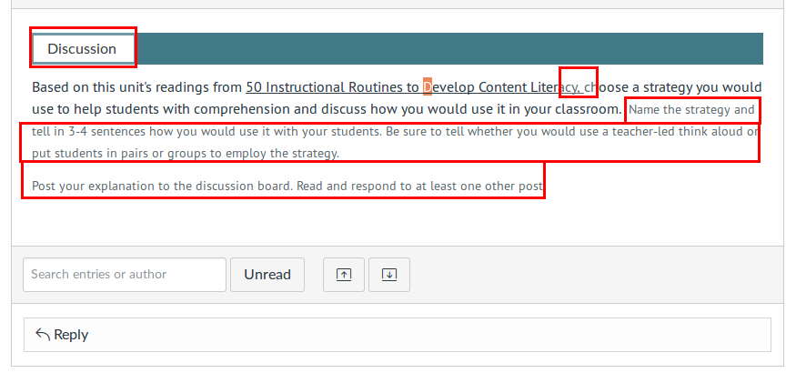

**ISSUE #20: U3 L2**

Same problem as ISSUE #11.

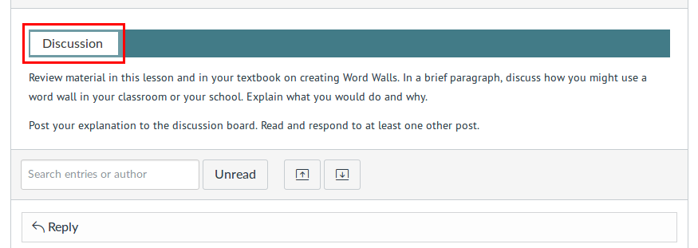

**ISSUE #21: U3 L2 Quiz**

‘Lesson 2 Quiz’ is within a white box at the header. This problem appears in every quiz at every lesson at every unit.

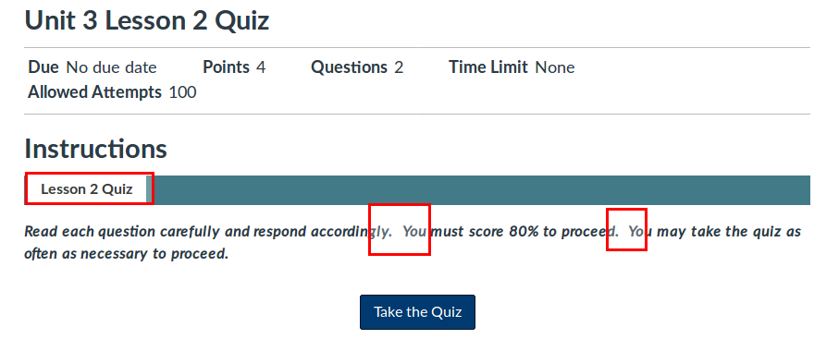

**ISSUE #22: U4 L1 Discussion 1**

Elements enclosed by red box should be formated as list elements. Also this ISSUE has the same problem as ISSUE #11.

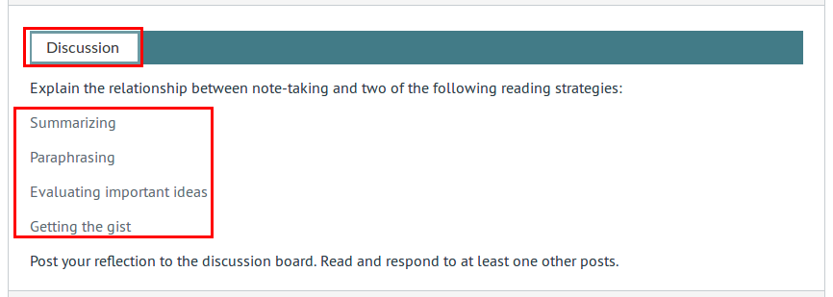

**ISSUE #23: U4 L1 Discussion 2**

Same problem as ISSUE #19.

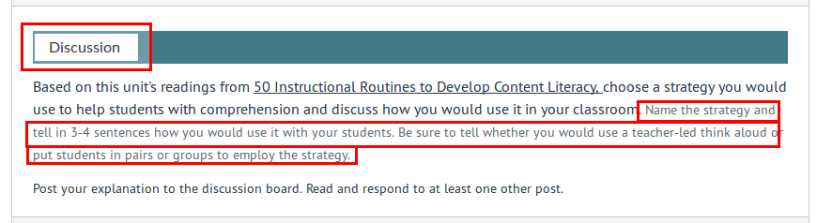

**ISSUE #24: U4 L1 Quiz**

Same problem as ISSUE #21. This problem occurs in every quiz in Unit 4.

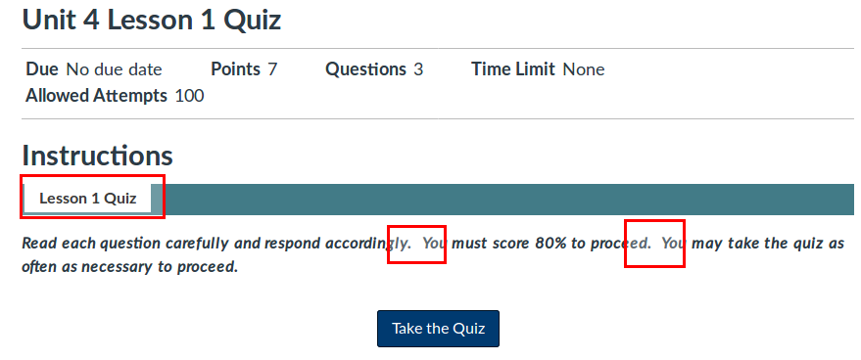

**ISSUE #25: U4 L3 T2.**

Elements enclosed by red box should be formated as list elements.

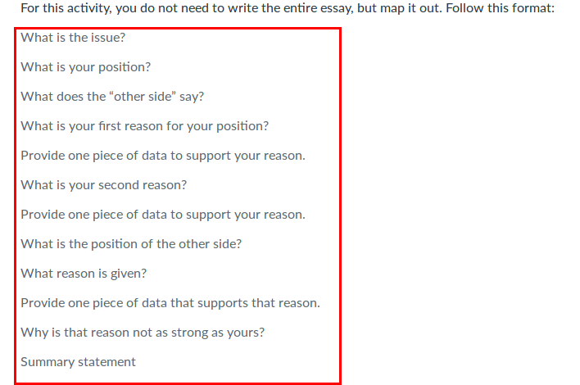

**ISSUE #26: U4 L1 Discussion 2**

Same problem as ISSUE #23.

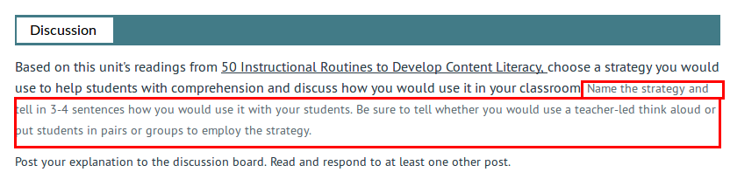

**ISSUE #27: U4 L4 Discussion 2**

Same problem as ISSUE #19.

