|  |  |
| --- | --- |
| **I****NTL 702** **-- CONTENT AREA LITERACY INSTRUCTION** | |
| Browser | *Chrome* |
| Lessons | *None* |
| Time | *42 minutes* |

**Issue #*1***

Location: [**Unit 3 Lesson 2 Discussion**](https://teachersoftomorrow.instructure.com/courses/1825/discussion_topics/13341)

Description: The whole text is formated with another font size that is not commonly used.

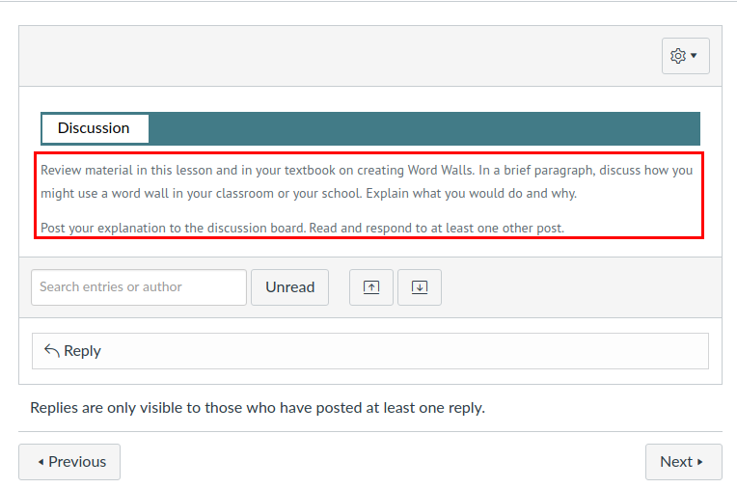

**Issue #*2***

Location:[**Unit 2 Lesson 2 Discussion 2**](https://teachersoftomorrow.instructure.com/courses/1825/discussion_topics/13344)**, Unit 4 Lesson 2 Discussion 2**

Description: There are different font sizes within the text.

