## **REPORTS: TTL 501 CASE STUDIES AND FIELD WORK IN CLASSROOM MANAGEMEN**

**ISSUE #0: Getting started**

The Word “PHYSICAL” is misspelled at **DOMAIN III** section.

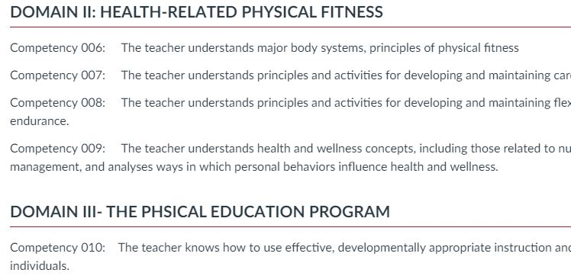

There’re 2 capital letters in the word **Physical.** Column titles show inconsistent use of capital letters. A “?” appears in the middle of the text.

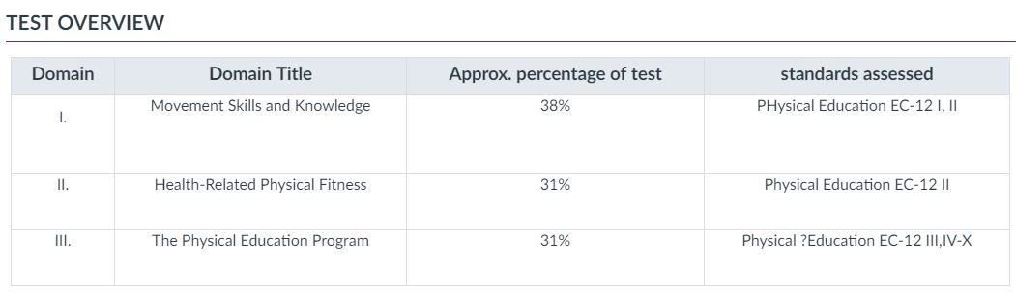

A period is missing at the end of the sentence.

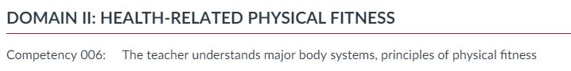

**ISSUE #1: Competency 001: The teacher understands and applies principles of motor development and motor learning.**

The sentence *For websites please visit*: looks confusing. No URLs or links were provided, just a search suggestion.



**ISSUE #2: Competency 002: The teacher understands principles and practices for developing, combining and integrating motor skills.**

Set of link looks messy and the sentence ‘Body Systems’ looks confusing.

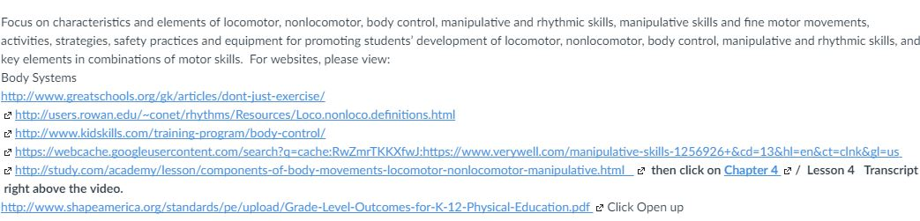

**ISSUE #3: Competency 005: The teacher understands principles, techniques, skills and safety practices for dance, personal performance activities, cooperative and nontraditional games, recreational activities and outdoor pursuits.**

There’re 2 blank spaces at the end of every sentence.

.

**ISSUE #4: Competency 005: The teacher understands principles, techniques, skills and safety practices for dance, personal performance activities, cooperative and nontraditional games, recreational activities and outdoor pursuits.**

‘open up’ is an inconsistent use of comments next to the URLs

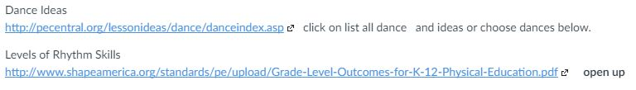

**ISSUE #5: Competency 006: The teacher understands major body systems, principles of physical fitness development and training and the benefits of a healthy, active lifestyle.**

Two blank spaces after ‘lifetime,’. Bolded words ‘and see competency 001 and 002’ don’t show consistency.

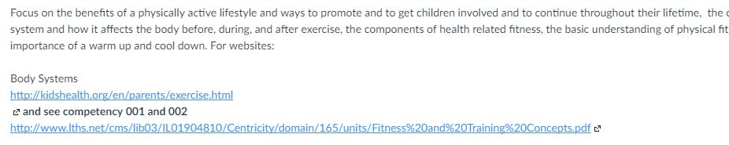

**ISSUE #6: Competency 007: The teacher understands principles and activities for developing and maintaining cardiovascular endurance.**

Sometimes URLS are not shown in a consistent way.



**ISSUE #7: Competency 008: The teacher understands principles and activities for developing and maintaining flexibility, posture and muscular strength and endurance.**

There’s no space between the text and the URL.

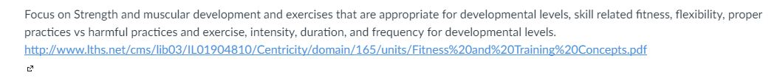

**ISSUE #8: Competency 009: The teacher understands health and wellness concepts, including those related to nutrition, weight control and stress management, and analyses ways in which personal behaviors influence health and wellness.**

The text doesn’t refer to the URL as: ‘For websites:’ just as the past competencies.

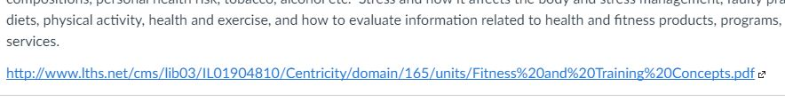

There’re 2 blank spaces.

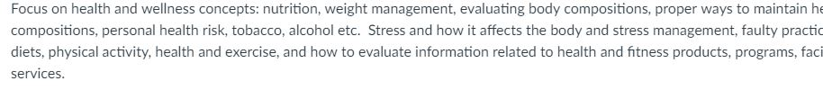

Weird ‘E’ in the middle of 2 sentences.



There’s no space between the text and the URLs, also, it looks messy.

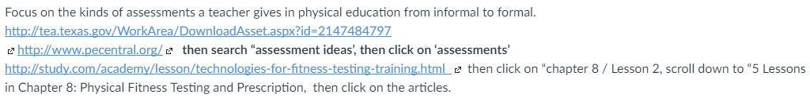

**ISSUE #9: Competency 011: The teacher understands factors relevant to learning and performance in physical education and uses this knowledge to create learning environments and opportunities that promote students’ development in various domains (e.g., cognitive, social, emotional).**

There’s just 1 single marker. Other elements (2,3,..) don’t have that marker.

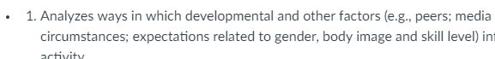

The text below the number 8 doesn’t have the same font size

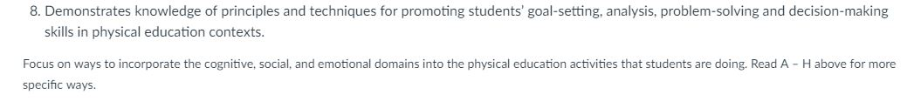

**ISSUE #10: Competency 012: The teacher understands the structure, organization, goals and purposes of physical education** programs**.**

There are 2 blank spaces.



**ISSUE #11: Competency 013: The teacher understands legal issues and responsibilities of physical education teachers in relation to supervision, planning and instruction, safety, first aid and risk management.**

There’s just 1 list markers next to 1-list element.



URLs looks messy.

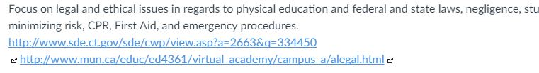

**ISSUE #11: Test Resources**

Broken URL.



