**REPORTS:** [**TTL 403 THE INTEGRATED CURRICULUM**](https://teachersoftomorrow.instructure.com/courses/1514)

**ISSUE #0**

‘Getting started’ and ‘Start Here’ redirect to the same, unlocked module.

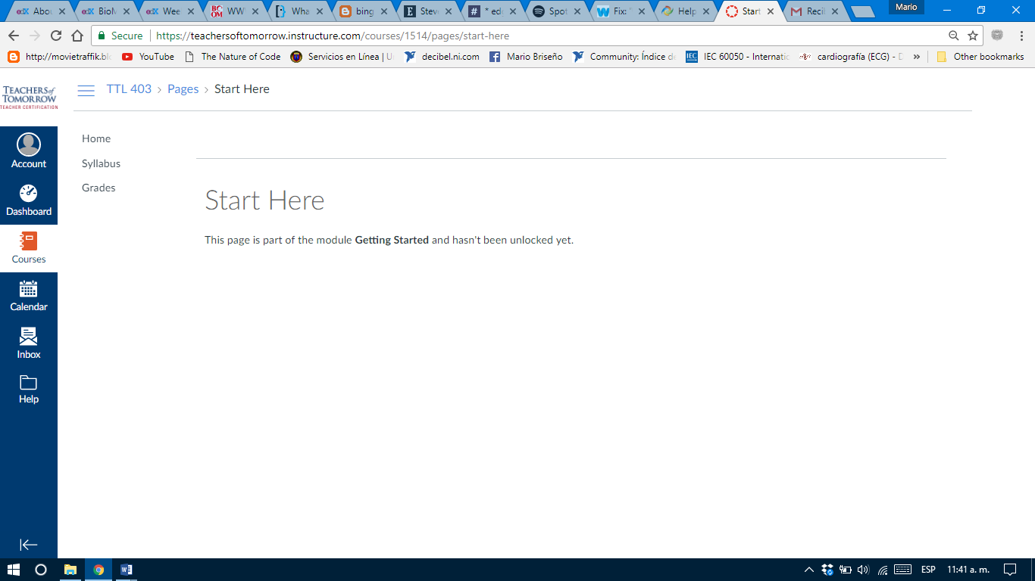

**ISSUE #1: L1T1**

After some sentences there’re 2 blank spaces. The end of the second paragraph looks like a list is going to be presented but the text below does not have the format.

