**REPORTS:** [**(DEV) TTL 404 MATERIALS AND RESOURCES K - 12**](https://teachersoftomorrow.instructure.com/courses/1515)

**ISSUE #0**

When the course is shown to be accepted the title appears twice.

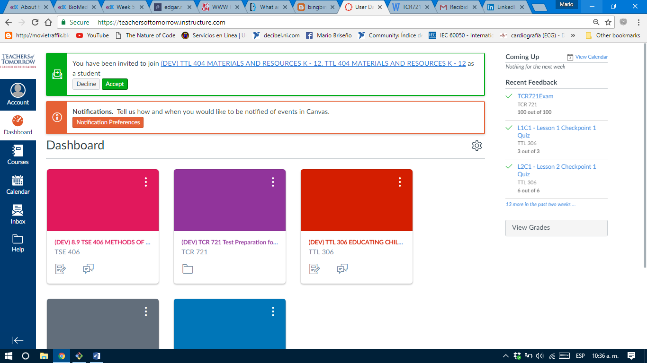

**ISSUE #1:**

The name of the course is not shown after ‘TTL-404’.

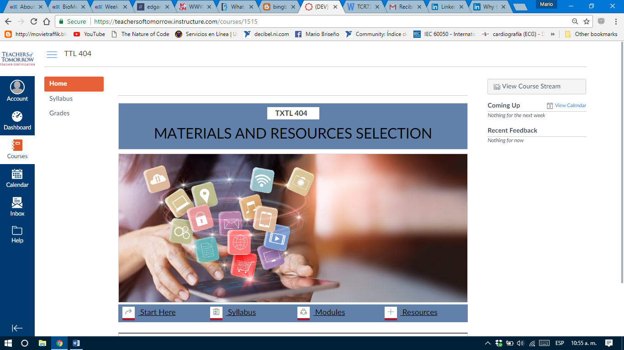

**ISSUE #2: Pages > Start here.**

Maybe some list markers should be put before every sentence.

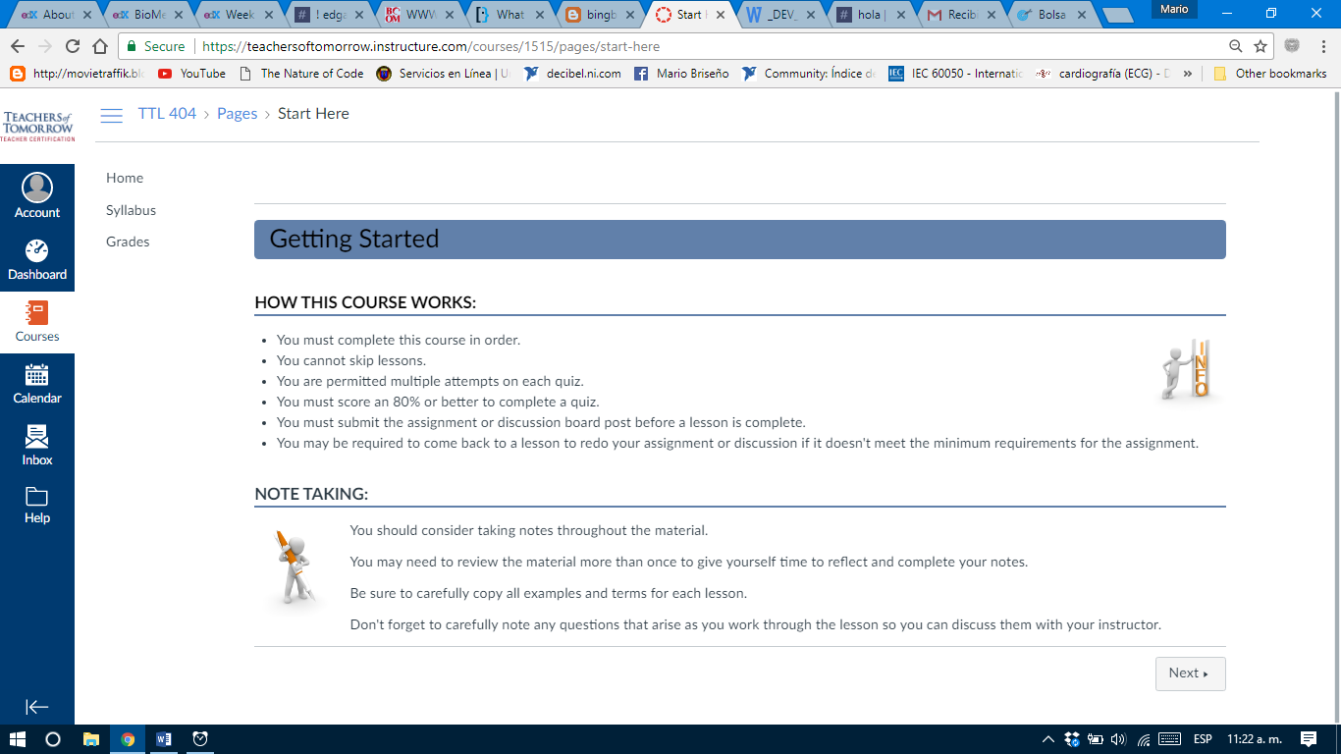

**ISSUE #3: L1T1**

There’re 2 blank spaces after some sentences are finished.

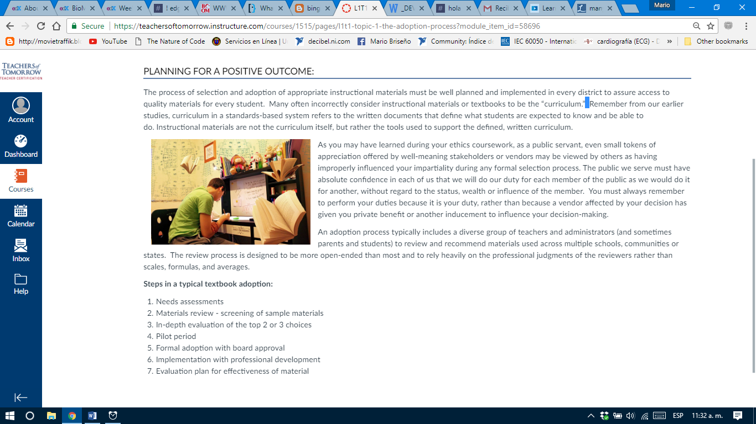

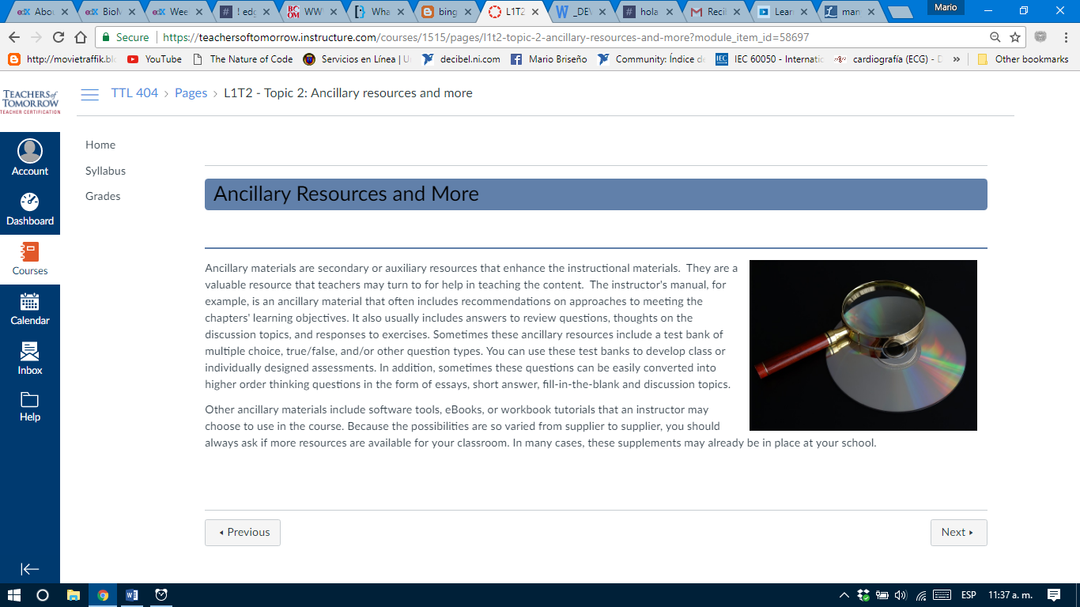

**ISSUE #4: L1 D**

The header ‘Discussion’ is framed in a white box.

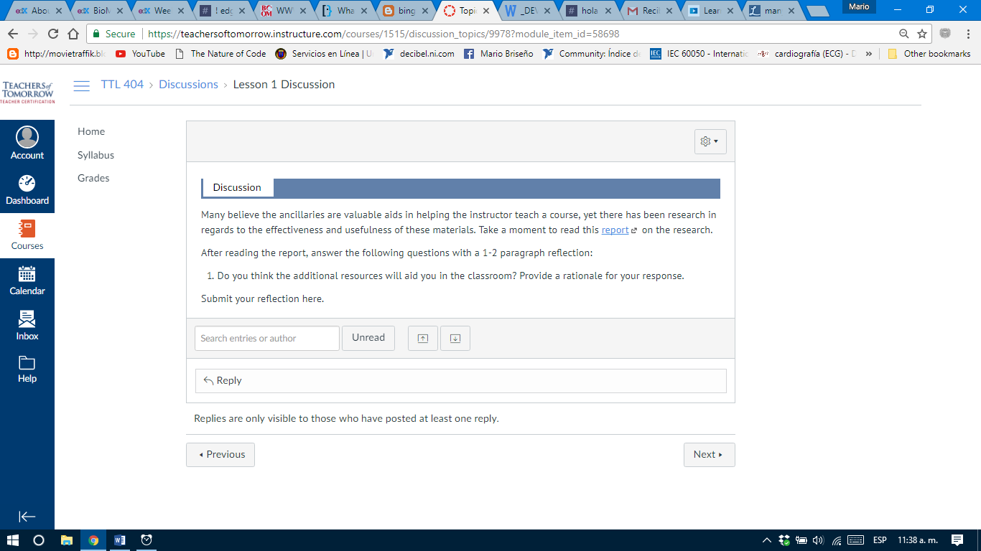

**ISSUE #5: L1 Quiz**

‘Lesson 1 Quiz 1’ is enclosed within a white box.

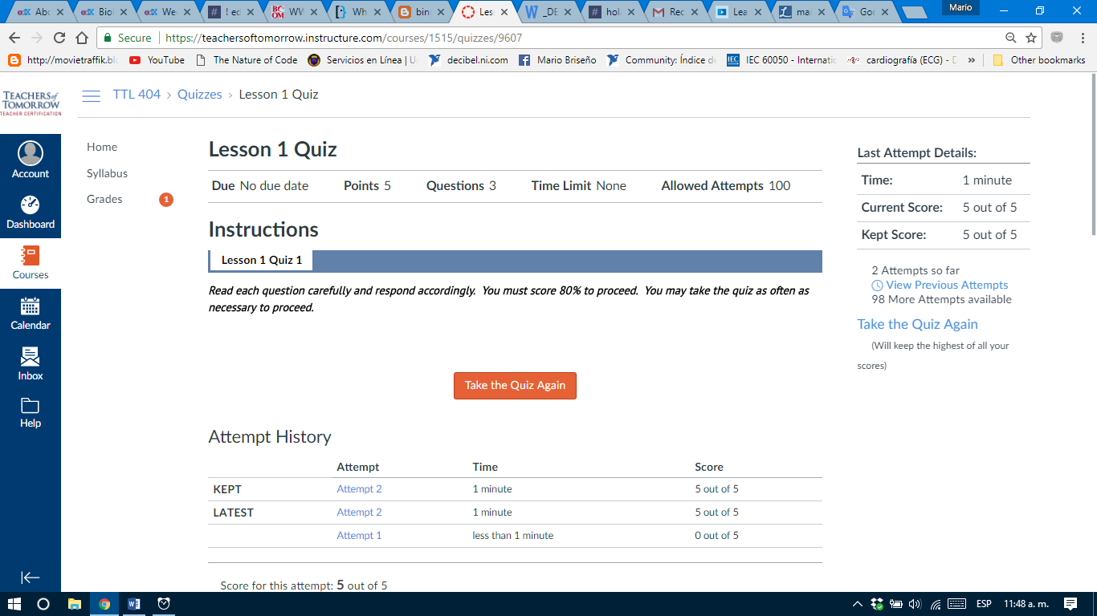

**ISSUE #6: L2T1 Quiz**

There’re 2 blank spaces.

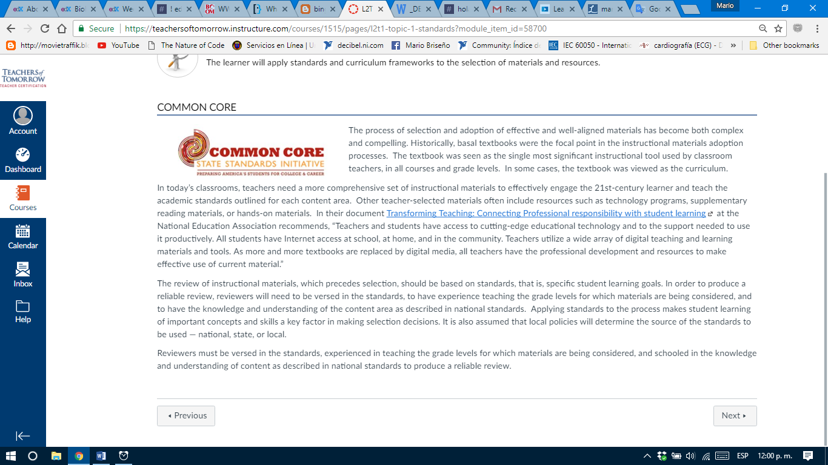

**ISSUE #7: L2 D**

‘Lesson 1 Discussion 1’ is enclosed within a white box.

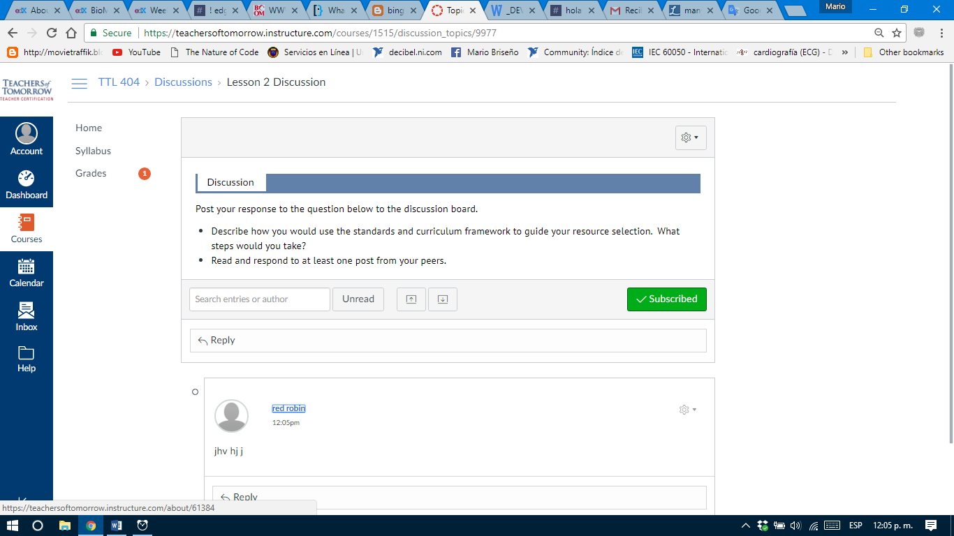

**ISSUE #8: L2 Quiz**

‘Lesson 2 Quiz 1’ is enclosed within a white box. Formula copied from Wikipedia as an image included a reference that is not in the text.

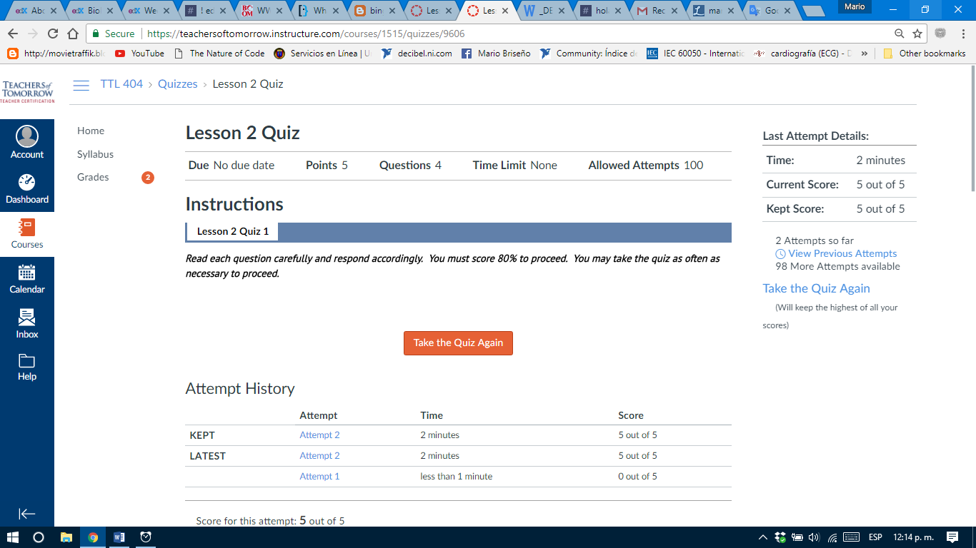

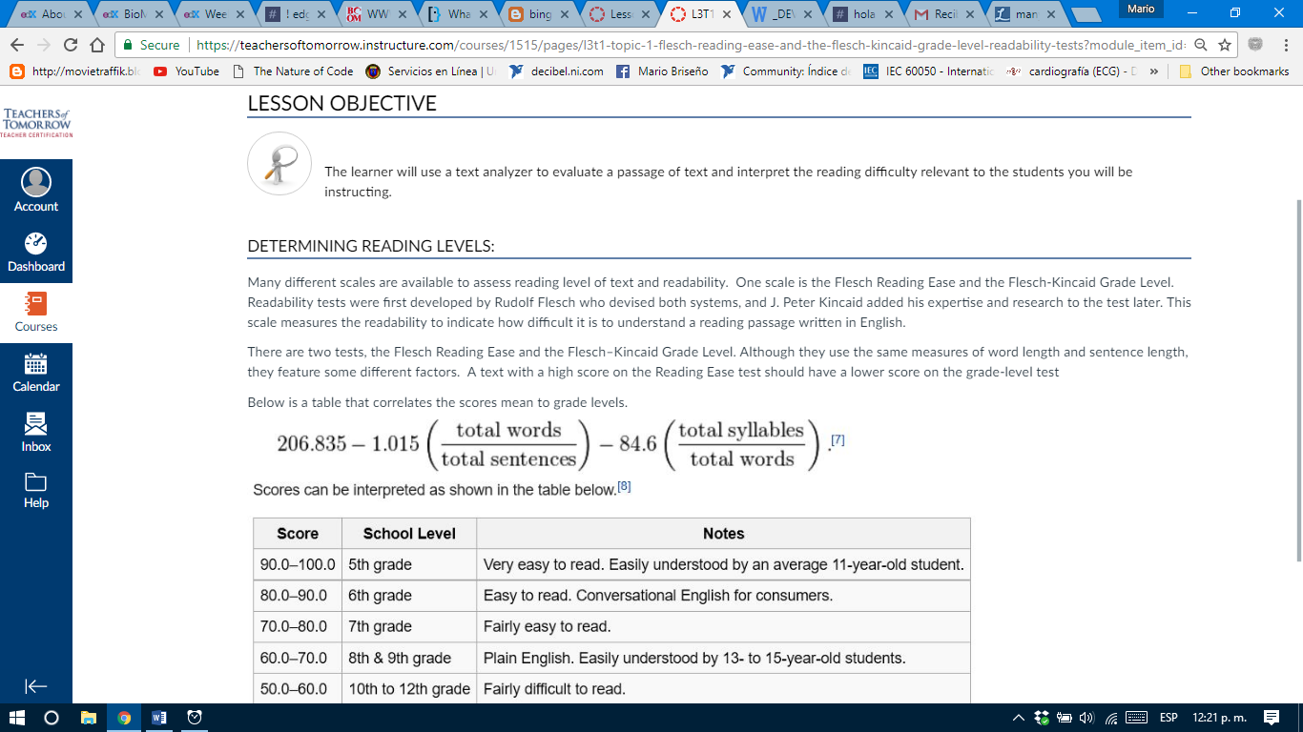

**ISSUE #9: L3 Discussion**

‘Discussion is enclosed within a white box.

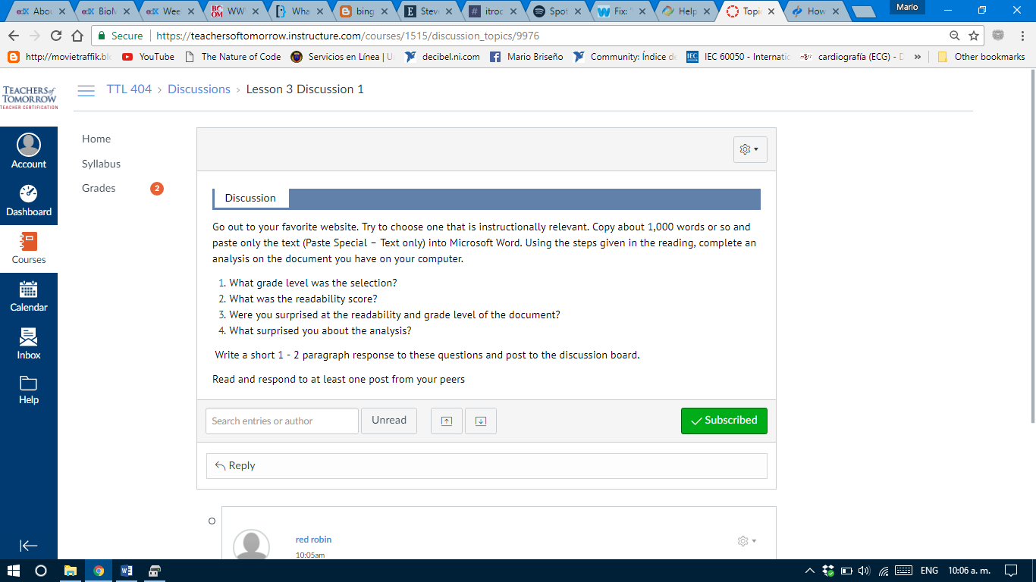

**ISSUE #10: L3 Discussion 2**

‘Discussion is enclosed within a white box.

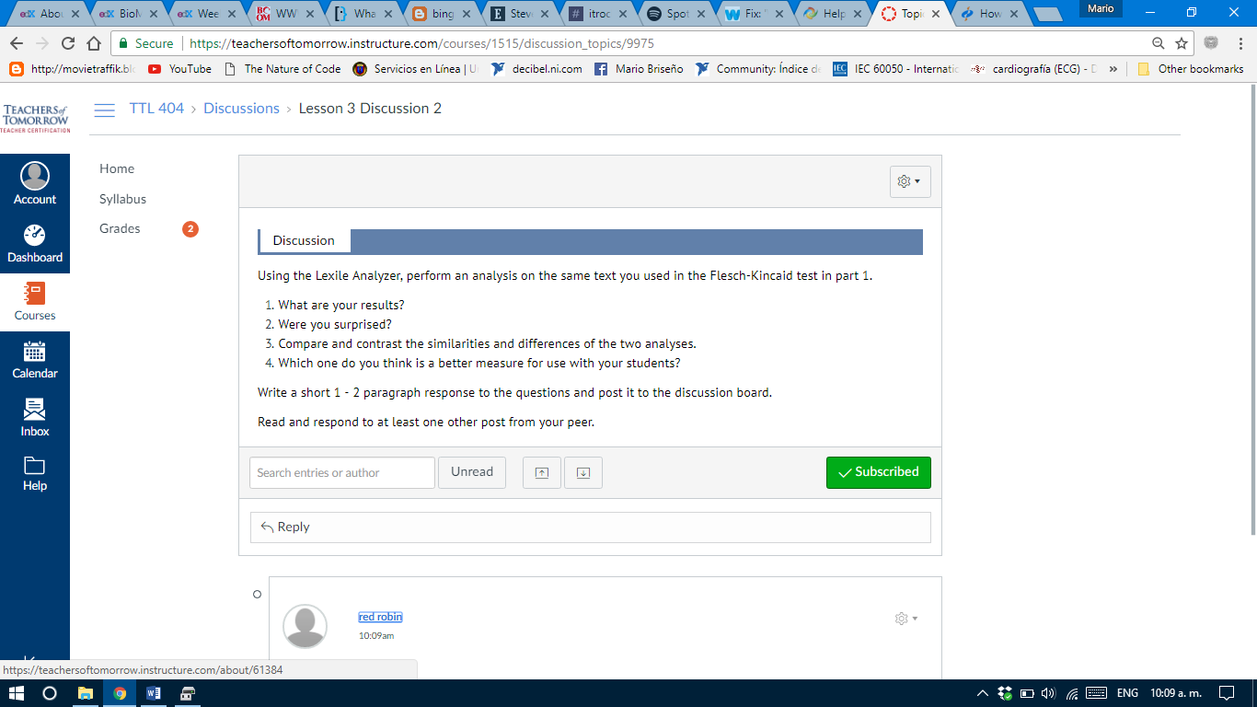

**ISSUE #11: L4T1**

There’re many blank spaces.

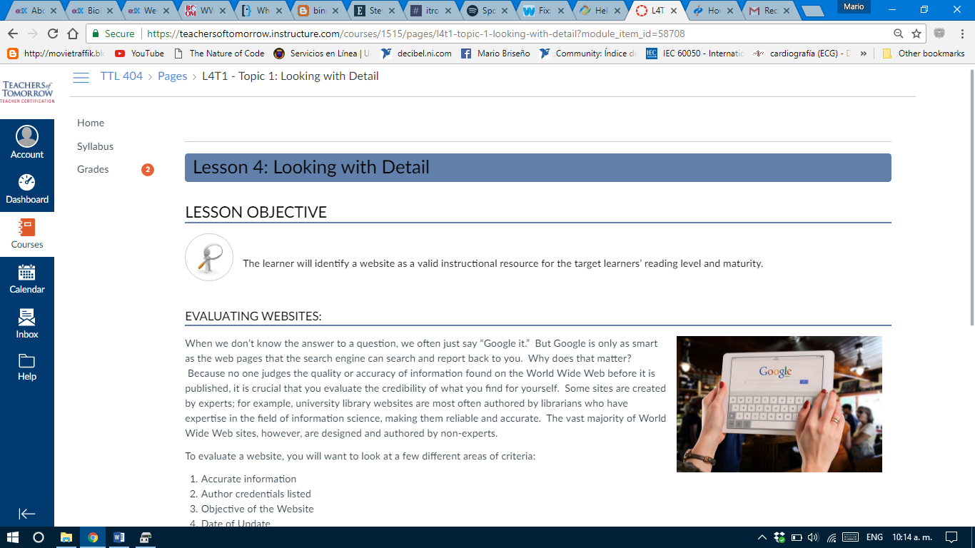

**ISSUE #12: L4T1**

There’s an orthographic mistake at ‘you must then decide if it right for your students?

There’re many blank spaces.

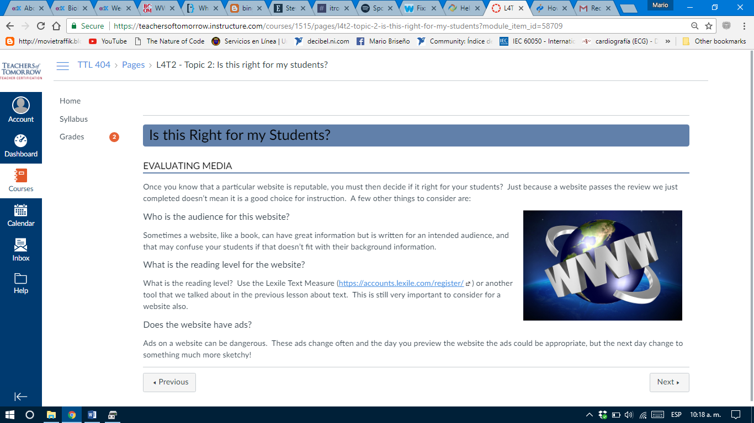

**ISSUE #13: L4 Discussion.**

‘Discussion is enclosed within a white box.

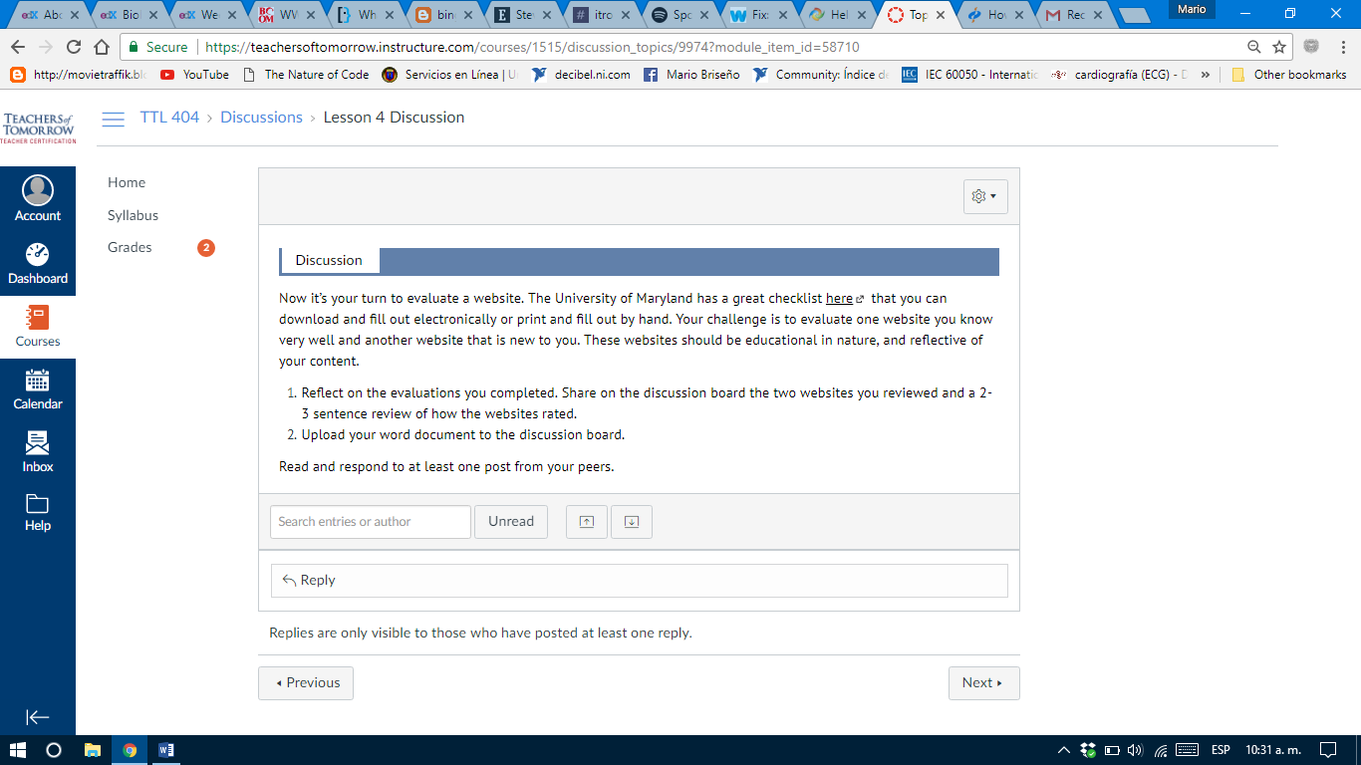

**ISSUE #14: L5T1**

There’re many double blank spaces.

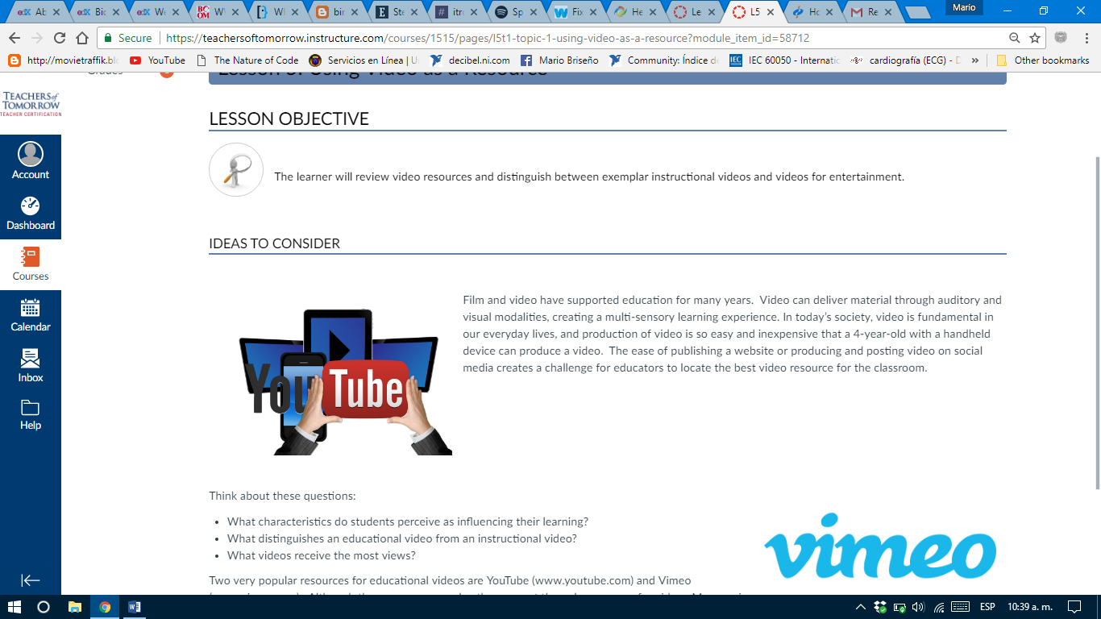

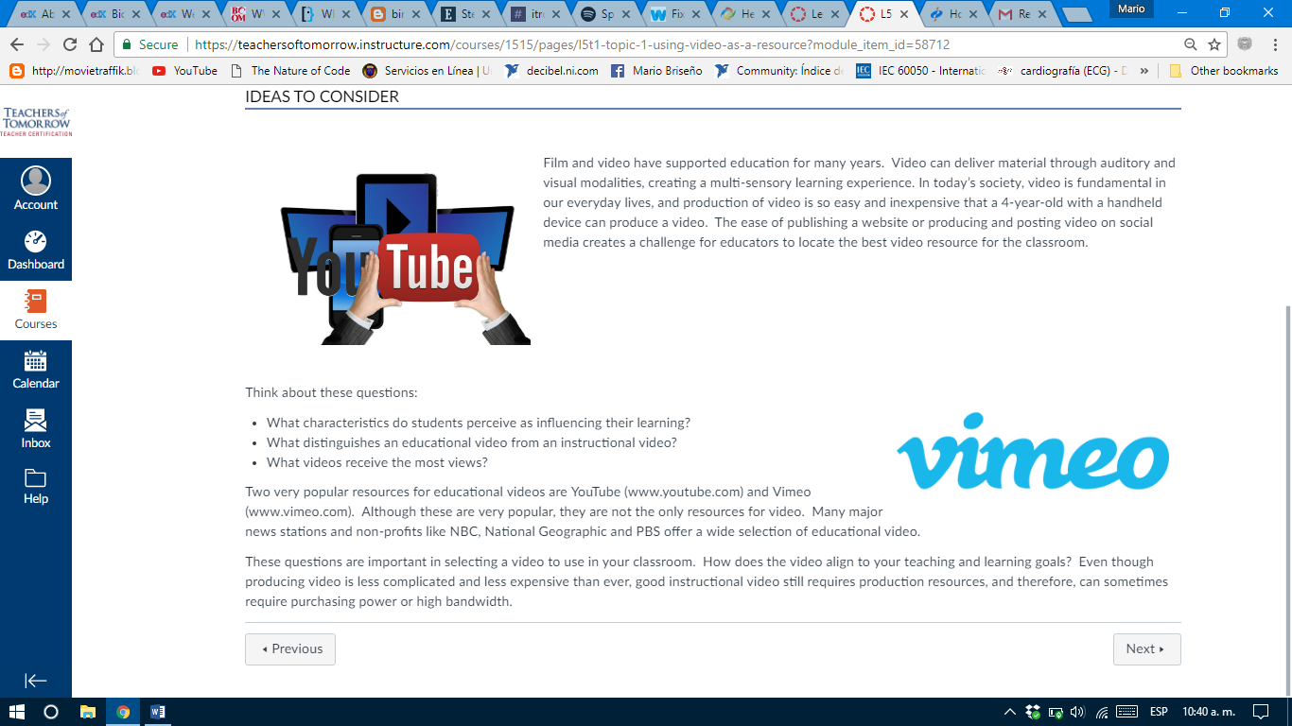

**ISSUE #15: L5T1**

Text at list elements 7,8,9 and 10 starts with a lowercase letter.

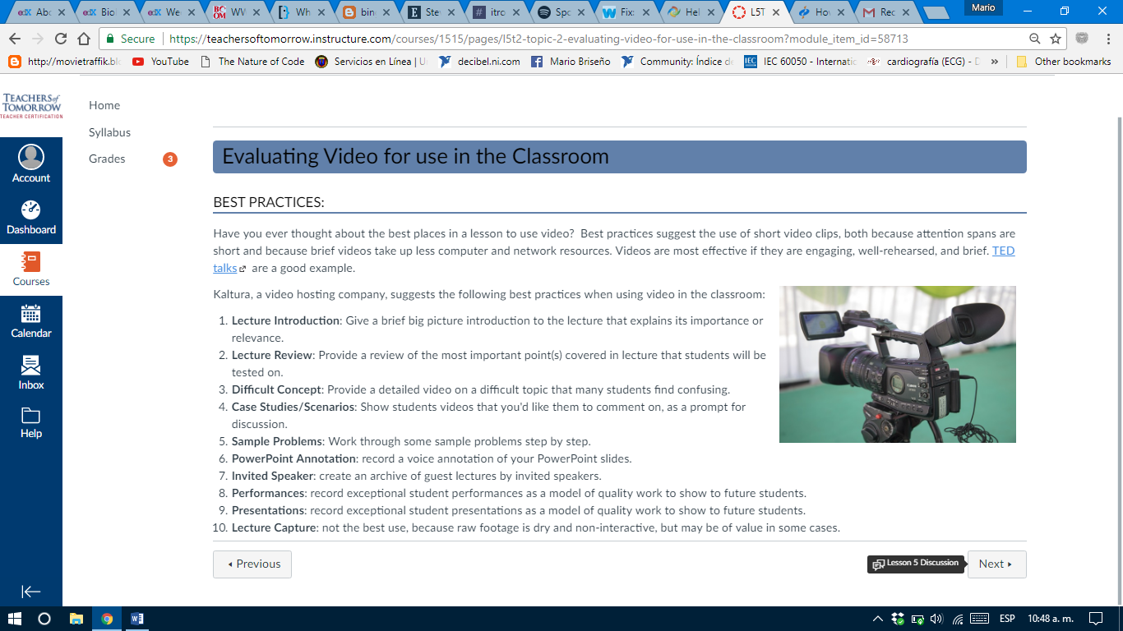

**ISSUE #16: L5 Discussion**

‘Discussion is enclosed within a white box.

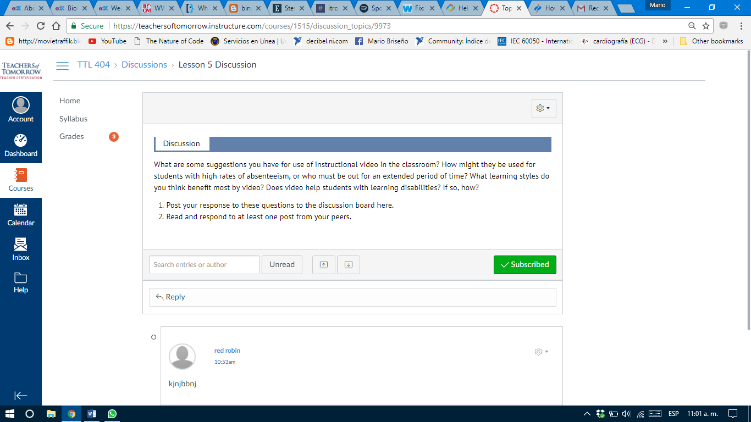

**ISSUE #17: Resources**

There’re many 2 blank spaces. A link doesn’t work

