## **REPORTS: (DEV) TTL 411 INDEPENDENT STUDY - INTEGRATING TECHNOLOGY**

**ISSUE #0: Getting started**

Markers at this page and all ‘Lesson objective’ pages appear to have the same mistake. Listed elements and their markers are separated by the image.

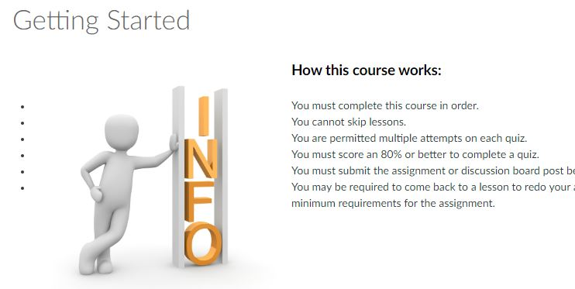

# **ISSUE #1: L1T1 - Topic 1: SAMR and TPACK Frameworks**

There’re some grammar mistakes in the text.

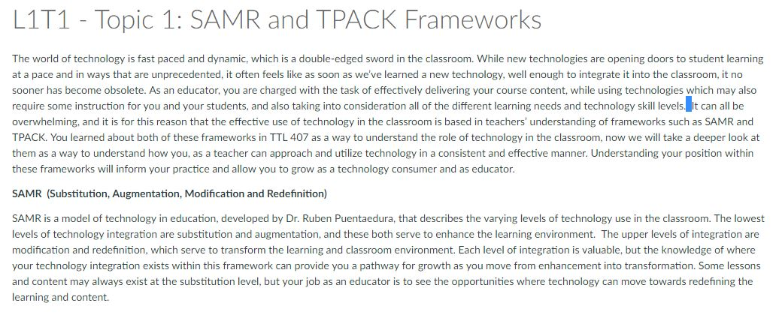

# **ISSUE #2: L1T1 - Topic 1: SAMR and TPACK Frameworks**

An URL is shown as text.

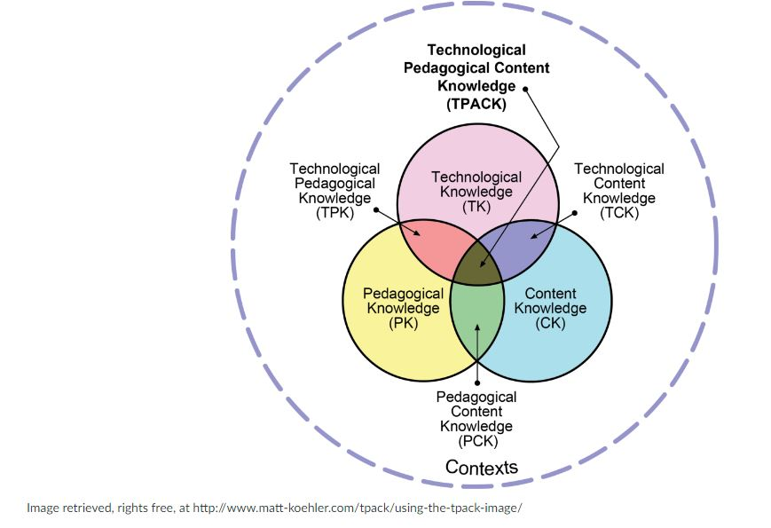

# **ISSUE #3: L3 - Lesson Objective**

The listed sentences are not consistent. While the second sentence starts with an uppercase letter, the end the first one doesn’t have a period.

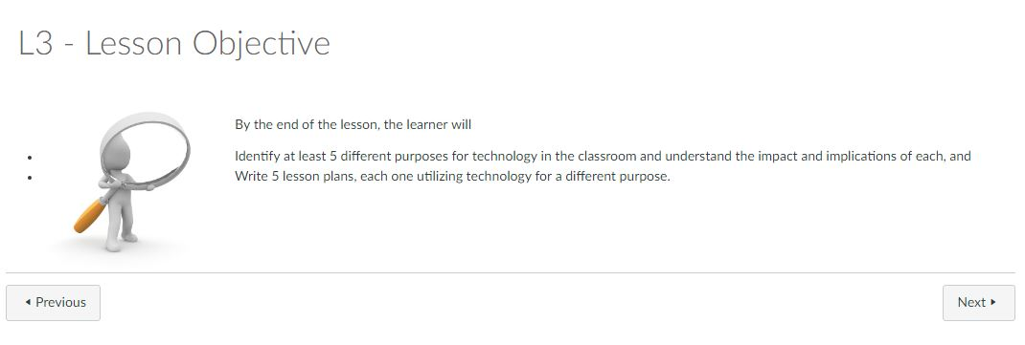

# **ISSUE #3: L3T1 - Topic 1: Technology as a Presentation Tool**

An URL doesn’t work.

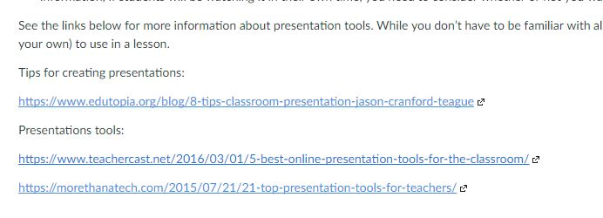

# **ISSUE #4: L3T3 - Topic 3: Technology for Student Research or Primary Source Information**

Blank spaces appear twice when a sentence ends and other starts.

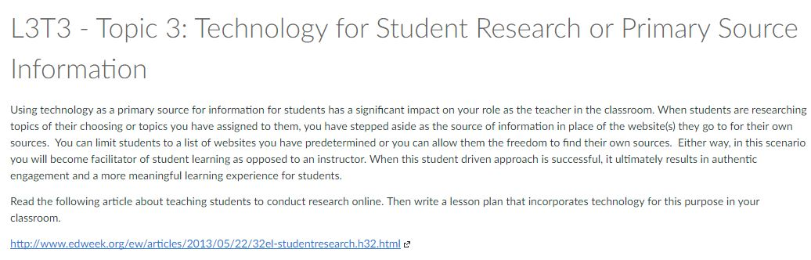

# **ISSUE #5: Courses**

When the course is finished it took me out.

