## **REPORTS: TTL 501 CASE STUDIES AND FIELD WORK IN CLASSROOM MANAGEMENT**

**ISSUE #0: Getting started**

Syllabus section doesn’t show the lessons names and Course Summary doesn’t show any details about quizzes, dates and assignments. All lesson objectives must be checked

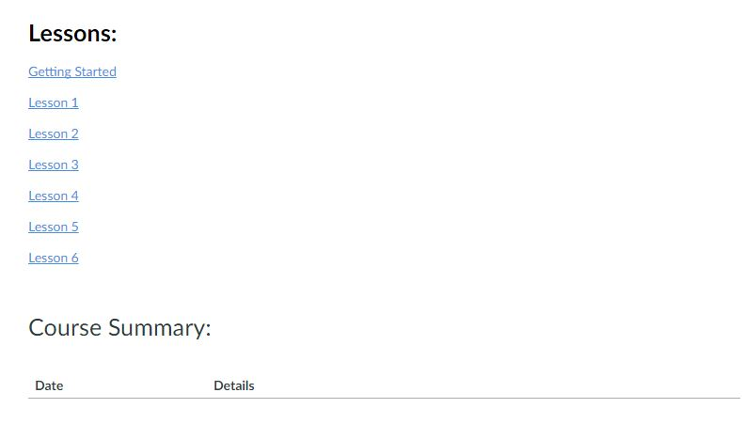

**ISSUE #1: Lesson objective**

Listed elements and their markers are separated by the image.



# **ISSUE #2: L1T2 - Topic 2: Five Significant Components of Classroom Management**

Space too narrow between the image and the text shown below.

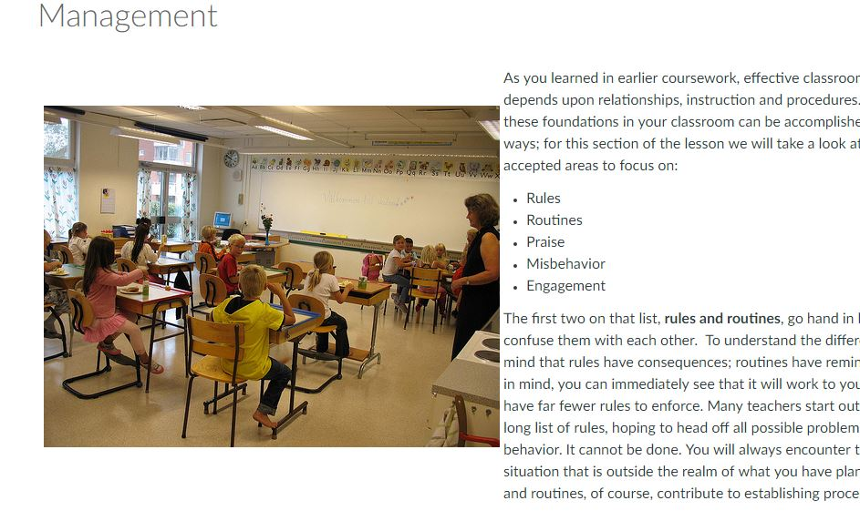

# **ISSUE #3: L1T2 - Topic 2: Five Significant Components of Classroom Management**

There are 2 blank spaces after the word ‘mentor.’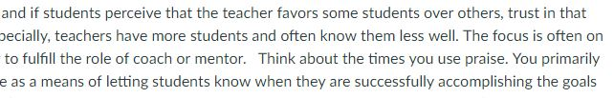

# **ISSUE #4: L1T3 - Topic 3: Impact of Classroom Management on Individual Teacher Self-Efficacy**

At 3rd paragraph. Unexpected punctuation mark.

# 

# **ISSUE #5: L2T1 - Topic 1: Establishing/Implementing Rules**

Space too narrow between image and info.

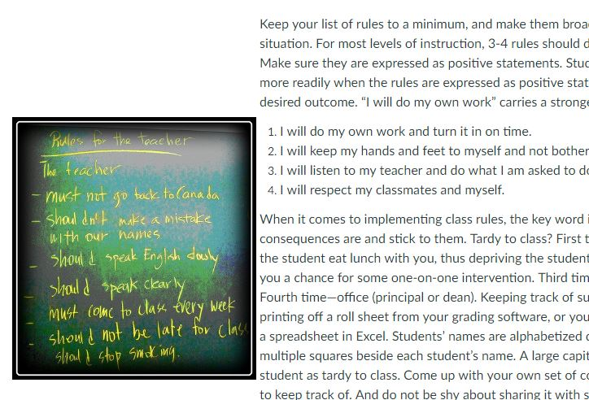

**ISSUE #6: L2T1 - Topic 1: Establishing/Implementing Rules**

Space too narrow between image and the text.

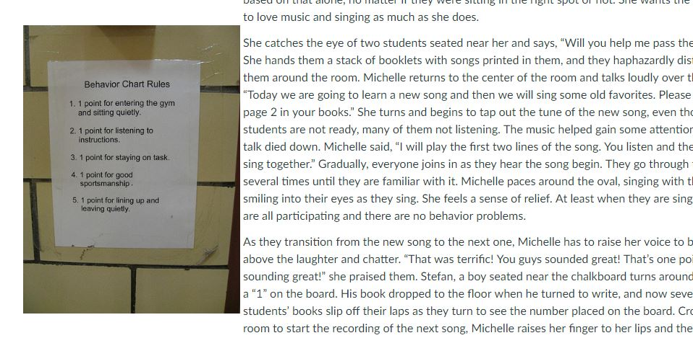

# **ISSUE #7: L3T2 - Topic 2: Scenario 2 - Classroom Routine**

Image shown below is using too much space. A full column space is occupied by the image. Space too narrow between the image and the text

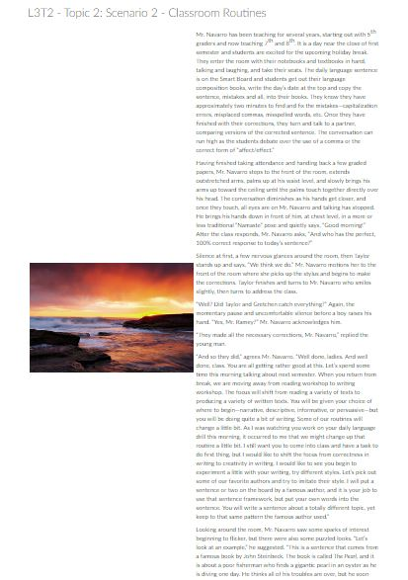

# **ISSUE #8: L3T2 - Topic 2: Scenario 2 - Classroom Routine**

Too much unused space. Space to narrow between image and text.

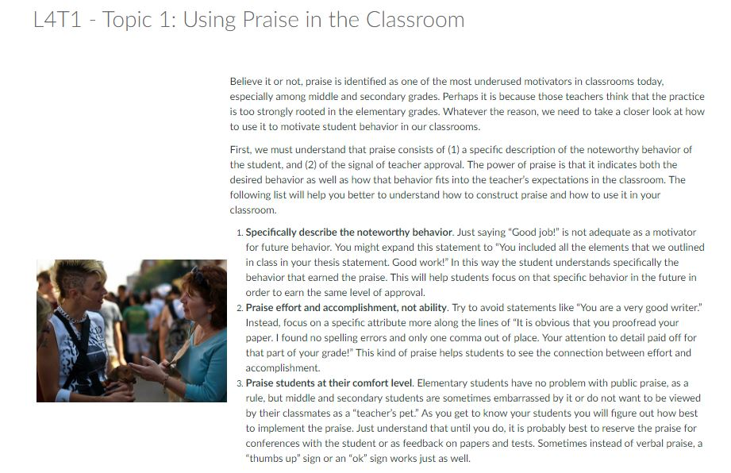

# **ISSUE #9: L4T1 - Topic 1: Using Praise in the Classroom**

Video thumbnail is shown in a messy way making the text break apart.

