## **REPORTS: (DEV) TTL 306 EDUCATING CHILDREN WITH SPECIAL NEEDS**

**ISSUE #0: Getting started**

Markes at this page and all ‘Lesson objective’ pages show the same mistake. Text and marker are separated by the image.

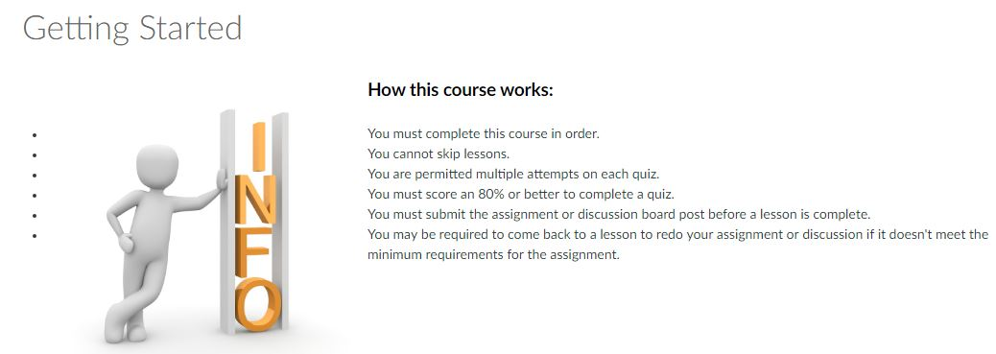

# ISSUE #1: Topic 1: What is the purpose of special education?

Blank space next to underlined word “all” is also underlined.

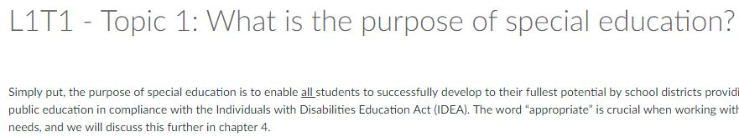

**ISSUE #2: L2C1 - Lesson 2 Checkpoint 1 Quiz**

Question 2 doesn’t show the right answer

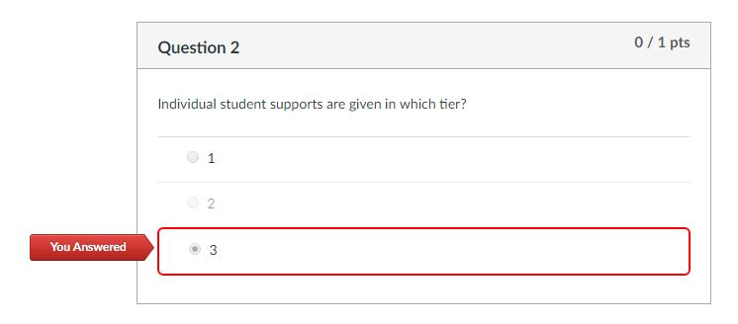

# ISSUE #3: Topic 1: Most Common Disability Categories

# The second shown URL doesn’t work.

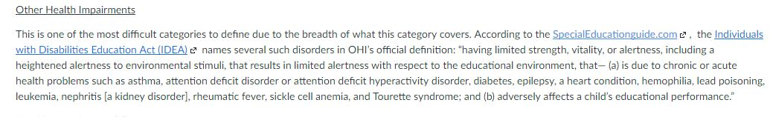

# ISSUE #4: L4T1: Critical components of individual education plans

# Markers are not in place

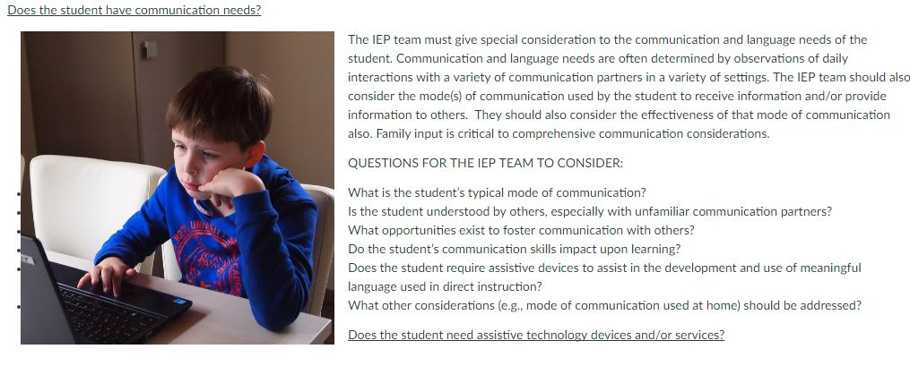

# ISSUE #5: L4T6 TOPIC 6: Services

# Unexpected character/figure/text next to list elements.

# 