REPORTS

ISSUE #0: Getting started

Markes at this page and all ‘Lesson objective’ pages show the same mistake. Text and marker are separated by the image.

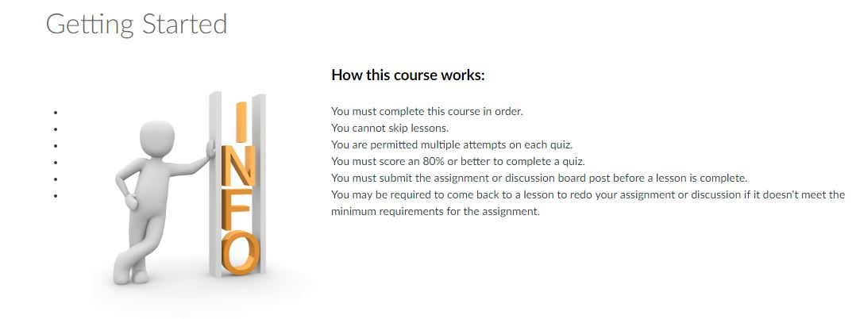

ISSUE #1: (DEV) 8.9 TSE 406 METHODS OF TEACHING MATHEMATICS

Blurry image.
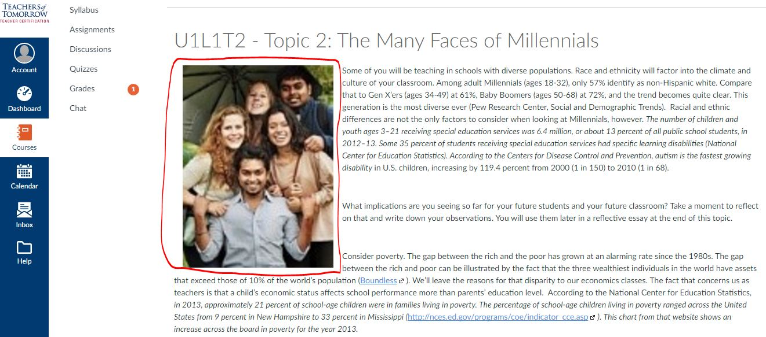

ISSUE #2

An URL is not shown as an URL. It’s shown as a comments or as a part of the text.

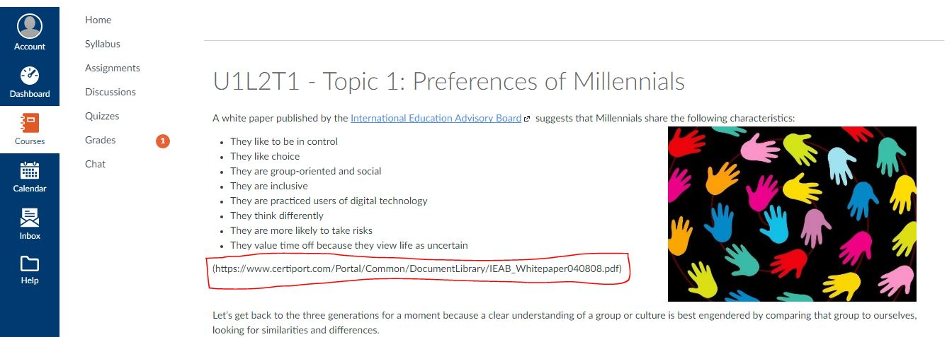

ISSUE #3: U1L2T1 - Topic 1: Preferences of Millennials

An inserted video has messed up the paragraphs.
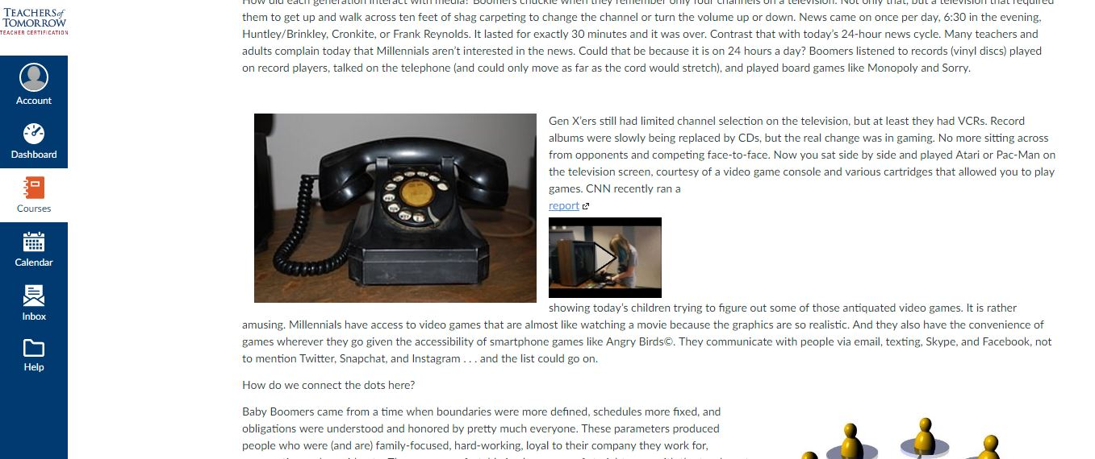

ISSUE #4: U1L2T2 - Topic 2: Engaging the Millennial Learner
Marked URL doesn’t work
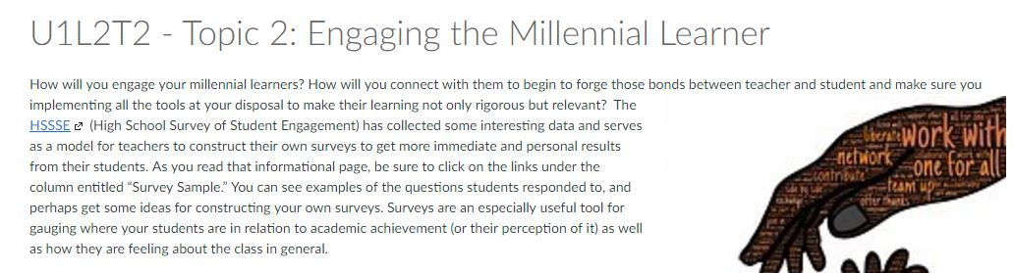

ISSUE #4: U1L3T1 - Topic 1: Teaching For Purpose
Too much space between the title and text.
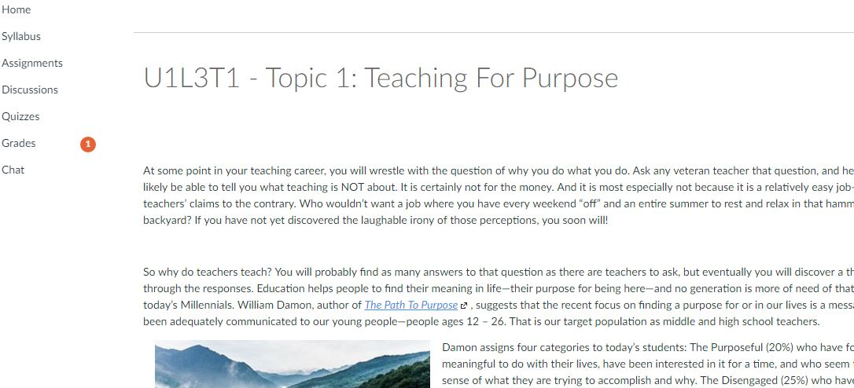

ISSUE #5: U1L3T2 - Topic 2: Teaching for Purpose on the World Stage
Some words don’t make sense
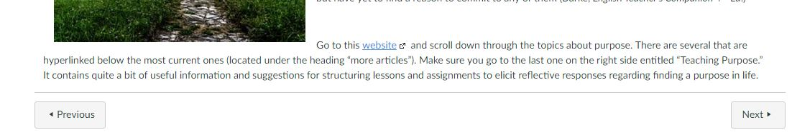

ISSUE #5: TOPIC 2: Teaching for Purpose on the World
The video breaks the paragraphs.
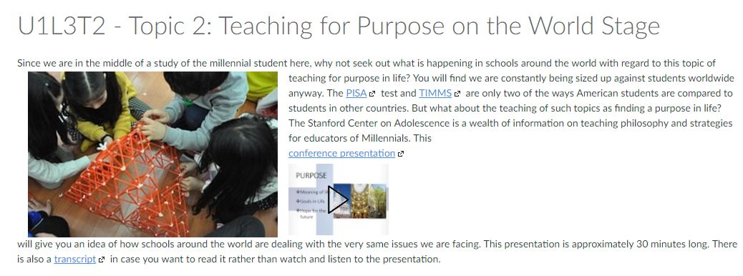

ISSUE #6: TOPIC 2: Teaching for Purpose on the World
The video the paragraphs.
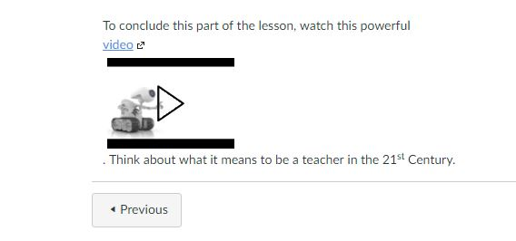

ISSUE #7: U1L4T1 - Topic 1: The Creature in its Natural Habitat
This link tries to download a video instead of showing it.
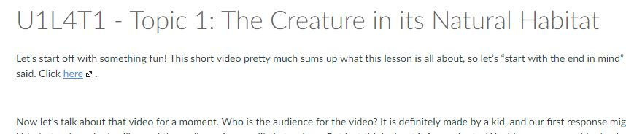

ISSUE #7: U1L4T1 - Topic 1: The Creature in its Natural Habitat
Bad orthography
