REPORTS

ISSUE #0: Getting started

Markes at this page and all ‘Lesson objective’ pages show the same mistake. Text and marker are separated by the image.

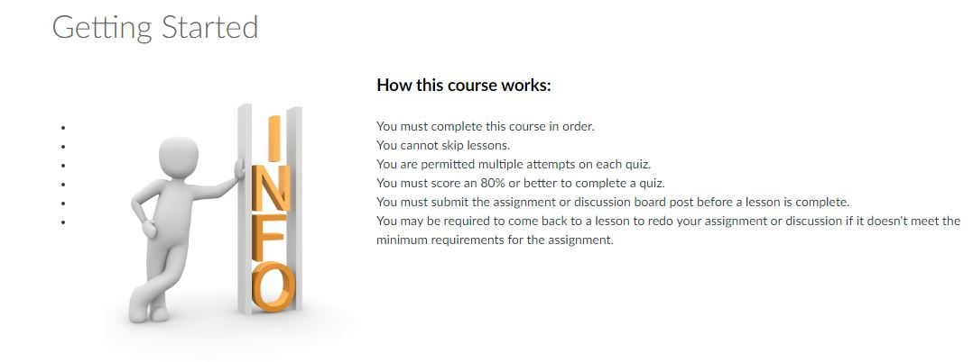

ISSUE #1: (DEV) 8.9 TSE 406 METHODS OF TEACHING MATHEMATICS

Blurry image.
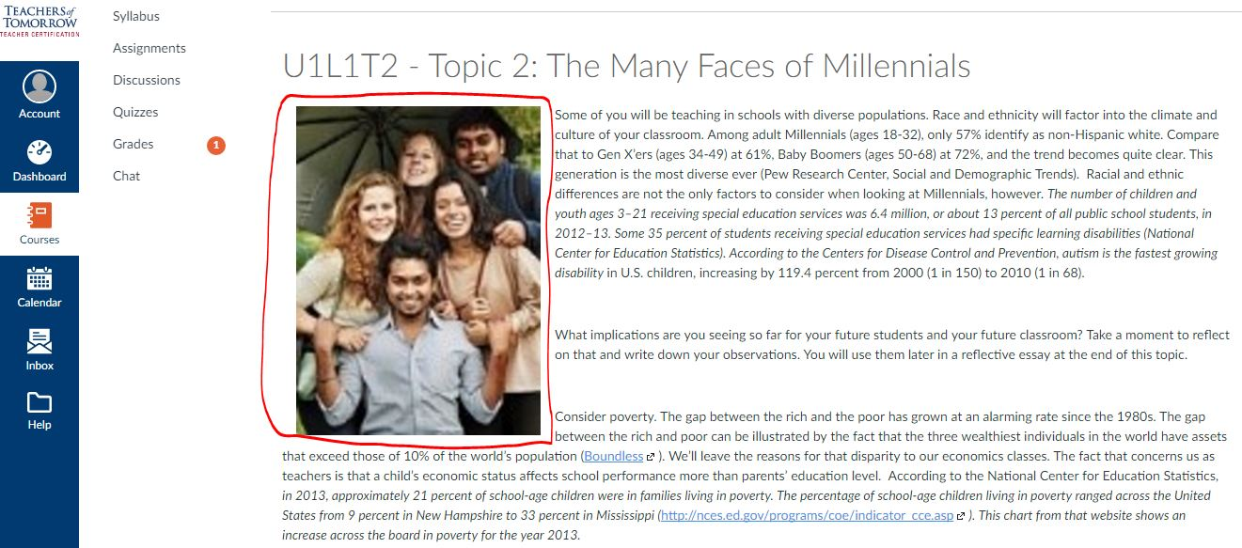

ISSUE #2

An URL is not shown as an URL. It’s shown as a comment or as a part of the text.

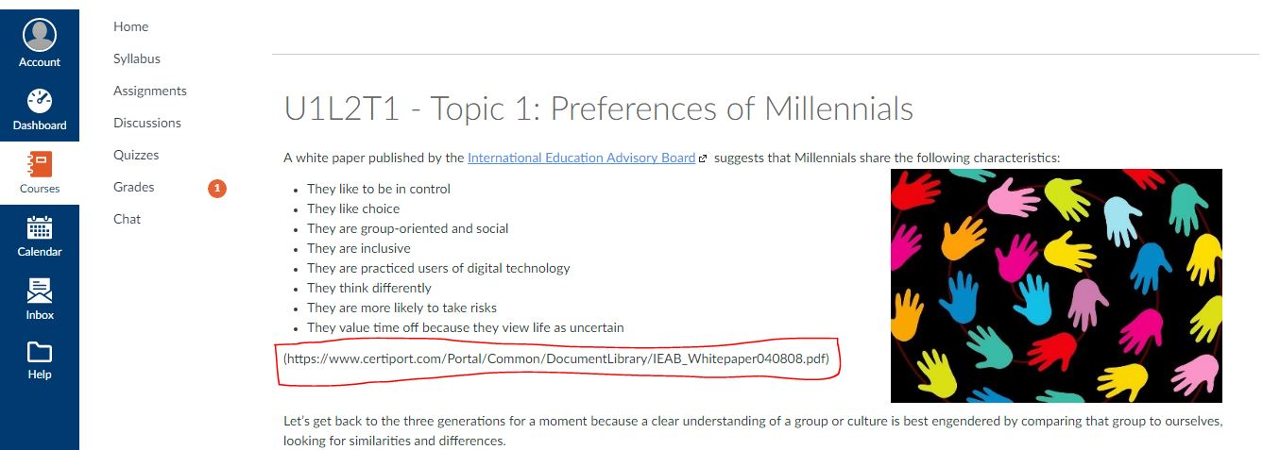

ISSUE #3: U1L2T1 - Topic 1: Preferences of Millennials

An inserted video has messed up the paragraphs.
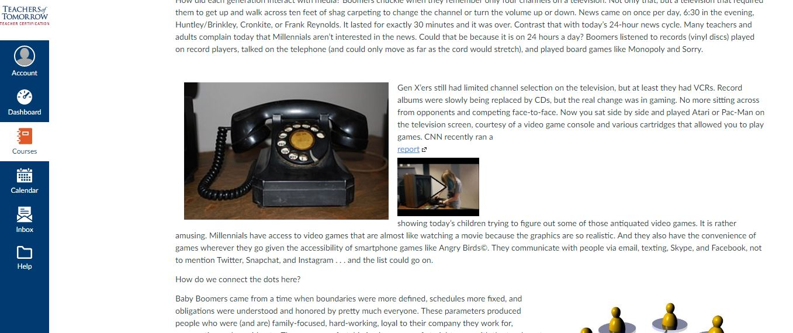

ISSUE #4: U1L2T2 - Topic 2: Engaging the Millennial Learner
Marked URL doesn’t work
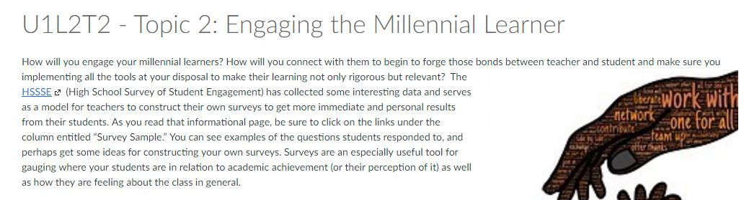

ISSUE #5: U1L3T1 - Topic 1: Teaching For Purpose
Too much space between the title and text.
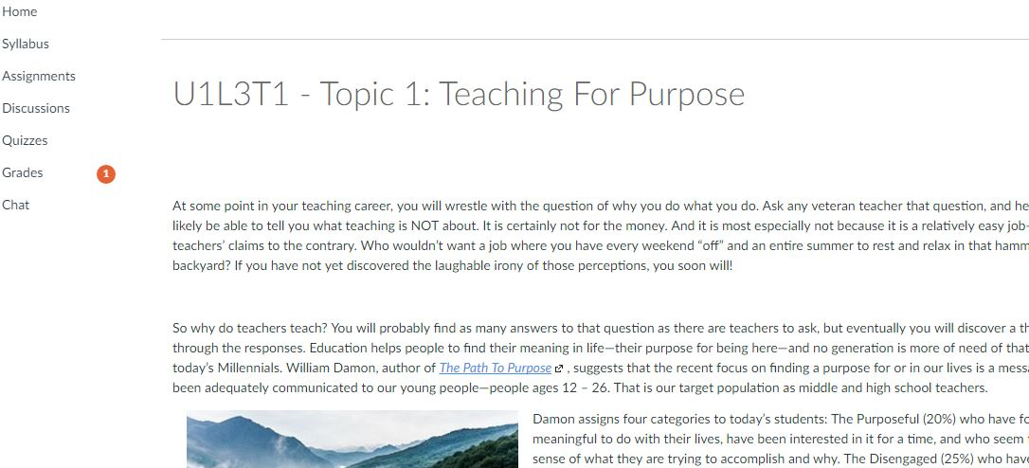

ISSUE #6: U1L3T2 - Topic 2: Teaching for Purpose on the World Stage
Some words don’t make sense
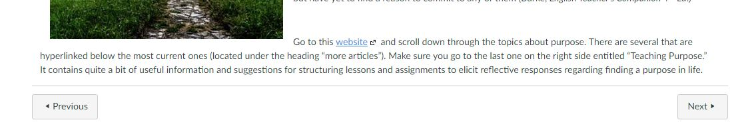

ISSUE #7: TOPIC 2: Teaching for Purpose on the World
The video breaks the paragraphs.
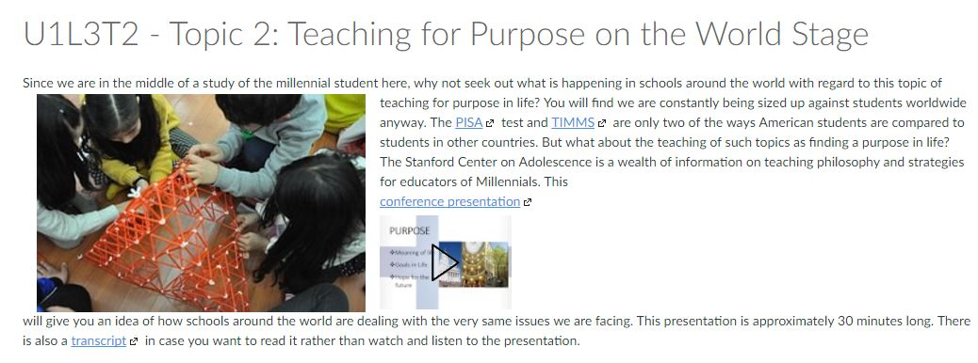

ISSUE #8: TOPIC 2: Teaching for Purpose on the World
The video the paragraphs.
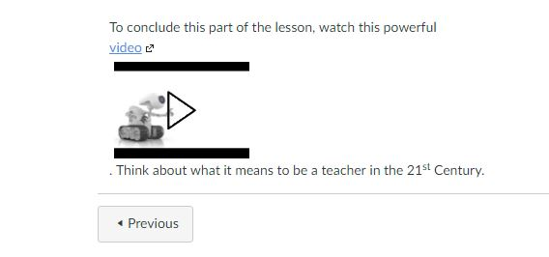

ISSUE #9: U1L4T1 - Topic 1: The Creature in its Natural Habitat
This link tries to download a video instead of showing it.
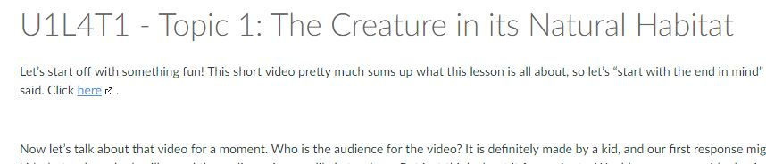

ISSUE #10: U1L4T1 - Topic 1: The Creature in its Natural Habitat
Bad orthography
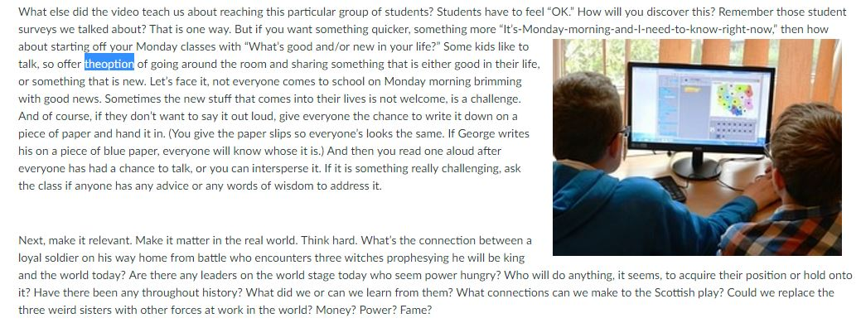

ISSUE #11: U1L4T2 - Topic 2: Professional Reading
The server’s service is down. The URL doesn’t work.
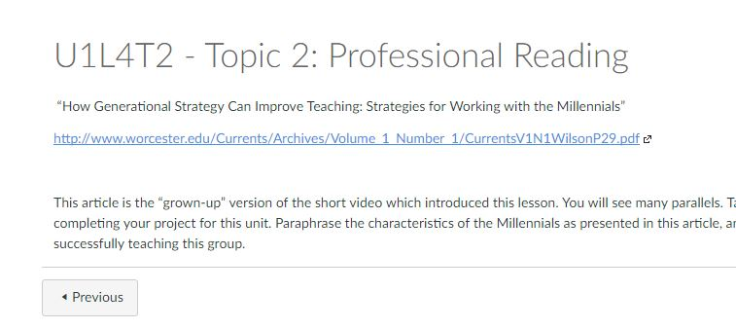

ISSUE #12
A submit form or entry is missing. Then, to take U2 one must submit U1L4C1 Checkpoint 4.
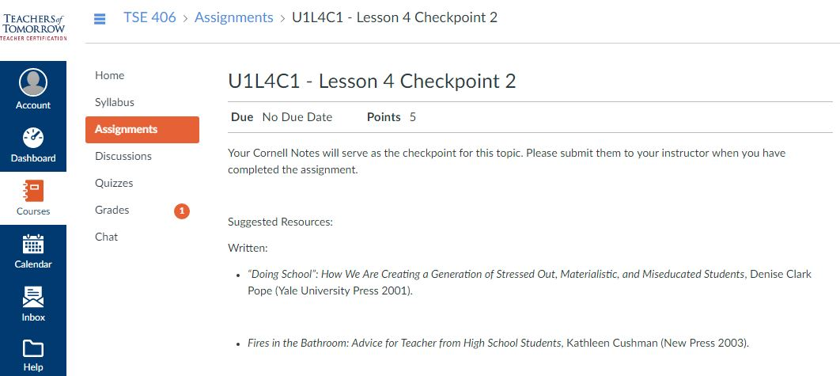

ISSUE #13
U1L4C1 is a reference for Unit 1 Lesson 4 Checkpoint 1 when Checkpoint 2 is shown.
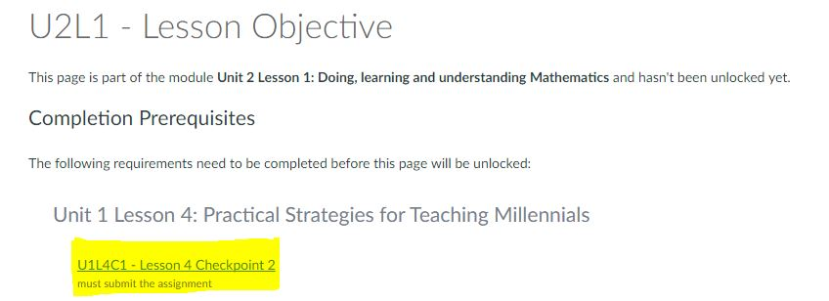

ISSUE #14
All links which redirect to lessons are broken.
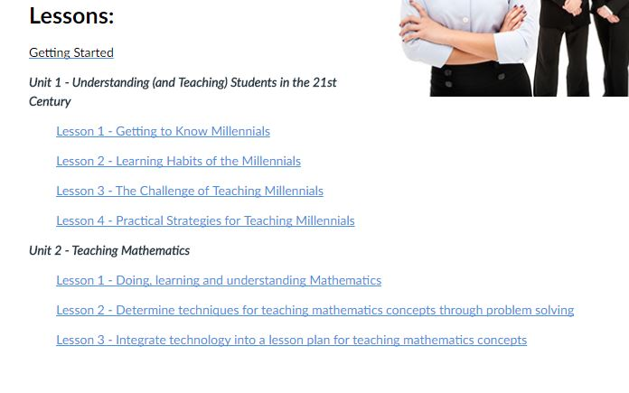

ISSUE #15
There’s no quiz at all.
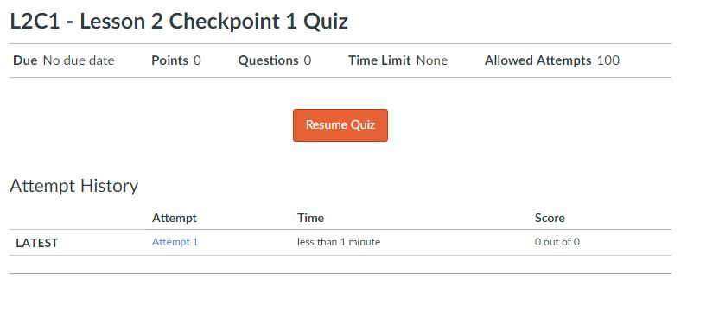

ISSUE #16
There’s no quiz at all.

