## **REPORTS: (DEV) TTL 403 THE INTEGRATED CURRICULUM**

**ISSUE #0: Getting started**

The **getting started** link, located at syllabus doesn’t work.

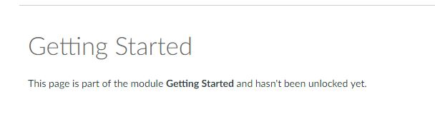

**ISSUE #1: Lesson objective**

An image is between list markers and the list elements.

