Here is our course notes for this week:

***This Week’s Topic(s) / Objectives***

**● Lecture Topic: Review of HTML Tags and the Essentials of Web Scripting**

**• Lecture Topic: Creating a Simple Web Portfolio with HTML.**

**• Lecture Topic: Using MS Paint for Graphic Image Manipulation.**

**• Lecture Topic: Introduction to Style Sheets**

**• Lecture Topic: Introduction to Adobe Dreamweaver**

**• Review the following link:**

[**http://www.w3schools.com/quiztest/quiztest.asp?qtest=HTML**](http://www.w3schools.com/quiztest/quiztest.asp?qtest=HTML)

**• Useful Web sites**

GIF Images

[**http://www.gifanimations.com**](http://www.gifanimations.com)

Online Research Tool ( Learn HTML )

[**http://www.w3schools.com**](http://www.w3schools.com)

Online Research Tool

[**http://www.htmlgoodies.com**](http://www.htmlgoodies.com)

Online Research Tool

[**http://www.webopedia.com**](http://www.webopedia.com)

**________________________________________________________**

**Review of HTML Tags**

Some basic HTML tags and their functions are summarized below.

|  |  |  |
| --- | --- | --- |
| HTML **Tag** | type | **Purpose** |
| **<html>** | paired | opens the page code and encloses other HTML tags |
| **<head>** | paired | contains the page title and sometimes **<script>** tags |
| **<title>** | paired | encloses the Web page title |
| **<body>** | paired | encloses other HTML tags in the body of the Web page |
| **<h1>** | paired | the largest heading ( **<h6>** is the smallest heading ) |
| **<br />** | non - paired | creates a line break |
| **<hr />** | non - paired | creates a horizontal rule |
| **<p>** | paired | creates a paragraph |
| **<marquee>** | paired | scrolls the enclosed text |
| **<a>** | paired | anchors text and navigates user to another page |
| **<img>** | non - paired | holds an image |
| **<hr />** | non - paired | horizontal line is created |
| **<p>** | paired | adds a paragraph to your Web page |
| **<i>** | paired | italicizes the enclosed text |
| **<u>** | paired | underlines the enclosed text |
| **<sub>** | paired | subscripts the enclosed text |
| **<sup>** | paired | superscripts the enclosed text |

Some basic HTML character entities are summarized below.

|  |  |  |
| --- | --- | --- |
| HTML **entity** |  | **Purpose** |
| **&nbsp;** |  | creates a space |
| **&cent;** |  | cent sign |
| **&copy;** |  | copyright sign |
| **&reg;** |  | registered trademark sign |
| **&times;** |  | multiplication sign |

**Creating an Online Web Portfolio and Posting the Page to a Server**

**<html xmlns="http://www.w3.org/1999/xhtml">**

**<head>**

**<title>Web Portfolio</title>**

**<style type = "text/css">**

**<!--**

**body,td,th {**

**font-family: Tahoma;**

**color: #6633CC;**

**font-weight: bold;**

**}**

**body {**

**background-color: #FFFF33;**

**}**

**-->**

**</style></head>**

**<body>**

**<p><a name="top" id="top">My Portfolio</a></p>**

**<p>Sammy Student</p>**

**<p><a href="mylab1.gif">Lab 1</a> </p>**

**<br><br>**

**<p><a href="mylab2.gif">Lab 2</a> </p>**

**<p>&nbsp;</p>**

**<p>&nbsp;</p>**

**<p>&nbsp;</p>**

**<p>&nbsp;</p>**

**<p><a href="#top">back to the top</a></p>**

**<p>&nbsp;</p>**

**</body>**

**</html>**

**Using MS Paint**

Here are some hints to create your graphic in MS Paint.

As shown below, the MS Paint program’s design interface consists of a **Toolbox**, a **Color Selector** and a **Design Canvas**.

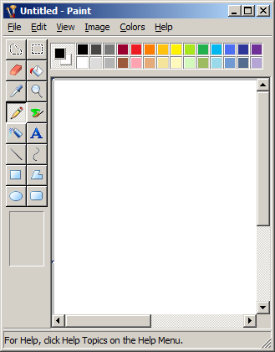

You can use the **Pencil** Tool, which is shown selected above, to create a free - form drawing. You can use the **Brush** Tool and the **Fill Bucket** Tool to add a selected color to your drawing.

The **Text** Tool can be used to add a text box to your image.

A geometry tool such as a Rectangle, Ellipse or Polygon can add a dimension of spatial form for your image.

You can always use the **Select** Tool to allow for copying and pasting a section of your drawing.

When finished, save your artwork as a GIF image.

**Introduction to CSS**

**<html xmlns="http://www.w3.org/1999/xhtml">**

**<head>**

**<meta http-equiv="Content-Type" content="text/html; charset=utf-8" />**

**<title>Untitled Document</title>**

**<style type="text/css">**

**<!--**

**body,td,th {**

**font-family: Verdana, Arial, Helvetica, sans-serif;**

**color: #FFCC66;**

**}**

**body {**

**background-color: #000000;**

**}**

**-->**

**</style>**

**</head>**

**<body>**

**Goldfinger**

**</body>**

**</html>**

**Getting Started with Adobe Dreamweaver CS 6**

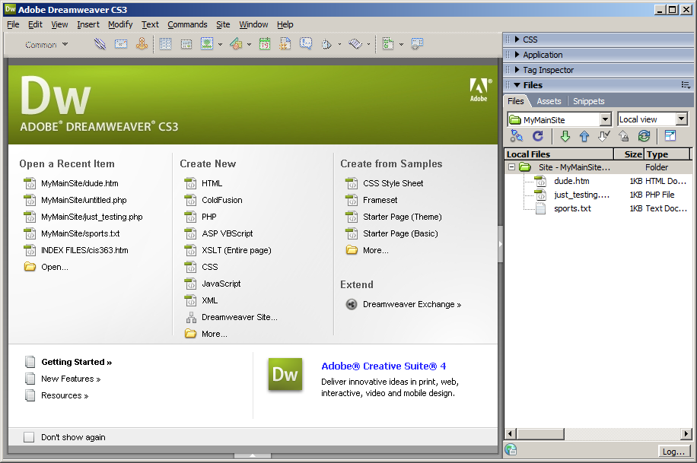

**In - class Review**

Visit the following link:

[**http://www.w3schools.com/quiztest/quiztest.asp?qtest=HTML**](http://www.w3schools.com/quiztest/quiztest.asp?qtest=HTML)

Review each of the 20 questions, at the above link, for next week’s quiz.

**Quick Review ( Week 1 )**

**(1)** HTML is an application of ____ .

(a) XML Incorrect.

(b) SGML CORRECT ANSWER Correct.

(c) Open GL Incorrect.

(d) DHTML Incorrect.

**(2)** ____ elements have no inherent meaning or connection to the data.

(a) XML Incorrect.

(b) HTML Correct.

(c) CSS Incorrect.

(d) None of the above Incorrect.

**(3)** ____code has meaningful element names that could match the field names in a database.

(a) XML Correct.

(b) HTML Incorrect.

(c) CSS Incorrect.

(d) None of the above Incorrect.

**(4)** XHTML conforms to ____ syntax rules.

(a) XML Correct.

(b) HTML Incorrect.

(c) CSS Incorrect.

(d) None of the above Incorrect.

**(5)** XML tags can ____ .

(a) be nested and overlap Incorrect.

(b) be nested but not overlap Correct.

(c) cannot be nested Incorrect.

(d) None of the above Incorrect.

**(6)** ____ is case-sensitive.

(a) HTML Incorrect.

(b) XML Correct.

(c) Both a and b Incorrect.

(d) None of the above Incorrect.

**(7)** In ____ , certain elements have optional closing tags.

(a) XML and HTML Incorrect.

(b) XML Incorrect.

(c) HTML Correct.

(d) hypertext Incorrect.

**(8)** Empty elements ____ have a closing tag ____ be marked empty by a slash (/) in the single tag.

(a) must, and Incorrect.

(b) must, but cannot Incorrect.

(c) must either, or Correct.

(d) cannot, nor can Incorrect.

**(9)** Attribute values must be ____ .

(a) underlined Incorrect.

(b) contained in quotes Correct.

(c) in lowercase Incorrect.

(d) in uppercase Incorrect.

**(10)** Because XHTML is an application of XML, you must use ____ to render style in XHTML.

(a) trees Incorrect.

(b) graphs Incorrect.

(c) style sheets Correct.

(d) None of the above Incorrect.