**Web Page Design Hints and Tips**

**HTML Table Design**

To create this table

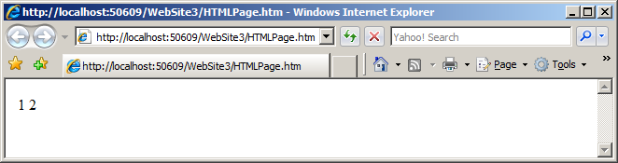

use this code ( one row, two columns )

**<table border = "0">**

**<tr>**

**<td >**

**1**

**</td>**

**<td>**

**2**

**</td>**

**</tr>**

**</table>**

**Heading Elements**

To create this table

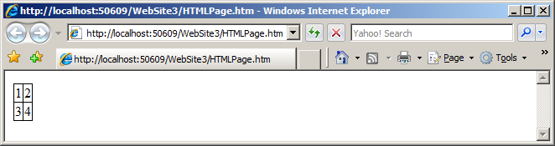

use this code ( two rows, two columns )

In the head:

**<style type = "text/css">**

**table, td**

**{ border: 1px solid #000; border-collapse: collapse; }**

**</style>**

In the body:

**<table>**

**<tr><td>1</td><td>2</td></tr>**

**<tr><td>3</td><td>4</td></tr>**

**</table>**

**CSS and Table Designs**

**<style type = "text/css">**

**table, td**

**{ border: 1px solid #ffca7f; border-collapse: collapse; }**

**td**

**{ border-style: dashed; border-right: 1px solid #ffca7f }**

**</style>**

**Table Designs**

How many rows and columns are present?

**<table>**

**<tr><td>1</td><td>2</td></tr>**

**<tr><td>3</td><td>4</td></tr>**

**<tr><td>5</td><td>6</td></tr>**

**</table>**

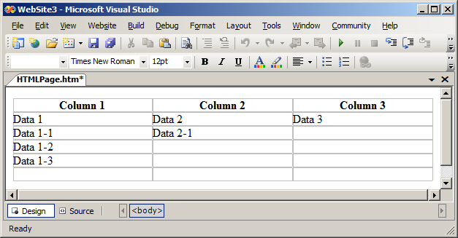

**Example Tables**

**<table border = "0" width = "100%" cellspacing = "0"**

**cellpadding = "0" summary = "Subject of table">**

**<tr>**

**<th>Column 1</th>**

**<th>Column 2</th>**

**<th>Column 3</th>**

**</tr>**

**<tr>**

**<td>Data 1</td>**

**<td>Data 2</td>**

**<td>Data 3</td>**

**</tr>**

**<tr>**

**<td>Data 1-1</td>**

**<td>Data 2-1</td>**

**<td>&nbsp;</td>**

**</tr>**

**<tr>**

**<td>Data 1-2</td>**

**<td>&nbsp;</td>**

**<td>&nbsp;</td>**

**</tr>**

**<tr>**

**<td>Data 1-3</td>**

**<td>&nbsp;</td>**

**<td>&nbsp;</td>**

**</tr>**

**<tr>**

**<td>&nbsp;</td>**

**<td>&nbsp;</td>**

**<td>&nbsp;</td>**

**</tr>**

**</table>**

**Example Tables**

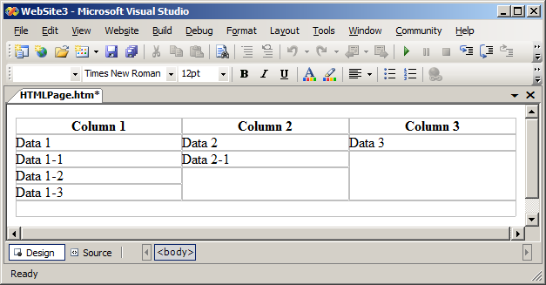

**<table width="100%" border="0" cellspacing="0" cellpadding="0" summary="Subject of table">**

**<tr>**

**<th>Column 1</th>**

**<th>Column 2</th>**

**<th>Column 3</th>**

**</tr>**

**<tr>**

**<td>Data 1</td>**

**<td>Data 2</td>**

**<td>Data 3</td>**

**</tr>**

**<tr>**

**<td>Data 1-1</td>**

**<td>Data 2-1</td>**

**<td rowspan="3">&nbsp;</td>**

**</tr>**

**<tr>**

**<td>Data 1-2</td>**

**<td rowspan="2">&nbsp;</td>**

**</tr>**

**<tr>**

**<td>Data 1-3</td>**

**</tr>**

**<tr>**

**<td colspan="3">&nbsp;</td>**

**</tr>**

**</table>**

**Using JavaScript**

**Simple JavaScript ( Alert box )**

**<html>**

**<head>**

**<script type = "text/javascript">**

**function disp_alert()**

**{**

**alert("I am an alert box!!");**

**}**

**</script>**

**</head>**

**<body>**

**<input type = "button" onclick = "disp_alert()" value =**

**"Display alert box" />**

**</body>**

**</html>**

**Simple JavaScript ( Confirm box )**

**<html>**

**<head>**

**<script type="text/javascript">**

**function disp_confirm()**

**{**

**var r=confirm("Press a button");**

**if (r==true)**

**{**

**document.write("You pressed OK!");**

**}**

**else**

**{**

**document.write("You pressed Cancel!");**

**}**

**}**

**</script>**

**</head>**

**<body>**

**<input type="button" onclick="disp_confirm()" value="Display a confirm box" />**

**</body>**

**</html>**

**Simple JavaScript ( Prompt box )**

**<html>**

**<head>**

**<script type="text/javascript">**

**function disp_prompt()**

**{**

**var name=prompt("Please enter your name","Harry Potter");**

**if (name!=null && name!="")**

**{**

**document.write("Hello " + name + "! How are you today?");**

**}**

**}**

**</script>**

**</head>**

**<body>**

**<input type="button" onclick="disp_prompt()" value="Display a prompt box" />**

**</body>**

**</html>**

**[ HTML Code Segments ]**

**Unordered Lists**

**<!DOCTYPE html>**

**<html>**

**<body>**

**<h2>Unordered List with Default Bullets</h2>**

**<ul>**

**<li>Apples</li>**

**<li>Bananas</li>**

**<li>Lemons</li>**

**<li>Oranges</li>**

**</ul>**

**</body>**

**</html>**

**Ordered Lists**

**<!DOCTYPE html>**

**<html>**

**<body>**

**<h2>Ordered List</h2>**

**<ol>**

**<li>Apples</li>**

**<li>Bananas</li>**

**<li>Lemons</li>**

**<li>Oranges</li>**

**</ol>**

**</body>**

**</html>**

**<!DOCTYPE html>**

**<html>**

**<body>**

**<h2>Ordered List with Lowercase Roman Letters</h2>**

**<ol type="i">**

**<li>Apples</li>**

**<li>Bananas</li>**

**<li>Lemons</li>**

**<li>Oranges</li>**

**</ol>**

**</body>**

**</html>**

**Nested Lists**

**<!DOCTYPE html>**

**<html>**

**<body>**

**<h2>A Nested List</h2>**

**<ul>**

**<li>Coffee</li>**

**<li>Tea**

**<ul>**

**<li>Black tea</li>**

**<li>Green tea</li>**

**</ul>**

**</li>**

**<li>Milk</li>**

**</ul>**

**</body>**

**</html>**

**Menu Lists**

**<!DOCTYPE html>**

**<html>**

**<head>**

**<style>**

**ul#menu li {**

**display:inline;**

**}**

**</style>**

**</head>**

**<body>**

**<h2>Horizontal List</h2>**

**<ul id="menu">**

**<li>Apples</li>**

**<li>Bananas</li>**

**<li>Lemons</li>**

**<li>Oranges</li>**

**</ul>**

**</body>**

**</html>**

**<!DOCTYPE html>**

**<html>**

**<head>**

**<style>**

**ul#menu {**

**padding: 0;**

**}**

**ul#menu li {**

**display: inline;**

**}**

**ul#menu li a {**

**background-color: black;**

**color: white;**

**padding: 10px 20px;**

**text-decoration: none;**

**border-radius: 4px 4px 0 0;**

**}**

**ul#menu li a:hover {**

**background-color: orange;**

**}**

**</style>**

**</head>**

**<body>**

**<h2>Horizontal List</h2>**

**<ul id="menu">**

**<li><a href="Page1.html">Tables</a></li>**

**<li><a href="Page2.html ">Lists</a></li>**

**<li><a href="Page3.html ">Blocks</a></li>**

**<li><a href="Page4.html ">Classes</a></li>**

**</ul>**

**</body>**

**</html>**