Select export, to gcs

Create new bucket=> CB-WESTLAKE-MCM---BASKET-LOCATIONS

High level we are going to take data from other systems and migrate it to gcp bigquery.

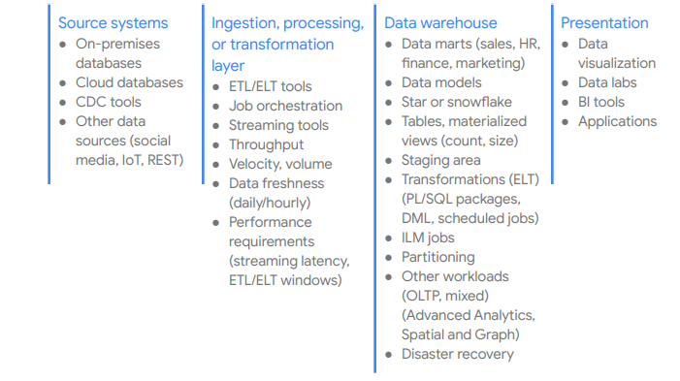

In traditional DW’s , the resources we manage are “users, privileges, roles, and profiles” , while in gcp we use IAM

uses Identity and Access Management (IAM) to manage access to “ organizations, projects, datasets, tables, and views.”

IAM provides these types of roles:

● Predefined roles are meant to support common use cases and access control patterns.

● Primitive roles include the Owner, Editor, and Viewer roles. Predefined roles provide granular access for a specific service and are managed by Google Cloud.

● Custom roles provide granular access according to a user-specified list of permissions.

When you assign both predefined and primitive roles to a user, the permissions granted are a union of the permissions of each individual role

Issues We will have

1. There is no row level security, we need to build individual views and grant that or we can build out some strategy using GCP’s SESSION_USER() function in BigQuery, which returns the email address of the currently running user.

In gcp we will have table of groups and usernames like below:

{engineers, [example@google.com](mailto:example@google.com)}

{engineers, [some_engineer@google.com](mailto:some_engineer@google.com)}

{administrators, [some_admin@google.com](mailto:some_admin@google.com)}

In GCP we alter existing views to join on grouping tables to provide for authorization.

#standardSQL

SELECT c.customer,

c.id

FROM private.customers c

INNER JOIN ( SELECT DISTINCT group FROM private.access_control

WHERE user_name = SESSION_USER() ) g

ON c.allowed_group = g.group;

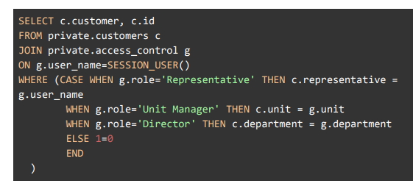

There are other options like adding another column to your table for the user who is allowed to see the row.

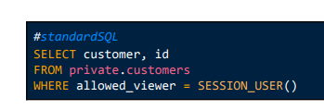

1. Bigquery is serverless cloud EDW, with separated storage and compute layers.
2. BigQuery decouples data storage and compute and stores data in Colossus, in which data is compressed and stored in a columnar format called Capacitor.
3. BigQuery lets you query historical snapshots of tables up to seven days and restore deleted tables within two days by using table decorators.
4. BigQuery offers per-user cache, and if data doesn’t change, results of queries are cached for approximately 24 hours.
5. <https://cloud.google.com/bigquery/docs/bq-command-line-tool>
6. <https://cloud.google.com/bigquery/docs/reference/rest>
7. <https://cloud.google.com/blog/products/g-suite/connecting-bigquery-and-google-sheets-to-help-with-hefty-data-analysis>

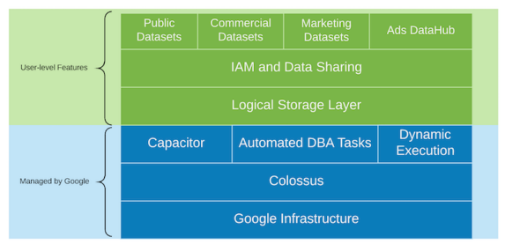

<https://console.cloud.google.com/home/dashboard?project=natural-iridium-331506&_ga=2.181760098.47787328.1645825045-1054239679.1633562406&_gac=1.27623118.1645825045.Cj0KCQiAmeKQBhDvARIsAHJ7mF76kTzt-WZFMmxjGxsUkuDbHqOLZi7KdUnH2Nk8f24KSTMCxo6VEXoaAm86EALw_wcB&pli=1>

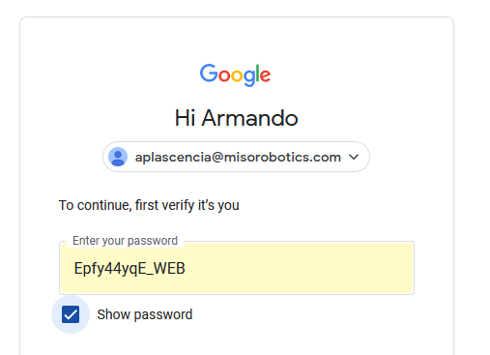

goto google cloud platform under project miso robotics

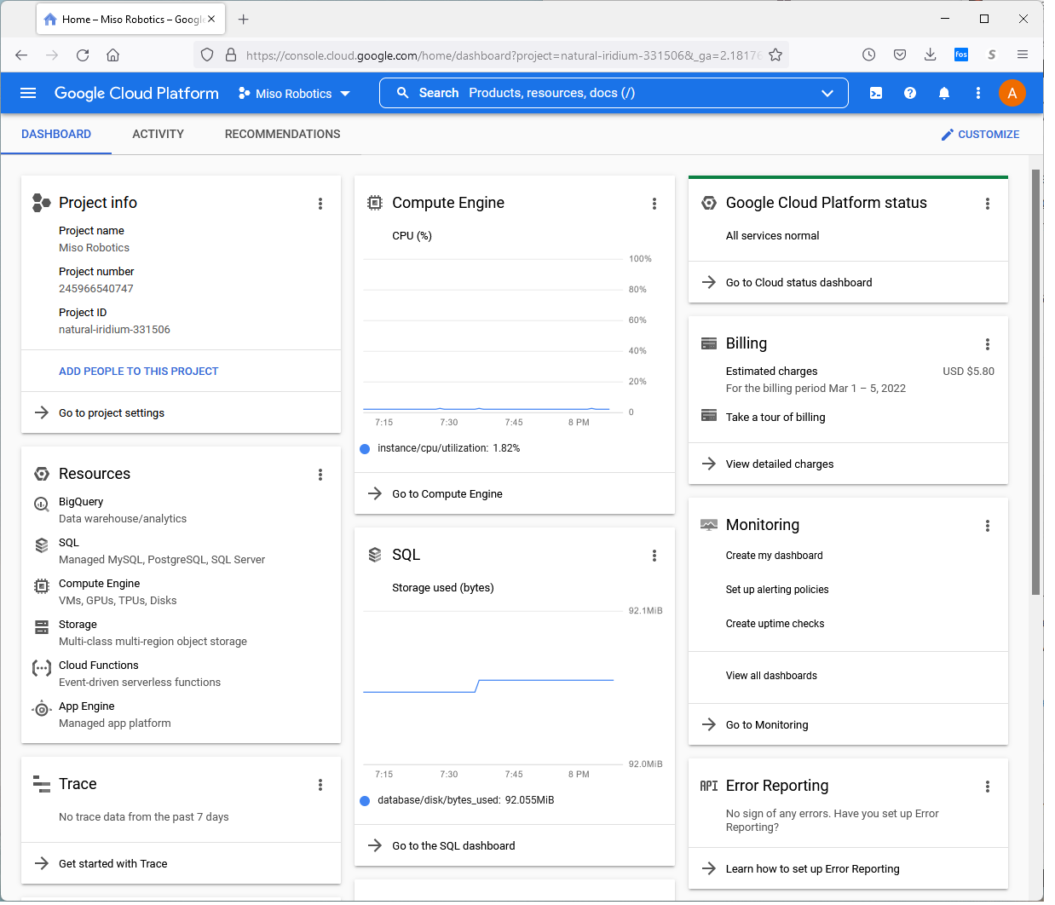

**Project info**

Project name Miso Robotics

Project number 245966540747

Project ID natural-iridium-331506

Select Big Query

https://console.cloud.google.com/bigquery?project=natural-iridium-331506&_ga=2.181760098.47787328.1645825045-1054239679.1633562406&_gac=1.27623118.1645825045.Cj0KCQiAmeKQBhDvARIsAHJ7mF76kTzt-WZFMmxjGxsUkuDbHqOLZi7KdUnH2Nk8f24KSTMCxo6VEXoaAm86EALw_wcB&pli=1

Explore projects

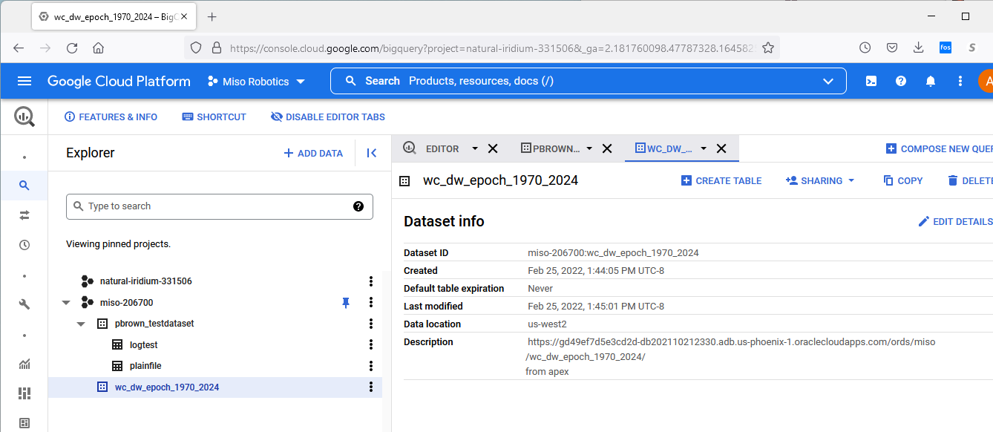

<https://console.cloud.google.com/bigquery?project=natural-iridium-331506>

We are going to use the rest api for a specific day

<https://gd49ef7d5e3cd2d-db202110212330.adb.us-phoenix-1.oraclecloudapps.com/ords/miso/wc_dw_epoch_1970_2024/?q=%7B%22start_date_p1%22:%7B%22$like%22:%222022/02/20%2021%25%22%7D%7D>

**miso/wc_dw_epoch_1970_2024/?q={"start_date_p1":{"$like":"2022/02/20 21%25"}}**

or use full api

https://gd49ef7d5e3cd2d-db202110212330.adb.us-phoenix-1.oraclecloudapps.com/ords/miso/wc_dw_epoch_1970_2024/

And build a bigquery for => wc_dw_epoch_1970_2024

To get all epoch time for all 15 minute intervals for a specific day use

[https://gd49ef7d5e3cd2d-db202110212330.adb.us-phoenix-1.oraclecloudapps.com/ords/miso/wc_dw_epoch_1970_2024/ ?q={%22start_date_p1%22:{%22$like%22:%222022/02/20%20%25%22}}&limit=999999999](https://gd49ef7d5e3cd2d-db202110212330.adb.us-phoenix-1.oraclecloudapps.com/ords/miso/wc_dw_epoch_1970_2024/%20?q=%7b%22start_date_p1%22:%7b%22$like%22:%222022/02/20%20%25%22%7d%7d&limit=999999999)

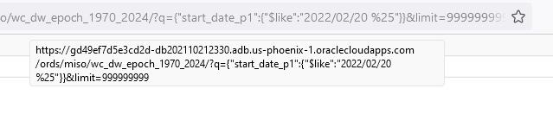

Steps

1. Remove first {"items":
2. Remove last

,"hasMore":false,"limit":10000,"offset":0,"count":96,"links":[{"rel":"self","href":"https://gd49ef7d5e3cd2d-db202110212330.adb.us-phoenix-1.oraclecloudapps.com/ords/miso/wc_dw_epoch_1970_2024/?q=%7B%22start_date_p1%22:%7B%22%24like%22:%222022%2F02%2F20+%25%22%7D%7D"},{"rel":"edit","href":"https://gd49ef7d5e3cd2d-db202110212330.adb.us-phoenix-1.oraclecloudapps.com/ords/miso/wc_dw_epoch_1970_2024/?q=%7B%22start_date_p1%22:%7B%22%24like%22:%222022%2F02%2F20+%25%22%7D%7D"},{"rel":"describedby","href":"https://gd49ef7d5e3cd2d-db202110212330.adb.us-phoenix-1.oraclecloudapps.com/ords/miso/metadata-catalog/wc_dw_epoch_1970_2024/"},{"rel":"first","href":"https://gd49ef7d5e3cd2d-db202110212330.adb.us-phoenix-1.oraclecloudapps.com/ords/miso/wc_dw_epoch_1970_2024/?q=%7B%22start_date_p1%22:%7B%22%24like%22:%222022%2F02%2F20+%25%22%7D%7D&limit=10000"}]}

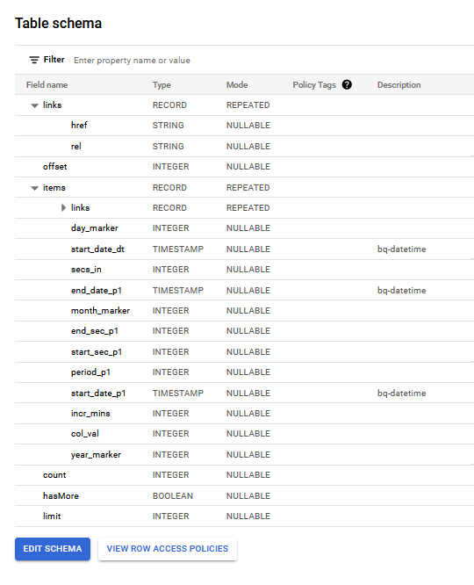

set colsep ',';

set pagesize 0 line 3000 trimspool on termout off echo off verify off feedback off;

spool c:\sam\apex_to_gcp\gcp_cma.cma

select ltrim(rtrim(hhmm))||','||period_number from gcp_find_96_periods_15 order by period_number;

spool off;

SELECT * FROM `miso-206700.wc_dw_epoch_1970_2024.GCP_15_MIN_PERIODS`