Practical 1

EERI 418

Submitted to: Prof. Kenny Uren

Date: 29/03/2021

Author: Mr. AM Viljoen

Student number: 30257506

### Abstract

Milestone A:

This part of the report means to document the design of a desired plant's third-order transfer function, which will be implemented using operational amplifiers. In this report, the desired transfer function is provided with the relevant constants and design specifications. Thereafter, the applicable circuitry necessary to produce a solution is introduced and the relevant component values are calculated. The developed model is implemented in two simulation software packets namely MATLAB 2020a – Simulink and LtSpice. The responses obtained from the respective simulations are then compared and discussed.

Milestone C:

This part of the report means to document the design and incorporation of antialiasing filters and a phase lead compensator to the developed plant as discussed in the preceding milestone. In this report, the second order approximation obtained shall be analysed to determine an appropriate sampling frequency. The sampling frequency shall then be used to develop antialiasing filters, that are to be incorporated in the system and used to determine the discrete-time system transfer function. Thereafter, the discrete-time transfer function shall be used to design a phase lead compensator to improve the system’s phase margin as stated in the practical specification document.

Table of Contents

Abstract 1

List of Figures 3

List of Tables 3

Nomenclature 4

MILESTONE A

1. Objective 5

2. Mathematical Derivations 5

3. MATLAB/Simulink Simulations 10

4. LtSpice Model Simulations 12

5. Results 13

6. Discussion 14

7. References – Milestone A 15

MILESTONE C

1. Objective 16

2. Sampling frequency 17

3. Antialiasing Filters Design 18

4. Lead Compensator Design 20

5. Results 24

6. Discussion 25

7. References 26

### 

### List of Figures

Figure 1: Generic Low-Pass Sallen and Key Circuit 6

Figure 2: Generic First Order Low-Pass Filter 8

Figure 3: MATLAB Simulation Model 10

Figure 4: Step Input Parameters for MATLAB Simulation 10

Figure 5: Third order vs Second order systems - Open Loop Plant Step Response 11

Figure 6: LtSpice Simulation Model 12

Figure 7: LtSpice Simulation Settings 12

Figure 8: Second-Order Open Loop Response vs Step Input: MATLAB 13

Figure 9: Second-Order Open Loop Response vs Step Input: LtSpice 13

Figure 10: 2nd order Plant Step Response - Settling Time and Percentage Overshoot 14

Figure 1: First order RC low-pass filter 18

Figure 2: System and Signal flow graphs 20

Figure 3: Discrete-time system bode plot 22

Figure 4: Lead compensated discrete-time system bode plot 24

Figure 5: System frequency analyses comparison 25

Figure 6: System step response comparison 25

### List of Tables

Table 1: Table of Nomenclature 4

Table 2: Plant Constants 5

### Nomenclature

The symbols used in this report are listed below in order of appearance. Though this table provides some context to this document, the general assumption is made that the reader of this document has some rudimentary knowledge of power electronics and control systems. The table does not necessarily include all symbols used in this document as it means to simply add context to areas where it is necessary and where symbols have not been clarified.

Table 1: Table of Nomenclature

|  |  |
| --- | --- |
| Symbol | Meaning |
| $$G_{p}\left(s\right)$$ | Plant transfer Function. |
| $$K$$ | DC gain constant. |
| 𝜁 | System damping constant. |
| $$ω_{n}$$ | System natural frequency. |
| $$G_{p1}\left(s\right)$$ | Desired Second-Order Low-pass Sallen and Key transfer function. |
| $$G_{p2}\left(s\right)$$ | Desired First Order Low-Pass Filter transfer function. |
| $$T_{V1}\left(s\right)$$ | A general expression for Second-Order Low-pass Sallen and Key transfer function. |
| $$T_{V2}\left(s\right)$$ | A general expression for First Order Low-Pass Filter transfer function. |
| $$R_{1},R_{2},R_{a},R_{c},R$$ | Resistor component values. |
| $$C_{1},C_{2},C$$ | Capacitor component values. |
| $$v_{i},v_{o},v_{1}$$ | Node voltages. |
| $$T_{s}$$ | System response settling time. |
| $$P.O.$$ | System response percentage overshoot. |
|  |  |
| $$T\left(s\right)$$ | Continuous-time closed loop transfer function |
| $$τ$$ | System time constant. |
| $$f_{s}$$ | System sampling frequency. |
| $$H\left(s\right)$$ | Antialiasing filter transfer function. |
| $$Q\left(z\right)$$ | Discrete-time system characteristic equation. |
| $$G\left(s\right)$$ | Continuous-time transfer function. |
| $$D\left(w\right), D(z)$$ | Lead compensator transfer functions. |

Milestone A:

# Objective

The objective of Milestone A is to demonstrate the ability to construct a plant with the desired transfer function using operational amplifiers. The general form of the plant is given by the following equation:

|  |  |  |
| --- | --- | --- |
|  | $$G_{p}\left(s\right)=\frac{Kω_{n}^{2}10ζω_{n}}{\left(s^{2}+2ζω_{n}s+ω_{n}^{2}\right)\left(s+10ζω_{n}\right)}$$ $$=\frac{5{\left(2000\right)}^{2}(10000)}{(s^{2}+2000s+{\left(2000\right)}^{2})(s+10000)}$$ | (1.1) |

Where the constants are given in Table 2 below:

Table 2: Plant Constants

|  |  |  |
| --- | --- | --- |
| Symbol | Designation | Value |
| $$K$$ | DC gain. | $$5$$ |
| $$ζ$$ | Equivalent second order  system damping constant. | $$0.5$$ |
| $$ω_{n}$$ | Equivalent second order  system natural frequency. | $$2000 rad/s$$ |

The following subsections concern the design of a plant that realizes the transfer function given in equation (1.1) and the derivation of the relevant component values. Thereafter, the design shall be implemented in MATLAB Simulink and LtSpice to confirm the response to a step input. Notably, the rail voltages of the operational amplifiers may not exceed $±5 VDC$.

# Mathematical Derivations

This section concerns the design and development of a circuit diagram that can realize the desired transfer function.

Firstly, the transfer function is separated as the product of two smaller transfer functions as follows:

|  |  |  |
| --- | --- | --- |
|  | $$G_{p}\left(s\right)=G_{p1}\left(s\right)×G_{p2}\left(s\right)$$ |  |

where:

|  |  |  |
| --- | --- | --- |
|  | $$G_{p1}\left(s\right)=\frac{Kω_{n}^{2}}{(s^{2}+2ζω_{n}s+ω_{n}^{2})}=\frac{5{\left(2000\right)}^{2}}{(s^{2}+2000s+{\left(2000\right)}^{2})}$$ | (1.2) |
|  | $$G_{p2}\left(s\right)=\frac{10ζω_{n}}{(s+10ζω_{n})}=\frac{(10000)}{(s+10000)}$$ | (1.3) |

Where $G_{p1}\left(s\right)$ are realized by a Second-Order Low-pass Sallen and Key circuit and $G_{p2}\left(s\right)$ are realized by a First Order Low-pass Filter. Figure 1 below demonstrates a generic Low-pass Sallen and Key circuit.

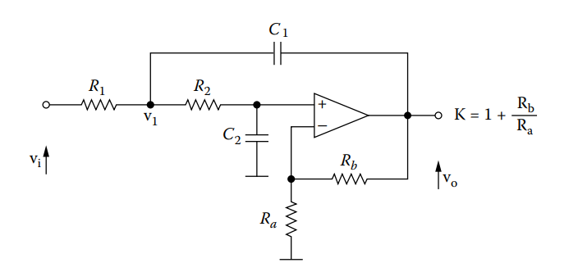

Figure 1: Generic Low-Pass Sallen and Key Circuit

Where the transfer function of a second-order Low-pass Sallen and Key circuit displayed in Figure 1 is given by the following equation [1]:

|  |  |  |
| --- | --- | --- |
|  | $$T_{V1}\left(s\right)=\frac{\frac{K}{R_{1}R_{2}C_{1}C_{2}}}{s^{2}+s(\frac{1}{R_{1}C_{1}}+\frac{1}{R_{2}C_{1}}+\frac{1-k}{R_{2}C_{2}})+\frac{1}{R_{1}R_{2}C_{1}C_{2}}}$$ | (1.4) |

where:

|  |  |  |
| --- | --- | --- |
|  | $$K=1+\frac{R_{b}}{R_{a}}$$ | (1.5.1) |

Setting $T_{V1}\left(s\right)= G_{p1}\left(s\right)$, the following equations are obtained:

|  |  |  |
| --- | --- | --- |
|  | $$5=1+\frac{R_{b}}{R_{a}}$$ | (1.5.2) |
|  | $${\left(2000\right)}^{2}=\frac{1}{R_{1}R_{2}C_{1}C_{2}}$$ | (1.6.1) |
|  | $$2000= \frac{1}{R_{1}C_{1}}+\frac{1}{R_{2}C_{1}}+\frac{1-k}{R_{2}C_{2}}$$ | (1.7.1) |

To satisfy the relationship expressed in equation (1.6), the values of $R_{a}$ and $R_{b}$ are chosen as reasonable values so that $\frac{R_{b}}{R_{a}}=4$. Through an iterative process of calculating the values of $T_{V1}\left(s\right)$, the values of $R_{a}$ and $R_{b}$ were chosen as, keeping in mind that actual values may vary:

$$R_{a}=500 Ω$$

$$R_{b}=2 kΩ$$

Consequently, the equations (1.7.1) and (1.8.1) are left to be solved. For these two equations, four unknown variables exist. Thus, two of which can be chosen as the remaining two calculated to satisfy both equations. The values of the capacitors are chosen as it is easier to model resistors to comply with capacitors than the other way around. Through an iterative process of calculating these values, it became apparent that to achieve reasonable resistance values, the capacitor values need approximately be in the range of $0.5μF-5μF$. To simplify the calculations further, the following capacitor values were chosen:

$$C_{1}=1 μF$$

$$C_{2}=1 μF$$

Simplifying equations (1.7.1) and (1.8.1) with the chosen capacitor values, the following equations can be solved:

From equation (1.7.1):

|  |  |  |
| --- | --- | --- |
|  | $$R_{1}R_{2}=250 000$$ | (1.6.2) |

and from equation (1.8.1):

|  |  |  |
| --- | --- | --- |
|  | $$R_{1}R_{2}2000= R_{2}\left(\frac{1}{C_{1}}\right)+R_{1}\left(\frac{1}{C_{1}}\right)-R_{1}(\frac{4}{C_{2}})$$ | (1.7.1) |

Substituting equation (1.7.2) in equation (1.8.2), the following values are obtained for $R_{1}$ and $R_{2}$. , keeping in mind that actual values may vary and the closest possible values will be selected for the implementation.

$$R_{1}≈217 Ω$$

$$R_{2}≈1151 Ω$$

Next, the First Order Low-Pass Filter is to be designed. Figure 2 below illustrates a generic First Order Low-Pass Filter.

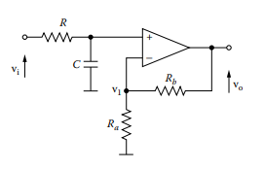

Figure 2: Generic First Order Low-Pass Filter

Where the transfer function of the First Order Low-Pass Filter displayed in Figure 2 is given by the following equation [1]:

|  |  |  |
| --- | --- | --- |
|  | $$T_{V2}\left(s\right)=\frac{Kω_{n}}{s+ω_{n}}$$ | (1.8) |

where:

|  |  |  |
| --- | --- | --- |
|  | $$ω_{n}=\frac{1}{RC}$$ | (1.9.1) |

and equation (1.5.1) applies. Comparing equation (1.8) and equation (1.9.1) to equation (1.3), the following relationships are established.

|  |  |  |
| --- | --- | --- |
|  | $$ω_{n}=\frac{1}{RC}=10 000$$ | (1.9.2) |
|  | $$K=1+\frac{R_{b}}{R_{a}}→1$$ | (1.5.2) |

Through the same iterative process described in derivations of the Second Order Low-pass Sallen and Key circuit, the value of the capacitor was chosen, and the resistance modelled accordingly to satisfy the relationship expressed in (1.9.2). The values were calculated as follows, keeping in mind that actual values may vary, and the closest possible values will be selected for the implementation.:

$$C= 1 μF$$

$$∴R=100 Ω$$

Finally, to complete the transfer function of the First Order Low-Pass Filter, the gain constant $K$ needs to be determined. To satisfy equation (1.5.2), the relationship $\frac{R_{b}}{R_{a}}→0$. Thus, the values of $R_{a}$ and $R_{b}$ were chosen as, keeping in mind that actual values may vary, and the closest possible values will be selected for the implementation.:

$$R_{a}=100 Ω$$

$$R_{b}=100 kΩ$$

Consequently, the component values of both circuits have been calculated and the operation is verified in both MATLAB Simulink and LtSpice in the following sections of this report.

# MATLAB/Simulink Simulations

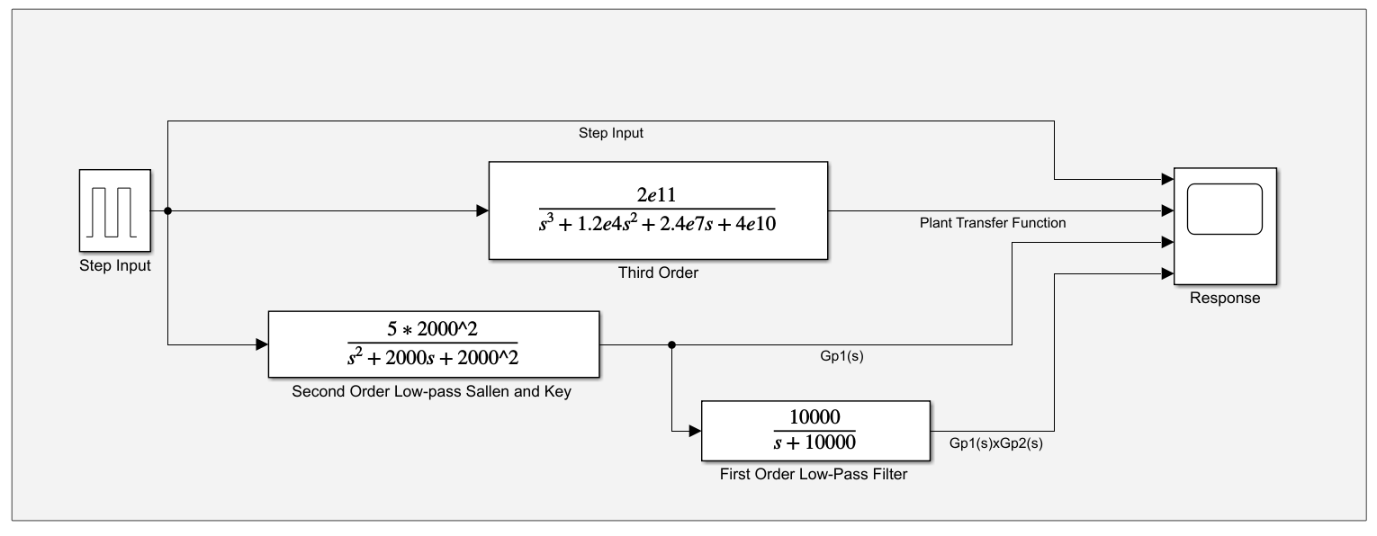The following model was constructed in MATLAB Simulink to emulate the response of the plant. The response of this simulation is seen as the desired response to which the developed LtSpice model will be compared and evaluated. Figure 3: MATLAB Simulation Model below displays the model used to generate the plant response in MATLAB Simulink.

Figure : MATLAB Simulation Model

The following settings were used in the step input block of the model.

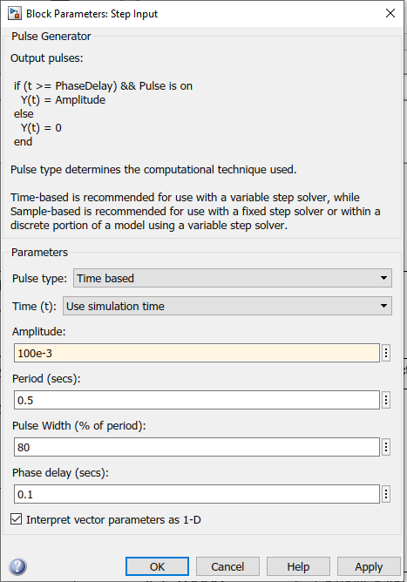

Figure 4: Step Input Parameters for MATLAB Simulation

Concluding the MATLAB simulations, it is clear that the second order approximation of the plant, denoted in Figure 3: MATLAB Simulation Model as $G_{p}1(s)$ is a satisfactory approximation for the plant transfer function as seen in the direct comparison provided in Figure 5: Third order vs Second order systems - Open Loop Plant Step Response.

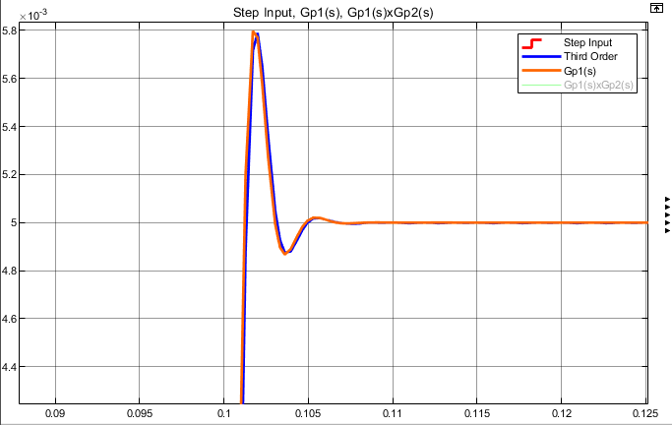

Figure : Third order vs Second order systems - Open Loop Plant Step Response

Thus, for any further implementation, the second order plant shall be used, a further discussion as to why this is the case can be found in the discussion at the end of this milestone.

# LtSpice Model Simulations

The following model was developed in LtSpice. The response obtained from the LtSpice and MATLAB simulations will be compared and discussed in the next section of this document.

Figure : LtSpice Simulation Model

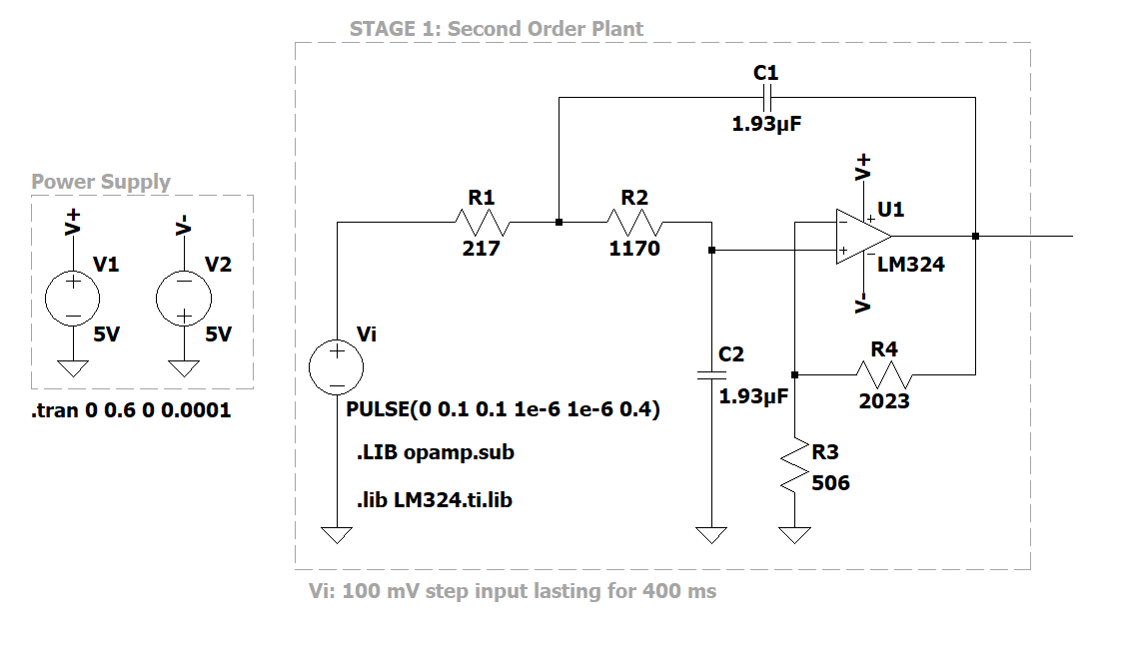

The following simulation settings were used to obtain the LtSpice 2nd order plant response:

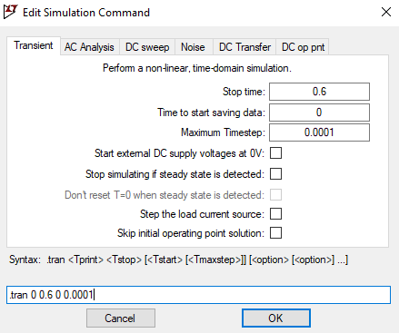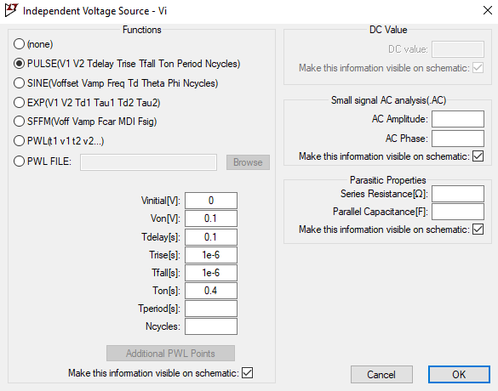

Figure : LtSpice Simulation Settings

# Results

The following section verifies the 2nd order open loop plant response in both MATLAB and LtSpice.

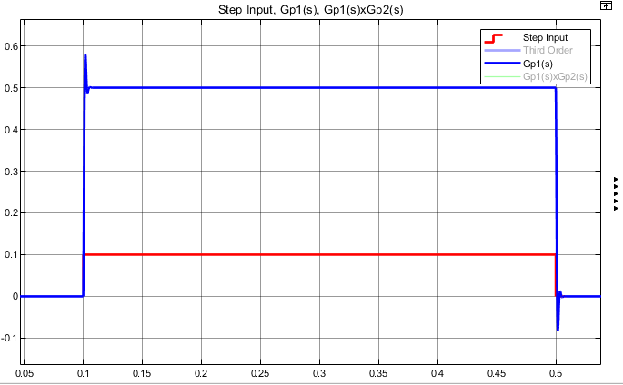

Figure 8: Second-Order Open Loop Response vs Step Input: MATLAB

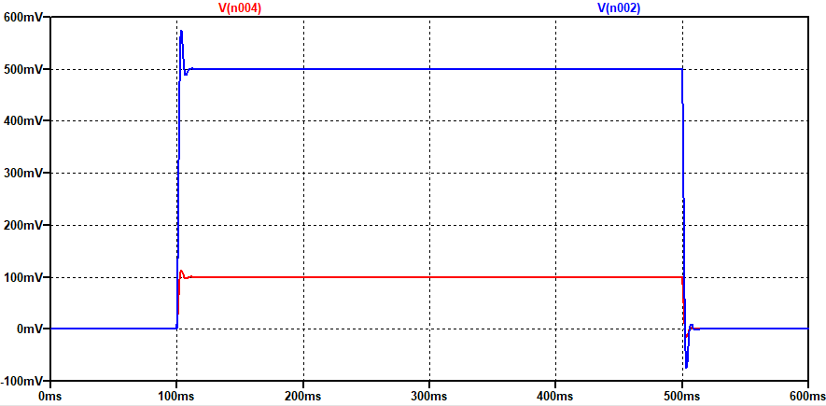

Figure 9: Second-Order Open Loop Response vs Step Input: LtSpice

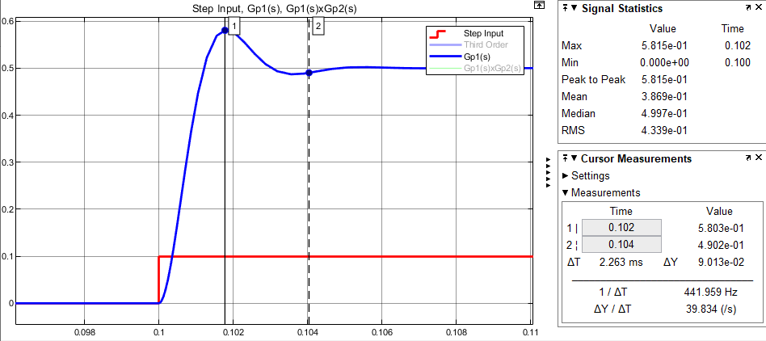

Figure : 2nd order Plant Step Response - Settling Time and Percentage Overshoot

Lastly, from Figure 10 the 2nd order open loop plant is analysed in terms of percentage overshoot and settling time for a step input of $100 mV$. The respective calculations are shown below.

$$T_{s}=0.104-0.1=4 ms$$

To a settling criterion of:

$$\frac{0.5-0.49}{0.5}×100=2\%$$

$$P.O. =\frac{0.0803}{0.5}×100= 16.1\%$$

# Discussion

Concluding Milestone A, a design of an op-amp circuit that realizes the desired transfer function was developed. Furthermore, there can be observed that the second-order approximation to the system, implemented as the Second Order Low-pass Sallen and Key circuit, is an adequate realization of the plant and the secondary First Order Low-Pass Filter bears no effect on the resulting system. Thus, during the construction of the plant, the second-order approximation shall prove adequate and the other unnecessary components may be omitted. An explanation for the lack of influence of the First Order Low-Pass Filter is the pole placement. The pole of the First Order Low-Pass Filter is located as $s= -10 000$, as a result, the distance from the origin is too great to contribute any effect to the remaining system.

# References – Milestone A

|  |  |
| --- | --- |
| [1] | S. A. PACTITIS, “2. Sallen and Key Filters,” in *Active Filters: Theory and Design*, London, New York, CRC Press, 2007, pp. 21-36. |

Milestone C:

# Objective

The objective of Milestone C is to design and incorporate antialiasing filters to the second order plant transfer function obtained in the preceding milestones. Thereafter, the closed-loop characteristic equation of the resulting system is obtained in order to determine the phase lead compensator to satisfy the design specifications.

The second order plant realised with actual component values obtained by substituting for said values in the mathematical derivation section in the preceding milestone delivers the following:

|  |  |  |
| --- | --- | --- |
|  | $$G_{p}\left(s\right)= \frac{5.28×{10}^{6}}{s^{2}+(1.5×{10}^{3})s+(1.06×{10}^{6})}$$ | (1.1) |

The purpose of this report is to document the following design procedures:

1. The analytical determination of an appropriate sampling frequency for the system.
2. The design and incorporation of appropriate antialiasing filters.
3. The design and incorporation of a phase lead compensator that will improve the phase margin to $40°$.

The following subsections of this document concerns the design and incorporation of the abovementioned points. To conclude the design procedure, the resulting system shall be implemented in MATLAB to confirm that the response is satisfactory.

# Sampling frequency

Firstly, we consider the second order approximation provided in equation (1.1). The closed-loop transfer function, for unity feedback, when the rest of the system is ignored is given by the following equation:

|  |  |  |
| --- | --- | --- |
|  | $$T\left(s\right)= \frac{G_{p}\left(s\right)}{1+H(s)G_{p}\left(s\right)}$$ |  |

which simplifies into the following:

|  |  |  |
| --- | --- | --- |
|  | $$T\left(s\right)=\frac{5.28×{10}^{6}}{s^{2}+(1.5×{10}^{3})s+(1.06×{10}^{6})+5.28×{10}^{6}}$$ | (2.1) |

The denominator of $T(s)$ can now be compared to the general second order characteristic equation, provided below, to determine the damping constant, natural frequency, and ultimately the sampling frequency.

|  |  |  |
| --- | --- | --- |
|  | $$s^{2}+2ω_{n}ζs+{ω_{n}}^{2}$$ | (2.2) |

Comparing the denominator of equation $T(s)$ with the general second order characteristic equation, the following values for the damping constant and natural frequency are determined, respectively:

|  |  |  |
| --- | --- | --- |
|  | $$ζ=0.298$$ |  |
|  | $$ω_{n}=2517.94$$ |  |

Finally, the time constant for the system can be determined as follows

|  |  |  |
| --- | --- | --- |
|  | $$τ=\frac{1}{{ζω}_{n}} ≈1.33 ms$$ | (2.3) |

Choosing the right sampling frequency is especially important in terms of quantization errors. In practice, one should choose a sampling rate that is large enough so that the Tustin transformation is valid but sufficiently small so that the quantization noise does not dominate.

A rule of thumb often used for selecting sample rates is that a rate of at least five samples per time constant is considered a good first choice, which in this case equates to a sample rate of roughly $3.8 kHz$, though for this implementation, the STM32F411RE shall serve as the digital compensator and is capable of achieving incredibly fast sample rates. Thus, the sampling period is chosen as approximately one twentieth the time constant, with the prerequisite that it quantisation noise would present itself, the sampling rate would be adjusted if the resulting response is not satisfactory. Thus, the sampling was chosen:

$$f_{s}=15 kHz$$

# Antialiasing Filters Design

When an input signal contains frequency components that exceeds the Nyquist frequency, aliasing may occur due to the inadequate number of samples provided to accurately depict the input signal. To mitigate the effects of aliasing during the sampling process, a considerably high sampling rate have been chosen and in addition to the high sampling rate, simple low-pass RC filters are applied before and after the sampler as seen in Figure 12: System and Signal flow graphs.

The transfer function of a first order RC low-pass filter is given by the following expression:

|  |  |  |
| --- | --- | --- |
|  | $$H\left(s\right)=\frac{\frac{1}{RC}}{s+ \frac{1}{RC}}$$ | (3.1.1) |

Where $f_{c}$ is the cut-off frequency of the filter. As the sampling frequency, has been chosen as $15 kHz$, the Nyquist condition states that frequencies up to $7,5 kHz$ are allowed. Thus, the low-pass filters shall be designed to attenuate frequency components greater than the Nyquist frequency.

The cut-off frequency of a first order low-pass RC filter is given below:

|  |  |  |
| --- | --- | --- |
|  | $$f_{c}=\frac{1}{2πRC}$$ | (3.2) |

For the given circuit diagram:

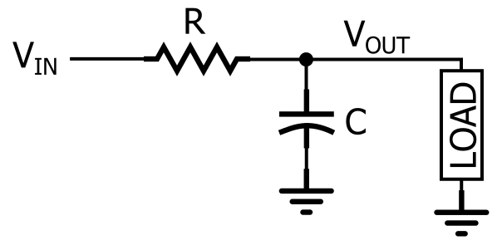

Figure : First order RC low-pass filter

Similar to the procedures in the previous milestones, the capacitor value is chosen arbitrarily, and the remaining values calculated. As such, the desired values of the low-pass antialiasing filters are:

|  |  |  |
| --- | --- | --- |
|  | $$C= 0.1 µF$$ $$R≈212 Ω$$ |  |

Keeping in mind that actual values may vary, and the closest possible values will be selected for the implementation which is closer to $R≈215 Ω$. When these values are combined with equations (3.1.1) and (3.2), the transfer function of the plant can be determined as:

|  |  |  |
| --- | --- | --- |
|  | $$H\left(s\right)=\frac{46512}{s+ 46512}$$ | (3.1.2) |

# Lead Compensator Design

The desired system diagram has been provided below in Figure 12: Desired Control System. Unfortunately, no transfer function can be written for the system in which the input is applied to an analogue element before being sampled. Thus, the system is to be rearranged as in :

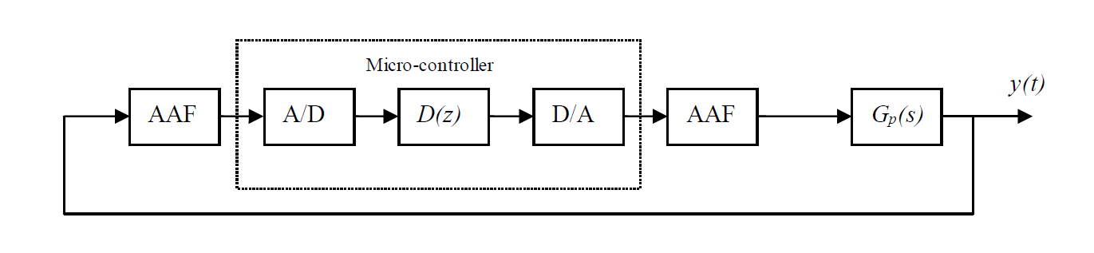

Figure : Desired Control System

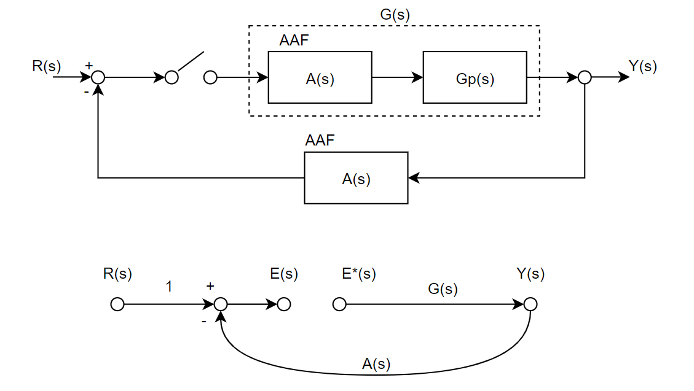

Figure : System and Signal flow graphs

Since the transfer functions of the antialiasing filters are now known, we can proceed to the design of the lead compensator. We use Figure 13: System and Signal flow graphs to derive the characteristic equation for the closed loop system. Note that some of the symbols below have been omitted in Table 1: Table of Nomenclature as most are simply used to derive the discrete-time system characteristic equation, which is of importance.

|  |  |  |
| --- | --- | --- |
|  | $$E\left(s\right)=R\left(s\right)-E^{*}\left(s\right)G(s)A\left(s\right)$$ | (4.1) |

Which can be rewritten when the star transform is applied as:

|  |  |  |
| --- | --- | --- |
|  | $$E^{*}\left(s\right)= \frac{R^{*}(s)}{1+{\overline{GA}}^{*}(s)}$$ | (4.2) |

From which the output is determined in the discrete domain as:

|  |  |  |
| --- | --- | --- |
|  | $$Y(z)=E\left(z\right)G(z)$$ $$= \frac{G(z)}{1+{\overline{GA}}^{*}(z)}R(z)$$ | (4.3) |

Where the characteristic equation is the denominator of equation (4.3).

|  |  |  |
| --- | --- | --- |
|  | $$Q\left(z\right)=1+{\overline{GA}}^{*}\left(z\right)=0$$ | (4.4) |

From the characteristic equation, we proceed to design the phase lead compensator by determining the forward path which now includes the antialiasing filters from equations (1.1) and (3.1.2).

|  |  |  |
| --- | --- | --- |
|  | $$G\left(s\right)=\frac{5.28×{10}^{6}}{s^{2}+\left(1.5×{10}^{3}\right)s+\left(1.06×{10}^{6}\right)}×{\left(\frac{46512}{s+ 46512}\right)}^{2}$$ $$= \frac{1.142×{10}^{16}}{s^{4}+(9.4524×{10}^{4})s^{3}+(2.304×{10}^{9})s^{2}+(3.344×{10}^{12})s+2.293×{10}^{15}}$$ | (4.5) |

Of which the discrete-time transfer function can be obtained by applying the bilinear transform, where the sampling frequency is 15 kHz, to obtain:

|  |  |  |
| --- | --- | --- |
|  | $$G\left(z\right)=\frac{0.00317z^{3}+0.01322z^{2}+0.00388z+7.368×{10}^{-5}}{z^{4}-1.99z^{3}+1.078z^{2}- 0.08531z+0.001833}$$ | (4.6) |

The bode diagram of the discrete-time transfer function is provided below, that includes both the gain and phase margins:

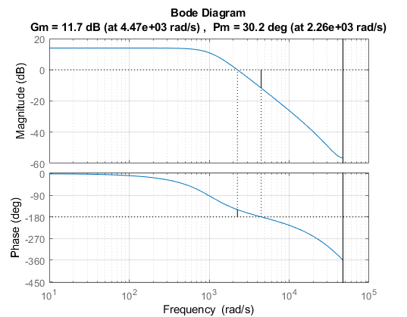

Figure : Open loop System bode plot

From Figure 13: Discrete-time system bode plot, an arbitrary frequency $ω_{w1}$ must be chosen such that the following three conditions are met:

Condition 1:

|  |  |  |
| --- | --- | --- |
|  | $$∠G\left(jω_{w1}\right)<-180°+Φ_{m}$$ | (4.7.1) |

where $Φ_{m}$ is the desired phase margin, which is specified as $40°$.

Condition 2:

|  |  |  |
| --- | --- | --- |
|  |  | (4.7.2) |

where $a_{0}$ is the compensator dc gain, and as there is no required gain adjustments, $a_{0}=1$.

Condition 3:

|  |  |  |
| --- | --- | --- |
|  |  | (4.7.3) |

where $θ$ is the angle associated with $∠D\left(jω_{w1}\right)$ and can be determined by means of the following expression:

|  |  |  |
| --- | --- | --- |
|  | $$θ= ∠D\left(jω_{w1}\right)= 180°+Φ_{m}- ∠G\left(jω_{w1}\right)$$ | (4.7.4) |

Based on an iterative design procedure, that is $ω_{w1}$ was chosen for various values until the improved phase margin was exactly $40°$. Consequently, $ω_{w1}$ was chosen as $2500 rad/s$, to yield the following values.

|  |  |  |
| --- | --- | --- |
|  |  |  |

Where all three the conditions are satisfied. Next, the constants needed to produce the compensator are calculated as follows:

|  |  |  |
| --- | --- | --- |
|  |  | (4.8.1) |
|  |  | (4.8.2) |

For the lead compensator:

|  |  |  |
| --- | --- | --- |
|  | $$D(w)=\frac{a_{1}w+a_{0}}{b_{1}w+1}=\frac{3.8754×{10}^{-4} w+1}{ 2.2186×{10}^{-5}w+1}$$ | (4.9.1) |

With the discrete-time transfer function, obtained by applying the bilinear transform:

|  |  |  |
| --- | --- | --- |
|  | $$D(z)=\frac{1.6492(z-0.8416)}{(z+0.7388)}$$ | (4.9.2) |

That can be rewritten as the following difference equation:

|  |  |  |
| --- | --- | --- |
|  | $$y\left[n\right]=1.6492x\left[n\right]-1.3879x\left[n-1\right]+0.7388y[n-1]$$ | (4.9.3) |

The bode diagram of the lead compensated open loop system is provided below, that includes both the gain and phase margins:

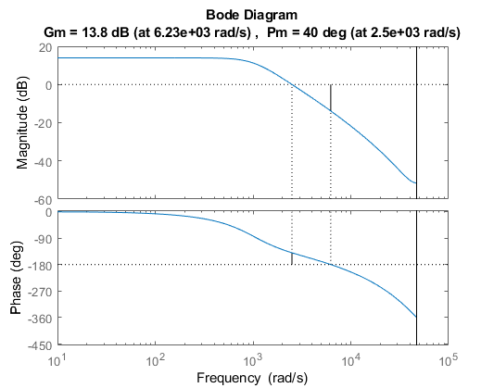

Figure : Lead compensated open loop system bode plot

# Results

To conclude this report, both the frequency analyses and step responses of the compensated and uncompensated systems are provided for a more direct comparison:

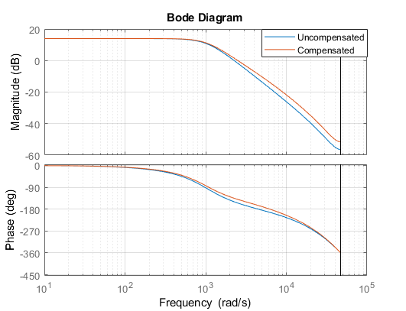

Figure : Open Loop Compensated vs Uncompensated Bode Plot Comparison

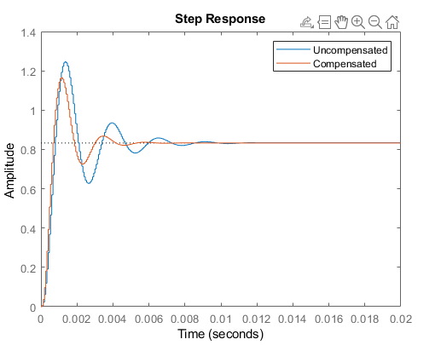

Figure : Open Loop Compensated vs Uncompensated Step Response Comparison

# Discussion

This report documents the determination of an appropriate sampling frequency for the system, such that quantisation noise is minimised whilst remaining realisable in practical implementation. The antialiasing filters was developed using said sampling frequency and was accounted for during the calculation of the discrete-time system transfer function. Thereafter, the discrete-time system transfer function was used to design a phase lead compensator to improve the system’s phase margin to $40°$ as stated in the practical specification document. The results obtained in this milestone shall be used to realise the plant via a microcontroller.

# References – Milestone C

|  |  |
| --- | --- |
| [1] | S. A. PACTITIS, “2. Sallen and Key Filters,” in *Active Filters: Theory and Design*, London, New York, CRC Press, 2007, pp. 21-36. |