1 Database design

The system must support uploading and managing photos and attachments, the creation of and engagement in private and public discussion threads, as well to do polls at the message level. The upload limit must be dynamically adapted according to the social status that the user reached on the forum.

**The following Logical entities need to be considered for the database design:**

**Users**: People who engage in the online forum, exchange posts and vote on polls. Users are associated with their respective login credentials, user picture and community status determined by their activity on the forum.

**Topics/Threads:** These are posted by users to engage in discussion with the community, where other users may reply using comments/replies. A user may have multiple threads simultaneously and threads may have multiple uploads that is limited by the social status that the user reached on the forum. Topics/Threads is associated with a unique id, topic name, topic contents and uploads.

Additionally, engagement in private and public discussion threads may be implemented by allowing a select group of individuals access to a certain topic/thread.

**Comments/Replies:** Also posted by users as a form of replies to topics/threads, users may have multiple comments/replies simultaneously on different or even on the same threads. Comments/replies may have multiple uploads that is limited by the social status that the user reached on the forum. Comments/Replies is associated with a unique id, topic contents and uploads.

**Polls:** A means for users to ask the community on their opinion on topics by means of a voting system. Various users may vote on a poll and a single user may have multiple poles running simultaneously.

Additionally, engagement in private and public polls may be implemented by allowing a select group of individuals access to a certain poll.

**Votes**: A mechanism put in place to prevent users from voting multiple times on a single poll. A vote is associated with a poll and a user. When a user has voted on a poll, this mechanism prevents the user from injecting multiple votes. Additional measures may be implemented to allow user to change their vote.

Uploads: Non-text content that may be uploaded to threads or comments. Where the upload limit shall be dynamically adapted according to the social status that the user reached on the forum

**Sessions:** A unique identifier that prevents a PHP session from being hijacked without authentication on every page.

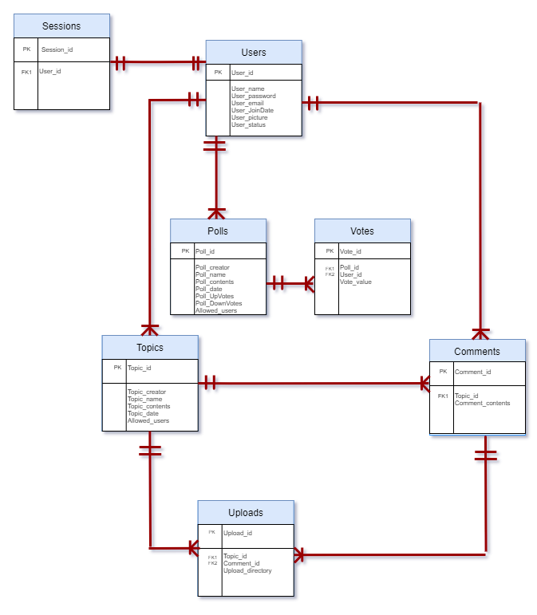**Internet Forum ERD**

**Note:**

Allowed_users: may be a text entry containing a list of usernames that are allowed access to a certain poll of thread. A default value may be assigned when the poll/thread remains public.

**Web interface**

**Session management:** The session identifier is uniquely generated and is associated with the authenticated user and this association is confirmed on every page.

**User Authentication:** User sensitive information such as passwords are encrypted as part of good practice.

**User Registration:** Users registration and login procedures are handled using an HTML forms. Precautions are put in place to prevent SQL injection. Additionally, verification such as email validity, username availability and password length shall also be accounted for.

**User Experience:** Forms are intended to have an intuitive yet stylish feel with functionality such as cycling through fields by use of the tab button and even possible autofill functionality, depending on the browser.

**Aesthetics:** A minimalistic design aims to improve usability with a shared stylesheet among forms to produce coherent design elements.

**Possible Hurdles:**

There are many challenges in the web development environment. For certain lack of experience in the development area is a big hinderance.

Very often environments change, and steadfast solutions becomes inefficient or outdated.

Then there is the issue of intellectual rights and what is deemed allowable to integrate into one’s solution.

Possible timeframe may also be an issue and a bit of a controversial term that my roommate loves to use: “idiot testing”, which he describes as the arduous process of exhausting every possible creative input that a user may purposely on unconsciously inject into the system and accounting for it by producing an appropriate response.