Basic Inferential Data Analysis of the ToothGrowth data

Arman Iskaliyev

28/02/2018

### **Overview**

We will explore the ToothGrowth dataset from the base R. It contains information about the effects of vitamin C’s dosage on tooth growth of Guinea Pigs. We will perform exploratory analysis and hypothesis testing to figure out is there a relationship between tooth growth and daily dosage of vitamin C.

### **Basic exploratory data analysis**

Dataset description:

The response is the length of odontoblasts (cells responsible for tooth growth) in 60 guinea pigs. Each animal received one of three dose levels of vitamin C (0.5, 1, and 2 mg/day) by one of two delivery methods, (orange juice or ascorbic acid (a form of vitamin C and coded as VC).

Codebook:

* len - numeric, Tooth length
* supp - factor, Supplement type (VC or OJ).
* dose - numeric, Dose in milligrams/day

Load data and required packages:

library(ggplot2)  
library(dplyr)  
library(tidyr)  
library(purrr)  
library(broom)  
options(tibble.width = Inf)   
data("ToothGrowth")

Explore the dataset:

glimpse(ToothGrowth)

## Observations: 60  
## Variables: 3  
## $ len <dbl> 4.2, 11.5, 7.3, 5.8, 6.4, 10.0, 11.2, 11.2, 5.2, 7.0, 16....  
## $ supp <fct> VC, VC, VC, VC, VC, VC, VC, VC, VC, VC, VC, VC, VC, VC, V...  
## $ dose <dbl> 0.5, 0.5, 0.5, 0.5, 0.5, 0.5, 0.5, 0.5, 0.5, 0.5, 1.0, 1....

summary(ToothGrowth)

## len supp dose   
## Min. : 4.20 OJ:30 Min. :0.500   
## 1st Qu.:13.07 VC:30 1st Qu.:0.500   
## Median :19.25 Median :1.000   
## Mean :18.81 Mean :1.167   
## 3rd Qu.:25.27 3rd Qu.:2.000   
## Max. :33.90 Max. :2.000

ToothGrowth$dose <- factor(ToothGrowth$dose)

Exploring variables via visualization:

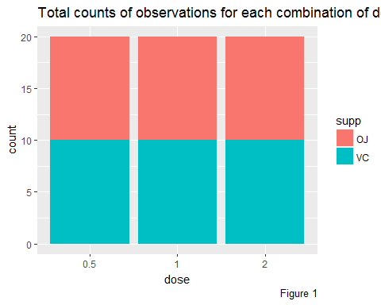

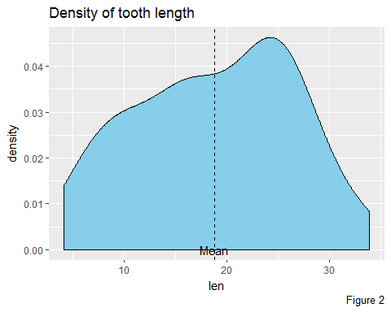

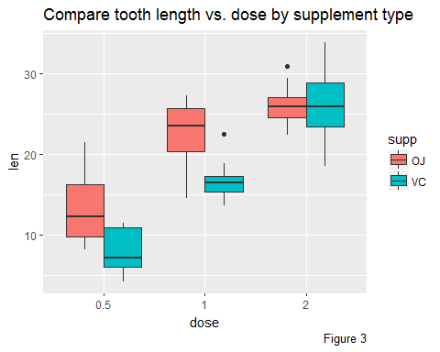

### **Hypothesis tests**

In the previous step of exploratory data analysis we see that there is a obvious relationship between the dose levels of vitamin and tooth growth. Therefore we can say the dosage affects the tooth length. Also visualizations show us that supplement delivery method has no robust impacts on tooth length.

Let’s calculate t-test for both groups.

1. Testing tooth growth by supplement delivery method:

Null Hypothesis : different supplement types have no effect on tooth length

t.result1 <-   
 tidy(t.test(len~supp, data = ToothGrowth)) %>%  
 print()

## estimate estimate1 estimate2 statistic p.value parameter conf.low  
## 1 3.7 20.66333 16.96333 1.915268 0.06063451 55.30943 -0.1710156  
## conf.high method alternative  
## 1 7.571016 Welch Two Sample t-test two.sided

Here We can not reject the Null Hypothesis, cause the Confidence interval contains zero and also the p.value (0.0606345) is greater than 0.05.

1. Testing tooth growth by dose:

Null Hypothesis : dosage levels have no effect on tooth length

We will compare doses 0.5 with 1, 1 with 2 and 2 with 0.5

t.result2 <-   
ToothGrowth %>%   
 mutate(dose.group = "0.5-1") %>%   
 bind_rows(ToothGrowth) %>%   
 mutate(dose.group = if_else(is.na(dose.group), "1-2", dose.group)) %>%  
 bind_rows(ToothGrowth) %>%   
 mutate(dose.group = if_else(is.na(dose.group), "2-0.5", dose.group)) %>%  
 filter((dose.group == "0.5-1" & dose %in% c(.5, 1)) |  
 (dose.group == "1-2" & dose %in% c(1, 2)) |  
 (dose.group == "2-0.5" & dose %in% c(2, .5))) %>%  
 select(-supp) %>%  
 group_by(dose.group) %>%  
 do(tidy(t.test(len~dose, data = .))) %>%  
 print()

## # A tibble: 3 x 11  
## # Groups: dose.group [3]  
## dose.group estimate estimate1 estimate2 statistic p.value parameter  
## <chr> <dbl> <dbl> <dbl> <dbl> <dbl> <dbl>  
## 1 0.5-1 -9.13 10.6 19.7 -6.48 1.27e- 7 38.0  
## 2 1-2 -6.37 19.7 26.1 -4.90 1.91e- 5 37.1  
## 3 2-0.5 -15.5 10.6 26.1 -11.8 4.40e-14 36.9  
## conf.low conf.high method alternative  
## <dbl> <dbl> <fct> <fct>   
## 1 -12.0 -6.28 Welch Two Sample t-test two.sided   
## 2 -9.00 -3.73 Welch Two Sample t-test two.sided   
## 3 -18.2 -12.8 Welch Two Sample t-test two.sided

The confidence intervals for these doses groups allow us to reject the Null Hypothesis.

### **Conclusion**

* Supplement delivery method has no effect on tooth growth
* Increasing the dose level increases tooth growth

### **Appendices**

Code to plot Figure 1:

ggplot(ToothGrowth, aes(x = dose, fill = supp)) +   
 geom_bar() +   
 labs(caption = "Figure 1", title = "Total counts of observations for each combination of dose and supplement type")

Code to plot Figure 2:

ggplot(ToothGrowth, aes(x = len)) +   
 geom_density(fill = "skyblue") +   
 geom_vline(xintercept = mean(ToothGrowth$len), lty = "dashed") +   
 annotate(geom = "text", x = mean(ToothGrowth$len), y = 0, label = "Mean") +   
 labs(caption = "Figure 2", title = "Density of tooth length")

Code to plot Figure 3:

ggplot(ToothGrowth, aes(x = dose, y = len, fill = supp)) +  
 geom_boxplot() +   
 labs(caption = "Figure 3", title = "Compare tooth length vs. dose by supplement type")