CPE301 – SPRING 2020

Design Assignment 2C

Student Name: Mateo Markovic

Student #: 2001338139

Student Email: Markom1@unlv.nevada.edu

Primary Github address: <https://github.com/mateom99/submission_da>

Directory: DesignAssignments/DA2C

1. **COMPONENTS LIST AND CONNECTION BLOCK DIAGRAM w/ PINS**

* Atmega328PB-Xmini w/ Atmel Studio 7.0
* Multifunction shield (Push Button, LEDs)
* Generic Logic Analyzer

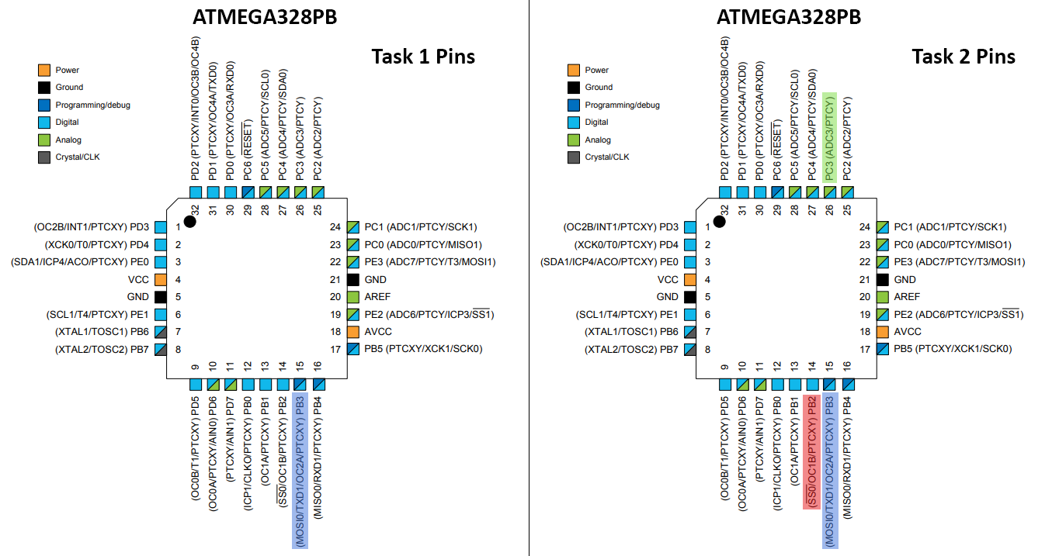

1. **INITIAL/MODIFIED/DEVELOPED CODE OF TASK 1**

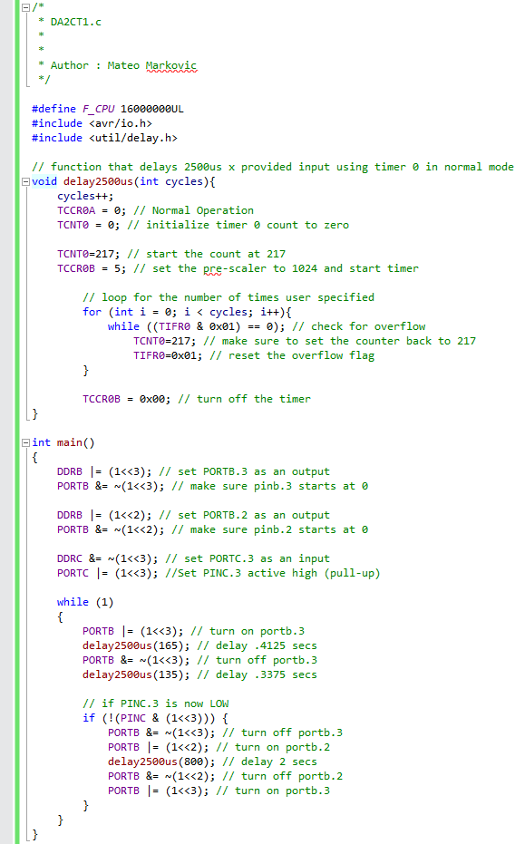

1. **INITIAL/MODIFIED/DEVELOPED CODE OF TASK 2**

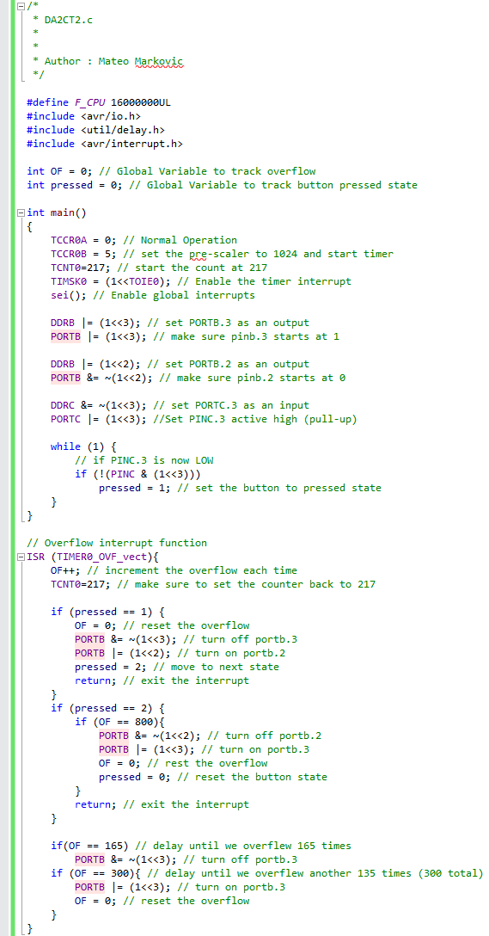

1. **INITIAL/MODIFIED/DEVELOPED CODE OF TASK 3**

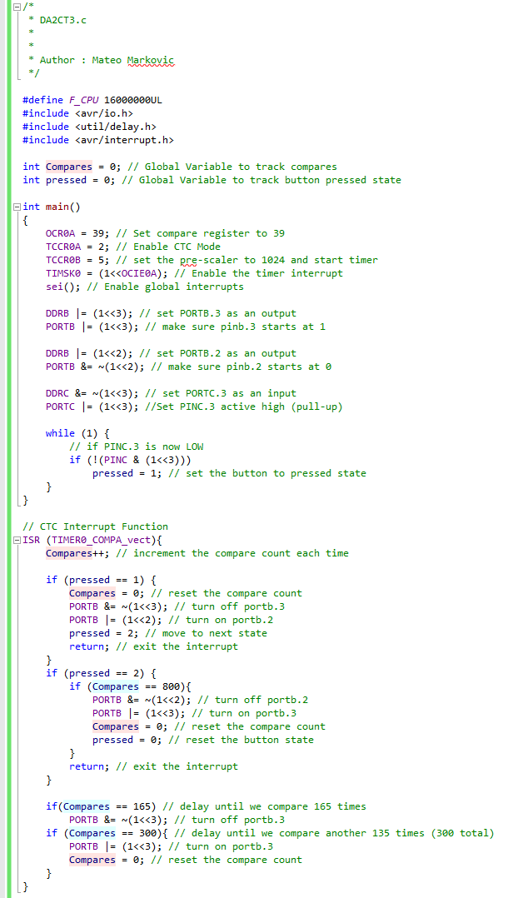

1. **SCHEMATICS**

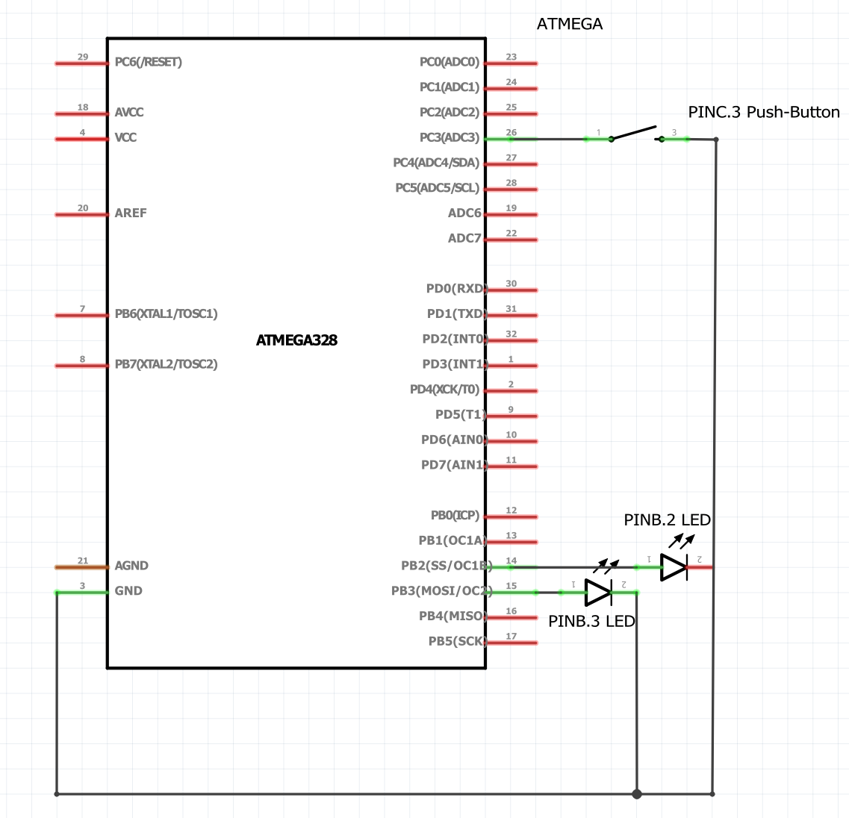

1. **SCREENSHOTS OF EACH TASK OUTPUT (ATMEL STUDIO OUTPUT)**

**Delay Proof Via Simulation**

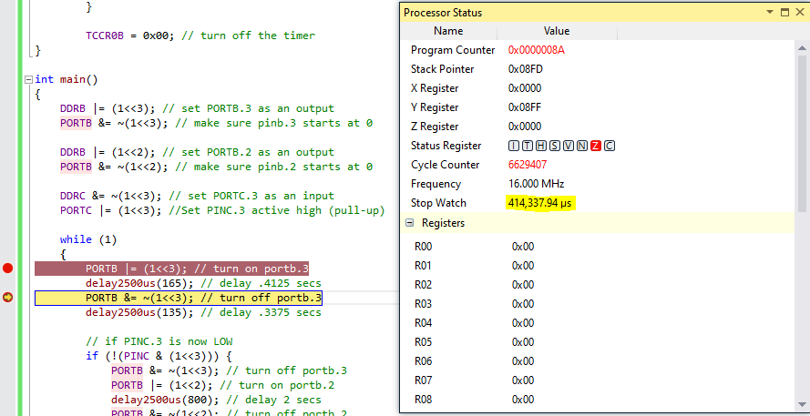

0.4125 Second Delay Proof via Sim

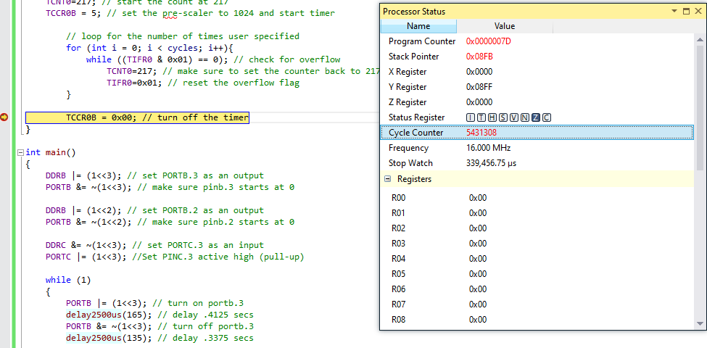

0.3375 Second Delay Proof via Sim

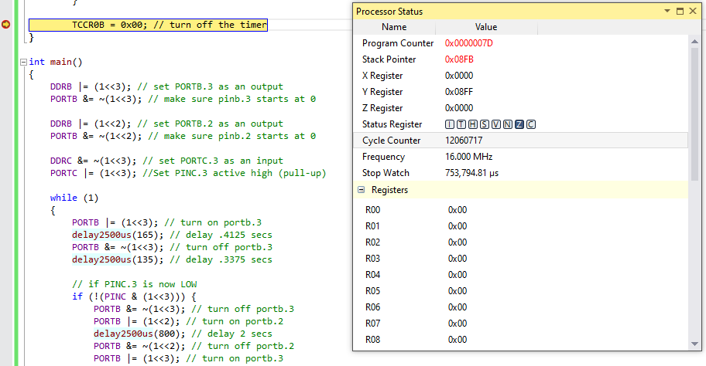

0.75 Second Period Proof via Sim

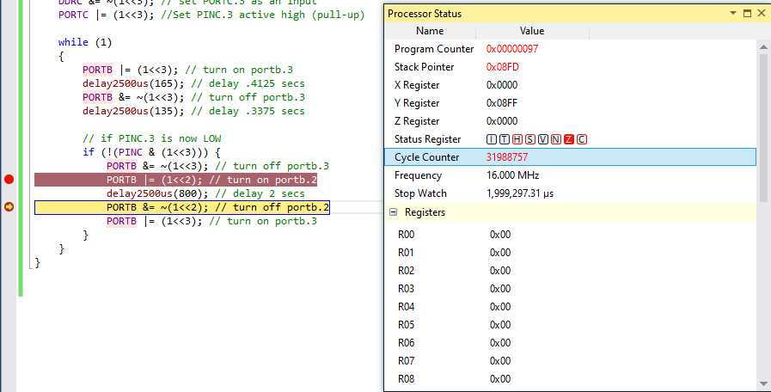

2.0 Second Delay Proof via Sim

**Delay Proof Via Logic Analyzer**

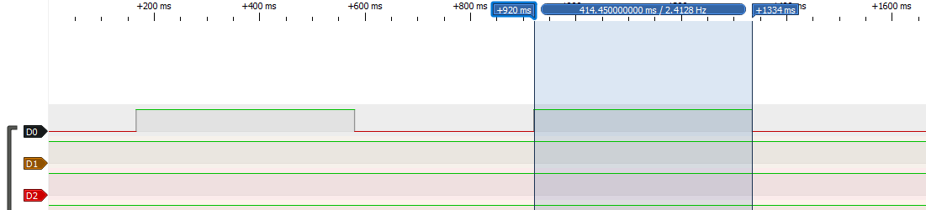

0.4125 Second Delay Proof via Logic Analyzer

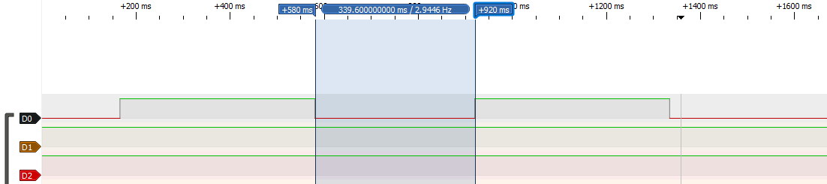

0.3375 Second Delay Proof via Logic Analyzer

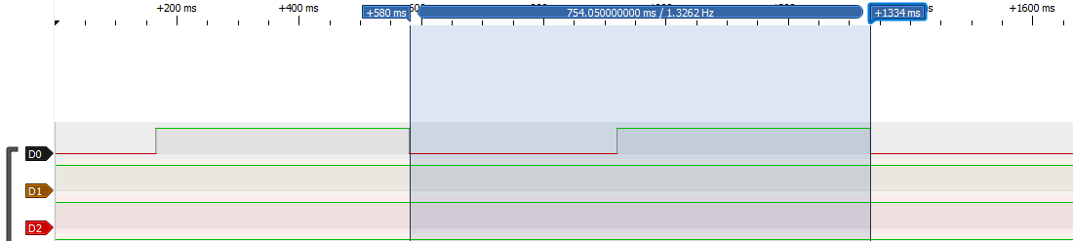

0.75 Second Period Proof via Logic Analyzer

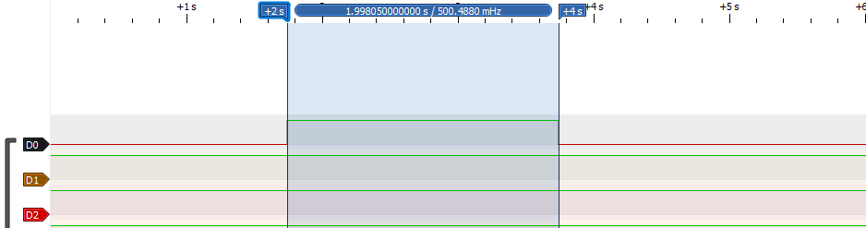

2.0 Second Delay Proof via Logic Analyzer

1. **SCREENSHOT OF EACH DEMO (BOARD SETUP)**

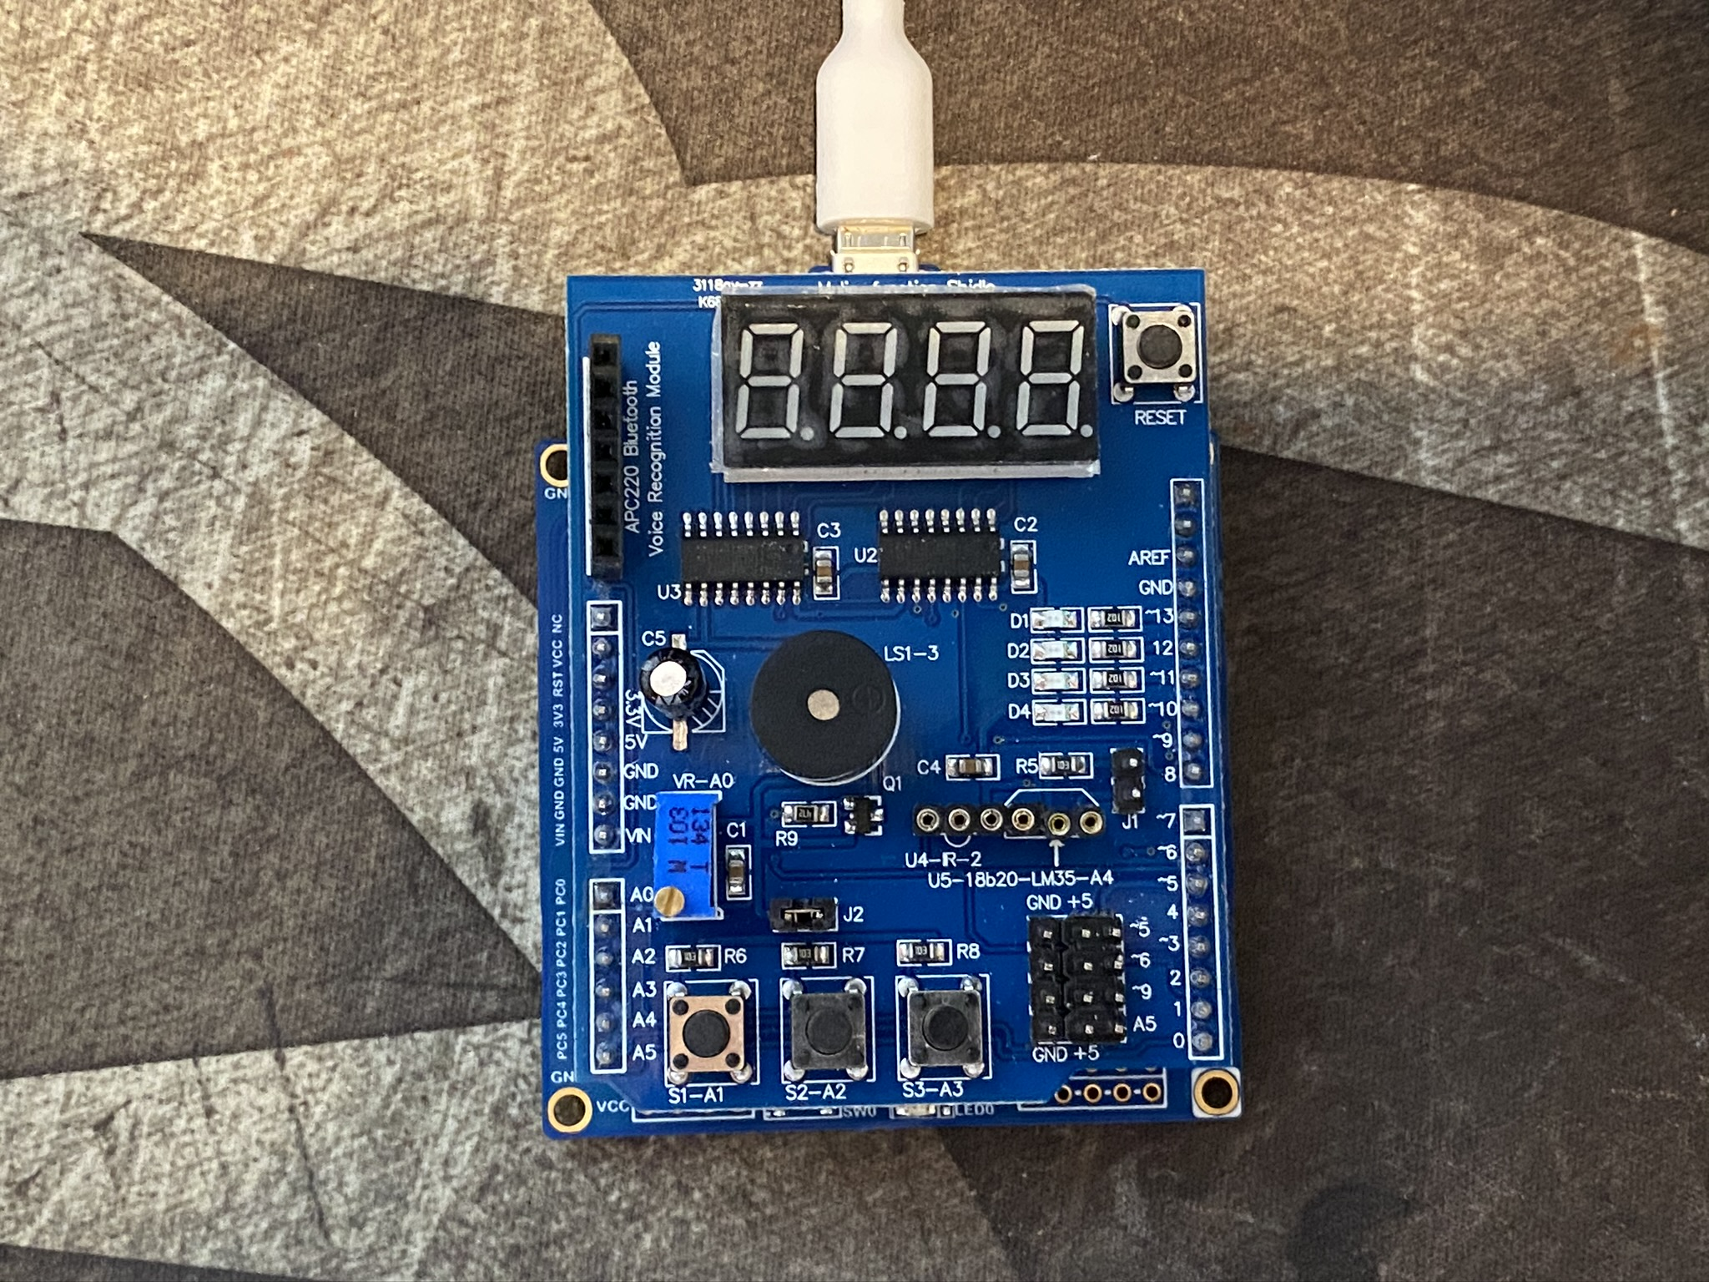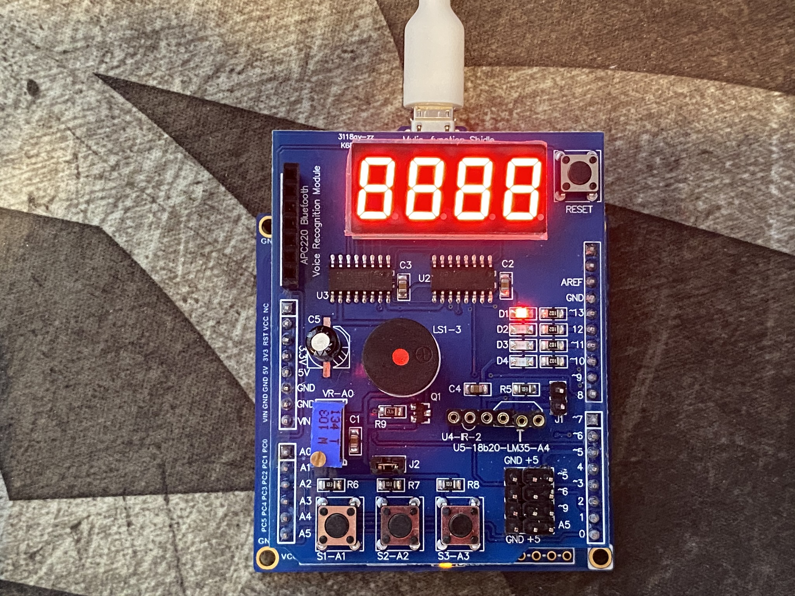

Board with multifunction shield (Off and On)

1. **VIDEO LINKS OF EACH DEMO**

Task 1 Demonstration: <https://youtu.be/3glNAlqX3xE>

Task 2 Demonstration: <https://youtu.be/bHehcwOBfPc>

Task 3 Demonstration: <https://youtu.be/ybXBhIUlVlI>

1. **GITHUB LINK OF THIS DA**

[https://github.com/mateom99/submission_da/tree/master/DesignAssignments/DA2C](https://github.com/mateom99/submission_da/tree/master/DesignAssignments/DA2CA)

**Student Academic Misconduct Policy**

<http://studentconduct.unlv.edu/misconduct/policy.html>

“This assignment submission is my own, original work”.

Mateo Markovic