CPE301 – SPRING 2020

Design Assignment 4A

Student Name: Mateo Markovic

Student #: 2001338139

Student Email: Markom1@unlv.nevada.edu

Primary Github address: <https://github.com/mateom99/submission_da>

Directory: DesignAssignments/DA4A

1. **COMPONENTS LIST AND CONNECTION BLOCK DIAGRAM w/ PINS**

* Atmega328PB-Xmini w/ Atmel Studio 7.0
* Atmega328PB Debugger
* Arduino Multi-Function Shield (Potentiometer at PC0 and button at PC3)
* DC Motor w/ TB6612FNG Driver IC

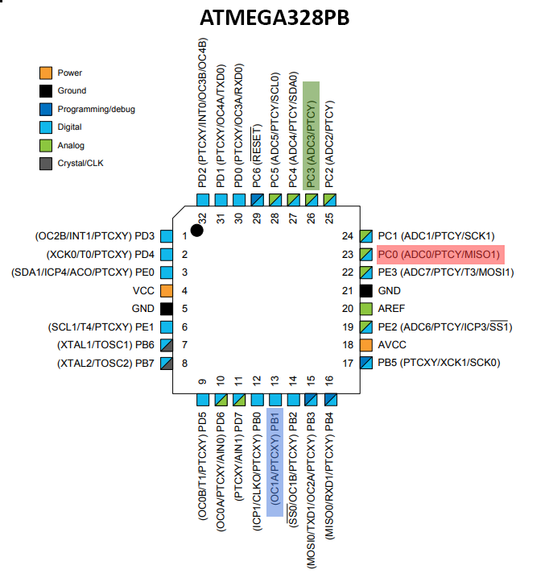

1. **INITIAL/MODIFIED/DEVELOPED CODE OF TASK 1/A**

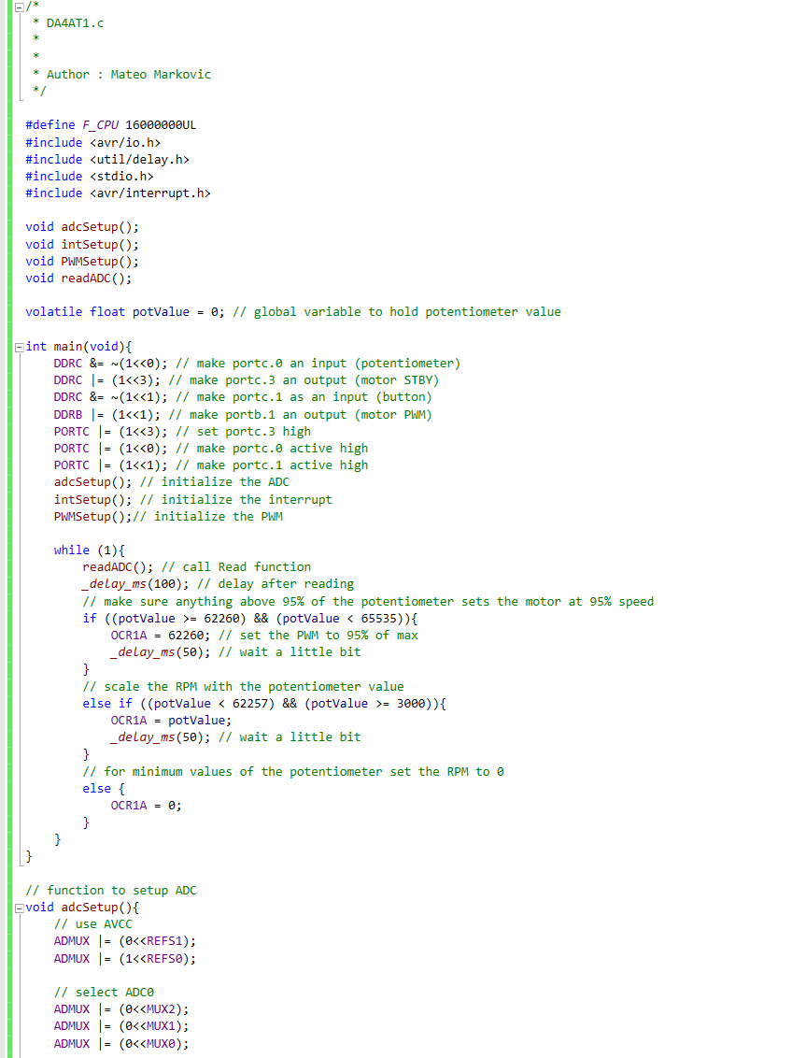

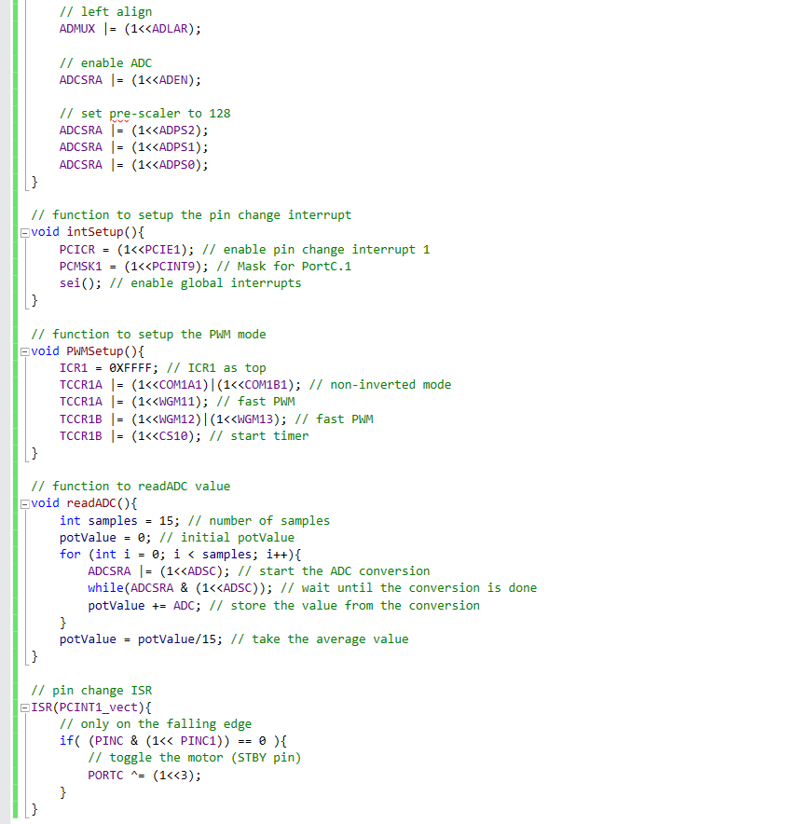

1. **SCHEMATICS**

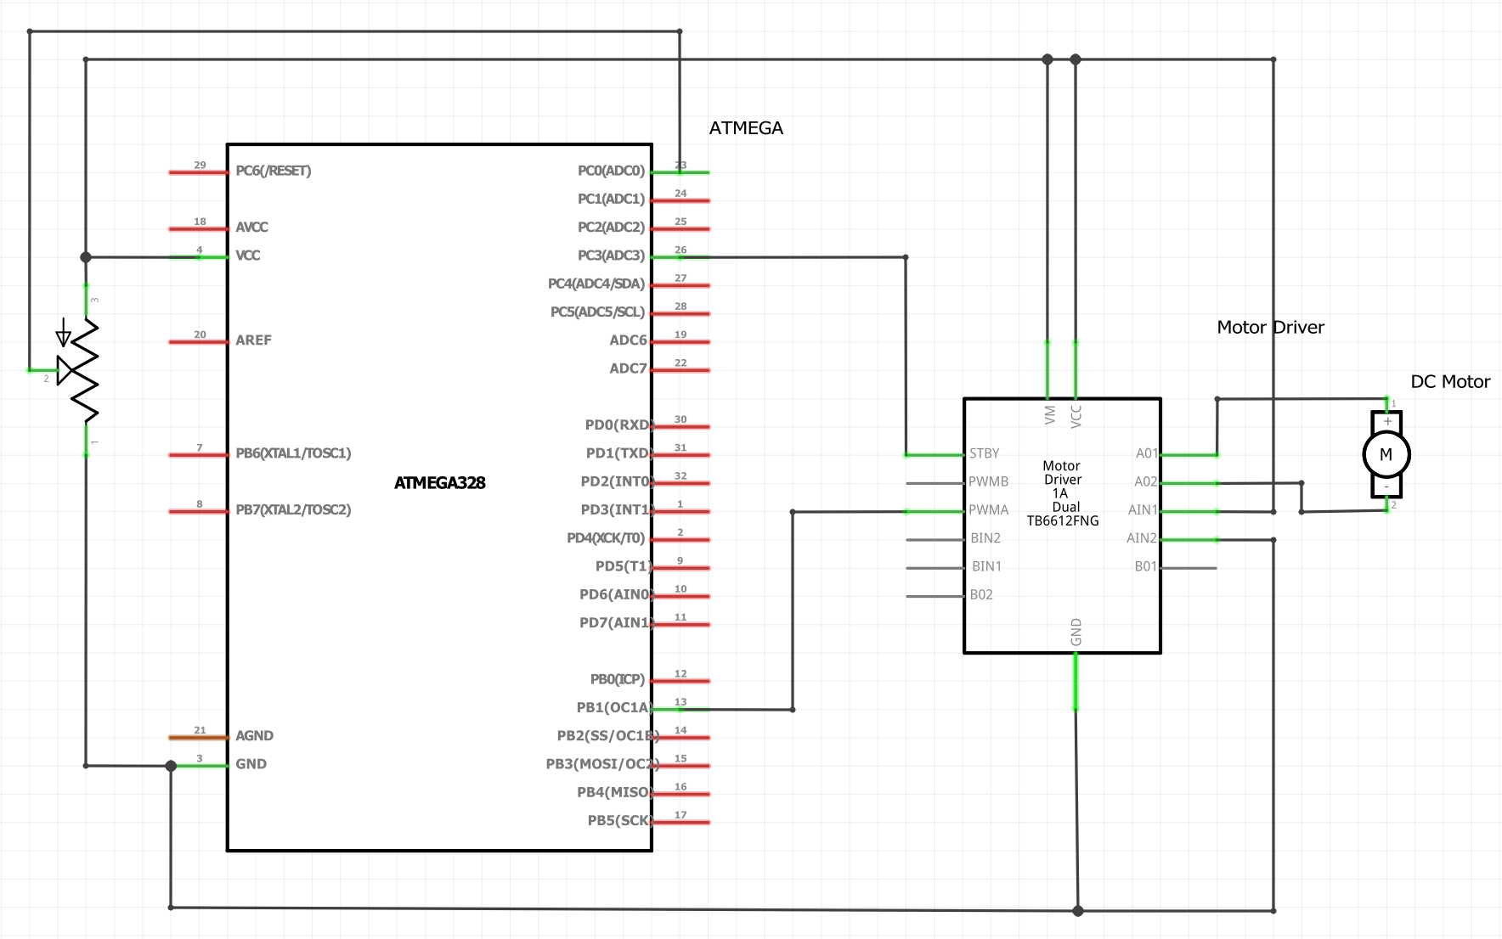

Fritzing Schematic of pins used

1. **SCREENSHOT OF EACH DEMO (BOARD SETUP)**

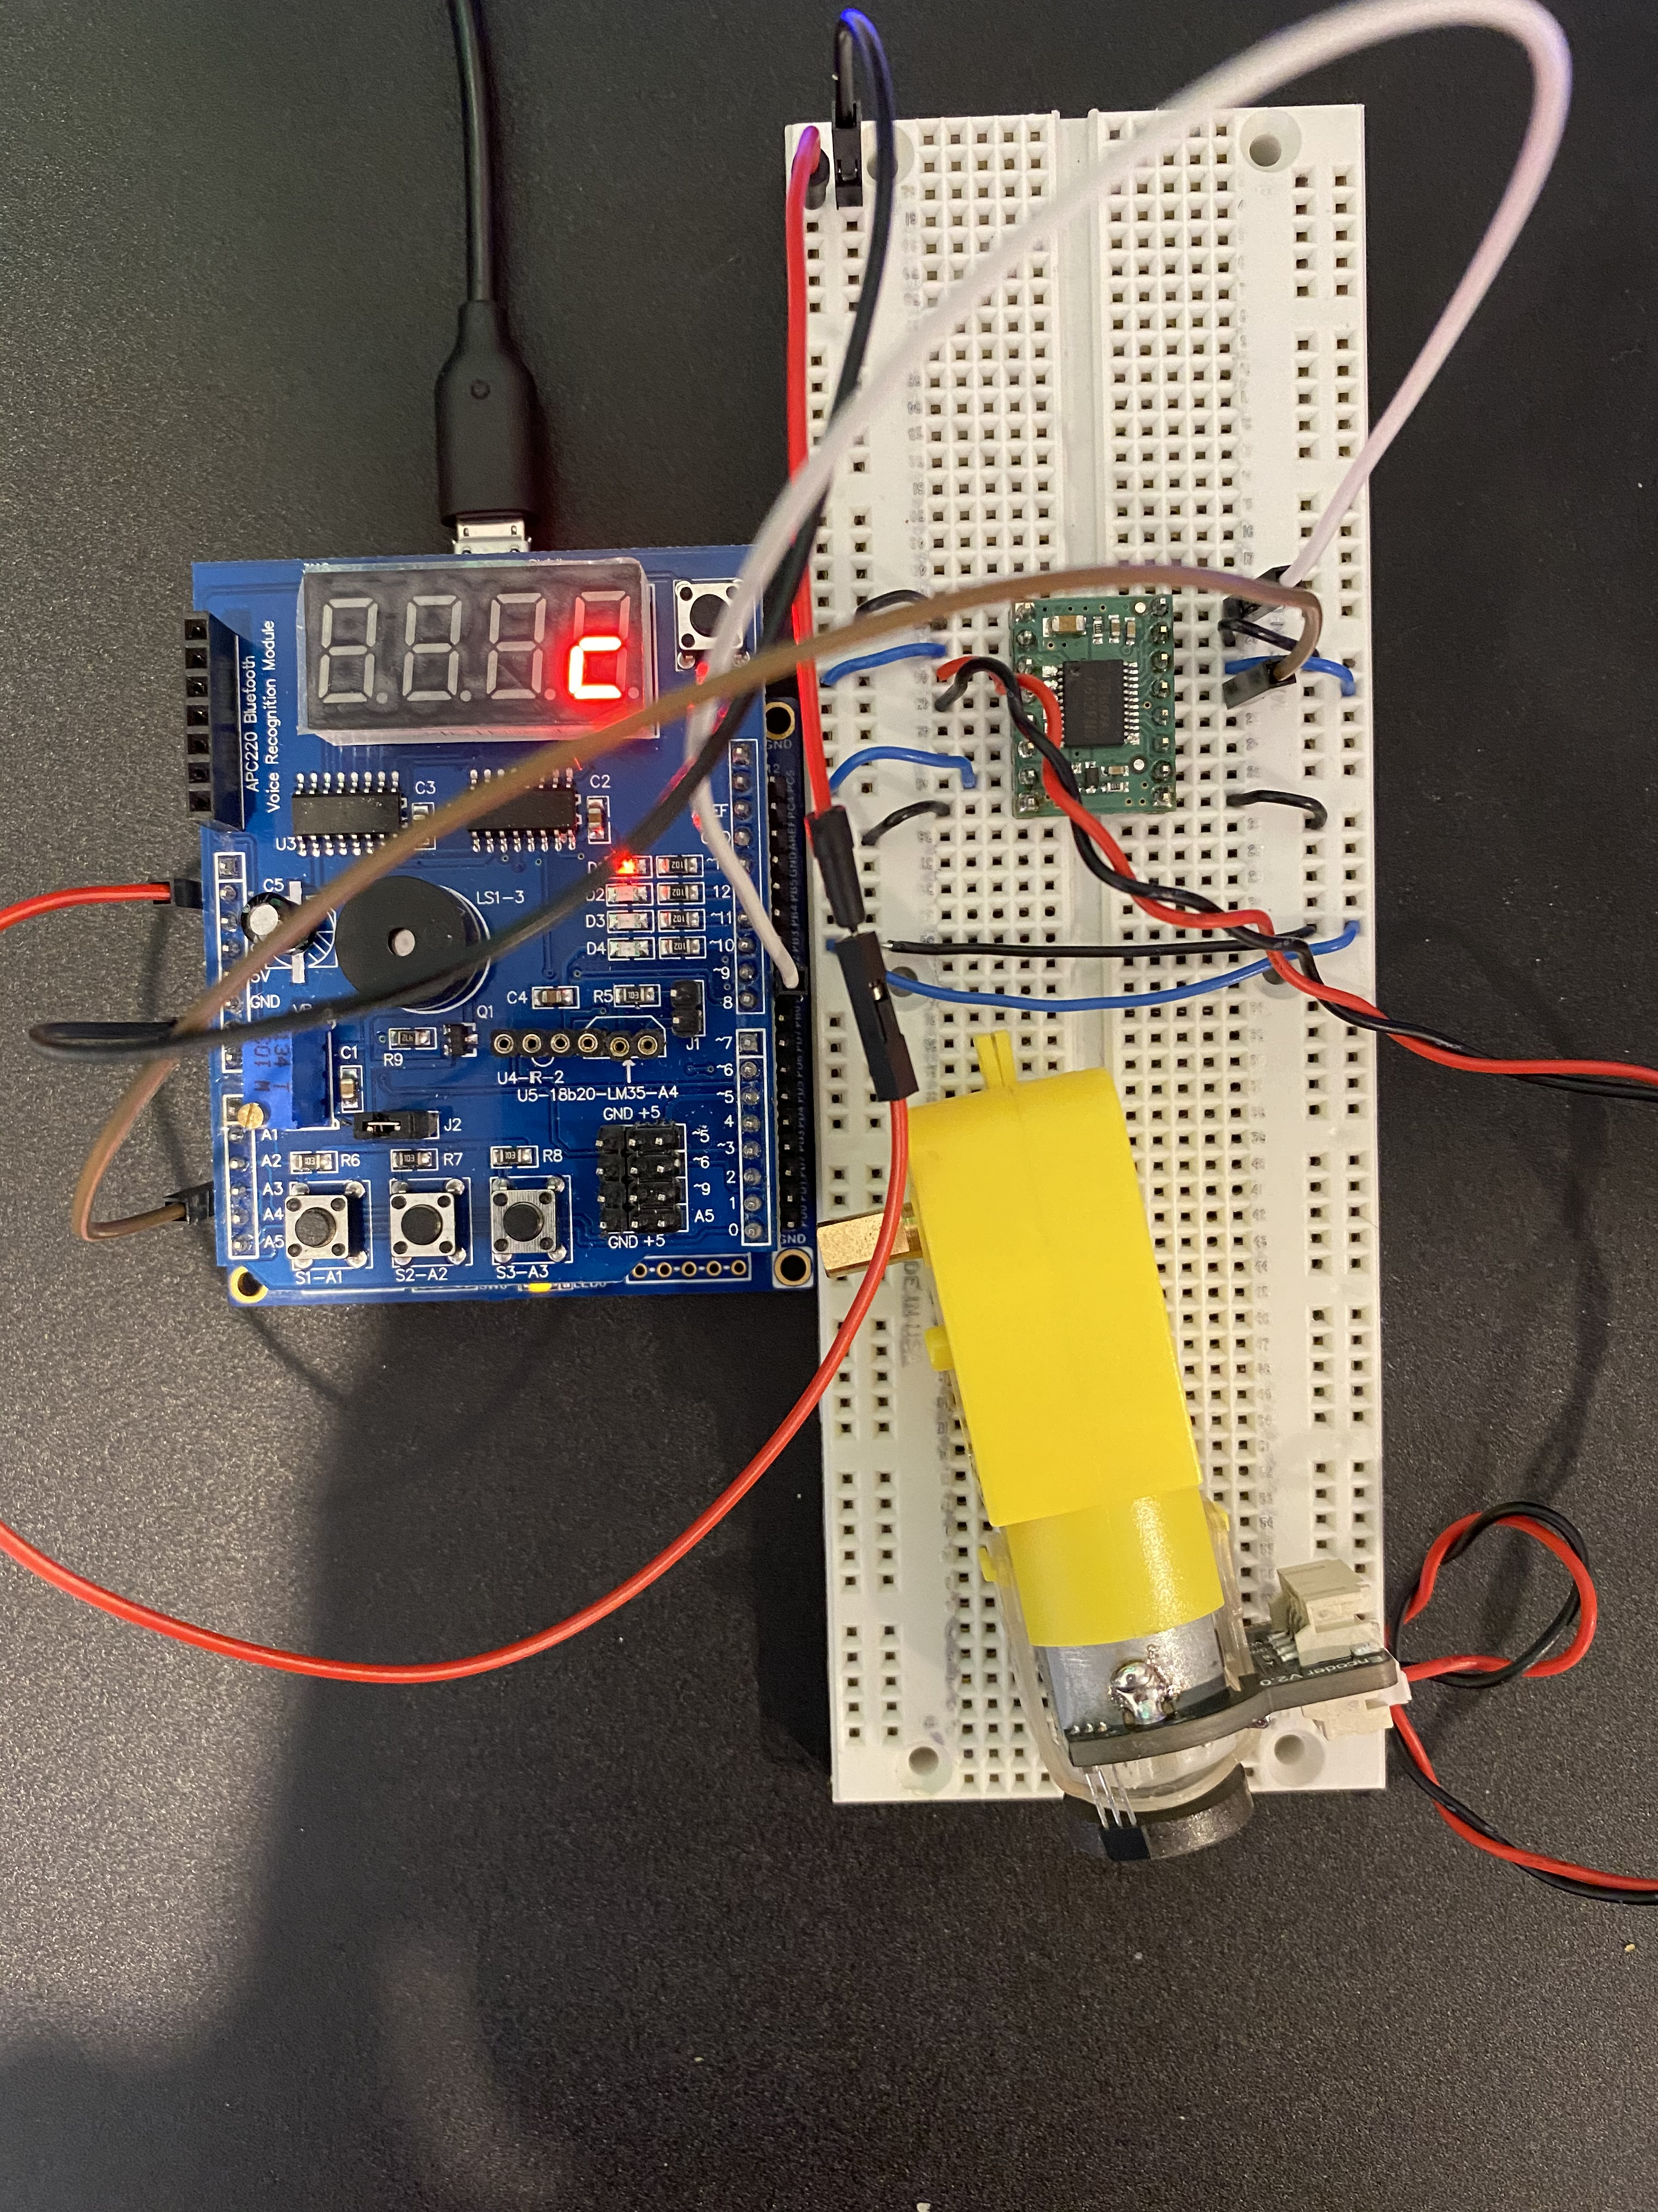

1. **VIDEO LINKS OF EACH DEMO**

Demonstration: <https://youtu.be/aBSTqmXfsOw>

1. **GITHUB LINK OF THIS DA**

<https://github.com/mateom99/submission_da/tree/master/DesignAssignments/DA4A>

**Student Academic Misconduct Policy**

<http://studentconduct.unlv.edu/misconduct/policy.html>

“This assignment submission is my own, original work”.

Mateo Markovic