CPE301 – SPRING 2020

Design Assignment 4B

Student Name: Mateo Markovic

Student #: 2001338139

Student Email: Markom1@unlv.nevada.edu

Primary Github address: <https://github.com/mateom99/submission_da>

Directory: DesignAssignments/DA4B

1. **COMPONENTS LIST AND CONNECTION BLOCK DIAGRAM w/ PINS**

* Atmega328PB-Xmini w/ Atmel Studio 7.0
* Atmega328PB Debugger
* Arduino Multi-Function Shield (Potentiometer at PC0)
* 28BYJ-48 Stepper Motor with ULN2003AN Driver IC
* 3001HB Servo Motor

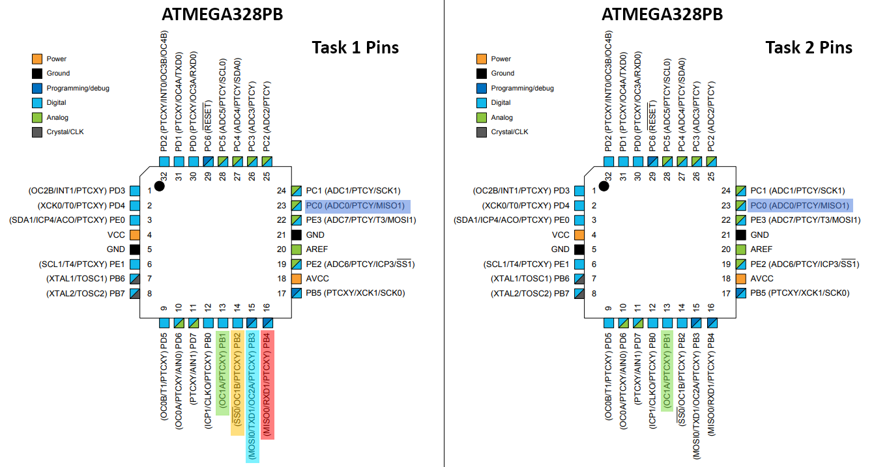

1. **INITIAL/MODIFIED/DEVELOPED CODE OF TASK 1**

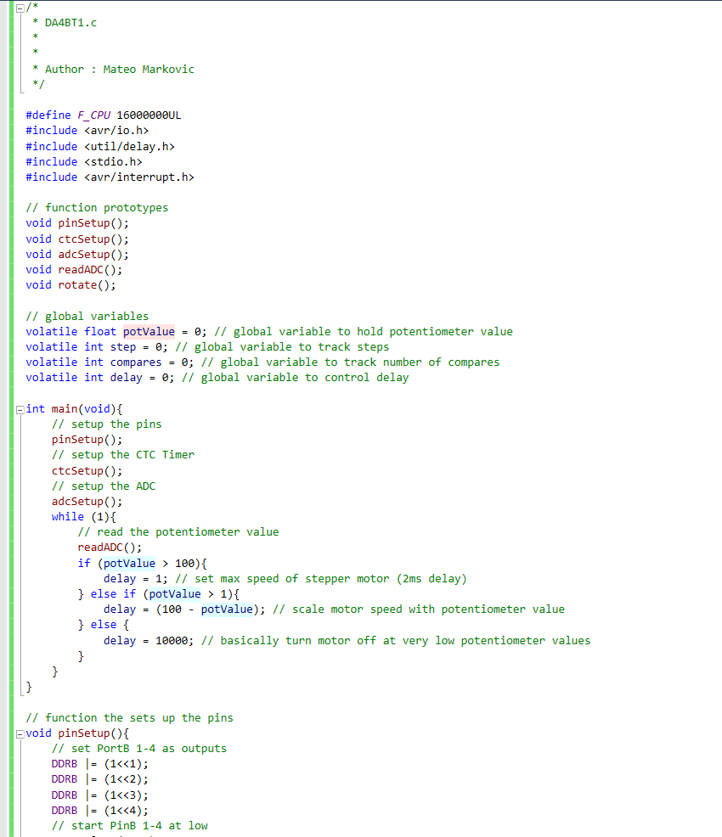

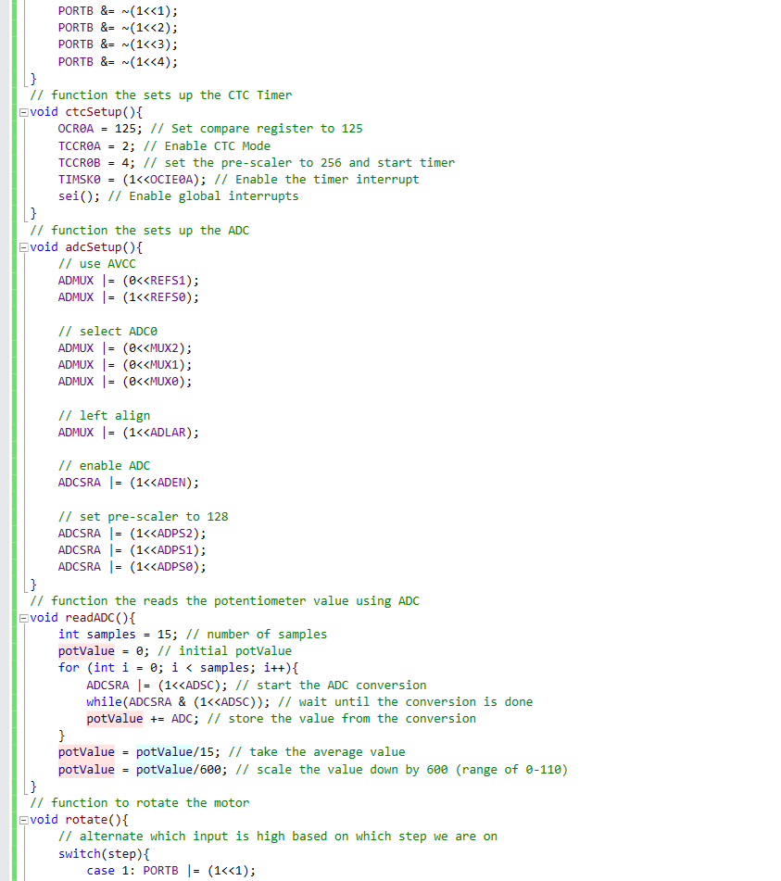

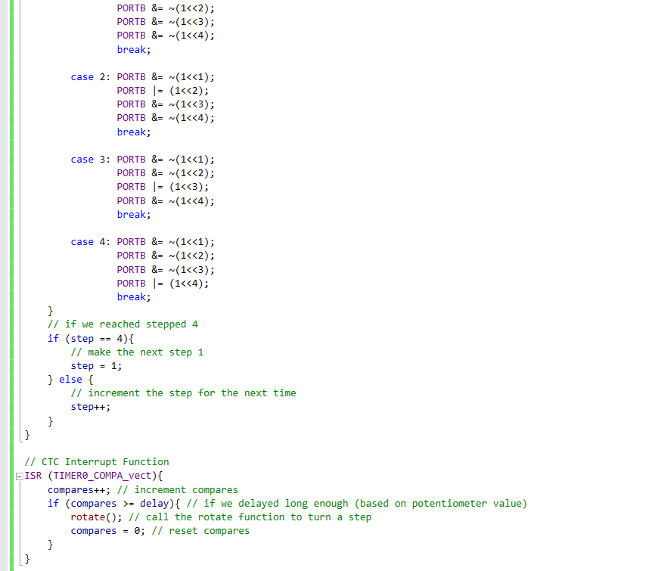

1. **INITIAL/MODIFIED/DEVELOPED CODE OF TASK 2**

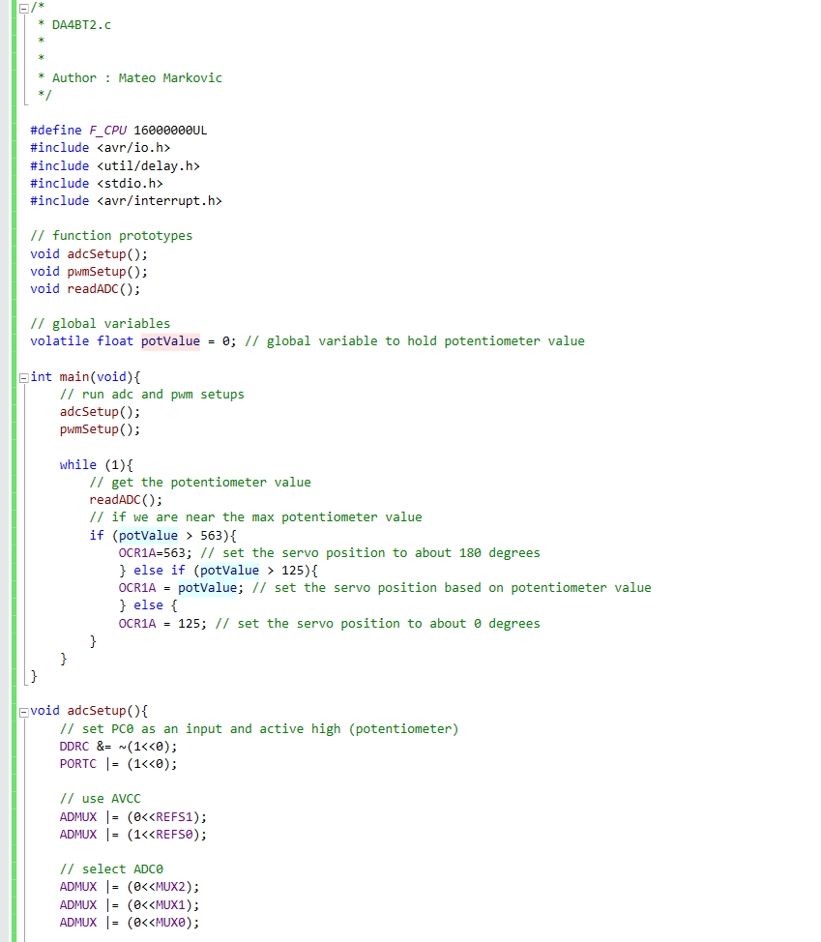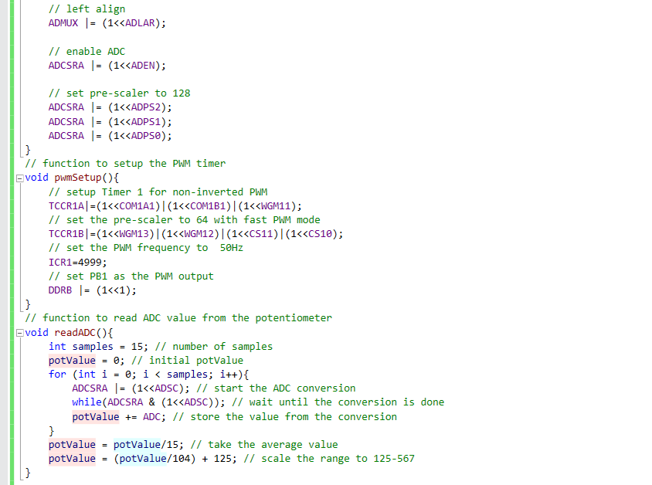

1. **SCHEMATICS**

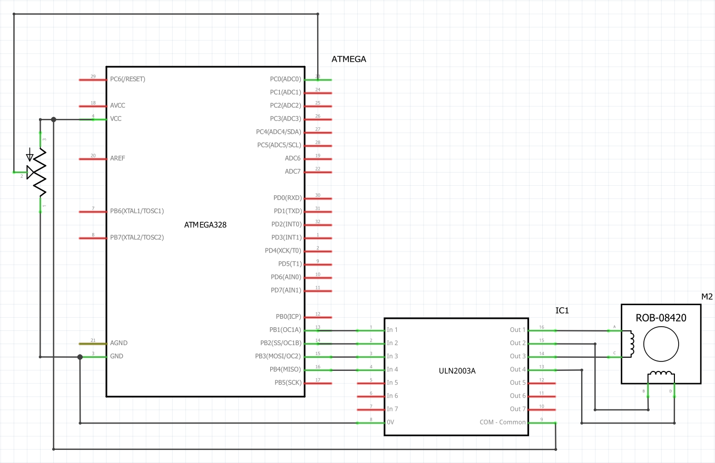

Fritzing Schematic Task 1

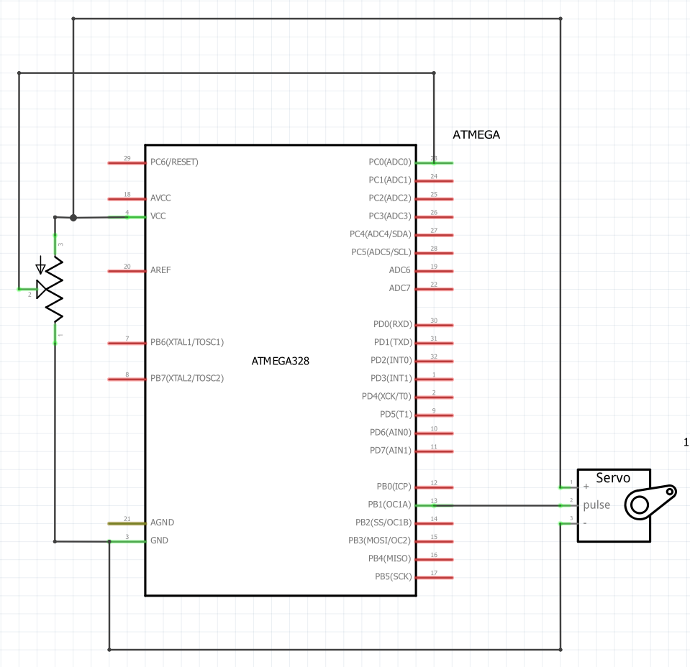

Fritzing Schematic Task 2

1. **SCREENSHOT OF EACH DEMO (BOARD SETUP)**

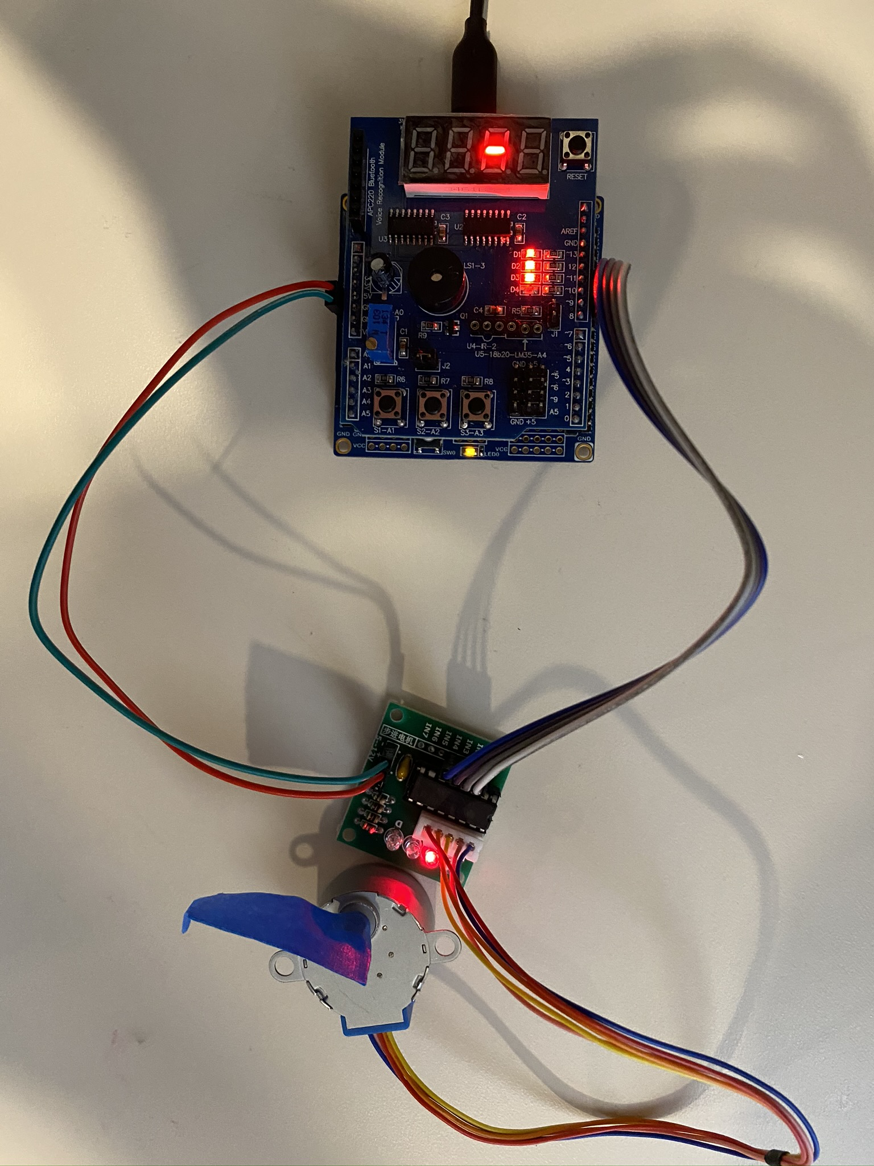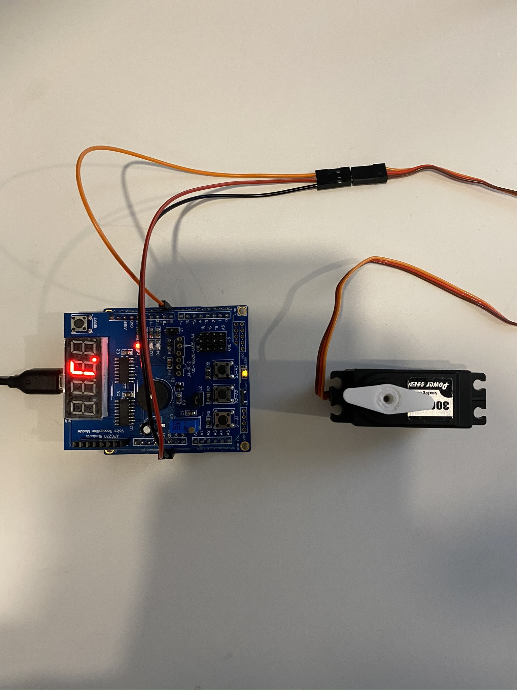

Task 1 Board Setup

Task 2 Board Setup

1. **VIDEO LINKS OF EACH DEMO**

Task 1 Demonstration: <https://youtu.be/GiE5C-mGvaE>

Task 2 Demonstration: <https://youtu.be/WVMHzz8ivzU>

1. **GITHUB LINK OF THIS DA**

<https://github.com/mateom99/submission_da/tree/master/DesignAssignments/DA4B>

**Student Academic Misconduct Policy**

<http://studentconduct.unlv.edu/misconduct/policy.html>

“This assignment submission is my own, original work”.

Mateo Markovic