CPE301 – SPRING 2020

Design Assignment 5

Student Name: Mateo Markovic

Student #: 2001338139

Student Email: Markom1@unlv.nevada.edu

Primary Github address: <https://github.com/mateom99/submission_da>

Directory: DesignAssignments/DA5

1. **COMPONENTS LIST AND CONNECTION BLOCK DIAGRAM w/ PINS**

* Atmega328PB-Xmini w/ Atmel Studio 7.0
* Atmega328PB Debugger for Serial to USB output
* Arduino Multi-Function Shield (2x Shift Registers)
* LM35 Temperature Sensor (PC4)
* DS18B20 1-wire Temperature Sensor (PC0)

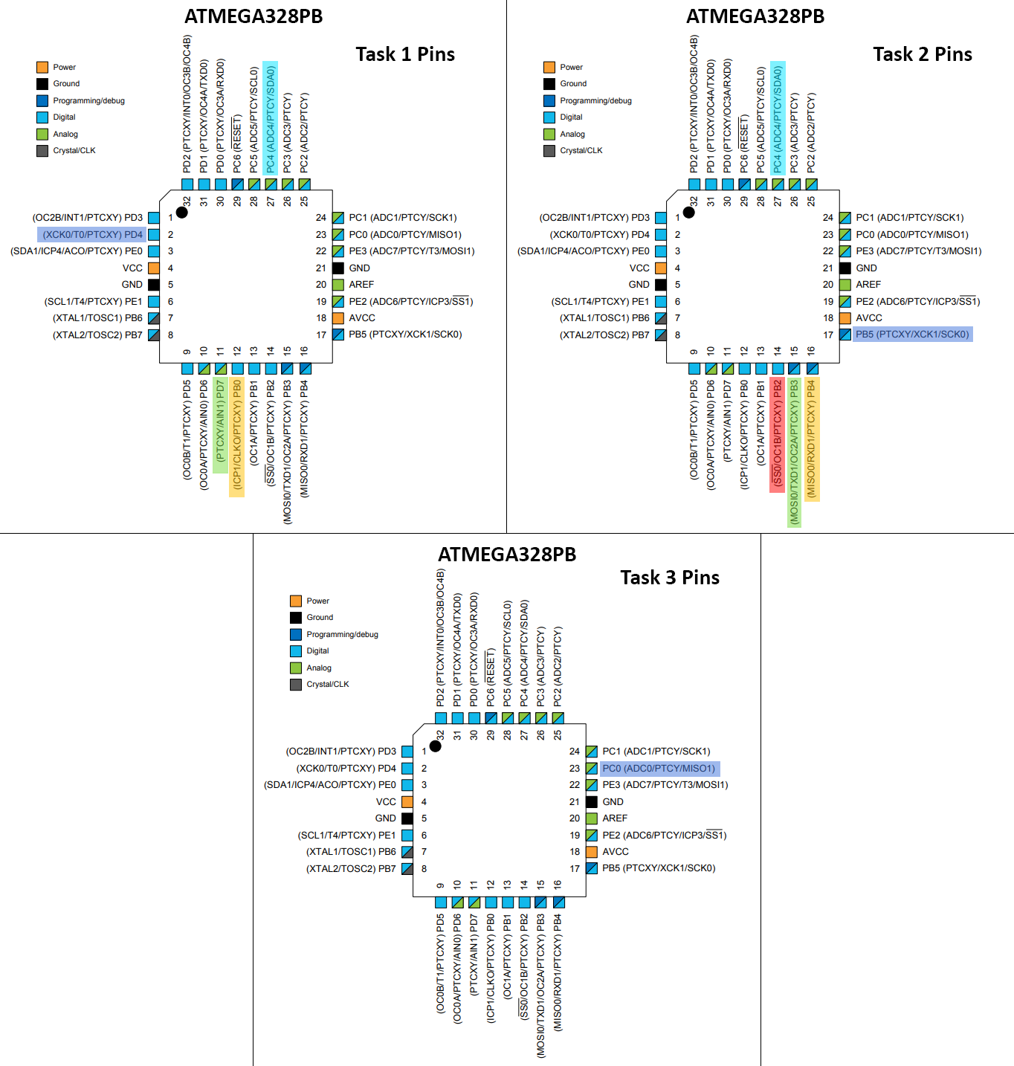

1. **INITIAL/MODIFIED/DEVELOPED CODE OF TASK 1**

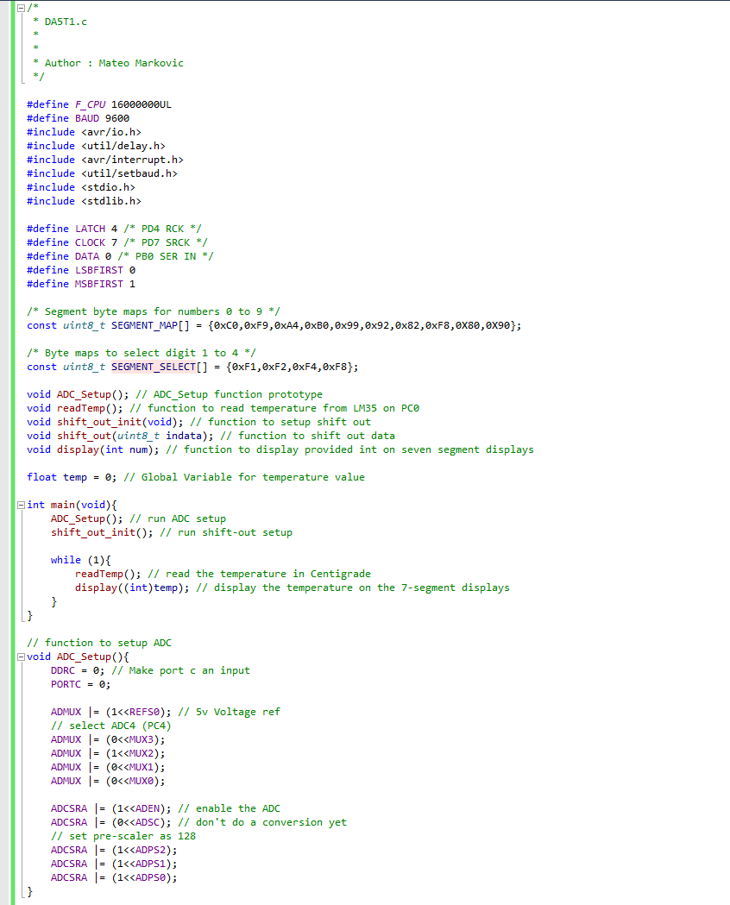

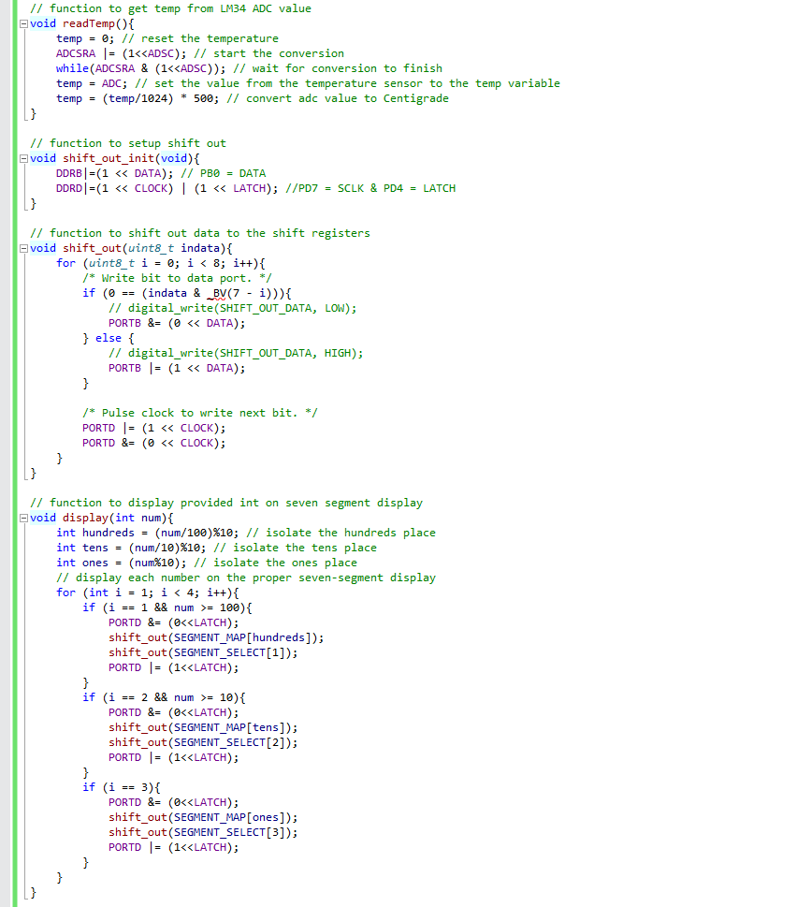

1. **INITIAL/MODIFIED/DEVELOPED CODE OF TASK 2**

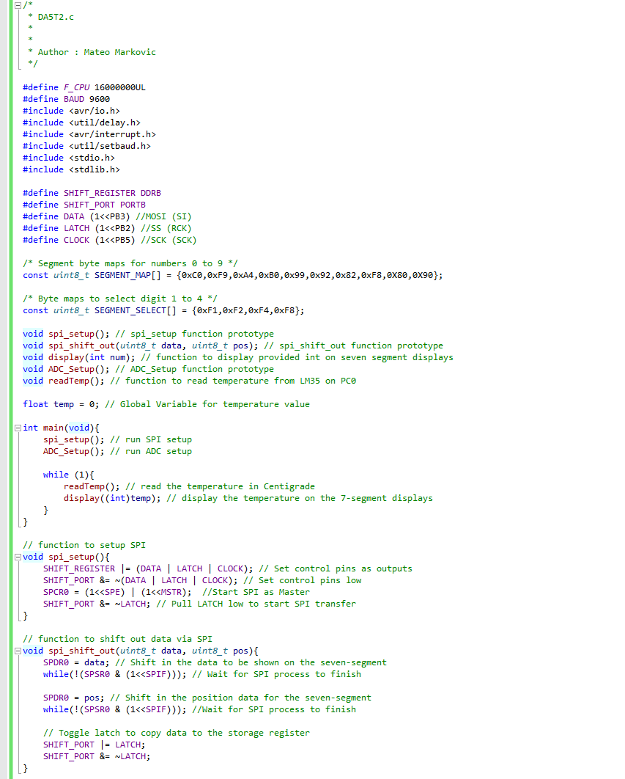

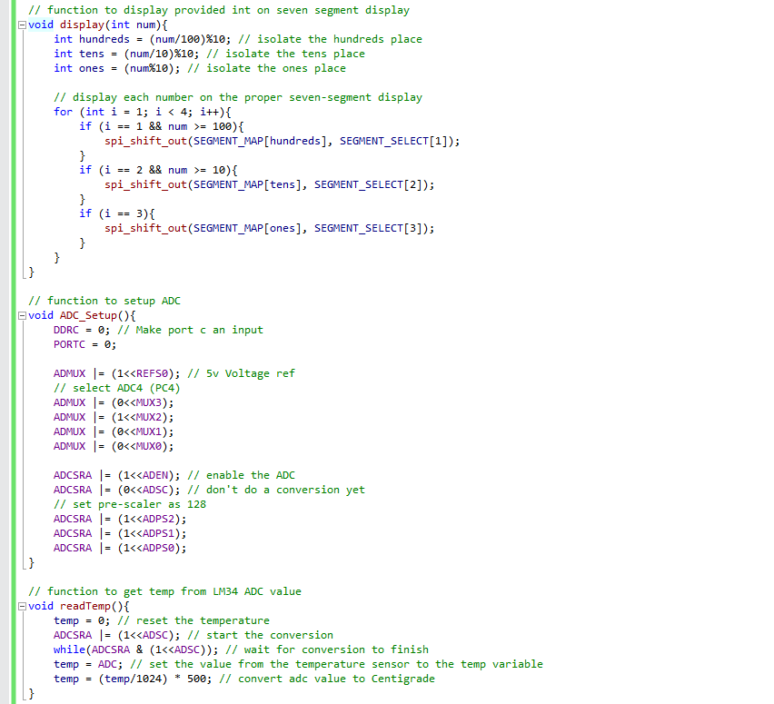

1. **INITIAL/MODIFIED/DEVELOPED CODE OF TASK 3**

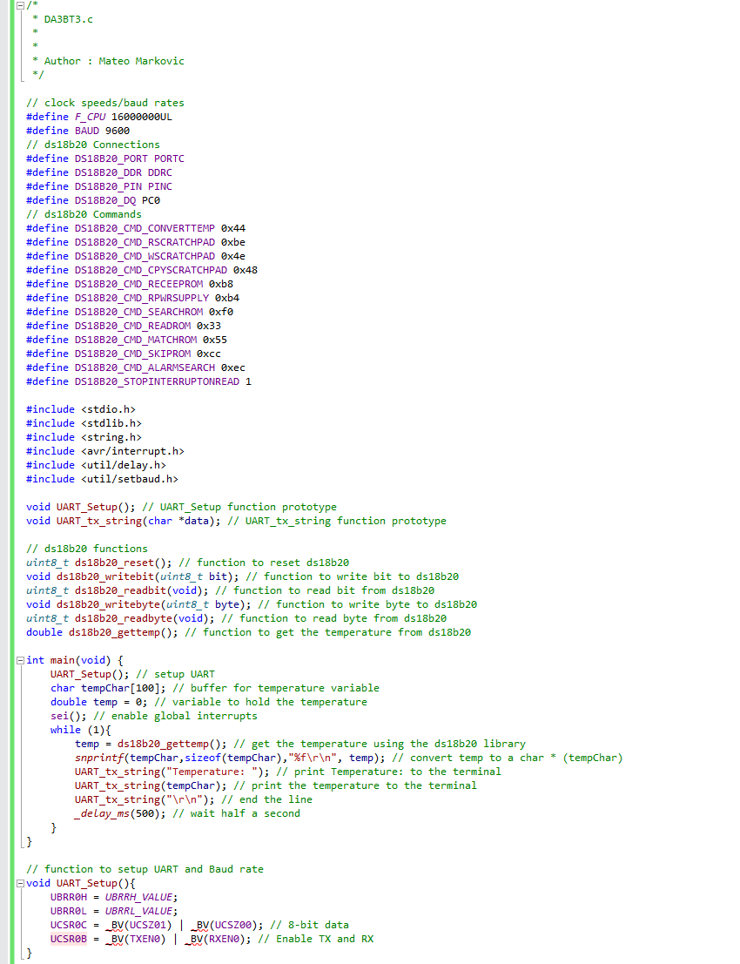

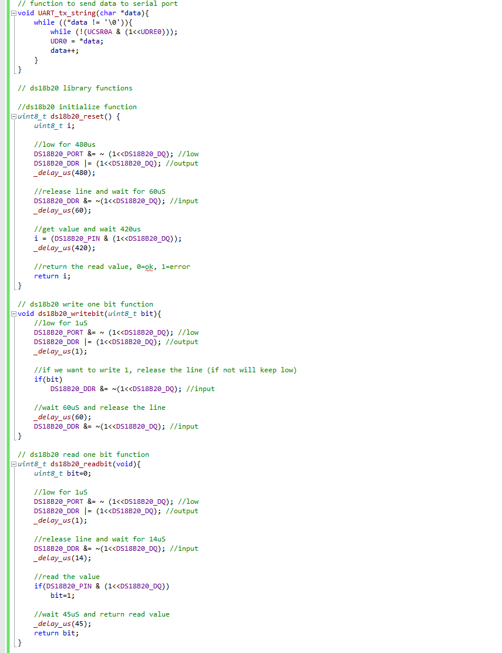

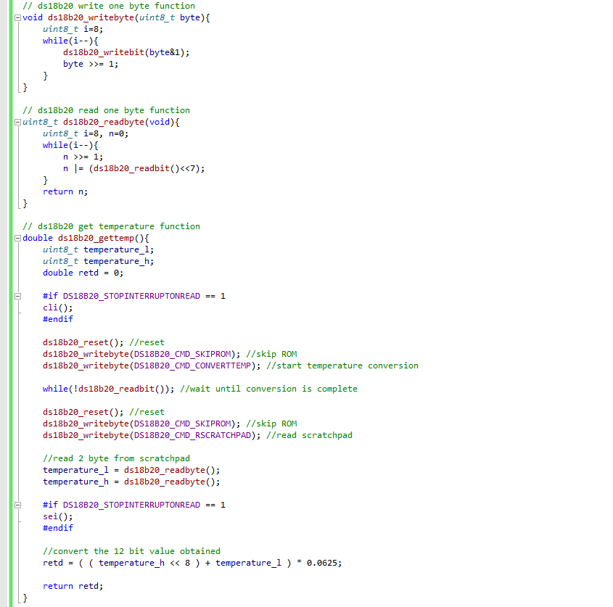

1. **SCHEMATICS**

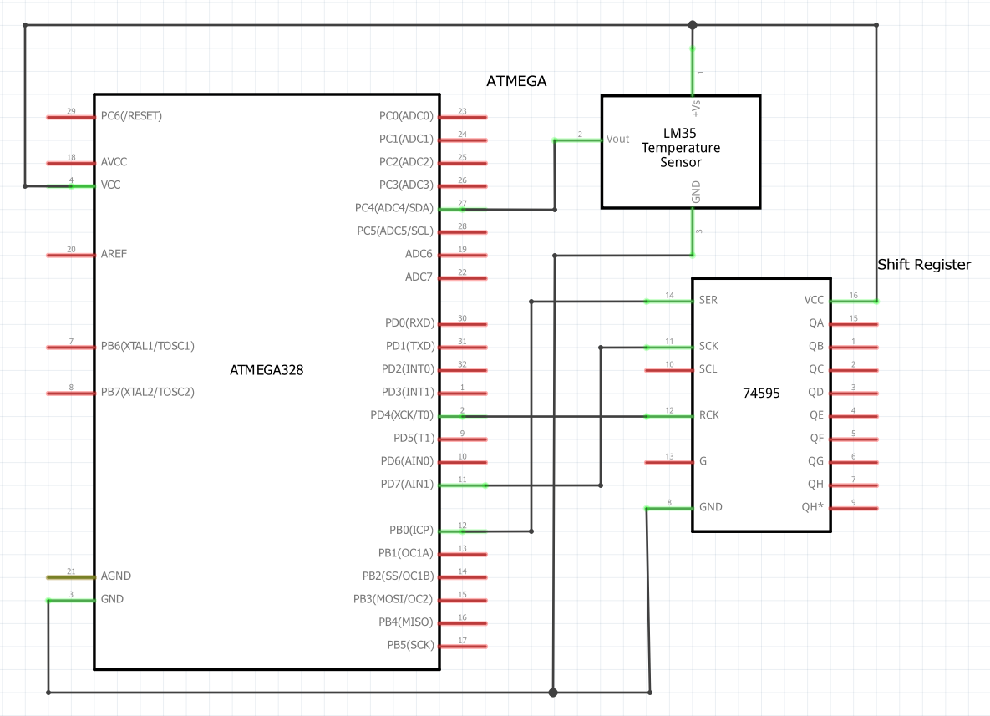

Task 1 Fritzing Schematic

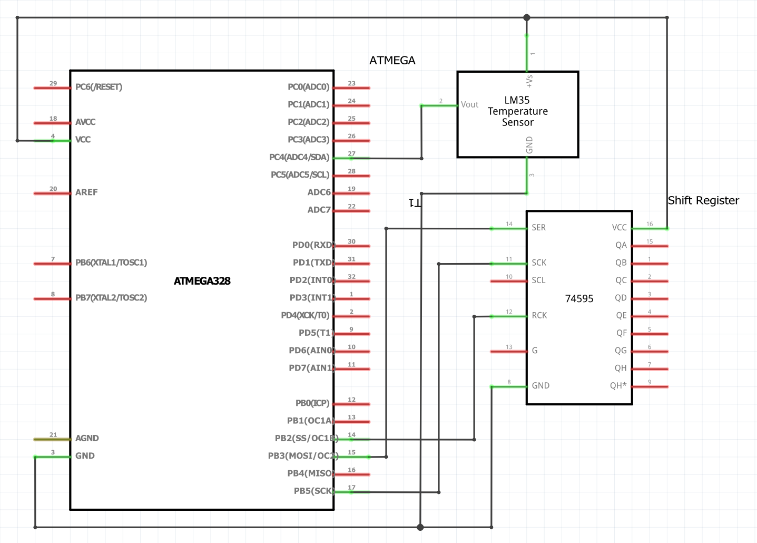

Task 2 Fritzing Schematic

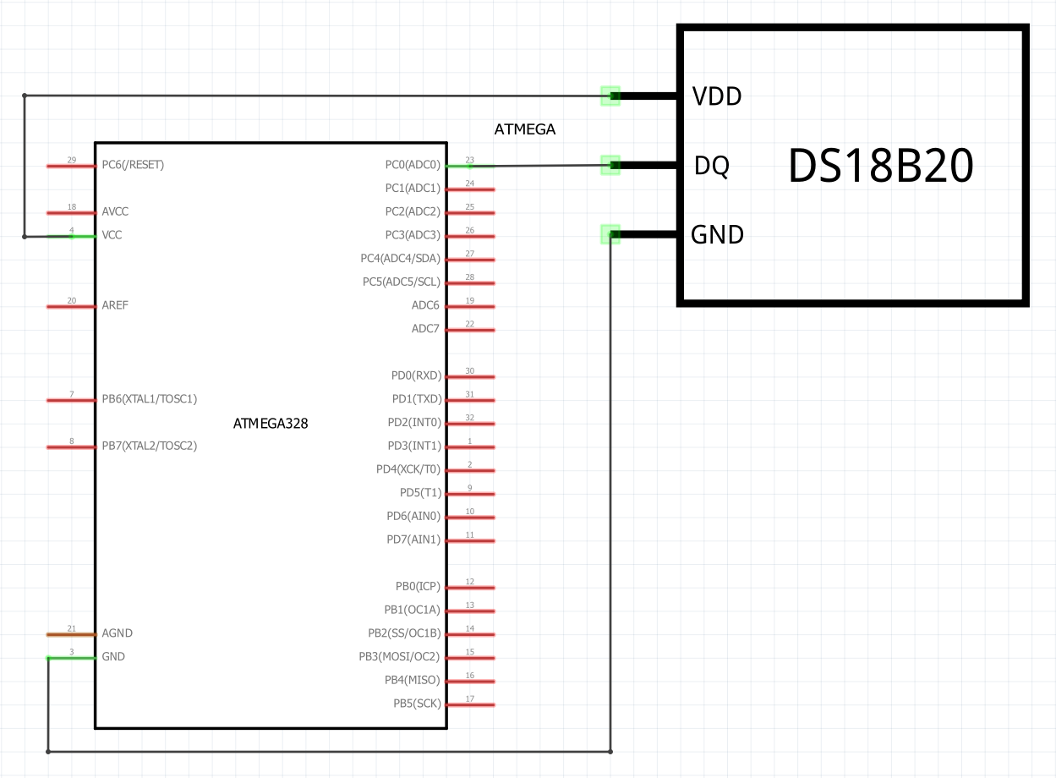

Task 3 Fritzing Schematic

1. **SCREENSHOTS OF EACH TASK OUTPUT (ATMEL STUDIO OUTPUT)**

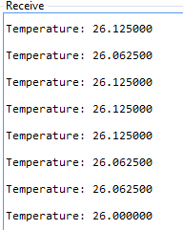

Task 3 Atmel Studio Output

1. 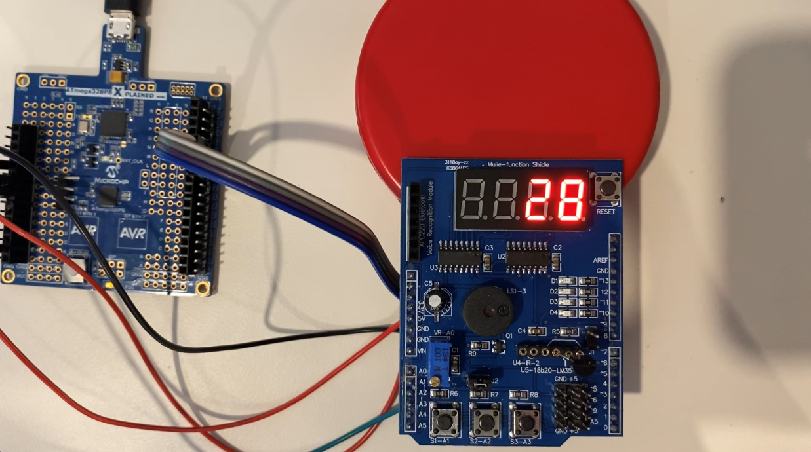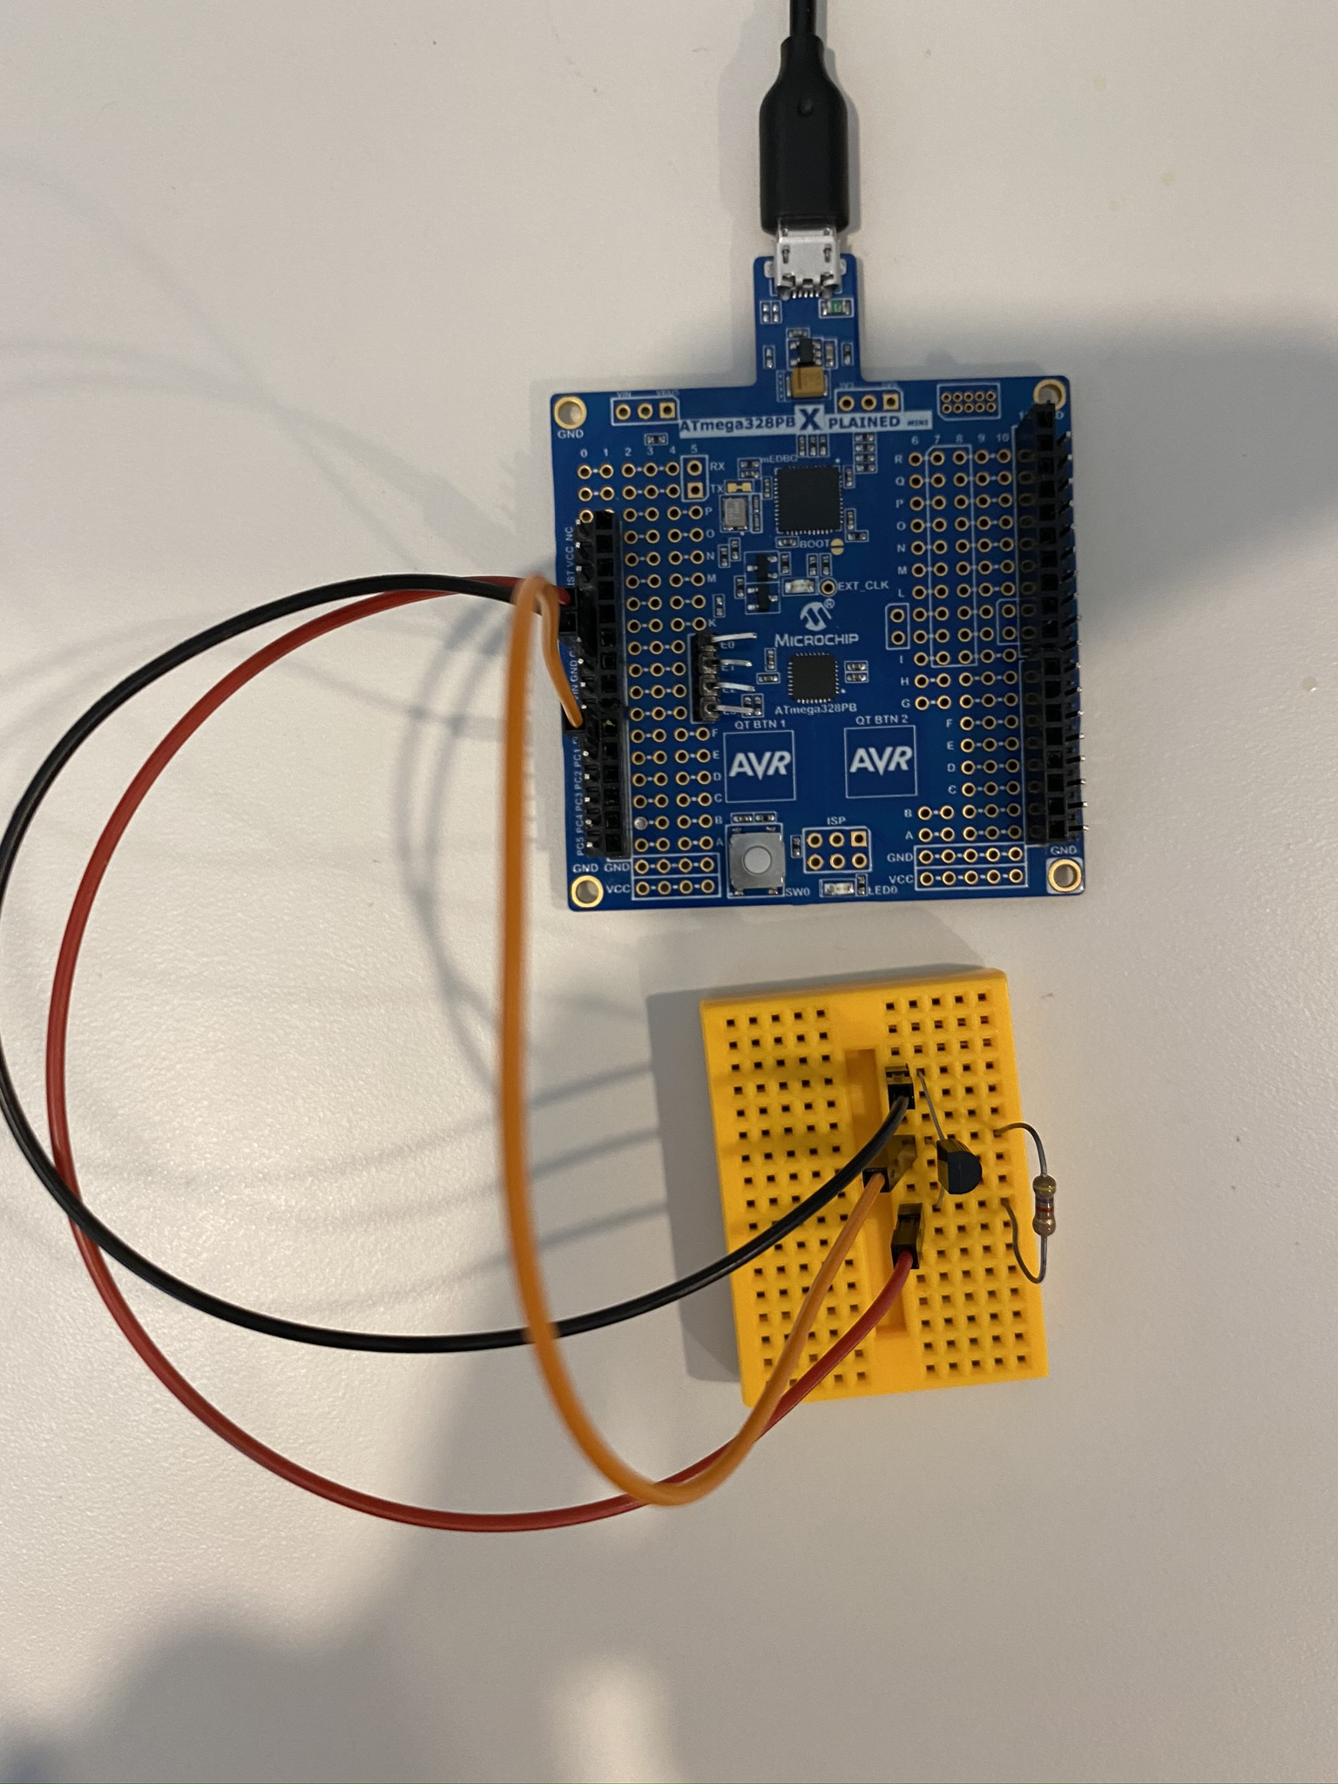**SCREENSHOT OF EACH DEMO (BOARD SETUP)**

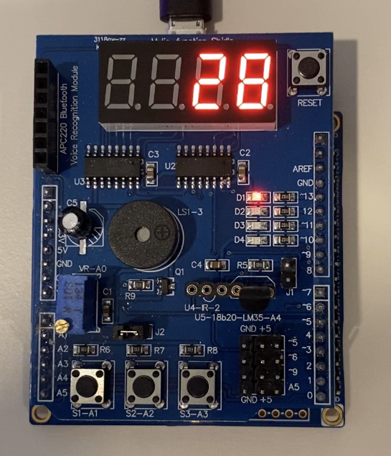

Task 1 Board Setup

Task 3 Board Setup

Task 2 Board Setup

1. **VIDEO LINKS OF EACH DEMO**

Task 1 Demonstration: <https://youtu.be/J6HMgnClpWY>

Task 2 Demonstration: <https://youtu.be/h_E63161afI>

Task 3 Demonstration: <https://youtu.be/GznrYvhBJqE>

1. **GITHUB LINK OF THIS DA**

<https://github.com/mateom99/submission_da/tree/master/DesignAssignments/DA5>

**Student Academic Misconduct Policy**

<http://studentconduct.unlv.edu/misconduct/policy.html>

“This assignment submission is my own, original work”.

Mateo Markovic