CPE301 – SPRING 2020

Design Assignment 6

Student Name: Mateo Markovic

Student #: 2001338139

Student Email: Markom1@unlv.nevada.edu

Primary Github address: <https://github.com/mateom99/submission_da>

Directory: DesignAssignments/DA6

1. **COMPONENTS LIST AND CONNECTION BLOCK DIAGRAM w/ PINS**

* Atmega328PB-Xmini w/ Atmel Studio 7.0
* Atmega328PB Debugger for Serial to USB output
* MPU-6050 3-Axis Acceleration Gyroscope (PC5/PC4)

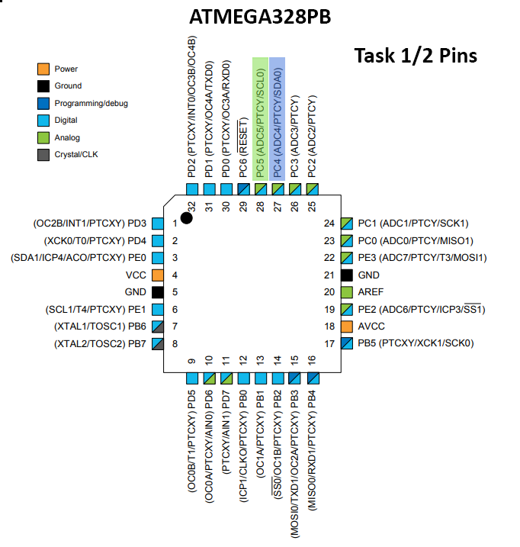

1. **INITIAL/MODIFIED/DEVELOPED CODE OF TASK 1**

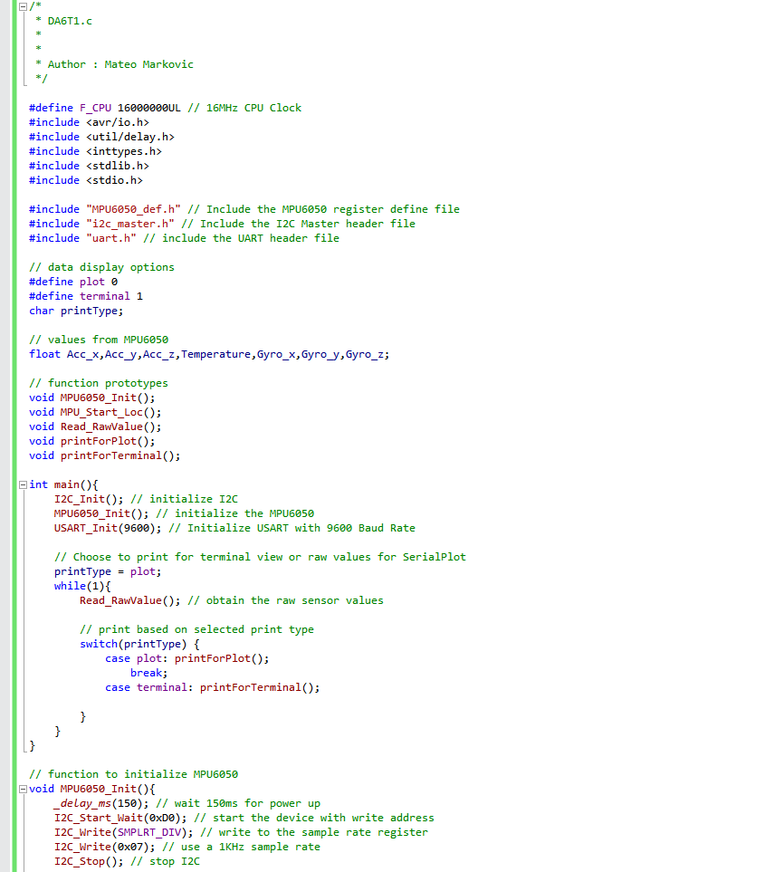

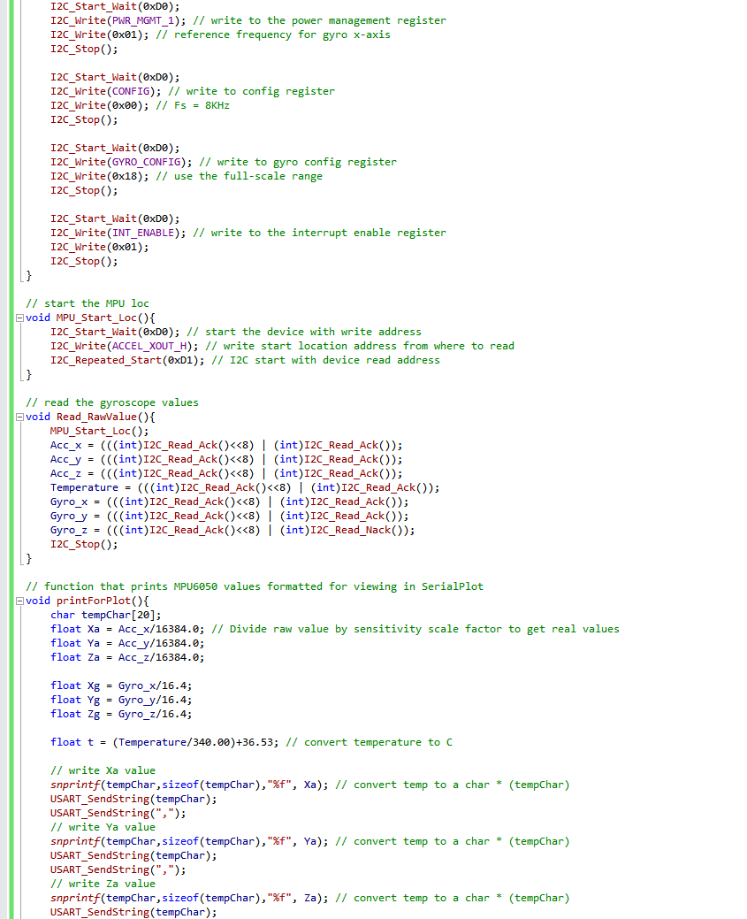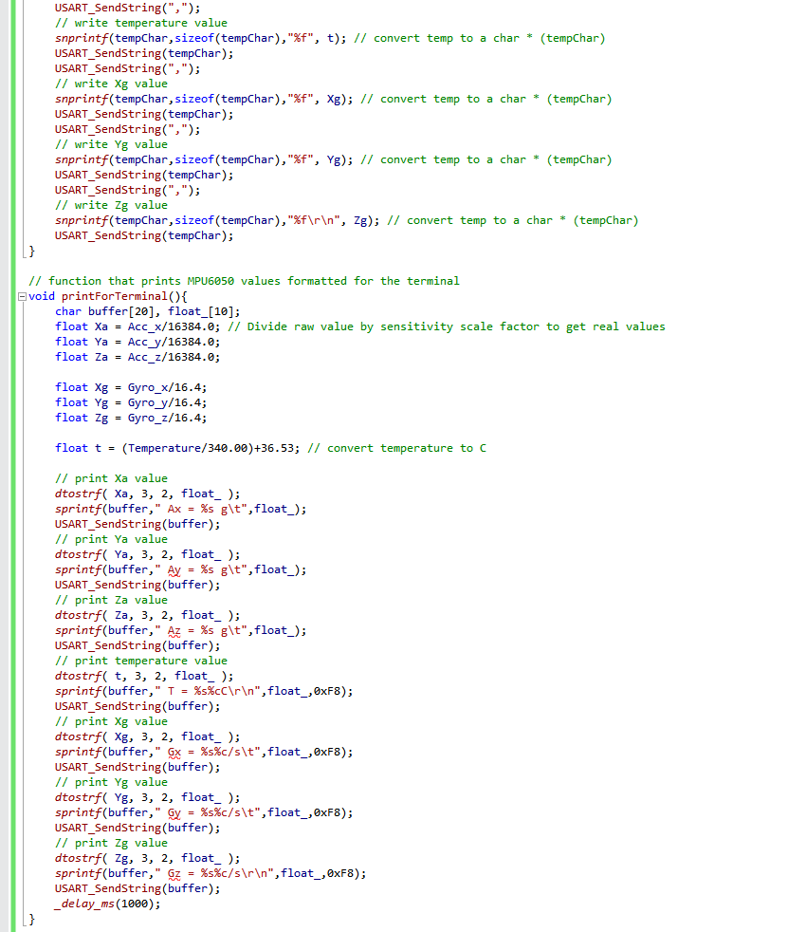

1. **DEVELOPED MODIFIED CODE OF TASK 2 from TASK 1**

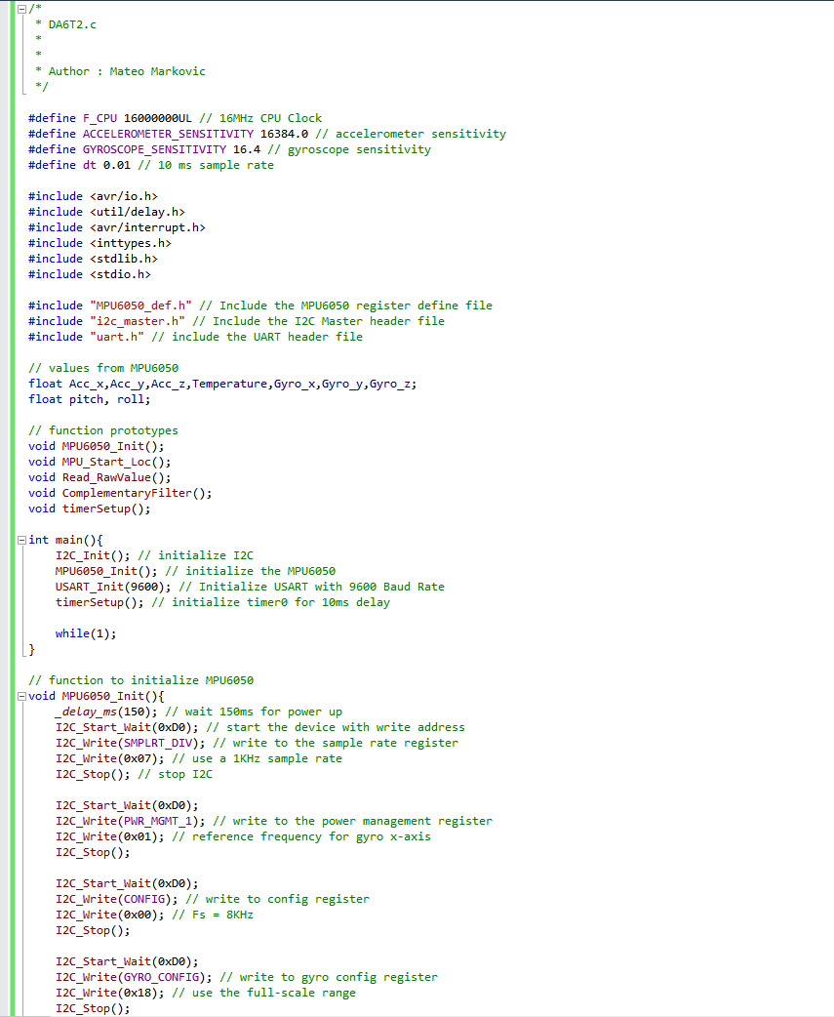

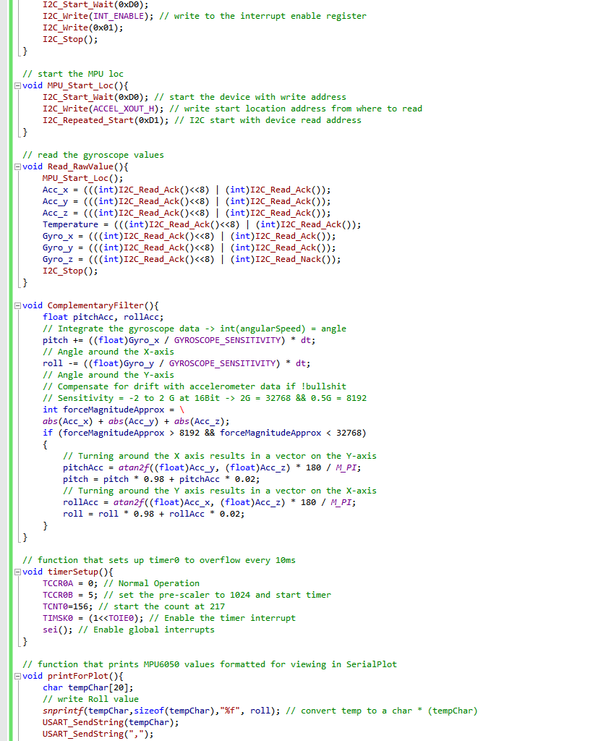

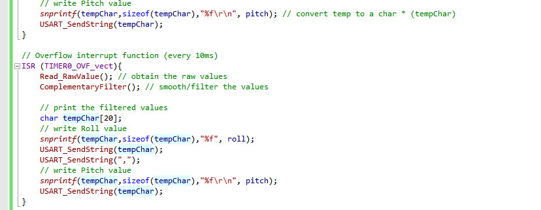

1. **SCHEMATICS**

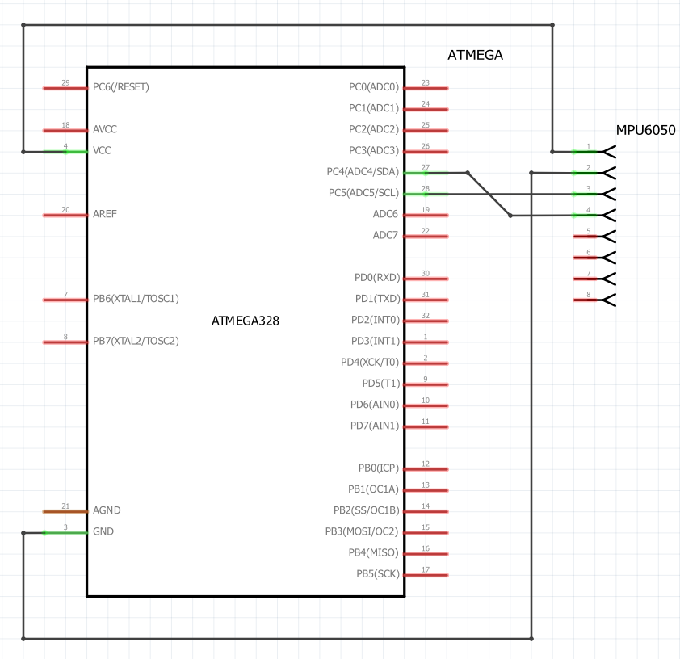

Task 1-2 Fritzing Schematic

1. **SCREENSHOTS OF EACH TASK OUTPUT (ATMEL STUDIO OUTPUT)**

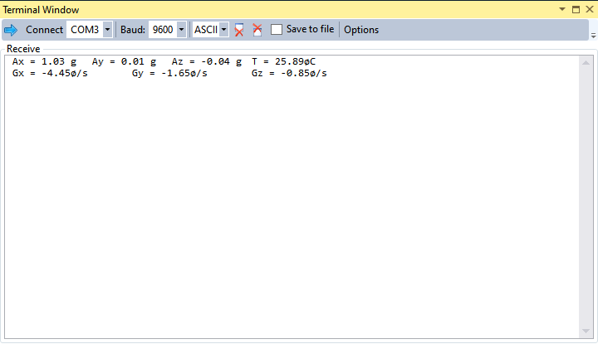

Task 1 Atmel Terminal Output

1. **SCREENSHOT OF EACH DEMO (BOARD SETUP)**

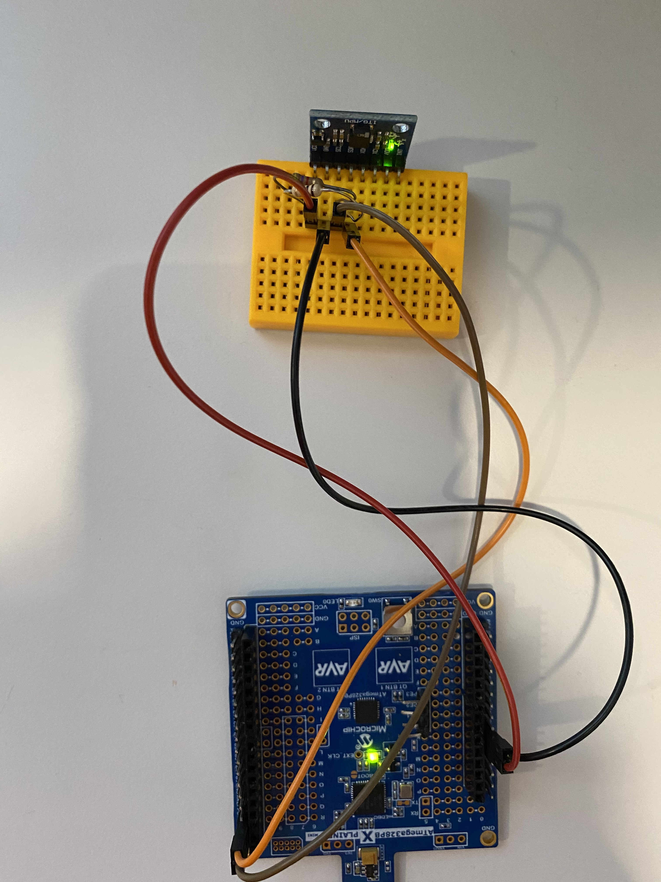

Task 1-2 Board Setup

1. **VIDEO LINKS OF EACH DEMO**

Task 1 Demonstration: <https://youtu.be/NgdmizYe-JI>

Task 2 Demonstration: <https://youtu.be/Qt4Oyg7iNuQ>

1. **GITHUB LINK OF THIS DA**

[https://github.com/mateom99/submission_da/tree/master/DesignAssignments/DA6](https://github.com/mateom99/submission_da/tree/master/DesignAssignments/DA4B)

**Student Academic Misconduct Policy**

<http://studentconduct.unlv.edu/misconduct/policy.html>

“This assignment submission is my own, original work”.

Mateo Markovic