**The rule book**

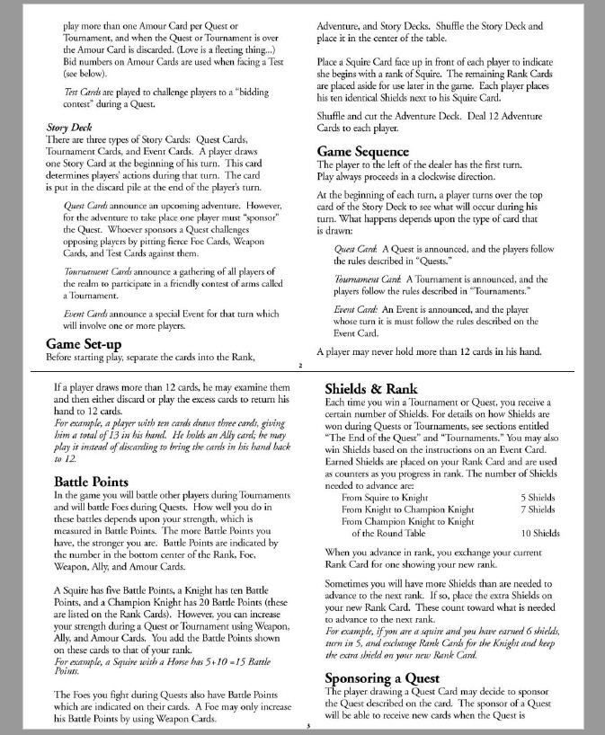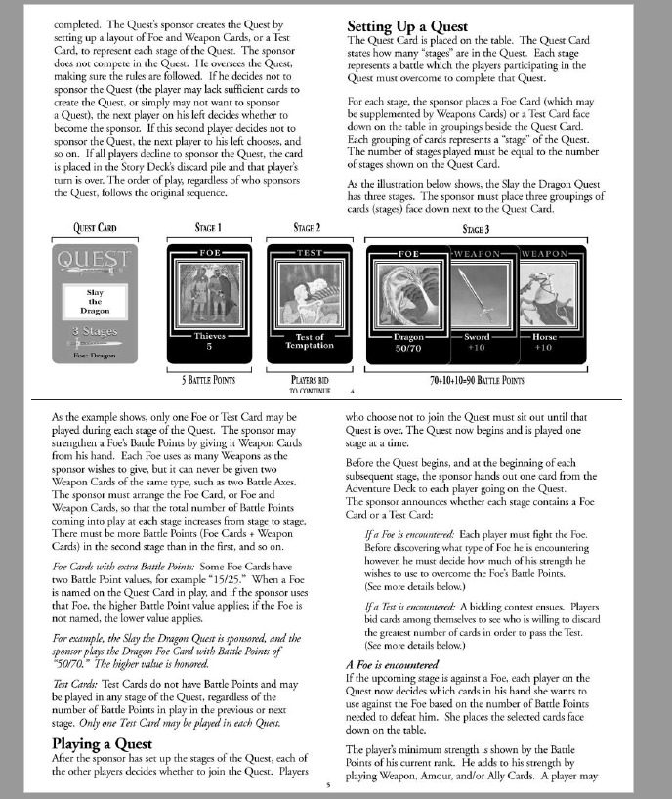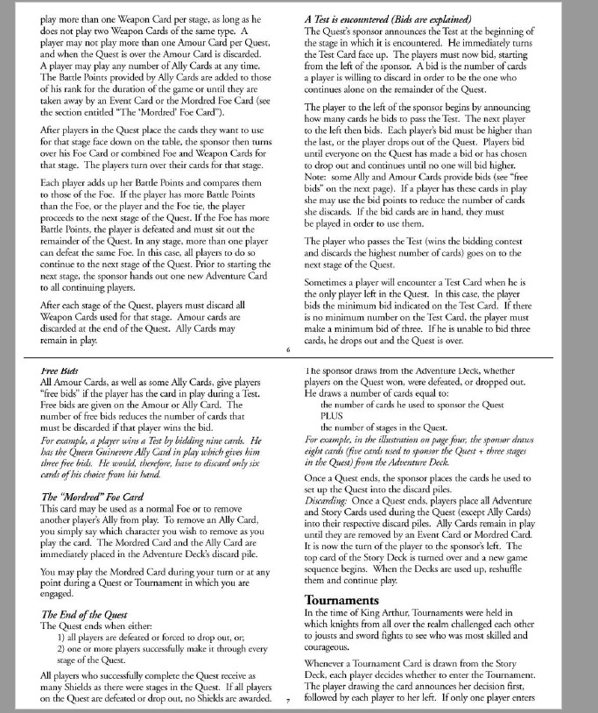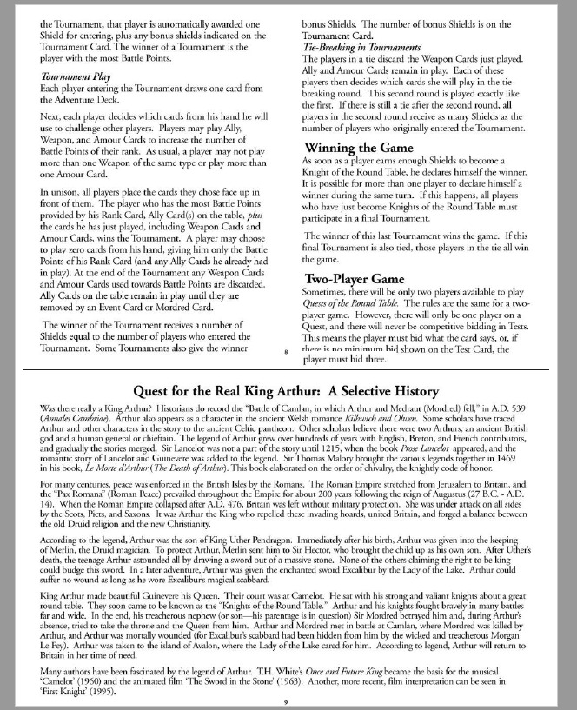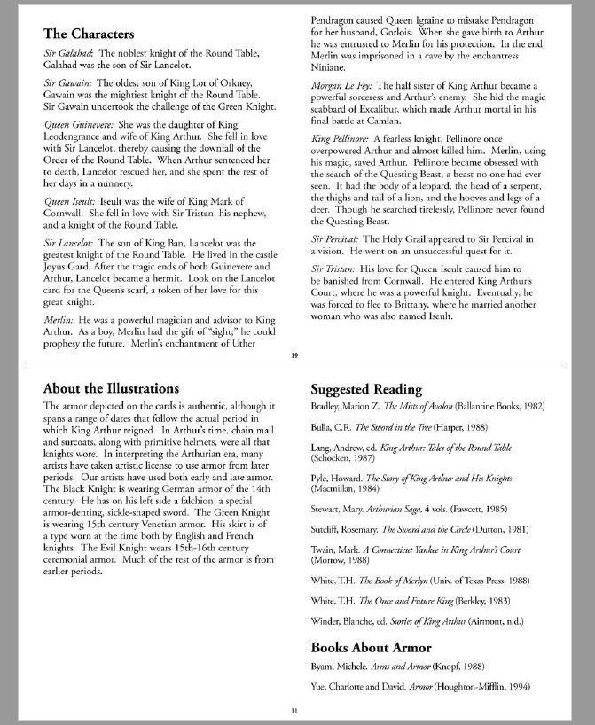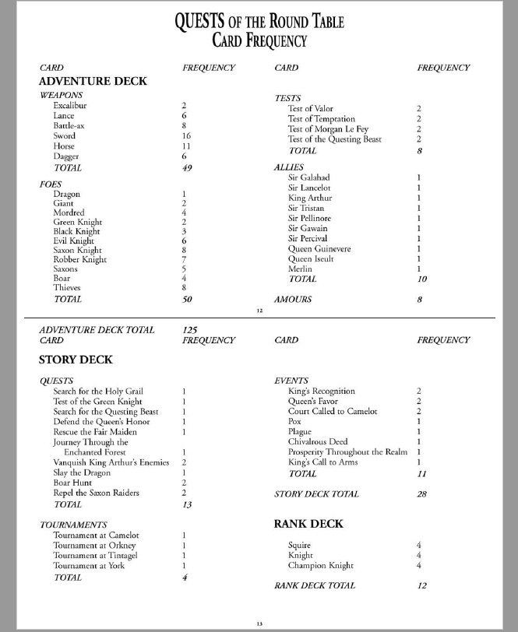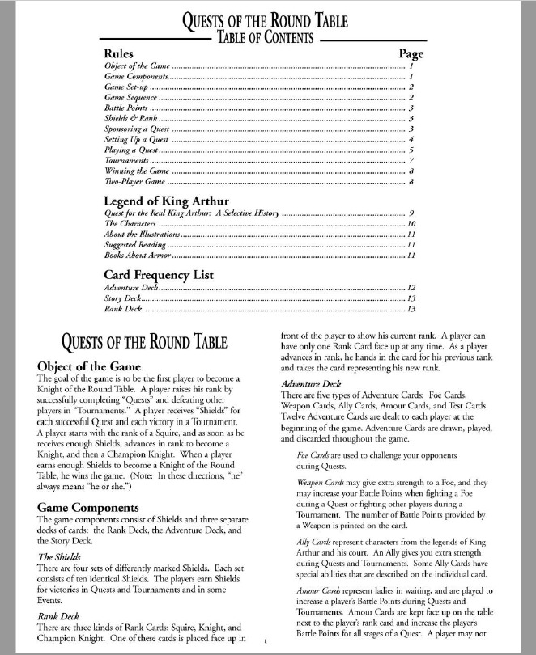

**Assumptions**

|  |  |  |
| --- | --- | --- |
| **ID** | **Assumption** | **Justification** |
| **A-01** | The game is only functional if it has all players present during game play. | If a player is not present during game play, for instance a player shuts the game down in a middle of a game it will not continue to the next round. |
| **A-02** | Who ever opens the game first(the host) must start the game, If not then the game will never start. | When first window is open the first browser opened will automatically become the host and given the task to start the game. |
| **A-03** | You can not play allies at any time. An example of this would be if you are playing tournaments you can only play “Foe” cards. | Will automatically lose the tournament if you do not use any foe cards to play. |
| **A-04** | A player must have the required cards to sponsor a quest. If not the game will not continue. | If you try to sponsor a quest with out having the correct cards in hand the game will stay in your turn and not move on from your turn. |
| **A-05** | Every player must wait their turn to complete a certain stage to be completed. | The players have to wait their turns. No one can move forward to the next stage unless that part has been completed. |
| **A-06** | Every players information will be available to everyone playing the game. | Once the game has started every players (including your own) will be displayed for everyone to see. |

**Use Case Diagram**

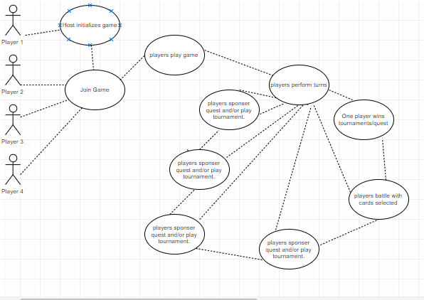

**Use Case Descriptions**

|  |  |
| --- | --- |
| **UC-01** | **Admin Initializes Server** |
| **Description** | As shown in the acm , the first player starts up the server for the game. |
| **Actors** | Host/First player |
| **Triggering Event** | First player initializes the start of the game |
| **Pre-Condition** | N/A |
| **Main Sequence** | 1. Host runs the website 2. Host begins hosting game. |
| **Post-Condition** | Game has started |
| **Resulting Event** | Waits for other players to connect to the game |
| **Alternative Scenarios** | N/A |

|  |  |
| --- | --- |
| **UC-02** | **Player Joins Game** |
| **Description** | As shown in the use case, players join Game |
| **Actors** | Players |
| **Triggering Event** | Player gets added to the game |
| **Pre-Condition** | First player initializes the start of the game |
| **Main Sequence** | 1. Player enters name. 2. Connects to the server 3. Player waits for host to start game 4. The game begins |
| **Post-Condition** | The player waits for game to be started |
| **Resulting Event** | Player is part of game play |
| **Alternative Scenarios** | Host never starts game and players are unable to play. |

|  |  |
| --- | --- |
| **UC-03** | **Players Play Game** |
| **Description** | Playing the game |
| **Actors** | 2, 3, or 4 Players |
| **Triggering Event** | All players joined |
| **Pre-Condition** | All players that decide to join game have joined |
| **Main Sequence** | 1. Players receive a hand of randomly shuffled cards 2. Players decide to whether or not to sponsor a quest 3. All players who sponsored the quest will battle with eachother 4. Go through all cards selected and decide a winner 5. Winner gains points depending on what the card provides 6. Continuation of the game lets say there is a tournament. 7. Each player has choice to participate in the tournament 8. All players select cards to play 9. Depending on who wins they receive the card awards them with what the card provides. 10. Repeat until there is a decided Winner. |
| **Post-Condition** | Game Winner announced |
| **Resulting Event** | Game ends |
| **Alternative Scenarios** | N/A |

|  |  |
| --- | --- |
| **UC-04** | **Players Perform a Turn** |
| **Description** | If quest , turns are enforced in the game. |
| **Actors** | 2, 3, or 4 Players |
| **Triggering Event** | First turn OR previous turn has ended without a winner |
| **Pre-Condition** | Player order is set |
| **Main Sequence** | 1. Players select cards wanted. 2. Players wait for each player to play 3. Players battle with other players. 4. Players play until a winner is announced |
| **Post-Condition** | All players have played another turn |
| **Resulting Event** | Players are ready to play another turn |
| **Alternative Scenarios** | N/A |

|  |  |
| --- | --- |
| **UC-05** | **Players Play Cards** |
| **Description** | This use case describes the steps for the players to play their Cards |
| **Actors** | 2, 3, or 4 Players |
| **Triggering Event** | Players notified to play cards |
| **Pre-Condition** | N/A |
| **Main Sequence** | 1. Every time a certain scenario in the games pops up the game will notify you to select the cards. |
| **Post-Condition** | The selected cards will be played in the scenario specified. |
| **Resulting Event** | Players await the result of the cards selected. |
| **Alternative Scenarios** | N/A |

|  |  |
| --- | --- |
| **UC-06** | **Winning the round** |
| **Description** | This use case describes players resolving battles |
| **Actors** | 2, 3, or 4 Players | |
| **Triggering Event** | After game has specified a certain scenario | |
| **Pre-Condition** | All players connected | |
| **Main Sequence** | 1. Players select all cards they want to play for the specific scenario 2. Battle begins 3. Game will compare the cards 4. Game will select a winner for that scenario | |
| **Post-Condition** | Winner has gained the rewards for that round | |
| **Resulting Event** | Next scenario begins | |
| **Alternative Scenarios** | N/a | |

|  |  |
| --- | --- |
| **UC-7** | **Players Wins** |
| **Description** | This use case describes the result of a player winning the game |
| **Actors** | 2, 3, or 4 Players |
| **Triggering Event** | The game has determined a winner |
| **Pre-Condition** | N/A |
| **Main Sequence** | 1. The game notifies the winner and loser(s) |
| **Post-Condition** | Players play another game |
| **Resulting Event** | The game is over |
| **Alternative Scenarios** | N/A |