
ABES ENGINEERING COLLEGE
Ghaziabad, Uttar Pradesh
SOFTWARE REQUIREMENTS SPECIFICATION
for
StockSmart
Retail Inventory Optimization
Retail Inventory Management System with Barcode/RFID and KPI Reporting
Agile Capstone Case Study (Scrum: 8 Epics, 15 Sprints)
Full Stack Development - JAVA | Project ID: P_004
Submitted by | Arman Maurya
Roll Number | 2400320100271
Institute | ABES Engineering College
Team | Individual project
Project Guide | [Sakshi mohinia]
Project Type | Full Stack Development - JAVA
Domain | Retail
Technology | Java, Spring Boot, Angular, Oracle Database, Docker
Delivery Model | Agile / Scrum
Document version | 1.0

1. Introduction

1.1 Purpose and Scope
This Software Requirements Specification (SRS) defines the requirements of StockSmart, a web-based Retail Inventory Optimization system built as an Agile capstone case study. It follows IEEE Std 830 and is meant for the project guide, evaluators, the Scrum team and anyone who maintains or extends the system.
StockSmart lets a retail business keep a product catalog, track stock across several stores and warehouses, manage suppliers and purchase orders, process customer orders from reservation to shipment, and identify items by barcode and RFID tag. It turns the stock and order data into KPI reports and rule-based reorder suggestions, so the business avoids stockouts without tying up cash in slow-moving items. The system is delivered in 8 epics over 15 two-week Scrum sprints.
Out of scope: online payments, a customer-facing storefront, point-of-sale billing integration, GST invoicing and accounting, machine-learning forecasting, and RFID hardware design. RFID readers connect through reader middleware that posts tag reads over REST; barcode scanners work as keyboard-wedge devices.

1.2 Definitions and References
SKU | Unique internal product code | Safety stock | Extra stock held to cover demand variation during lead time
Location | A store or warehouse holding stock | Stock movement | Immutable ledger entry for every stock change
PO / SO | Purchase Order to a supplier / Sales Order from a customer | Barcode | Machine-readable product code (EAN-13, UPC-A, Code 128, QR)
Available stock | Quantity on hand minus quantity reserved | RFID / EPC | Radio-frequency tag and its Electronic Product Code
Reorder point | Calculated stock level at which a new order should be raised | Reader middleware | Software that filters reader output and forwards it to StockSmart
Cycle count | Counting a location's stock to compare with system quantity | Keyboard-wedge scanner | Scanner that sends the code as typed keystrokes
ABC analysis | Ranking products by consumption value into classes A, B and C | KPI | Key Performance Indicator, such as turnover or fill rate
REST, JSON, JPA, JWT, RBAC, CI/CD, ER and CRUD are used in their standard senses.
References: IEEE Std 830-1998; The Scrum Guide (scrumguides.org); Spring Boot (spring.io), Angular (angular.dev) and Oracle Database (docs.oracle.com) documentation; GS1 General Specifications and EPC Tag Data Standard (gs1.org); Docker, Jenkins and Jira documentation.

2. Overall Description

2.1 Product Perspective and Functions
StockSmart is a new three-tier web application: an Angular single-page app talks over HTTPS to a Spring Boot REST API, which stores data in Oracle Database through Spring Data JPA. Both tiers run as Docker containers. Two edge devices feed it: barcode scanners type into the screen in use, and UHF RFID readers post batches of tag reads to a REST endpoint protected by a per-device API key. SMTP is the only other external service (low-stock emails). Its main functions are grouped into the eight epics listed in Section 5: access control, product catalog, multi-location stock, procurement, order processing, barcode and RFID, KPI reporting, and DevOps and quality.

2.2 User Classes
User class | Description
Administrator | Manages users, roles and RFID reader devices; can view every module and report.
Inventory Manager | Manages products, locations, adjustments, transfers and stock counts; reviews KPIs, reorder suggestions and ABC analysis; receives alerts.
Procurement Officer | Manages suppliers, raises purchase orders (including from reorder suggestions) and records goods received.
Sales Executive | Manages customers and sales orders through picking, packing, shipment or cancellation.
Store / Warehouse Associate | Works on the floor with a scanner, RFID reader or tablet: receives goods, picks orders, moves stock and takes part in stock counts.

2.3 Environment, Constraints and Assumptions
Operating environment | Java 17 (LTS) and Spring Boot 3.x in Docker; Oracle Database 19c or later (Oracle Database Free for development and tests); any modern browser, including tablets; keyboard-wedge barcode scanners; UHF RFID readers (EPC Class-1 Gen-2) whose middleware can send JSON over HTTP.
Constraints | Back end in Java with Spring Boot and Maven; Angular (TypeScript) front end; REST/JSON API documented with OpenAPI; Oracle accessed through JPA/Hibernate with versioned Flyway migrations; Spring Security with JWT and BCrypt password hashes; reader API keys stored only as hashes; barcodes follow GS1 or Code 128 / QR; the RFID tag registry decides which product a tag belongs to; Docker packaging and Jenkins builds; work tracked in Jira over 15 two-week sprints.
Assumptions | Users have a browser and network access; data is entered accurately; products carry a barcode and RFID tags are attached before registration; every function also works by typing when scanners are unavailable; point-of-sale integration is out of scope, so sales orders entered in StockSmart supply the demand data; an SMTP account is available (otherwise alerts stay in the application); locations are logical, with no aisle or bin model.

2.4 Technology Stack
Layer | Choice | Purpose
Process | Scrum, 2-week sprints; Jira | Backlog and sprint tracking
Front end | Angular 17+, TypeScript, Angular Material, RxJS, Chart.js | Screens, forms, scan input, KPI charts
Back end | Java 17, Spring Boot 3.x, Spring Security, Spring Data JPA | REST API and business rules
Database | Oracle Database 19c+, Flyway | Relational data, versioned schema
Capture | Keyboard-wedge barcode scanners; UHF RFID readers + middleware | Product and tag identification
Delivery | Docker; Jenkins; SonarQube | Repeatable build, quality gate, deploy
Testing | JUnit 5, Mockito, Testcontainers (Oracle), Jasmine/Karma, Postman | Unit, integration and API checks

3. Specific Requirements

3.1 External Interfaces
User interface | Responsive browser screens with role-based menus, validated forms, paginated lists and a KPI dashboard home page. Scan screens keep the scan box focused and show a clear success or error after each scan.
Hardware | Keyboard-wedge barcode scanners (USB or Bluetooth, 1D or 2D); UHF RFID readers through middleware; barcode labels as PDF for any printer. No device drivers are built in.
Software and communication | Oracle JDBC through Spring Data JPA; SMTP for alerts; HTTPS with REST/JSON; JWT bearer tokens for users and an API-key header for reader devices; CORS limited to the front-end origin; OpenAPI (Swagger UI).

3.2 Functional Requirements
ID | Requirement | Priority
Epic 1 - Identity and Access
FR-01 | Log in/out with username and password; issue a JWT on success. | High
FR-02 | Administrator manages users, roles and home locations. | High
FR-03 | Restrict screens and API endpoints by role; deny unauthorised requests. | High
FR-04 | Users can change their own password; passwords are stored only as hashes. | Medium
Epic 2 - Product Catalog
FR-05 | Add, edit, view and deactivate products (SKU, category, supplier, cost, price, reorder level). | High
FR-06 | Enforce unique SKUs. | High
FR-07 | Manage categories in a parent-child hierarchy. | Medium
FR-08 | Search, filter, sort and paginate products by name, SKU, barcode, category and status. | High
Epic 3 - Multi-Location Inventory
FR-09 | Manage stores and warehouses (code, name, type, address, status). | High
FR-10 | Track quantity on hand and reserved per product and location; available = on hand - reserved. | High
FR-11 | Stock adjustments need a reason and may not make stock negative. | High
FR-12 | Transfer stock between locations atomically (both movements saved, or neither). | High
FR-13 | Log every stock change as an immutable movement (type, quantity, user, time, reference, source). | High
FR-14 | Show stock by product, location and category, with consolidated totals. | High
FR-15 | Stock counts per location: record counts, show variance, post approved variances as adjustments. | High
Epic 4 - Supplier and Procurement
FR-16 | Manage suppliers (contacts, lead time, status). | High
FR-17 | Create purchase orders with line items, receiving location and expected date. | High
FR-18 | PO states: DRAFT, SENT, PARTIALLY_RECEIVED, RECEIVED, CANCELLED. | Medium
FR-19 | Record goods receipt (including partial) against PO lines; increase stock and log movements. | High
FR-20 | Reject receipts above the outstanding ordered quantity. | Medium
FR-21 | Record actual receipt date and compute each supplier's on-time rate. | Medium
Epic 5 - Order Processing
FR-22 | Manage customers (name, contact, address). | Medium
FR-23 | Create sales orders with line items and a fulfilling location; default price from the catalog. | High
FR-24 | Reserve stock on confirmation; reject if short and record the shortage per line. | High
FR-25 | SO states: DRAFT, CONFIRMED, PICKING, PACKED, SHIPPED, DELIVERED. | High
FR-26 | Record shipment (carrier, tracking); deduct on-hand and reserved stock when shipped. | High
FR-27 | Cancel orders before shipment and release reserved stock. | High
FR-28 | Prevent overselling under concurrency using transactions and optimistic locking. | High
Epic 6 - Barcode and RFID
FR-29 | Register barcodes (EAN-13, UPC-A, Code 128, QR) per product; validate format; reject duplicates. | High
FR-30 | Generate printable barcode labels (PDF). | Medium
FR-31 | Resolve scanned barcodes to products on receipt, picking, transfer, count and lookup screens. | High
FR-32 | Show product details, price and stock by location after a scan. | Medium
FR-33 | Administrator registers RFID reader devices and issues or revokes their API keys. | High
FR-34 | Maintain an RFID tag registry linking each EPC to a product and location, with a status. | High
FR-35 | Accept batches of tag reads from authorised readers via REST; ignore duplicate reads and repeated batches. | High
FR-36 | Fill stock-count quantities from RFID reads; list unregistered or unexpected tags as exceptions. | High
FR-37 | Log unmatched scans and tag reads and list them for review. | Medium
Epic 7 - KPI Reporting and Optimization
FR-38 | KPI dashboard (stock value, turnover, days on hand, stockout rate, fill rate, stock accuracy) by location and date. | High
FR-39 | Flag products at or below the reorder point and email the Inventory Manager via a scheduled job. | Medium
FR-40 | Calculate reorder point, safety stock and suggested order quantity from demand and lead time. | High
FR-41 | Create draft purchase orders from selected reorder suggestions. | Medium
FR-42 | ABC classification by consumption value, and a slow-moving stock list. | Medium
FR-43 | Stock valuation, movement, purchase, sales and supplier reports with CSV export. | Medium
FR-44 | Store a daily KPI snapshot (scheduled job) for trend display. | Medium
Epic 8 - DevOps, Quality and Release
FR-45 | Run front end and back end from Docker images. | High
FR-46 | Build, test and deploy through a Jenkins pipeline on every change to main. | High
FR-47 | Expose a health-check endpoint and Swagger/OpenAPI documentation. | Medium
FR-48 | Validate all input on the server with consistent error responses. | High
FR-49 | Audit-log logins, user and device-key changes, tag registrations and stock-changing actions. | Medium

3.3 Key Use Cases
Create and confirm sales order (Actor: Sales Executive)
Precondition | User is logged in; customer, products and a location with stock exist.
Main flow | 1. Select customer and fulfilling location. 2. Add products and quantities (prices default from the catalog; available stock is shown). 3. Save as DRAFT, then confirm. 4. The system checks every line's available stock in one transaction. 5. It reserves the stock and sets the order to CONFIRMED.
Alternate / exception | If another user changes the same stock at once, the system detects the version conflict, refreshes the figures and asks for a retry. If stock is short, confirmation is rejected, the short items are named and the shortage is recorded; the order stays DRAFT.
Postcondition | Stock is reserved and ready for picking.
Run stock count with RFID (Actors: Inventory Manager; RFID reader)
Precondition | The location has a registered reader device and its items carry registered tags.
Main flow | 1. Create a count for the location with method RFID; expected quantities are listed. 2. Walk the location with the reader; middleware posts batches of tag reads. 3. The system drops duplicate reads, resolves each EPC to a product and fills counted quantities. 4. The manager reviews variances and unregistered or unexpected tags. 5. On approval, variances are posted as adjustments with source RFID.
Alternate / exception | A repeated batch number is ignored. Quantities can be recounted by barcode or typing. An unregistered EPC is listed as an exception and changes no quantity; a revoked device key rejects the batch.
Postcondition | Stock matches the count, variances are in the ledger and the stock accuracy KPI is updated.

3.4 Non-Functional Requirements
Performance | 95% of API calls within 500 ms at 50 concurrent users; paginated lists; barcode lookup within 300 ms (95%); a batch of 500 RFID reads processed within 5 seconds.
Security | BCrypt password hashes; JWT or device API key on every API except login; server-side role checks; input validation and parameterised queries; HTTPS.
Reliability and integrity | Transactional stock changes; optimistic locking for reservations; stock never negative; idempotent tag-read batches; 99.5% availability target with automatic container restart.
Usability | Simple screens for new staff; keyboard-only scan screens that also work on tablets; clear error messages.
Maintainability and portability | Controller-service-repository layering; at least 70% unit-test coverage of services; SonarQube gate before deployment; runs anywhere Docker runs; schema created only through Flyway; structured logs and Actuator health and metrics endpoints.
Data accuracy | KPI values are reproducible from the movement ledger, orders and counts using the formulas in Section 4.6.

4. System Models

4.1 Use Case and Architecture Diagrams
Figure 1 shows the actors and use cases. "Any logged-in user" stands for all five role actors; the scanner / RFID reader and the email service are secondary actors. Figure 2 shows the three-tier architecture: the Angular front end, the Spring Boot API (security filter, controllers, services, repositories, scheduler) and Oracle Database, with scanners and RFID readers as edge devices.
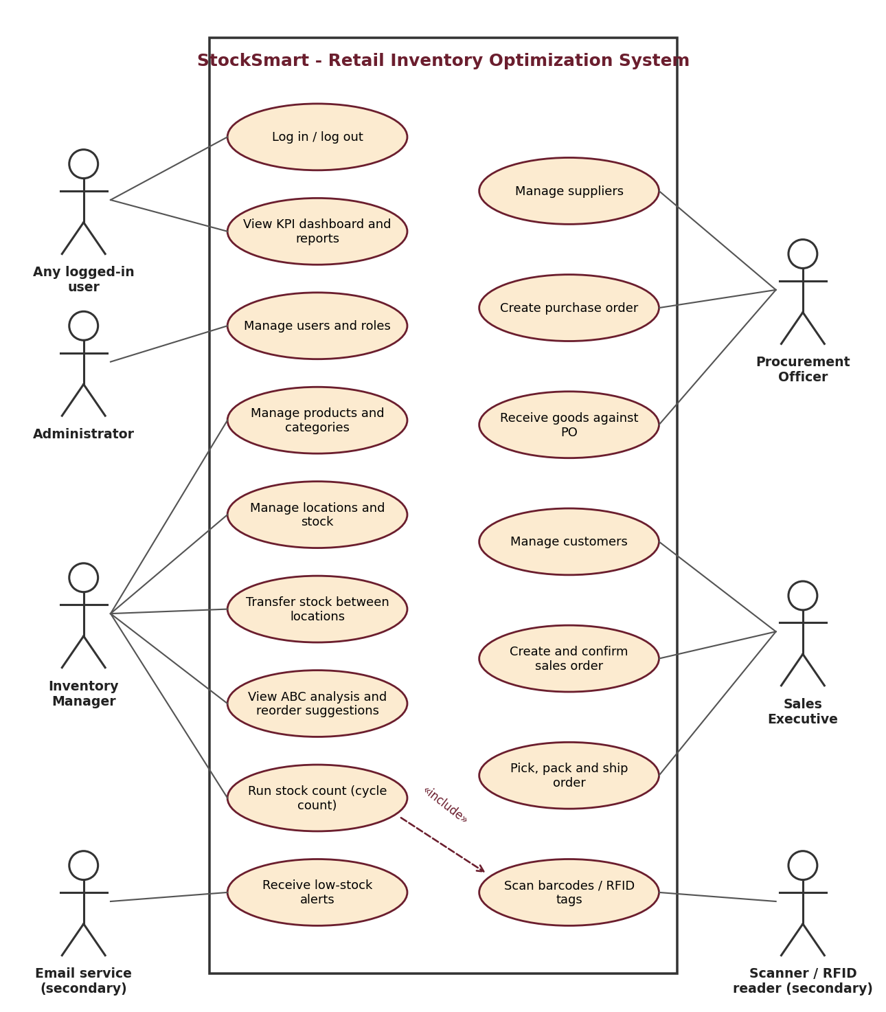  Figure 1: Use case diagram | 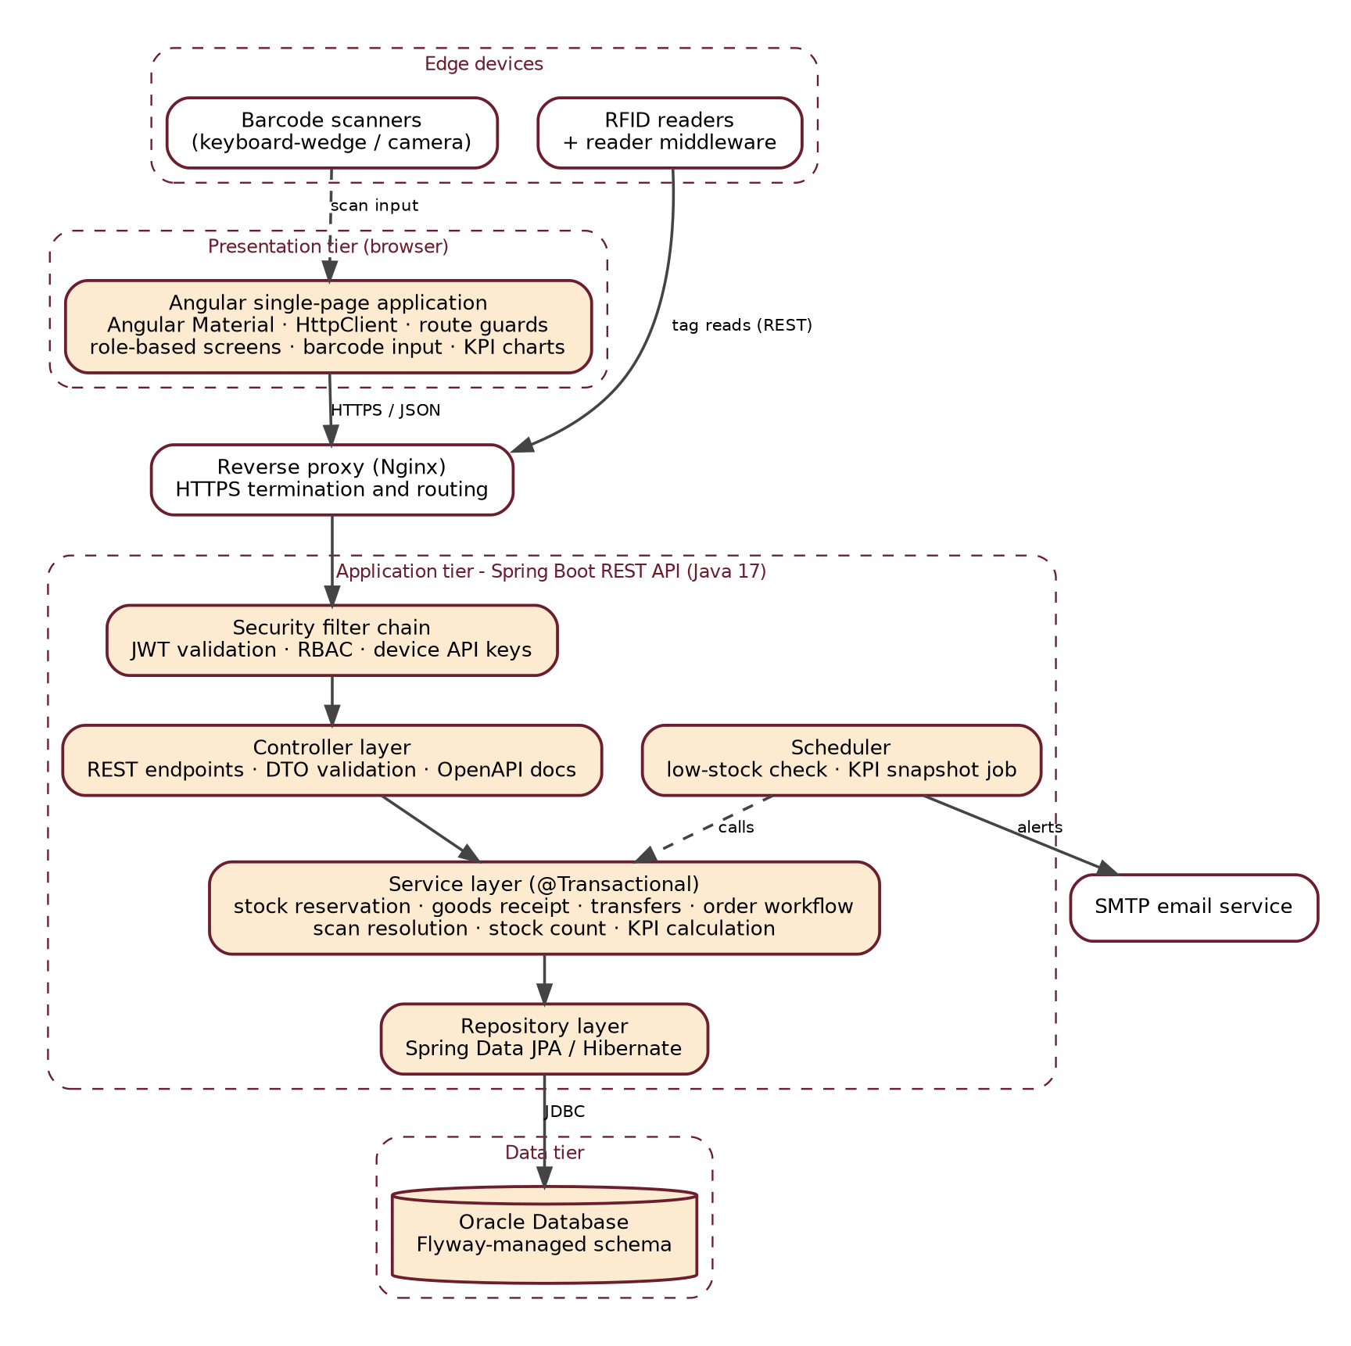  Figure 2: Layered architecture

4.2 Entity-Relationship Diagram and Data Dictionary
Figure 3 shows the main entities and relationships (a bar marks the "one" side, a crow's foot the "many" side). Reader_Device, Scan_Event, KPI_Snapshot and Audit_Log are omitted from the figure and described in the dictionary below.
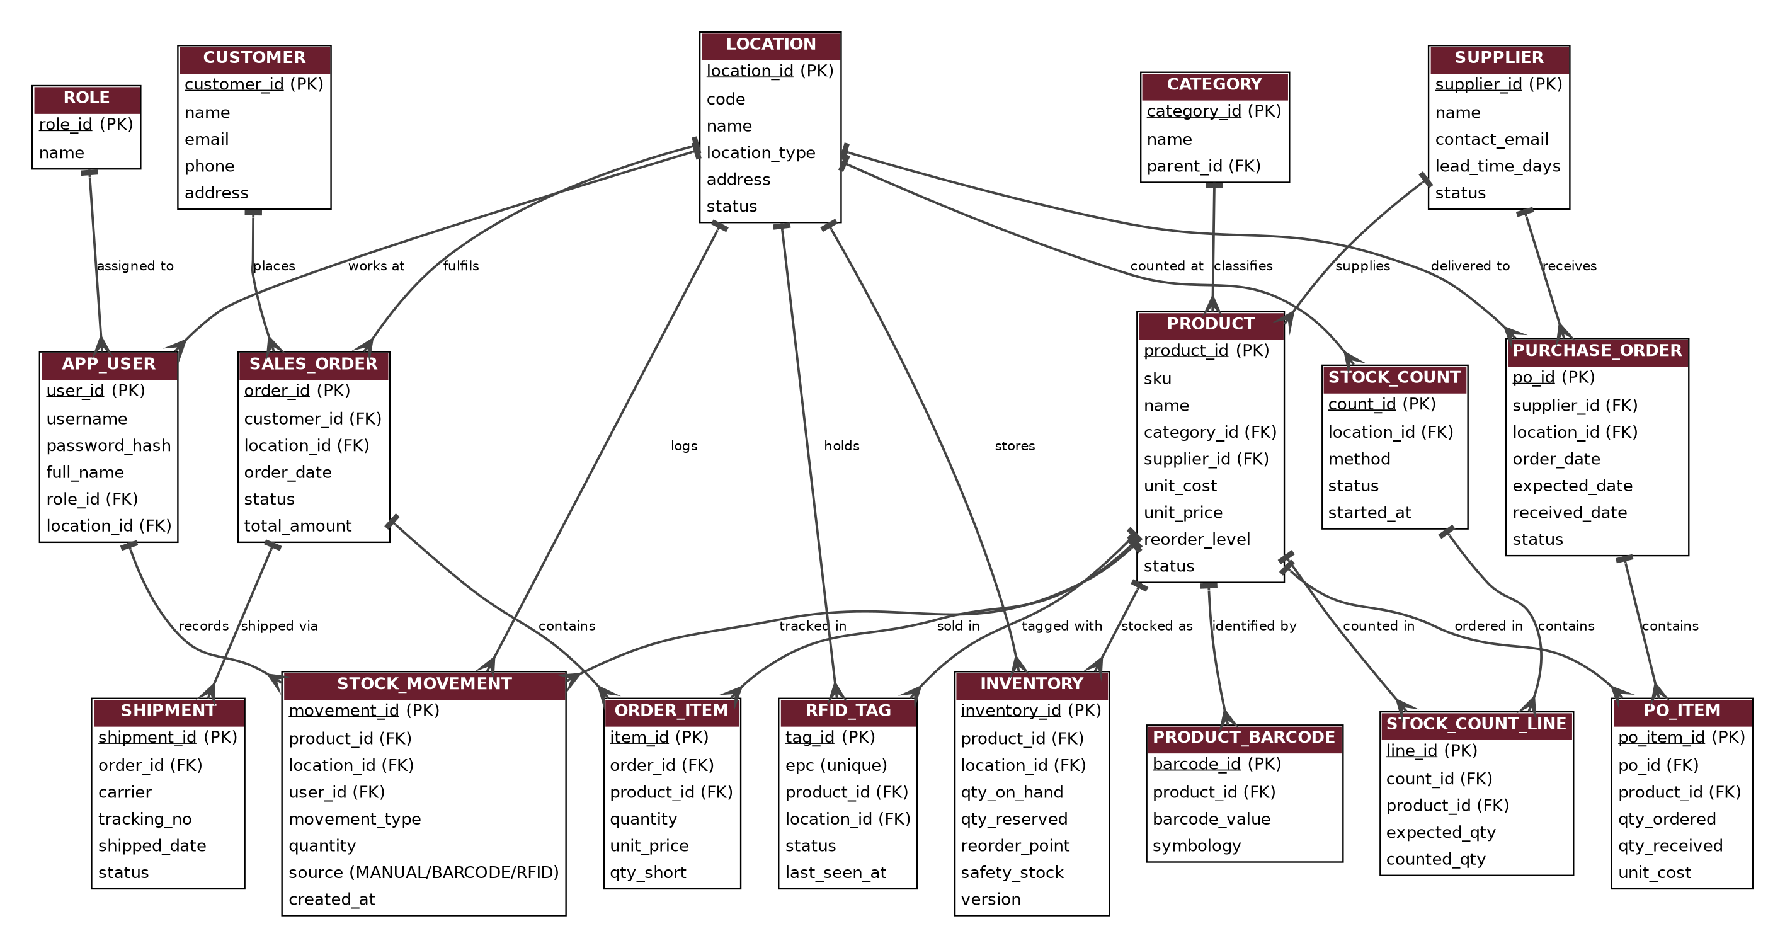
Figure 3: ER diagram of StockSmart
Entity | Attributes (PK underlined in Figure 3; FKs end in _id)
Role / App_User | role_id, name; user_id, username, password_hash, full_name, email, role_id, location_id, is_active
Location | location_id, code (unique), name, location_type (STORE or WAREHOUSE), address, status
Category / Supplier | category_id, name, parent_id; supplier_id, name, contact_email, phone, lead_time_days, status
Product | product_id, sku (unique), name, category_id, supplier_id, unit_cost, unit_price, reorder_level, status
Product_Barcode | barcode_id, product_id, barcode_value (unique), symbology, is_primary
Rfid_Tag | tag_id, epc (unique), product_id, location_id, status, last_seen_at
Inventory | inventory_id, product_id, location_id, qty_on_hand, qty_reserved, reorder_point, safety_stock, version; unique (product_id, location_id)
Stock_Movement | movement_id, product_id, location_id, user_id, movement_type, quantity, source (MANUAL, BARCODE, RFID), reference_no, created_at
Stock_Count / Line | count_id, location_id, method, status, started_at, closed_at; line_id, count_id, product_id, expected_qty, counted_qty
Purchase_Order / PO_Item | po_id, supplier_id, location_id, order_date, expected_date, received_date, status; po_item_id, po_id, product_id, qty_ordered, qty_received, unit_cost
Customer | customer_id, name, email, phone, address
Sales_Order / Order_Item | order_id, customer_id, location_id, order_date, status, total_amount; item_id, order_id, product_id, quantity, unit_price, qty_short
Shipment | shipment_id, order_id, carrier, tracking_no, shipped_date, delivered_date, status
Reader_Device / Scan_Event | device_id, name, location_id, api_key_hash, is_active, last_seen_at; event_id, device_id, user_id, location_id, code_value, code_type, result (MATCHED or UNMATCHED), batch_id, scanned_at; unique (device_id, batch_id, code_value)
KPI_Snapshot / Audit_Log | snapshot_id, snapshot_date, location_id, kpi_code, kpi_value; log_id, user_id, action, entity, entity_id, created_at
The Inventory version column supports optimistic locking (FR-28). Primary keys use Oracle identity columns or sequences; amounts are NUMBER(12,2), quantities NUMBER(10), text VARCHAR2 and times TIMESTAMP.

4.3 Workflow (State) Models
Sales and purchase orders move only through the transitions in Figures 4 and 5. Confirming a sales order raises quantity reserved; shipping reduces both on-hand and reserved stock; cancelling releases the reservation. Receiving a purchase order raises on-hand stock at the receiving location and logs a movement per line.
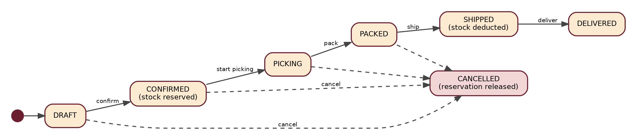
Figure 4: Sales order lifecycle
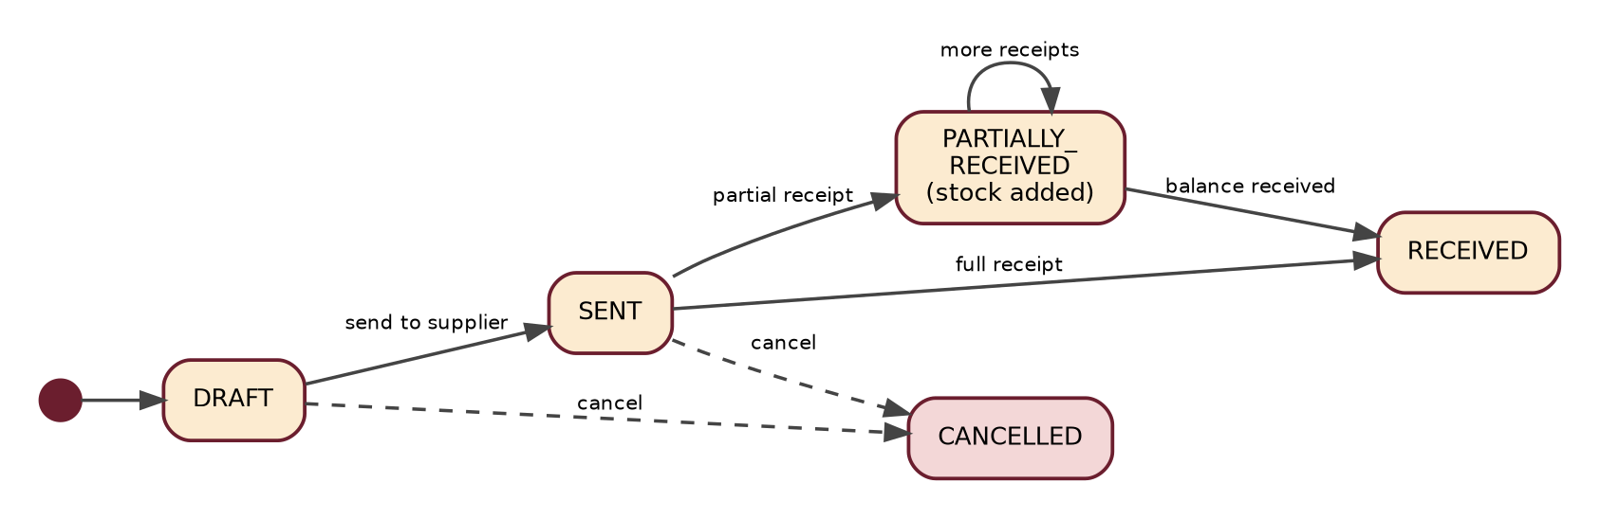
Figure 5: Purchase order lifecycle

4.4 Barcode and RFID Data Flow
Every scan follows the four steps in Figure 6, so a barcode scan and an RFID read are treated the same once resolved to a product. The scanner types the code into the focused scan box; RFID middleware removes repeated reads and posts a batch (batch number plus EPC list), and the API key identifies the device and its location. A batch number is accepted once per device, so a retry cannot double a count. A barcode is matched through Product_Barcode and an EPC through Rfid_Tag, so the registry stays authoritative for any EPC scheme (such as SGTIN-96). Unmatched codes are stored as UNMATCHED scan events for review and never change stock; every stock change from a scan is logged with source BARCODE or RFID.

4.5 Deployment and CI/CD
Figure 7 shows the path from a Jira story to the running system. Each push to main triggers Jenkins to build with Maven, run unit and Testcontainers integration tests against a disposable Oracle container, pass the SonarQube gate, build and scan Docker images, push them to a registry and deploy.
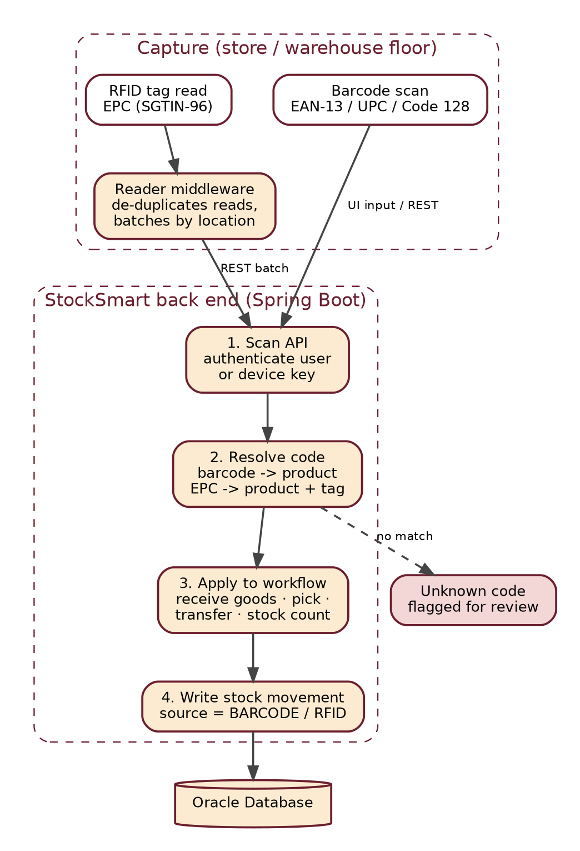  Figure 6: Barcode and RFID data flow | 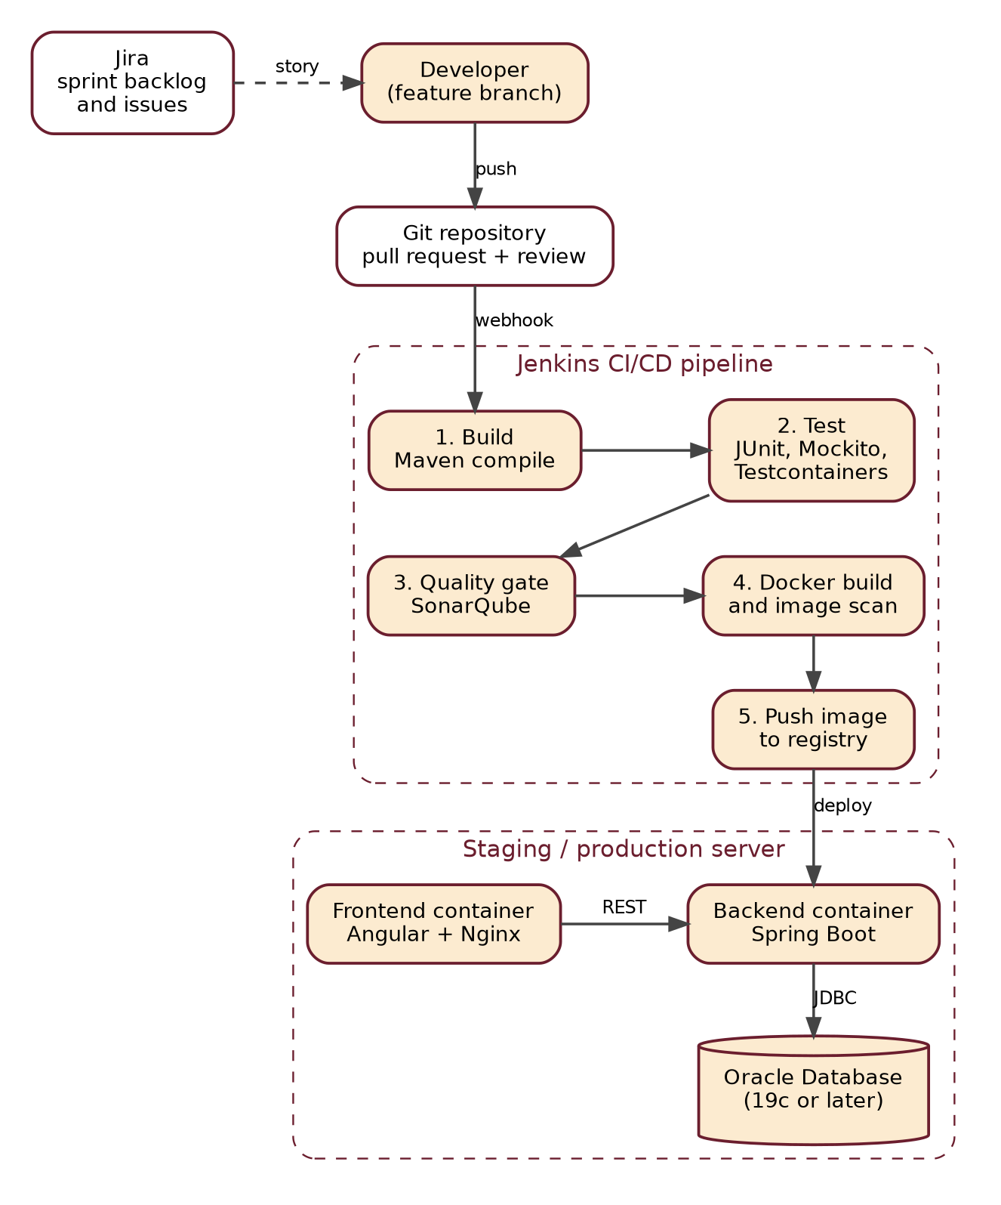  Figure 7: CI/CD pipeline and deployment

4.6 KPI and Optimization Rules
StockSmart uses transparent, rule-based formulas so every figure can be checked by hand; defaults are configurable.
KPI | Definition | Source
Stock value | Sum of quantity on hand x unit cost at the selected location(s). | Inventory, Product
Inventory turnover | Cost of goods shipped in the period / average stock value (mean of daily snapshots). | Movements, snapshots
Days of inventory | Days in the period / inventory turnover. | Derived
Stockout rate | Share of active product-location pairs with zero available stock, averaged over daily snapshots. | Inventory, snapshots
Fill rate | Order lines reserved in full at first confirmation / lines submitted for confirmation. | Order_Item (qty_short)
Stock accuracy | Count lines with zero variance / count lines counted. | Stock_Count_Line
Supplier on-time rate | POs received on or before expected date / POs received. | Purchase_Order

Rule | Formula and defaults
Average daily demand | Units shipped in the last N days / N, per product and location (default N = 90).
Safety stock | z x sigma_d x sqrt(L): sigma_d is the standard deviation of daily demand, L the supplier lead time in days, z = 1.65 for a 95% service level.
Reorder point | Average daily demand x L + safety stock. Without demand history the manual reorder level is used.
Order-up-to level | Average daily demand x (L + R) + safety stock, with review period R = 7 days.
Suggested quantity | Order-up-to level - (available stock + quantity on open POs), never below zero; grouped by supplier for draft POs.
ABC class / slow-moving | Rank by units shipped x unit cost over 12 months: A = top products to 80% of cumulative value, B = next 15%, C = rest. Slow-moving = stock on hand with no shipment in 90 days.

5. Agile Delivery Plan
The project guide acts as Product Owner and the student (or team) plays Scrum Master and Development Team. Each 2-week sprint starts with planning in Jira, has a daily stand-up, and ends with a review and retrospective. The 8 epics are delivered over 15 sprints (30 weeks); Sprint 1 sets up the repository, skeletons, Docker Compose with Oracle, Flyway and the first CI build, and Sprint 15 covers hardening, regression and acceptance testing, documentation and release.
Epic | Name | Main user stories | FRs | Sprints
1 | Identity and Access | Log in, manage users and roles, restrict features by role. | FR-01-04 | 1, 15
2 | Product Catalog | Add and edit products, organise categories, search and filter. | FR-05-08 | 2-3
3 | Multi-Location Inventory | Locations, stock per location, adjustments, transfers, counts, ledger. | FR-09-15 | 6-7, 13
4 | Supplier and Procurement | Suppliers, purchase orders, partial receipts, supplier delivery tracking. | FR-16-21 | 8-9
5 | Order Processing | Customers, orders, reservation, pick-pack-ship, safe cancellation. | FR-22-28 | 10-12
6 | Barcode and RFID | Barcodes and labels, scan screens, RFID tags and readers, tag-read ingestion. | FR-29-37 | 12-13
7 | KPI Reporting and Optimization | KPIs, low-stock alerts, reorder suggestions, ABC analysis, reports. | FR-38-44 | 14
8 | DevOps, Quality and Release | Docker, Jenkins, validation, audit log, testing and release. | FR-45-49 | 1, 15
Definition of Done: code reviewed and merged by pull request; unit and integration tests and the SonarQube gate pass in Jenkins; acceptance criteria demonstrated at the sprint review; OpenAPI and Flyway changes included; increment deployed to staging and the Jira story closed.

6. Verification and Future Enhancements

6.1 Verification of Requirements
Each requirement is checked by a test case: JUnit and Mockito for business rules, Testcontainers for Oracle behaviour, Postman for the API, Jasmine for Angular components, and manual checks at each sprint review. Scanners and readers are tested with a keyboard-wedge scanner or simulated input and recorded tag-read batches. All items are Planned until their sprint completes.
Requirement | Test | Expected result
FR-01-03 | Log in as each role; call a restricted endpoint with no token and the wrong role | Correct access; 401 or 403 otherwise
FR-11, FR-12 | Adjust stock below zero; force a failure mid-transfer | Adjustment rejected; no partial transfer
FR-19, FR-20 | Receive a PO in two parts, then over-receive | Stock added twice; over-receipt rejected
FR-24, FR-28 | Confirm with short stock; run two parallel orders for the last units | Short order rejected; only one order reserves
FR-29, FR-31 | Register a duplicate barcode; scan a known barcode on the receipt screen | Duplicate rejected; scan finds the right line
FR-35, FR-36 | Post one batch twice, with an unregistered EPC; run an RFID count with a missing and an extra tag | Counted once; exception listed; adjustment only after approval
FR-40, FR-41 | Load sample demand and lead times; create a draft PO from a suggestion | Values match hand calculation; draft PO per supplier
FR-38, FR-39 | Load a known data set; reduce stock to the reorder point | KPIs match hand figures; product flagged and email sent
FR-45, FR-47 | Commit to main; open health and Swagger pages | Pipeline passes and deploys; both respond

6.2 Future Enhancements and Conclusion
Planned extensions: point-of-sale integration, RFID dock-door portals and camera-scanning mobile apps, machine-learning demand forecasting, bin-level locations, partial shipments and returns, an online storefront with payments, and single sign-on with accounting and GST integration. In summary, StockSmart gives a retailer one system for the catalog, multi-location stock, suppliers and orders; barcode and RFID capture keep records accurate, and KPI reports and reorder suggestions show what to order and when.

