**Conclusions about crowdfunding campaigns**

Relative to the goal set, there were three ranges where 100% of the crowdfunding campaigns were successful and 0% of the campaigns failed (see sheet5). At goal ranges set from 15,000 to 19,999, at 20,000 to 24,999, and at 30,000 to 34,999, all crowdfunding campaigns reported were successes and none were failures. Despite this, the total number of campaigns was 24 (10 for 15,000 to 19,999, 7 for 20,000 to 24,999, and 7 for 30,000 to 34,999). Given that a total of 986 projects (although there are 1,000 total, the 14 live projects are not included and only the successful, failed and canceled are accounted for), this accounts for less than 3% of the total projects (24 out of 986). Honing in on a specific goal range where the number of total projects was significant and the difference between the number of success and failures was great, that would be the goal range set at 1,000 to 4,999. Within this goal range, there were 231 projects of which 83% were successful, 16% failed, and 1% were canceled. Contrast that with the goal range set at 5,000 to 9,999, out of 315 total projects, 52% were successful, 40% failed, and 8% were canceled. *Thus, when planning on having a successful crowdfunding campaign with a small possibility of failure, setting a goal fund within 1,000 to 4,999 appears to be ideal.*

Looking at the successful campaigns relative to the month they were created regardless of year, the greatest gap between failure and success occurred in the months of June and July. With 55 successes, 28 failures, and 58 successes, 31 failures, respectively, *the months of June and July may be the most advantageous months to launch a successful crowdfunding campaign with a low probability of failure.*

Looking specifically at the parent category, by absolute number, the greatest amount of successful crowdfunding campaigns belonged to that within the theater group with 187. Despite the great number of successes, the relative rate of success within the theater group was 54% (187 out of 344). This is visualized in the stacked 2D column chart (sheet 2). Thus, as visualized in the stacked 2D column chart, although the parent group of technology had an overall lesser amount of successful crowdfunding campaigns at 64, the relative success rate is high, 67% (64 out of 96); thus, *crowdfunding campaigns that fall under the parent category of technology should be considered as a premium choice when deciding on what categories to pursue when developing a successful crowdfunding campaign.*

**Limitations of the dataset**

One limitation is that most of this data is garnered from the United States and not from other countries. Thus, it would not be prudent to declare this data indicative of international tendencies and may be better suited to describe crowdfunding campaigns within the USA. Also, given that the majority of data was collected within the USA, knowing where the specific areas were, such as knowing the specific state, county, or city may give further insights as to what areas of the USA may have better success at these crowdfunding campaigns.

Another limitation are the sub-categories. Specifically, the theater parent category had the most total number of crowdfunding campaigns at 344. The next highest was the parent category of film and video with 178. But in terms of sub-category, the theater parent category had only one field, plays, as a sub-category. Thus, there really is no sub-category under the parent category of theater because there is only one sub-category. Contrast this with that of film and video which has six sub-categories. In order to get a better understanding of the failures and successful crowdfunding campaigns within the parent category of theater, more sub-categories should be included. A few examples of these sub-categories may be tragedies, comedies, tragi-comedies, musicals, historicals, melodramas. Generally, the more sub-categories within each parent category, a better understanding of the crowdfunding campaigns may be achieved.

Another limitation involves the backers. Specifically, details of how these backers were attained (outreach through websites, in-person, phone calls, emails, social gatherings) may prove informative. Additionally, the additional metrics that can be attained by these backers, such as annual income, demographics regarding place of residence, occupation, age, gender, race, would also likely allow future crowdfunding campaigns to hone in on specific peoples, or more importantly, where to delegate resources and where not to during the recruitment of backers.

**Other Possible tables/graphs**

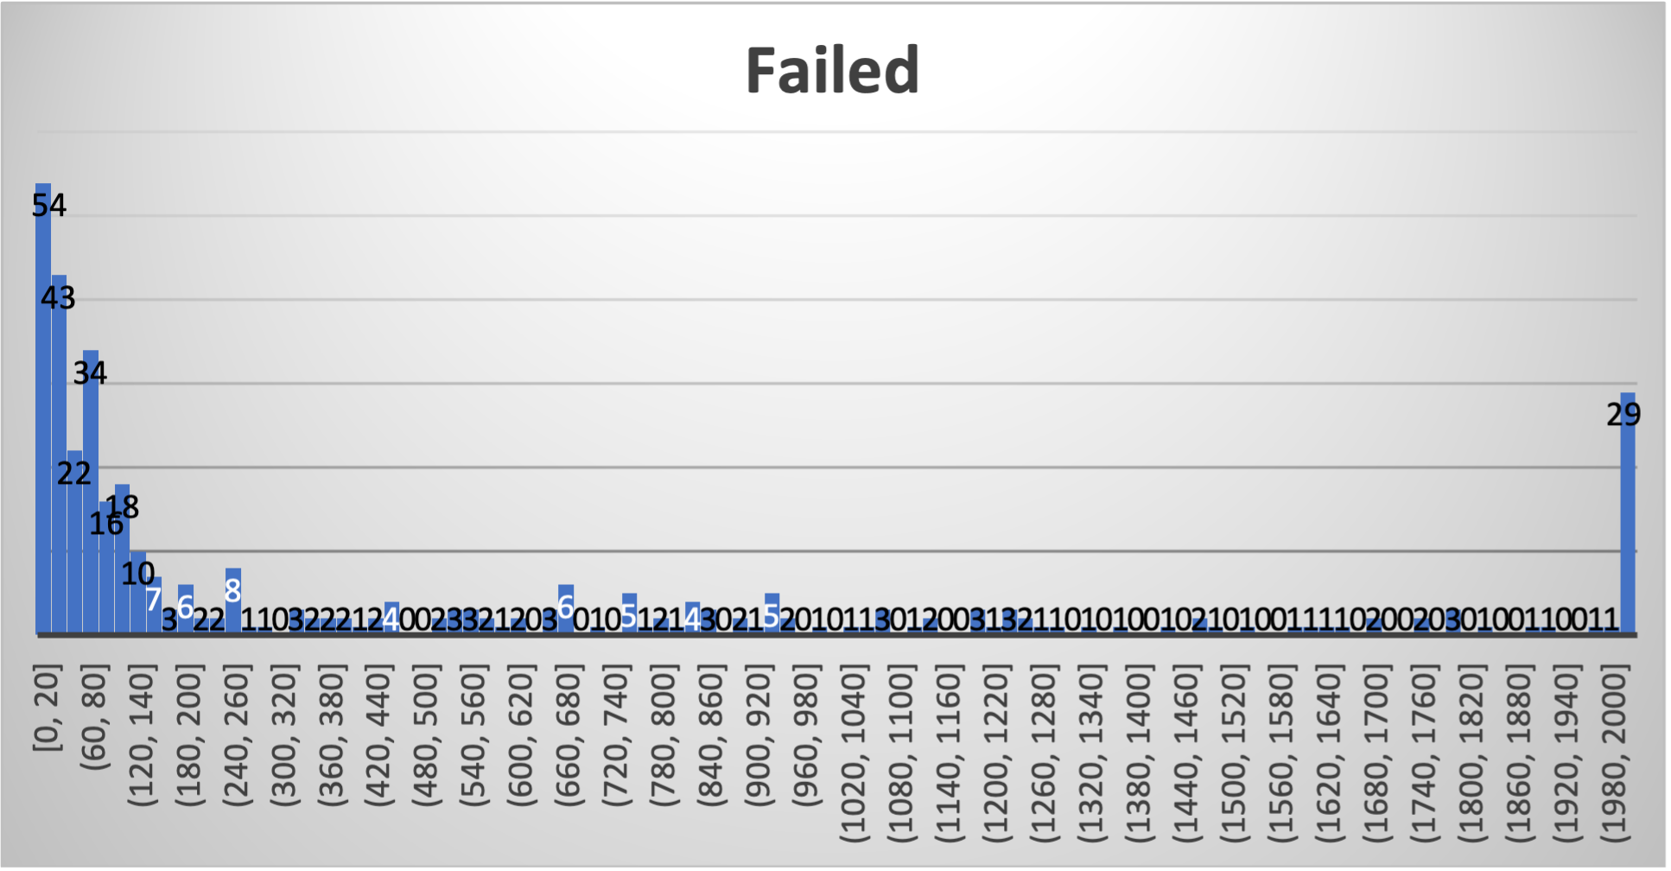In order to assess the number of backers relative to successful and failed crowdfunding campaigns, a histogram would be another possible graph. Shown here is a histogram analyzing the number of backers for those crowdfunding campaigns that failed. With a bin width set to 20 and an overflow set at 2,000, one can visualize that the majority of the failures occurs when the number of backers is less than 200 (213 out of the 364, 59%, failed crowdfunding campaigns had the number of backers equal or less than 200).

Another possible pivot table to include involves using spotlight and/or staff pick to assess how those metrics impact the outcome of a crowdfunding campaign.

Another table would be to look at goal versus outcome. One may be interested in assessments of the average goal desired for failed and/or successful campaigns.

**Statistical analysis of backers**

The central limit theorem states that as the sample size gets larger, the mean of that data gets closer to a normal distribution. For either data set, the mean is greater than the median. For the successful and failed data sets, the mean is ~323% larger (mean =851, median = 201) and ~410% larger (mean = 586, median = 115), than the median, respectively. Thus, each data set is right skewed, and in right skewed data, the mean overestimates the most common values. So the median reflects the data better than the mean.