3D Surface Fuels & Vegetation Modeling
Prize Challenge — Phase-1 Submission
A measured, field-calibrated 1 m surface-fuel product that beats FastFuels’ uniform layer — from free spaceborne data, anywhere.
Phase-1 deadline 2026-07-20 · all results reproducible from open data & code

Contents

1. The thesis, in one figure
FastFuels paints surface fuel as one number per 30 m LANDFIRE fuel-model class — uniform within the class, by construction. We measure it at 1 m and calibrate it to destructive ground truth. The same 510 m OSBS scene, two products:
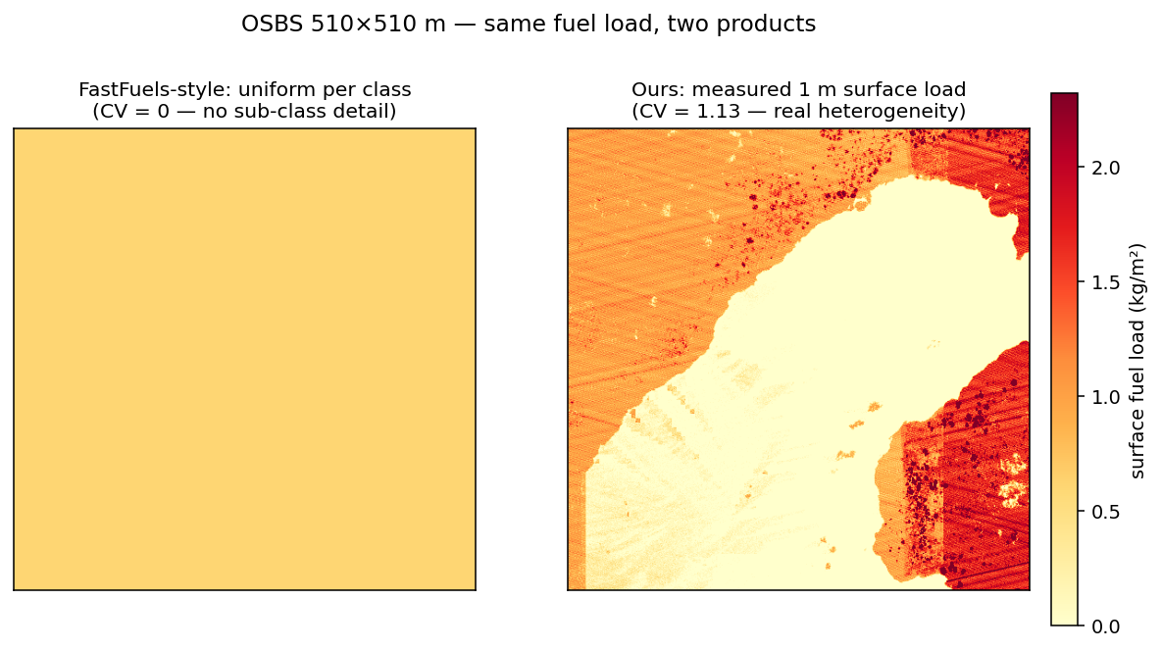
Figure 1. FastFuels-style uniform surface load (CV 0) vs. our measured 1 m surface load (CV 1.13) over OSBS. Same mean load; only ours carries the sub-class heterogeneity that fire models consume.

2. Method
From LiDAR we compute vertical occupancy (the fraction of 0.15–4 m height-bins that contain returns — a density-robust understory-structure metric), voxelize it to 1 m³ bulk density, and field-calibrate it to surface fuel load against RxCADRE destructive clip plots (occupancy → total load, slope 1.33 kg/m², R² 0.93). Where airborne LiDAR is absent, a per-pixel gradient-boosting model predicts that same occupancy from globally-free spaceborne inputs — AlphaEarth embeddings, Sentinel-1 C-band, ALOS PALSAR L-band, and global canopy height — with conformal uncertainty and an out-of-distribution flag, then disaggregates to a FastFuels-compatible 1 m³ NetCDF. Simple, explainable, and every layer is measured or field-anchored — no hallucinated structure.
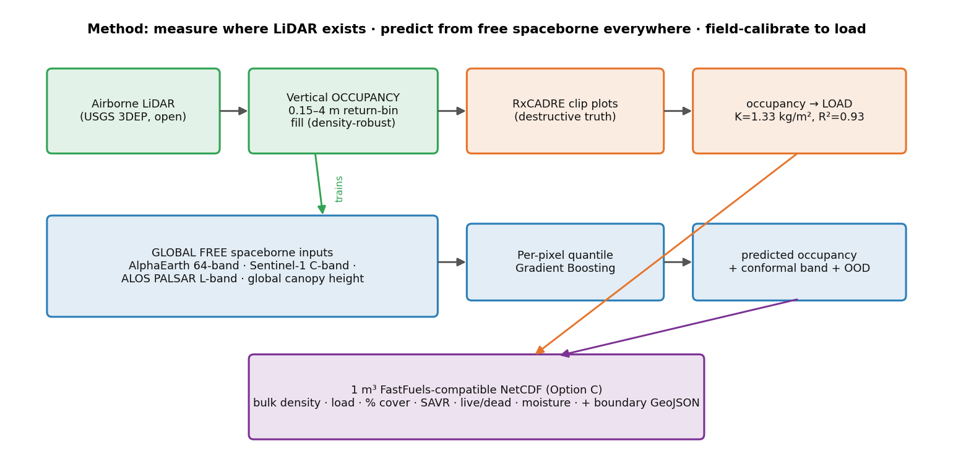
Figure 2. End-to-end method. LiDAR-measured occupancy trains a per-pixel model on free spaceborne inputs; RxCADRE clip plots calibrate occupancy to load; output is a 1 m³ FastFuels-compatible NetCDF.
Differentiator vs the host team’s ForestGen3D and de Conto (2025): they generate/predict canopy structure; we deliver an independent physical measurement of the surface/understory layer, calibrated to destructive truth, with honest uncertainty.

3. Deliverables in this submission
Deliverable | Where
1 m³ voxel NetCDF, FastFuels “Option C” (measured / uniform / generalized) | build_deliverable_osbs.py → osbs_*_1m.nc
AOI boundary polygon (WGS84 + native CRS) | osbs_boundary.geojson
Property maps + interactive 3D viewer | figures/ + Streamlit dashboard
Validation documentation | research/RESULTS.md, VALIDATION.md
Python ingestion/visualization tool (one command) | scripts/read_deliverable.py
Global “generate anywhere” demo | dashboard/app.py

Fuel properties in the NetCDF (empty cells use the challenge sentinel 1.23456):
Variable | Dims | Units | Tier
bulk_density | (z,y,x) | kg/m³ | P1
fuel_load | (y,x) | kg/m² | P1
percent_cover | (y,x) | % | P1
savr | (z,y,x) | 1/m | P2
live_fraction | (z,y,x) | – | P2
dead_fuel_moisture | (y,x) | % | P2
live_fuel_moisture | (y,x) | % | P2
heat_of_combustion | (z,y,x) | kJ/kg | P3
avg patch size, <2 m heterogeneity | attrs | m, – | P3

4. Evidence, mapped to the Phase-1 judging criteria

(1) Utility of the methodology
Head-to-head vs the real FastFuels method (LANDFIRE FBFM40 → SB40 load lookup) on the OSBS 1 m product:
Product | overall R² | within-block R² (sub-30 m) | heterogeneity CV
FastFuels uniform | −0.00 | 0.00 (by construction) | 0.00
Ours (end-to-end) | 0.664 | 0.274 | 0.73 (truth 0.89)
Our within-block R² of 0.27 is exactly the sub-class heterogeneity FastFuels cannot represent. Output is drop-in FastFuels-compatible, in field-calibrated kg/m².

(2) Generality of approach
The identical pipeline runs across 15 ecosystems on 4 continents (US savanna, desert, conifer, deciduous, wetland; European temperate + hemiboreal; equatorial Amazon + Borneo rainforest) with no code changes. Cross-ecosystem leave-one-site-out:
- Between-biome / absolute level: solved — GLOBAL R² 0.49, between-biome R² 0.81.
- Within-biome fine structure, unseen forest: works — median within-R² +0.11; within-Spearman ~0.3–0.6 (mean ~0.4).
- A conservative per-biome-radius OOD flag marks locations unlike any training ecosystem — grounded where trained, honestly flagged elsewhere.

(3) Data acquisition challenges & cost
100% free / open, and no field campaign is required at inference. Inputs: USGS 3DEP LiDAR, AlphaEarth (free S3 mirror), Sentinel-1 + ALOS PALSAR + Copernicus DEM (Planetary Computer), Meta/WRI canopy height (open AWS), ESA WorldCover; truth from RxCADRE (USFS) + NEON. The global model needs only spaceborne inputs at inference — LiDAR is used to train, not to deploy.

(4) Clarity of methodology
Every step compresses to one sentence and every number is script-reproducible. We use a per-pixel gradient-boosting model — and proved it is the right choice at this scale via a faithful head-to-head vs the de Conto (2025) fully-convolutional EfficientNetV2 paradigm on the same target and spatial folds:
Model | R² (all) | under-canopy | interval coverage
Ours: per-pixel quantile GBM | 0.628 | 0.375 | 85%
de Conto: fully-conv CNN (NLL) | −0.147 | −0.380 | 14%
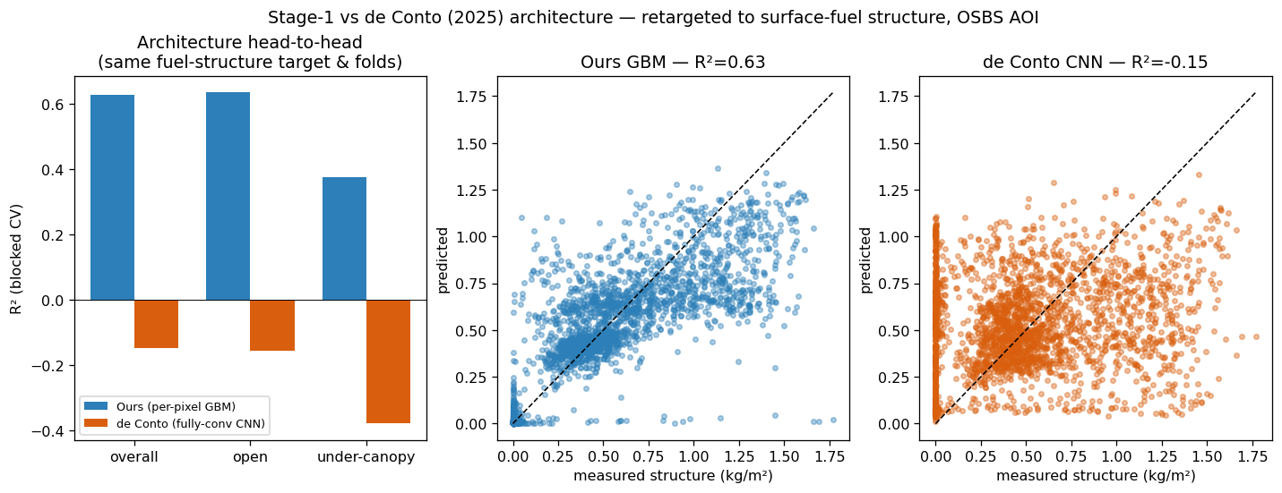
Figure 3. At AOI scale a per-pixel model with proper spatial CV beats the CNN paradigm decisively (the CNN needs continental training our tiled design supports).

(5) Credibility of validation (top-weighted)
- Spatially-blocked cross-validation everywhere; leave-one-site-out for cross-ecosystem generality.
- Calibrated uncertainty: conformal prediction intervals (85% empirical coverage) + per-cell OOD score.
- Field calibration to destructive truth: occupancy → RxCADRE total surface load, R² 0.93 across 9 Eglin burn blocks (grass 0.21 → forest 1.12 kg/m²).
- Honest negative results reported (cross-ecosystem within-biome is hard; NEON herb clips are the wrong stratum, R² 0.02).
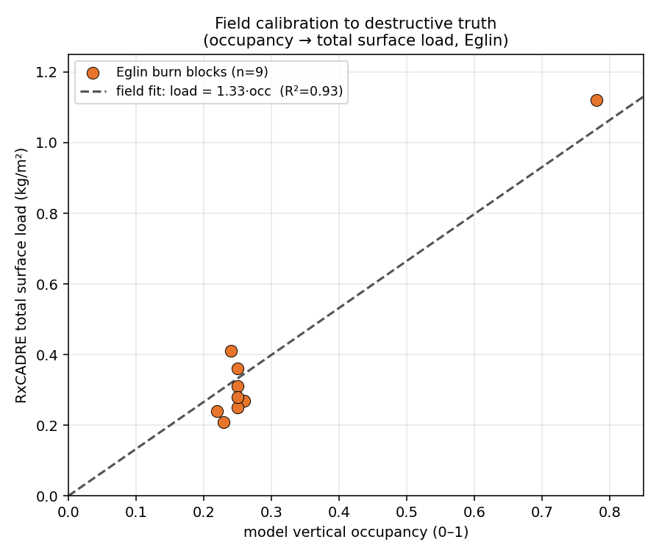
Figure 4. Absolute load is field-anchored: model occupancy vs RxCADRE destructive total surface load, slope 1.33 kg/m², R² 0.93.

(6) Relevance to surface & understory fuels
The target is explicitly the 0.15–4 m understory stratum (vertical occupancy → surface load), calibrated to RxCADRE surface clip plots — distinct from canopy-structure indices (de Conto’s WSCI) and from FastFuels’ canopy voxels. SAR + canopy-height features infer understory where optical saturates.

(7) Practical scalability
Global by design: free spaceborne inputs, on-demand per-AOI inference with a canonical-tile disk cache, memory-safe by construction (10 m inference, hard AOI cap, voxel-budgeted 1 m export). Coverage extends tile-by-tile — adding Amazon + Borneo moved the tropics from OOD to in-distribution.

5. The delivered product
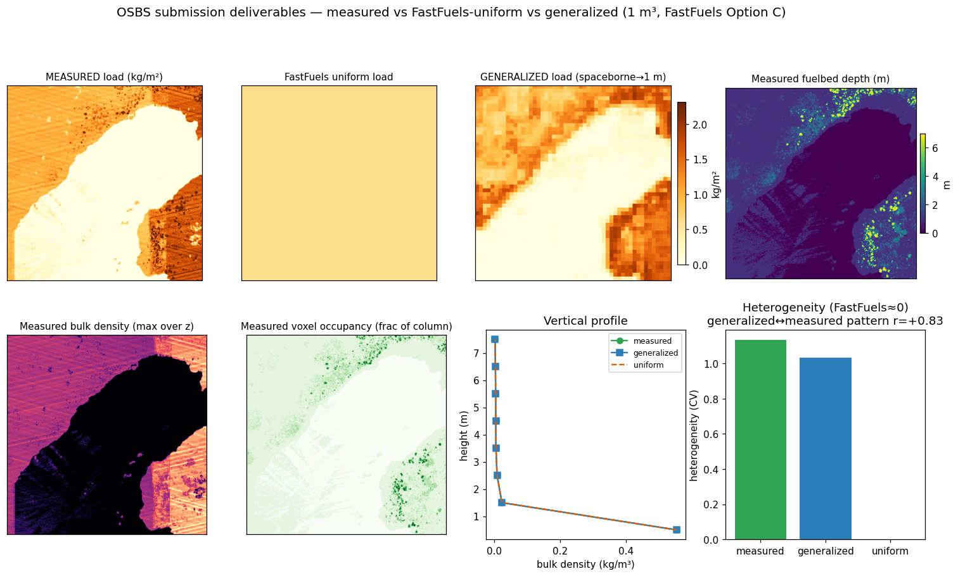
Figure 5. OSBS 1 m deliverable property maps: measured load, FastFuels-uniform baseline, generalized (spaceborne) load, fuelbed depth, bulk density, and voxel occupancy.
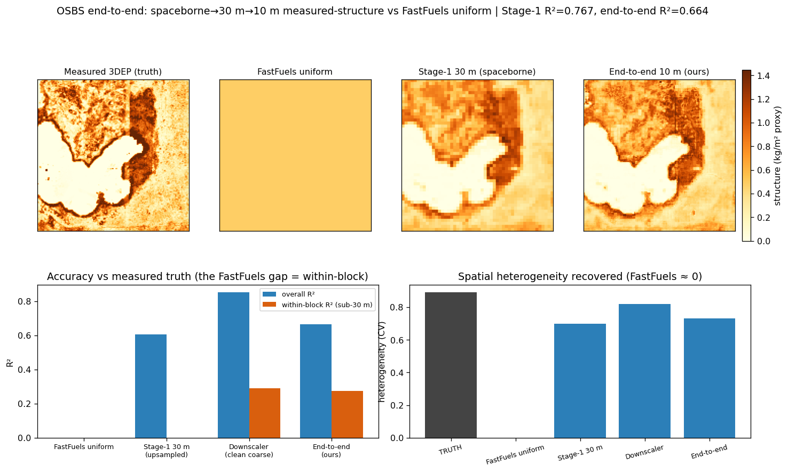
Figure 6. End-to-end spaceborne→ 30 m → 10 m pipeline validated against measured 3DEP truth vs a FastFuels-style uniform layer.

6. Limitations (stated plainly)
- Absolute-load calibration is single-ecosystem (Eglin/RxCADRE, R² 0.93 over a wide range); multi-site destructive plots would refine per-biome transfer (forests read slightly low, deserts slightly high).
- Within-biome fine structure in a brand-new biome is partially solved (forests) — the genuine sensing limit; L-band + canopy height help, GEDI is sparse.
- Fuel moisture (P2) is populated but coarse: dead FM from ERA5 (near-uniform at AOI scale), live FM a Sentinel-2 NDVI proxy. Species mix (P3) is out of scope for Phase 1.
- The OOD flag is conservative by design — it warns rather than silently extrapolating.

7. Reproducibility & data sources
pip install -r requirements.txt, then: build_deliverable_osbs.py (product), read_deliverable.py (ingest/viz), build_pipeline_osbs.py [--site] (end-to-end + generality), calibrate_load_field.py (RxCADRE calibration), compare_load_vs_fastfuels.py, global_coverage_table.py, deconto_headtohead.py, streamlit run dashboard/app.py.
Data (all free/open): USGS 3DEP; AlphaEarth (Source Coop S3); Sentinel-1, ALOS PALSAR, Copernicus DEM, ESA WorldCover, Sentinel-2 (Microsoft Planetary Computer); Meta/WRI global canopy height (AWS Open Data); ERA5 (Copernicus CDS); RxCADRE (USFS Research Data Archive); NEON.

8. Eligibility & IP
Team eligibility (18+, U.S./NATO citizens, non-federal, no federal funds) per the challenge terms. Participants retain IP; the U.S. Government and partners receive permanent access per the rules. No protective markings applied.

