Student Performance AI
Two-Page Project Summary
BIT Management System Prototype
Problem Statement  Predict student performance bands and identify students who are academically at risk. | Current Results  Accuracy: 0.6458  Weighted F1: 0.6349  Train/Test: 960 / 240  Target: Low / Medium / High
1. Objective
- Predict student performance bands from academic and behavioral inputs.
- Identify students who are academically at risk.
- Generate recommendation-oriented intervention support.
2. Why Random Forest
- Works well on structured student data such as attendance, GPA, quizzes, and assignments.
- Captures non-linear relationships between academic indicators.
- More stable than a single decision tree and easier to explain in project review.
- Provides feature importance, which supports explainability.
3. Inputs And Target
- Numeric features: attendance, assignments, quizzes, internal exam, labs, study hours, LMS logins, GPA, project score.
- Categorical features: department, study mode, internet access, part-time job, extracurricular activity.
- Low: Performance score below 105
- Medium: Performance score between 105 and 123
- High: Performance score above 123
4. Working Of The System
- Dataset is generated or loaded.
- Numeric and categorical columns are preprocessed separately.
- Missing values are handled with median/most-frequent imputation.
- Categorical values are converted using one-hot encoding.
- Random Forest predicts the performance band.
- A recommendation layer converts weak indicators into academic actions.
5. Core Visuals
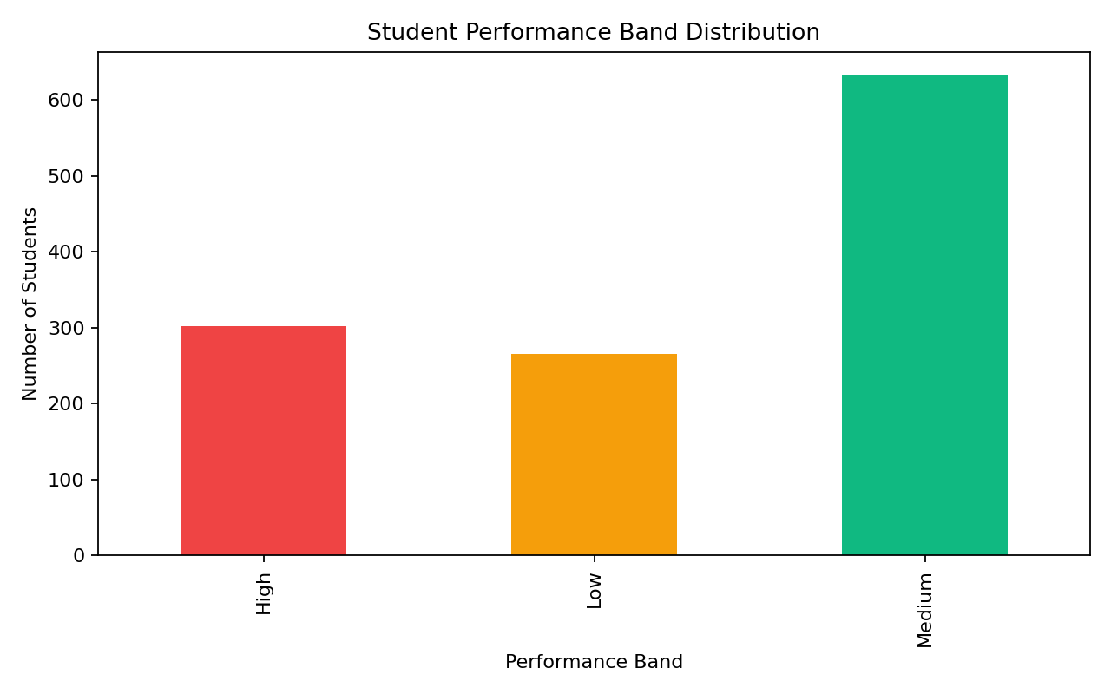 | 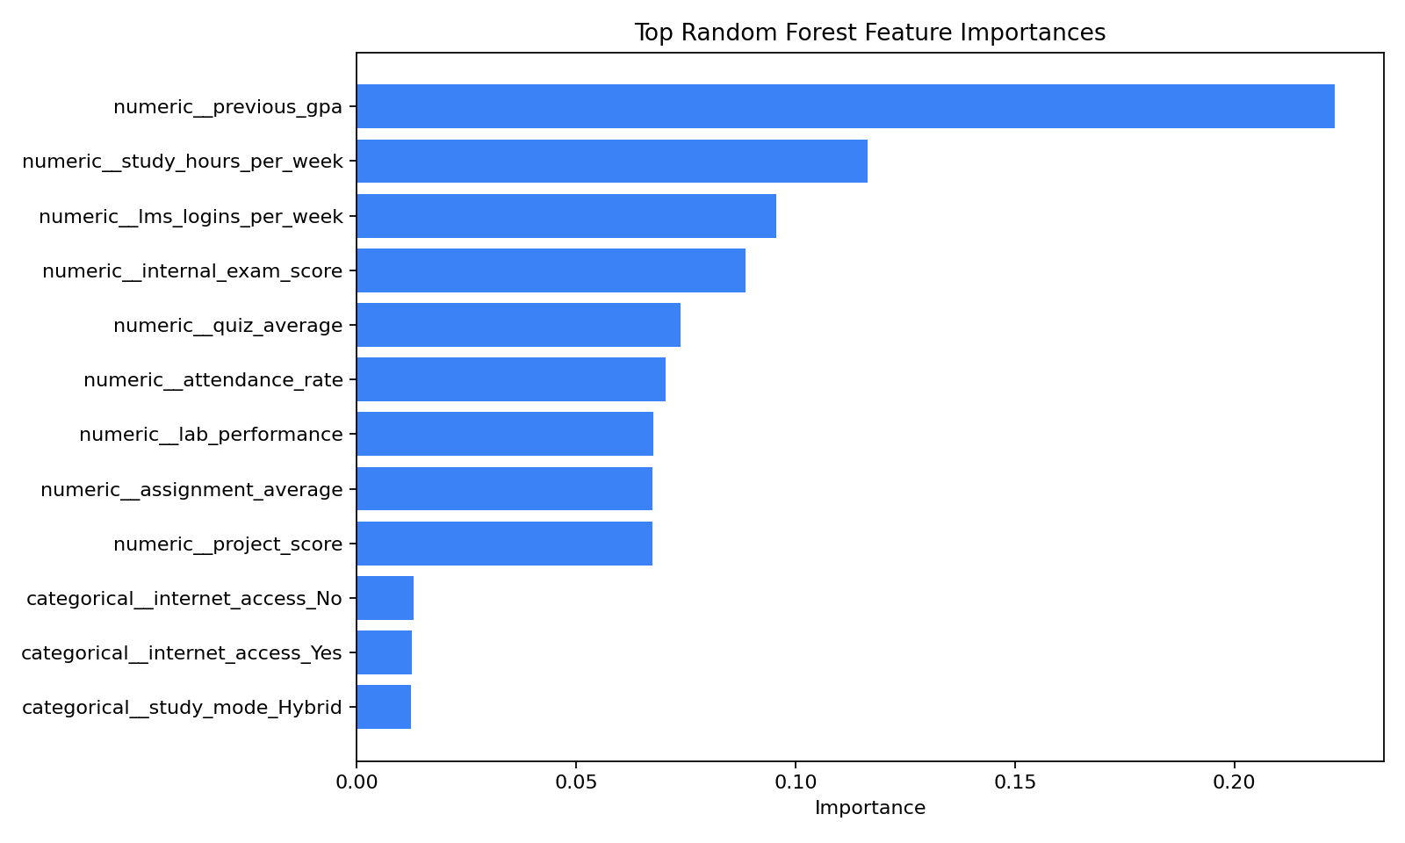

6. Model Performance
Actual \ Predicted | Low | Medium | High
Low | 24 | 29 | 0
Medium | 13 | 102 | 12
High | 1 | 30 | 29
- The model predicts Medium-class students most strongly.
- Some Low and High students still overlap with Medium, which is realistic for a prototype.
- The current performance is suitable for demonstration and further extension with real data.
7. Recommendation Output
- Low attendance triggers attendance mentoring.
- Weak internal exam score triggers remedial support.
- Low assignment or quiz scores trigger targeted academic guidance.
- Low study hours or LMS usage trigger engagement and planning recommendations.
8. Risk Visualization
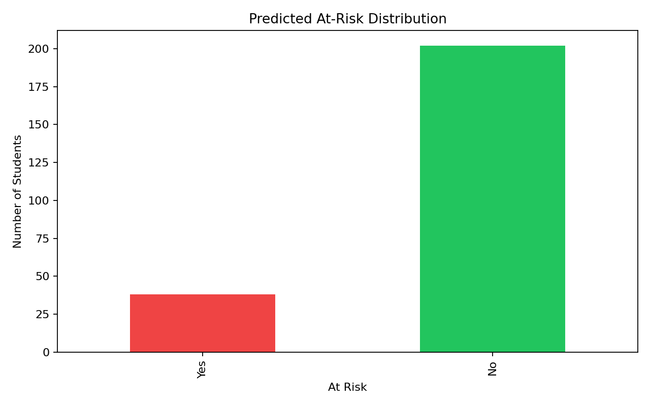
9. How To Run
- Use run_app.bat or run_app.ps1 for one-click launch.
- Manual flow: create .venv, install requirements, generate data, train model, run Streamlit.
- Dashboard features: metrics, charts, sample predictions, and live student prediction form.
10. Conclusion
- Random Forest is an appropriate choice because it is reliable, explainable, and effective on tabular educational data.
- The prototype combines prediction, analytics, and recommendations in a single dashboard.
- The next step is integration with real BIT Management System data.

