Student Performance AI
Report-Ready Project Document
BIT Management System Prototype

Abstract
This report presents a Student Performance AI prototype developed for a BIT Management System. The system predicts student performance bands, identifies at-risk students, and produces practical recommendations using a Random Forest model trained on a realistic synthetic dataset.

1. Introduction
The objective of this project is to extend a student management system with AI-driven analytics and intervention support. Instead of only storing records, the system uses student data to estimate performance and highlight areas where academic support may be required.

2. Problem Statement
Predict student performance bands and identify students who are academically at risk.

3. Objectives
- Predict student performance as Low, Medium, or High.
- Identify academically at-risk students.
- Generate recommendation-oriented intervention suggestions.
- Present outputs through a dashboard suitable for project review.
- Prepare the project for future system integration.

4. Dataset And Features
The prototype uses a realistic synthetic dataset because live institutional data was not connected during the prototype phase. The feature set includes academic, behavioral, and contextual variables.
Feature columns used by the model:
- attendance_rate
- assignment_average
- quiz_average
- internal_exam_score
- lab_performance
- study_hours_per_week
- lms_logins_per_week
- previous_gpa
- project_score
- department
- study_mode
- internet_access
- part_time_job
- extracurricular_activity

5. Model Choice: Random Forest
Random Forest was selected because it is reliable on structured tabular data, easier to explain in an academic review, robust against overfitting compared with a single decision tree, and capable of providing feature importance.
- Works well on structured educational data.
- Captures non-linear relationships between student indicators.
- Improves stability by combining multiple trees.
- Provides feature importance for explainability.
- Gives strong baseline performance for a prototype.

6. How The Model Works
- Student data is collected through input features.
- Numeric fields are imputed with median values.
- Categorical fields are imputed with the most frequent values.
- Categorical features are encoded using one-hot encoding.
- A Random Forest classifier predicts the performance band.
- Predictions are translated into at-risk information and recommendations.

7. Target Definition
- Low: Performance score below 105
- Medium: Performance score between 105 and 123
- High: Performance score above 123

8. Model Performance
Accuracy: 0.6458
Weighted F1-score: 0.6349
Training rows: 960
Test rows: 240
Class-wise performance:
- Low: precision=0.6316, recall=0.4528, f1-score=0.5275
- Medium: precision=0.6335, recall=0.8031, f1-score=0.7083
- High: precision=0.7073, recall=0.4833, f1-score=0.5743

9. Confusion Matrix Interpretation
Actual \ Predicted | Low | Medium | High
Low | 24 | 29 | 0
Medium | 13 | 102 | 12
High | 1 | 30 | 29
The model predicts the Medium class most accurately, while some Low and High students are still being grouped into Medium. This is acceptable for a prototype and indicates a realistic classification challenge.

10. Top Important Features
- numeric__previous_gpa: importance=0.2229
- numeric__study_hours_per_week: importance=0.1164
- numeric__lms_logins_per_week: importance=0.0955
- numeric__internal_exam_score: importance=0.0886
- numeric__quiz_average: importance=0.0738

11. Recommendation Layer
The model is combined with a rule-based recommendation engine. After prediction, the system checks attendance, exam performance, assignment quality, quiz scores, study hours, LMS activity, connectivity, and workload indicators to produce intervention-oriented recommendations.
- Attendance mentoring
- Remedial internal-exam support
- Assignment tracking
- Topic-wise quiz practice
- Study planning and LMS engagement support

12. Dashboard And Demo Value
The dashboard displays model metrics, class distributions, feature importance, sample predictions, and a live student prediction form. This makes the prototype demonstration-ready.
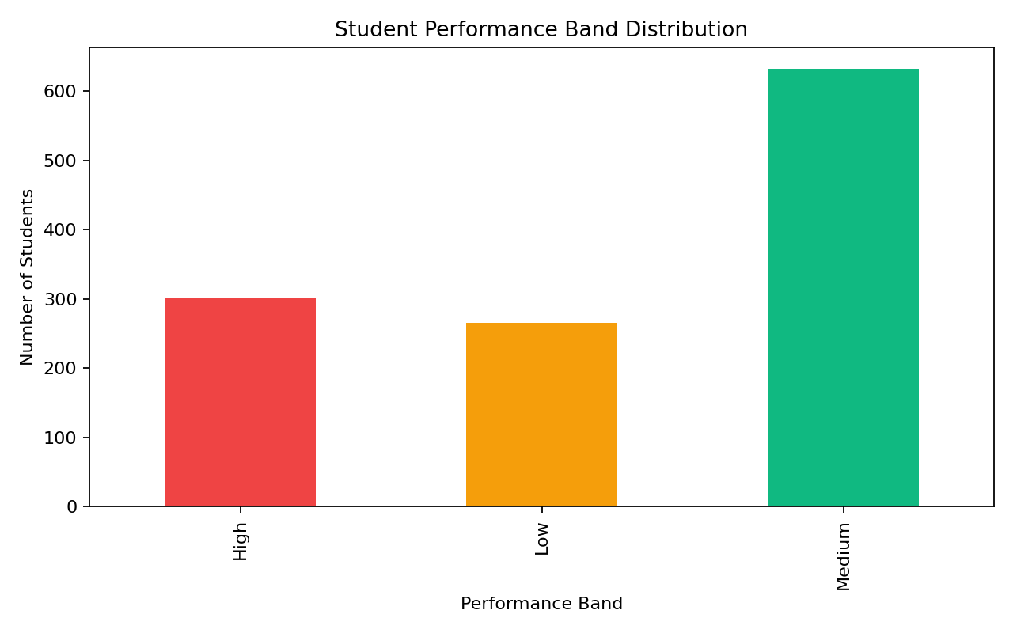
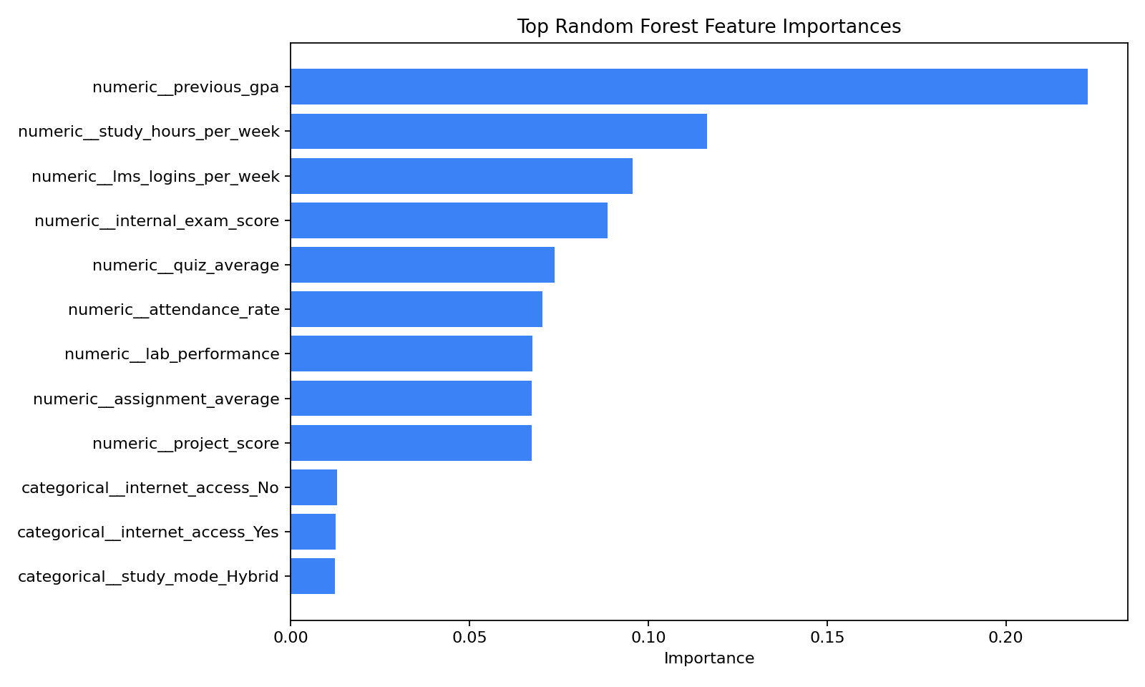
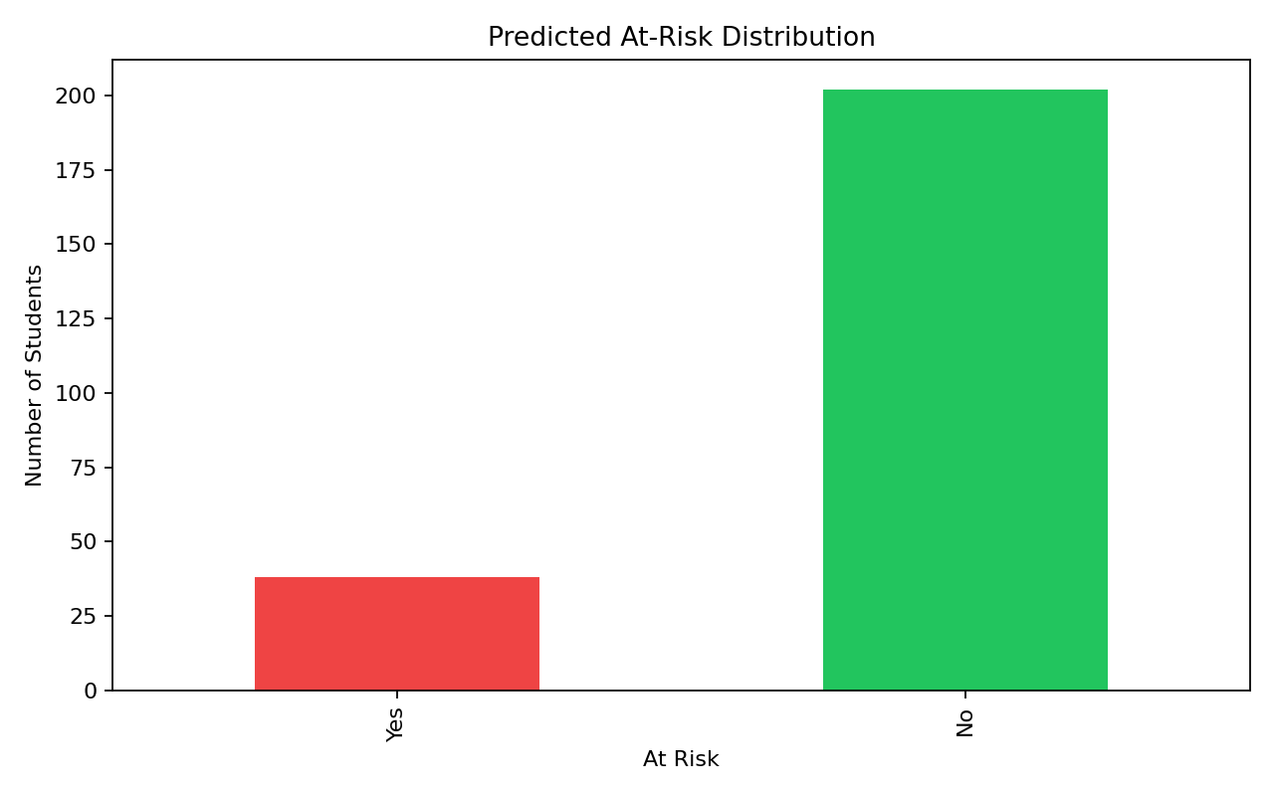

13. How To Run The Application
- python -m venv .venv
- .venv\Scripts\activate
- pip install -r requirements.txt
- python -m src.student_performance_ai.data_generation
- python -m src.student_performance_ai.training
- streamlit run app/dashboard.py
You can also use the one-click launchers: run_app.bat or run_app.ps1.

14. Limitations
- The dataset is synthetic rather than live institutional data.
- Recommendations are rule-based and not directly learned by the model.
- The project is still a prototype and not yet integrated into a production backend.
- The current accuracy is suitable for review and demo, but not final deployment.

15. Conclusion
The Student Performance AI prototype demonstrates how a BIT Management System can be enhanced with AI-driven analytics and recommendation support. Random Forest is an appropriate model for this stage because it is explainable, effective on tabular data, and useful for demonstrating feature-driven insights.

