Project 7 Chapter 10:

**Testing cases:**

|  |  |  |  |
| --- | --- | --- | --- |
| **Cases** | **Input** | **Expected Result** | **Actual Result** |
| Contains(3,3) | C1.contains(3,3) | True | True |
| Contains(4,5,10.5) | C1.contains(4, 5, 10.5) | False | False |
| getArea() | C1.getArea() | 95 |  |

UML:

|  |
| --- |
| **Circle2D** |
| +double: x  +double: y  +double: radius |
| +Circle2D()  +Circle2D(double xi, double yi, double ri)  +getRadius()  +getX()  +getY()  +getArea()  +getPerimeter()  +contains(double x2, double y2)  +contains(Circle2D circle)  +overlaps(Circle2D circle) |

Screenshot:

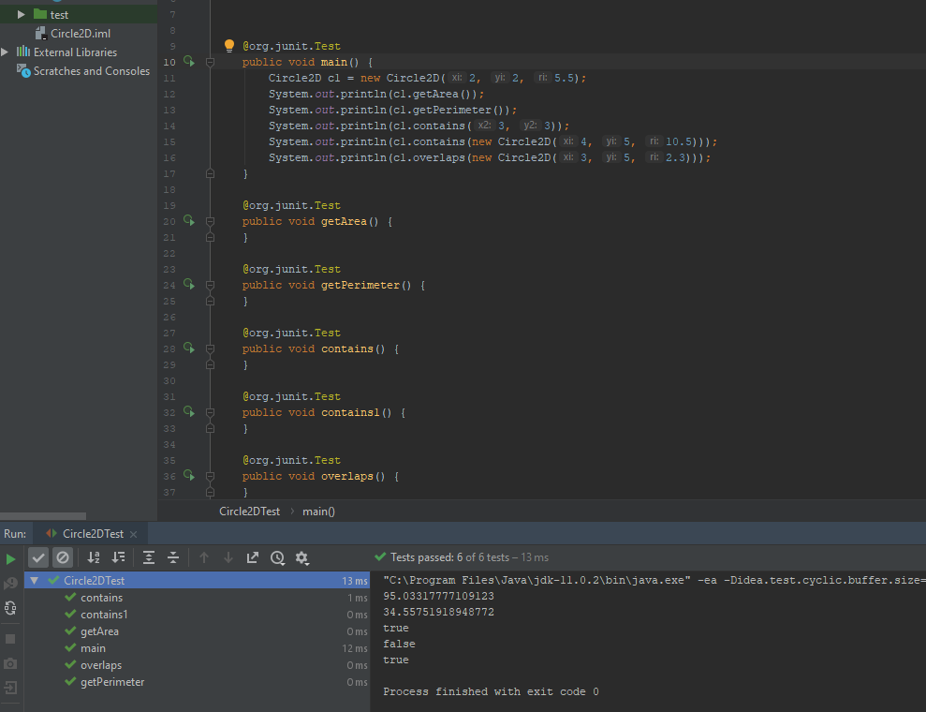

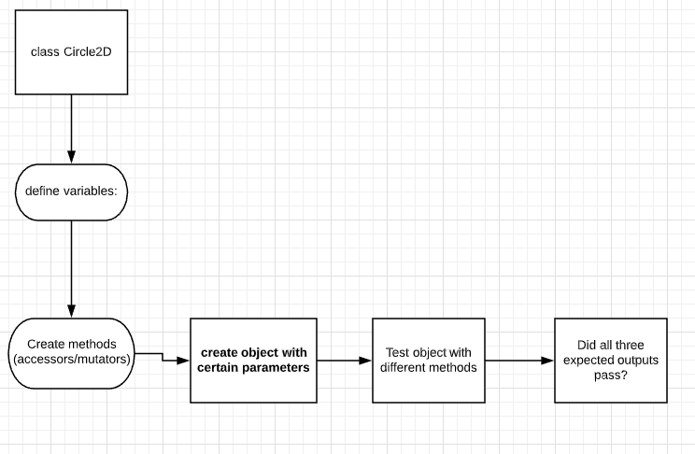

Lessons learned:

Troubleshooting and making sure you are able to read error messages are important and can help you solve issues faster when you are programming.