Christian Armatas

CS 325 – Analysis of Algorithms

Implementation 3 – Report

3/16/2017

**Warm-Up Question:**

*Your report must include…*

* *The linear program for the general problem written as an objective and set of constraints:*

Find the values of *a* and *b* that **minimize ( maximize 1 <= i <= n |axi + b - yi| )**:

That is, for the following instances (pairs of [x,y] coordinates):

(1, 3),(2, 5),(3, 7),(5, 11),(7, 14),(8, 15),(10, 19)

**minimize ( S )** subject to **S >= axi + b - yi**

**-S <= axi + b - yi**

for i = 1, … , n

* *The best solution for the specific problem above:*

y = 1.7142857 x + 1.8571429

* *The output of the LP solver that you used (showing that an optimal solution was found):*

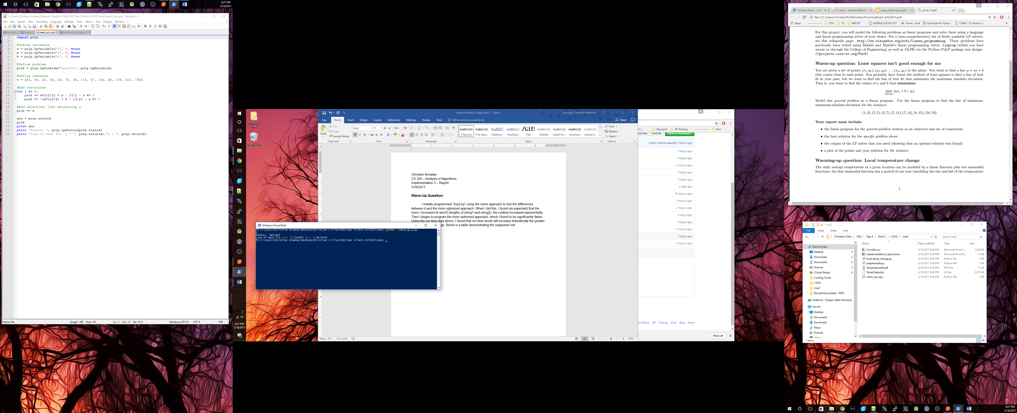

* 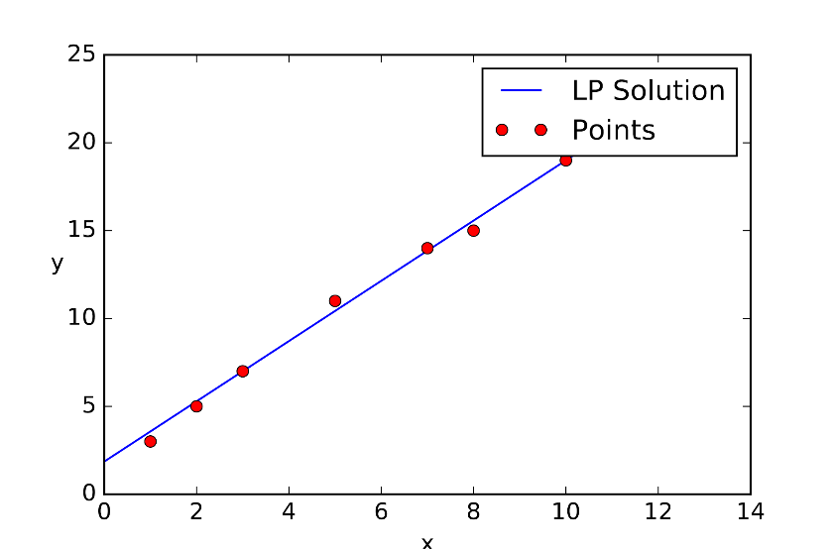*A plot of the points and your solution for the instance:*

**Warming-Up Question:**

*Your report must include…*

* *A description for a linear program for finding the best fit curve for temperature data:*

To find the best fit curve for temperature data, we must base our linear program off the given linear and sinusoidal functions. The linear function **x0 + x1 * d** is straight forward, in that it models the standard linear function **y = mx + b** accurately, where **x1** represents the slope (average change in temperature per day) and **x0** represents the y-intercept (origin temperature at day 0).

The first sinusoidal function, **x2** **\* cos(2πd / 365.25) + x3** **\* sin(2πd / 365.25)**,has a period of one year and represents the seasonal temperature fluctuation pattern, or the rise and fall of temperature in a year while accounting for the seasonal changes.

The last sinusoidal function, **x4*cos(2πd / 365.25*10.7) + x5*sin(2πd / 365.25*10.7)**,has a period of 10.7 years, and represents the temperature fluctuation across an entire solar cycle. In other words, the last portion of the function models the rise and fall of temperature in one solar cycle.

Now, with the model of average temperature on a given day **d** explained, we can use linear programming to find the best fit curve for the provided temperature data. As described above, our objective is to minimize **S**, which represents the absolute value constraints with respect to our LP variables [for i = 1, 2, …, n]**.** Pulp makes finding the solution to this seemingly intricate linear and sinusoidal function extremely easy. We must first declare our LP variables, **S, x0, x1, … , x5,** and import our data (pairs of (*di, Ti*) values) from the file “Corvallis.csv”, and append said data to our problem instance, **t** . Next, we simply make a “*for loop*” to iterate through all the day/temperature pairs in **t** and add them to a problem variable, with respect to the absolute value constraints.

* 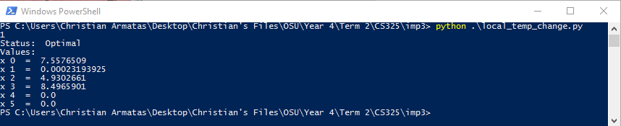*The values of all the variables to your linear program in the optimal solution that your linear program solver finds for the Corvallis data:*
* 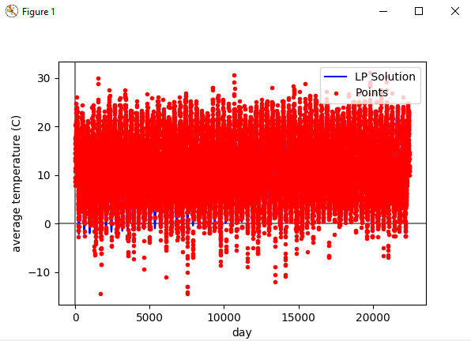*A single plot:*
* *Based on the value* ***x1*** *how many degrees Celsius per century is Corvallis changing and is it a warming or cooling trend?*

The variable **x1** represents the slope of the linear trend portion of the linear program we are solving. The fact that our linear program outputs **x1** equal to *0.00023193925* means that each day, the average temperature will increase roughly *0.00023* degrees Celsius. Each year, the average temperature will increase roughly *0.08395* degrees Celsius, and each century, the temperature will increase roughly *8.395* degrees Celsius.