Class Diagram Hotel System

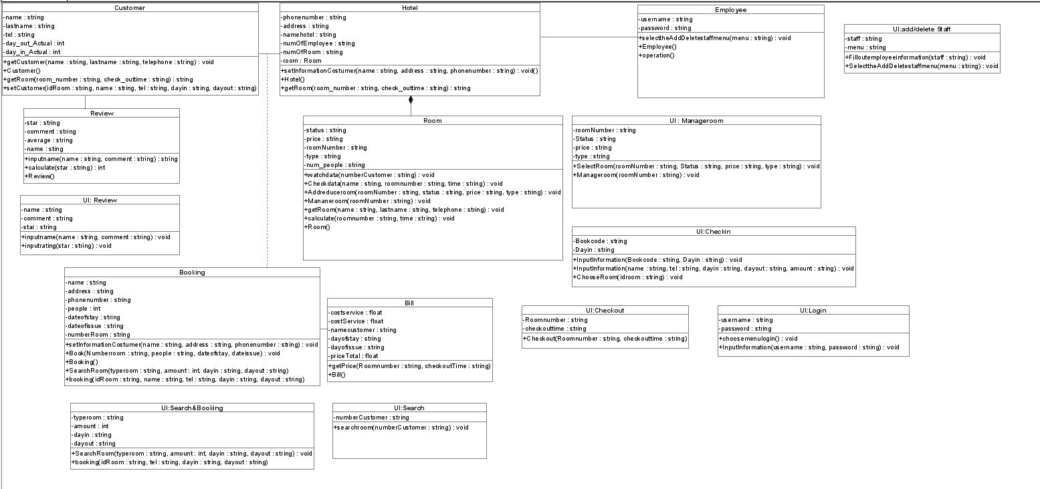

Login Sequence Diagram

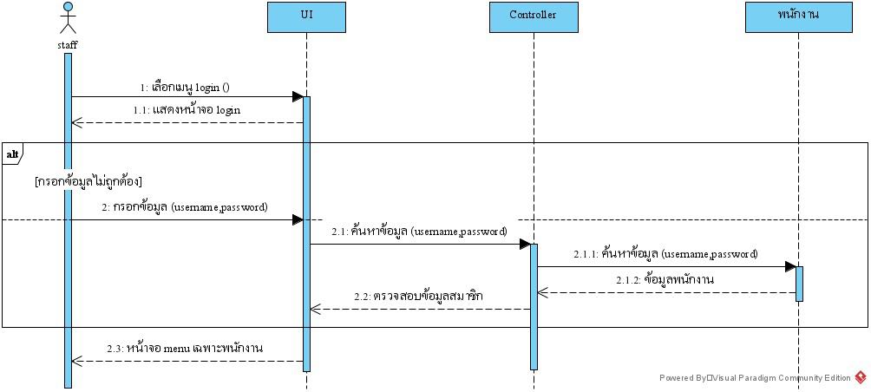

Search room Sequence Diagram

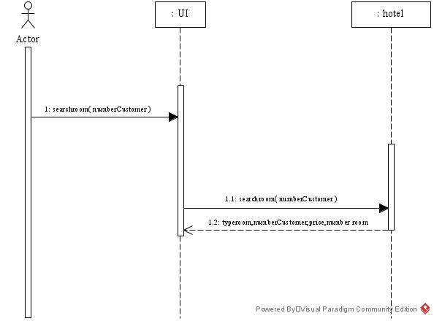

Booking Sequence Diagram

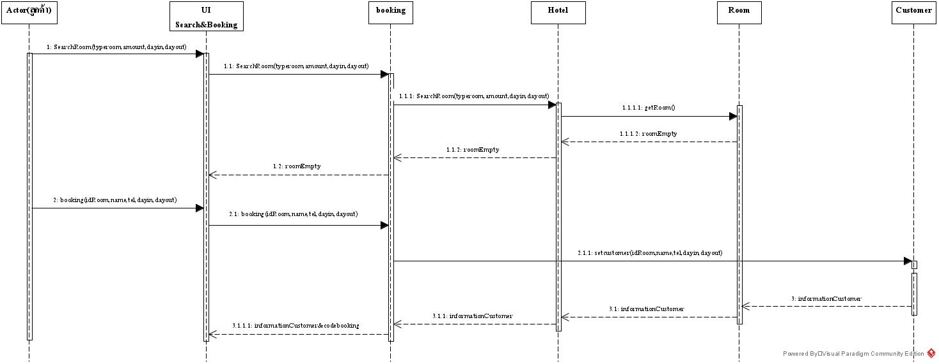

Check-in System Sequence Diagram (Walkin)

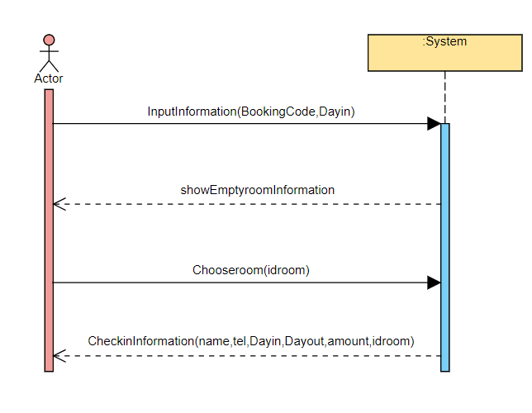

Check-in Sequence Diagram (Walkin)

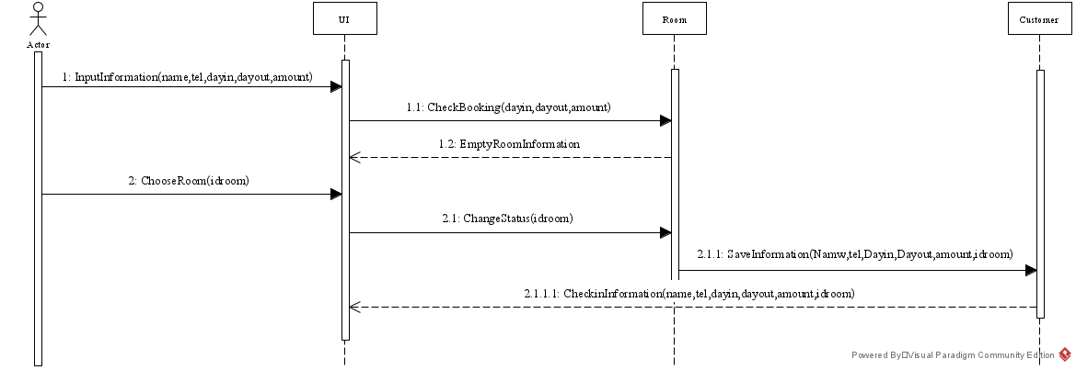

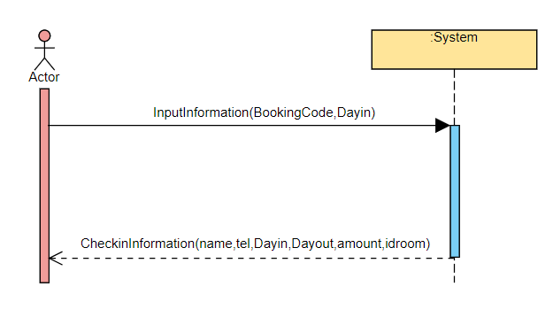Check-in System Sequence Diagram (Booked)

Check-in Sequence Diagram (Booked)

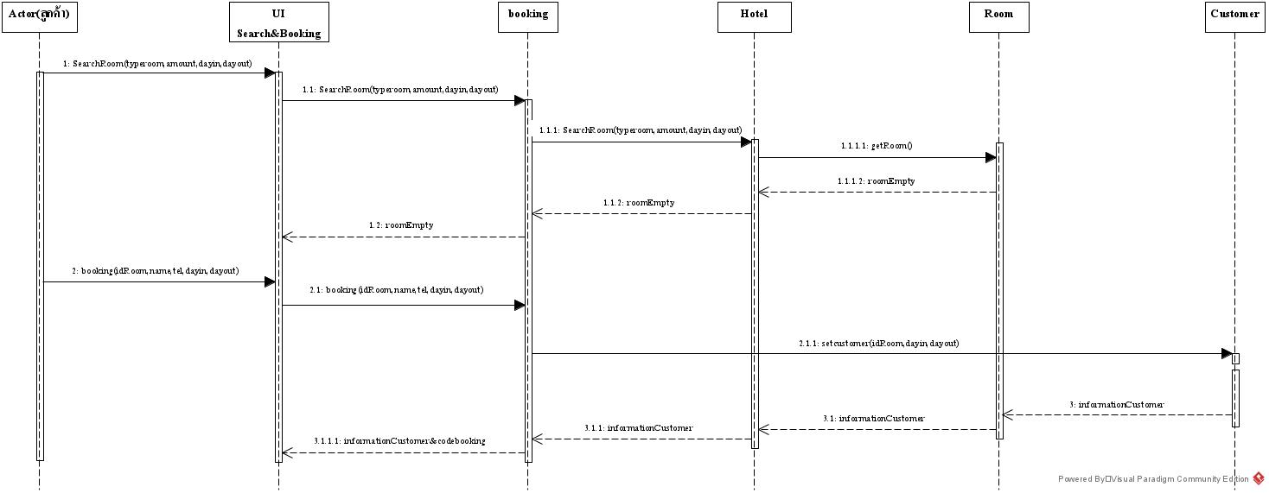

Check-out Sequence Diagram

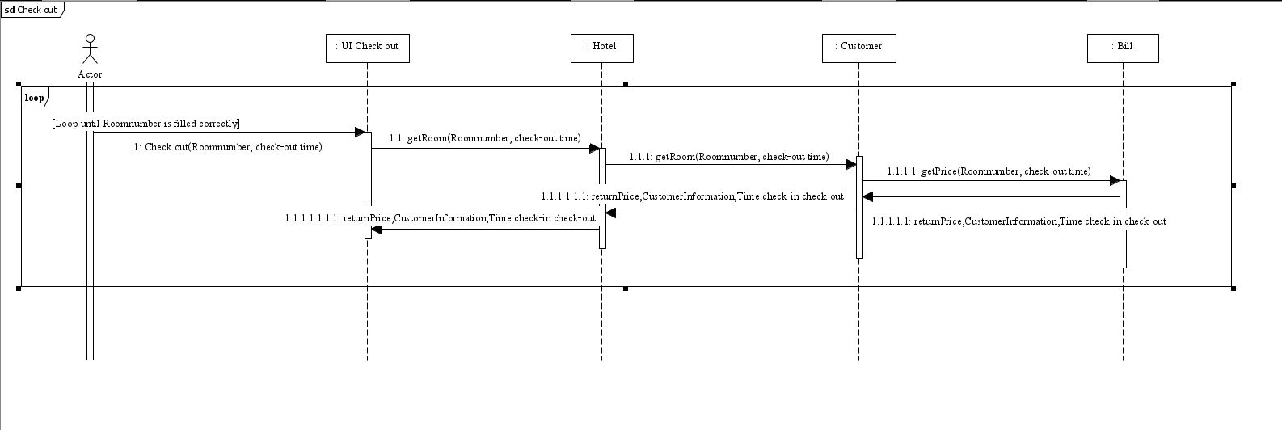

Review hotel Sequence Diagram

